National Park Service  U.S. Department of the Interior | Zion National Park  Use the complete site name here (e.g. Palo Alto Battlefield Historic Site). |  | Springdale, Utah 84767  435 772-3256 phone  435 772-3426 fax  www.nps.gov/zion
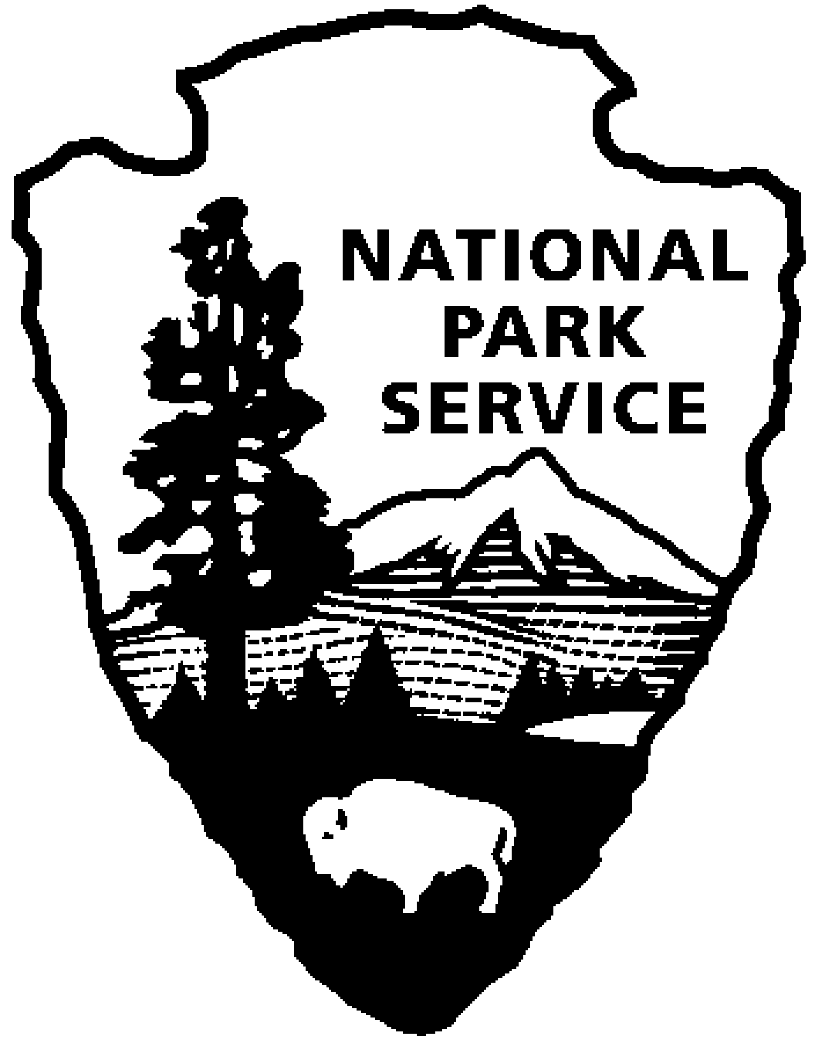
Zion National Park News Release
Use a “short-hand” version of the site name here (e.g. Palo Alto Battlefield not Palo Alto Battlefield National Historical Site).

July 19, 2007
For Immediate Release
David Eaker 435 772-7811
07-19

Wildland Fires in Zion Continue to Grow

Backcountry Remains Closed

The Dakota Hill Fire Complex showed moderate activity today. The fires continue to spread to the north and east. The east fire crossed Zion National Park’s eastern boundary last night onto private and Bureau of Land Management lands. Originally called the Zion 1, 2 and 3 fires, they are now being called the east and west fires, since last night the Zion 1 and 2 fires burned together. The east fire, located north of Orderville Canyon, is being estimated at 1,567 acres and the west fire, located south of Lava Point, at 5,776 acres. This includes total acreage, both in and outside of the park. Both of these lightning caused fires are in remote areas with difficult access. A Type 2 Incident Management Team from the southwest will take over management of the fire tomorrow morning from the local Type 3 team.

Kane County has issued a Mandatory Evacuation Order for the North Fork Road area, east of the park. For more on evacuation information call 435-644-2667.

A backcountry closure remains in effect for all of Zion National Park until further notice. No permits for canyoneering or backcountry use are being issued at this time.

Smoke will continue to be an issue in the park and surrounding area, especially in the evening and early morning hours as it settles into the basins and canyons.

A new fire was discovered today in the park. The Beehive Fire is located on an isolated mesa top near the Streaked Wall, above Zion Canyon. It is a holdover from the same storm on Sunday evening that ignited the others now burning in the park. It is currently being worked with aerial resources. No estimation of size yet, although the mesa top covers about 40 acres. At this time there is little potential for the fire to impact anything other than the mesa top. Zion firefighting personnel are standing by to respond if the fire falls off the mesa top into the canyons below.

-NPS-

