CADD NOTE 5

Technical Release 73 provides various standards to use in developing CADD drawings. The purpose of this CADD Note is to clarify and expand upon some of the standards in TR-73.

INSTALLING

To install the files associated with this CADD Note, perform the following steps. These instructions assume you will be using drive B. If drive A is used, substitute A for all references to B.

1. Place the CADD Note diskette in drive B.

2. From the DOS prompt, enter the following

B:INSTALL

3. Answer any prompts that may appear.

4. The files should be copied and a message will indicate that installation is done.
NOTE: You will need to perform the steps outlined in the sections below to utilize the files copied.

PEN SIZES

The table below defines the size that should be used for pens 1 through 4. The AutoCAD drawing color related to each pen is also shown along with the intended uses.

Table 5.1 . Pen Sizes
 | Pen Size |  |  | AutoCAD
Pen # | mm | inches | Color |  | Use for the following:
1 | 0.25 | 0.010 | 1 (red) or  7 (white) |  | Dimensions, notes, minor text, hidden lines, etc.
2 | 0.35 | 0.014 | 2 (yellow) |  | Titles
3 | 0.50 | 0.020 | 3 (green) |  | Object lines
4 | 0.70 | 0.028 | 4 (cyan)

If you wish to use a drawing color beyond those listed above, the following convention should be used:

AutoCAD colors Convention
01-89 tens digit is linestyle, ones digit is pen # (e.g., 23 would use linestyle 2 with pen 3). Available linestyles (1-8) are seen by selecting "Pen Assignments", "Feature legend" from the Plot dialog box.
90-255 ones digit is pen #
(e.g., 175 would use pen 5)

PEN SIZES (cont.)

Included with this CADD note are two files that can be used to update the pen assignments to match these conventions. One file is for setting the DraftPro plotter and the other is for the LaserJet 4/IIISi. Follow the steps below for each plot device to update its pen assignments.

1. Enter PLOT at the AutoCAD Command: prompt. The plot dialog box should appear.
2. Select "Device and Default Selection...".
3. Highlight the desired device (e.g., HP DraftPro Plus or LaserJet 4/IIISi).
4. Select "Get Defaults From File...".
5. A file selection dialog box appears. Enter the filename below for the device highlighted in step 3.
HP DraftPro Plus: C:\ACAD\DRV\HPGL2\SCSDPRO.PCP
Laserjet 4/IIISi: C:\ACAD\DRV\HPGL2\SCSLASR4.PCP
A message should indicate there were no errors.
6. Select "OK" to exit "Device and Default Selection..." dialog box.
7. To check that pen settings were set, select "Pen Assignments". Select "OK" when done checking.
8. Press “OK” . At “Press RETURN...” prompt, press Ctrl-C to cancel plotting.
9. Repeat steps for the other device.

LAYERS

Layers allow various drawing features to be separated. The layers shown in the table below should be used to provide consistency in drawings. In the case of simple drawings, all of the drawing items may be placed on AutoCAD's 0 layer.

Layer Name Layer Contents
AS_BUILT As-built drawing
BORDER Border and permanent title block text
CULTURAL Cultural features (e.g, buildings, wells, etc.)
DIMENSIONS Structural dimensions
DRAW_RECORD Drawing record
FENCES Fence lines
GEOLOGY Geologic features
GRID_BOLD Bold grid lines
GRID_LIGHT Light grid lines
LEGEND Legend for a map or the drawing
MISC Miscellaneous records
MISC_NOTES Miscellaneous notes that you wish not to plot
NOTES Drawing notes
ROADS Roads
STEEL Reinforcing steel with marking and spacing
STR_LINES Structural lines
TITLES User entered text for title block
TREES Trees, brush, etc.
UTILITIES Utilities (e.g., gas or water lines)
WATER Water edge, streams, etc.

Additional layers may be used if a drawing requires more separation than the above list or if an item is not in the above list.

LAYERS (Eagle Point)

Eagle Point software creates layers for various features (e.g., contours, TINs, profiles, etc.). The default layer names should be used. When multiple items of a particular feature are desired (e.g., multiple TIN lines), the default layer name should be appended with text that further describes the feature. For example, you could use TINORG for original TIN lines and TINFINAL for final TIN lines.

TEXT

All text that may be reduced in size should have 0.06 inch minimum height after reduction. Titles should be all capitals, with 0.09 inch minimum height after reduction. Table 5.2 below shows small, medium, and large text sizes to use for the most common sheet sizes used.

Table 5.2. Text Sizes
 | Text sizes (inches on plotted output)
Sheet Size | Small | Medium | Large
L (SCS) (8.5”x11”)  N (SCS) (10.5”x15”)  A (8.5”x11”)  B (11”x17”) | 0.08 | 0.12 | 0.16
E (SCS) (21”x30”)  D (22”x34”) | 0.12 | 0.18 | 0.24

It is suggested that only 2 sizes be used on a single drawing; either small and medium or medium and large depending on the complexity of the drawing. Dimension text and notes should use the smaller of the two and title text should use the larger of the two. Arrow sizes should use the “medium” size listed above in both cases.

When entering a text height in AutoCAD's model space, you must enter it in real world coordinates, not plotted units. For example, if you want 0.06 inch text and you are plotting at a 1"=100' scale, you will need to enter 6 (0.06 x 100) as your text height. Eagle Point's settings of horizontal scale and text size handle the conversion for you when you use any Eagle Point function that generates text.

The text style used should be consistent throughout the drawing. The suggested style to use is ROMANS with a 15° oblique angle.

After installing this CADD Note, a program is available to assist you in setting the appropriate text sizes as well as dimension text and arrow sizes. It is explained on the following page.
To use it, type the following at the Command: prompt,

SETTEXT

A dialog box will then appear as shown below.

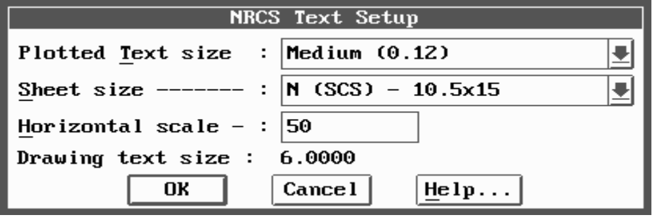

You should then do the following:

1. Select the desired text size for plotted output (small, medium, or large).
2. Select the sheet size you intend to plot on.
3. Enter the horizontal scale.
4. Press OK.

The drawing text size is computed (plotted text size x horizontal scale) and displayed. When you press OK, the text style is set to ROMANS with a 15° oblique angle, text size is set to computed text size, the dimension scale factor is set to the entered scale, dimension text size is set to the selected plotted text size, and dimension arrow size is set to the medium plotted text size.

TECHNICAL INFORMATION

INSTALLED FILES

This CADD Note installs the following files:

In the \ACAD\DRV\HPGL2 subdirectory,

SCSDPRO.PCP Plot configuration file for HP DraftPro Plus plotter.
SCSLASR4.PCP Plot configuration file for HP LasertJet 4 printer.

In the \ACADNRCS subdirectory,

NRCS.LSP Main lisp routine that loads NRCS created routines
SETTEXT.CFG File to save last used settings.
SETTEXT.DCL Dialog control file.
SETTEXT.HLP Help file.
SETTEXT.LSP Lisp routine to assist in setting text sizes.

The files ACADR12.BAT and EAGLE.BAT are updated to include \ACADNRCS in the ACAD environment variable.

