Joint Hurricane Testbed Semi-annual Progress Report
Project: Evaluation of Upper Ocean Mixing Parameterizations
Principal Investigator: Dr. S. Daniel Jacob; 301-614-5906; jacob@nemo.gsfc.nasa.gov
Co Investigators: Dr. Nick Shay; 305-361-4075; NShay@rsmas.miami.edu and
Dr. George Halliwell; 305-361-4621;GHalliwell@rsmas.miami.edu

Introduction:

Past observational, theoretical and numerical studies have substantiated the fact that tropical cyclone intensity is sensitive to the upper ocean heat potential in the directly forced region of the storm. Observational and numerical investigation of ocean response during hurricane Gilbert in the western Gulf of Mexico suggested that the upper ocean heat and mass budgets have a strong dependence on the entrainment mixing scheme. Thus, one of the major uncertainties in a coupled hurricane ocean forecasting model is the choice of mixing scheme as significant oceanic mixed layer cooling and deepening during a storm passage is due to mixing. As part of this Joint Hurricane Testbed (JHT) funded project, using the Hybrid Coordinate Ocean Model (HYCOM) configured with different entrainment mixing schemes, this issue will be investigated in detail. Available high-resolution oceanic observations during the passage of three tropical cyclones (Gilbert 1988, Isidore 2002 and Lili 2002) in the Atlantic provide the data set to evaluate model results. Overall, 702 temperature, 102 salinity and 210 current profiles acquired during these storms will be directly compared to simulated results to identify the best mixing schemes for different forcing characteristics and background oceanographic conditions that can be used in the coupled intensity prediction models. In this report, the progress so far on the project in deriving the initial conditions and forcing data is presented.

Objectives for the first six months:

Our principal objectives during the past six months were:

- Configuration of the numerical model based on suitability of geographic coverage and vertical structure representation;

- Derivation of realistic initial conditions for hurricanes Gilbert and Isidore using a combination of in situ and remotely sensed data; and

- Derivation of realistic boundary layer forcing by blending in situ and aircraft derived quantities with the large scale model fields.

These objectives have been achieved as per the schedule and now we are focusing on validating the initial conditions by comparing them to profiler observations and examining the sensitivity of the vertical structure representation in the model. Details are presented briefly in the following sections. This is scheduled to be completed by the end of February and will be followed by detailed simulations of ocean response for hurricane Gilbert in the next six months.

Model Configuration:

Two configurations of HYCOM are set up to perform the numerical simulations for the different mixing schemes. As most of the observations are in the western Gulf of Mexico during hurricane Gilbert, the model domain extends from 80 to 98° W longitude and from 14 to 31° N latitude. With a horizontal grid resolution of 0.07°, the model has 250×242 horizontal points and 26 layers in the vertical. The bathymetry used in the model is derived from ETOPO 5 topography and the boundaries along Florida Straits and the Caribbean sea are closed by vertical sidewalls as the area of interest is in the Western Gulf of Mexico.

With the occurrence of hurricanes Isidore and Lili in the same general geographic region, ocean response simulations are combined into a single continuous case spanning 30 days. The model domain extends from 65º to 98º W and 9º to 31º N with a resolution of 0.08°. The model has 26 vertical layers on a 413×296 horizontal grid and the boundary conditions are provided from basin-scale Atlantic Ocean HYCOM simulations driven by realistic atmospheric forcing. While the profiler acquired data are at very high resolution in the vertical (~ 1 m), the model is configured with a 5 m resolution at the surface and increasing it with depth until it transitions into the isopycnic domain. This will be reduced to 3 m if necessary during the simulation phase.
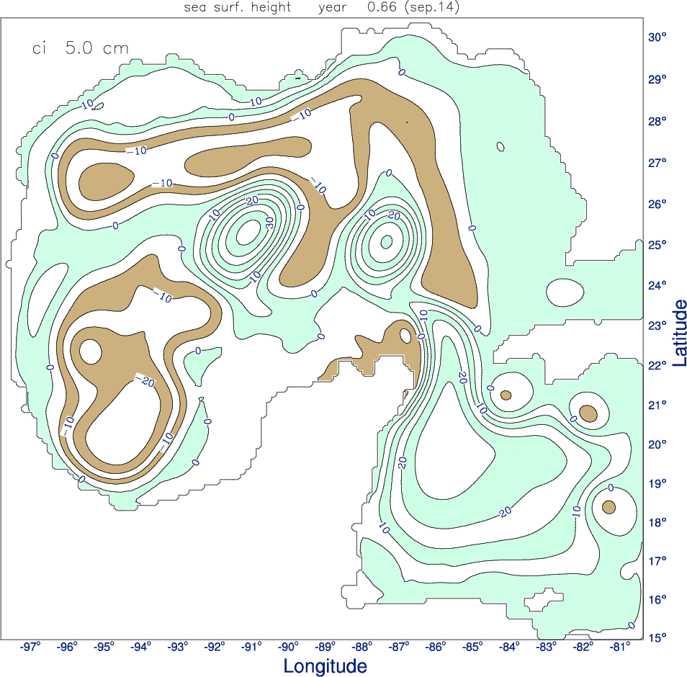

Figure 1: Sea surface height field corresponding to initial conditions for the Gilbert case. Pre-storm oceanic variability is represented well by the eddy located at 91.2° W, 25.4° N.

Initial Conditions:

A combination of climatology and in situ measurements are used to provide the oceanic initial conditions for Gilbert. Prior to the passage of Gilbert, extensive data were acquired by the Minerals Management Service. The data from yeardays 187 to 217 are designated as the yearday 200 data and are objectively analyzed at every 10 m depth (Shay et al. 1998). The Temperature-Salinity (T-S) relationship of this data set compares well with the historic T-S curves for the different water masses in the Gulf of Mexico. These data are combined with the Levitus (1982) climatology data set to derive model layers/ levels. Using the Coupled Ocean Atmospheric Data Set (COADS) climatological forcing, the ocean model is integrated for 60 days to provide a realistic pre-storm condition prior to the passage of Gilbert. While the model temperature profiles are comparable with observations at the end of the integration, the model eddy has a maximum sea surface height of 35 to 40 cm (Fig.1). The velocities associated with the eddy in the model are about 0.8 to 0.9 ms⁻¹ compared to 1 ms⁻¹ from the observations. The major and minor axes of the eddy ellipse are about 225 km and 110 km, respectively compared to the observed maximum of 250 km.
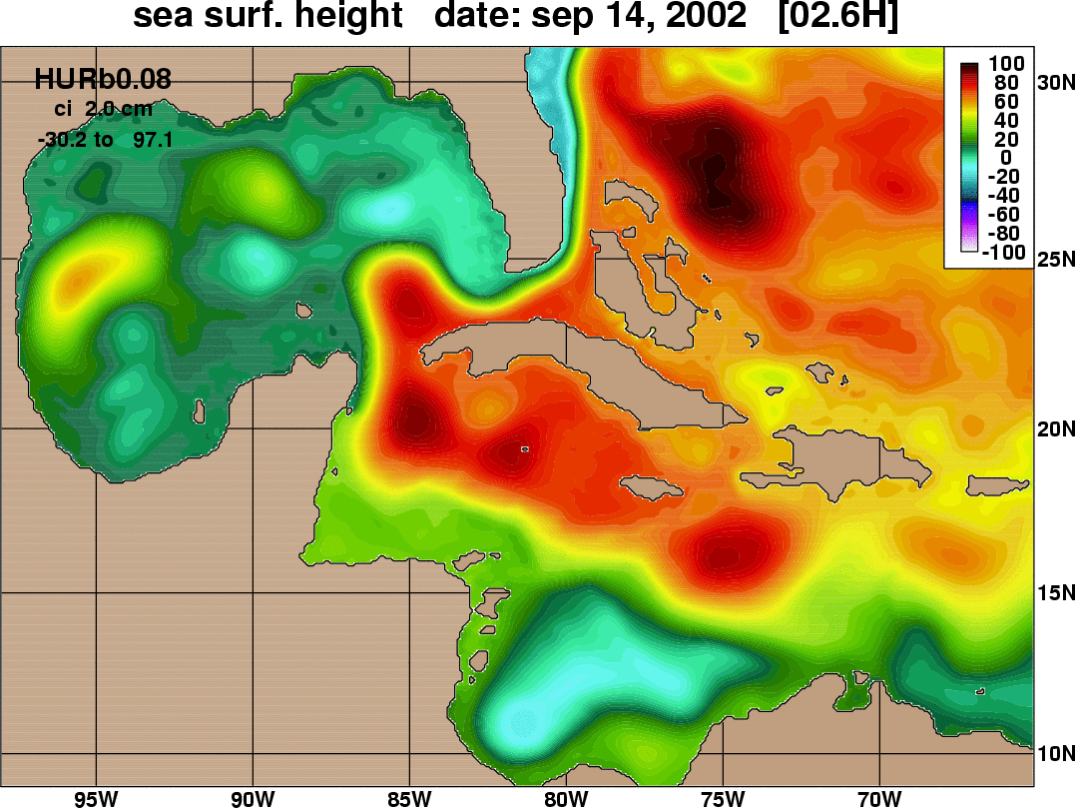

Figure 2: Pre-storm oceanic variability for hurricane Isidore as indicated by the sea surface height field. The mesoscale oceanic features are positioned accurately corresponding to altimetric height observations.

In the case of Hurricanes Isidore and Lili pre-storm measurements, the initial fields are derived from the standard 1/12° Atlantic HYCOM simulations. Sea surface height anomalies derived from satellite altimeters have been assimilated into these runs using an optimal interpolation scheme, so ocean eddies and boundary currents are reproduced quite accurately. Fig.2 shows the pre-Isidore sea surface height patterns in the eastern Gulf of Mexico and Caribbean Sea. Initial comparisons of the simulated vertical structure with the expendable profiler data acquired as part of NOAA/NSF USWRP program indicate good agreement with observations. Quantitative comparisons will be performed in the next month to further validate these initial conditions.

Surface Forcing:

As part of a previous study (Jacob et al. 2000), Gilbert boundary layer winds are objectively analyzed with the ECMWF model generated 10 m winds in the model domain to provide realistic surface winds every 3 hours. Due to the lack of data, a simpler wind speed dependent precipitation data profile is derived for use with the Gilbert simulations. Surface forcing during hurricanes Isidore and Lili is derived using a different approach. As the three-hourly NOAA HRD HWIND analyzed surface winds during these storms were made available to us by Dr. Mark Powell, the objective analysis technique of Mariano and Brown (1992) is used to blend the large scale 3 hourly 10 m winds from the basin scale HYCOM with these analyzed winds in the hurricane core. Rainfall rates from TRMM satellite and Special Sensor Microwave/ Imager during Isidore and Lili are also available to be interpolated to the model grid to investigate the salinity budgets and ensure that the vertical mixing parameterizations properly account for these effects.

Summary:

The initial focus of this work has been on the derivation of realistic initial conditions and boundary layer forcing that is crucial to simulating the upper ocean response accurately during hurricanes Gilbert, Isidore and Lili. The project is proceeding on schedule with further validation of the derived conditions with quantitative comparison with in situ data planned for the next month followed by numerical simulations for the different entrainment mixing schemes for hurricane Gilbert. Initial comparisons and validation of these initial conditions will be presented at the Interdepartmental Hurricane Conference.

References:

Jacob, S.D., L.K. Shay, A.J. Mariano and P.G. Black, 2000: The 3-D oceanic mixed-layer response to Hurricane Gilbert. J. Phys. Oceanogr., 30, 1407-1429.

Levitus, S., 1982: Climatological Atlas of the World Ocean. NOAA Prof. Paper 13, U.S. Govt. Printing Office, Washington D.C. 20401, 173pp.

Mariano, A.J., and O.B. Brown, 1992: Efficient objective analysis of heterogeneous and nonstationary files via parameter matrix. Deep. Sea. Res., Part A, 39(7), 197-207.

Shay, L.K., A.J. Mariano, S.D. Jacob and E.H. Ryan, 1998: Mean and Near-Inertial Ocean Current Response to Hurricane Gilbert. J. Phys. Oceanogr., 28, 858-889.

