September 2007 NC Weather Review

Monthly Headlines

…Extreme to exceptional drought conditions spread across North Carolina…
…September 2007 was one of the hottest and driest September’s on record…

September 2007 Precipitation

Rainfall became scarcer in September than in the previous months, which increased the severity of the ongoing drought. Many reporting stations from Elizabeth City and Roanoke Rapids, to Roxboro, Asheboro, and Albemarle recorded an inch or less of rain. In fact, a large majority of the Piedmont and northern Coastal Plain recorded less than 20 percent of their normal rainfall, as depicted in figure 2. The spatial distribution of monthly rainfall amounts from official National Weather Service sites and local cooperative observers is shown in figure 1.

Drought conditions continued to worsen as a result of the extremely dry and hot weather experienced across North Carolina during September. In fact, the drought status across North Carolina fell into the two worst categories possible by the end of the month. The crops, plants, and water supplies continued to wither away, which resulted in substantial agricultural losses statewide. Meanwhile, the stream flow along main stem rivers and into local reservoirs continued to decline. The North Carolina Drought Monitor released October 2, 2007 (see figure 3), shows the extreme to exceptional drought conditions that had rapidly expanded across the state.

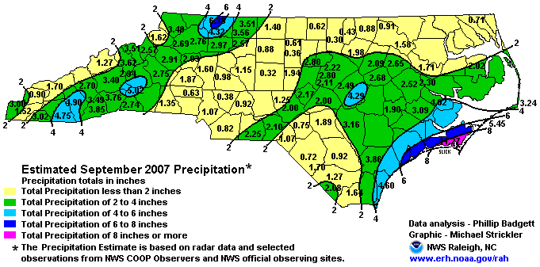

Figure 1. Total reported rainfall for September 2007. Plotted data was recorded by National Weather Service observation systems or cooperative observers.

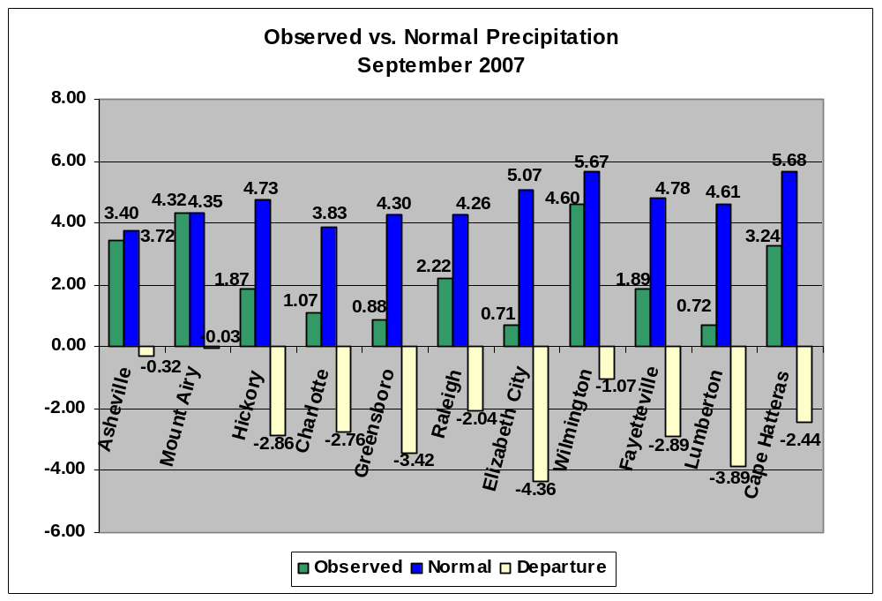

Figure 2. Comparison of observed precipitation and normal precipitation for September 2007, at selected locations across North Carolina.

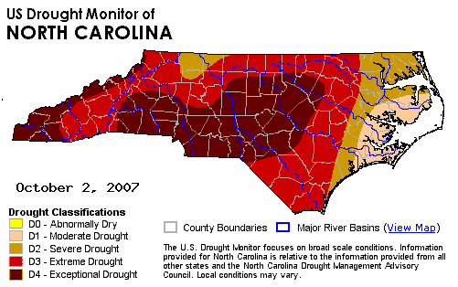

Figure 3. N.C. Drought Monitor as observed on October 2, 2007.

September 2007 Temperatures

The monthly temperatures across the state, depicted in figure 4, averaged well above normal (generally by 2 to 4 degrees). Indeed, many areas recorded one of their hottest September’s on record. For example, Greensboro averaged 73.9 degrees (4.1 degrees above normal), which was the third hottest average monthly temperature on record for September. Similarly, Raleigh-Durham recorded an average of 75.0 degrees (3.8 degrees above normal), which was the second hottest average monthly temperature on record for September. The daily maximum and minimum temperatures observed at Raleigh-Durham (RDU) and Greensboro (GSO) are depicted in figures 5 and 6, respectively.

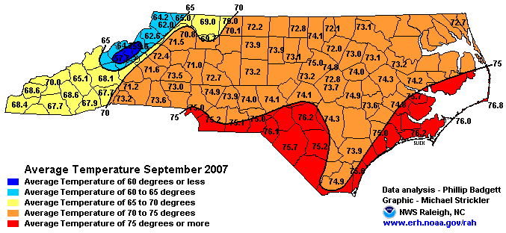
Figure 4. Average Monthly Temperatures for September.

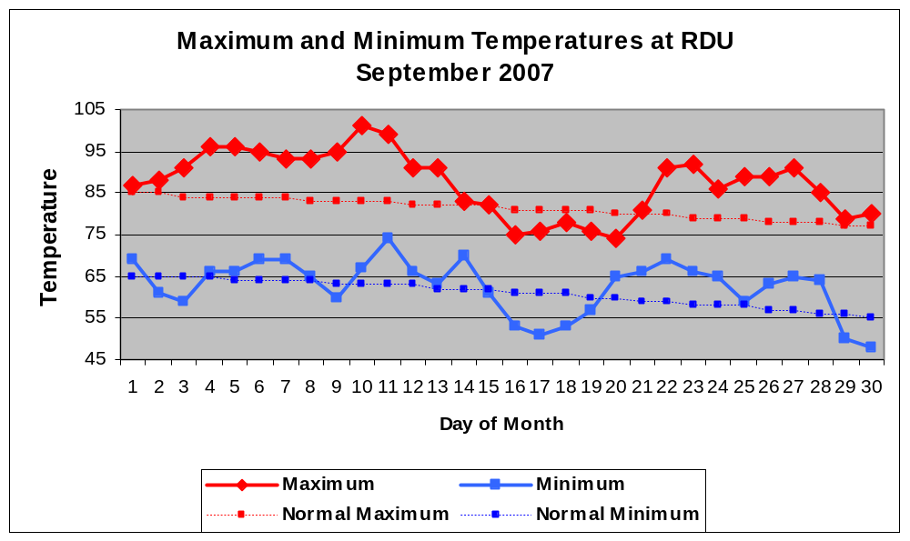

Figure 5. Daily maximum and minimum temperatures observed during September 2007 at Raleigh-Durham (RDU).

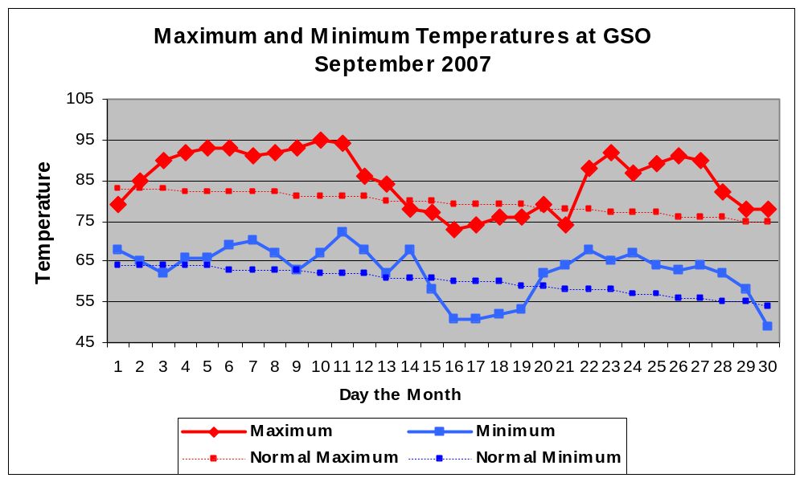

Figure 6. Daily maximum and minimum temperatures observed during September 2007 at Greensboro (GSO).

The dry and hot conditions this spring and summer have led to a dramatic increase in the number of 90 degree days, plotted in figure 7. Raleigh-Durham averages about 37 days per year that the temperature reaches or surpasses 90 degrees. A staggering total of 83 had been recorded by the end of September, which set a new record for the number of 90 degree days recorded in any year at RDU. The previous record was 82 days, set in 1953. Interestingly, the number of 90 degree days at Raleigh exceeded those recorded at both Fayetteville and Lumberton.

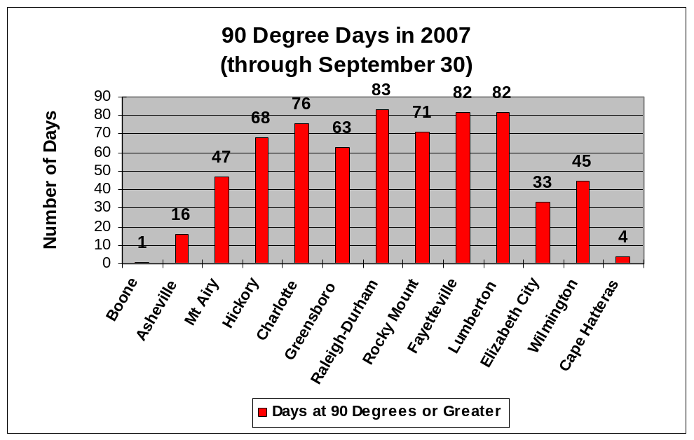
Figure 7. The number of days in which the temperature has reached or exceeded 90 degrees.
(January 1-September 30, 2007).

Current, Semi-Annual and Annual Temperature Trends

The heat in September at both Greensboro and Raleigh continued the general trend of above normal temperatures in the past 12 months. Six of the past seven months, and nine of the past eleven months have been warmer than normal at both Greensboro and Raleigh-Durham.

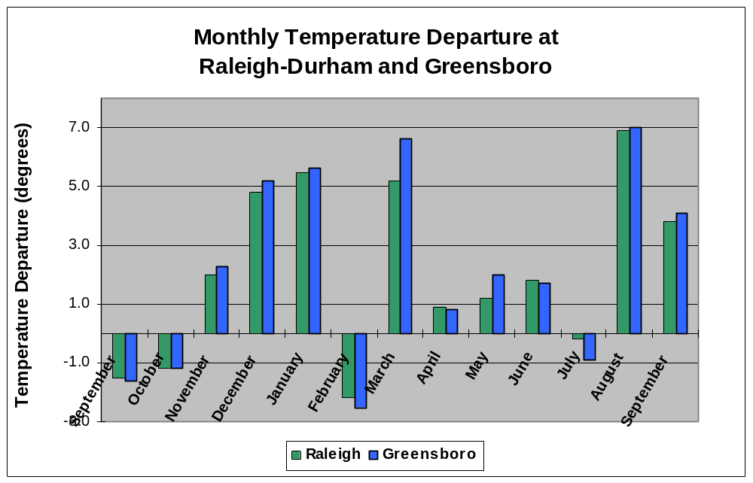
Figure 8. Monthly temperature departures from normal at Raleigh-Durham and Greensboro from September 2006 through September 2007.

Current, Semi-Annual, and Annual Precipitation Trends

The well below normal rainfall totals recorded at Greensboro and Raleigh-Durham in September continued the very dry trend of 2007. Seven of the nine months this year have been drier than normal. The rainfall deficit at Greensboro for 2007 reached 12.02 inches. The drier than normal September at Raleigh-Durham made it the sixth month in nine this year with sub par rainfall. The rainfall deficit at RDU during the first nine months of the year was at 7.64 inches. Figures 9 and 10 depict the monthly precipitation versus the normal precipitation at both Raleigh-Durham and Greensboro in the past 13 months.

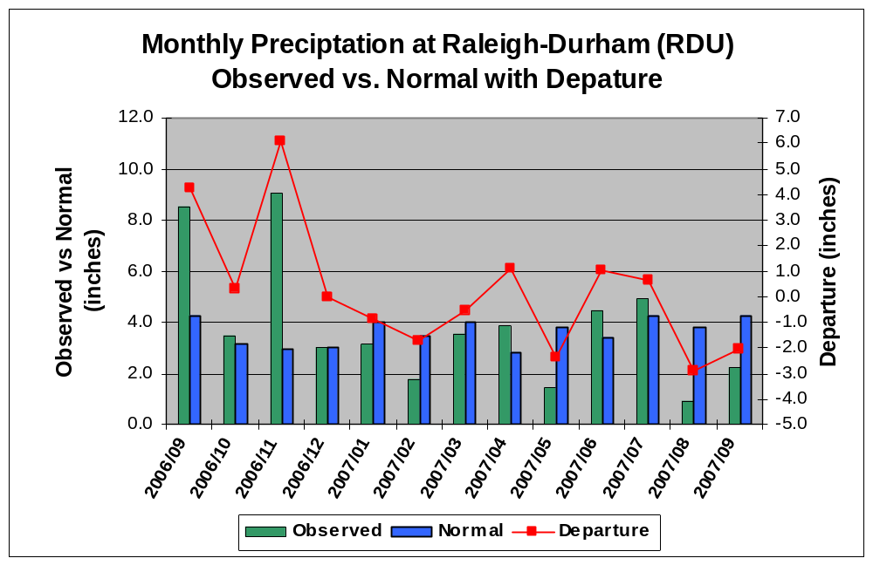

Figure 9. Semi-annual and annual precipitation trends at Raleigh-Durham (RDU).

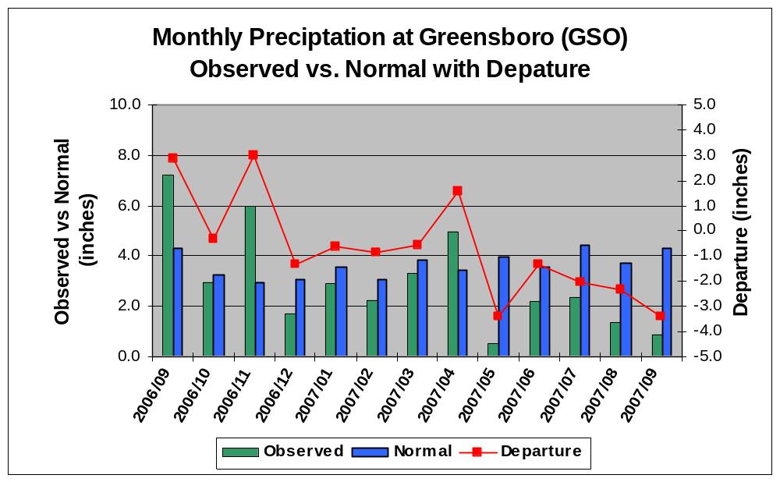
Figure 10. Semi-annual and annual precipitation trends at Greensboro (GSO).

North Carolina Water Resources Information and Outlook

The general lack of any significant rain during September pushed most of the state into the extreme to exceptional drought category. Such drought conditions have negatively affected the major metropolitan areas of Charlotte, Winston-Salem-Greensboro-High Point, and Raleigh-Durham. Stream and river levels over central North Carolina declined to as low as 5 percent of long term average. Falls Lake, the main water supplier for Raleigh and surrounding municipalities, continued well below targeted levels. Inflow into Falls Lake, including the Eno River flow, fell to less than 5 percent of the long term average. The inflow into Jordan Lake from the Haw River fell to 5 percent of the long term average. The drought severity was worst over the southwest part of the state, where many mountain locals were running yearly rainfall deficits of 20 to 25 inches.

For the latest information concerning the drought, visit:
http://www.ncwater.org/drought/ or

http://www.erh.noaa.gov/rah/drought

Climate Outlook for the winter season

The Climate Prediction Center recently released the winter outlook. Details concerning this forecast can be found at the web address below:

http://www.cpc.ncep.noaa.gov/products/predictions/

The rainfall outlook for the winter season indicated increased odds of below normal precipitation. The 90 day precipitation forecast for the winter season is depicted in Figure 11. If below normal rainfall is realized this winter, there is a distinct possibility of very little in the way of drought relief as depicted in Figure 12.

You can keep up with latest monthly and seasonal forecasts by visiting the Climate Prediction Center website at http://www.cpc.ncep.noaa.gov/.

Enhanced local three month temperature outlooks are now available at http://www.weather.gov/climate/calendar_outlook.php?wfo=rah

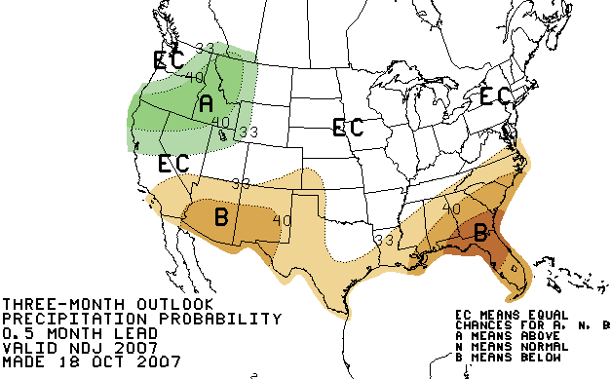

Figure 11. Precipitation Outlook from the Climate Prediction Center for November 2007 through January 2008.

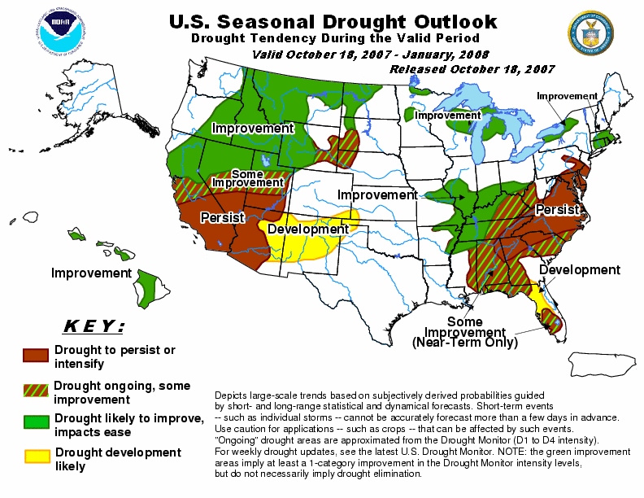

Figure 12. U.S. Seasonal Drought Outlook valid through January 2008, released on October 18, 2007.

NC Weather Review Team

Phillip Badgett
Michael Strickler

