August 2007 NC Weather Review

Monthly Headlines

…Severe to extreme drought spread across the state during August 2007…
…The hottest month ever recorded at several locations…

August 2007 Precipitation

Rainfall was yet again well below normal across much of the state of North Carolina during August. Many areas across the central and western sections recorded less than one inch (less than 20 percent of normal). In fact, there were numerous reports of monthly rainfall amounts of less than one half inch, which is less than 10 percent of normal. When combined with sunny skies and temperatures in the 90s to lower 100s with each passing day, crops, plants, and water supplies withered away. Severe agricultural losses were expected. The stream flow into main stem rivers and local reservoirs continued to decline. The monthly rainfall amounts from official National Weather Service sites and local cooperative observers are depicted in figure 1.

Drought conditions worsened very quickly throughout the state, as the oppressive heat and lack of rain continued throughout the month. The NC Drought Monitor, shown in figure 2, showed the rapid expansion of extreme drought conditions throughout the state as of September 18. Figure 3 depicts the observed rainfall and departure from normal. Of note are the strong negative departures observed this month at generally all locations.

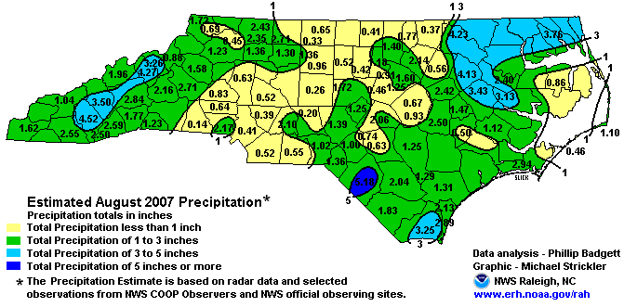

Figure 1. Total reported rainfall for August 2007. Plotted data was recorded by National Weather Service observation systems or cooperative observers.

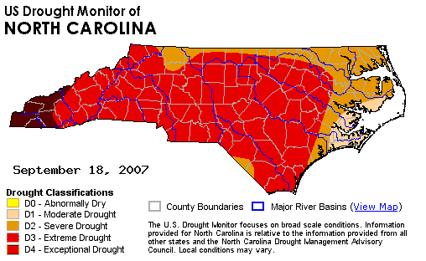

Figure 2. N.C. Drought Monitor as observed on September 18, 2007.

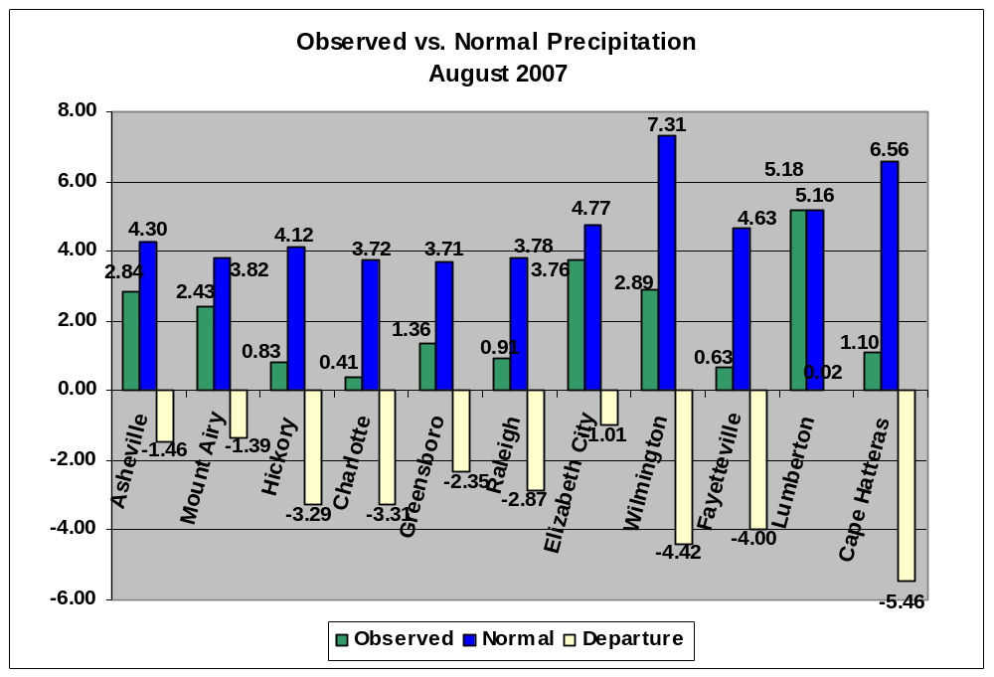

Figure 3. Comparison of observed precipitation and normal precipitation for August 2007 at selected locations across North Carolina.

August 2007 Temperatures

The monthly temperatures across the state, depicted in figure 4, averaged well above normal. Many areas recorded their hottest August on record, and several locations even recorded their hottest month on record. For example, Greensboro averaged 83.2 degrees, which was a whopping 7.0 degrees above normal. It was the hottest August on record and the hottest month all-time at the PTI Airport. There were 7 daily record highs set during the month. Raleigh-Durham recorded an average of 84.1 degrees, which was 6.9 degrees above normal. This broke the record of the hottest August on record at the RDU Airport. It was also the hottest month in recorded history for the Raleigh-Durham area, where records have been kept since 1887. See figures 5 and 6 for the daily maximum and minimum temperatures observed at Raleigh-Durham (RDU) and Greensboro (GSO), respectively.

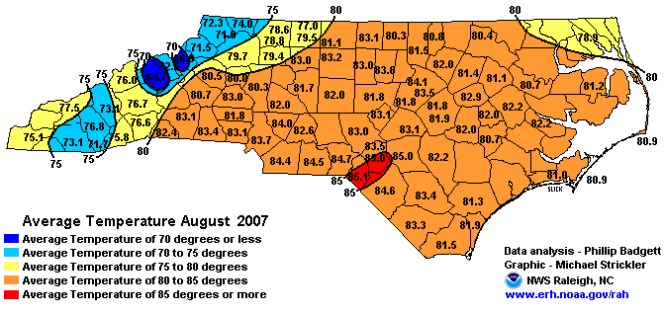
Figure 4. Average Monthly Temperatures for August.

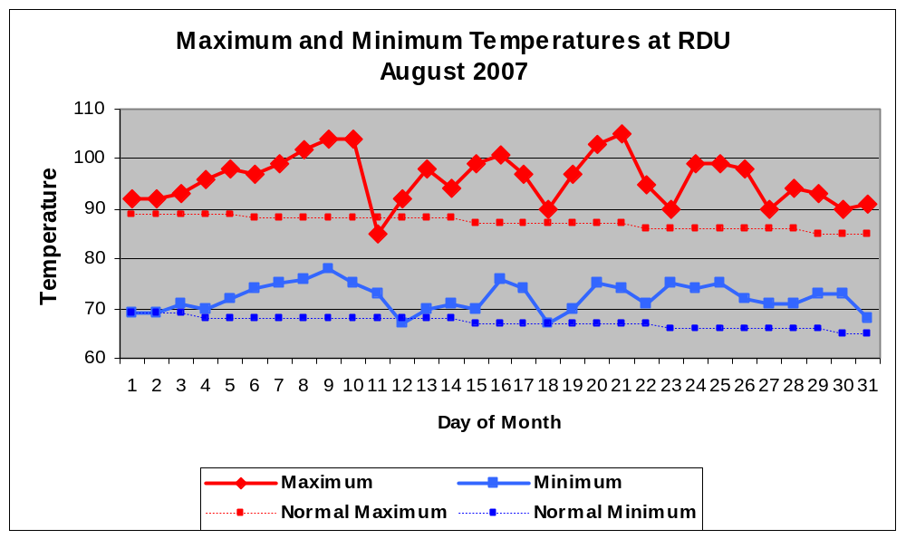

Figure 5. Daily maximum and minimum temperatures observed during August 2007 at Raleigh-Durham (RDU).

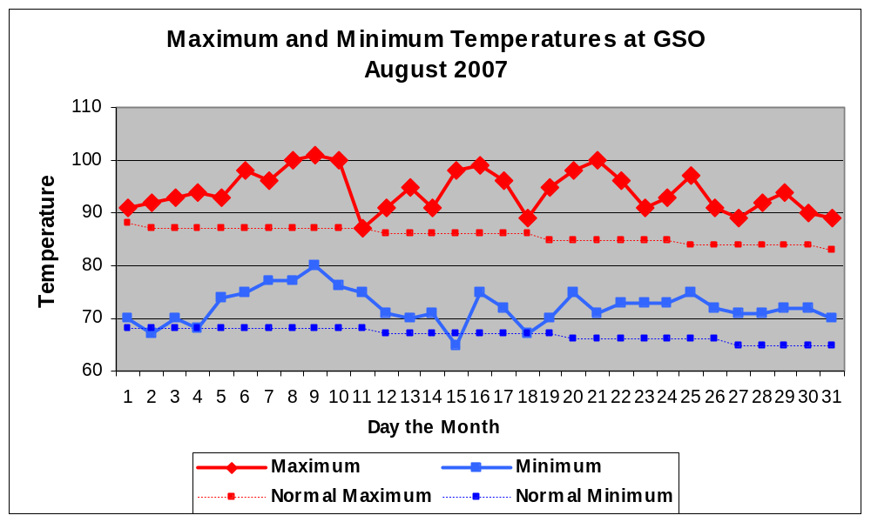

Figure 6. Daily maximum and minimum temperatures observed during August 2007 at Greensboro (GSO).

The dry and hot conditions this spring and summer have led to a dramatic increase in the number of 90 degree days, which are plotted in figure 7. Raleigh-Durham averages about 37 days of the year that the temperature reaches or surpasses 90 degrees. A staggering total of 66 had already been recorded through August 31, with September yet to come.

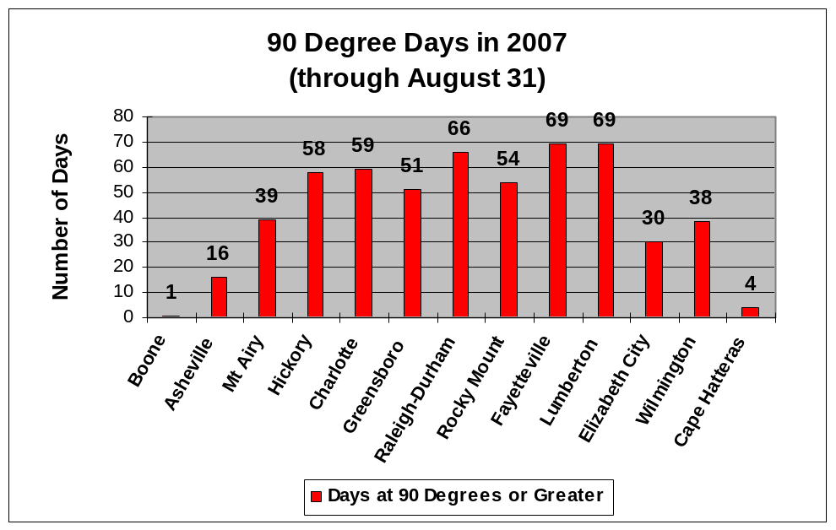
Figure 7. The number of days in which the temperature has reached or exceeded 90 degrees.
(January 1-August 31, 2007).

Current, Semi-Annual and Annual Temperature Trends

The very hot August at both Greensboro and Raleigh continued the general trend of above normal temperatures in the past 12 months. Five of the past six months, and eight of the past ten months have been warmer than normal at both Greensboro and Raleigh-Durham.

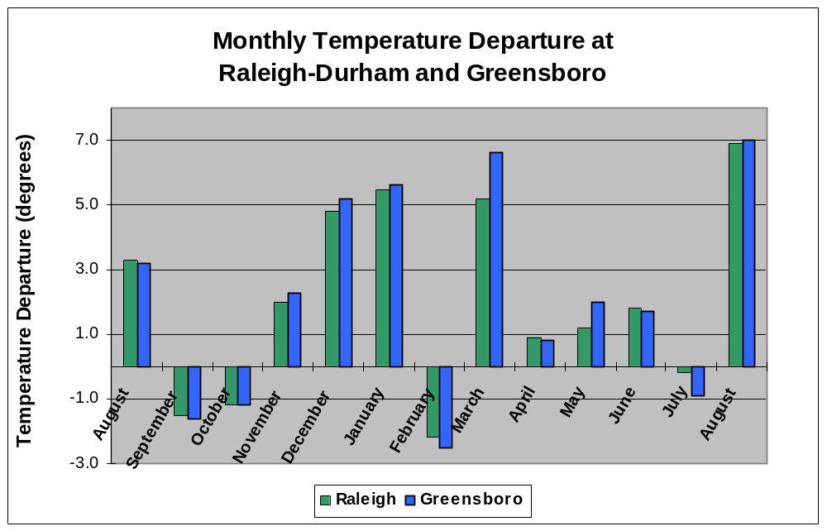
Figure 8. Monthly temperature departures from normal at Raleigh-Durham and Greensboro from August 2006 through August 2007.

Current, Semi-Annual, and Annual Precipitation Trends

The below normal rainfall recorded at Greensboro and Raleigh-Durham in August continued the dry trend of 2007. Six of the seven months this year have been drier than normal. The rainfall deficit at Greensboro for 2007 reached 8.60 inches. In addition, this marked the first time in over a year that rainfall over the past twelve months had fallen into a deficit. The current annual deficit for the months of August 2006 through July 2007 was 1.44 inches. The drier than normal August at Raleigh-Durham made it the fifth month in eight this year with sub par rainfall. The rainfall deficit at RDU during the first eight months of the year was at 5.60 inches. Figures 9 and 10 depict the monthly precipitation versus the normal at both Raleigh-Durham and Greensboro in the past 13 months.

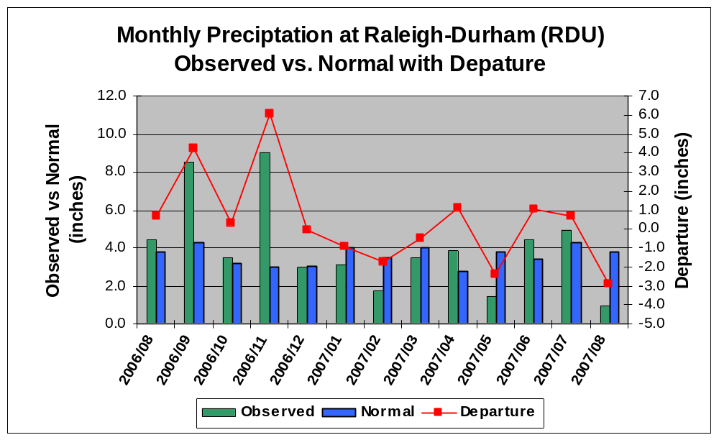

Figure 9. Semi-annual and annual precipitation trends at Raleigh-Durham (RDU).

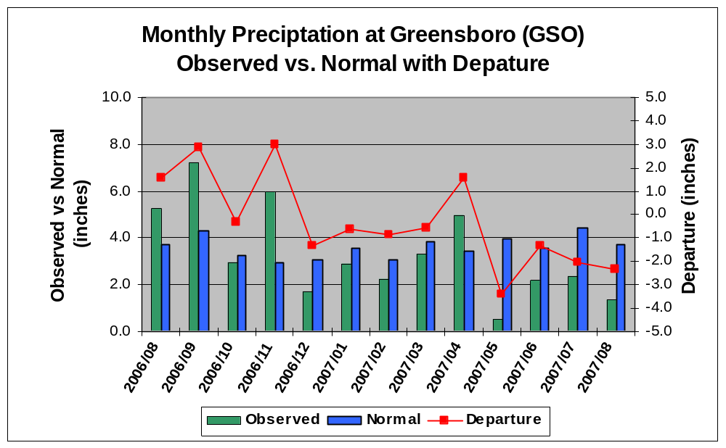
Figure 10. Semi-annual and annual precipitation trends at Greensboro (GSO).

North Carolina Water Resources Information and Outlook

The general lack of any significant rain during August pushed most of the state into the extreme drought category. Such drought conditions have affected the major metropolitan areas of Charlotte, Winston-Salem-Greensboro-High Point, and Raleigh-Durham. Stream and river levels over central North Carolina declined to as low as 5 percent of long term average. Falls Lake, the main water supplier for Raleigh and surrounding municipalities, continued below targeted levels. Inflow into Falls Lake, including the Eno River flow, fell to less than 5 percent of the long term average. The inflow into Jordan Lake from the Haw River fell to 5 percent of the long term average. The drought severity was worst over the southwest part of the state, where many mountain locals were running yearly rainfall deficits of 20 to 25 inches.

For the latest information concerning the drought, visit:
http://www.ncwater.org/drought/

Climate Outlook for the fall 2007

The Climate Prediction Center recently released the fall outlook. Details concerning this forecast can be found at the web address below:

http://www.cpc.ncep.noaa.gov/products/predictions/

The rainfall outlook for September through November calls for an equal chance of receiving above normal, near normal, or below normal rainfall. The 90 day rainfall forecast for the fall season is depicted in Figure 11. If near or above normal rainfall is realized between September and November, there is still a possibility of drought improvements over North Carolina as depicted in Figure 12.

You can keep up with latest monthly and seasonal forecasts by visiting the Climate Prediction Center website at http://www.cpc.ncep.noaa.gov/.

Enhanced local three month temperature outlooks are now available at http://www.weather.gov/climate/calendar_outlook.php?wfo=rah

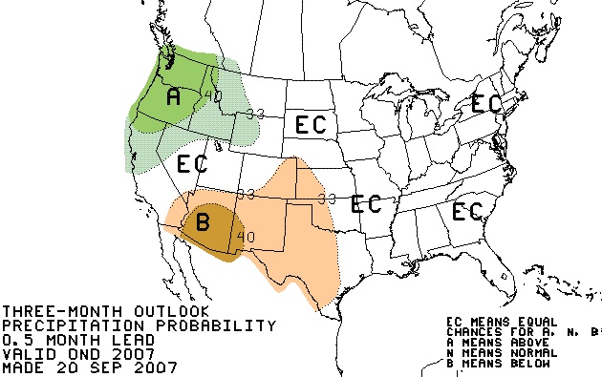

Figure 11. Precipitation Outlook from the Climate Prediction Center for October through December 2007.

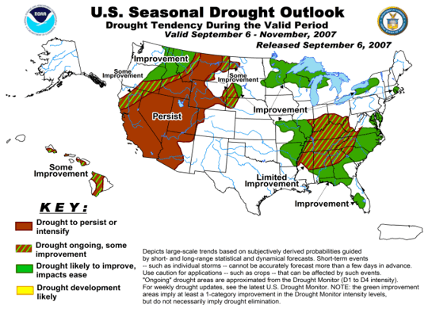
Figure 12. U.S. Seasonal Drought Outlook issued on September 6, 2007, valid through November 2007.

NC Weather Review Team

Phillip Badgett
Michael Strickler

