“”
USDA Foreign Agricultural Service
GAIN Report

Global Agriculture Information Network
Template Version 2.07

Required Report - public distribution
Date: 11/17/2003
GAIN Report Number: TW3047
Taiwan
Retail Food Sector
Report
2003

Approved by:
Hoa Huynh, Director, ATO Taipei
American Institute in Taiwan
Prepared by:
Amy Hsueh, Marketing Specialist

Report Highlights:

After twenty years of rapid expansion, Taiwan’s food retail industry has now entered a phase of maturity. Mergers and strategic alliances will continue to take place over the next few years. The larger chains continue to grow at a constant rate while small chains have begun to stagnate.
Taiwan has become a full member of the World Trade Organization (WTO) in 2002. With the liberalization of the Taiwan market, there have improvement of market access for U.S. consumer food products such as high quality beef, fresh fruits and vegetable, seafood, frozen prepared foods, and other processed foods. Many food retail chains are expanding direct or indirect imports of new-to-market items. U.S. suppliers are encouraged to contact these retail chains directly.

Includes PSD Changes: No
Includes Trade Matrix: No
Unscheduled Report
Taipei ATO [TW2]
[TW]

Section I. Market Summary

Modern Western-style food retail stores - supermarkets, hypermarkets, and convenience store - have been present in Taiwan for more than twenty years. Over the past ten years, throughout 1990’s, Taiwan’s food retailers have experienced a period of rapid expansion and increasingly fierce competition. The rapid expansion of the hypermarkets and convenience stores has now slowed due to the overall economic slowdown and strong competition since the last two years. Supermarkets began slowing in 1996 because of strong competition from hypermarkets, convenience stores, and traditional wet markets.

Industry executives indicated that Taiwan’s food retail industry has entered a phase of maturity. Mergers and strategic alliances will continue to take place over the next few years. The larger chains continue to grow at a constant rate while small chains have begun to stagnate. The Netherlands cash-and-carry chain Makro was the first foreign retailer to open a store in Taiwan in late 1989 but decided unexpectedly to shut down its remaining six stores in Taiwan in February 2003, citing high operating costs and keen competition. In 2002, Hong Kong-based Wellcome Supermarket merged with local Kasumi’s 23 supermarket outlets and further strengthens its position as the largest supermarket chain in Taiwan. Wellcome’s new “Superstore,” a combination of traditional wet market and modern supermarket format as well as “Jasons Market Place,” which carries higher end and imported foods to cater to the needs of city dwellers, might become fashionable for a time in Taiwan. Globalization is a distinguishing characteristic of Taiwan’s food retail market. Foreign operators, including Wellcome, Auchan of France, Britain’s Testo, France’s Geant, and Costco of the U.S. continue to dominate Taiwan’s food retail market.

According to the Ministry of Economic Affairs’ statistics, Taiwan supermarkets, hypermarkets, warehouse stores, convenience stores, and department stores reported total sales of US$19 billion in 2002, a six percent increase compared to 2001. The domestic economy growth for the first half of the year was slow due to the war in Iraq and SARS outbreak in Taiwan between March and June 2003. However, Taiwan’s economy has gradually turned around in the second half of the year. Taiwan’s Directorate General of Budget, Accounting and Statistics (TGBAS) has adjusted upward its economic growth forecast for 2003 to 3.15. It is anticipated that these food retail stores will become lively as soon as the economic recovery continues. 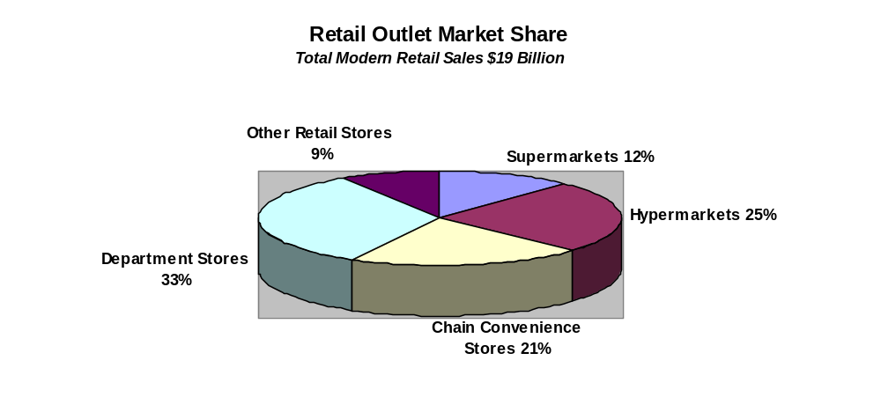
Hypermarkets

In Taiwan, growth by very large supermarkets such as hypermarkets and cash-and-carry stores has been rapid since the first store, Makro Taiwan, opened in late 1989. The rapid expansion of the hypermarkets has now slowed due to an overall economic slowdown of the past few years and intensifying competition. In 2002, Taiwan hypermarkets generated a total of US$4.8 billion in sales, a nearly 4 percent increase from the previous year. Total sales turnover of this sector in 2002 dropped below its annual 20% growth rate. The average per store sales of hypermarkets dropped by 10-20 percent in 2002. There are now 110 hypermarkets in Taiwan, some foreign owned and some locally owned and operated. Foreign operators, including Carrefour, RT Mart/Auchan, Aimai Geant, Tesco, and Costco, continue to dominate the Taiwan market, holding a 65% market share.

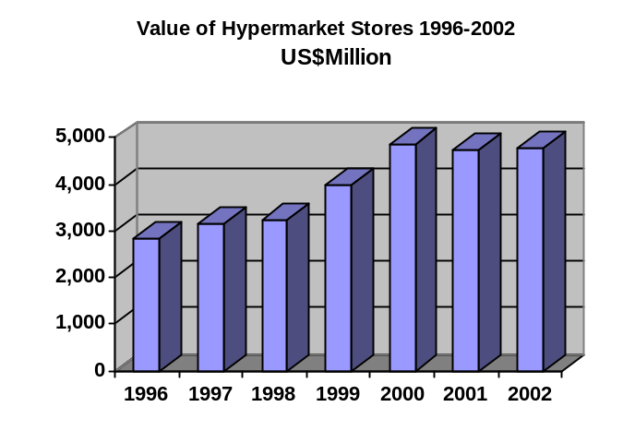Industry executives indicated that competition among Taiwan’s hypermarkets will continue to intensify. Mergers and strategic alliances are likely to continue over the next few years. Some store chains have chosen to restructure to meet competitive challenges rather than open new venues. Growth in the hypermarket sector will remain flat with an additional 6-8 new stores being opened in 2003. Most of Taiwan’s hypermarkets and warehouse stores are located in suburban areas. However, the current tendency is to compete with each other for positioning new stores in the urban metropolitan areas, as land prices have decreased. Recently opened hypermarkets have tended to be smaller in area. To lower operating costs, as well as to differentiate themselves from their competitors, many hypermarkets have increased their volumes of imported and private label items.

Currently, each hypermarket serves an average of 200,000 people in Taiwan. In the European Union, there is a hypermarket store for every 30,000-50,000 people. Based on this, Taiwan’s Food Industry Research & Development Institute (FIRDI) predicted that there is still much room for growth in hypermarkets in Taiwan. However, adding that operating a hypermarket is harder in Taiwan. Tough competition comes not only from modern food retail stores but also from the numerous street stalls and traditional wet markets which provide not only convenience but also cater to local tastes.

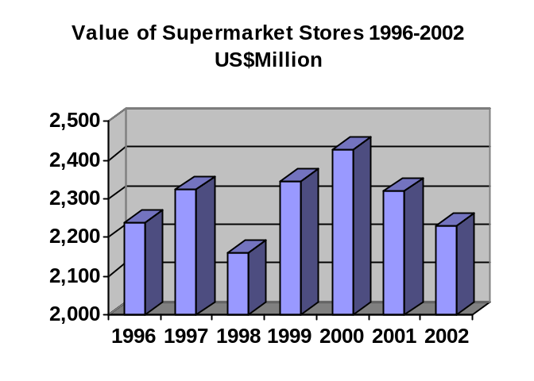Supermarkets
The supermarket industry has reached a plateau after approximately 20 years of rapid expansion. Supermarkets, caught in a squeeze between hypermarkets and convenience stores, reported sales of over US$2.2 billion in 2002. The average growth of supermarket stores in Taiwan, in terms of revenues generated, has declined to minus 1.5 percent in 2002. The Wellcome Supermarket Chain was the only exception with a 7 percent sales increase.
Continued economic slowdown plus fierce competition from hypermarkets and convenience stores, have made it difficult for small supermarkets to survive. Mergers among supermarkets are expected to continue over the next few years, forming an aspect of concentration on one or two large chains.
The idea of “freshness” for supermarkets serves as a tool to attract customers, and to generate profits. Fresh items carried in supermarkets have seen an increase in recent years, reaching about 50 percent of the total items carried. Fresh fruit and vegetables, meat, and seafood are also used by supermarkets to differentiate themselves from hypermarkets and conveniences stores as well as to guarantee the profitability of a store and attract more customers. Additionally, supermarket stores will continue to extend their services such as home delivery, and other internal services, for example, bakeries, photo studios, laundry, and ready-to-eat hot and prepared foods. Industry executives indicated that in the 21st century, only those supermarkets that provide customers with "convenience," "reasonable prices," and "freshness" will survive.

Convenience Stores

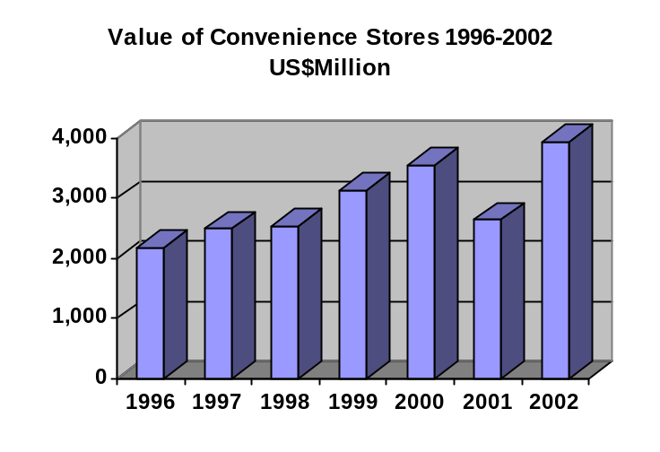Taiwan’s top five convenience store chains, including 7-Eleven, Family Mart, Hi-Life, Circle K, and Niko Mart, together opened a total of 592 new outlets in 2002. This segment generated nearly US$4 billion in sales in 2002, an increase of 11 percent from the previous year. Total sales turnover of this sector in 2002 dropped below its annual 17% growth rate, mainly due to the overall economic slowdown and growing competition from department stores, and foreign food retailers, such as Costco, Geant, Auchan, Costco, and Wellcome. In terms of number of stores, 7-Eleven continued to lead as the largest convenience store chain in Taiwan. As of September 2003, there were 7,371 chain convenience stores in Taiwan. 7-Eleven, with nearly 3,500 outlets island-wide, accounts for 46 percent of the market, followed by Family Mart (19%, 1454 stores), Hi-Life (12%, 901 stores), OK (10%, 739 stores), and Niko Mart (5%, 320 stores). These five major chains altogether account for over 90% of the total market. Of the 7,371 stores, 56 percent stores are located in Northern Taiwan. These chains have all set a high growth target for the next few years. However, with the rate of over 500 new stores opened by these five chains each year, the take for individual stores is going down. Reportedly, 7-Eleven is expected to further expand to 4,000 outlets island-wide by the end of 2005.

In 2002, the most popular products sold in Taiwan’s convenience stores were home meal replacement (HMR) and fresh ready-to-eat food items, such as lunch boxes, Japanese style rice rolls (sushi), hot dogs, sandwiches, buns, pizzas, fried rice/noodles, and hamburgers. Taiwan’s “eat-out’ market is valued at approximately $9 billion and is growing significantly. Convenience stores, currently accounting for 8 percent of the market, continue to make efforts in developing and marketing new convenience foods, especially lunch boxes, breakfasts, and dinners. And, at the same time they continue to extend service items, such as on-line shopping/home delivery packages, international express mail, and public utility fee collection. Currently, these leading five convenience store chains account for over 10% of Taiwan’s baked bread market, worth US$700 million. They continue to earn market share at an annual sales volume growth of 15-20%.

To meet fierce competition, these chains continue to eliminate poorly performing products, and at the same time, focus on promoting only popular items and aggressively sourcing new products with market potential from all over the world. In 2002, 7-Eleven first launched its “My Health Dairy” which includes various types of nutritional supplements. Because of the success of these functional food items, more convenience stores are scrambling for a share of the functional food market valued at US$900 million annually.

Although the market is mature, it is still expected to grow at a steady pace for the next two or three years. Market observers indicated that Taiwan’s convenience stores are entering a phase of market saturation from the period of rapid expansion from 1988 throughout the 1990s. According to a report by the Taiwan cabinet-level Fair Trade Commission, Taiwan leads all other countries around the world in terms of the number of stores per capita. With a population of 23 million people, there is one convenience store for every 3,400 people in Taiwan. Expansion will continue over the next few years. With Taiwan’s WTO accession in 2002 and the resulting market liberalization, 7-Eleven, Family Mart and other convenience stores are expanding direct or indirect imports of new-to-market items. U.S. suppliers are encouraged to contact these convenience store chains directly. A list of these retail chains is available at the ATO Taipei upon request.

Department Stores

Most department stores in Taiwan have supermarkets in their basements. The main effect of these supermarkets is to draw customers to the store by carrying a wide range of gourmet products. In the past, these supermarkets were not profit centers for the store. However, recently they have become more popular and better revenue earners. This segment generated total revenues of US$6 billion in 2002, compared to US$1.8 billion generated in 1993. The department store industry will continue to expand over the next few years.

Currently, the Taiwan-Japan joint ventures Shin Kong Mitsukoshi and Pacific Sogo, and local Far Eastern Department Store, altogether dominate the Taiwan market. Together with Sogo and Mitsukoshi, other Japanese operators, including Takashimaya, and Hanshin have become the mainstream of the Taiwan’s department store industry.

Imported Food vs. Domestic Products

Currently, about 15-20% of the products sold in Taiwan’s supermarkets and hypermarkets, as well as about 15% of the products sold in convenience stores are imported, and this is increasing. After Taiwan’s WTO accession in early 2002 and the resulting tariff reduction and further market liberalization, imports from all over the world have been increasing.

Trends in services offered by retailers

Each food retail chain will continue to increase the number of products carried and services offered to attract more customers. With many women working, the eating-out population and single-person households are becoming more common. As a result, small packaged products and ready-to-cook dishes are becoming more popular. The percentage of convenience foods, microwaveable foods, vegetarian foods, organic foods, and health foods will continue to increase in retail stores. Retail stores will continue to extend their service items, such as home delivery and other service businesses inside their stores--examples include bakeries, restaurants, dry-cleaning, photo studios, and ready-to-eat hot and prepared food kiosks.

Private Label

To offer differentiation and to increase markups, many of Taiwan’s retail chains, including 7-Eleven, Makro, Wellcome, Geant, Costco, and Tesco, are aggressively expanding and promoting private label products (both imported and domestically produced). As the average selling price of private label products is 15-20% lower than branded items, they are increasing in popularity in the market.

Demographics

Taiwan is 13,900 square miles in area. About two-thirds of the island is covered with lushly forested mountains. People on the west coast spend more on food than people living on the east coast. Taipei and Kaohsiung have the highest expenditures for food. The majority of all department stores, convenience stores, supermarkets, and hypermarkets are located in the northern portion of the island.

Advantages and Challenges Facing U.S. Agriculture in Taiwan

Advantages | Disadvantages
U.S. products are perceived by Taiwan  consumers to be of high quality. | Lack of knowledge of U.S. brands by importers and retailers.
The majority of Taiwan consumers can afford  imported food products. | Lack of brand awareness by consumers
Taiwan’s WTO accession in early 2002 and resulting in further market liberalization and import tariff reduction have provided U.S. exporters with more market opportunities | Competition among major world agricultural and food exporters for a share of Taiwan’s growing food import market will further intensify after WTO accession.
The growing modern retail industry is looking for new imported food products. | Lack of importer and retailer knowledge and training in purchasing, handling, and merchandising U.S. products.

Section II. Road Map for Market Entry

Entry Strategy

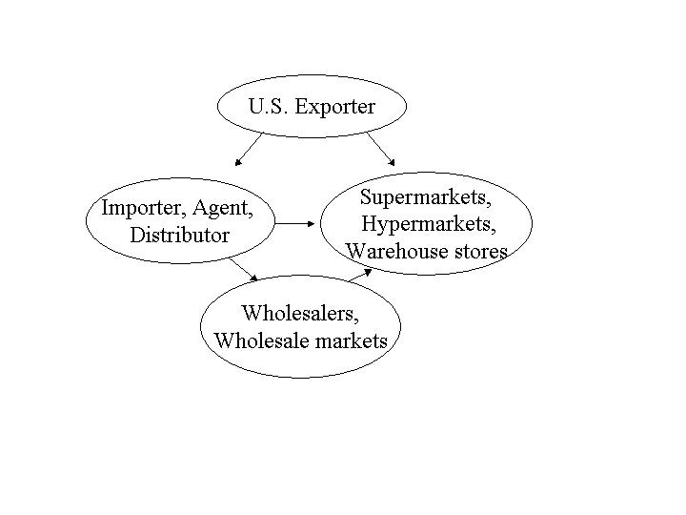
Direct - The best method to reach Taiwan’s retail buyers is to initially contact them directly via e-mails or faxes. Product catalogues and price lists are essential. Sample products are very helpful. U.S. suppliers can obtain a list of major Taiwan retail stores from the ATO Taipei.

Indirect - U.S. companies may wish to concentrate on establishing their business relationships with a reliable and efficient importer and distributor, who in turn will sell the imports to retail stores. The ATO Taipei maintains listings of potential importers for U.S. suppliers. A visit to Taiwan is an excellent way to start to establish a meaningful relationship with potential Taiwan buyers. U.S. suppliers are encouraged to bring product samples to Taiwan to provide to potential buyers as many importers and retailers rely heavily upon subjective factors when deciding on new products to represent.

On Line Procurement - Some retail chains, especially those with foreign joint venture partners such as Carrefour and RT Mart, currently purchase on line a very limited number of product items.

A. SUPERMARKETS, HYPERMARKETS AND WAREHOUSE OUTLETS

Market Structure

Imported Processed Foods

Taiwanese buyers in retail stores tend to buy and import directly those products that are already well known in the market. The reason according to purchasing managers is that they do not want to risk trying out a new product. Instead, stores prefer to buy new-to-market imported products from local suppliers. A trend for supermarkets/hypermarkets is to begin importing directly from a consolidator who can arrange one consolidated shipment for a variety of new and/or already in-the-market products. However, purchasing managers of these Taiwan retail stores state that they welcome offers with market potential from any reliable and dependable supplier. Carrying a wide variety of high quality products and new-to-market products is regarded as crucial to the profitability of a store. Industry sources estimate that currently up to 96% of imported processed foods are imported through importers. The direct imports by retail stores are anticipated to increase.

Imported Unprocessed Foods

-- Fresh fruit: Industry sources estimate that approximately 15 percent of imported fresh fruit is now imported directly by supermarkets, hypermarkets, and warehouse stores. The remaining 75 percent is imported by importers/distributors. Direct import of fresh fruit by retail stores is expected to continue to increase over the next few years.

-- Fresh and Frozen meat. On average, the ratio of direct and indirect beef imports by Taiwan’s hypermarkets is 40:60. Supermarkets currently do not import beef directly but buy from local importers. Almost 100 percent of pork is purchased by supermarkets and hypermarkets from local pork processors/wholesalers.

-- Fresh and Frozen seafood. It is estimated that approximately 3% of seafood is imported directly by retail stores. The remaining is sold to retail stores through importers, wholesalers, and distributors.

Company Profiles

Major Hypermarket/Warehouse Store Profile

Retailer and Outlet Type | Ownership | 2002 Sales US$Mil | 2002  No.of Outlets | Locations | Purchasing Agent Type
Carrefour  Hypermarket | French/Taiwan | 1,301 | 28 (29) | Nationwide | Direct, importer, wholesaler, agent
RT Mart  Hypermarket | French/Taiwan | 1,012 | 21 (21) | Nationwide | Direct, importer, wholesaler, agent
Aimai Geant  Hypermarket | French/Taiwan | 434 | 13 (14) | Nationwide | Direct, importer, wholesaler, agent
Costco  Warehouse | U.S./Taiwan | ** | 3 (3) | Nationwide | Direct, importer, wholesaler, agent
Tesco  Hypermarket | UK | ** | 3 (4) | Nationwide | Direct, importer, wholesaler, agent
Dollars  Hypermarket | Local | 174 | 3 (4) | Southern Taiwan | Direct, importer, wholesaler, agent
Taiwan Sugar | Local | 40 | 3(3) | Nationwide | Impoter, wholesaler, agent
Source: Distribution News; Retailing Mart
* Figures inside the parentheses represent number of outlets as of October 2003.
** Not available

-- Makro Taiwan, a joint wholesaler/distributor for Dutch-based SHV Holdings and Taiwan-based Holmgren Goup, unexpectedly shut down its six remaining stores in Taiwan in February 2003, citing high operating costs and keen competition.

-- Due to its failure with marketing in convenience stores over the past 7 years, the state-run Taiwan Sugar Corporation plans to continue to shift its retail business focus to hypermarkets. In addition to sugar production and other diversified domestic/overseas investments, TaiSugar has established three hypermarkets in Southern Taiwan since 2001, and plans to expand to 9 stores within the next couple of years.

-- Taiwan’s leading food retail store, Carrefour Hypermarket Chain, recently indicated that localization, product differentiation, private labels, and flexible new store openings are the main factors of its success in Taiwan. In order to tally with Taiwan’s limitations on land use, Carrefour has established two types of stores in Taiwan. The “blue” stores are hypermarket format stores located in commercial or residential areas. The “green” stores are cash-and-carry niche, concentrating on industrial areas. Carrefour will open two additional stores by the end of 2003, bringing its total number of stores to 31 by 2003.

-- Tesco, one of the most aggressive hypermarkets chains in Taiwan, inaugurated its first store in Northern Taiwan in June 2001 and opened its fourth outlet in Taipei City in late 2003. Tesco originally intended to set up 20 outlets around the island within five years. However, the expansion plan has slowed down due to the overall economic slowdown and severe competition. Tesco announced in October 2003 that it will expand to 10 outlets island-wide by 2006.

-- RT Mart, a joint venture of French hypermarket operator Auchan SA and local Ren Tai Group, merged with Trans Asia Hypermarket and joined in a strategic alliance with Safe and Save Hypermarket Chain in 1998 to become the second largest hypermarket chain, behind Carrefour, in Taiwan. RT’s Marketing Manager indicated in a media interview that Taiwan’s hypermarket has become mature. Expansion plans for all chains operating in Taiwan will slow, with each opening an additional one to two stores each year. RT has set a growth target of 22 outlets and US$1,100 for 2003.

Major Supermarket Store Profile

Retailer and Outlet Type | Ownership | 2002 Sales US$Mil | 2002  No.of Outlets | Locations | Purchasing Agent Type
Wellcome | HongKong/  Taiwan | 347 | 122 (146) | Nationwide | Direct, importer, wholesaler, agent
Sung Ching/  Marukyu | Local | 162 | 73 (75) | North/central Taiwan | Direct, importer, wholesaler, agent
Taipei Agr. | Local |  | 20 (15) | Taipei | Direct, importer, wholesaler, agent
Sinon | Local | ** | 27 (27) | Central  Taiwan | Direct, importer, wholesaler, agent
Sun-Mart | Local | ** | 8 (8) | Taipei | Direct, importer, wholesaler, agent
Source: Distribution News
* Figures inside the parentheses represent number of outlets as of October 2002.
** Not available

-- In 2002, Shin Tong Yang Foods Group’s Kasumi Supermarket withdrew from the Taiwan market and was acquired, with the approval from Taiwan’s Fair Trade Commission, by the Wellcome Supermarket Taiwan.

With the acquisition of twenty-two stores from Kasumi, Wellcome further strengthens its position as the largest supermarket chain in Taiwan. Wellcome currently operates 146 outlets island-wide, which doubles Wei-chuan Foods Group’s Sung Chin/Marukyu, in second position, in terms of number of stores. Wellcome currently accounts for 15 percent of the market and reportedly plans to expand to 160 outlets by 2003 and 200 outlets by 2005.

-- Wellcome Supermarket launched its first “Jasons Market Place,” a new store format which mainly carries higher-end and imported foods, in November 2003. Jasons’ organic/healthy food corners - its distinguishing characteristics - carry an estimated 1,200 items of HMR and other food products with low fat, low salt, high fiber, and non-dairy. In addition, Wellcome has located in the Taipei Metropolitan area two superstores. The Wellcome superstores are a format combining concept of a modern supermarket with a traditional wet market. It carries a high percentage of fresh items, such as fresh produce, meat, poultry meat, and seafood.

-- Wei Chuan Foods Group’s two supermarket chains, Sung Ching and Marukyu, joined in a strategic alliance with each other in late 2000. The two chains formed a joint purchasing team. Currently, the team mainly purchases dry goods. As soon as the number of stores reaches 100, the two chains will merge.

-- Sinon, the largest supermarket chain in central Taiwan, has focused on restructuring poorly performing stores instead of opening new venues over the past three years since the 1999 earthquake hit. The company planned to expand stores to 33 in 2003. To differentiate themselves from competitors, the company continues to expand their fresh items and further strengthen the management of these fresh items.

B. Convenience Stores

Entry Strategy

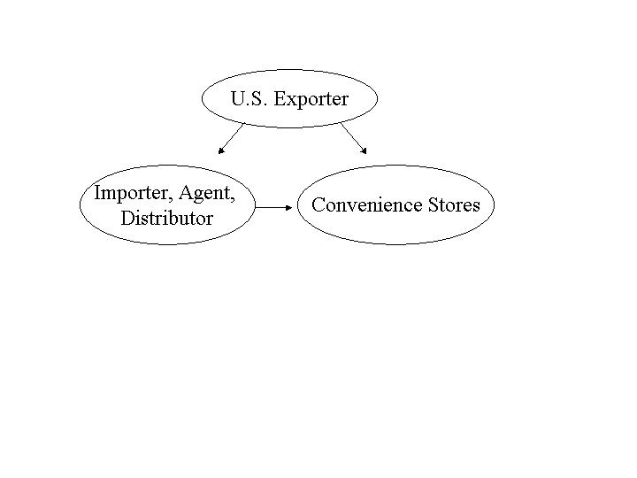
The same importers, wholesalers, and distributors that provide for the supermarkets and hypermarkets provide for the convenience stores. Taiwan convenience store chains either import directly or purchase from local importers and manufacturers. U.S. suppliers can sell directly to these convenience stores by contacting their purchasing managers. In addition, U.S. suppliers should locate a reliable and efficient agent/importer/distributor to ensure that products are consistently available in the market. The ATO in Taipei maintains listings of major convenience store chains and potential importers/distributors. U.S. companies interested in expanding their businesses with these retail stores should contact ATO/Taipei for lists of potential buyers.

Market Structure

Major Taiwan convenience store chains import directly. They also rely on importers, agents, and distributors for products. Major Taiwan convenience store chains have their own distribution centers to distribute products, both dry and chilled/frozen goods, to each outlet. The other convenience stores have ties with other distribution centers.

Company Profile
Major Convenience Store Profile

Retailer and Outlet Type | Ownership | 2002 Sales US$Mil | 2002  No.of Outlets | Locations | Purchasing Agent Type
7-Eleven | Local | 2,082 | 3,183 (3,417) | Nationwide | Direct, importer, wholesaler, agent
Family Mart | Japan/Taiwan | 630 | 1,302 (1,454) | Nationwide | Direct, importer, wholesaler, agent
Hi-Life | Local | 405 | 820 (901) | Nationwide | Direct, importer, wholesaler, agent
Circle K | U.S./Taiwan | 289 | 680 (739) | Nationwide | Direct, importer, wholesaler, agent
Niko Mart | Local | 133 | 320 (337) | Nationwide | Direct, importer, wholesaler, agent
Source: Distribution News
*Figures inside the parentheses represent number of outlets as of September 2003. ** Not available

-- Family Mart joined in a strategic alliance with the State-run Taiwan Sugar Corporation’s Milin Convenience Store Chain in June 2003, bringing its total number of stores to 1,500 by 2003.

-- In 2002, 7-Eleven first launched a series of “My Health Dairy” nutritional supplement products. Reportedly, sales have been successful that other convenience stores have followed the example of 7-Eleven to sell these functional foods in their respective stores. The market size of functional foods in Taiwan is estimated at US$870million.

-- Currently, total annual sales of fresh ready-to-eat food items in 7-Eleven stores reach US$371 million, accounting for 16% of the total revenues of 7-Eleven. It is expected that sales will increase and account for 20% of total sales by 2005.

-- Circle K celebrated its 15th anniversary in October 2003. Circle K mainly focused on restructuring, shutting down 60 poorly performing stores during 2002. It has set a growth target to reach 1,000 total outlets by 2005.

-- Niko-Mart, in the fifth position, has maintained a slow growth rate in relation to the other chains. It has only grown by 52 outlets in five years. Its target for growth is 380 stores by 2003.

-- Family Mart, Hi-Life, OK and Niko-Mart jointly formed a new company, CVS.COM Co., Ltd., in October 2000. Part of the objective of this newly established company is to seek new products to be sold in the four convenience store chains. U.S. companies are encouraged to contact the company directly.

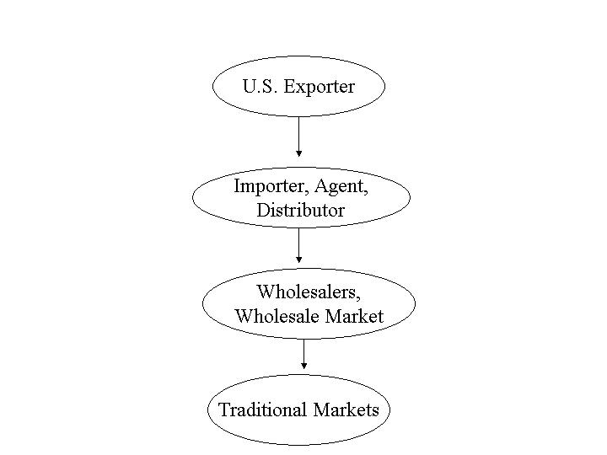
C. Traditional Markets

Entry Strategy

The importers, distributors and wholesalers are the same who supply the supermarkets, hypermarkets, and convenience stores. Unlike supermarkets, hypermarkets, and convenience stores, the wholesalers and regional wholesale markets play the most important role in distribution of products for traditional markets. Sales of imported goods in traditional markets should not be overlooked. Industry sources estimate that around 55 percent of imported fruit from the United States is sold in wet markets island wide.

Market Structure

Traditional markets, including wet markets and mom & pop grocery stores, rely heavily on wholesalers for products. Currently, modern warehouse stores, such as Costco Wholesale also provide products for traditional markets.

Grocery products are usually supplied by local wholesalers, although agricultural products are often purchased at regional wholesale markets.

Company Profile

Mom and Pop Grocery Stores: Mom and Pop grocery stores are still common in smaller towns on the island. Grocery products are usually supplied by local wholesalers. Although these ‘mom and pop’ grocery stores tend to be well located in the heart of residential areas, they are limited by the lack of shelf space and offer fewer varieties of products. Local consumers are increasingly turning to the greater product variety offered by supermarkets, hypermarkets, and convenience stores.

Wet Markets: According to statistics released by Taiwan’s Ministry of Economic Affairs, there are 631 public/private wet markets and 639 street stall gathering places in Taiwan. These businesses generate approximately US$13 billion in annual sales. The major items sold in these traditional markets--meat, seafood, and fresh produce--account for over 50% of total wet market sales. Beginning in July 1999, Taiwan authorities have implemented a five-year program to upgrade and remodel traditional wet markets.

Section III. Competition

In 2002, Taiwan imported US$0.7 billion worth of consumer food products from many different sources, of which 68% was imported from the United States. The United States was the number one supplier of consumer food products to Taiwan, followed by France, Canada, Denmark, Singapore, Italy, and the United Kingdom. The United States dominates the fresh vegetables (99% market share), fresh fruit (96%), poultry meat (94%), prepared/preserved red meat (93%), processed fruit and vegetable (89%), tree nuts (83%), and fruit & vegetable juices (81%) import markets and is very competitive in other consumer ready food products.

With Taiwan’ accession to the WTO in January 2002, import tariffs for agricultural products have dropped from 22 percent to the current 14 percent. With the liberalization of the Taiwan market, there is improved market access for U.S. beef, fresh fruit and vegetables, seafood, frozen prepared foods, and other processed foods. However, competition among major world’s food and agricultural exporters for a share of Taiwan’s growing food import market will further intensify. U.S. products carry a high quality image in Taiwan. Promotions or product samplings should be conducted to ensure that consumers are aware that their purchases are from the United States.

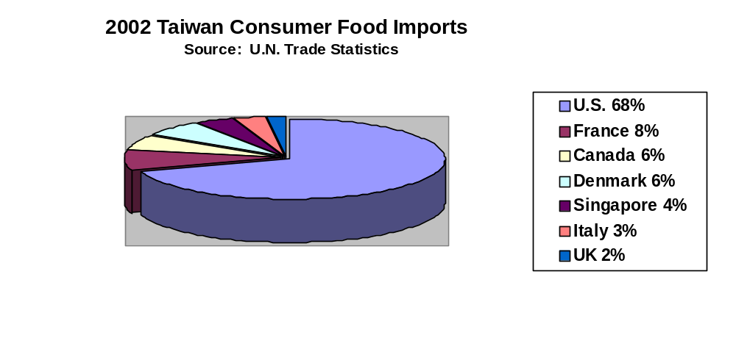
Section IV. Best Product Prospects

A. Products Present in the Market Which have Good Sales Potential

-- Fruit and Vegetable Juices
-- Ice Cream, cheese, yogurt and other dairy products
-- Edible oil, including sunflower oil, corn oil, and safflower oil
-- Frozen/microwaveable foods/other convenience foods
-- Fresh fruit and vegetables
-- Fish and seafood
-- Food ingredients
-- Meat and meat products
-- Baked products
-- Snack products
-- Nuts and dried fruit
-- Gift packs (examples: wine/spirits, imported fresh fruits, and coffee are currently popular gift pack items in Taiwan)

B. Products Not Present in Significant Quantities but Which Have Good Sales Potential

-- Health oriented (low-fat, high-fiber, and low-cholesterol) snack foods
-- Organic/health foods

V. Post Contact and Further Information

If you have any questions or comments regarding this report or need assistance exporting to Taiwan, please contact the U.S. Agricultural Trade Office in Taiwan at the following address. Also, you are welcome to visit the ATO/Taipei homepage ( or USDA/FAS homepage (http:/www.fas.usda.gov) for information on exporting to Taiwan.

Agricultural Trade Office Taipei
American Institute in Taiwan
Room 704, 136 Renai Road, Section 3
Taipei, Taiwan
Tel: (886-2) 2705-6536
Fax: (886-2) 2706-4885
e-mail: ato@mail.ait.org.tw
Homepage:

