RF SPUTTER ETCH AS A SURFACE CLEANING PROCESS FOR CdTe SOLAR CELLS

V. Viswanathan, D. L. Morel and C. S. Ferekides
Clean Energy Research Center, Department of Electrical Engineering
University of South Florida, Tampa, FL 33620

ABSTRACT

Thin film CdTe/CdS solar cells benefit from the use of a wet chemistry step prior to the application of the back contact electrode. A nitric-phosphoric acid mixture and a bromine solution are the most commonly used etchants. Following the CdCl₂ heat treatment the CdTe/CdS structures are briefly etched in one of the above solutions in order to remove native oxides and leave the CdTe surface Te-rich. A higher carrier concentration at the surface of CdTe is believed to be a key factor in facilitating the formation of an effective back contact. The primary objective of this work is to investigate the potential of an alternative dry, vacuum-based process, as a surface modification step for CdTe prior to the application of the back contact electrode. RF-sputter etch has been used as an alternative surface cleaning process. The process was optimized for the type of etchant gas, pressure, time, and sputter power. Solar cells exhibited V_{OC}’s greater than 830 mV and FF’s in the high 60’s. This performance demonstrates the potential of this process for the development of an all-dry vacuum based CdTe technology.

INTRODUCTION

The formation of an effective back contact to CdTe solar cells has been in general accomplished using a wet chemistry step prior to the application of the back contact electrode. The two most commonly utilized solutions are based on a nitric-phosphoric acid mixture and bromine diluted in methanol. In both cases it has been reported that after treatment the CdTe surface becomes Te-rich (or p+)[1,2]. A Te-rich surface is one of the necessary conditions for fabricating effective ohmic contacts to CdTe. In addition to the Te-rich surface, the chemical treatment is important in that it removes native surface oxides that can be present on the CdTe surface as a result of the CdCl₂ heat treatment which is carried out in the presence of O₂ (air). In addition to these wet chemistry methods, ion milling has also been utilized as a surface modification/cleaning step, in conjunction with sputter deposited ZnTe:Cu [3]. An alternative dry, vacuum based surface cleaning process is the main focus of this work. Instead of the typical Br₂/methanol etch, the CdTe surface was exposed to an rf plasma (N₂ or Ar), following the CdCl₂ heat treatment and immediately prior to the application of the back electrode.

EXPERIMENTAL

Solar cell fabrication up to the formation of the back contact was based on previously developed processes [4]. Borosilicate glass substrates were coated with SnO₂ bi-layers by chemical vapor deposition (CVD). The CdS films were prepared using chemical bath deposition (CBD), and the CdTe films using close spaced sublimation (CSS). The CdCl₂ heat treatment was carried at 400°C in the presence of O₂ (20%) For this work the excess CdCl₂ following the CdCl₂ heat treatment was rinsed ultrasonically using methanol. Ultimately, for a completely dry fabrication process, a vapor based CdCl₂ process would be desirable, since such a technique leaves no CdCl₂ residue on the CdTe surface [5]. After rinsing the excess CdCl₂, the devices were exposed to an rf plasma using a MARCH Plasmod sputter etcher. Gases utilized included N₂, Ar, and N₂/O₂; the main reason for including O₂ in the sputter gas mixture, was to simply determine the tolerance of the process to this gas. The devices were sputter-etched using plasma power ranging from 30-100W, and gas pressures ranging from 150-400 mTorr. Following the sputter etch process a back electrode of graphite doped with HgTe:Cu was applied to the surface of CdTe to complete the fabrication of the back contact. The geometry of the plasma etcher was such that allowed for uniform etching of samples with approximate area of 2 x 2 cm². Solar cells were characterized using standard J-V measurements.

RESULTS AND DISCUSSION

The rf sputter etch process was optimized empirically for optimum solar cell performance. The parameters studied included: (a) sputter power, (b) etch time, (c) ambient, and (c) pressure. The following sections summarize the results obtained during this study.

Plasma Power – Etch Time

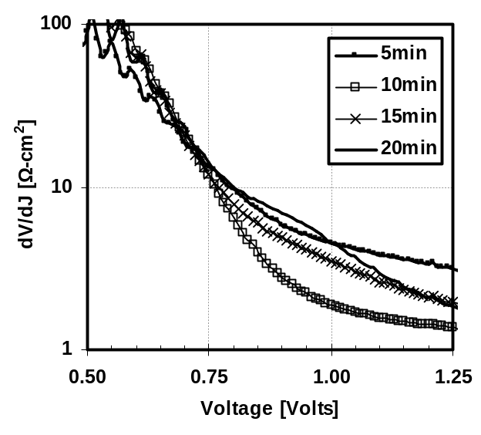
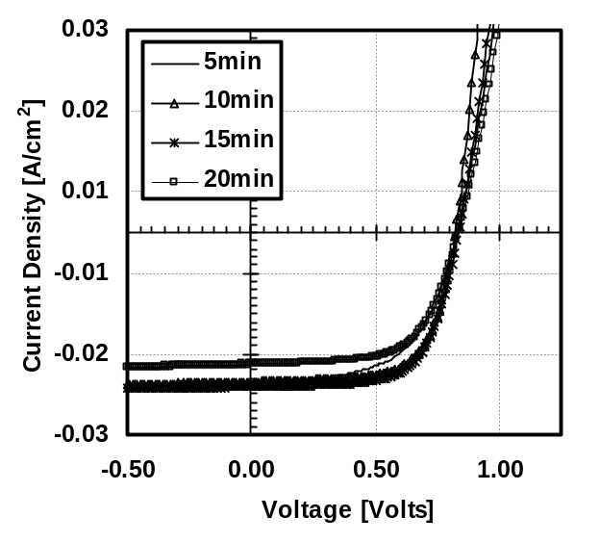
The V_{OC} and FF for a series of cells for which the CdTe surface was sputter etched using different power levels and for different times are shown in Fig. 1; the sputter gas was N₂, and the pressure was 250 mTorr. From these data it is evident that a plasma power of 50W provides the highest V_{OC} which progressively decreases as the power is increased. The V_{OC} is also influenced by the etch time, in that at lower power it improves with time reaching a maximum for a 10-15 minute etch time. At higher powers (above 50W) it deteriorates with the time of etch. The effect of sputter power on the FF appears to be similar to that of V_{OC}, suggesting that the observed behavior is a reflection of the back contact properties. This behavior is illustrated by comparing the effect of etching time at 50W on the J-V characteristics of the solar cells (see Fig. 2). The improvement in FF initially with the etch time is due to improved contact characteristics with time. The reduction in the FF is due to the onset of rectification observed in the J-V curves of Fig. 2 as one moves away from the optimum time of 10-5 min. The onset of rectification at the back contact is better illustrated in Fig. 3, where the dynamic resistance (i.e. dV/dJ [Ω-cm²]) is shown in the range of 0.5 – 1.25 Volts. The resistance of the devices shown, initially decreases with time (from 5 to 10 minutes), but increases monotonically for the two longest times of 15 and 20 minutes. The inflection point in the dynamic resistance of the device etched for 20 minutes (see arrows on Fig. 3) clearly indicates the presence of a non-ohmic (presence of a barrier) back contact. To a lesser extent this behavior is present for the device etched for 15 minutes. This behavior is similar to what was obtained for the devices sputter-etched at 75 W; in that case however (as indicated in Fig. 1) the FF’s were overall lower than the devices sputter-etched at 50W.
Fig. 3. The dynamic resistance (dV/dJ) for the cells shown in Fig. 2
Fig. 2. Light J-V characteristics of cells for which the CdTe surface was sputter-etched at a 50W power level

Effect of Pressure - Ambient

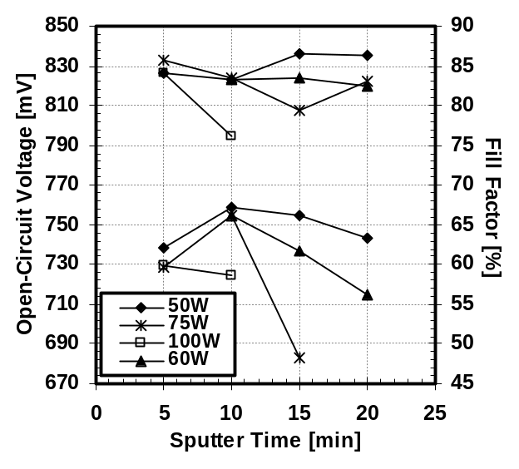
The effect of the total gas pressure during the sputter etch process was also studied; the sputter power for the experimental results discussed in this section was 50 W, and the sputter gas was N₂. Solar cell results are tabulated in table 1. These results suggest that the effect of the etch pressure on V_{OC} is rather insignificant, as in all cases the V_{OC} was in the 810-830 mV range. This is not true for the FF which is in the mid 50’s for the highest pressure and only 61% for the lowest. The cause for the observed decrease can be deduced using the comparison of light J-V curves of devices etched at 250, 300 and 400mT shown in Fig. 4. It can be seen that the slight reduction in the V_{OC} and the greater reduction in FF of the device etched at 400mT is due to a softer knee in the J-V curve; this is believed to be caused by a voltage dependent collection; shunting does not affect the FF and V_{OC} in this case, as the shunt resistance based on the cells’ reverse bias characteristics (around 1.5-2.0 V) is essentially the same for all cells shown.
Fig. 1. The effect of sputter power and time on V_{OC} and FF

Table 1. The Effect of Etch Pressure on Solar Cell Performance
Etch Pressure [mTorr] | V_{OC} [mV] | FF [%]
150 | 831 | 60.6
200 | 826 | 61.6
250 | 823 | 67.1
300 | 819 | 66.5
400 | 814 | 56.8

The above behavior where there exists an optimum intermediate pressure for this process can be explained based on the energy of the ions. At higher pressures the collision probability increases leading to lower ion energy and therefore the CdTe surface is not effectively cleaned. At the other extreme, at low pressures the ions can impinge the surface with much higher energy leading to surface damage, and compensation which can possibly damage the CdTe leading to poor collection of deeply generated carriers.
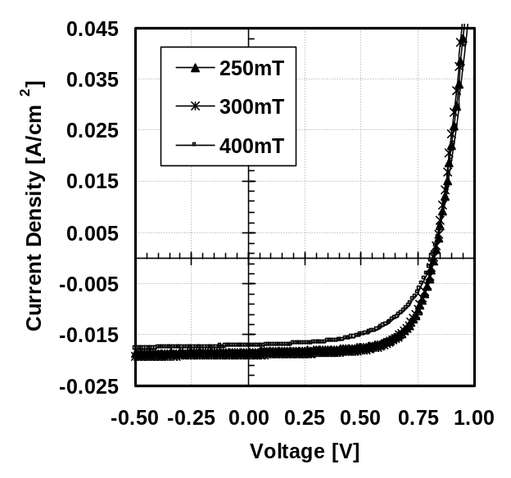
Fig 4. Light J-V characteristics for CdTe cells sputter-etched at different pressures
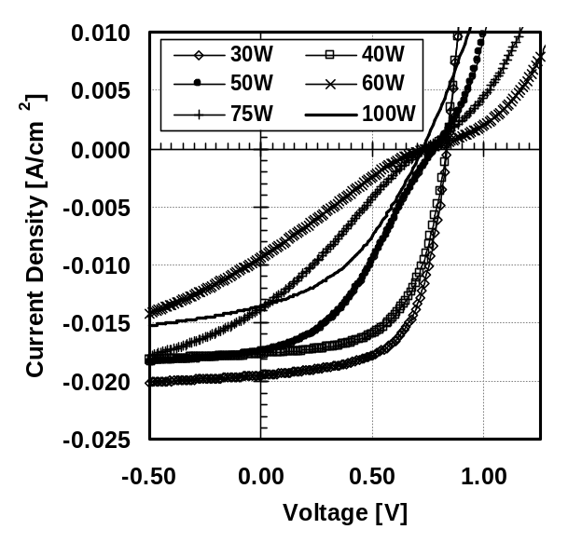
A similar set of experiments as the ones described above was carried out using Ar as the sputter gas; the pressure was maintained at 250 mTorr. The light J-V for several cells sputter-etched at different power levels are shown in Fig. 5. The general trends observed with N₂ exist in this case also. As the power decreases device performance improves mainly due to improvement in the characteristics of the back contact; at lower power levels no back barrier forms leading to improved FF’s. In this case however, ohmic contacts form at lower power levels than the ones required for devices sputter-etched in N₂. This behavior as well as the results previously described (in Fig 1 and table 1) can be explained using the same model: there exists an optimum set of conditions where the sputtering process results in a clean CdTe surface free of oxides. Conditions of low power levels, short etch times, and high pressures do not result in effective oxide removal/surface cleaning, and therefore the conditions for the formation of an ohmic back contact are not optimum. At the other extreme, high power levels, long etch times, and low pressures are conditions that yield high energy ions, that can cause significant damage to the surface of the CdTe. A damaged surface region can be heavily compensated leading to low effective acceptor levels and therefore non-ohmic contacts, and/or can affect collection of deeply generated carriers. Therefore a range of intermediate optimum conditions must be developed that will result in effective surface cleaning without damage.
Fig. 5. Light J-V characteristics for solar cells sputter-etched with Ar at various power levels

Effect of O₂

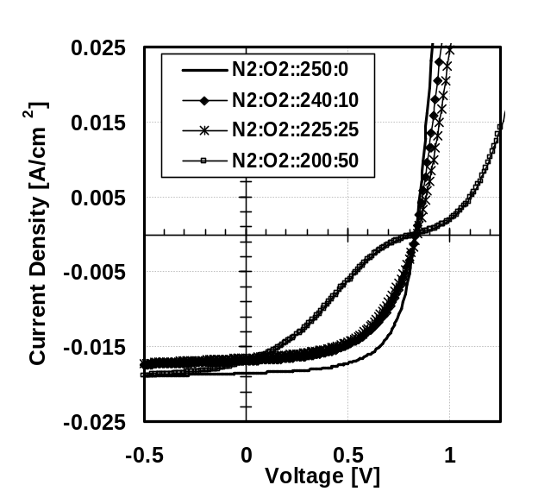
A series of devices were also sputter etched in a N₂/O₂ mixture, to determine at what levels O₂ can be tolerated; the total pressure was maintained at 250 mTorr, and the power was 50 W. The J-V characteristics for these devices are shown in Fig. 6. It is clear that the addition of even 4% O₂ (a smaller amount of O₂ could not easily measured due to equipment limitations), leads to losses in the FF, even if the back contact shows no sings of a back barrier. At higher levels of O₂ (20%; N₂:O₂ 200:50 mTorr) it is clear that a back barrier is present, presumably due to the formation of oxides on the surface of CdTe.
Fig. 6. Light J-V characteristics for solar cells sputter-etched in N₂/O₂ mixtures; total pressure 250 mTorr

CONCLUSION/SUMMARY

An alternative dry surface cleaning process for thin film CdTe/CdS solar cells has been studied. The results obtained from this work, V_{OC} and FF in the range of 810-830 mV and >65% respectively, clearly suggest that an all-dry process can be developed, with manufacturing advantages over existing wet chemistry procedures, and without significant performance limitations. The solar cell characteristics obtained suggest that a set of optimum conditions for power, pressure, and time, must be developed that will result in effective oxide removal and in general surface cleaning of the CdTe surface. Conditions that do not effectively remove all surface oxides, or cause significant damage to the surface of the CdTe lead to the formation of a rectifying back contact, and can affect collection of deeply generated carriers in CdTe.

Acknowledgements
This work was supported by the National Renewable Energy Laboratory (NREL) under subcontract NDJ-2-30630-18.

REFERENCES

- Niles D. W., X. Li, P. Sheldon, and H. Hochst, J. Appl. Phys. 77 (9), (1995), p 4489

- Kotina I. M., L. M. Tukhonen, G. V. Patsekina, A. V. Shchukarev, and G. M. Gusinskii, Semicond. Sci. Technol. 13, (1998), p 890

- Gessert T. A., A. Duda, S. E. Asher, C. Narayanswamy, and D. Rose, Proc. IEEE PVSC, (2000), pp. 654-657

- Ferekides C. S., D. Marinskiy, V. Viswanathan, B. Tetali, V. Palekis, P. Selvaraj, and D. L. Morel, Thin Solid Films, 361-362, (2000), pp. 520-526

- Zhao H., V. Palekis, P. Selvaraj, D. L. More, and C. S. Ferekides, Proc. 29th IEEE PVSC, (2002), pp. 668-671

