Disk Capillary Repair
ATL-IP-ES-0136
March 23, 2007
M. Gilchriese

This repair procedure applies to joining two ends of a disk capillary and starts with facing the ends after cutting. A copper sleeve is used to join the two ends precisely. The dimensions of the sleeve are shown below (not to scale). The 0.042”,0.039”,0.032” correspond to drill #s 58,61 and 67, respectively. The copper sleeve is vacuum clean.

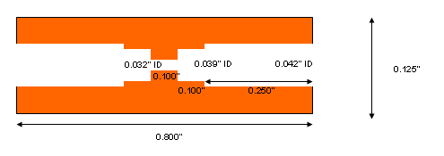
Procedure

- Square ends e.g. by using diamond stone(medium grit) or other(file) to remove end of capillary that has become oval after cutting. Stone/file until end appears round. Tap out debris and/or blow out debris. Deburr edges e.g. with fine grit diamond stone or file. Edge burrs are bad because of tight fit in sleeve.
- Clean out hole with deburring tool(see picture below)
- Use 1200 sand paper for about 1” from end to clean capillary surface.
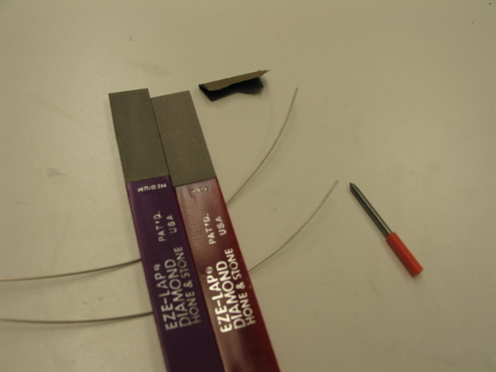
- Clean ends of capillary with phosphoric acid solution followed by neutralizer. http://www.vishay.com/company/brands/measurements-group/guide/a110/acc/wbc.htm . And also http://www.setonresourcecenter.com/msds/docs/wcd00046/wcd046d1.htm Blow dry.
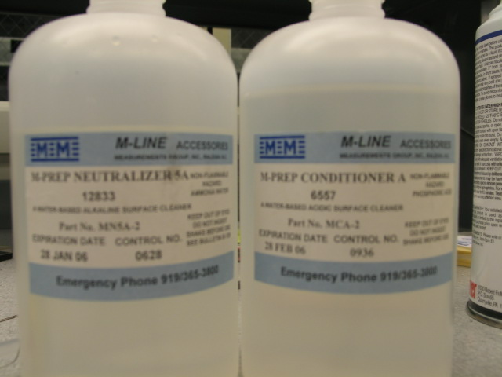
- Clean end of sleeve in the same way and blow dry.
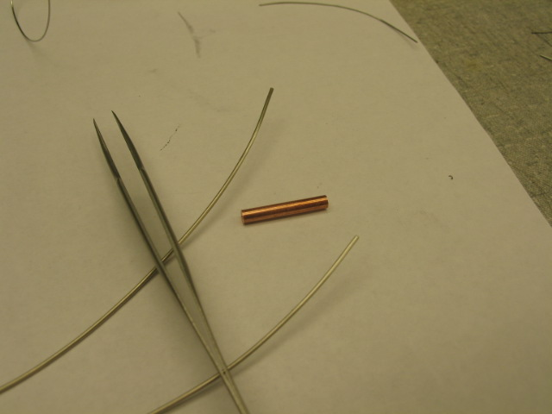
- Crimp(exactly how this is done depends on where done)
  - Position crimp tool securely(see picture below of tool)
  - Put sleeve in crimp tool and center. Measure that it is centered.
  - Insert capillary one side, then the other. Push hard to make sure seated.
  - Tighten crimp tool while hold capillaries in place securely(by hand)
  - When think tightening is complete, gently try to remove capillary. Should be held by crimp. If not, reseat and keep tightening.
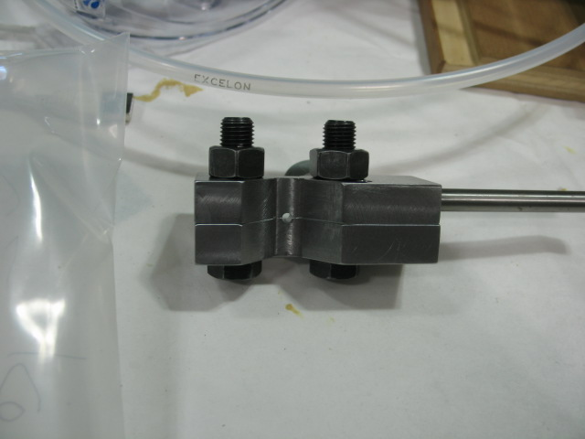

- Wrap no-clean flux solder around capillary(picture below). Hold capillary securely so does not wave around. One tight wrap of solder. Use tweezers to squeeze solder around capillary.
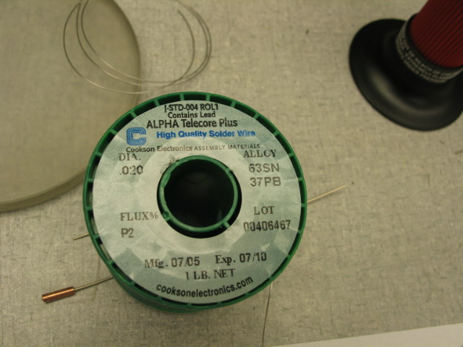
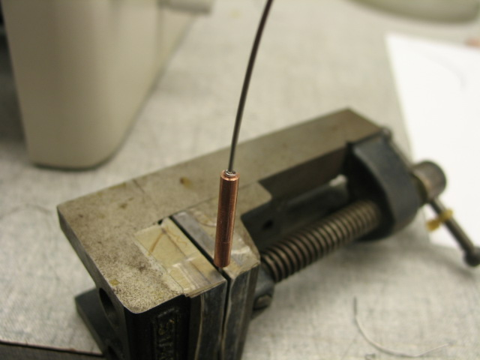
- Heat with butane microtorch. This requires some feel and practice. Sleeve should be about 3/8” from “blue” part of flame. Do not overheat, move torch around. Heat sleeve from below until solder melts and flows well. Immediately remove heat and let cool without moving capillary. Repeat on other side.

