Promising Transit Applications of Fuel Cells, Alternative Fuels and their Applications

William P. Chernicoff
Aviva Brecher
Kevin Green

Volpe National Transportation Systems Center
Research and Special Programs Administration
U.S. Department of Transportation

Cambridge, Massachusetts

National Association of
Environmental Professionals
Annual Meeting
June, 2002

There are no clean vehicles...only “cleaner” vehicles

Options should be examined in the context of total energy utilized from well to wheels and environmental impact from cradle to grave

Context for Understanding Fuel Cells, New Technologies, and Success

- Technologies
- Issues
- Paths to success
- Timelines, policies, and economics
- Are buses an ideal platform?

Why Buses
The Case for Fuel Cell and AFV Buses

- Buses present a unique niche market that is highly suitable to take advantage of the FC and address the numerous challenges associated with a shift to a hydrogen economy
- Offer an opportunity to replace 75,000 transit vehicles. A shift from some of the “dirtiest” vehicles to “cleanest”
- Immediate and profound impact on congested urban centers and population

Environmental Concerns of Diesel ICE Buses

- Cancer agents from emissions
- Smog and ozone
- Quality of life
- Concentrated exactly where people are
- 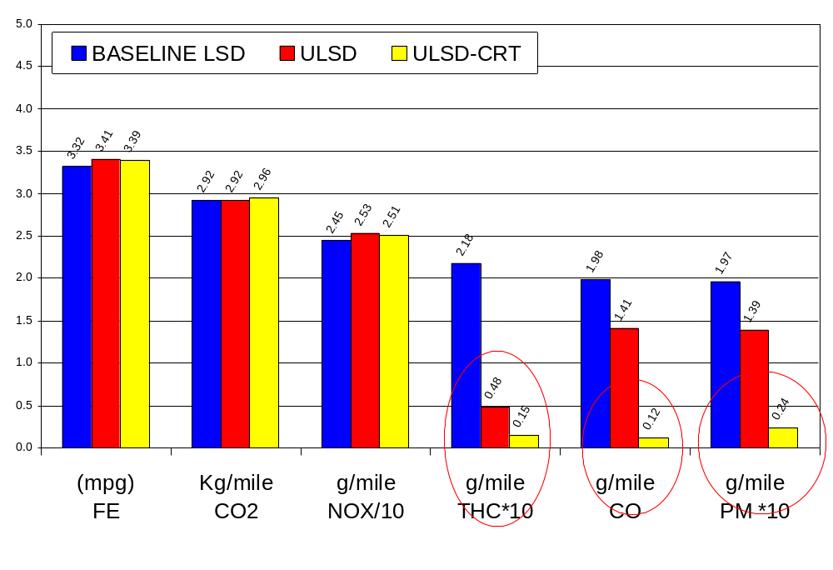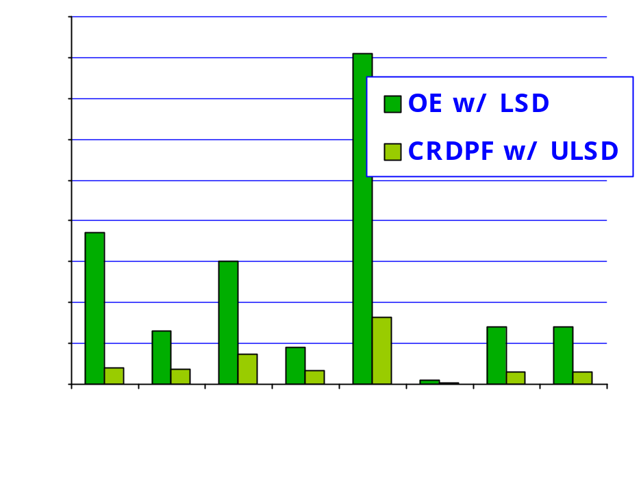Respiratory irritants

The figure shows emissions data from NYCT bus fleet.

Energy Demand

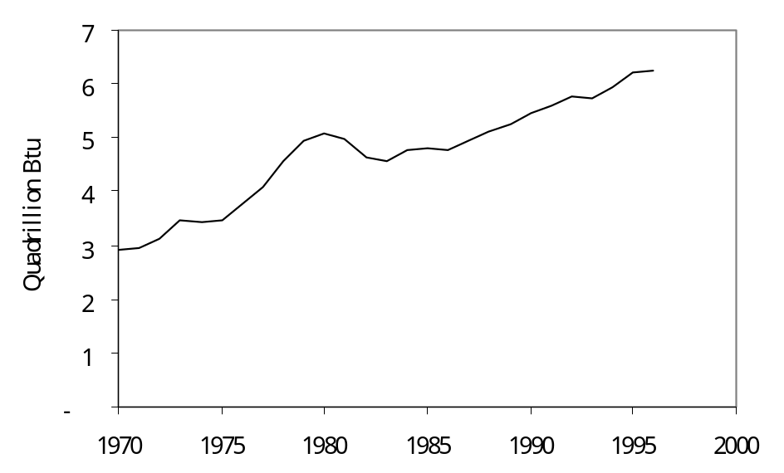
Our demand is only increasing while fuel economy is not.

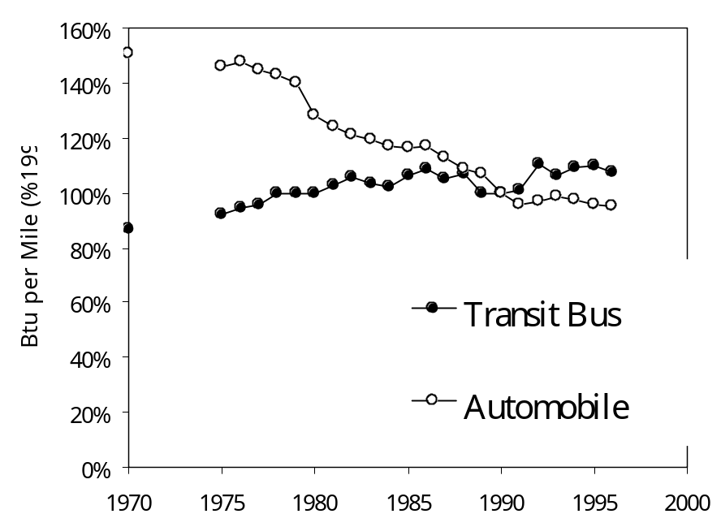The figure shows U.S. Energy consumption by medium and heavy-duty vehicles. Energy consumption has increased from 3 quadrillion BTU in 1970 to over 6 quadrillion BTU in 1997.

The figure shows energy intensity of automobiles and transit buses. Transit bus fuel intensity has increased slightly from 80% of 1990 intensity in 1970 to 110% of 1990 intensity in 1997, while automobile energy intensity has decreased from 150% of 1990 intensity in 1970 to 95% of 1990 intensity in 1997.

Bus Fuel Cost

- Diesel accounts for approx. 5% of total annual operating cost of a transit bus
- Gaseous fuel: large upfront capital cost. Potentially cheaper on a dge basis
- Transit agencies are subsidized

What is a Fuel Cell?

- Fuel cells make electricity directly from chemical reactions, like batteries, but:
  - Are refueled like engines
  - Don’t need recharging
- Spacecraft has used fuel cells since the 1960’s
- Fuel cells are quiet, efficient, and have very low emissions, however:
  - Most use hydrogen for fuel (energy)
  - Fuel processors (reformers) to convert gasoline and other fuels into hydrogen are still in development
  - Fuel cells are still too costly for mass-produced vehicles

Schematic of a Fuel Cell

Proton Exchange Membrane (PEM) Fuel Cell
Single Membrane Electrode Assembly (MEA)

The figure shows a diagram of a fuel cell. Hydrogen gas enters at one node and undergoes a chemical reaction (facilitated by a catalyst) with oxygen at a membrane, forming and releasing water and oxygen gas.
H₂
O₂
H₂O + O₂
H+
H+
H+
H+
H+
H+
H+
H+
H+
H+
H+
H+
H+
H+
H+
H+
e⁻
e⁻
MEA Schematic
Air Plenum
Hydrogen Plenum
Membrane with
catalyst coatings

PEM Fuel Cells

Today’s Fuel Cells have higher power, are cheaper, and more compact.

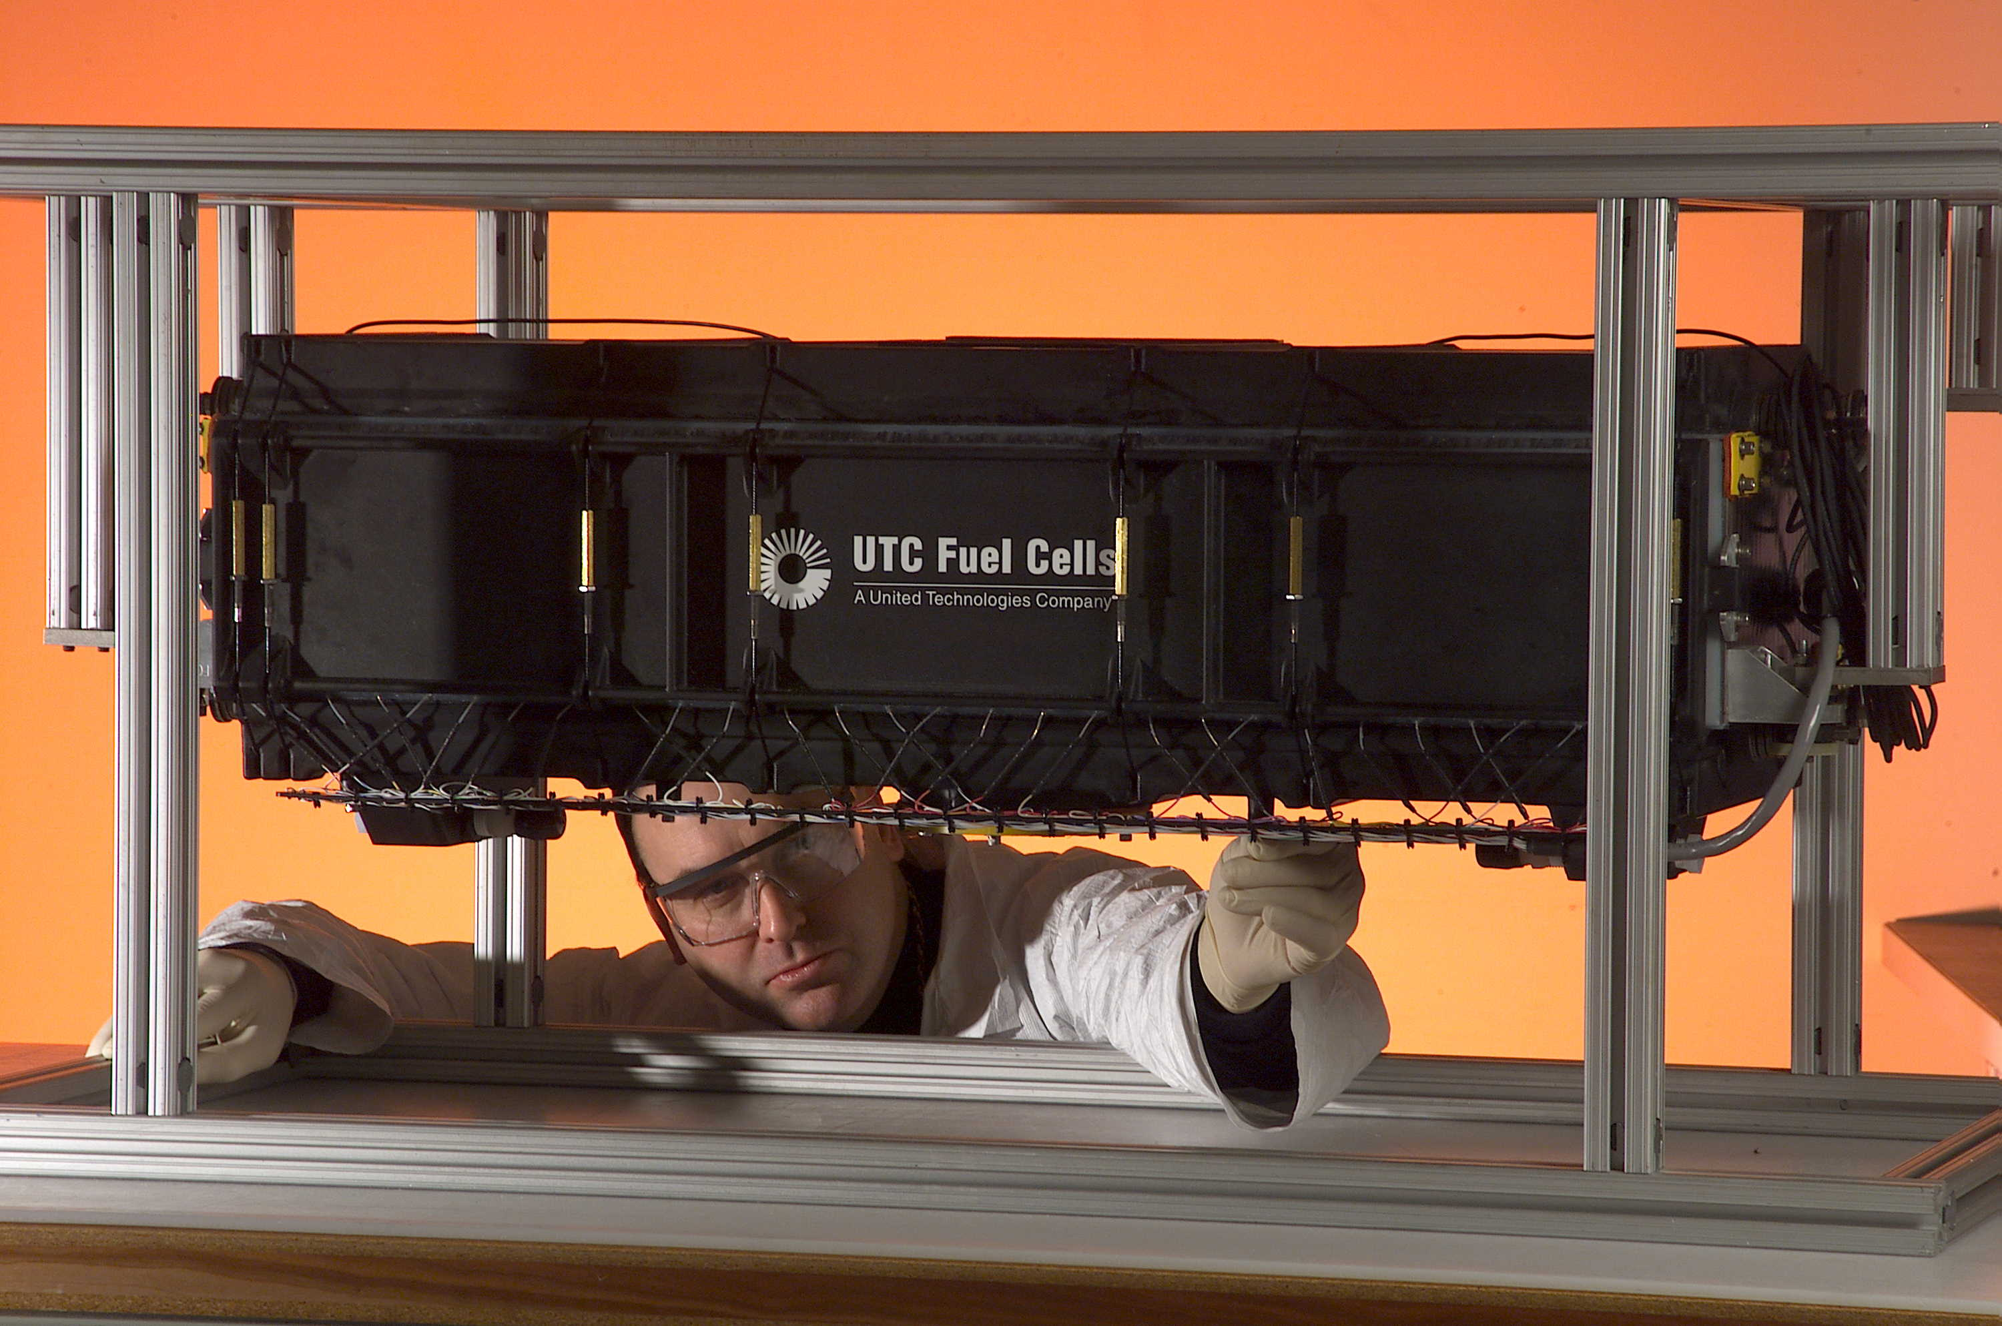

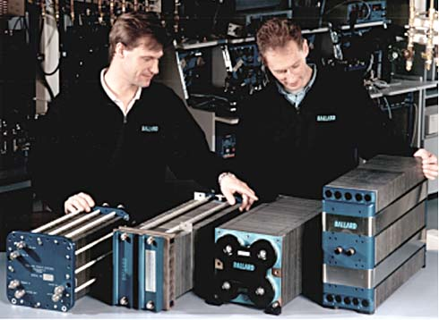
The pictures are photographs of fuel stacks and assemblies.

FTA Fuel Cell Buses

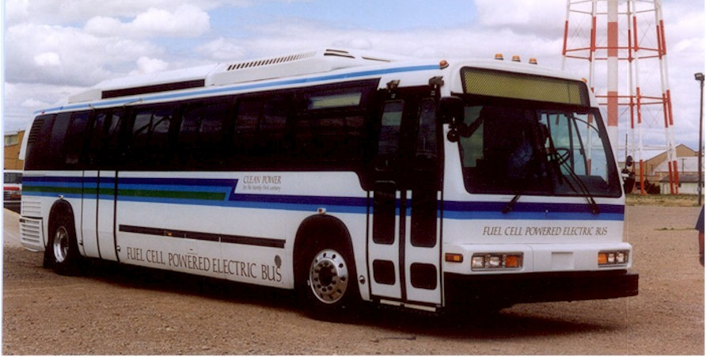
The picture is a photograph of a 40 foot methanol fuel cell bus.
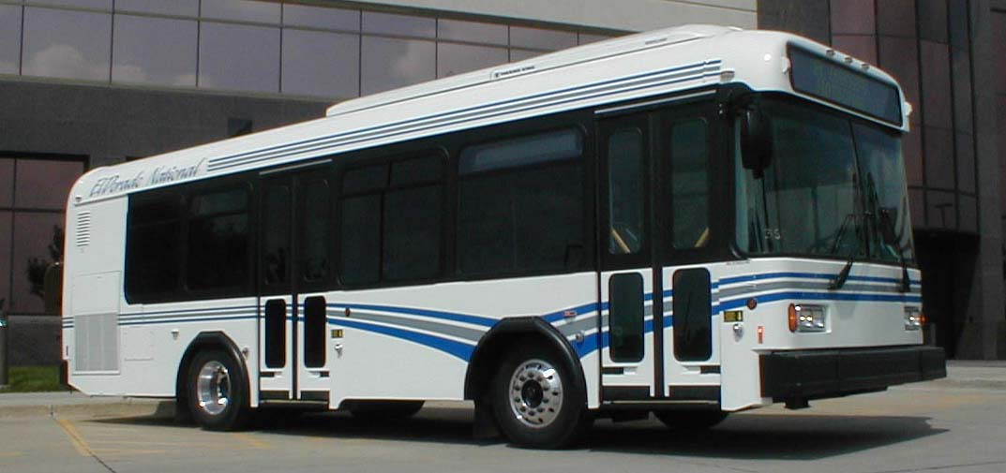
The picture is a photograph of a 30 foot fuel cell bus.

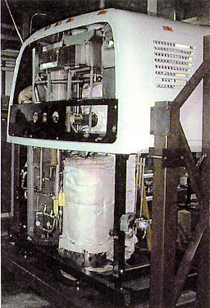
The picture is a photograph of a phosphoric acid FC engine.

Energy Solution

Thinking outside the wall
The key to the Fuel Cell’s Value
Conventional Approach and Fuel Streams

Hydrocarbons --> Hydrogen via reformation or electrolysis --> Renewables --> New Hydrogen Stream or Energy Storage

Advantages of the Bus as a Fuel Cell Platform

- Well defined duty cycle
- Centralized fueling and maintenance infrastructure
- Dedicated maintenance staff
- Trained operators
- Risk mitigation
- Size
- Proximity to people
- Performance improvement vs ICE
- Can attract new “white collar” users
- Technology platforms can be applied to other medium and heavy duty vehicles

Pathways to Success
Eliminating the “Chicken and Egg Complex”

- Bridging Technologies-Myths and Realities
  - Hybrid
  - Natural Gas
  - Other Fuels
- Centralized vs. Decentralized Fueling Infrastructure
One chasm...many bridges --> Buses address all of these issues.
Technical Challenges

- On-board energy storage
  - Fuel
  - Electricity
- Materials limitations of the fuel cell (Approx. 80% of Cost)
  - Platinum
  - Nafion (“remember this...Plastics”)
  - FC sensitivity to impurities
    - In the Fuel Stream
    - From the Environment
- Limited life – the disposal vehicle?

Zero Emissions?

- Well-to-wheels (Hydrogen production can be energy-intensive)
- But renewables are clean, right?
- Emissions displacement
- Does offer the potential

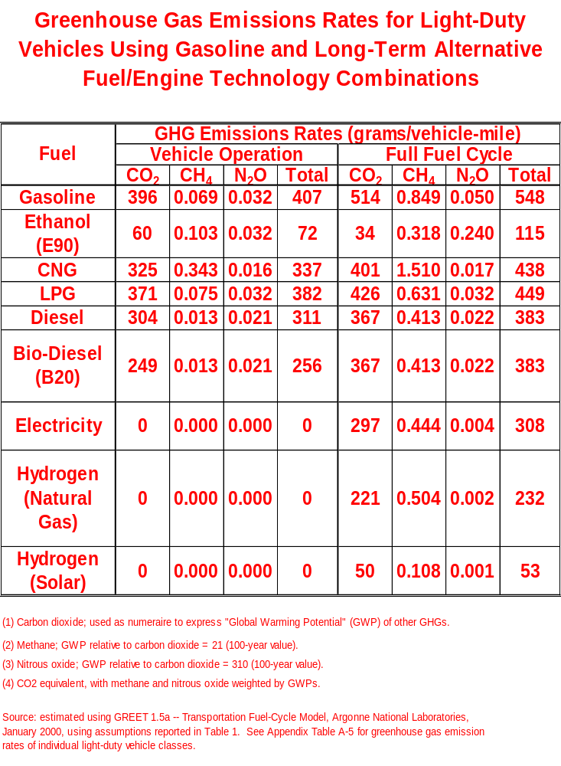

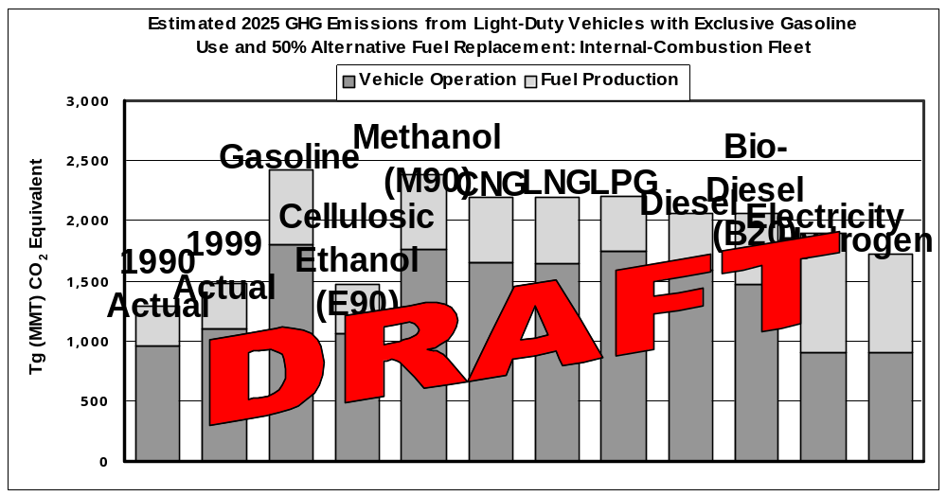
The figure shows estimated 2025 GHG emissions from light-duty vehicles with exclusive gasoline use and 50% alternative fuel replacement: internal-combustion fleet.

Technology Policy Options
For RC Buses and Vehicles

- Decide the monetary value of having cleaner air and a reduction in petroleum consumption
- Sensible financial incentives designed to achieve specific objectives and goals in conjunction with...
- Legislative action that promotes these objectives and goals
- Support
  - Basic R&D
  - Demonstration programs
- To date only partially effective
- Need sustainable, long-term commitments and plans

In Conclusion

Buses using current alternative fuel and propulsion technology offer a significant improvement to air quality, but are best justified as a pathway to fuel cell propulsion.

While fuel cells offer the promise of “clean” transportation, significant technological, economic, and policy hurdles remain.

Buses offer a good platform for initial technology deployment and testing.
Timeframe: 5-10 years before initial non-prototype deployment.
For More Information:

William P. Chernicoff
Advanced Vehicle Technologies Division
Phone: (617) 494-2756
Fax: (617) 494-2961
Email: chernicoff@volpe.dot.gov
http://www.volpe.dot.gov

Hybrid Propulsion

- Platform for developing systems integration...but only goes so far
- Platform to use battery or other electrical charge devices
- Exposure and experience with high voltage systems
- Technology is beyond initial prototype
- Can use much of the existing infrastructure

Hybrid vs. Conventional System
Diesel
Engine
Standard Propulsion
Transmission
Large IC Engine
and Mechanical
Transmission

The figure shows a large IC engine and mechanical transmission.

The figure is a schematic of a hybrid propulsion system. It shows a small IC engine generator electric drive motor and energy storage system controller.
System Controller
Generator
Batteries
Hybrid
Propulsion
Electric
Motor
Diesel
Engine
Small IC Engine
Generator
Electric Drive Motor
Energy Storage
System Controller

Natural Gas

- Possibility of providing hydrogen backbone
- Experience with high pressure gas
- Some infrastructure compatibility with hydrogen
- Immediate “interim” solution
- Technology is mature
- Already in use and deployed
- Well developed Codes, Standards, and Best Practices
  - Transfer knowledge and experience to hydrogen systems

Hydrogen Production Paths

- Electrolysis
- Hydrocarbon reformation
  - On-board methanol
  - On-board gasoline or diesel
  - Off-board natural gas
- Other

