
Life Science
A curriculum and activity guide for Carlsbad Caverns National Park

Middle School Biology

Life Science
Biology Curriculum

Animal Life 64
- The Taxonomic Shuffle
- Sorting out Species Activity designed to help students establish a criteria to separate items into groups. 65
- All in the Family Activity design to help students understand how scientists classify animals. 72
- Desert Animal Adaptations
- Why Do We Look the Way We Do? Activity to provide students with hands-on exploration of animal adaptations, specifically the different beaks and feet of common birds. 76
- Help! I’m Dehydrating activity designed to increase the students’ understanding of how desert animals conserve water. 84
- Designer Animal Adaptations Research of desert animal adaptations in order to discover how animals are designed to survive in the harsh desert climate. 88
- Animals That Live in the Dark Activity to help students understand the characteristics of different cave animal adaptations. 92
- Build an Animal Students design a hypothetical desert animal and classify it into its proper group. 97
- Nature Detective A day hike anywhere (Rattlesnake Springs, Carlsbad Caverns Nature Trail, school grounds, are all options) allowing students to observe and investigate plants and animals in the environment. 102
- Build a Desert Diorama Students will design a diorama to show desert animals in their natural habitat. 106



Animal Life
Desert animals have some impressive ways of handling the challenges of desert life. These adaptations help the animals escape the harsh desert heat, retain water, and maintain their body temperature. Carlsbad Caverns National Park is a safe haven for many animals. It is said that the park is one of the richest areas in the state for insect life. There are three large native hoofed animals in the park. Mule deer are browsers preferring shrubs, such as catclaw acacia and desert willow, but are adapted for aridity with a flexible diet. The cave swallow is a very special summer resident in the park. Rattlesnake Springs is a hotspot for migratory birds. The area attracts 19 species of flycatchers, 35 species of warblers, and many other species of bird.
This unit will focus on animal classification and the adaptations desert animals utilize in order to survive in the harsh climate. In the first two activities, students will be learning about taxonomy or classification of animals. In the activity, Why Do We Look the Way We Do?, students will participate in a hands-on activity to explore the adaptations of different types of bird beaks and feet. In the activity, Help! I’m Dehydrating!, students will design experiments in develop an understanding of how desert animals conserve water. In the activity, Designer Animal Adaptations, students will discover how animals are designed to survive in the harsh desert climate. In the activity, Animals That Live in the Dark, students will study the special characteristics and adaptations of cave animals. In the activity, Build an Animal, students are free to design an animal that would survive in a given environment. The activity, Nature Detective, is an optional field trip opportunity for students to explore and investigate animals in their natural environment. The final activity, Build a Desert Diorama, allows students to design a diorama to show desert animals in their natural habitat.

Sorting Out Species?
How do we all fit together?
Summary: This lesson is designed to establish criteria to separate items into groups.
Duration: 1 class period
Setting: Classroom
Vocabulary: classification, taxonomy, evolution, kingdom, phylum, class, order, family, genus, species
Standards/Benchmarks Addressed: SC3-E1, SC6-E2, SC6-E3, SC6-E4, SC6-E6, SC6-E7, SC10-E2, SC11-E4, SC11-E5

Objectives
Students will:
- design and adhere to established criteria to sort items.
Background
Scientists are people who want to know how the world works. Biologists are people who study living things on our planet. They study how things evolved, how they are related, how they function, and how many different species there are. With the nearly 100 million species on Earth it is very complicated to organize species into their correct groups.
Biologists group animals together using relationships. This organization and classification of living things is called taxonomy. Karl von Linne developed this system of taxonomy in 1758. Using this system, every living thing is given a unique classification.
Taxonomists group similar kinds of creatures together based on their evolutionary relationships. This may sound simple, but it is not. The similarities and differences between species can be very subtle.
Taxonomy is a crucial part of our understanding of life on Earth; it reveals the order and diversity in the teeming life around us. The system that taxonomists use is based on the relationships of different groups of organisms to each other.
There are seven major levels of classification. These seven major levels from largest to smallest are: kingdom, phylum, class, order, family, genus, and species. Each level can be divided into clusters of organisms that are most closely related. These clusters form the next level of classification. For example, each kingdom is divided into a smaller phylum, each phylum into classes, each class into orders, and so on all the way down to species.
Another way to describe the different classifications is in terms of shared genetic material. It is for this reason that an understanding of species is so important: each species represents a unique and irreplaceable genetic resource. The concept of biodiversity cannot be properly understood without an appreciation of the species.
MATERIALS
Animal illustration cards
Double stick tape
Prep
Copy the animal illustration cards. Each group will need a complete set.
Procedure
Warm up: Each student will have a picture of a desert animal taped to his or her back. Students should not know what animal they are. Students are to go around the room and ask other students for clues as to what they are. Students may get only one clue from each person although they may ask as many people as necessary for clues. (Ex. Am I a mammal? Do I have horns or antlers?) Explain that scientists use groupings to sort animals into categories.
Activity
- Divide class into groups of 2-4 students.
- Hand out the sets of animal illustration cards.
- Tell students they will be sorting these animals into groups using any criteria they choose. They can focus on shape, size, pattern, etc. Have students be creative in the ways they sort these animals.
- When students are finished sorting their animals they are to share with the class the criteria they chose to sort the animals into groups.
- After all groups share their animal groupings, explain to them that scientists also sort animals into groups. They often sort animals based on teeth, tail, feet, coloring, skeletal structure, geographic region, and habitat. Emphasize that more and more weight is being placed on DNA similarities as a major criterion for classification. Be sure that the students understand that all the animals that they were given can all be grouped together, because they are all Chihuahuan Desert animals.
Wrap Up: Ask the students what other criteria they could use to classify or group animals. Ask students to tell you what they did, how they did it, and how can they use this information again.
Assessment
Teacher observation, participation
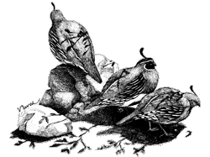  Gamble’s Quail |  | 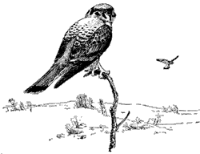  American Kestrel |  | 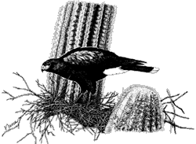  Harris’ Hawk
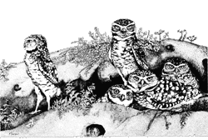  Burrowing Owl |  | 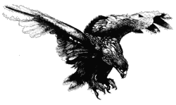  Golden Eagle |  | 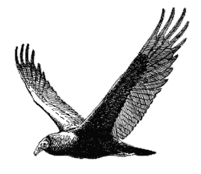  Turkey Vulture
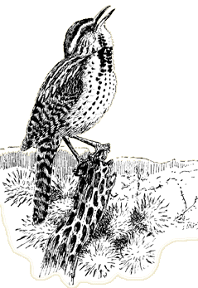  Cactus Wren |  | 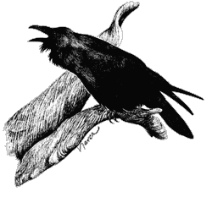  Common Raven |  | 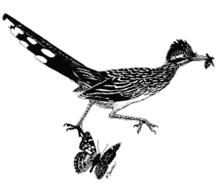  Greater Roadrunner
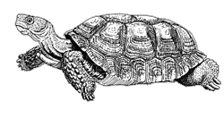  Desert Tortoise |  | 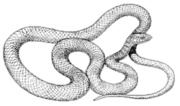  Western Coachwhip |  | 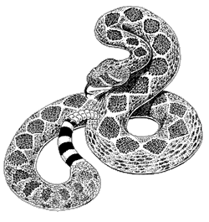  Western Diamondback Rattlesnake
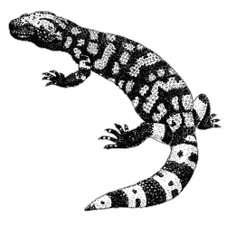  Gila Monster |  | 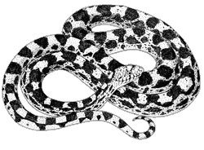  Gopher Snake |  | 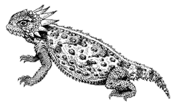  Horned Lizard
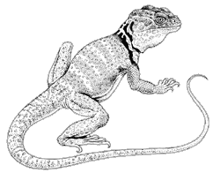  Collared Lizard |  | 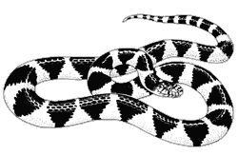  Desert Kingsnake |  | 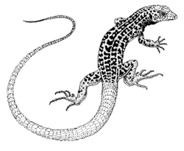  Checkered Whiptail Lizard
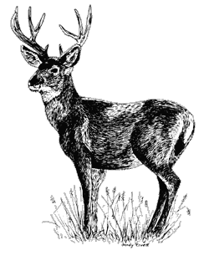  Mule Deer |  | 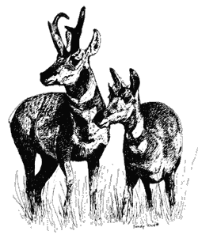  Pronghorn |  | 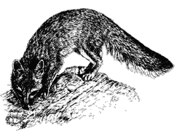  Grey Fox
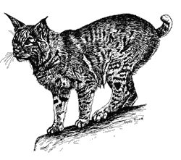  Bobcat |  | 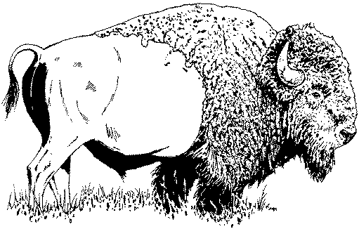  Bison |  | 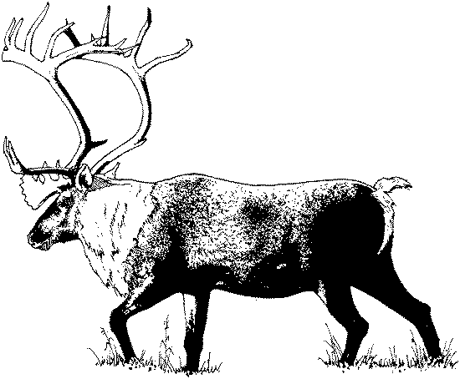  Elk
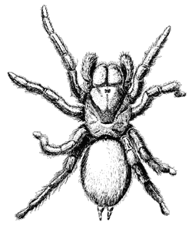  Desert Tarantula |  | 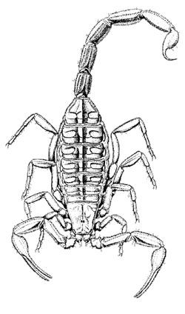  Bark Scorpion |  | 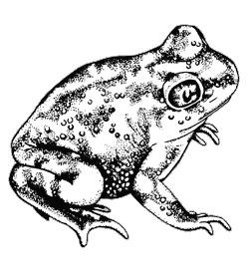  Couch’s Spadefoot
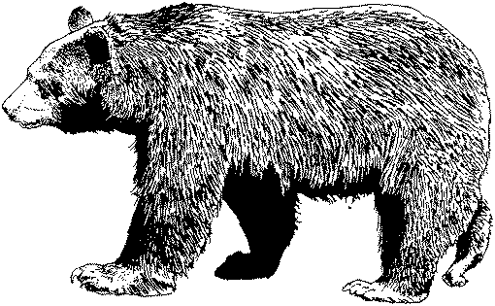  Black Bear |  | 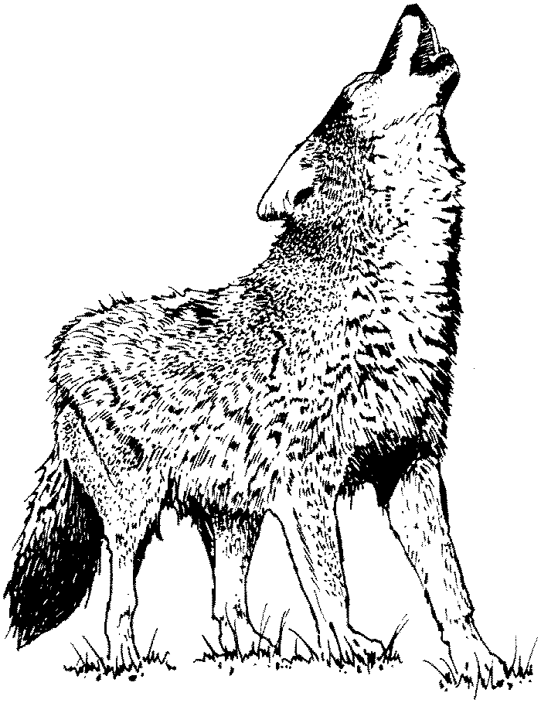  Mexican Gray Wolf |  | 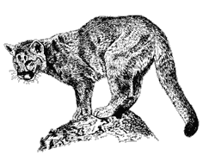  Mountain Lion
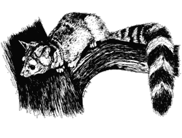  Ringtailed Cat |  | 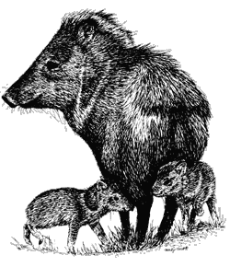  Javelina |  | 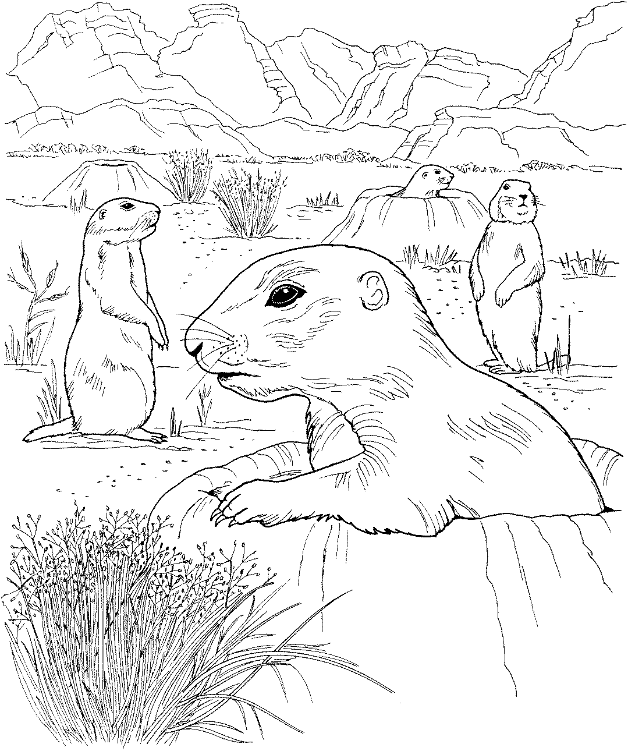  Black-tailed Prairie Dog
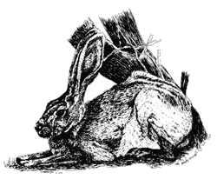
Black-tailed Jack Rabbit |  | 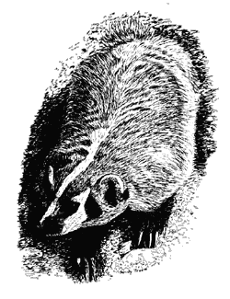  Badger |  | 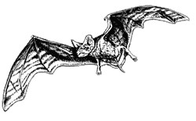  Mexican Free-tailed Bat
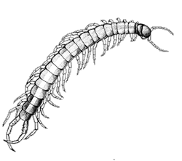  Centipede |  | 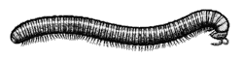  Millipede |  | 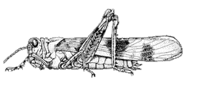  Banded Wing Grasshopper
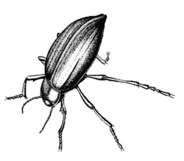  Pinacate Beetle |  | 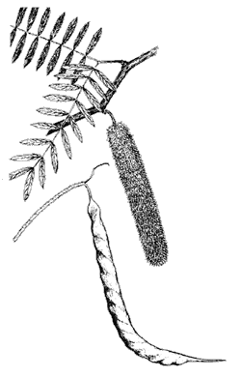  Honey Mesquite |  | 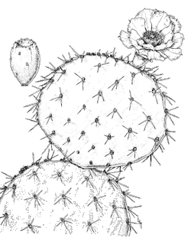  Engelmann Prickly Pear
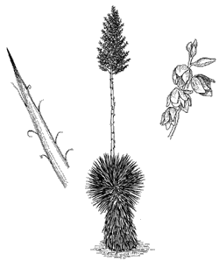  Soaptree Yucca |  | 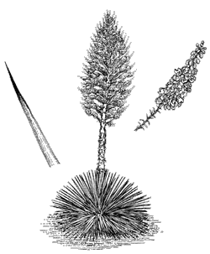  Spanish Bayonet |  | 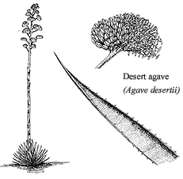  Desert Agave

All In the Family
Summary: Like all organisms, animals are named and classified into a hierarchy of relatedness. In this lesson students will learn the principles of classification in order to classify animals into their proper group.
Duration: 1 class period
Setting: Classroom
Vocabulary: class, kingdom, family, phylum, species, genus, order, animalia, chordata, mammalia, carnivora, canidae, canis
Standards/Benchmarks Addressed: SC1-E1, SC2-E2, SC3-E1, SC6-E1, SC6-E2, SC6-E3, SC10-E2, SC11-E1, SC11-E4, SC11-E5

Objectives
Students will:
- be able to define species.
- be able to order the taxonomic levels.
Background
Scientists are people who want to know how the world works. Biologists are people who study living things on our planet. They study how things evolved, how they are related, how they function, and how many different species there are. With the nearly 100 million species on Earth it is very complicated to organize species into their correct groups.
One way of making sense of the millions of species in the world is to organize them into groups based on their relationships. This system of uniform organization is called taxonomy: the classification of living things. This systematic organization and classification of living things was developed by Karl von Linne in 1758.
Taxonomists group similar kinds of creatures together based on their evolutionary relationships. Using this system, every living thing is given a unique classification.
This may sound simple, but it is not. The similarities and differences between species can be very subtle.
Taxonomy is a crucial part of our understanding of life on Earth; it reveals the order and diversity in the teeming life around us. The system that taxonomists use is based on the relationships of different groups of organisms to each other.
There are seven major levels of classification. These seven major levels from largest to smallest are: Kingdom, Phylum, Class, Order, Family, Genus, and Species. Each level can be divided into clusters of organisms that are most closely related. These clusters form the next level of classification. For example, each kingdom is divided into a smaller phyla, each phylum into classes, each class into order, and so on all the way down to species.
Another way to describe the different classifications is in terms of shared genetic material. The creatures at each level share a greater proportion of genetic material than those at the level below them. It is for this reason that an understanding of species is so important: each species represents a unique and irreplaceable genetic resource. The concept of biodiversity cannot be properly understood without an appreciation of the species.
Like all organisms, animals are named and classified into a hierarchy of relatedness. Organisms in the same species are more closely related than organisms in the same genus, and organisms in the same genus are more closely related than organisms in the same order, and so on.
Materials
Game pieces
Classification reference diagram
Procedure
Warm up: Students will be placed in groups of four and given a set of game cards. They will be asked to place these animals into groups. After a specified amount of time, ask each group to share how they grouped their cards. Introduce the concept of taxonomy and categorizing animals into groups. Refer to background information as needed.
Activity: Students will be given a classification reference diagram.
In the first column (address analogy) students are to write the country they live. In the next column (general scientific terms) they are to note the word kingdom. In the third column explain to the students that there are two major kingdoms, plants and animals. Ask the students to look at their game cards and determine which kingdom the pictured species are in (students should write, Animalia. Animalia are eukarotic, multicellular, and feed by ingesting other organisms or parts of other organisms).
In the first column, second row, students should write the state that they live in. In the second column, second row, students should note the word phylum (monophyletic assemblage derived from a single ancestor. Explain to the students that phyla can be sorted into arthropods (animals without backbones, invertebrates) and chordates(animals with backbones, vertebrates). Ask the students to sort their cards into the two categories. In the third column, second row, students should write chordata (members of this group are characterized by a notochord, pharyngeal gill slits, a dorsal tubular nerve cord, and a postanal tail). Students would retain only the animal cards in that category.
In the first column, third row, students should write the name of their city. In the second column, third row, students should note the term class. Explain to the students that in the phyla category there are four classes, amphibians, reptiles, birds, and mammals. Amphibians have moist skin, lay jellylike eggs and spend part of their life cycle in water. They are ectothermic (cold-blooded). Reptiles have scales or horny plates and usually lay leathery eggs. They are also ectothermic. Birds have feathers and wings. They lay hard-shelled eggs and have no teeth. Birds are endothermic (warm-blooded). Mammals are at least partially covered by hair, have specialized teeth, are endothermic, and young are nursed from mammary glands. Ask the students to sort their cards into these classes. In the third column, third row, students should write the word mammalia (members are at least partially covered by hair, have specialized teeth, are endothermic, and young are nursed from mammary glands). Students should retain only the cards from that class.
In the first column, fourth row, students should write their street name. In the second column, fourth row, students should note the term order. In the mammalia class there are five orders, rodents, primates, carnivores, omnivores, and herbivores. Rodents are usually small plant-eaters with gnawing teeth. Primates have five fingers with they can move separately and have flat fingernails instead of claws. Carnivores have sharp teeth, paws, claws, and eat meat. Have the students sort their cards into these categories. In the third column, fourth row, students will write the word carnivora (any organism that eats flesh). Students should retain only these cards.
In the first column, fifth row, students should write their street number. In the second column, fifth row, students should note the term family. Ask them to divide their cards into families. In the third column, fifth row, students will write the word canidae. Students should retain only the cards that fit this category.
In the first column, sixth row, students should write their last name. In the second column, sixth row, students should note the term genus. In the third column, sixth row, students should write Urocyon. What card do you have left?
In the first column, seventh row, students should write their first name. In the second column, seventh row, students should note the term species (a group of populations in which genes are actually, or potentially, exchanges through multiple generations). In the third column, seventh row, students have students write cinereoargenteus (scientific name for grey fox).
Wrap Up: Discuss the procedure just completed. Ask students to verbalize the analogy used with the address being compared to the classification system of animals. Students may play a game with the animal cards. Students should create an acronym in order for them to remember the classification order.
Assessment
Teacher can create a Classification Reference Diagram that has certain terms omitted. Students will fill in the missing words. Teachers can also name an animal and ask student to classify it.
All in the Family Activity
Classification Reference Diagram
Address Analogy | Classification | Name
 | Kingdom
 | Phylum
 | Class
 | Order
 | Family
 | Genus
 | Species

Why Do We Look the Way We Do?
How do animals adapt to their environment?
Summary: This hands-on lesson is designed to provide students with the opportunity to explore animal adaptations.
Duration: 2 class periods
Setting: Classroom/lab
Vocabulary: adaptation, flora, fauna, raptors, evolution, survival of the fittest, Charles Darwin, natural selection
Standards/Benchmarks Addressed: SC1-E1, SC1-E2, SC2-E2, SC2-E3, SC3-E1, SC4-E3, SC4-E4, SC4-E5, SC5-E2, SC6-E1, SC6-E2, SC6-E3, SC6-E6, SC11-E2, SC11-E4

Objectives
Students will:
- comprehend that birds physically adapt in relation to their food source.
- deduce what beaks are most efficient for given foods by experimenting with imitation beaks and hypothetical food sources.
- describe what would happen to a bird population if its environment could no longer support the bird’s food source.
- create a hypothetical bird for a desert environment.
Background
A change in physical appearance or behavior that allows an organism to survive in its natural environment is an adaptation. Animals change over time to fit the needs of their environment. If an environment changed the animals in that environment would have to change—adapt—in order to survive. Darwin’s theory of survival of the fittest implies the individuals with the best combination of inherited traits are most likely to survive. Darwin’s idea of natural selection implies that organisms best suited to the environment will survive and reproduce, therefore passing their genes to the next generation.
Animals change over a long period of time to fit their environment. Bird bills and tongues are modified for a variety of feeding habits and food sources. For example, the tongue of a woodpecker is barbed for extracting grubs from the bark of trees. Sapsuckers excavate holes in trees and use a brushlike tongue for licking the sap that accumulates in these holes. The tongues of hummingbirds and other nectar feeders are rolled into a tube and used for extracting nectar from flowers.
It is common practice to group birds by their feeding habits. This is somewhat artificial because birds may eat different kinds of food at different stages in their life history, or they may change diets simply because of changes in food availability. Robins, for example, feed largely on worms and other invertebrates when these foods are available. In the winter, however, robins feed on berries.
The appendages of birds have also been modified. Some bones in the front appendages have been lost or fused to serve as points of attachment for flight feathers. The rear appendages are used for hopping, walking, running, and perching. Perching tendons run from the toes across the back of the ankle joint to muscles of the lower leg. When the ankle joint is flexed, as in landing on a perch, tension on the perching tendons is increased, and the foot grips the perch. The automatic grasp helps the bird to perch even while sleeping. The muscles of the lower leg can increase the tension on these tendons, for example, when an eagle grasps a fish in its talons.
Materials
Beaks:
2 eyedroppers
1 pair of pliers
5 sets of chopsticks
4 tweezers
1 shoestring
1 sponge strip
1 straw
1 wrench
2 slotted spoons
1 strainer
3 tongs
1 envelope
1 bar-b-que fork
Food:
Colored water
Gummy worms
Sunflower seeds
Styrofoam
Popped popcorn
Rice
Marshmallows
Loose tea leaves
Other:
Potting soil
Shallow pans
8 boxes
8 cups
Graduated cylinder
Tree bark
Data sheets
Pictures of birds
Overhead of beaks and feet
Procedure
Warm up: Brainstorm ideas about what students know about birds. What makes a bird a bird? What do birds need to survive? What kind of foods do birds eat? Where do birds live? What kinds of birds can you find by your home or school?
Activity
- On the overhead, discuss the different bird beaks (cracker, shredder, chisel, probe, strainer, spear, tweezer, Swiss Army knife), what they look like, what they do, what kinds of birds have them; students should be taking notes and drawing the beaks. Do the same with the bird feet (grasping, scratching, swimming, perching, running, and climbing).
- Around the room have the following stations set up:
  - A graduated cylinder filled with colored water
  - A dish of potting soil with gummy worms buried throughout
  - Sunflower seeds spread throughout a pan
  - A shallow dish of water with Styrofoam floating in it
  - A dish of water with loose-leaf tea
  - Popped popcorn
  - Rice grains tucked into the bark of a log
  - Marshmallows hanging on strings
- These stations represent different food sources available. Students will visit each station and predict what type of beak and which type of feet that particular bird needs to posses in order to eat that food source. Have the students write their predictions down.
- Discuss the students’ predictions on the different stations to see if they are correct.
    - Nectar – probing beak, perching feet
    - Worms – Swiss Army knife beak, scratching feet
    - Seeds – cracker or Swiss Army knife beak, feet may vary
    - Fish – strainer or spear beak, swimming feet
    - Fine bits of vegetation – strainer beak, swimming feet
    - Flying insects – tweezer or Swiss Army knife beak, feet may vary
    - Small insects – chisel beak, climbing feet
    - Meat – shredder beak, grasping feet
- Divide students into groups (there are 8 challenges so divide accordingly). Each group will get a challenge. Pass out challenges and supplies to each group. After reading their challenge card the group should predict which beak (utensil) would work best for eating their specific food and write down their prediction on the data table. The group will then time (in seconds) how long it takes to obtain a given amount of food with each utensil (they must have three times for each utensil) and write the times on the data table. Then the students should average the three times and graph the results.
- Discuss the students’ predictions and results. Have them write an explanation next to their prediction. Was their prediction supported with evidence? How do you see things differently after this experiment?
- Discuss and/or research the following questions: What might happen to a bird population if its natural environment experienced a natural disaster where all the flora (plants) and fauna (animals) were wiped out? What would happen if a farmer used an insecticide that killed off all the insects? What would happen to the woodpeckers and other birds that eat insects? What would happen if the old trees were cut down? Where would eagles and other raptors watch for their meals?
Wrap Up: Students will create a bird that feeds on a particular food source. The students must include adaptations, other than beaks, that help the bird survive. For example: swimming feet for swimming animals like ducks and geese. The students will draw the bird and write a description of the adaptations needed for this bird to survive.
Assessment
Teacher observation, participation, notes, research, created birds with description, complete data table
Bird Feet Adaptations
Why Do We Look the Way We Do? Activity
Shape | Type | Adaptation | Example bird
 | Climbing | Enables the bird to climb without falling backwards | Woodpecker
 | Swimming | Web-lined feet; used like paddles for swimming. | Ducks and other web-lined swimming birds
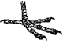 | Perching | Used to grab and perch tightly. | Robins
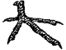 | Scratching | Used to scratch soil in search of food; have nail-like toes. | Pheasants
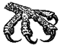 | Grasping | Have large curved claws used to snatch fish from the water and grab prey. | Raptors
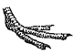 | Running | Have three toes rather than four; making them run faster. | Fast running birds
Pictures borrowed from: The Norman Bird Sanctuary
Bird Beak Adaptations
Why Do We Look the Way We Do? Activity
Shape | Type | Adaptation | Example bird
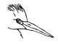 | Spear | Spear-like bill; adapted for fishing. | Herons, Kingfishers
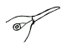 | Probe | Long and slender; used for probing flowers for nectar. | Hummingbirds
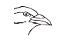 | Swiss Army Knife | A multipurpose bill; allows the bird to eat fruit, seeds, insects, fish, and other animals. | Crows
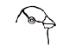 | Cracker | Short, thick conical bill; used for cracking seeds. | Sparrows, Cardinals
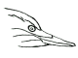 | Chisel | Long and chisel-like bills; used for boring into wood to eat insects. | Woodpeckers
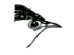 | Tweezer | Thin and pointed bills; used to eat insects. | Warblers
 | Shredder | Sharp curved bills; used for tearing meat. | Hawks, Owls
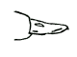 | Strainer | Long, flat bill; used to strain small plants and animals from the water. | Ducks
Pictures borrowed from: The Norman Bird Sanctuary

Why Do We Look the Way We Do? Challenges

Challenge #1
You have been given a graduated cylinder of water as a food source. You have also been given sample beaks: 1) a shoestring, 2) a medicine dropper, and 3) a sponge tip. Your challenge is to find out how many seconds it takes each “beak” to get 10mL of water from the graduated cylinder to the cup. Try several trials with each “beak.” Record the three times in the data table provided. Calculate the average time for each “beak.” Construct a bar graph of the averages.

Challenge #2
You have been given gummy worms as your food source. You have also been given sample beaks: 1) a straw, 2) chopsticks, and 3) a wrench. Your challenge is to find out how many seconds it takes to remove the gummy worms from the dirt using each “beak.” Use multiple trials, burying the worms after each trial. Record the times on the data table provided. Calculate the average time for each “beak.” Construct a bar graph of the averages.

Challenge #3
You have been given floating sunflower seeds as your food source. You have also been given sample beaks: 1) pliers, 2) chopsticks, and 3) tweezers. Your challenge is to find out how many seconds it takes each “beak” to crack the shell and remove the seed inside. Record the times on the data table provided. Calculate the average time for each “beak.” Construct a bar graph of the averages.

Challenge #4
You have been given Styrofoam squares as your food source. You have also been given sample beaks: 1) chopsticks, 2) tweezers, and 3) a slotted spoon. Your challenge is to find out how many seconds it takes each “beak” to remove all the Styrofoam squares from the water. Try several trials, returning the squares after each trial. Record the times on the data table provided. Calculate the average time for each “beak.” Construct a bar graph of the averages.

Challenge #5
You have been given tea leaves as your food source. You have also been given sample beaks: 1) a slotted spoon, 2) a strainer, and 3) tweezers. Your challenge is to find out how many seconds it takes each “beak” to get all the tea from the water. Try this several times, returning the materials each time. Record the times on the data table provided. Calculate the average time for each “beak.” Construct a bar graph of the averages.

Challenge #6
You have been given popped popcorn as your food source. You have also been given sample beaks: 1) tongs, 2) a medicine dropper, and 3) tweezers. A group member will gently toss some kernels into the air. Your challenge is to find out how many seconds it takes to capture 20 kernels with each “beak.” The kernels must be caught while they are still in the air. Try this several times with each “beak.” Record the times on the data table provided. Calculate the average time for each “beak.” Construct a bar graph of the averages.

Challenge #7
You have been given rice as your food source. You have also been given sample beaks: 1) a medicine dropper, 2) tongs, and 3) tweezers. Your challenge is to find out how many seconds it takes for each “beak” to remove thirty grains of rice from the tree bark. Try this several times, returning the rice to the tree bark after each time. Record the times on the data table provided. Calculate the average time for each “beak.” Construct a bar graph of the averages.

Challenge #8
You have been given marshmallows hanging from a string as your food source. You have also been given sample beaks: 1) chopsticks, 2) tongs, and 3) a bar-b-que fork. Your challenge is to find out how many seconds it takes for each “beak” to remove five marshmallows from the strings. Try this several times. Record the times on the data table provided. Calculate the average time for each “beak.” Construct a bar graph of the averages.

Name ____________________

Bird Beak Challenge Data Table
(Why Do We Look the Way We Do Activity)
Predict which beak (utensil) will work best for eating your specific food source.
Sample Beak Used | Trial 1 Time | Trial 2 Time | Trial 3 Time | Average

Was your prediction supported with evidence? Explain.
______________________________________________________________________________________________________________________________________________________________________________________________________________________________________________________________________________________________________________________________________________________________________________________________________________________________________________________________________________________________________________________________________________________________________________________________________________________________________________________

How do you see things differently now that you have completed this experiment? Explain.
______________________________________________________________________________________________________________________________________________________________________________________________________________________________________________________________________________________________________________________________________________________________________________________________________________________________________________________________________________________________________________________________________________________________________________________________________________________________________________________

Help! I’m Dehydrating!
How do animals conserve water?
Summary: This hands-on lesson is designed to help students understand how difficult it is for animals to conserve water in a desert environment.
Duration: 2 class periods
Setting: Classroom/lab
Vocabulary: conservation, nocturnal, adaptation, microhabitats
Standards/Benchmarks Addressed: SC1-E2, SC2-E1, SC2-E2, SC2-E3, SC3-E1, SC4-E3, SC4-E4, SC4-E5, SC5-E2, SC6-E1, SC6-E2, SC6-E4, SC6-E6, SC6-E7, SC11-E1, SC11-E2, SC11-E3, SC14-E3

Objectives
Students will:
- observe a model situation and make inferences about real organisms.
- communicate their observations relating to specialized organisms adapted to dry desert environments.
Background
A variety of organisms live in almost any habitat you could name. The desert, for example, is a challenging habitat for the plants and animals that live there. Yet for thousands of years plant and animal species have adapted and thrived in these arid lands. How? Because each organism has its own way of life which often requires a different environment from that of other organisms, plants and animals inhabit specific microhabitats within the environment of a general habitat. This microhabitat allows them to accommodate their needs and survive the harshness of the desert. A microhabitat is simply a small, distinctly specialized habitat.
For some animals their respite is the cool interior of a burrow. Rattlesnakes, kit foxes, and kangaroo rats spend most of the day resting in underground burrows. They choose the night for their active period to avoid the intense dehydrating heat of the daytime sun. During the day, the cool microclimate of their burrows helps protect them. How cool is it? While the soil surface up top may be 165 degrees Fahrenheit, their underground dens may be a livable 80 degrees Fahrenheit. In their cozy microhabitat, these animals can conserve their energy for nighttime hunting or seed gathering expeditions. Astonishingly, over half of all vertebrate animals, including those that live in caves and underground, are nocturnal.
During the dry times, animals such as the Spadefoot Toad, an amphibian that lives in the American Southwest, Can be found in a burrow dug with its spade-shaped back feet. It will continue to lie dormant until the sound of raindrops hitting the surface awakens the toad. At that point the race is on. Within approximately 8-10 days the cycle of finding a mate to laying the eggs to becoming a toad will be complete.
Some plants use combined strategies of dormancy and an accelerated life cycle. The seeds of the Sand Verbena will remain dormant (sometimes for years) until there is enough rain. When there is sufficient rain, they grow quickly, making their flowers and seeds and then dying all within a period of a few weeks. Some plants bloom at night in order to minimize water loss.
An arroyo, a ditch carved by water in desert regions, makes for the perfect microhabitat for Javelinas. When the steep banks erode, shallow cavities are created that provide warmth in the winter and cool in the summer. The Javelinas will hide in these shallow cavities to prevent water loss and stay cool on hot summer days.
Cave entrances can provide microhabitats for a variety of plant and animal species and provide growing conditions similar to a forest. It is not uncommon to find a fringe of green around the entrances to caves. Upon closer examination, evidence of animals such as birds, snakes, skunks, or mice living in the mouth of the cave can be found.
A variety of microhabitats can be found in any environment. Plants and animals find “their place” in logs, under boulders, in cacti, or even under a refuse can. Places such as a shady area under a tree or shrub are microhabitats because they provide a home for shade loving plants or respite for the desert lizards.
Materials
Sponges
Water
Natural desert materials (brush, vegetation, logs, etc…will be used as protection from the dry heat)
Balance scales
Desert animal profiles
Data sheet
Procedure
Warm up: Brainstorm ideas about what animals do to conserve water. Write a list of the students’ responses. What do desert animals do during the day? How do they escape from the desert heat? What adaptations have they made to survive in the harsh desert climate?
Activity
- Divide students into groups of 2 or 3. Each group will be given a sponge saturated with water. This sponge represents a desert animal with a very limited water supply. The students are to conserve as much of the animal’s water as possible. For a 24-hour period the group is to care for the “creature” in a way to achieve this goal using only natural materials. The creature must remain in the open for at least 4 hours (this represents feeding time).
- The students should weigh their sponge to get a baseline weight of the sponge. Write this weight down to compare to the ending weight of that same sponge. Students need to develop a strategy to conserve the water in their critter, write it down and make a prediction on what they think will happen. During the 24 hour observation time the students will make and write down observations as to what is happening with their animal. At the end of the time the students should weigh their sponges and compare beginning and ending weight. Students should make inferences about the results in relation to real organisms. (There should be a control sponge that is left out for the whole time for comparisons).
- Have the students share their plan, predictions, and results with the entire class. Have a class discussion on methods, results, and how it all relates to adaptations for desert survival of real living organisms.

Wrap Up: Students will invent a hypothetical desert animal. They may either draw or build the animal and write the adaptations the animal has that help it survive.
Assessment
Presentation of experiment results, animal presentation.
Name. ____________________
Help! I’m Dehydrating! Data Sheet
Sponge | Initial weight | Final Weight
Control Sponge
My Sponge

My strategy to conserve water:
________________________________________________________________________________________________________________________________________________________________________________________________________________________________________________________________________________________________________________

What I think will happen to my sponge:
________________________________________________________________________________________________________________________________________________________________________________________________________________________________________________________________________________________________________________

My observations:
________________________________________________________________________________________________________________________________________________________________________________________________________________________________________________________________________________________________________________

My results:
________________________________________________________________________________________________________________________________________________________________________________________________________________________________________________________________________________________________________________

How does this relate to real organisms?
________________________________________________________________________________________________________________________________________________________________________________________________________________________________________________________________________________________________________________

Designer Animals
Can you create an animal that could survive in a given environment?
Summary: This lesson is designed to extend the student’s knowledge of animal adaptations. This lesson could lead to the concept of the survival of the fittest (Darwinism).
Duration: 1 class period
Setting: Classroom/lab
Vocabulary: adaptations, global warming, habitat, ecosystem, climate, camouflage, mimicry
Standards/Benchmarks Addressed: SC1-E1, SC1-E2, SC2-E1, SC2-E2, SC2-E3, SC3-E1, SC4-E1, SC4-E5, SC6-E2, SC6-E3, SC6-E6, SC6-E7, SC11-E1, SC11-E2, SC11-E3, SC11-E4

Objectives
Students will:
- recognize animal adaptations.
- create an animal that would survive in a given environment.
Background
Sometimes little things can turn into big things. If global temperatures rise above normal levels for a few days, it’s no big deal—the Earth will stay more or less the same. But if temperatures continue to rise over a longer period of time, then the Earth may experience some problems.
The average global temperature has increased almost 1⁰ F over the past century; scientists expect the average global temperature to increase an additional 2 to 6⁰ F over the next hundred years. This may not sound like much, but it could change the Earth’s climate as never before. At the peak of the ice age (18,000 years ago), the temperature was only 7⁰ F colder than it is today, and glaciers covered most of North America.
Even a small increase in temperature over a long time can change the climate. When the climate changes, there may be big changes in the things that people and animals depend on. These things include the levels of the oceans and the places we plant crops. They also include the air we breathe and the water we drink.
Climate change may alter the world’s habitats and ecosystems—all living things are included in and rely on these places. Many of these places rely on a delicate balance of rainfall, temperature, and soil type. A rapid change in climate could upset this balance and endanger many living things.
Most past climate changes occurred slowly, allowing plants and animals to adapt to the new environment or move somewhere else. However, if future climate changes occur as rapidly as some scientist predict, plants and animals may not be able to react quickly enough to survive.
Materials
Drawing materials
Animal habitat cards
Procedure
Warm up: Brainstorm and list animal adaptations. Remind students that adaptations include camouflage, physical features, and behavioral features that help animals survive in their natural habitats. It is now the year 3000, humans are now able to design and create their own animals. The task is to develop an animal that would survive in a given environment.
Activity: Students will be given 1 animal habitat card. The students are going to draw an animal and label the adaptations that the animal has that help it survive in the given environment.
Criteria for animal:
Size
What does it eat?
How will it catch/get food and water?
How will it keep warm/cool?
Where will it take shelter?
What is the animal’s reproduction rate and gestation period?
How do the parents and infants interact?
How will it defend or protect itself from attackers?
Your animal cannot be a top predator (one that can eat everything else and survive).
All the above criteria must be labeled on the animal to receive credit.
Wrap Up: Students present and discuss the adaptations that their animal has in order to survive in the environment they were given.
Assessment
Rubric
Designer Animal Habitat Cards
This habitat is dark and cold most of the time. It is very mountainous. It rains almost all day. Because of the wet, dark conditions, the only plants that grow well are small mosses and fungi. The animals in this habitat include a type of mouse, a nocturnal large hunting cat, fish, and a variety of insects.

This habitat is dry and hot. Most of the surface is flat. Water is mostly found in underground streams, however there is a little water at the surface. Most of the terrain is covered in sand, although there are patches of dry grass. When plants are able to get their roots down into the water table, they grow into tall trees with leaves at the top but not along the trunk. Plants not connected to the water table are small and dry, but they are edible. The animals in this habitat include insects, a species of bird, which roosts in the high trees, a sand-colored lizard, and a type of rat.

This habitat is tropical: wet and hot. Most of the terrain is rainforest. The land is very flat. Water collects in large pools and lakes, which have water in them all year round. A species of poisonous plant grows thickly on the ground. The spines of this plant are poisonous; any animal that steps on one is sure to die. The vegetation is plentiful, and includes leaves, fruits, and nuts. Animals include carnivorous snakes, varieties of insects, monkeys, fish, and birds.

This habitat has a moderate climate. It never gets very hot or very cold, but stays mild all year long. It rains for part of the year and the water forms pools and lakes that dry up towards the end of the year, and then the habitat is very dry. The landscape is partly mountainous and partly flat. Vegetation includes tall trees with high leaves and fruit, and a smaller plant that bears nuts. However, these nuts are inside hard shells that need to be removed before the nut can be eaten. Animals include rats and mice which live underground, insects, birds that nest in the tall trees, slow moving mammals which also live in the trees, and a species of carnivorous nocturnal wolf.
Designer Animal Rubric
Designer Animal | Self evaluation | Teacher evaluation
Animal criteria: |  | /28
Size
What does it eat?
How will it catch/get food and water?
How will it keep warm/cool?
Where will it take shelter?
How will it defend or protect itself from attackers?
What is the animal’s reproduction rate and gestation period?
How do the parents and infants interact?
Overall: |  | /12
Has the student fulfilled all the parts of the task?
Has the student chosen appropriate adaptations to help the animal survive?
Is the picture neatly presented and labeled?
4 – no mistakes 3 – few mistakes 2 – many mistakes 1 – incomplete (however is present) 0 – not evident or not included

Percentage Animal Overall ________

Animals That Live in the Dark
Can you correctly place cave animals in their place in a cave?
Summary: This lesson is designed to extend the student’s knowledge of animal adaptations. This lesson will explore the life of cave animals and where they live in the cave system.
Duration: 1 class period
Setting: Classroom
Vocabulary: trogloxenes, troglophiles, troglobites, twilight zone, variable temperature zone, constant temperature zone, cave
Standards/Benchmarks Addressed: SC1-E1, SC2-E3, SC3-E1, SC4-E5, SC5-E2, SC6-E1, SC6-E2, SC6-E3, SC6-E4, SC6-E5, SC6-E6, SC6-E7, SC10-E2, SC11-E1, SC11-E2, SC11-E3, SC11-E4, SC11-E5

Objectives
Students will:
- place a group of cave animals into the correct placement within a cave system.
- identify the 3 zones of a cave.
- define the terms associated with cave life.
Background
There is an abundance of life within a cave. The characteristics and adaptations these animals have depend on the location within the cave that the animals live. There are three zones within a cave system.
The twilight zone is at the mouth of the cave, where the natural sunlight still enters the cave. The twilight zone is cooler than the outside temperature. Animals often take cover from the harsh outside temperatures in the cool twilight zone. For example, snakes, raccoons, packrats, skunks, birds, and some green plants grow. These animals are known as trogloxenes—they are animals that sometimes call caves their home.
The next is the variable temperature zone. The temperature here does not change much from the twilight zone. However, it is DARK! Mushrooms, molds, and fungi grow here. The animals that live in this zone include bats, crickets, and salamanders. These animals are known as troglophiles; they are animals that prefer to live in caves (they may also live other places like bats) most of their life; however, they leave the cave at night in order to eat. Green plants will not grow here because they need sunlight to grow.
The final life zone in the cave is the constant temperature zone. It is completely pitch-black. The air and water in this zone stay a constant temperature. Some bacteria and mold grow here. Some very strange cave dwellers live here as well. For example: blind crayfish, copepod, and blind shrimp. These animals are blind and colorless. They rely on touch, sound, and taste to find their food. These animals are called troglobites. They are animals who live only in caves and cannot survive anywhere else.
Materials
Paper
Pencils
Cave animal pictures
Procedure
Warm up: Brainstorm and list animals you may find in a cave, as well as information about caves.
Activity
- Discuss with students the three zones in a cave system. Discuss the characteristics and living organisms of each zone. As you go over the information students should take notes.
- Have the students draw a cave system and label the zones correctly. Then have the students place a list of organisms into the correct cave zones.
Wrap Up: Go over the adaptations that the cave animals have in order to survive in their special habitat. Make a list and discuss how these adaptations help the animals survive.
Assessment
Has the student fulfilled all the parts of the task?
Has the student correctly labeled the three zones?
Has the student correctly placed the living organisms in the correct place?
Is the picture neatly presented and labeled?
Name ____________________
Animals That Live In the Dark
Worksheet
Directions: Using another piece of paper, draw a cave system, and label the following cave zones and animals in the correct location.
- Twilight Zone
- Copepod
- Cave Cricket
- Snakes
- Cave salamander
- Constant Temperature Zone
- Cave swallows
- Barn owl
- Blind crayfish
- Bat
- Variable Temperature Zone
- Blind fish
- Spiders
- Isopod
- Skunks
- Ringtail
- Bacteria
Matching: Identify each animal as trogloxenes, troglophiles, or troglobites by circling the correct classification.
- Bats trogloxenes, troglophiles, or troglobites
- Ringtails trogloxenes, troglophiles, or troglobites
- Blind Crayfish trogloxenes, troglophiles, or troglobites
- Skunks trogloxenes, troglophiles, or troglobites
- Mountain lions trogloxenes, troglophiles, or troglobites
- Cave Crickets trogloxenes, troglophiles, or troglobites
- Isopods trogloxenes, troglophiles, or troglobites
- Cave swallows trogloxenes, troglophiles, or troglobites
- Blind fish trogloxenes, troglophiles, or troglobites
- Spiders trogloxenes, troglophiles, or troglobites
- Copepods trogloxenes, troglophiles, or troglobites
- Snakes trogloxenes, troglophiles, or troglobites
Animals that Live in the Dark
Worksheet Key
Matching: Identify each animal as trogloxenes, troglophiles, or troglobites by circling the correct classification.
- Bats trogloxenes, troglophiles, or troglobites
- Ringtails trogloxenes, troglophiles, or troglobites
- Blind Crayfish trogloxenes, troglophiles, or troglobites
- Skunks trogloxenes, troglophiles, or troglobites
- Mountain lions trogloxenes, troglophiles, or troglobites
- Cave Crickets trogloxenes, troglophiles, or troglobites
- Isopods trogloxenes, troglophiles, or troglobites
- Cave swallows trogloxenes, troglophiles, or troglobites
- Blind fish trogloxenes, troglophiles, or troglobites
- Spiders trogloxenes, troglophiles, or troglobites
- Copepods trogloxenes, troglophiles, or troglobites
- Snakes trogloxenes, troglophiles, or troglobite
Cave Animal Pictures
(Animals that Live in the Dark)
These are just some examples of animals you might find in a cave. Look carefully at the adaptations that these animals possess.

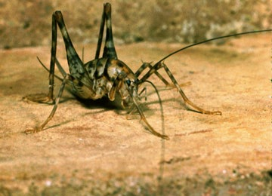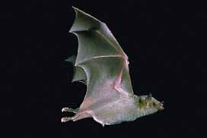
Camel “Cave” Cricket Mexican Long-Nosed Bat

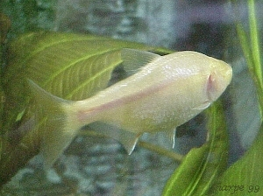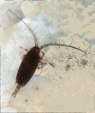
Blind Cave Fish Copepod

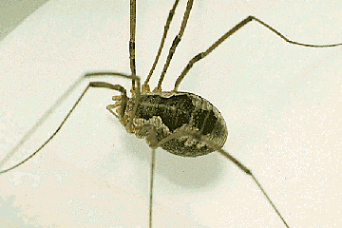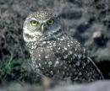
Harvestman Spider Burrowing Owl

Build An Animal
Will your animal survive the harsh desert environment?
Summary: This lesson is the culminating activity for the animal unit. It will bring together the ideas discussed throughout the unit and tie them together.
Duration: 1 to 2 weeks
Setting: Classroom
Vocabulary: phylum, hypothetical, theoretical, genus, species
Standards/Benchmarks Addressed: SC1-E2, SC2-E2, SC2-E3, SC3-E1, SC4-E5, SC5-E3, SC6-E1, SC6-E2, SC6-E3, SC6-E5, SC6-E6, SC6-E7, SC10-E2, SC11-E1, SC11-E2, SC11-E3, SC11-E4, SC11-E5

Objectives
Students will:
- design a hypothetical desert animal and construct a model of that animal.
- classify their animal into its correct phylum.
- infer which physical structures help the animal survive in the desert.
Background
Review background information on these following lessons:
- Why Do We Look The Way We Do?
- Help! I’m Dehydrating!
- Animals That Live in the Dark
- Sorting Out Species?
- All in the Family
- Make a Desert Diorama
Materials
Colored paper
String
Colored clay
Pins
Straws
Buttons
????, Be creative on material for the animals. Be sure not to include perishable items.
Procedure
Warm up: Review animal adaptations in reference to their environment.
Activity
- Review information on deserts, animal classification, and animal adaptations needed to survive in the desert.
- Decide what your hypothetical desert animal would look like (be creative – make it look strange and different from anything you have ever seen). What special adaptations would it have?
- Name the animal using proper genus and species format and classify it in a real (APPROPRIATE) phylum. Example: a person is a Homo sapien.
- Describe in writing the animal’s behavior, including the way it obtains food, the kind of dwelling it prefers, reproduction, its defensive behavior, and how it moves and gets oxygen.
- Use a variety of materials to create a model of the animal and answer the questions in the assessment section.
Wrap Up: Students create the model of their animal and review their writing. Both paper and animal will be turned in for a grade.
Assessment
Questions: (Due at the same time as the animal model)
- Describe the specific physical conditions that exist in your animal’s environment; include climate and landforms (temp, wind, rain, soil, and sunshine)
- For each condition above, describe a characteristic of your animal that makes it well-suited to the environment.
- State the characteristics that enable you to classify the animal in the phylum you selected.
Animal Grading Criteria
See rubric
Extensions
Create a story about the life of this animal and the future it may face.
Create a photo collage of animals dealing with dangers.
Make a short “documentary” video of an animal’s habits and behaviors.
Name ____________________
Build an Animal Assessment Questions
Due at the same time as the animal model!
1. Describe the specific physical conditions that exist in your animal’s environment, include climate and landforms (temp, wind, rain, soil, and sunshine).
____________________________________________________________________________________________________________________________________________________________________________________________________________________________________________________________________________________________________________________________________________________________________________________________

2. For each condition above, describe a characteristic of your animal that makes it well-suited to the environment.
____________________________________________________________________________________________________________________________________________________________________________________________________________________________________________________________________________________________________________________________________________________________________________________________

3. State the characteristics that enable you to classify the animal in the phylum you selected.
____________________________________________________________________________________________________________________________________________________________________________________________________________________________________________________________________________________________________________________________________________________________________________________________
Name ____________________
Classification Reference Diagram
(Build an Animal Activity)
Address Analogy | Classification | Name
 | Kingdom
 | Phylum
 | Class
 | Order
 | Family
 | Genus
 | Species

Name ____________________
Build an Animal Rubric
Build An Animal | Self evaluation | Teacher evaluation
Animal criteria: |  | /16
Animal created could survive in a desert environment.
Adaptations are appropriate for desert survival.
Animal is classified into an appropriate phylum.
Animal is named in the appropriate genus and species format.
Writing: |  | /8
Describe in writing the animal’s behavior, including the way it obtains food, the kind of dwelling it prefers, reproduction, its defensive behavior, and how it moves and gets oxygen.
Proper use of grammar
Overall: |  | /12
Has the student fulfilled all the parts of the task?
Has the student chosen appropriate adaptations to help the animal survive?
Has the student correctly answered the assessment questions?
4 – no mistakes 3 – few mistakes 2 many mistakes 1 – incomplete (however is present) 0 – not evident or not included

Percentage: Animal Writing Overall

The Nature Detective
What plants and animals live in this habitat?
Summary: This field trip is designed to help students become aware of their natural surroundings using keen observation skills.
Duration: 2-5 hours
Setting: Outdoors (nature hike at a National Park or on school grounds)
Vocabulary: riparian
Standards/Benchmarks Addressed: SC1-E1, SC2-E3, SC5-E2, SC6-E1, SC6-E2, SC6-E3, SC6-E4, SC6-E5, SC6-E6, SC10-E2, SC11-E1, SC11-E2, SC11-E4, SC11-E5

Objectives
Students will:
- discover and use clues to infer what plants and animals live in a certain habitat.
- take field notes about what is discovered.
- construct a plants and animals field guide.
Background
Nature hikes are a very important concept in developing students’ personal relationships with nature. Developing a nature journal as the students hike is a way for young explorers to observe, participate, sketch, count, reflect, and write as they interact with nature. Exploration activities, such as a desert scavenger hunt, encourage youngsters to see smell, hear, and touch nature in their own intimate way.
After a hike the students could research one plant and one animal to include in a nature guide. Below are two nature guide entries that include the appropriate information and layout (a nature guide would include a photograph of the plant and animal).
Mountain Lion – Puma concolor
Size: Total length about 78 inches, tail about 30 inches; weight, 100-200 pounds.
Habitat: Almost any habitat with sufficient topographic or vegetative stalking cover. In the Southwest, it favors edges of rimrock country, where scrub desert ends and forest begins.
Range: Throughout the western United States, Mexico, and southeastern Canada.
Also known as: cougar, catamount (short for “cat of the mountains”), puma, and panther
Similar species: Jaguar and ocelot have spots. Bobcat is much smaller, with a short, stubby tail.
Discussion: The mountain lion’s range once exceeded that of any other American mammal, extending from southeastern Alaska to southern South America and spanning the continental United States. Over hunting and habitat destruction have confined this secretive and solitary cat to large tracts of remote terrain.
The male’s territory averages a hundred square miles and may overlap with the smaller home ranges of several females. Mountain lions mark their territories with “scrapes”—visible mounds of dirt, needles, and twigs that are often scented with urine or feces.
Though the habits of mountain lions vary from high mountains to desert to tropical jungle, their appearance is similar. As indicated by the name concolor, the cat’s tawny coat is a monotone shade across most of its body, with lighter areas under the belly and inside the legs. It holds its tail—which is long, cylindrical, and may be tipped in black—close to the ground.
This highly efficient predator dines mainly on deer. It stalks its prey, pouncing with full weight from close range. After making the kill, the lion drags the carcass to a secluded spot to gorge. When satiated, it covers the remaining meat with leave and soil, bedding near the carcass by day and returning nightly to feed.
Banana Yucca – Yucca baccata, Agave Family (Agavaceae)
Description: As a group, yuccas are generally widespread in the northern Chihuahuan Desert and are often the most obvious large plant. In Yucca baccata, the leaves are very thick, and the trunk is usually stout but short. This species flowers from April to June and rarely at other times of the year when temperature and moisture are adequate.
Habitat: Also known as datil, the plants occur in rocky areas throughout our region. These plants can be found in Carlsbad Caverns National Park, Guadalupe Mountains National Park, and White Sands National Monument.
Discussion: The edible large fruits, which look something like bananas, were eaten by Native Americans. The fresh flowers are also edible, and leaf fibers are used to make baskets and similar items.
Rattlesnake Springs and Carlsbad Caverns Nature Trail, part of Carlsbad Caverns National Park, are great examples of places to take a hike. They are great examples of two different habitats. Rattlesnake Springs is a riparian area (an area with a water source) surrounded by lush vegetation and wildlife. Many of the animals you can see include aquatic life (crayfish, perch, and other fish species) and a variety of birds. The Carlsbad Caverns Nature Trail is a wonderful example of a desert environment. On the trail you can focus on the plant life of the Chihuahuan Desert and look for signs of animal life (tracks and scat).
Materials
Variety of desert plant and animal field guides
Pens and paper
Clipboards
Camera
Procedure
Warm up: Focus the students on the purpose of the trip. We are going to become Nature Detectives. We will have to closely observe our surroundings to find clues about the plants and animals that live here. With the information that we find we will be constructing a field guide. For instance, in the Chihuahuan Desert we would include rattlesnakes, Mexican Gray Wolf, Desert Agave, Soaptree Yucca, etc.
Activity
- Show the students the field guides and how to use them.
- Show the students how to set up their field notes and what information you want included (sketchings of plants, animals, tracks, and scat that you see, as well as descriptions on what they see, hear, feel, and smell).
- Divide the class into groups of 2. Have the pairs closely observe an area for a given amount of time and take notes, draw pictures, and take pictures of plants, animals, and things of interest that they see.
- Review with the students what they found.
Wrap Up: Discuss the information that should be present in a field guide. Have each student pick (or assign each student) a plant and animal to research and put into the field guide. When each student is finished with their research you should assemble them into one student-produced field guide.
Assessment
Research on assigned plant and animal for the field guide.
Extensions
Students graph the colors they see while on the trip.
Blindfold the students and take them to a tree. They are to use their senses of touch, smell, and hearing to learn as much about the tree as possible. They are returned to a central meeting point and asked to find their tree. Students can then describe the experience in a journal. What did they learn about the tree? What was the most difficult part of the experience?
Name ____________________
Nature Detective Field Guide Rubric
Nature Detective Field Guide | Self evaluation | Teacher evaluation
Animal criteria: |  | /12
Includes a picture
Includes both scientific and common names
Includes a detailed summary with a description of animal characteristics and adaptations
Plant criteria |  | /12
Includes a picture
Includes both scientific and common names
Includes a detailed summary with a description of plant characteristics and adaptations
Overall: |  | /12
Has the student fulfilled all the parts of the task?
Has the student chosen appropriate adaptations to help the plants and animals survive?
Has the student used proper grammar and sentence structure?
4 – no mistakes 3 – few mistakes 2 – many mistakes 1 – incomplete (however is present) 0 – not evident or not included

Percentage: Animal Plant Overall ________

Make a Desert Diorama
What plants and animals live in a desert habitat?
Summary: This activity helps the students share their knowledge of desert plants and animals and their natural habitat.
Duration: 2 class periods
Setting: Classroom
Vocabulary: microhabitat, desert
Standards/Benchmarks Addressed: SC1-E1, SC2-E2, SC2-E3, SC3-E1, SC4-E5, SC5-E2, SC5-E3, SC6-E2, SC6-E3, SC6-E4, SC6-E5, SC6-E6, SC11-E2, SC11-E3, SC11-E6

Objectives
Students will:
- design a diorama to show desert animals in their natural habitat.
Background
A diorama is a miniature scene with lifelike figures and objects set against a painted or colored background. The diorama is like a stage set that has all the props needed to represent the actual habitat (plants and animals).
Desert animals have some impressive ways of handling the challenges of desert life. Like plants, they need to beat the heat, get water, stay warm on cool nights, and stay unburned on sunny days. Unlike plants, they can’t send down a taproot for water or a web of roots to catch rain. They also do not make their own food using photosynthesis.
Animals do have one advantage: they can move around. Lizards waddle into the sun to warm up, and then shift into the shade to cool down. Bats migrate hundreds of miles so they can sip the nectar of many different plants. A vulture flies high, where the air temperature is cooler and it can get a better view of the ground.
Moving around is not the only way animals cope with desert conditions. For many desert animals a meal is both food and drink. Seeds can be 20-50 percent water, enough to quench the thirst of plant eaters. An animal’s body may be as much as 75 percent water, so meat eaters get water from their food, too. Some animals like the kangaroo rat actually make water in their bodies, as a by-product of the foods they eat. Others, like the desert cockroach can extract water directly from the air.
The big ears of desert hares, rabbits, and foxes help them to keep cool. Ears, long legs, and bare patches of skin where blood vessels are close to the surface act as natural radiators. Blood circulating through these spots radiates heat to the surrounding air. This cools the animal off.
Wet fur or skin can cool an animal even more. That’s why kangaroo rats lick their fur, foxes pant, and birds move their throats to evaporate water from their lungs and mouths. All these animals make use of evaporative cooling. The water on their skin absorbs their body heat. As it evaporates, it takes some of that heat away from their bodies and into the air.
To guard themselves against unpredictable desert food supplies, some animals stock up. Harvester ants and kangaroo rats store bushels of seeds in underground burrows for times of scarcity. Other animals go to sleep when food is scarce. Pocket mice, kangaroo rats, some ground squirrels, and some birds enter a state called torpor and may remain in that state for months. In torpor their breathing and other body processes slow down, saving energy. By saving energy, they need less food. Venom also helps desert predators subdue their prey quickly, with a minimum amount of energy.
Materials
Variety of desert plant and animal field guides
Cardboard boxes
Varity of art supplies (paints, markers, colored pencils, etc…)
A collection of natural objects (small rocks, plant material, leaves, grass, etc…)
Glue
Scissors
Procedure
Warm up: Review what the students know about desert plants and animals. They should have a good understanding of adaptations, and how these adaptations help the plants and animals survive in the desert. Students will build a diorama displaying what we have learned about desert plants and animals.
Activity
- Discuss what a diorama is and how to create one. Point out that in a diorama the background is the bottom of the box. It should be colored with a background that depicts the natural desert habitat. Then the animal and plant figures can be set in front of the background scene.
- Have each student pick an animal to research and learn about its natural environment.
- Give the students a box and have them begin making their dioramas. Each diorama must include at least one figure of the student’s animal. Students can draw the animal, cut out the animal from another resource, make modeling clay animals, or use any other material they can think of. Encourage the students to be creative. Use as many natural objects as possible to help set the appropriate tone for the desert environment. Suggest that the students glue the objects into the diorama so that the objects do not move or fall out when they are carried.
Wrap Up: Students share their dioramas with the class, explaining the features of their animal’s habitat.
Assessment
Rubric for diorama.
Name ____________________
Desert Diorama Rubric
Desert Diorama Rubric | Self evaluation | Teacher evaluation
Diorama criteria: |  | /24
Diorama depicts a desert habitat.
Background is neat and depicts a desert habitat.
Diorama includes at least one figure of the animal.
Diorama shows thorough knowledge of a variety of desert plants and animals.
Student has included mirohabitats (places the animal goes to escape the heat).
Student uses a variety of natural materials to depict the desert environment.
Presentation: |  | /8
Presenter followed appropriate speaking rules (eye contact, voice, appeal, enthusiasm)
Presentation quality, organization, appeal, and information
Overall: |  | /4
Has the student fulfilled all the parts of the task?
4 – no mistakes 3 – few mistakes 2 – many mistakes 1 – incomplete (however is present) 0 – not evident or not included

Percentage: Diorama Presentation Overall ________

