Ecology

T.M. Poston and M.R. Sackschewsky

Ecology is an integrating discipline that defines the relationships between organisms and their environment. Ecological evaluations are organized by broad habitat type and include terrestrial and aquatic ecosystems. Terrestrial ecosystems include upland and riparian/wetland habitats. This section addresses the habitat, flora, and fauna found in terrestrial (Section 4.5.1) and aquatic ecosystems (Section 4.5.2). A third section addresses species formally listed as threatened, endangered, or special status by federal and state agencies (Section 4.5.3).

Other descriptions of the ecology of the Hanford Site can be found in Cadwell (1994); Downs et al. (1993); ERDA (1975); Jamison (1982); Landeen (1996); Rogers and Rickard (1977); Sackschewsky and Downs (2001); Watson et al. (1984); Weiss and Mitchell (1992); and Poston et al. (2004).

Terrestrial Ecology

Terrestrial ecosystems on the Hanford Site include upland and riparian/wetland habitat. Upland habitat at Hanford is influenced by arid climate and characterized by vegetation and wildlife adapted to hot summers, cold winters, and low precipitation. Riparian habitat occurs along bodies of water and is inhabited by plants requiring more water than that provided by precipitation. Wetlands are areas where some open water is present and soils and associated vegetation reflect the presence of water. The upland habitat within the Hanford Site, located within the Columbia Basin (Plateau) Ecoregion is predominantly shrub-steppe (Stroms et al. 1997). Shrub-steppe ecosystems are typified by a shrub overstory and a grass and forb understory (Daubenmire 1970). Lichens and mosses, often times referred to as “microbiotic or cryptogamic crust,” provide a soil stabilizing growth on undisturbed soils in the shrub-steppe ecosystem. The Columbia Basin (Plateau) Ecoregion historically included over 6 million hectares (14.8 million acres) of steppe and shrub-steppe vegetation across most of central and southeastern Washington, as well as portions of north-central Oregon. Much of this land has been developed for agriculture, industrial, and other developments.

In the early 1800s, the dominant vascular plants in the area were big sagebrush underlain by perennial bunchgrasses and forbs. With the advent of Euro-American settlement, livestock grazing and agricultural production contributed to colonization by non-native plant species that currently dominate portions of the landscape. Agriculture and livestock production were the primary subsistence activities at the turn of the 20th century. Although these activities ceased when the Hanford Site was created in January 1943, remnants of past agricultural practices are still evident. Many places on the Hanford Site are relatively free of non-native species and are extensive enough to retain characteristic populations of shrub-steppe plants and animals that are absent or scarce in developed or fire-impacted areas of the ecoregion. Because of its location, the Hanford Site provides important connectivity with other undeveloped portions of the ecoregion.

Large areas of the Hanford Site have experienced recent range fires that influence the vegetation composition and distribution of wildlife. During 1984, a major fire burned across 800 km² (310 mi²) of the Hanford Site (Price et al. 1986). During 2000, a range fire burned across the Hanford Site consuming most of the shrub-steppe habitat on the Fitzner-Eberhardt Arid Lands Ecology Reserve Unit, a small section of the McGee-Riverlands Unit, and other southwestern portions of the Site. The fire burned a total of 655 km² (250 mi²) of federal, state, and private lands before it was controlled (BAER 2000).

These fires have altered the composition of the shrub-steppe habitat. Much of the year 2000 burn was considered to be low severity. Low severity refers to a burn that leaves the soil structure and seed bank intact. The belowground portions of most perennial plants were unharmed and have returned. Much of the burned area is in various stages of recovery. Sagebrush may take considerably longer to recover than perennial bunchgrass areas depending on the availability of seed in the soil, severity of the burn, and the distance to other seed sources. Reestablishment of mature sagebrush stands is likely to take a minimum of 10 to 20 years. Some of the burned areas continue to be invaded by non-indigenous plant species such as Russian thistle (Salsola tragus, formerly kali) and tumble mustard (Sisymbrium altissimum). In some areas, efforts have been taken to reestablish big sagebrush (Artemesia tridentata).

Vegetation

The Hanford Site contains some of the highest quality shrub-steppe habitat in the state of Washington and the larger ecoregions in the northwest. In some areas, unique and rare communities exist in spite of past wildfires and the presence of non-native species introduced by man. Because of the diversity of habitats on the Hanford Site, including a relatively large elevation range of 1000 m, the riparian corridor, sand dunes, and other special habitats, there is a high number of plant species on site. A total of 727 species representing 90 families of vascular plants are recorded for the Hanford Site (Sackschewsky and Downs 2001). Of this total, 179 are non-native species. Cheatgrass (Bromus tectorum) is the dominant non-native species. It is an aggressive colonizer and has become well established across the Hanford Site (Rickard and Rogers 1983). Hanford Site plants are adapted to low annual precipitation (17 cm [6.8 in.]), low water-holding capacity of the rooting substrate (sand), dry summers, and cold winters.

Microbiotic crusts are an important component of the shrub-steppe communities found at Hanford. The microbiotic (or cryptogamic) crusts generally occur in the top 1 to 4 mm (0.04 to 0.16 in.) of soil and are composed of primarily algae, lichens, and mosses. These crusts are formed by organisms and their by-products, creating a consolidated layer of soil particles bound together by organic materials. Microbiotic crusts are common in the semi-arid Columbia Basin, where the dominant organism tends to be green algae (Johansen et al. 1993). The functions of microbiotic crusts include soil stability and protection from erosion; fixation of atmospheric nitrogen; nutrient contribution to plants influencing soil-plant water relations; and increasing water infiltration, seedling germination, and plant growth. The ecological roles of microbiotic crusts depend on the relative cover of various crustal components. Carbon inputs are higher when mosses and lichens are present than when the crust is dominated by cyanobacteria. Nitrogen inputs are higher with greater water infiltration. Soil surface stability is related to cyanobacterial biomass as well as total moss and lichen cover (Belnap et al. 2001). The lichen and mosses of the Hanford Site were surveyed and evaluated by Link et al. (2000). They found 29 soil lichens in 19 genera and 6 moss species in 4 genera. Twelve (41 percent) lichen species are of the crustose growth form (flat and firmly attached to the substrate), eight (28 percent) are squamulose (having small, flat scales that do not adhere tightly to substrate), seven (24 percent) are foliose (having leaf-like lobes, attached in the center to substrate by clusters of rhizomes), and two (7 percent) are fruticose (plant-like growth attached at one point). More recent surveys have found a total of 120 taxa of lichens and mosses on the Hanford Monument lands surrounding the central portion of the Hanford Site (Evans et al. 2003).

Soll et al. (1999) conducted plant surveys on Fitzner-Eberhardt Arid Lands Ecology Reserve Unit, the Wahluke Slope, central Hanford, and riparian communities along the Columbia River shoreline from 1994 through 1997. These surveys tentatively identified 30 “potential” terrestrial plant communities. Designation as a potential community indicates a type of community that would exist in an area if it were free of disturbance. In addition to characterizing potential plant communities, Soll et al. (1999) found 112 populations/occurrences of 28 rare plant taxa on the Hanford Site. Rare plant taxa are defined by the Washington Natural Heritage Program as plants that are followed because of loss of habitat and dwindling populations. When combined with observations preceding the 1994-1999 inventory, a total of 127 populations of 30 rare plant taxa have been documented on the Hanford Site. A more general description of the vegetation cover types found on Hanford, including shrublands, grasslands, microbiotic crust, tree zones, and riparian habitat, follows.

Shrublands. Shrublands occupy the largest area in terms of acreage and comprise seven of the nine major plant communities on the Hanford Site (Sackschewsky and Downs 2001). Of the shrubland types, sagebrush-dominated communities are predominant, with other shrub communities varying with changes in soil and elevation. About 287 km² (111 mi²) of shrub habitat dominated by big sagebrush was destroyed in the year 2000 fire and is in various stages of shrub recovery.

Of the vegetation types found on the Hanford Site (Figure 4.5-1), those with a shrub component (i.e., big sagebrush, threetip sagebrush [Artemisia tripartita], bitterbrush [Purshia tridentata], gray rabbitbrush [Ericameria nauseousa previously Chrysothamnus nauseosus], green rabbitbrush [Chrysothamnus viscidiflorus], black greasewood [Sarcobatus vermiculatus], winterfat [Krascheninnikovia (Ceratoides) lanata], snow buckwheat [Eriogonum niveum], and spiny hopsage [Grayia (Atriplex) spinosa]) are considered shrub-steppe. These stands typically have an understory dominated by bunchgrasses such as bluebunch wheatgrass (Pseudoroegnaria spicata previously Agropyron spicatum), Sandberg’s bluegrass (Poa sandbergii [secunda]), needle-and-thread grass (Hesperostipa comata previously Stipa comata), Indian ricegrass (Achnatherum hymenoides previously Oryzopsis hymenoides), bottlebrush squirreltail (Elymus elymoides previously Sitanion hysterix), and prairie junegrass (Koeleria cristata), as well as a number of broad-leaf forbs. Heavily grazed or disturbed areas often have an understory dominated by cheatgrass. Heterogeneity of species composition varies with soil, slope, and elevation. Vegetation types with a significant cheatgrass component are generally of lower habitat quality than those with bunchgrass understories. A list of common plant species in Hanford areas is presented in Appendix B, Table B-1 and Sackschewsky and Downs (2001).

Grasslands. Most grasses occur as understory in shrub-dominated plant communities. Because shrubs have been removed by fire in many areas, there are large areas of grass-dominated communities on the Hanford Site. Cheatgrass has replaced many native perennial grass species and is well established in many low-elevation (less than 244 m [800 ft]) and/or disturbed areas (Rickard and Rogers 1983, Soll et al. 1999). Of the native grasses that occur on the Hanford Site, bluebunch wheatgrass occurs at higher elevations. Sandberg’s bluegrass is widely distributed throughout the Columbia Basin and the intermountain west. Needle-and-thread grass, Indian ricegrass, and thickspike wheatgrass (Elymus macrourus previously Agropyron dasytachyum) occur in sandy soils and dune habitats. Species preferring more moist locations include streambank or riparian wheatgrass (Elymus lanceolatus previously Agropyron dasystachyum var. smithii), bentgrass (Agrostis spp.), bluegrass (Poa spp.), meadow foxtail (Alopecurus aequalis), lovegrasses (Eragrostis spp.), and reed canarygrass (Phalaris arundinacea) (DOE 2001a). A list of common plant species in grassland areas is presented in Appendix B, Table B-1.

Trees. Within the past few hundred years, the Hanford Site upland landscape had few trees and the Columbia River shoreline supported a few scattered cottonwood (Populus spp.) or willows (Salix spp.). Homesteaders and Manhattan Project construction workers planted trees in association with agricultural areas and housing camps. Shade and ornamental trees were planted in the 1950s around former military installations and industrial areas on the Hanford Site. Currently, approximately 23 species of trees occur on the Site. The most commonly occurring species are black locust (Robinia pseudo-acacia), Russian olive (Eleagnus angustifolia), cottonwood (Populus trichocarpa), mulberry (Morus alba), sycamore (Platanus occidentalis), and poplar (Populus spp.). Many of these non-indigenous species are aggressive colonizers and have become established along the Columbia River (e.g., mulberry, poplar, Russian olive), serving as a functional component of the riparian zone (DOE 2001a). Trees provide nesting habitat and cover for many species of mammals and birds.

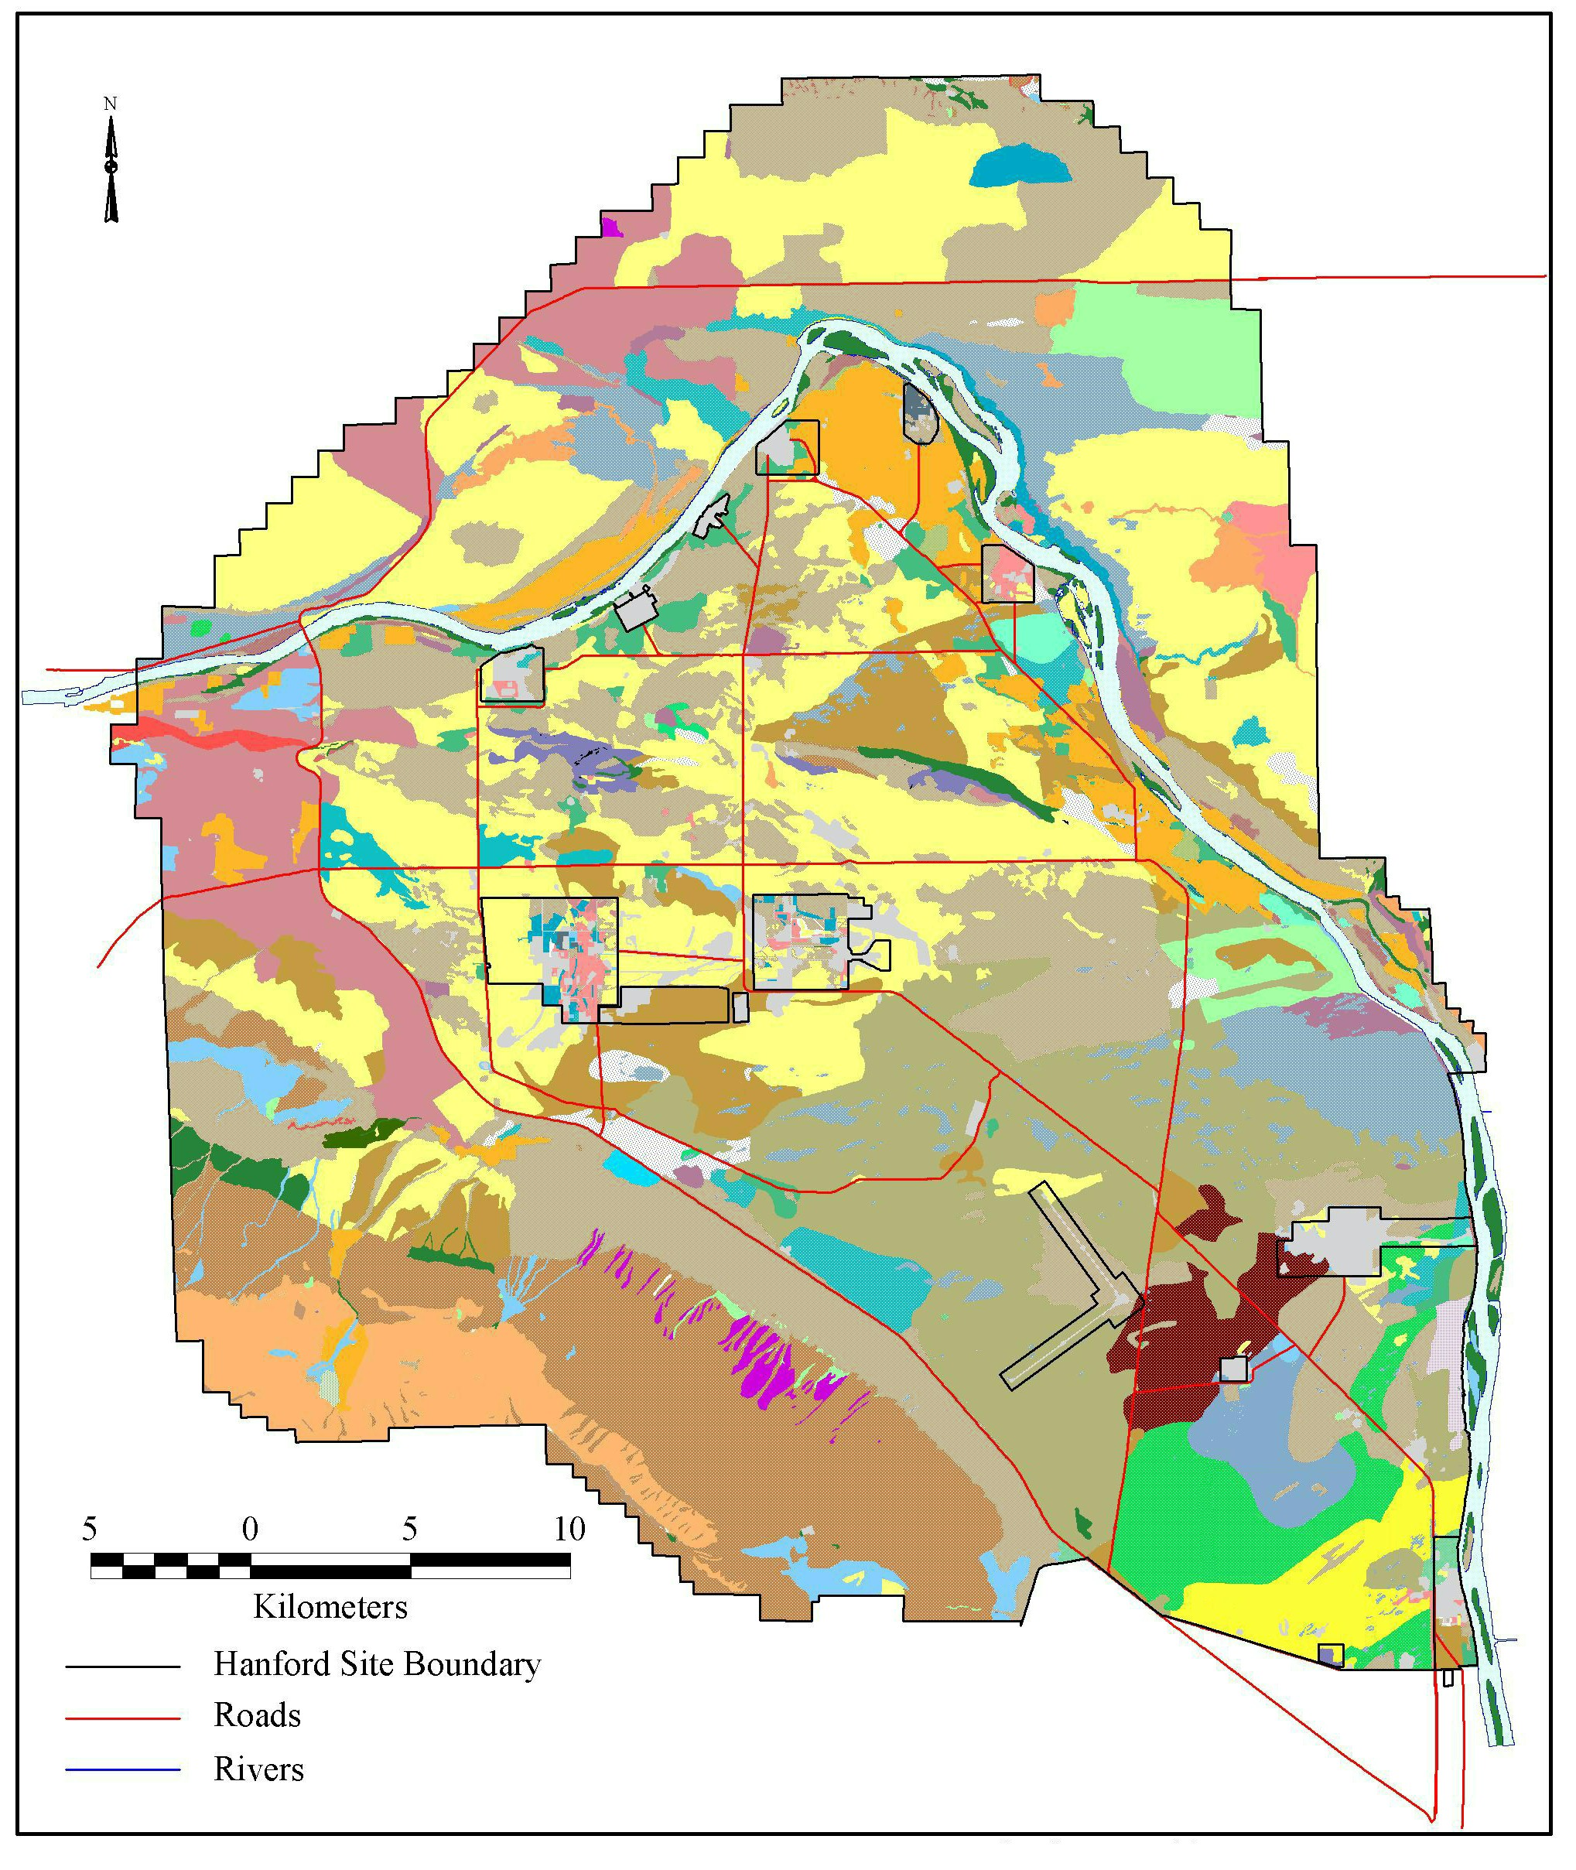

Figure 4.5-1. Distribution of Vegetation Types and Areas on the Hanford Site, Washington, before the Year 2000 Fire

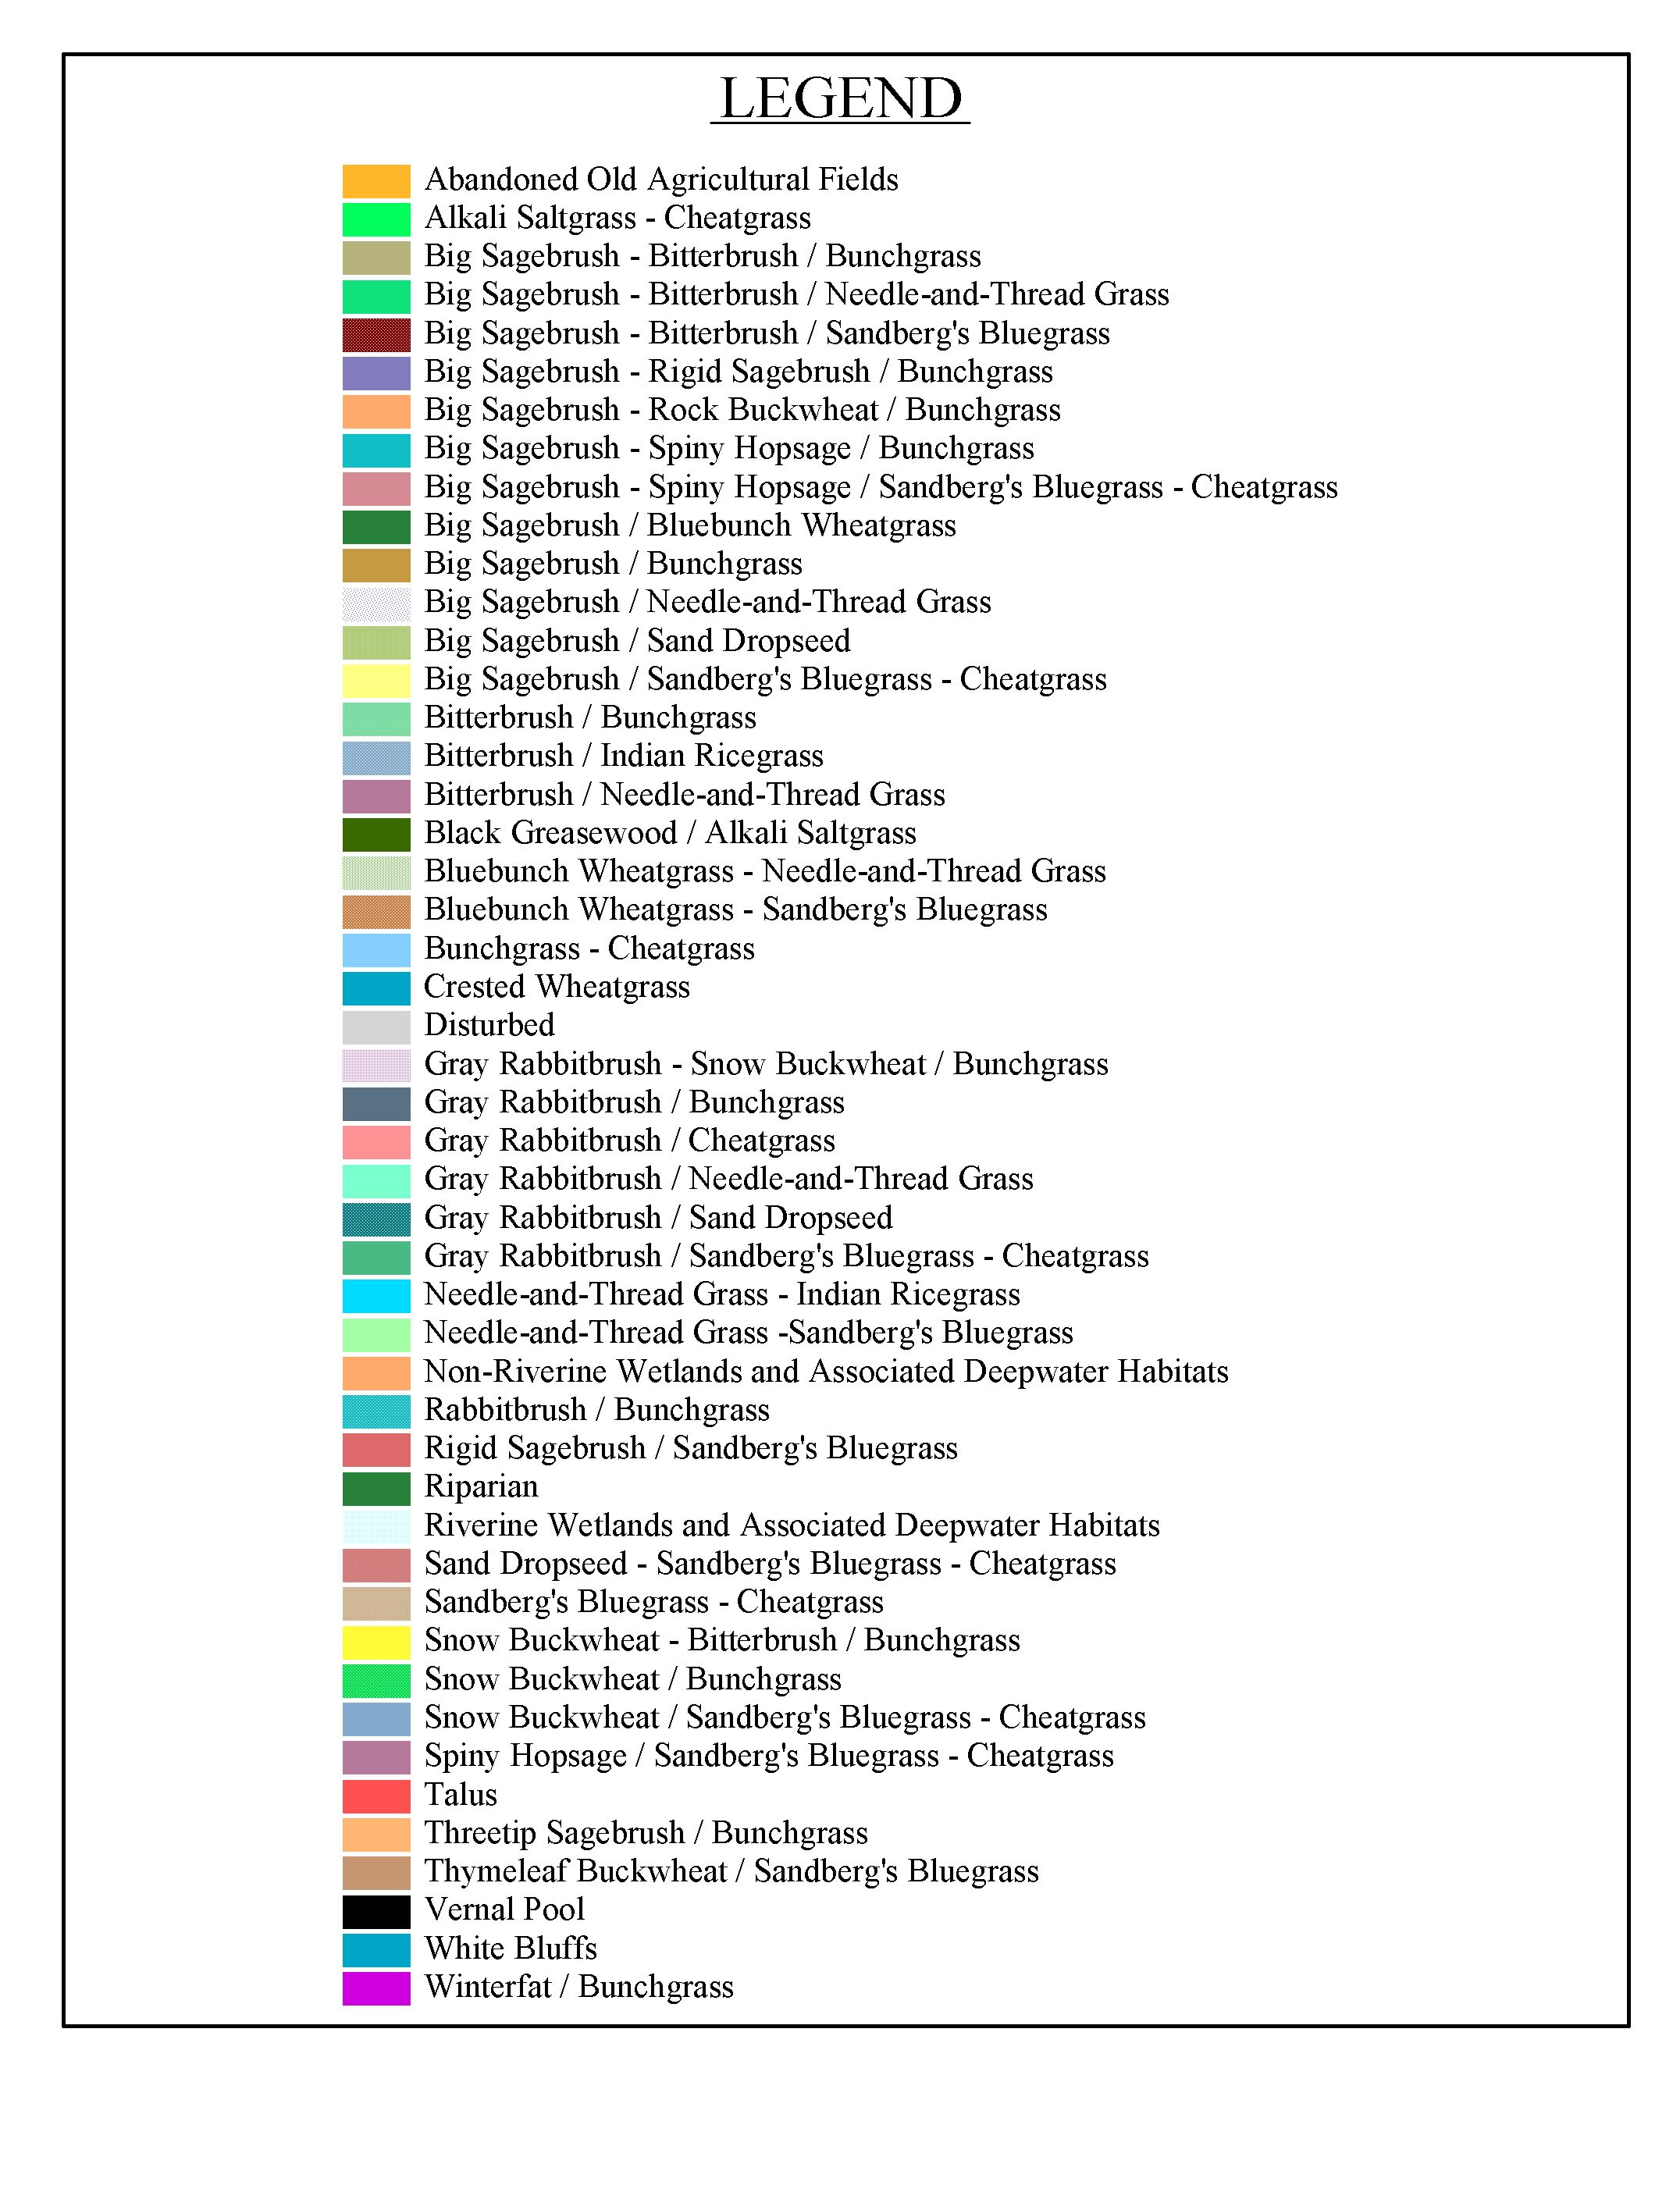
Figure 4.5-1. (cont’d)

Hanford Operational Facilities and Retired Reactor Areas. Yearly vegetation surveys are conducted around many of the Hanford Site operational facilities and retired reactor areas including facilities in the 100, 200, and 300 Areas (Figure 4.0-1). In addition, there have been several studies that examined the vegetation in the 200 Area Plateau region and vegetation north of the 300 Area (Sackschewsky et al. 2001, Brandt et al. 1993).

The 100 Area upland region consists of old agricultural fields dominated by cheatgrass and tumble mustard. Scattered big sagebrush and gray rabbitbrush also occur throughout the 100 Areas (Landeen et al. 1993). An area of natural big sagebrush habitat near the 100-D Area experienced a significant and apparently natural decline during the mid 1990s (Cardenas et al. 1997). A total area encompassing 17.8 km² (6.9 mi²) was affected, and a central core area of 2.8 km² (1.1 mi²) experienced more than 80 percent mortality of sagebrush.

Waste management areas, reactors, and crib sites are generally either barren or vegetated by non-native species, including Russian thistle, tumble mustard, and cheatgrass. Most of the waste disposal and storage sites are covered with non-native vegetation such as crested wheatgrass or are kept in a vegetation-free condition with the use of herbicides to prevent plant root intrusion to waste constituents. Russian thistle and gray rabbitbrush that occur in these areas are deep rooted and have the potential to function as a pathway to other parts of the ecosystem (Landeen et al. 1993).

The undisturbed portions of the 200 Areas are characterized as sagebrush/cheatgrass or sagebrush/Sandberg’s bluegrass communities. The dominant plants on the 200 Area Plateau are big sagebrush, rabbitbrush, cheatgrass, and Sandberg’s bluegrass (Sackschewsky and Downs 2001, Sackschewsky et al. 2001). Most of the waste disposal and storage sites are planted with crested or Siberian wheatgrass to stabilize surface soil, control soil moisture, or displace more invasive deep-rooted species like Russian thistle.

Vegetation surveys were conducted at the 300-FF-5 Operable Unit located north of the 300 Area during 1992. The shrub-steppe vegetation community in the unit is characterized as antelope bitterbrush/Sandberg’s bluegrass with an overstory of bitterbrush and big sagebrush and an understory of cheatgrass and Sandberg’s bluegrass (Brandt et al. 1993).

Riparian and Wetland Areas. Riparian areas are vegetated wetlands, especially associated with rivers and streams, and include shoreline areas along sloughs and backwaters. Wetlands also include the shorelines of lakes, ponds, vernal pools temporarily formed by melting snow in basalt outcrops, industrialized ponds, and irrigation wasteways and ponds on the Wahluke Slope.

Riparian habitat that occurs in association with the Columbia River includes riffles, gravel bars, backwater sloughs, and cobble shorelines. These habitats occur infrequently along the Hanford Reach and have acquired greater significance because of the net loss of wetland habitat elsewhere within the region. Vegetation that occurs along the river shoreline includes water smartweed (Polygonum amphibium), sedges (Carex spp.), reed canary grass (Phalaris arundinacea), bulbous bluegrass (Poa bulbosa), common witchgrass (Panicum capillare), and large barnyard grass (Echinochloa crusgalli). Rushes and sedges occur along the shorelines of the Columbia River and at several sloughs along the Hanford Reach. Trees include willow (Salix spp.), mulberry (Morus alba), and Siberian elm (Ulmus pumila). A list of common Hanford Site riparian plants is provided in Appendix B, Table B-1.

Noxious weeds are also becoming established along the riparian zones of the Hanford Reach. Purple loosestrife (Lythrum salicaria), tamarisk (Tamarix parviflora), yellow nutsedge (Cyperus esculentus), reed canary grass, knapweed (Centaurea spp.), and yellow star thistle (Centaurea solstitialis) are some of the more common species found near or on wetlands on the Hanford Site. The Department of Energy and the USFWS have an ongoing program to control populations of noxious weeds with aerial applications of herbicides.

Some wetland habitat exists in the riparian zones of some of the larger spring streams on the Fitzner-Eberhardt Arid Lands Ecology Reserve Unit. These are not extensive and usually amount to less than 0.01 km² (0.004 mi²) in size, although the riparian zone along Rattlesnake Springs is probably about 2 km (1.2 mi) in length and consists of peach leaf willows, cattails, and other non-indigenous plants. Rattlesnake and Snively Springs support highly diverse biological communities (Cushing and Wolf 1984) that include bulrush (Scirpus spp.), spike rush (Eleocharis spp.), and cattail (Typha latifolia). Watercress (Rorippa nasturtium-aquaticum), which persists at these sites, is also abundant for a large portion of the year. In the past 30 years, introduced trees and shrubs have become established in the riparian zone along these springs. The riparian transects associated with Snively and Rattlesnake Springs were greatly impacted by the year 2000 fire (BAER 2000) (Figure 4.5-2).

Other wetland habitats can be found within the Saddle Mountain National Wildlife Refuge Unit and the Wahluke Unit. These two areas encompass all the lands extending from the north bank of the Columbia River northward to the Hanford Site boundary and east of the Columbia River from Ringold Springs north to Highway 24 in Adams County. Wetland habitat in these areas consists of fairly large pond habitat resulting from irrigation runoff. These ponds have extensive stands of cattails and other emergent aquatic vegetation surrounding the open-water regions (Figure 4.5-1). They are extensively used as nesting sites by waterfowl and support populations of warm water fish that have been introduced by the irrigation network.

Other Habitats. Basalt outcrops, river bluffs, dunes, and islands occur on the Hanford Site and their unique qualities create habitat for a distinct assemblage of vegetation (DOE 2001a). The top of Rattlesnake Mountain, Umtanum Ridge, Gable Butte, and Gable Mountain include rock outcrops and have thin rocky soils. Plant communities dominated by thyme buckwheat (Eriogonum thymoides) and Sandberg’s bluegrass most often occupy these basalt outcrops.

The White Bluffs border the Columbia River along the northern shoreline from RM 376 downstream to RM 356 presenting a steep environment with sparse and patchy vegetation. Dense patches of Indian ricegrass occupy the top of the bluff area. Primary shrubs found on the slopes of the bluff are greasewood and spiny hopsage. Bluff areas provide habitat for sensitive species (e.g., Hoover’s desert parsley [Lomatium tuberosum] and the White Bluffs bladderpod [Lesquerella tuplashensis], a Washington State endangered plant).

Bitterbrush and Indian ricegrass dominate a large dune area north of the Energy Northwest complex along the Columbia River shoreline (Figure 4.5-1). The terrain of the dune habitat rises and falls between 3 and 5 m (10 and 16 ft) above ground level, creating areas that range from 2.5 to several hundred acres in size (U.S. Department of the Army 1990). The dunes vegetation consists of a mosaic of shrubs and grasses, primarily bitterbrush and gray and green rabbitbrush with understory forbs and grasses that include scurfpea (Psoralea lanceolata), needle-and-thread grass, and thickspike wheatgrass. Smaller dunes containing basalt grains that impart a dark color to the sand are found near the 100-F Area and westward across the Site north of Gable Mountain. As a result of the fire that occurred during 2000, temporary dunes have formed along State Route 240 east to the 200 West Area and Army Loop Road. These burnt areas are in various stages of recovery.

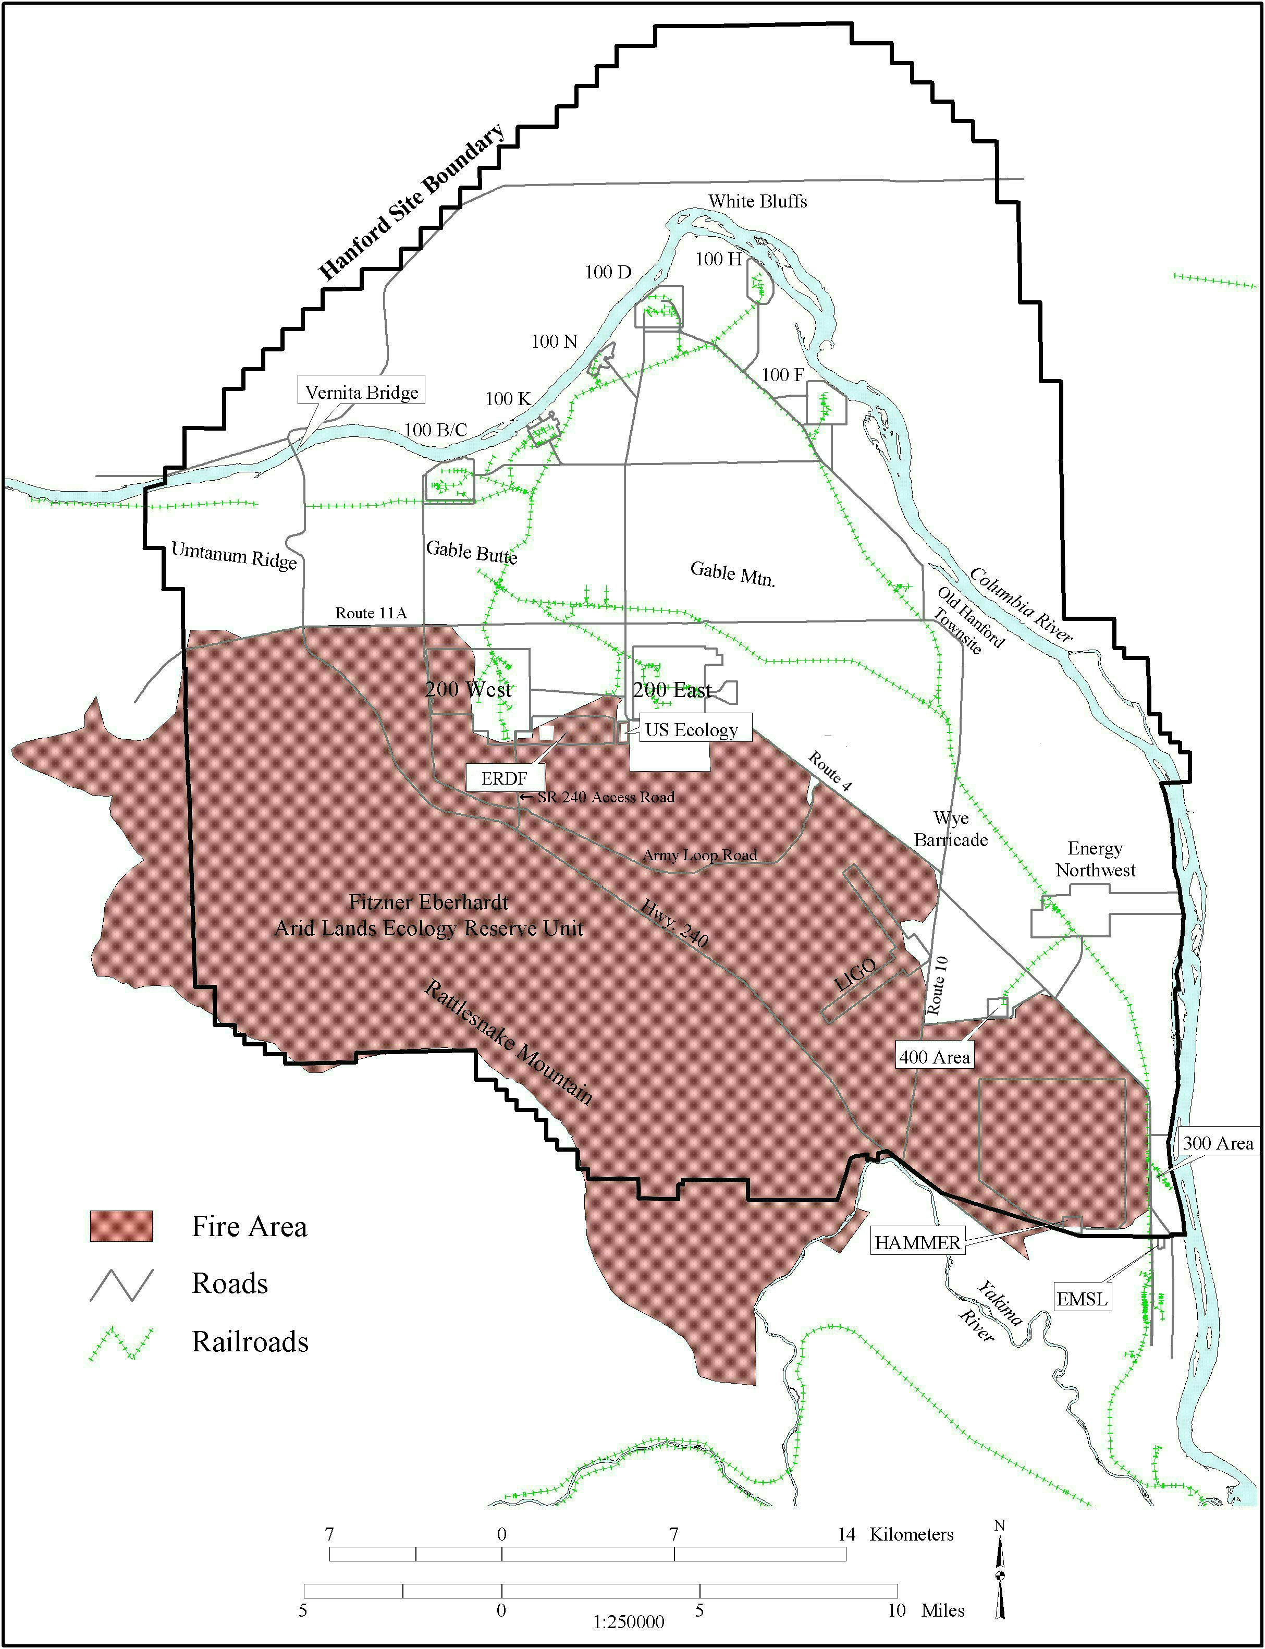

Figure 4.5-2. Area of Hanford Site, Washington, Burned as a Result of the June 27 to July 2, 2000, Wildfire

Island habitat accounts for approximately 4.74 km² (1.8 mi²) (Hanson and Browning 1959) and 64.3 km (39.9 mi) of river shoreline within the main channel of the Hanford Reach (Figure 4.5-3).⁽⁾ DOE owns and administers the upland portions of Locke Island (RM 371-373.5) and Wooded Island (RM 348-351). The Washington State Department of Natural Resources manages the shorelines of Locke and Wooded islands. Landslides caused by rotational slumping in the White Bluffs area caused accelerated erosion of Locke Island by the Columbia River. Shoreline riparian vegetation on the islands includes willow, poplar, Russian olive, and mulberry. Before regulation of river flows by dams, trees were generally not found along river shoreline habitat, with the exception of small willows and a few juniper trees near the 100-B/C Area and Riverlands. The most common tree to establish itself along the shoreline is mulberry. Species occurring on the island interior include buckwheat, lupine, mugwort, thickspike wheatgrass, giant wildrye, yarrow, and cheatgrass (Warren 1980).

West Lake and its immediate basin represent a habitat that is characterized by highly saline conditions (Poston et al. 1991). These conditions occur most likely from the evaporation of water from the pond and the accumulation of dissolved solids during the early years of operations on the Hanford Site. West Lake is now classified as a waste site under the Comprehensive Environmental Restoration, Compensation, and Liability Act of 1980 (CERCLA) (42 USC 9601, et seq.). Water levels of the pond fluctuate with wastewater discharge levels in the 200 Areas. Dominant plants at West Lake include salt grass (Distichlis stricta), plantain (Plantago species), and salt rattlepod (Swainsona salsula). Bulrush (Scirpus species) grows along the shoreline; however, the water in the lake is too saline to support aquatic macrophytes. The water level of West Lake has dropped following the decrease in water discharged to the ground in the 200 Areas during the early 1990s, exposing large sections of saline mud flats and salt deposits along the shoreline.

A series of vegetation/land cover maps (Appendix C) were prepared to provide information on available habitat in support of a review of ecological data for clean-up activities along the Columbia River shoreline (Poston et al. 2004). These maps represent the best available information on vegetation cover types and plant associations located in specific areas at the time the data were collected (from 1997 to 2004). Vegetation communities are subject to change depending on climatic conditions, physical disturbance, progress with clean-up, and natural recruitment and succession at the sites. For descriptions of upland vegetation the reader is referred Sackschewsky and Downs (2001); for descriptions of riparian vegetation, see Section 8.0 of the Hanford Site Annual Environmental Report (Poston et al. 2004).

The maps in Appendix C are subsets of maps originally constructed using aerial photography and limited ground surveys and should be appropriate for use in project planning. Maps are updated as information becomes available. However, the extent and boundaries of the vegetation cover types may change over time and the accuracy of the boundaries is further limited by the resolution of the source data used for mapping (usually +/- 20 to 30 m [66 to 98 ft] depending on the source). Reference to these maps cannot be used in place of project-specific site biological surveys for compliance. To access the most recent vegetation maps maintained for the areas of the Hanford Site, visit the PNNL project web site for the Ecological Monitoring and Compliance (EMC) Project (http://www.pnl.gov/ecomon) or request updated maps from the EMC Project at PNNL.

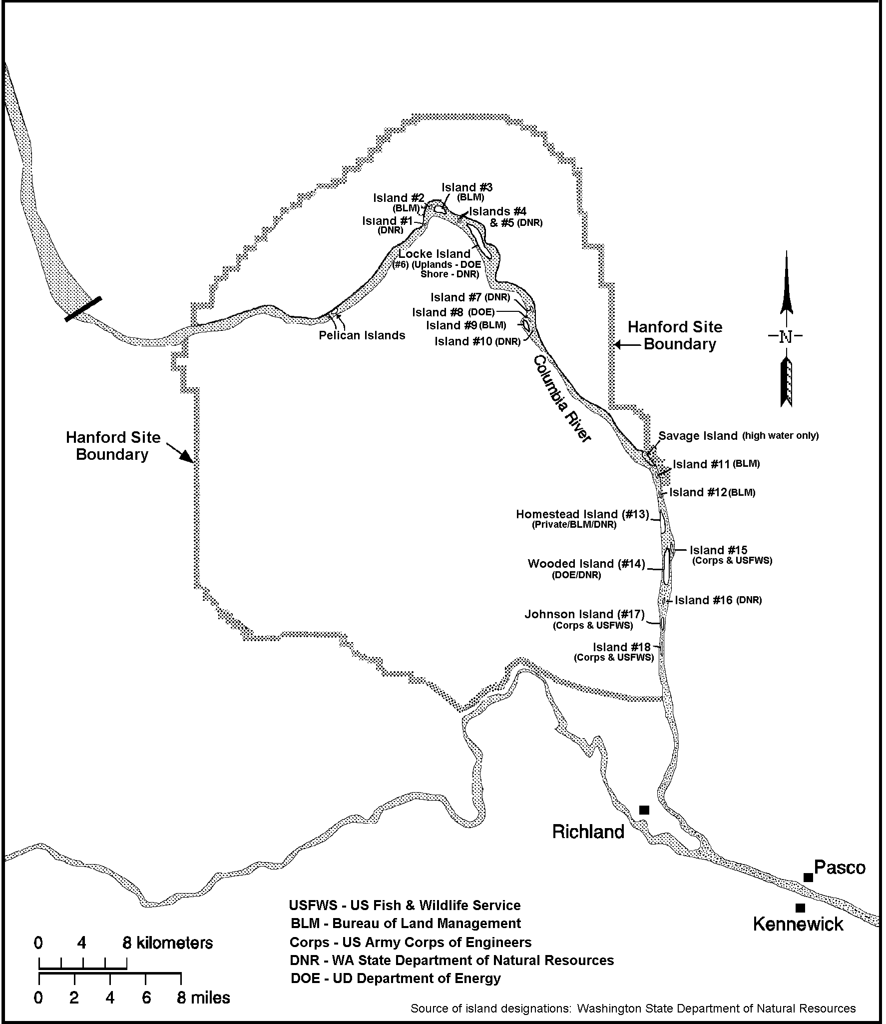

Figure 4.5-3. Columbia River Islands in the Vicinity of the Hanford Site, Washington

Wildlife

The characterization of Hanford Site wildlife includes descriptions of mammals, birds, reptiles, amphibians, and insects. Approximately 300 species of terrestrial vertebrates have been observed on the Hanford Site. The species list includes approximately 46 species of mammals (Appendix B, Table B-2), 246 species of birds (Appendix B, Table B-3), 6 species of amphibians, and 10 species of reptiles (Appendix B, Table B- 4) (Soll and Soper 1996, Brandt et al. 1993). From 1991 to 1993, surveys for birds, mammals, insects, and vegetation were conducted at several of the 100 and 300 Area operable units (Brandt et al. 1993, Landeen et al. 1993). Soll et al. (1999) recently summarized its observations of birds and mammal surveys. These surveys did not account for all of the species that have been documented historically on the Hanford Site. For example, 221 species of birds were observed in the bird surveys of The Nature Conservancy’s biodiversity 4-year effort (Soll et al. 1999). This number falls short of the 238 species identified historically (Landeen et al. 1992). By combining the 1994-1999 list of The Nature Conservancy with the site list (Landeen et al. 1992), a total of 258 species of birds have been documented on the Hanford Site (Soll et al. 1999). There are 144 bird species considered common to the Hanford Site (Appendix B, Table B 3). Site wildlife communities are generally associated with specific vegetation communities.

Shrub-steppe and Grassland Wildlife. The shrub and grassland habitat of the Hanford Site supports many groups of terrestrial wildlife. Species include large animals like Rocky Mountain elk (Cervus elaphus) and mule deer (Odocoileus hemionus); predators such as coyote (Canis latrans), bobcat (Lynx rufus), and badger (Taxidea taxus); and herbivores including deer mice (Peromyscus maniculatus), harvest mice (Riethrodontonomys megalotis), ground squirrels (Spermophilus spp.), voles (Lagurus spp., Microtus spp.), and black-tailed jackrabbits (Lepus californicus). The most abundant mammal on the Hanford Site is the Great Basin pocket mouse (Perognathus parvus). Many of the rodent species and some predators (badgers) construct burrows on the site. Other non-borrowing animals including cottontails (Sylvilagus nutalli), jackrabbits, snakes, and burrowing owls (Athene cunicularia) may utilize abandoned burrows of other animals.

There was a reported sighting of a cougar (Felis concolor) on Fitzner-Eberhardt Arid Lands Ecology Reserve Unit by experienced biologists during the elk relocation effort in March 2000, supplementing anecdotal accounts of other observations of the presence of cougars at the Hanford Site.

Mule deer rely mainly on shoreline vegetation and bitterbrush shrubs for browse (Tiller et al. 1997). Elk, which are more dependent on open grasslands for forage, seek the cover of sagebrush and other shrub species during the summer months. Elk first appeared on the Hanford Site during 1972 (Fitzner and Gray 1991), and have increased from approximately 8 animals observed in 1975 to approximately 900 in 1999. The Rattlesnake Hills herd of elk that inhabits the Hanford Site primarily occupies Fitzner-Eberhardt Arid Lands Ecology Reserve Unit and private lands that adjoin the reserve to the south and west. They are occasionally seen on the 200 Area Plateau and have been sighted at the White Bluffs boat launch on the Hanford Site. The herd tends to congregate on Fitzner-Eberhardt Arid Lands Ecology Reserve Unit in the winter and disperses during the summer months to higher elevations on the reserve, private land to the west, and the Yakima Training Center. Efforts were taken in March 2000 to remove and relocate about 200 elk from the Fitzner-Eberhardt Arid Lands Ecology Reserve Unit and another 31 elk were removed during 2002. Special hunts adjacent to the Hanford Site during 2000 accounted for the removal of 207 additional elk. The fire in June 2000 temporarily destroyed nearly all the elk forage on Fitzner-Eberhardt Arid Lands Ecology Reserve Unit. The herd moved onto unburned private land west of the site, to unburned areas on central Hanford, and along the Columbia River near the 100-B/C and 100-K Areas. Elk have returned to burned areas as the vegetation recovered.

Shrub-steppe and grassland provide nesting and foraging habitat for many passerine (i.e., perching) bird species. Surveys conducted during 1993 (Cadwell 1994) reported the occurrence of western meadowlarks (Sturnella neglecta) and horned larks (Eremophila alpestris) more frequently in shrub-steppe habitats than in other habitats on the Hanford Site. Soll et al. (1999) reported a total of 41 species that are considered steppe or shrub-steppe habitat dependent. Long-billed curlews (Numenius americanus) and vesper sparrows (Pooecetes gramineus) were also noted as commonly occurring species in shrub-steppe habitat. Species that are dependent on undisturbed shrub habitat include sage sparrow (Amphispiza belli), sage thrasher (Oreoscoptes montanus), and loggerhead shrike (Lanius ludovicianus). Both the sage sparrow and loggerhead shrike tend to roost and nest in sagebrush or bitterbrush that occurs at lower elevations (DOE 2001a). Ground-nesting species that occur in grass-covered uplands include long-billed curlews, western meadowlark, and burrowing owls.

Common upland gamebird species that occur in shrub and grassland habitat include chukar (Alectoris chukar), partridge (Perdix perdix), California quail (Callipepla californica), and ring-necked pheasant (Phasianus colchicus). Chukars are most numerous in the Rattlesnake Hills, Yakima Ridge, Umtanum Ridge, Saddle Mountain, and Gable Mountain areas of the Hanford Site. Less common species include greater sage grouse (Centrocercus urophasianus), and scaled quail (Callipepla squamata). Greater sage grouse were historically abundant on the Hanford Site; however, populations have declined since the early 1800s because of the conversion of sagebrush-steppe habitat to farmland, hunting, and destruction of habitat by range fires. Surveys conducted by the Washington Department of Fish and Wildlife and PNNL during 1993 and biodiversity inventories conducted in 1997 (Soll et al. 1999) did not observe greater sage grouse in the sagebrush-steppe habitat at Fitzner-Eberhardt Arid Lands Ecology Reserve Unit. Greater sage grouse were observed on Fitzner-Eberhardt Arid Lands Ecology Reserve Unit during 1999 and 2000.⁽⁾ A greater sage grouse was killed by an automobile near the 100-F area in the spring of 2003; however, this is considered an abnormal occurrence for this part of the Hanford Site. The fire in June 2000 destroyed potential greater sage grouse habitat, and it is unlikely that greater sage grouse will return until the vegetation has recovered to a point where it can support them.

Among the more common raptor species that use shrub and grassland habitat are the ferruginous hawk (Buteo regalis), Swainson’s hawk (B. swainsoni), and red-tailed hawk (B. jamaicensis). Northern harriers (Circus cyaneus), sharp-shinned hawks (Accipiter striatus), rough-legged hawks (B. lagopus), and golden eagles (Aquila chrysaetos) also occur in this habitat, although infrequently. During 1994, nesting by red-tailed, Swainson’s, and ferruginous hawks was known to occur in 41 nests located across the Hanford Site on high voltage transmission towers, trees, cliffs, and basalt outcrops. Since the mid-1990s, the number of breeding ferruginous hawks (a Washington State threatened species) on the Hanford Site has increased, due, in part, to their use of steel powerline towers for nesting in the open grass and shrub-steppe habitats.

The side-blotched lizard (Uta stansburiana) is the most abundant reptile species occurring on the Hanford Site. Short-horned (Phrynosoma douglassii) and sagebrush (Sceloporus graciosus) lizards are also found on the Hanford Site, but occur infrequently. The most common snake species include gopher snake (Pituophis melanoleucus), yellow-bellied racer (Coluber constrictor), and western rattlesnake (Crotalus viridis).

Many species of insects occur throughout all habitats on the Hanford Site. Butterflies, grasshoppers, and darkling beetles are among the most conspicuous of the about 1500 species of insects that have been identified from specimens collected on the Hanford Site (Soll et al. 1999). The actual number of insect species occurring on the Hanford Site may reach as high as 15,500. A total of 1509 species-level identifications were completed during 1999 and 500 more are expected. Recent surveys included the collection of 40,000 specimens and have resulted in the identification of 43 new taxa and 142 new findings in the state of Washington (Soll et al. 1999). The high diversity of insect species on the Hanford Site reflects the size, complexity, and relatively undisturbed quality of the shrub-steppe habitat.

Riparian Wildlife. Riparian areas provide nesting and foraging habitat and escape cover for many species of birds and mammals. Shoreline riparian communities are seasonally important for a variety of species. Willows trap food for waterfowl (e.g., Canada geese [Branta canadensis]) and birds that use shoreline habitat (e.g., Forster’s tern [Sterna forsteri]) as well as providing nesting habitat for passerines (e.g., mourning doves [Zenaida macroura]). Terrestrial and aquatic insects are abundant in emergent grasses and provide food for fish, waterfowl, and shorebirds.

Mammals occurring primarily in riparian areas include rodents, bats, furbearers (e.g., mink [Mustela vison] and weasel [Mustela spp.]), porcupine (Erithizon dorsatum), raccoon (Procyon lotor), skunk (Mephitis mephitis), and mule deer. Beavers (Castor canadensis) rely on shoreline habitat for dens and foraging. River otters (Lutra canadensis) have been observed infrequently in the Hanford Reach. During the summer, mule deer rely on riparian vegetation for foraging. Mule deer use Columbia River islands for fawning and nursery areas. Beaver and muskrat (Ondatra zibethica) rely on shoreline habitat for dens and foraging. The Columbia River and Rattlesnake Springs provide foraging habitat for bats including Yuma myotis (Myotis yumanensis), small-footed myotis (Myotis subulatus), silver-haired bats (Lasionycteris octivagans), and pallid bats (Antrozous pallidus), all of which feed on emergent aquatic insects (Becker 1993).

Common bird species that occur in riparian habitats include red-winged blackbird (Agelaius phoeniceus), American robin (Turdus migratorius), black-billed magpie (Pica pica), song sparrow (Melospiza melodia), and dark-eyed junco (Junco hyemalis) (Cadwell 1994). Upland gamebirds that use this habitat include ring-necked pheasants and California quail. Predatory birds include common barn owl (Tyto alba) and great horned owl (Bubo virginianus). Burrowing owls have been observed on some of the islands in the Columbia River. Species known or expected to nest in riparian habitat are Brewer’s blackbird (Euphagus cyanocephalus), mourning dove, black-billed magpie, northern oriole (Icterus galbula), lazuli bunting (Passerina amoena), eastern kingbird (Tyrannus tyrannus), western kingbird (Tyrannus verticalis), and western wood peewee (Contopus sordidulus). Bald eagles (Haliaeetus leucocephalus) have wintered on the Hanford Site since 1960. Great blue herons (Ardea herodias) and black-crowned night herons (Nycticorax nycticorax) are associated with trees in riparian habitat along the Columbia River and use groves or individual trees for perching and nesting. On occasion, great blue herons have constructed nests in the large metal powerline towers that are present on the shores of the Columbia River.

The Hanford Site is located in the Pacific Flyway, and the Hanford Reach serves as a resting area for neotropical migrant birds, migratory waterfowl, and shorebirds (Soll et al. 1999). The area between the Old Hanford Townsite and Vernita Bridge is closed to recreational hunting, and large numbers of migratory waterfowl find refuge in this portion of the river. Other species observed during this period include American white pelicans (Pelecanus erythrorhynchos), egrets (Casmerodius albus), double-crested cormorants (Phalacrocorax auritus), coots (Fulica americana), and common loons (Gavia immer).

Along with the reptiles and insects identified in the grasslands discussion, six amphibians have been identified on the site. The Great Basin spadefoot toad (Scaphiopus intermontanus), western toad (Bufo boreas), Woodhouse’s toad (Bufo woodhousei), Pacific tree frog (Hyla regilla), tiger salamander (Ambystoma tigrinum), and bullfrog (Rana catesbeiana) are the only amphibians found in close proximity to water on the Hanford Site (Soll et al. 1999, Brandt et al. 1993).

Wildlife Occurring in Other Hanford Site Habitats. Bluffs provide perching, nesting, and escape habitat for several bird species on the Hanford Site. The White Bluffs and Umtanum Ridge provide nesting habitat for prairie falcons (Falco mexicanus), red-tailed hawks, cliff swallows (Hirundo pyrrhonota), bank swallows (Riparia riparia), and rough-winged swallows (Stelgidopteryx serripennis). In the 1970s and ‘80s, Canada geese used the lower elevations of the White Bluffs for nesting and brooding. Bald eagles use the White Bluffs for roosting. Bluff areas provide habitat for sensitive species (e.g., peregrine falcon [Falco peregrinus]) that otherwise may be subject to impact from frequent or repeated disturbance. Trees that do not normally occur in arid steppe habitat supply nesting, perching, and roosting sites for many birds. Consequently, herons and raptors, such as ferruginous and Swainson’s hawks, can use trees for breeding in areas that previously did not support breeding populations. Ferruginous hawks also nest on electrical transmission line towers. These occurrences of raptor nesting in non-native trees occur in upland areas as well as riparian zones along the Hanford Reach.

Dune habitat is unusual in its association with the surrounding shrub-steppe vegetation type. The individuality of the dunes is noted in its vegetation component as well as its geologic formation. The Hanford dunes, located on the eastern border of the Site, provide habitat for mule deer, burrowing owls, and coyotes as well as many transient species. In contrast, the dunes in west central Hanford, formed as a result of the fire in June 2000, may be temporary and could disappear once vegetation is reestablished.

Islands provide resting, nesting, and escape habitat for waterfowl and shorebirds. Use of islands for nesting by Canada geese has been monitored since 1950. The suitability of habitat for nesting Canada geese is attributed to restricted human use of islands during the nesting season, suitable substrate, and adequate forage and cover for broods (Eberhardt et al. 1989). The nesting population fluctuates annually. Since the early 1990s, geese have used the downstream islands in the Hanford Reach for nesting as a result of coyote predation in the upper Reach islands. Islands also accommodate colonial nesting species including California gulls (Larus californicus), ring-billed gulls (Larus delawarensis), and Forster’s terns (Sterna forsteri). Island areas ranging from 0.1 to 0.2 km² (0.05 to 0.08 mi²) accommodate colonial nesting species that may range in population size up to 2000 individuals.

Aquatic Ecology

Aquatic resources on the Hanford Site are primarily associated with the Columbia River. The river crosses the Hanford Site entering at the northwest corner of the site, traveling eastward and then turning south, forming the eastern boundary of the site. The Columbia River and associated riparian zones provide habitat for numerous wildlife and plant species. The area known as the Hanford Reach, the Columbia River from Priest Rapids Dam (river mile [RM] 397) to McNary Pool (RM 346) is the last non-impounded, non-tidal segment of the Columbia River in the United States. Several small intermittent spring/streams are also found on the site and, with their unique riparian habitat, provide a break in the vast expanses of shrub-steppe habitat that dominate the Hanford Site.

Columbia River

The Columbia River is the dominant aquatic ecosystem on the Hanford Site and supports a large and diverse community of plankton, benthic and lotic invertebrates, fish, and other communities. Large rivers, like the Columbia River with its series of large reservoirs, contain significant populations of primary energy producers (e.g., algae and plants) that contribute to the biota’s basic energy requirements.

Phytoplankton (free-floating algae) and periphyton (sessile algae) are abundant in the Columbia River and provide food for herbivores such as immature insects. Plankton populations in the Hanford Reach are influenced by communities that develop in the reservoirs of upstream dams, particularly Priest Rapids Reservoir, and by the manipulation of water levels by dam operations in upstream and downstream reservoirs. Phytoplankton and zooplankton populations at the Hanford Site are largely transient, flowing from one reservoir to another. With the relatively rapid flow of the Columbia River, there is generally insufficient time for characteristic endemic groups of phytoplankton and zooplankton to develop in the Hanford Reach.

Phytoplankton. Phytoplankton species identified from the Hanford Reach include diatoms, golden or yellow-brown algae, green algae, blue-green algae, red algae, and dinoflagellates. Studies show diatoms are the dominant algae in the Columbia River phytoplankton, usually representing more than 90 percent of the populations. The main genera include Asterionella, Cyclotella, Fragilaria, Melosira, Stephanodiscus, and Synedra (Neitzel et al. 1982a). These are typical of those forms found in lakes and ponds and originate in upstream reservoirs. A number of algae found as free-floating species in the Hanford Reach of the Columbia River are actually derived from the periphyton; they were detached and suspended by currents and frequent fluctuations of the water level.

Cushing (1967a) found peak concentrations of phytoplankton occurred in April and May, with a secondary peak in late summer/early autumn. The spring pulse in phytoplankton density was probably related to increasing light and water temperature rather than to availability of nutrients, as phosphate and nitrate nutrient concentrations are never limiting. Minimum numbers were present in December and January. Green algae (Chlorophyta) and blue-green algae (Cyanophyta) occur in phytoplankton communities during warmer months but in substantially fewer numbers than diatoms. Diversity indices, carbon uptake, and chlorophyll concentrations for the phytoplankton show similar seasonal trends (Neitzel et al. 1982a, Wolf et al. 1976).

Periphyton. Communities of periphytic species or “benthic microflora” develop on suitable solid substrate wherever there is sufficient light for photosynthesis and adequate currents to prevent sediment from covering the colonies. Operation of Priest Rapids Dam results in frequent river level fluctuations. These fluctuations result in exposed shoreline areas that do not allow for the establishment of viable and persistent periphyton communities in shoreline areas inundated by water at flows greater than 1310 m³/s (46,300 cfs) (Tiller and Downs 2004). Cushing (1967b) observed peaks of production to occur in spring and late summer. Dominant genera are the diatoms Achnanthes, Asterionella, Cocconeis, Fragilaria, Gomphonema, Melosira, Nitzchia, Stephanodiscus, and Synedra (Beak Consultants Inc. 1980, Neitzel et al. 1982a, Page and Neitzel 1978, Page et al. 1979).

Macrophytes. Macrophytes are sparse in the Columbia River because of strong currents, rocky bottom, and frequently fluctuating water levels. Rushes (Juncus spp.) and sedges (Carex spp.) occur along shorelines of the slack-water areas such as White Bluffs Slough below the 100-H Area, the slough area downstream of the 100-F Area, and the Hanford Slough. Reed canary grass (Phalaris arundinacea) is a common non-native species found along shoreline areas. Macrophytes are also present along gently sloping shorelines that are subject to flooding during the spring freshet and daily fluctuating river levels (downsteam of Coyote Rapids and the 100-D Area). Commonly found plants include duckweed (Lemna sp.) and the native rooted pond weeds (Potamogeton sp. and Elodea canadensis). Where they exist, macrophytes have considerable ecological value. They provide food and shelter for juvenile fish and spawning areas for some species of warm-water game fish. Eurasian milfoil (Myriophyllum spicatum), an introduced macrophyte, has increased to nuisance levels since the late 1980s and may encourage increased sedimentation of fine particulate matter.

Zooplankton. The zooplankton populations in the Hanford Reach of the Columbia River are generally sparse. Studies by Neitzel et al. (1982b) indicate crustacean zooplankters were dominant in the open-water regions. Dominant genera were Bosmina, Diaptomus, and Cyclops. Densities were lowest in winter and highest in the summer, with summer peaks dominated by Bosmina, ranging up to 160,650 organisms/m³ (4500 organisms/ft³). Winter densities were generally less than 1785 organisms/m³ (50 organisms/ft³). Diaptomus and Cyclops dominated in winter and spring, respectively (Neitzel et al. 1982b).

Benthic Organisms. Benthic organisms are found either attached to or closely associated with the substratum. All major freshwater benthic taxa are represented in the Columbia River. Insect larvae such as caddisflies (Trichoptera), midge flies (Chironomidae), and black flies (Simuliidae) are dominant. Dominant caddisfly species are Hydropsyche cockerelli, Cheumatopsyche campyla, and C. enonis. Other benthic organisms include clams (Corbicula spp., Anodontia spp.), limpets (Fisherola spp.), snails (Physa spp.), sponges (Spongilla spp.), and crayfish (Astacus trowbridgii). Operation of Priest Rapids Dam results in frequent river level fluctuations. These fluctuations result in exposed shoreline areas during low-flow periods that do not allow for the establishment of persistent benthic communities. Clams and crayfish have difficulty in establishing populations in stranded shoreline areas that are frequently left dewatered by river level fluctuations. Species with rapid life cycles are less likely to be impacted by river fluctuations.

Early Hanford studies found crayfish numbers in shallow water areas ranged from 0.02 to 0.10 individuals/m² (0.2 to 1.1 individuals/ft²) of river bottom, with a diet primarily of vegetation (Coopey 1953), while insect larvae numbers were sometimes as high as 185.8/m² (2000/ft²) (Davis and Cooper 1951). Peak larval insect densities are found in late fall and winter, and the major emergence is in spring and summer (Wolf 1976). Stomach contents of fish collected in the Hanford Reach from June 1973 through March 1980 revealed that benthic invertebrates were important food items for nearly all juvenile and adult fish. There was a correlation between food organisms in the stomach contents and those in the benthic and invertebrate drift communities. A survey by Soll et al. (1999) identified 21 new taxa of aquatic invertebrates in the Hanford Reach bringing the total number of aquatic invertebrate taxa to 151.

Fish. Gray and Dauble (1977) listed 43 species of fish in the Hanford Reach of the Columbia River. The brown bullhead (Ictalurus nebulosus), collected since 1977, and the blue catfish (Ictalurus furcatus) listed by Washington Department of Fish and Game, brings the total number of fish species identified in the Hanford Reach to 45 (Appendix B, Table B-5). Sixteen of these 45 species are introduced (Wydoski and Whitney 1979). Of these species, Chinook salmon (Oncorhynchus tshawytscha), sockeye salmon (Oncorhynchus nerka), coho salmon (Oncorhynchus kisutch), and steelhead trout (Oncorhynchus mykiss) use the river as a migration route to and from upstream spawning areas and are of the greatest economic importance. Additionally, fall Chinook salmon and steelhead trout spawn in the Hanford Reach. The relative contribution of up-river bright stocks to fall Chinook salmon runs in the Columbia River increased from about 24 percent of the total in the early 1980s, to 50 to 60 percent of the total by 1988 (Dauble and Watson 1990). Inundation of other mainstream Columbia spawning grounds by dams has increased the relative importance of the Hanford Reach to fall Chinook salmon production in the Columbia and Snake rivers (Watson 1970, 1973; Dauble and Watson 1997). Operation of Priest Rapids Dam can result in frequent river level fluctuations exposing shoreline and cobble bars during low-flow periods. In recent years, Priest Rapids Dam has operated with an objective to stabilize fall river levels to prevent salmon from spawning in areas that will be exposed at low river flow during the winter, thus protecting salmon redds from desiccation and temperature extremes. Fall Chinook salmon redd surveys have been conducted in Hanford Reach since 1950. There are presently 10 areas identified in the Hanford Reach (Figure 4.5.4) that support salmon spawning (Dauble and Watson 1997, Poston et al. 2004).

The steelhead fishery in the Hanford Reach (Highway 395 Bridge to Priest Rapids Dam) consists almost exclusively of summer-run fish. The Washington State Department of Fish and Wildlife (WDFW)
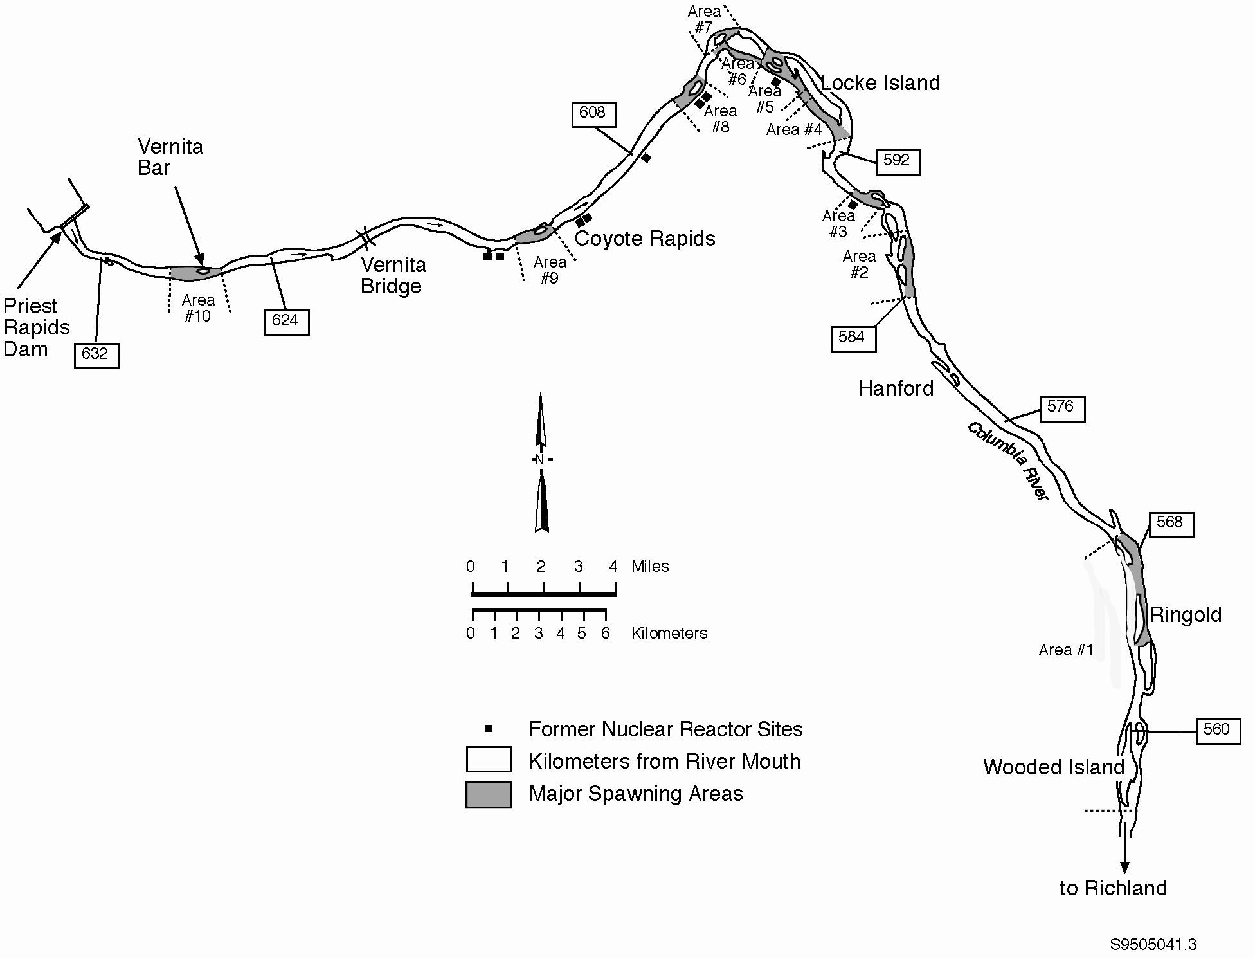

Figure 4.5.4. Fall Chinook Salmon Spawning Areas in Hanford Reach Area of the Columbia River, Washington

estimates steelhead sport catch for the 2002 season at 1100 fish. The majority of these fish were marked hatchery fish. In recent years the return of fall Chinook salmon has been high with 7550 adults and about 1000 jacks (precocious males) harvested during 2002 (http://wdfw.wa.gov/fish/harvest/harvest.htm ).

American shad (Alosa sapidissima), an introduced anadromous species, may also spawn in the Hanford Reach. The upstream range of the shad has been increasing since 1956 when less than 10 adult shad passed McNary Dam. Since then, the number of shad ascending Priest Rapids Dam has risen to many thousands each year, and young-of-the-year have been collected in the Hanford Reach. Shad are not dependent on the same conditions that are required by salmonids for spawning and apparently have found favorable conditions for reproduction.

Other fish of importance to sport fishermen are the native mountain whitefish (Prosopium williamsoni) and white sturgeon (Acipenser transmontanus). Introduced species like smallmouth bass (Micropterus dolomieui), crappie (Pomoxis nigromaculatus), catfish (Ictalurus punctatus), walleye (Stizostedion vitreum), and yellow perch (Perca flavescens) are also popular. Large populations of rough fish are also present, including introduced carp (Cyprinus carpio) and native species such as redside shiner (Richardsonius balteatus), suckers (Catostomus macrocheilus), and northern pikeminnow (Ptychocheilus oregonensis). Because northern pikeminnow feed on juvenile salmon, WDFW has established a bounty program on adult pikeminnow to bolster salmon runs. Northern pikeminnow removed from the Hanford Reach are usually turned in at bounty stations located at Columbia Point in Richland and at the Vernita Bridge rest stop.

Spring Streams

Small interrupted streams, such as Rattlesnake, Bobcat, and Snively springs located on the Fitzner-Eberhardt Arid Lands Ecology Reserve Unit, contain diverse biotic communities and are extremely productive (Cushing and Wolf 1984). Dense blooms of watercress arise and are lost when flash floods occur. Aquatic insect production is fairly high as compared with mountain streams (Gaines 1987). The macrobenthic biota varies from site to site and is related to the proximity of colonizing insects and other factors. The fire of 2000 has had little direct impact on the stream ecology, even though the riparian transect along the lower two-thirds of the stream was heavily damaged by the fire (BAER 2000).

Rattlesnake Springs, on the western side of the Hanford Site, forms a small surface stream that flows for about 2.5 km (1.6 mi) before disappearing into the ground as a result of seepage and evapotranspiration. Base flow of this stream is about 0.01 m³/s (0.4 ft³/s) (Cushing and Wolf 1982). Water temperature ranges from 2° to 22°C (36° to 72°F). Mean annual total alkalinity (as CaCO₃), nitrate nitrogen, phosphate phosphorus, and total dissolved solids are 127, 0.3, 0.18, and 217 mg/L, respectively (Cushing and Wolf 1982, Cushing et al. 1980). The sodium content of the spring water is about 7 ppm (Brown 1970). Rattlesnake Springs is of ecological importance because it provides a source of water to terrestrial animals in an otherwise arid part of the Hanford Site. Snively Springs, located west of and at a higher elevation than Rattlesnake Springs, is another source of drinking water for terrestrial animals. Both springs provide a valuable source of drinking water for the Rattlesnake Hills elk herd. The major rooted aquatic plant, which in places may cover the entire width of the stream, is watercress. Isolated patches of bulrush, spike rush, and cattail occupy less than 5 percent of the streambed.

Primary productivity at Rattlesnake Springs is greatest during the spring and coincident with the maximum periphyton standing crop. Net primary productivity averaged 0.9 g/cm²/d organic matter during 1969 and 1970; the spring maximum was 2.2 g/cm²/d. Seasonal productivity and respiration rates are within the ranges reported for arid region streams. Although Rattlesnake Springs is a net exporter of organic matter during much of the growing season, it is subject to flash floods and severe scouring and denuding of the streambed during winter and early spring, making it an importer of organic materials on an annual basis (Cushing and Wolf 1984).

Secondary production is dominated by detritus-feeding collector-gatherer insects (mostly Chironomidae and Simuliidae) that have multiple cohorts and short generation times (Gaines et al. 1992). Overall production is not high and is likely related to the low diversity found in these systems related to the winter spates that scour the spring streams. Total secondary production in Rattlesnake and Snively springs is 16,356 and 14,154 g dry weight/m²/yr, respectively. There is an indication that insects in these spring-streams depend on both autochthonous (originating within the stream) and allochthonous (originating outside the stream) primary production as an energy source, despite significant shading by non-native species of trees and shrubs (Mize 1993).

Invertebrate surveys on the Fitzner-Eberhardt Arid Lands Ecology Reserve Unit identified 30 new taxa at Rattlesnake Springs and 12 new taxa at Snively Springs (Soll et al. 1999). These recent findings bring the total number of taxa at each spring to 43 and 24, respectively.

There are other springs occurring on the Rattlesnake Hills (Schwab et al. 1979). Limited physical and chemical data are reported for each site.

Temporary Water Bodies

West Lake is a small saline pond created by a rise in the water table in the 200 Areas and is not fed by surface flow. Evaporation of groundwater and possible disposal of sewage during the early Hanford years created highly saline and alkaline conditions that greatly restricted the complement of biota in West Lake (Poston et al. 1991).

Several artificial water bodies, both ponds and ditches, were formed as a result of wastewater disposal practices associated with operation of the reactors and separation facilities. Most of these have been taken out of service and have been backfilled with the cessation of activities. When present, however, they formed established aquatic ecosystems complete with representative flora and fauna (Emery and McShane 1980). The temporary wastewater ponds and ditches existed for as long as two decades and covered fairly large areas. Rickard et al. (1981) discusses the ecology of Gable Mountain Pond, one of the former major lentic sites at Hanford. Emery and McShane (1980) present ecological characteristics of all the temporary water bodies. The ponds developed luxuriant riparian communities and became quite attractive to autumn and spring migrating birds. Several species have nested near the ponds. Section 4.4.1.8 describes those water bodies still active. These former sites have been decommissioned and are now covered with overburden and planted with grasses for stabilization.

Threatened and Endangered Species

There are a number of species of plants and animals on the Hanford Site that are considered to be rare and of management concern. Species listed as endangered or threatened by either the federal government under the Endangered Species Act (ESA) (50 CFR 17) or by the State of Washington (WNHP 2005, WDFW 2005) are listed in Table 4.5.1. There are no federal- or state-listed endangered or threatened mammals, reptiles, amphibians, or invertebrates on the Hanford Site, but there are three species of fish, five species of birds, and 11 species of plants listed as threatened or endangered by either the state or federal governments.

Of the three listed fish species, only the upper Columbia River steelhead trout (Oncorhynchus mykiss) spawns in the Hanford Reach, although the extent of spawning is not known. Upper Columbia River spring Chinook salmon (O. tshawytscha) do not spawn in the Hanford Reach, but adults pass through the Hanford Reach while migrating to spawning grounds, and the juveniles use the Hanford Reach as a nursery area while they migrate toward the ocean. The bull trout (Salvelinus confluentus) primarily inhabits smaller streams, usually at higher elevations. Bull trout have been observed in the Hanford Reach on very rare occasions, usually associated with the spring freshets. Bull trout are not considered to be residents of the Hanford Site.

The bald eagle (Haliaeetus leucocephalus) is a relatively common winter resident along the Hanford Reach that occasionally attempts to nest on the Hanford Site. However, bald eagles have never successfully nested on the Hanford Site. Bald eagle roosting and nesting sites are protected from site employees by access controls that are in place from November to March of each year.

Ferruginous hawks (Buteo regalis) have successfully nested on site, especially on several steel transmission line towers. The white pelican (Pelecanus erythrorhynchos) is relatively common along the Hanford Reach but does not appear to nest or reproduce on site. The sandhill crane (Grus canadensis) migrates over the site, and on rare occasions is observed on the shore or islands of the Hanford Reach. The greater sage grouse (Centrocercus urophasianus) was formerly more common on the Hanford Site, especially on the Fitzner-Eberhardt Arid Lands Ecology (ALE) Reserve Unit. It disappeared for a number of years following several large fires in the 1980s. Since the late 1990s, there have been
Table 4.5.1. Federal or Washington State Threatened and Endangered Species on the Hanford Site
Common Name | Scientific Name | Federal^{(a)} | State^{(a)}
Fish^{(b)}
Bull trout | Salvelinus confluentus | Threatened | Candidate
Spring-run Chinook | Oncorhynchus tshawytscha | Endangered | Candidate
Steelhead | Oncorhynchus mykiss | Endangered | Candidate
Birds^{(b)}
American white pelican | Pelecanus erythrorhynchos |  | Endangered
Bald eagle ^{(c)} | Haliaeetus leucocephalus | Threatened | Threatened
Ferruginous hawk | Buteo regalis | Species of Concern | Threatened
Sandhill crane | Grus canadensis |  | Endangered
Greater sage grouse | Centrocercus urophasianus | Candidate | Threatened
Plants^{(d)}
Awned halfchaff sedge | Lipocarpha (= Hemicarpha) aristulata |  | Threatened
Desert dodder | Cuscuta denticulata |  | Threatened
Geyer’s milkvetch | Astragalus geyeri |  | Threatened
Grand redstem | Ammannia robusta |  | Threatened
Loeflingia | Loeflingia squarrosa var. squarrosa |  | Threatened
Lowland toothcup | Rotala ramosior |  | Threatened
Persistentsepal yellowcress | Rorippa columbiae | Species of Concern | Endangered
Rosy pussypaws | Calyptridium roseum |  | Threatened
Umtanum desert buckwheat | Eriogonum codium | Candidate | Endangered
White Bluffs bladderpod | Lesquerella tuplashensis | Candidate | Threatened
White eatonella | Eatonella nivea |  | Threatened
(a) Endangered = species in danger of extinction within all or a significant portion of its range.
Threatened = species likely to become endangered in the foreseeable future.
Candidate = species believed to qualify for threatened or endangered species status, but for which listing proposals have not been prepared.
Species of concern = species not currently listed or candidates under the ESA, but are of conservation concern within specific USFWS regions.
(b) http://www.dnr.wa.gov/nhp/refdesk/lists/animal_ranks.html .
(c) Currently under review for removal from the list of threatened or endangered species.
(d) http://www.dnr.wa.gov/nhp/refdesk/lists/plantrnk.html .

scattered sightings of greater sage grouse on ALE, and during 2003 a dead sage grouse was found near the 100-F Area.

There are no plant species on the Hanford Site that are currently listed as threatened or endangered under the ESA, but two species of plants are candidates for federal protection: Umtanum desert buckwheat (Eriogonum codium) which occurs in several small, highly localized populations on Umtanum Ridge, and the White Bluffs bladderpod (Lesquerella tuplashensis) which occurs on the White Bluffs. Several additional plant species are listed as threatened or endangered by Washington State. Several of these, including the awned halfchaff sedge (Lipocarpha aristulata), grand redstem (Ammannia robusta), lowland toothcup (Rotala ramosior), and persistentsepal yellowcress (Rorippa columbiae) are restricted to wetlands in the riparian zone of the Columbia River. Other plant species, such as loeflingia (Loeflingia squarrosa) and rosy pussypaws (Calypdridium roseum), are small annuals that have been found in relatively undisturbed sagebrush areas in the vicinity of Gable Mountain. The remaining three state threatened or endangered plant species (Geyer’s milkvetch [Astragalus geyeri], white eatonella [Eatonella nivea], and desert dodder [Cuscuta denticulata]) have been found at various sites on the Wahluke slope.

In addition to the species listed by the state or federal resource agencies as threatened or endangered, there are numerous species listed by the State of Washington as candidate or sensitive animal species (Table 4.5-2) or as sensitive, review, or watch list plants (Table 4.5-3). The common loon (Gavia immer) and the peregrine falcon (Falco peregrinus) are the only animal species on the Hanford Site listed as sensitive by Washington State; there are 17 species of plants listed as state sensitive species.

The Washington ground squirrel (Spermophilus washingtoni), listed as a candidate species by both the state and federal governments, is most likely to occur in the Franklin or Grant county portions of the Hanford Site. The Townsend’s ground squirrel (S. townsendii), a Washington State candidate species, may be found on the Benton County portions of the Hanford Site.

Several state candidate and sensitive species, including the loggerhead shrike (Lanius ludovicianus), burrowing owl (Athene cunicularia), sagebrush lizard (Sceloporus graciosus), peregrine falcon, goshawk (Accipiter gentilis), Columbia River spire snail (Fluminicola columbiana), and California floater (Anodonta californiensis), as well as the state threatened ferruginous hawk are considered to be animal species of concern by the U.S. Fish and Wildlife Service (USFWS). Three state sensitive plant species, Columbia milkvetch (Astragalus columbianus), Hoover’s desert parsley (Lomatium tuberosum), and gray cryptantha (Cryptantha leucophaea), as well as the state endangered persistentsepal yellowcress, are considered by USFWS to be species of concern in the mid-Columbia Basin. Species of concern are not protected under federal law, but are considered to be vulnerable and of special management concern. More information about the plant species listed in Table 4.5-3 can be found in Sackschewsky and Downs (2001).

A species of springsnail was discovered in the lower Hanford Reach during 2004 that, depending on the taxonomic system used, is either the Columbia springsnail (a species of Pyrgulopsis that has not been formally described or named) or the Jackson Lake springsnail (Pyrgulopsis robusta). Regardless of the name, the USFWS is currently evaluating this species for possible listing as endangered or threatened (70 FR 20512). This species currently has no federal or state status.

The USFWS has indicated that four additional federally listed threatened, endangered, or candidate species may be present in Benton, Franklin, or Grant counties (USFWS 2004). The pygmy rabbit (Brachylagus idahoensis) is a federal and state endangered species that is restricted to a few small populations north of the Hanford Site in Grant and Adams counties. Biologists have searched for this species on the Hanford Site, but it has not been conclusively observed. Ute Ladies tresses (Spiranthes diluvialis) is a threatened orchid that potentially could be found along the Columbia River but has not been observed near the Site; it is documented in Chelan and Okanogan counties (WNHP 2005). The yellow-billed cuckoo (Coccyzus americanus) is a federal candidate species that has been rarely observed in southeast Washington. It normally requires relatively large forested wetland areas for successful breeding. Such habitat is not available on the Hanford Site, and the species has not been observed on the Hanford Site. The northern wormwood (Artemisia campestris var wormskioldii) is a federal candidate and state endangered species that occurs along the Columbia River near Wanapum Dam. Extensive surveys along the shore of the Hanford Reach have failed to locate this species on the Hanford Site. The USFWS (2004) also lists a number of additional species of concern for Benton, Franklin, and Grant Counties, including a number of bat species that may occur on the Hanford Site; most of these have no Washington State-level status designation.

Table 4.5-2. Washington State Candidate and Sensitive Animal Species on the Hanford Site
Common Name | Scientific Name
Molluscs
California floater^{(a)} | Anodonta californiensis
Giant Columbia River limpet | Fisherola (= Lanx) nuttalli
Giant Columbia River spire snail^{(a)} | Fluminicola (= Lithoglyphus) columbiana
Fish
Bull trout^{(b,c)} | Salvelinus confluentus
Mountain sucker^{(c)} | Catastomus platyrhynchus
Leopard dace^{(c)} | Rhinichthys flacatus
River Lamprey^{(c)} | Lampetra ayresi
Spring-run Chinook salmon^{(d)} | Oncorhynchus tshawytscha
Steelhead^{(d)} | Oncorhynchus mykiss
Insects
Columbia River tiger beetle^{(e)} | Cicindela columbica
Birds
Burrowing owl^{(a)} | Athene cunicularia
Common loon^{(f)} | Gavia immer
Flamulated owl^{(c)} | Otus flammeolus
Golden eagle | Aquila chrysaetos
Lewis’s woodpecker^{(c)} | Melanerpes lewis
Loggerhead shrike^{(a)} | Lanius ludovicianus
Peregrine falcon^{(a,f)} | Falco peregrinus
Merlin | Falco columbarius
Northern goshawk^{(a,c)} | Accipter gentilis
Sage sparrow | Amphispiza belli
Sage thrasher | Oreoscoptes montanus
Western grebe | Aechmorus occidentalis
Reptiles
Sagebrush lizard^{(a)} | Sceloporus graciosus
Striped whipsnake | Masticophis taeniatus
Mammals
Black-tailed jackrabbit | Lepus californicus
Merriam’s shrew | Sorex merriami
Townsend’s ground squirrel | Spermophilus townsendii
Washington ground squirrel^{(c,g)} | Spermophilus washingtoni
White-tailed jackrabbit | Lepus townsendii
(a) Federal species of concern.  (b) Federal threatened.  (c) Reported, but seldom observed, on the Hanford Site.  (d) Federal endangered  (e) Probable, but not observed, on the Hanford Site. | (f) State Sensitive (i.e., taxa vulnerable or declining) and could become endangered or threatened without active management or removal of threats..  (g) Federal candidate

Table 4.5-3. Washington State Plant Species of Concern on the Hanford Site
Common Name | Scientific Name | State Listing^{(a)}
Annual paintbrush | Castilleja exilis | Watch List
Annual sandwort | Minuartia pusilla var. pusilla | Review Group 1
Basalt milk-vetch | Astragalus conjunctus var. rickardii | Watch List
Beaked spike-rush | Eleocharis rostellata | Sensitive
Bristly combseed | Pectocarya setosa | Watch List
Brittle prickly pear | Opuntia fragilis | Review Group 1
Canadian St. John’s wort | Hypericum majus | Sensitive
Chaffweed | Centunculus minimus | Review Group 1
Columbia milkvetch | Astragalus columbianus | Sensitive ^{(b)}
Columbia River mugwort | Artemisia lindleyana | Watch List
Coyote tobacco | Nicotiana attenuata | Sensitive
Crouching milkvetch | Astragalus succumbens | Watch List
Desert evening-primrose | Oenothera caespitosa | Sensitive
Dwarf evening primrose | Camissonia (= Oenothera) pygmaea | Sensitive
False pimpernel | Lindernia dubia anagallidea | Watch List
Fuzzytongue penstemon | Penstemon eriantherus whitedii | Sensitive
Giant helleborine | Epipactis gigantea | Watch List
Gray cryptantha | Cryptantha leucophaea | Sensitive ^{(b)}
Great Basin gilia | Gilia leptomeria | Sensitive
Hedge hog cactus | Pediocactus simpsonii var. robustior | Review Group 1
Hoover’s desert parsley | Lomatium tuberosum | Sensitive ^{(b)}
Kittitas larkspur | Delphinium multiplex | Watch List
Medic milkvetch | Astragalus speirocarpus | Watch List
Miner’s candle | Cryptantha scoparia | Sensitive
Mousetail | Myosurus clavicaulis | Sensitive
Piper’s daisy | Erigeron piperianus | Sensitive
Porcupine sedge | Carex hystericina | Watch List
Robinson’s onion | Allium robinsonii | Watch List
Rosy balsamroot | Balsamorhiza rosea | Watch List
Scilla onion | Allium scilloides | Watch List
Shining flatsedge | Cyperus bipartitus (rivularis) | Sensitive
Small-flowered evening-primrose | Camissonia (= Oenothera) minor | Sensitive
Small-flowered nama | Nama densum var. parviflorum | Watch List
Smooth cliffbrake | Pellaea glabella simplex | Watch List
Snake River cryptantha | Cryptantha spiculifera (= C. interrupta) | Sensitive
Southern mudwort | Limosella acaulis | Watch List
Stalked-pod milkvetch | Astragalus sclerocarpus | Watch List
Suksdorf’s monkey flower | Mimulus suksdorfii | Sensitive
Thompson’s sandwort | Arenaria franklinii thompsonii | Review Group 2
Winged combseed | Pectocarya penicillata | Watch List
(a) Sensitive - Taxa that are vulnerable or declining and could become endangered or threatened without active management or removal of threats.
Review Group 1 - Taxa for which currently there are insufficient data available to support listing as threatened, endangered, or sensitive, and the State is actively searching for additional data or information.
Review Group2 - Taxa with unresolved taxonomic questions that would affect the listing status.
Watch List - Taxa that are more abundant and/or less threatened than previously assumed, but still of interest to the State.
(b) USFWS Columbia Basin federal species of concern.

This page intentionally left blank

(?) Management of these islands is the responsibility of the island owners, which include DOE, USFWS, and the U.S. Bureau of Land Management. Island ownership descriptions pertain to status prior to national monument designation and are subject to change with agreements among the agencies.
(?) Source: Personal communication between T. M. Poston and L.L. Cadwell, PNNL, April 2002.

