Regional sheet and rill soil erosion prediction with the Revised Universal Soil Loss Equation (RUSLE) – GIS Interface

by
Jacek Blaszczynski
Physical Scientist
BLM National Science and Technology Center (NSTC)

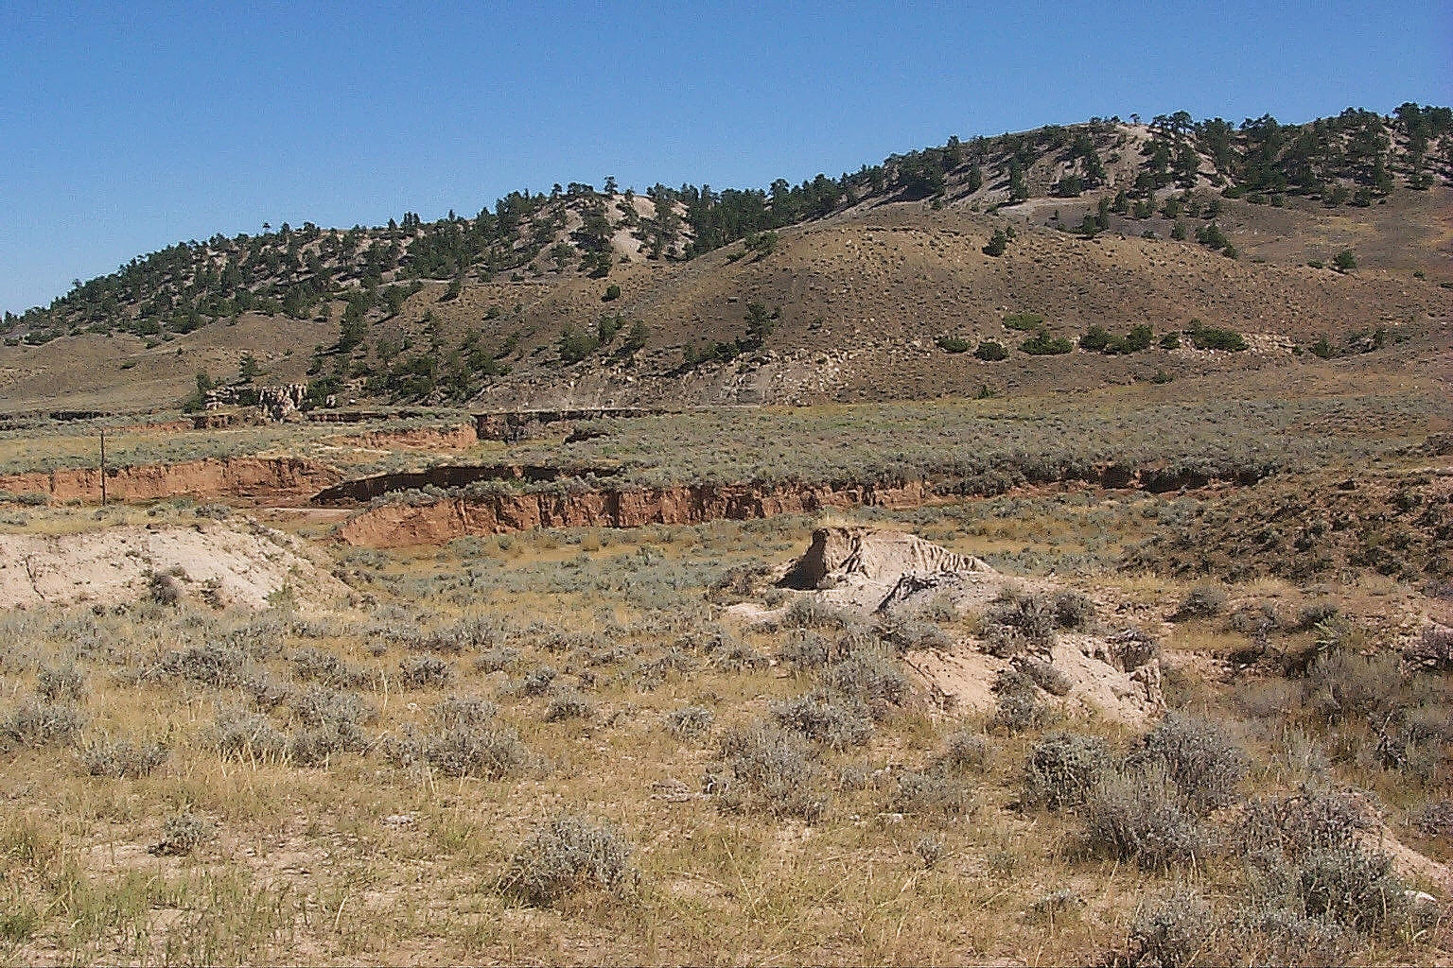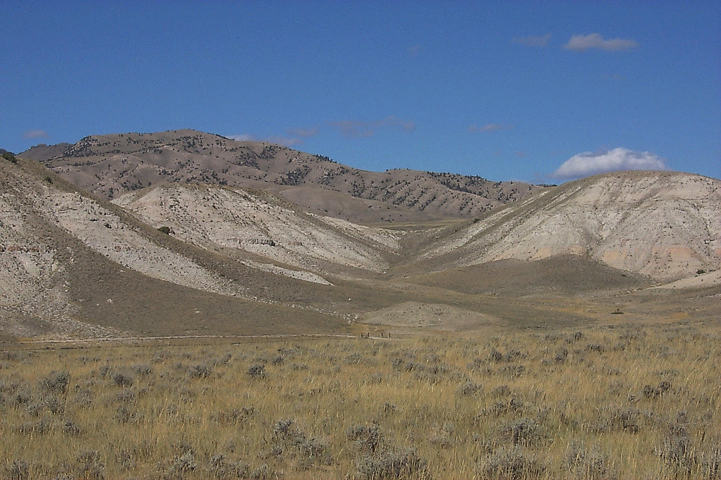

Introduction

An ecological issue of great importance to the United States and the world is degradation of rangelands, the major symptom of which is increase in the rate of water caused soil erosion. Livestock grazing and drought can combine to reduce the grass cover, compact the soil increasing runoff and erosion, and create a patchy distribution of of water and nutrients. If during periods of moderate drought grazing is intensified this can lead to decrease in grass cover that normally supports a uniform distribution of moisture and nutrients throughout the soil profile. Bare patches, which may have developed during the drought, become more pronounced. Topsoil is compacted by trampling causing less rainfall to infiltrate the topsoil leading to greater surface runoff and related sheet and rill erosion. The problem of erosion is further exacerbated by loss of organic matter in the topsoil that tends to hold the soil particles together. If overgrazing and drought continue the bare patches expand, and erosion becomes a significant problem as rain and nutrients are carried away from them to be deposited in nearby surface depressions. Creosote and mesquite shrubs begin to appear in these areas of concentration of soil, water, and nutrients. As soil around the grasses loses its depth, nutrients, and moisture through erosion and leaching, it can no longer sustain the grasses limiting their ability to regenerate. To avoid this downward spiral from which there might not be a recovery, management of rangeland soil resources has to be performed in a way that does not deplete the resource and result in loss of soil productivity. Technologies to estimate, manage and contain soil erosion are very much needed to help prescribe management practices so as to maintain existing rangelands in an ecologically healthy state and to return degraded rangelands to a more pristine condition.

For most of the world's regions accurate estimates of soil erosion are not available. An examination by experts of the available figures including a review carried out for the United Nations Food and Agriculture Organization concluded that these estimates have little scientific merit. The overwhelming share of land reported to the United Nations Environment Program (UNEP) as under danger from soil erosion and related desertification processes is rangeland. If global climate warming proves to be actual and leads to increase in mean surface temperature, the rates of desertification in various regions can sharply increase. Since a significant portion of the public lands managed by the Bureau of Land Management (BLM) is rangeland, the Bureau has a vested interest in issues related to rangeland soil erosion. Development and application of a soil erosion prediction methodology is therefore of utmost importance. The Revised Universal Soil Loss Equation (RUSLE)/Geographic Information System interface provides such methodology for regional level analysis of soil erosion. While it is likely that application of more complex models than RUSLE can provide more accurate estimates of soil erosion for specific sites, the data requirements of these models make them difficult to use on a regional scale. By comparison, data for utilization of RUSLE can be relatively easy to obtain.

Methodology

The RUSLE/GIS methodology permits calculation of potential soil loss from sheet and rill erosion for rangelands. The RUSLE equation calculates potential erosion (A) as follows:

A = R * K * L * S * C * P
Where R is the rainfall and runoff factor; K is the soil erodibility factor; L is the slope-length factor; S is the slope-steepness factor; C is the cover and management factor; and P is the erosion control practice factor. In the modeling procedure the values for the different RUSLE factors are assigned to their respective mapping units, i.e. a soil unit map, a vegetation class map, and a digital elevation model.

Values for the factors can be obtained from reference sources or calculated from mapped or field collected data about the project location. To facilitate calculation of RUSLE factors the user can input relevant information into a PC program, such as the RUSLE program prepared by BLM in 1987 upon which this interface is based. The rainfall and runoff R factor value is calculated from latitude and longitude and 2yr-6hr precipitation of the study area. The soil erodibility K factor values are obtained from soil surveys, or calculated from field information that includes percentage of silt and very fine sand in the soil, percentage of clay, percentage of organic matter, soil structure and permeability code. The slope gradient S and slope length L factors are calculated from digital elevation data using GIS hydrologic terrain analysis capabilities and map algebra. The C factor values are calculated using field survey information on percent and average height of vegetation cover, the root mass in the top 4 inches of soil, percent of rock, gravel, litter and vegetation on the ground surface. In calculation of the C factor the RUSLE program also provide a table of surface roughness values from which one can pick the appropriate roughness number. The erosion control P factor values are obtained from a table provided by the designers of the RUSLE. After the factor values have been assigned or calculated for each of the mapping units, the factor maps are overlaid to produce a visualization of soil erosion potential.

There has been a lot of controversy over the accuracy of the Universal Soil Loss Equation and its close cousin the Revised Universal Soil Loss Equation. However even if we regard the resultant soil-erosion potential map purely as a relative evaluation based on known interactions and influence of rainfall, soil cohesion, terrain, vegetation cover, and erosion control practices such a map still provides us with useful information. A preliminary run of the procedure based on existing data should provide us with a rapid reconnaissance level evaluation as to where we can expect low, medium, high, and very high erosion rates based on these environmental parameters expressed by the factors. Although the RUSLE model oversimplifies the complexity of erosion processes it’s estimates can be improved to by refining the quality of input data. Examples include using higher resolution digital elevation models to derive values for the terrain factor or enhancing the quality of soil surveys and vegetation data by combining them with slope gradient and aspect information. New techniques of automated terrain analysis are also proving useful for improving the predictive capability of RUSLE by orienting each site in the context of its location in the hydrologic network or on the hillslope or valley floor.

The RUSLE/GIS interface can be used to model various possible management and ecological health scenarios by changing the values for various environmental factors to simulate different conditions, such as seasonal change, change in precipitation, vegetation cover, terrain and management practice.

Automated calculation of terrain factor from Digital Elevation Models (DEMs)

At the National Applied Resource Sciences Center (NARSC) we developed automated tools to make the RUSLE/GIS procedure easier to perform. LSFACTOR.AML provides three methods of calculation of the RUSLE terrain factor from DEM data. The products are three terrain factor maps that represent the various methods. The first method calculates the terrain factor according the equation used by Simanton, J. R. 1987 in his Revised USLE for Rangeland, a BASIC program for DOS, Version 3.16, developed at USDA-ARS, Tucson, Arizona. The equations reflect the empirically derived model of how slope gradient and slope length influence potential erosion. The second and third method are based on the same approach originally developed for contour map analysis by Moore, I. D. and J. P. Wilson and described in their 1992 paper Length-slope factors for RUSLE: Simplified method of estimation (Journal of Soil Science Society of America, vol. 50, pp. 1294-1298). It was then adapted for grid cell processing by Helena Mitasova and described in her 1993 paper Surfaces and modeling (GRASS GIS Newsletter Grassclippings, Spring 1993). This algorithm calculates the terrain factor based on the upslope drainage area. The map LSFACTOR2 is calculated for hillslope areas defined as extending 244 meters (about 800 feet) from the ridge (slope length = 244 meters). LSFACTOR3 is calculated for hillslopes separated from drainages by having flow accumulation values less than 50 in contrast to drainages with flow accumulation values of 50 and above.

Benefits and Uses

Interfacing GIS geographic analysis capabilities with the Revised Universal Soil Loss Erosion provides the resource specialist with a tool to relatively quickly visualize the likely sheet and rill soil erosion potential (soil detachment potential but not transport and deposition) based on several major environmental parameters for large areas. This permits regional scale studies by quickly processing large amounts of information from data sources that are relatively easy to obtain from various government agencies.

The interface also permits modeling of various management alternatives and changing environmental conditions in space and time. This permits evaluation of the possible effects of each management practice on the stability of the soil resource. Because the procedure relies on standardized methodology it also allows for comparison of different geographic areas. Furthermore it provides maps of various resolutions depending on the resolution of the input data. The RUSLE/GIS interface can serves as core methodology for further GIS hydrologic and geomorphologic applications such as analysis of watershed condition, sediment loading of streams and rivers, non-point source pollution, the effects of hazardous wastes in soils on water quality, etc..

The RUSLE/GIS can also be seen as an example of how automation can help to standardize application of the RUSLE to large areas. Given that input map data is of equal quality, and the procedure is standardized, automated processing permits repetition of the same procedure on areas in different geographic regions. For example, automated derivation of slope gradients and slope lengths removes the subjective elements usually present in determination of these factors. Consistent application of the RUSLE/GIS interface could lead to development of an erosion index at recconnaissance level by which different areas can be compared for soil loss.

