Cloud Patterns in Toronto, Ontario, Canada

By Laurissa Werhun

Purpose:

The purpose of this lesson is for the students to gain an understanding of clouds and their role in the atmosphere. Students will analyse data and information from various sources about trends in local and global weather conditions to forecast local and global weather patterns.

Grade Level:

7 – 10

Estimated Time for Completing Activity:

Three sixty-minute periods

Virginia Standards of Learning:

ES.1c: The student will plan and conduct investigations in which scales, diagrams, maps, charts, graphs, tables, and profiles are constructed and interpreted.
LS.1: The student will plan and conduct investigations in which c) data are organized into tables showing repeated trials and means; h) continuous line graphs are constructed, interpreted, and used to make predictions; and i) interpretations from a set of data are evaluated and defended.
PS.1: The student will plan and conduct investigations in which b) length, mass, volume, density, temperature, weight, and force are accurately measured and reported using metric units (SI-International System of Units); h) data tables showing the independent and dependent variables, derived quantities, and the number of trials are constructed and interpreted; i)data tables for descriptive statistics showing specific measures of central tendency, the range of the data set, and the number of repeated trials are constructed and interpreted; j) frequency distributions, scattergrams, line plots, and histograms are constructed and interpreted; and k) valid conclusions are made after analyzing data.
PS.7: The student will investigate and understand temperature scales, heat, and heat transfer. Key concepts include Celsius and Kelvin temperature scales and absolute zero.

Prerequisites:

Students should be familiar with using the Internet to access websites and in using Excel to produce spreadsheets and graphs.

Tools:

Internet access and Microsoft Excel

Vocabulary:
Cloud

Background:

What are Clouds (see Worksheet: What are Clouds)
Types of Clouds (see Worksheet: Types of Clouds)

Procedure:

Patterns in Cloud Coverage in Toronto, Ontario, Canada
(see Worksheet: Patterns in Cloud Coverage in Toronto, Ontario, Canada)

What are Clouds?
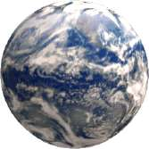
Begin the class with a discussion of how clouds are formed and their composition. During the course of the exercise students observe and comment on condensation. Encourage students to think about why some clouds produce rain while others do not. Why does it stop raining? Where does the water go? You may wish to incorporate these questions into a journal exercise.
What are Clouds?
Clouds are visible accumulations of water droplets or solid ice crystals that float in the Earth's troposphere (the lowest part of the Earth’s Atmosphere), moving with the wind. From space, clouds are visible as a white veil surrounding the planet.

Experiment For Students: Making a Cloud.
Materials: Large glass jar, warm water (enough to fill jar to one-third full), black paper (large enough to cover back of jar), matches, zipper-style storage bag, crushed ice or ice cubes.
Procedure:
1. Ask students what clouds are, of what are they made, and ask the focus question “How do you think clouds form?” The responses to this question could be written on the board to return to later.
2. Tell the students that we are going to perform a simulation of the forming of a cloud. Take out the jar and have one of the students tape the black piece of paper onto one side of the jar. Ask another student to pour the warm water into the jar until it is one third full.
3. Have a student cover the jar with a bag of ice. Observe for a while. Do they see anything?
4. Light a match and hold it in the jar for a few seconds and then drop it in. At this point, have a student quickly cover the jar with the bag of ice. Observe for a while. Now do they see anything?
5. Have the students record their observations and explore what happened. The following questions can be used to help the class learn about what was happening:
- What did you see in the jar? (a cloud)
- Where did the cloud come from? (the water in the bottom of the jar)
- How did the warm water effect the cloud formation? (caused the water to evaporate and warmed the air, causing it to rise)
- What did the ice cubes do to help the clouds form? (cooled the air [made the water vapour condense]).
- What role did the match and its smoke play in the cloud formation? (gave the water something to condense or grab on to)
- Now what would you tell me a cloud is made of? (small water droplets or ice crystals, which form around a condensation nucleus – for example smoke. Extension for those in colder climates: On a snowy day, go outside and catch a few flakes on your tongue. See if you can taste the type of particle that snowflake formed on.)
- Ask someone to describe the process of cloud formation from what they just learned.
Types Of Clouds
Clouds are classified into a system that uses Latin words to describe the appearance of clouds as seen by an observer on the ground. The table below summarizes the four principal components of this classification system
Latin Root | Translation | Example
cumulus | heap | fair weather cumulus
stratus | layer | altostratus
cirrus | curl of hair | cirrus
nimbus | rain | cumulonimbus
Further classification identifies clouds by height of cloud base. For example, cloud names containing the prefix "cirr-", as in cirrus clouds, are located at high levels while cloud names with the prefix "alto-", as in altostratus, are found at middle levels.
Types of Clouds
Using your textbook or researching on the internet fill in the following table
Type of Cloud  (Genus) | Image  (Draw a picture) | Appearance  (Describe in words) | Altitude (height)  (Record the height in meters and/or feet)
Cumulo-nimbus
(Thunderheads)
Cirro-stratus
Cirrus
Cirro-cumulus
Alto-cumulus
Alto-stratus
Strato-cumulus
Cumulus
Stratus
Nimbo-stratus
Fog
Mammatus clouds
Orographic clouds
Pileus cloud
Contrail (short for CONdensation TRAIL)

Solution
Type of Cloud  (Genus) | Image | Appearance | Altitude (height)
Cumulo-nimbus  (Thunderheads) |  | Can cause lightning, thunder, hail, strong rains, strong winds, and tornadoes | Near ground up to 75,000 feet (~23,000 m)  (convective clouds)
Cirro-stratus |  | Thin, wispy, appear in sheets. Located above thunderheads | Above 18,000 feet (~6,000 m)  (High-altitude clouds)
Cirrus |  | Thin, wispy, filamentous, or curly | Above 18,000 feet (~6,000 m)  (High-altitude clouds)
Cirro-cumulus |  | Small, puffy, patchy and/or with a wavelike appearance | Above 18,000 feet (~6,000 m)  (High-altitude clouds)
Alto-cumulus |  | Medium-sized puffy, patchy, scattered clouds - often in linear bands | 6,500 - 20,000 feet (~2,000-6,000 m)  (Middle-altitude clouds)
Alto-stratus |  | Thin, uniform | 6,500 - 20,000 feet (~2,000-6,000 m)  (Middle-Altitude clouds)
Strato-cumulus |  | Broad and flat on the bottom, puffy on top, | Below 6,500 feet (~2,000 m)  (Low-altitude clouds)
Cumulus |  | Puffy and piled up. | Below 6,500 feet (~2,000 m)  (convective clouds)
Stratus |  | Uniform, flat, thick to thin layered clouds will ill-defined edges | Below 6,500 feet (~2,000 m)  (Low-altitude clouds)
Nimbo-stratus |  | Uniform, dark, flat, low, featureless clouds that produce precipitation | Below 6,500 feet (~2,000 m)  (Low-altitude clouds)
Fog |  |  | In contact with the ground  (Ground-hugging clouds)

Have the students complete the following worksheet

Label the Clouds
Label the clouds using the terms given.
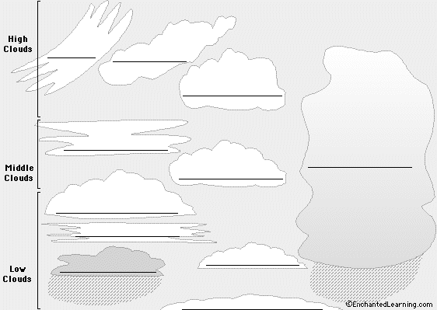 | alto-cumulus - Middle-level, medium-sized puffy clouds.  alto-stratus - Middle-level, layered clouds.  cirro-cumulus - High-altitude, small, wispy, patchy, puffy clouds.  cirro-stratus - High-altitude, thin, wispy clouds in layers.  cirrus - High-altitude, thin, wispy clouds.  cumulo-nimbus- Large, dense, towering clouds that cause thunderstorms.  cumulus - Low, puffy clouds.  fog - Ground-hugging clouds.  nimbo-stratus - Low, dark, rain cloud.  stratus - Low, layered, horizontal, wispy clouds with a flat base.  strato-cumulus - Low clouds, broad and flat on the bottom, puffy on top (higher than cumulus and lower than altocumulus).
http://www.enchantedlearning.com/subjects/astronomy/activities/label/clouds/

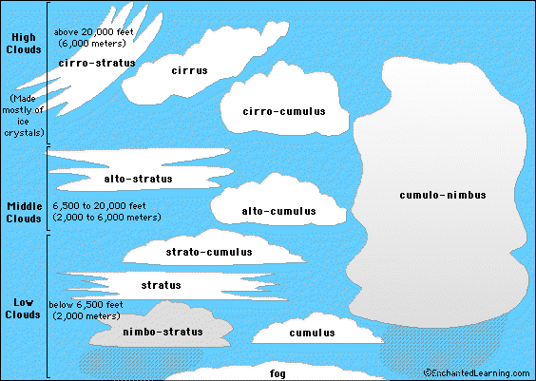

Make A Cloud Collage
Materials: Poster board, paper, glue, magazines with clouds pictures (that can be used for cut-outs), or a camera with film to take pictures.
Setting Up the Activity: Make a collage of as many different types and sizes of clouds as possible. This can also be done as a group activity. Record the type of weather associated with each cloud, such as fair, rainy, warm, or cold. The clouds can also be divided into types of cumulus, stratus, or cirrus.
Questions:
- What type of weather was found with each cloud?
- From what direction were most of the clouds moving ?
- How long was it before the weather changed, (cleared up, started raining, got warmer/colder?)
- What main types of clouds were present in fair weather? Stormy weather?
Taking It a Step Further: Take pictures of the same part of the sky at the same time of day for five days. Watch the local weather report each of those days, and record the weather forecast
Q. How do the clouds match up to the forecast? Can clouds be used to predict what the weather will be the next day?
A. They can to a certain extent. An increase in stratus clouds may mean rain is on the way. Very few or no clouds mean fair weather should be in place for awhile. If cumulus clouds are getting tall, thunderstorms may be forming in the near future.
Patterns in Cloud Coverage in Toronto, Ontario, Canada
Go to http://mynasadata.larc.nasa.gov

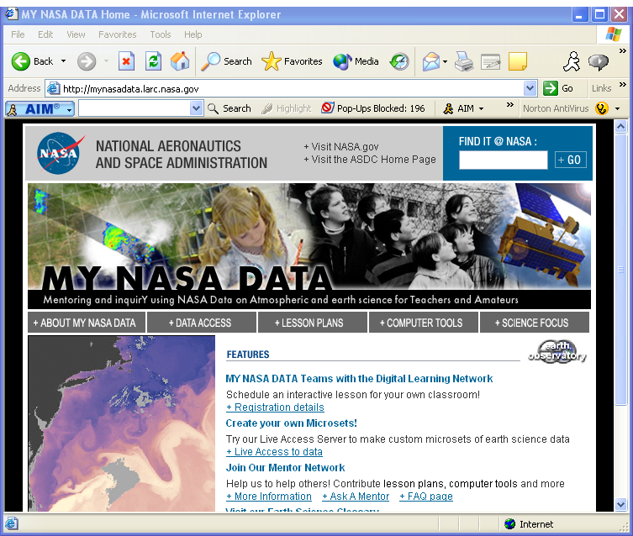

Click on DATA ACCESS

☞ Live Access Server
☞ Atmosphere
☞ Clouds
☞ Cloud Coverage
☞ Monthly Cloud Coverage (ISCCP)
☞ Next

☞ Change the select view: Time series
☞ Change the Select output: Tab separated (text)
☞ Enter Toronto’s Latitude and Longitude
43.41° N 79.41° W
☞ Your screen should look like this, then select next
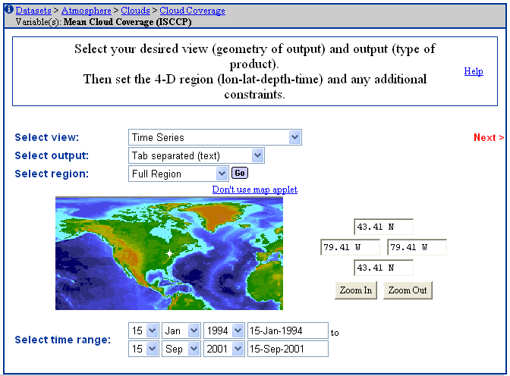

☞ Click on view output
☞ Download output into Microsoft Excel

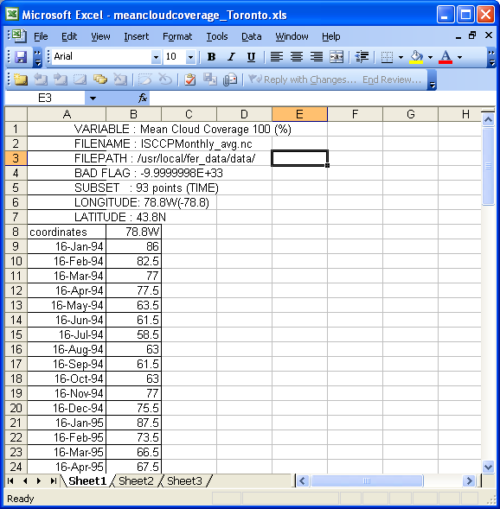

Complete a graph of the Month versus Mean Cloud Coverage

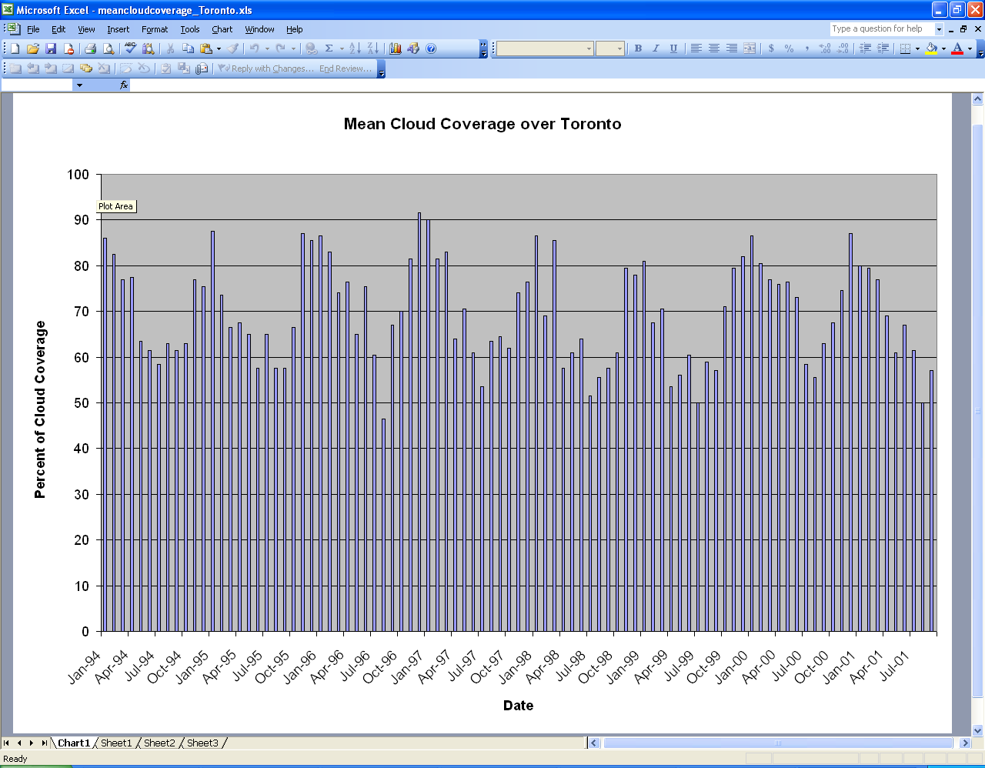

- Examine the graph, what patterns form?

- What possible explanations would exist for this pattern?

- Does this pattern exist with the other types of clouds, examine

  - Altocumulus
  - Cirrostratus
  - Cirrus
  - Cumulus
  - Nimbostratus
  - Stratocumulus
  - Stratus

- Write your conclusions below

Extensions

1. Examine the relationship between the various cloud cover and surface temperature.

- Scientists have been interested for some time in the global average cloud cover for Planet Earth. Estimates, from satellite data, generally vary from 50-70% or so (it depends on how well a particular satellite instrument can detect thin or small clouds). The ISCCP data (above) for Toronto are at or above the global average. One possible complication for ISCCP is snow cover in the Toronto area. In some cases, the satellite might misinterpret snow as cloud. Your mission, should you choose to accept it, is to find weather records, the amount of cloud cover in particular, for the Toronto area (or develop your own record by observing every day) to determine how accurate the ISCCP cloud cover data are for Toronto. If you develop your own record, you will have to compare it to the ISCCP data in a climatological sense, as ISCCP data are not ready until sometimes years after the measurements are taken.

To compare with ISCCP data in a “climatological sense”:

1. Obtain all the ISCCP data for cloud cover in Toronto (almost 6 years’ worth of data are in LAS).

2. Construct a climatology of cloud cover for Toronto from these data by averaging them to get a typical year. That is,
Mean January = (sum of January cloud cover for 6 years)/6
Mean February = (sum of Feb. cloud cover for 6 years)/6
...
Mean October = (sum of Oct. cloud cover - only 5 years)/5
Etc...

3. Compare this annual climatology to a year's worth of cloud observations.

OR if you find weather records for a single year in 1994-2001, for which ISCCP data are available; a direct comparison is possible. Keep in mind, though, that the geographical area (a square latitude/longitude box) covered by the ISCCP data will likely NOT be the same as the area of the weather record (maybe observations at Toronto’s airport, for example). So, the above statistical approach (Steps 1 and 2) may still be better.

