USDA Foreign Agricultural Service
GAIN Report

Template Version 2.09

Global Agriculture Information Network

Voluntary Report - public distribution
Date: 6/8/2005
GAIN Report Number: IS5001
IS5001
Israel
Product Brief
Race Horses
2005

Approved by:
Asif J. Chaudhry
U.S. Embassy, Cairo
Prepared by:
Gilad Shachar

Report Highlights:
Recently the social economic cabinet of Israel approved a plan to allow organized gambling on horse racing in Israel. The number of race horses is expected to increase from 250 to 1,200 (380 percent), in addition to the development of many supporting services. Two new hippodromes will be constructed, and it is estimated that horseracing gambling will begin in 2006. The future presents good opportunities for U.S. suppliers.

Includes PSD Changes: No
Includes Trade Matrix: No
Unscheduled Report
Tel Aviv [IS1]
[IS]

Market Overview:

Currently, the horse racing industry in Israel is very small, however it is expected to expand significantly in the immediate future, due to the approved plan by the social economic cabinet to legalize gambling on horse racing. However, the Israeli parliament (Knesset) must first approve the legislation for gambling at racetracks.

Events will be based at specially constructed hippodromes near the Gilboa area (northern Israel) and in the Negev region (south of the country). Besides two planned hippodromes, the proposal is expected to encourage entrepreneurs to invest in horse rearing infrastructure, veterinary hospitals, riding and training schools, breeding farms and to sustain local tourism around the two centers. According to industries sources, horserace betting will most likely start in 2006 and annual revenues are expected to reach $40-45 million for each of the next five years $223 million within five years.

Currently, there is one race track in Israel. It is located in Pardes-Chana (central Israel). The size of the site is 25 hectares. It was established in 1999 by a group of foreign and local businessmen and hosts approximately 10 contests per year.
The new hippodrome in the south of the country will open by the end of 2006. A 5,000 seats facility is planned for a 50 ha site. Israeli and French businessmen will invest approximately $15 million in the hippodrome. Three races per week are expected.

There are approximately 15,000 horses of all kinds in Israel (industry estimate), of which 6,000 are Quarters, 6,000 Arabian horses and the rest are Appaloosa, Tennessee Walkers, Paint, Andalusian and Thoroughbred horses. The figures are not official due to the fact that the majority of the horse owners raise their horses at their private own locations.
The two main horse associations in Israel are: Israeli Quarter Horse and the Arabian Horse.
There are 1,300 Quarters horses (official data) in Israel, of which half of them are males. Most of the Quarters were born in Israel. In addition, there are 3,000 Arabian horses (official data).

Approximately 250 racing horses exist in Israel, of which nearly 200 (80 percent) are Thoroughbreds and the remainder is Arabian horses and Quarters. The racehorse industry will demand approximately 1,200 horses, which means an additional import of 1,000 racing horses.

Import

In the last few years, approximately 90 horses were imported into Israel annually, mainly from the European Union (EU) and the USA. Most imports are of male horses, however demand for mares will increase in the immediate future. Live horse imports are not limited and are tax free.

Graph 1: Import of Live Horses, by Heads, Year

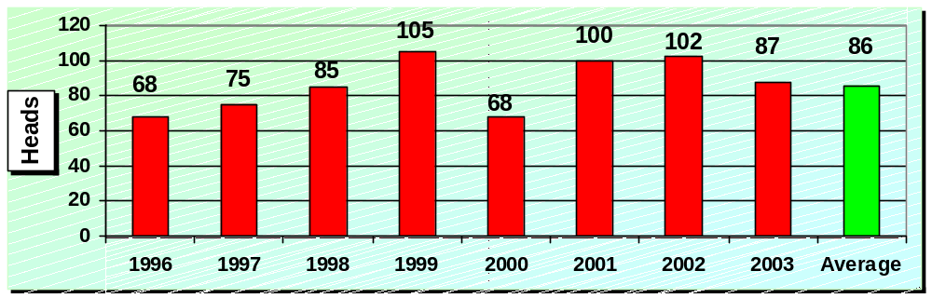
Source: Israeli Veterinary Services

Table 1: Imports of Live Horses, by Origin, Year, $ Thousands

 | Value ($ Thousands) |  |  | % of Total Import
Origin | 2000 | 2002 | 2003 | 2000 | 2002 | 2003
Belgium | 62 | 14 | 74 | 14.62 | 3.02 | 17.37
France | 10 | 0 | 5 | 2.36 | 0.00 | 1.17
Germany | 74 | 21 | 57 | 17.45 | 4.54 | 13.38
Netherlands | 144 | 133 | 24 | 33.96 | 28.73 | 5.63
U.K. | 0 | 44 | 18 | 0.00 | 9.50 | 4.23
Hungary | 10 | 11 | 0 | 2.36 | 2.38 | 0.00
U.S. | 118 | 240 | 244 | 27.83 | 51.84 | 57.28
Others | 6 | 0 | 4 | 1.42 | 0.00 | 0.94
Grand Total | 424 | 463 | 426 | 100.0 | 100.0 | 100.0
Source: CBS, Foreign Trade Statistics, Different Years.

Import Regulations

An application for the importation of horses must be made not less than 60 days before planned departure of the horse to enable the completion of required tests and attestations abroad. All imported horses shall be quarantined in an official quarantine station for a period of eight days or as decided by the director.
Contact details:
- The Director of Veterinary Services, Import-Export Officer P.O. Box 12, Beit Dagan 50250, Israel. Fax numbers are: 972-3-9688963 or 972-3-9605194; Tel: 972-3-9688986.
- The Israeli Nature & National Parks Protection Authority. Address: 3 Am VeOlamo St. Givat Shaul Jerusalem 95463 Israel. Tel: 972-2-5005463; Fax: 972-2-5005459.

Local Gambling Market

In 2003, the total domestic gambling market was estimated at $3.9 billion, of which $0.91 billion (22 percent) was legal gambling, $2.73 billion (70 percent) was illegal gambling and $0.23 billion was via the internet. Of the legal gambling total, $667 million (73 percent) was national lottery tickets and the remainder ($203 million) was sports contests.
In 2003, approximately 300,000 Israelis gambled abroad in the amount of $150 million.
In the last decade, the local gambling market has increased significantly, and it is expected to further expand in the near future. The horserace gambling market in Israel is expected to reach $223 million annually.

Graph 2: The Gambling Market in Israel, $, billion, 2003
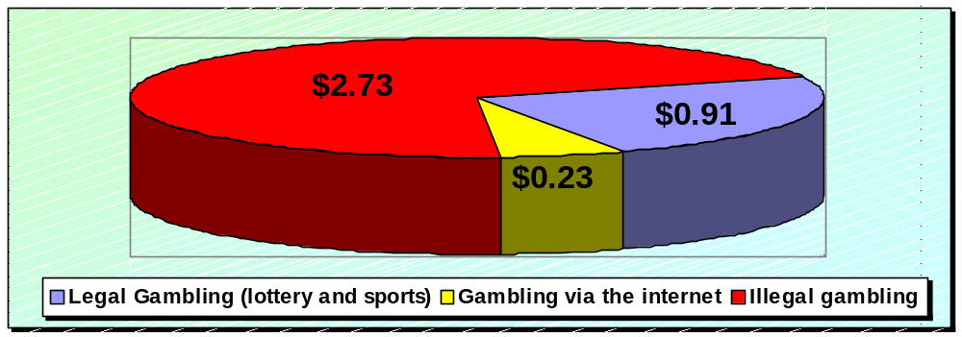
Source: University of Derby and BDI.

Business Opportunities in the Israeli Market

If the Israeli parliament approves the new plan, there will be an expected shortage of 1,000 race horses. In addition, demand for mares will increase, mainly for Quarters and Thoroughbreds. With the strengthening Euro, making many European products more expensive, it is likely that the demand for U.S. horses and products/services will increase. The best opportunities for importing live horses, products and services are during the next four years.

Table 3: Opportunities and Challenges for U.S. Exporters to Israel

Opportunities | Challenges
Legalized betting at horse races | U.S. exporters lack knowledge of the Israeli market and are unaware of new opportunities
Opening of two new race tracks in 2006/7 | Israeli buyers lack familiarity with U.S. sources
Lack of professional expertise | The intensive competition from the European Union, mainly Holland, Germany and U.K.
Lack of professional veterinarian and nutrition knowledge | Political and security conditions in the region are not conclusive for marketing activities that highlight U.S. products
Strong demand for Thoroughbred horses and a shortage of 1,000 race horses | Lack of awareness of new opportunities
Increasing demand for mares
Strong reputation of U.S. horses
With the euro getting stronger, it is likely that the demand for U.S. products may increase

Key Contacts and Further Information:

Israeli Quarter Horse Association - Ruthy Shadmot - Tel: 972-52-3666455
Dr. Tamar Milo – Tel: 972-54-4234685; E-mail: tamarm@netvision.net.il;
Web Site: www.ilqha.co.il

The Israel Equestrian Federation - Tel: 972-9-8850938; Fax: 972-9-8850939;
E-mail: office@ief.org.il; Web Site: www.ief.org.il/ief

Appaloosa Horse Club of Israel - Tel: 972-50-7808282; E-mail: il_appaloosa@yahoo.com
Web Site: http: http://ilappaloosa.tripod.com/index.htm

Arab Horse Association - Yiftach Shadmi – E-mail: yftach_s@walla.co.il;
Dr. Evelin Timor – E-mail: evelin_t@walla.co.il; Web Site: www.horse.co.il

The Israeli Jockey Club - Web Site: www.ph-racingclub-israel.co.il;
E-mail: isr-j-cl@zahav.net.il; Fax: 972-4-8524140; Tel: 972-4-8532081

The Israel Sports Betting Board - Web site: www.toto.org.il

Local Mailing address: Contact the Office of Agricultural Affairs in the U.S. Embassy in
Tel Aviv. Tel: 972-3-5197324/7686; Fax: 972-3-5102565;
E-mail: gilad.shachar@usda.gov; Web Site: http://www.usembassy-israel.org.il/fas/

