Software

DAVID Gene Functional Classification Tool: A novel biological module-centric algorithm to functionally analyze large gene list

Da Wei Huang^{1¶}, Brad T. Sherman^{1¶}, Qina Tan¹, Jack R. Collins³, W. Gregory Alvord⁴, Robert Stephens³, Michael W. Baseler⁵, H. Clifford Lane², Richard A. Lempicki^{1*}

¹ Laboratory of Immunopathogenesis and Bioinformatics, ⁵Clinical Services Program, SAIC-Frederick, Inc., National Cancer Institute at Frederick, MD 21702; ²Laboratory of Immunoregulation, National Institute of Allergy and Infectious Diseases, National Institutes of Health, Bethesda, MD, 20892; ³ Advanced Biomedical Computing Center, SAIC-Frederick, Inc., National Cancer Institute at Frederick, MD 21702; ⁴Computer & Statistical Services, Data Management Services, National Cancer Institute at Frederick, Frederick, MD 21702.

¶ These authors equally contributed to this study.
* Correspondence: Richard A Lempicki. E-mail: rlempicki@mail.nih.gov

E-mail addresses for authors:

Da Wei Huang huangdawei@mail.nih.gov

Brad T. Sherman bsherman@mail.nih.gov

Qina Tan tanq@mail.nih.gov

Jack R. Collins collinsj@ncifcrf.gov

W. Gregory Alvord gwa@css.ncifcrf.gov

Robert Stephens bobs@ncifcrf.gov
Michael W. Baseler mbaseler@mail.nih.gov

H. Clifford Lane clane@niaid.nih.gov

Richard A Lempicki rlempicki@mail.nih.gov

ABSTRACT
Numerous high-throughput genomic technologies, including microarray and proteomics platforms, generate large lists of genes. Major effort has been focused on algorithms to rapidly summarize enriched biological processes associated with gene lists. However, these algorithms usually do not take advantage of the rich inter-relationships between genes and biological terms. To address this issue, we developed the DAVID Gene Functional Classification Tool, which uses a novel fuzzy clustering algorithm to quickly condense a list of genes or associated biological terms into organized classes of related genes or biology, called biological modules. This organization is accomplished by mining the complex relationships found in 14 sources of functional annotation. Classes are ordered based on overall enrichment scores of each member, and tools are provided to better understand gene-to-term relationships within a class.
The DAVID Gene Functional Classification Tool provides a powerful method for investigators to group functionally related genes and terms into a manageable number of functional biological modules to more efficiently interpret genome-scale datasets. The tool is a component of the freely available DAVID Bioinformatics Resources (http://david.abcc.ncifcrf.gov).

RATIONALE
Biological interpretation of large gene lists derived from high-throughput genomic or proteomic studies can be a challenging and daunting process. Some of the difficulties include: 1) acquiring large amounts of functional annotation for every gene; 2) the distributed nature of annotation across numerous sources, i.e., not centralized; 3) summarizing which genes are associated with specific biological processes and ranking these processes by over-representation analysis; 4) condensing repetitive or redundant annotation data; 5) identifying functional biological modules consisting of related genes and terms, and 6) viewing inter-relationships between groups of genes and groups of biological terms. A number of publicly available bioinformatics tools have addressed points 1-3 above, including, but not limited to, GoMiner, DAVID, EASE, GOstat, Onto-express, GoToolBox, FatiGO, GOSSIP, GFINDer, GOBar, etc. [1-25]. The power of many of these applications is to systematically highlight the most over-represented biological terms, out of a list of hundreds or thousands of terms, to increase the likelihood of investigators identifying biological processes most pertinent to the biological phenomena under study [17]. While these tools are extremely useful, they are still weak in mining the many-to-many gene-to-term relationships found in functional annotation databases, as well as in condensing redundant content.
Individual genes can clearly be associated with multiple biological terms and, conversely, individual biological terms can be associated with multiple genes. These associations form a complex relationship network of “many-genes-to-many-terms” which represents the true complex nature of biological processes. Data-mining tools that can extract these complex and redundant relationships should be able to identify functional gene-term biological modules. This identification can be accomplished by using exploratory statistical methods that identify groups of genes sharing similar biological terms or, alternatively, identifying groups of biological terms sharing similar genes. For example, if a subset of genes in a list is sodium transporters, then one can expect that they will have major functional annotations in common. A method that can group these genes based on the strength of overlap of the functional annotation should identify modules of related genes and terms. Similarly, terms that have many genes in common can also be grouped into a module of related terms and genes; for example, the terms “apoptosis”, “cell death”, “death”, and “regulation of cell death” will be grouped together because these terms share a large number of common genes. The advantages of this method of classifying groups of genes and terms into biological modules are: 1) it largely reduces redundant results into a manageable size; 2) it is much easier to understand and visualize gene-to-gene, term-to-term, and gene-to-term relationships, since related genes and terms are brought together in one place; and 3) it is much easier to relate biological modules of interest to a study than it is to relate hundreds of individual terms.
To this end, we developed the DAVID Gene Functional Classification Tool and the DAVID Functional Annotation Clustering Tool to provide a module-centric approach for functional analysis of large gene lists. First, we developed a new method to measure gene-gene similarity, based on the assumption that genes that share global functional annotation profiles are functionally related to each other. Conversely, we measure term-term similarity based on the assumption that terms that share global gene profiles are functionally related to each other. Then, a novel fuzzy heuristic partitioning method was developed to group related genes or terms into functional groups (biological modules) based on the similarity distances measure. The fuzziness feature of the partitioning method allows a gene or term to participate in more than one functional group, better reflecting the true “multiple-roles” nature of genes that can be lost if exclusive methods, such as Hierarchical, K-mean, or SOM clustering are used. Functional groups are ranked based on all group members’ overall participation in the enriched biological processes associated with the total gene list. A global view of group-to-group relationships is also provided through a unique fuzzy heat map visualization. A subset of “drill-down” functions associated with each biological module allows investigators to explore and visualize relationships between genes and terms. In this paper, we will mainly describe the key algorithms associated with the DAVID Gene Functional Classification Tool, illustrate the usefulness of several of the functionalities, and demonstrate how quickly investigators can apply the information in a biological module to their study.

IMPLEMENTATION
The DAVID Gene Functional Classification Tool (http://david.abcc.ncifcrf.gov/gene2gene.jsp) and DAVID Functional Annotation Clustering Tool (http://david.abcc.ncifcrf.gov/summary.jsp) are two new components integrated in DAVID Bioinformatics Resources (http://david.abcc.ncifcrf.gov). They were designed as a server-client application on a UNIX server, with the Tomcat web server as the serving engine. Java is the primary language used for calculations as well as the user interface which utilizes Java Server Page (JSP) technology. In-memory Java data objects containing all mappings between genes and annotation were developed to advance the calculation speed. The DAVID Functional Annotation Clustering Tool uses the same algorithm as DAVID Gene Functional Classification Tool, but conversely. Therefore, to illustrate the key scientific concepts, we only describe the major procedures of the DAVID Gene Functional Classification Tool; these procedures consist of three major steps: measurement of functional relationship of gene pairs, heuristic fuzzy partitioning of genes into functional gene groups, and visualization of results in text and graphic modes (figure 1).
A novel approach to measure functional relationship of gene pairs based on the similarity of global annotation profiles.
The traditional ways of grouping related genes are based on either sequence similarity (sequence homologs), functional categories (protein domain families), or co-expression clusters (microarray clusters). In fact, the majority of co-functioning genes are neither sequence-related nor in the same protein families, such as genes in the same pathway. Therefore, the traditional phylogenetic grouping methods are powerful for evolution-based studies, but too specific and strict to be of much use in classifying genes for the purpose of functional annotation. We propose a novel method to identify related genes by measuring the similarity of their global annotation profiles based on the hypothesis that if two genes have similar annotation profiles, they should be functionally related. This method is able to identify much broader gene groups in which genes share major common biological features as well as tolerate some differences. For example, many different types of genes, with or without too much sequence similarity, could be grouped into a transcription regulation class. We believe that the broader functional groups are more useful for functional annotation purposes and hence, biological interpretation.
Firstly, a gene-term annotation matrix (figure 2 A) was compiled in a binary mode using thousands of annotation terms in 14 annotation categories (including Gene Ontology [GO], Biological Process, GO Molecular Function, GO Cellular Component, KEGG Pathways, BioCarta Pathways, Swiss-Prot Keywords, BBID Pathways, SMART Domains, NIH Genetic Association DB, UniProt Sequence Features, COG/KOG Ontology, NCBI OMIM, InterPro Domains, and PIR SuperFamily Names) collected in the DAVID knowledgebase [26] (additional file 7). Then, Kappa statistics, a chance-corrected measure of co-occurrence between two sets of categorized data, is adopted to statistically measure the annotation co-occurrence of any given gene pairs [27] (additional file 11). Since the annotation profile is in a binary categorical scale, kappa statistics are more suitable than the Pearson correlation, which is typically used for continuous, non-categorical data.
For given annotation profiles of genes m and n, O_{mn} represents the observed co-occurrence; A_{mn} represents chance co-occurrence; and K_{mn} is the kappa value representing the degree of annotation co-occurrence between genes m and n.
K_{mn}
=
O_{mn} - A_{mn}
1 - A_{mn}

Where K_{mn} is 1 for perfect co-occurrence and 0 for co-occurrence no better than random chance (figure 2 B).
While building the binary annotation matrix, the annotation terms could be redundant or in a structured relationship because many terms from different sources may have the same biological meaning; in addition, GO terms fall into a parent-child relationship in the GO hierarchical structure. We broke all redundant and structured terms into “independent” terms in a flat, linear collection (figure 2 A). We believe that an equally weighted, linear, all-inclusive strategy can greatly simplify the situation, as well as maximally leverage the heterogeneous annotations in the similarity measurement (additional file 12) . To answer the question, “Can this strategy specifically detect the real relationship of gene-gene?”, we conducted three studies. The first was to compare the kappa score distribution of every possible pair of human genes (~300 million pairs) to that of reported human protein-protein interaction pairs [28]. If the similarity measurement can specifically detect gene-gene relationships rather than random noise, we would expect to see the score distribution of the protein-protein interaction pairs to shift to the higher value end (figure 3 B). The second study was to detect the kappa score distribution of genes specifically selected because their names contained the word chemokine. Since we selected genes with an extreme bias of similarity, we expected the kappa scores to give much higher values (figure 3 B). The third study was to compare the kappa score distribution of all human gene pairs to that of artificial gene pairs with annotation profiles randomly generated, based on the true human annotation frequency. It was expected that the simulated kappa scores would only be located in the lower value end (figure 3 B). The three independent studies, combined with the extensive test analysis on microarray datasets, strongly supported the strategy that functional similarity measurement is able to specifically detect gene-gene relationships, particularly for the pairs with a kappa score 0.35 or above, as suggested by our randomization study (figure 3B). However, since the measurement relies on known annotation profiles, this method will obviously not work for the genes that lack annotation (figure 3 A) (additional file 10).

A novel fuzzy heuristic partitioning approach to classify a gene list into functionally related groups based on the functional similarity scores.
After the kappa score matrix of all possible pair-wide genes is calculated, it is possible to classify the highly related genes. We examined the typical clustering methods, including hierarchical tree, K-mean, hierarchical, FANNY, and SOM. All of them produced weaker clustering results (additional file 5) with our test datasets. The poor clustering results stem from one or more of the following weaknesses associated with the aforementioned clustering algorithms: 1) Genes must be assigned to one cluster, even though their absolute relationship is weak to all clusters. This results in higher contamination of clusters with noise by forcing membership of weakly related genes. 2) Genes can only belong to one cluster, which does not align well with the basic biological nature that of genes, in that one gene could participate in multiple, different roles. 3) Outliers and uneven cluster sizes can greatly affect clustering quality. 4) It is difficult to know the optimal K (number of clusters) for K-means, FANNY, or SOM.
This situation motivated us to develop a novel partitioning approach, heuristic fuzzy multiple-linkage partitioning, to better reflect the structure of functional annotation data. It can be described as three major steps (figure 4, additional file 13):
- Multiple initial seeds: Each gene is selected to serve as a medoid, or center of an initial cluster, as long as it meets minimum relatedness (user input parameters, such as genes, are related to more than 3 other genes with kappa >0.3) to other genes in the list.
- Merge seeds by a minimum, multiple linkage (i.e., merge two seeds when they share 50% of their group members).
- Repeat Step 2 until no more merging can occur.
This novel method works better than others for this particular type of analysis (additional file 5). This method: 1) eliminates overall irrelevant/weak elements, as orphan genes, to significantly push the signal out of noise; 2) allows for fuzziness by allowing genes to be assigned to more than one cluster which aligns with the biological nature; 3) automatically determines the number of clusters (K value); 4) generates grand groups for easy interpretation; 5) tolerates outliers extremely well by excluding them in step 1.
There is no gold standard or null hypothesis to evaluate clustering methods and hence no right or wrong answers for any given clustering algorithm. One method may work better than others in the sense that it is more sensitive to the natural structure of a particular problem. However, this method, like any other heuristic approach, has the common weakness that an improper running criteria setting can lead to distorted results. In order to aid less advanced users with the setting of these criteria, we preset 5 general levels representing combinations of the detailed settings from very low to very high stringencies; and based on our extensive tests on multiple datasets, the default stringency level (medium) (additional file 10) should be optimal for most of the cases.
To further examine the sensitivity (type I error) and specificity (type II error) of the heuristic fuzzy partitioning method, we tested the clustering method with two independent gene lists from our microarray studies. For the sensitivity test, each orphan gene eliminated by step 1 was post-examined to determine if it should be included in any of the final groups by satisfying the minimum kappa threshold (>=0.35) with a majority of group members (>=50%). Any orphan genes qualifying to be post-assigned to one or more of the final groups would be considered as “leaks” (false negative). We observed the leaking rate (type II error) to be between 1 and 2%, which falls into the generally accepted rate of less than 5%. For the specificity test, kappa distributions of all possible gene pairs within each group show 1-3% of kappa scores below the minimum kappa threshold. We found that a typical classification job usually results in an ~1-5% false positive rate, an ~1-5% false negative rate and with ~20% of genes being eliminated as “orphan genes.” Most importantly, the method is able to identify key members of groups so that the major biology of each group can quickly be determined. Since the analytic approach is biological module-centric, the major biology associated with each gene group is determined by the majority of gene members rather than by individual genes. Thus, the biology of each group should be very stable, even though there is a small chance that a few members could be missing (type II error). In summary, this clustering method shows reasonable performance by eliminating irrelevant, “noisy” genes and by bringing together strongly related functional groups, while maintaining the fuzzy nature of biology.
The last question is, “Which final functional gene groups are more significant for the experiment?” We extended the traditional enrichment analysis logic so that a gene group is more important if a majority of its gene members is associated with highly enriched annotation terms as found in the traditional enrichment analysis of the total gene list. Thus, the enrichment score of each group is measured by the geometric mean of EASE Scores (modified Fisher Exact) [2] of the enriched annotation terms related to the group. In order to emphasize that the geometric mean is a relative score instead of an absolute p-value, minus log transformation is applied on the geometric mean (additional file 6). Therefore, the group enrichment scores are intended to order the relative importance of the gene groups instead of as absolute decision values. A higher score for a group indicates that the group members are involved in more important (enriched) roles.

Visualization of results in a very simple text format and a novel fuzzy heat map view
We implemented both a very simple text format (figure 5) and a comprehensive novel fuzzy heat map graphic view (additional file 4) to present the functional groups derived from the above procedure. The text format simply lists all functional gene groups identified by the algorithm. Although it looks like linear format, the view allows the user to visualize the multidimensional data of the groups, i.e., group members consisting of multiple related genes and terms. Users are able to easily explore the major functional groups by viewing many related genes and annotation terms brought together by the tool. Some accessory, “drill-down” functionalities (e.g., Enriched Terms Report, 2-D View, etc.) (figure 5) are available for each functional group for users to rapidly explore the associated biology in detail. For example, the “Enriched Term Report” button lists the major annotation terms associated within the functional groups based on the DAVID enrichment engine; the “2-D View” button gives the detailed relationship of genes-to-terms in a 2-dimensional heat map view so that the user is able to examine the rich relationship of related genes and annotations in-depth (figure 6); the “Related Genes” button allows users to refine the group gene members in different scopes, which can extend the membership of interest and also correct potential type I & II errors in the clustering algorithm (additional file 9 C). Furthermore, the text format provides links to the list of orphan genes not classified into any functional groups. These genes are orphaned because they do not meet one or more of the partitioning criteria (i.e., group membership thresholds, etc.) The list is provided since they may be important genes for the user to examine.

RESULTS AND DISCUSSION
We examined the newly developed biological module-centric tools (see additional file 8 for graphic tutorial of using the tools) on a published microarray dataset of which the gene list was available as demo list 2 on our tool entry page [29]. It is important to mention that, to avoid potential bias, the dataset of this case study is different than those used during algorithm development. In this example dataset, authors treated freshly isolated peripheral blood mononuclear cells (PBMCs) with an HIV envelope protein (gp120) and further measured genome-wide gene expression changes using Affymetrix U95A chips [29, 30]. This study provides a global view of the complex interaction between viral and cellular factors, which is an essential mechanism for HIV replication in resting or suboptimally activated PBMCs. A functionally significant annotation of ~400 genes (additional file 1) derived from the microarray experiment, was classified by the authors into five major functional categories: Cytokines, Chemokines, Transcription Factors, Kinases, and Membrane Fusion [29]. While the Cytokine and Chemokine categories were systematically highlighted by EASE (a Gene Ontology enrichment analysis based on the Fisher Exact Test) [2], other annotation categories reported in the publication were discovered through semi-manual analysis by bioinformatics experts with an advanced level of knowledge of both biology and computer tools.

The same data re-analyzed by typical Functional Annotation Tools
After the continuous additions of annotation for genes as well as the refinement of gene-term enrichment algorithms during the years since this study was published, it is interesting to see how the systematic results from current functional annotation tools compare to those reported in this publication. Some of the popular functional annotation tools, such as DAVID Gene Functional Annotation Tool, GOStat, and GoMiner [1, 3, 16], were chosen to identify major biological terms with the same gene list, respectively. In order to maximally reflect the design spirit of each tool and also make the results more comparable, we kept all default parameters of the tools unchanged, except for synchronizing the data coverage scope within all GO levels (DAVID covers multiple data sources and GOstat covers GO level 3 or above by default). Although all of the testing tools are based on similar gene-term enrichment algorithms, the sensitivity and specificity could be different due to different updates of GO data content, different background gene lists, different ranking score algorithms, different gene ID mapping schemes, etc. After obtaining hundreds of annotation terms reported by each of the above tools, the top 20 terms were compared with each other (table 1). Approximately 30% of the top terms overlapped between at least two of the tools, e.g., cytokine/chemokine activity, inflammatory response, etc. Even though the results from the tools all point in the same biological direction, there are four obvious problems: 1) Redundant/similar terms appear in different (significance) levels within the reports, (e.g., response to stress, response to wounding, response to pathogenic bacteria, response to other organisms, response to external biotic stimulus, inflammatory response, etc.), which makes it difficult for the user to gain or maintain a clear focus of the whole biological picture. It is not easy for users to comprehensively pool all genes related to the same key biology without manually summarizing all related redundant terms. 2) The redundancy of terms could largely dilute the focus on other key biology which has few or no redundancies (e.g., only one term is for establishment of cellular localization). If several redundant terms are represented in the top of the list, less redundant terms may be pushed down the list, possibly decreasing the chance of discovery; for example, a transcription regulation term, reported in an original publication, was not listed in the top 20 by any of the tools). 3) In contrast, due to differences of the annotation levels of different sources, redundant terms may themselves be diluted. While alone a single term may not be at the top of the list, in combination with redundant/similar terms, the biological function may be very significant. 4) Current tools do not emphasize the inter-relationships between key biological terms (e.g., relationships between chemokine/cytokine and signal transduction).
In conclusion, the recent improvement of functional annotation tools provides a powerful means for users to systematically identify key biological functions associated with a gene list. However, due to the weaknesses discussed above, refinement of current gene-term enrichment algorithms and improvement of software usability alone may not address all the issues. Therefore, the development of novel alternative algorithms as a complement is still very necessary.

The same data analyzed by the DAVID Gene Functional Classification Tool
The same gene list (additional file 1) was submitted to our newly developed DAVID Gene Functional Classification Tool described previously (additional file 8). The tool is able to efficiently handle up to 3000 genes at a time, within a few seconds. The tool classified the ~400 genes into 16 functional groups (table 2 and additional file 2). The result is much more focused, simplified, and in a manageable size for investigators’ interpretation comparing to a few hundred terms, of which many are redundant from the traditional tools. More importantly, all five reported annotation categories are covered by the 16 functional groups (table 2). In addition, the tool also lists another 11 interesting gene groups not reported in the original publication. For example, group 13 (tubulin genes) plays a critical role in the nucleation of microtubule assembly. Some studies suggest that HIV infection leads to enteric microtubule depolymerization, resulting in increases of HIV permeability [31]. This tool focuses on the overall major common annotation terms associated with a gene group rather than one term or one gene at a time, thereby producing clearer, more concise results that can better allow for focus on the major biology of the experiment. The tool simplifies the results by condensing the redundant terms and summarizing inter-relationships. This analytic logic and presentation format closely mimics how the human brain works and the results better represent the nature of biology.
The DAVID Gene Functional Classification Tool allows users to further explore a given biological module/gene group in-depth. For example, the enriched terms button “2D View” is able to list all related terms and genes for these kinase group. Thus, a user who is not familiar with kinases can explore the terms of kinase activity, transferase activity, ATP-binding, nucleotide binding, protein metabolism, tyrosine specificity, serine/threonine specificity, regulation of G protein signaling, and signal transduction, etc. in one view at the same time (figure 6). Therefore, we can quickly learn the biology for the kinase group with the above related terms in a single view and also identify the fine differences among them. For example, there are two G-protein coupling receptor kinases, three protein tyrosine kinases and 6 kinases involved in cell surface receptor-linked signal transduction among the 23 kinases within the group (figure 6). The fine details may be very important to pinpoint the key biology associated with the study.
Furthermore, the DAVID Gene Functional Classification Tool allows one gene to be present in more than one functional group, which closely reflects the nature of biology whereby one gene could play multiple roles in different processes. This fuzziness feature improves the chances of discovery by maximally preserving all of the true relationships. For example, general transcription factor II H (GTF2H4/TFIIH, 41371_at) was assigned to group 2 (transcription regulation group) and group 5 (DNA damage/repair group), respectively (additional file 2). Some studies suggest TFIIH increases polymerase processivity in HIV infection [32]. Currently, there are few reports about the TFIIH DNA repair mechanism being involved in HIV infection, although this DNA repair mechanism could be essential in HIV integration. Hence, the fuzzy capability allows users not only to focus on the TFIIH transcription regulation role but also to consider the possible role in HIV integration through the DNA repair mechanism. For another example, ring finger protein 40 (RNF40) is in group 2 (transcription regulation group) and group 10 (chromosome assembly) (additional file 2). Although the biological significance of ring finger protein in HIV infection is still largely unclear, the annotation result points out two potential areas for further exploration: 1. Ring finger protein regulates the TNF-related transcriptional pathway, which is critical to many aspects of HIV transcription. 2. It plays some role in DNA packaging and chromosome integration. Thus, the fuzziness capability is a powerful feature to maximally preserve the biological patterns and to discover fine differences of the same gene as compared to the exclusive methods.
The sensitivity of the Functional Classification Tool can vary with different datasets and stringency criteria. If the running criteria are not suitable to a particular dataset, the output can be distorted. In such cases, some exploration of different running stringencies is necessary in order to obtain the optimal results to meet the expectation of the study.

The same data analyzed by the Functional Annotation Clustering Tool
Due to the redundancy problems in the results obtained from traditional annotation tools (table 1), a Functional Annotation Clustering Tool was also developed to organize the highly redundant annotation term results into a simplified and clustered format. This new format allows investigators to focus on an annotation group level by quickly skipping many redundant terms within the group. Compared to 222 individual terms reported by the DAVID Functional Annotation Tool, a traditional term-centric enrichment method, the new tool was able to organize them into 65 annotation clusters (additional file 3). For example, the Annotation Cluster 3 (immune-response group) consists of 11 redundant terms, i.e., response to stress; inflammatory response; response to external stimulus; response to pest, pathogen or parasite; etc. These similar terms are spread throughout the traditional term-centric enrichment report list of 222 terms. Most importantly, the top 20 annotation clusters (table 3 and additional file 3) contain all annotation categories reported by the original publication, as well as interesting groups not identified. The highly organized and simplified annotation results allow users to quickly focus on the major biology at an annotation cluster level instead of trying to come to the same conclusions by putting together pieces which are scattered throughout a list of hundreds of terms. In addition, the annotation cluster is helpful in comprehensively pooling all related genes associated with an annotation cluster consisting of many related terms. For example, each of the 11 terms within Cluster 3 (immune-response cluster) associates with different genes. A pooled gene list brought together by cluster 3 regarding immune-response could be much more comprehensive, compared to the genes selected from one or a few individual terms. Moreover, the tool could possibly bring up the terms not passing the minimum enrichment threshold but highly related to other terms with significant enrichment scores. In conclusion, the clustered result condenses the data into smaller, much more organized biological term modules, which allows investigators to quickly and comprehensively focus on the key biology of interest.

CONCLUSIONS
The DAVID Gene Functional Classification Tool is able to organize and condense large gene lists into biologically meaningful modules. It changes functional annotation analysis from term- or gene-centric to biological module-centric. This method takes into account the redundant and network nature of biological annotation contents in order to concentrate on the larger biological picture rather than an individual term or gene. The DAVID Gene Functional Classification Tool is complementary to other functional annotation tools. The unique clustering and visualization techniques developed for this project can be extended to other applications, such as microarray expression analysis.

LIST OF ABBREVIATIONS

DAVID Database for Annotation, Visualization and Integrated Discovery

GO Gene Ontology

PIR Protein Information Resource

NCBI National Center for Biotechnology Information

NIAID National Institute of Allergy and Infectious Diseases

ABCC Advanced Biomedical Computing Center

SOM Self-Organizing Map

PBMC peripheral blood mononuclear cells

LIB Laboratory of Pathogenesis and Bioinformatics

ACKNOWLEDGEMENTS
The authors are grateful to the reviewers for their constructive comments. We would like to thank David Liu and David Bryant in the ABCC group for database and web server support. We thank Yongjian Guo in BSSP/OTIS/NIAID for his comments on the manuscript. We would like to thank Wei Gao, Melaku Gedil, Ping Ren, and Jun Yang in the LIB group for helpful works and discussions, and Doug Powell in the CS&S group for helpful statistical discussions. We also thank Bill Wilton and Mike Tartakovsky for information technology and network support. The project has been funded in whole with federal funds from the National Institute of Allergy and Infectious Diseases (NIAID), National Institutes of Health (NIH) through the National Cancer Institute, National Institutes of Health, under contract N01-CO-12400. The content of this publication does not necessarily reflect the views or policies of the Department of Health and Human Services, nor does mention of trade names, commercial products, or organizations imply endorsement by the U.S. Government.

REFERENCES

FIGURE LEGENDS

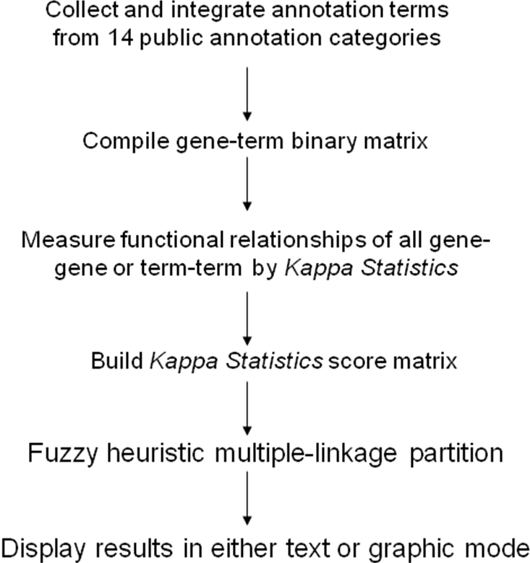

Figure 1. Flow chart of the procedures for the DAVID Gene Functional Classification Tool and the DAVID Functional Annotation Clustering Tool.
A

 | Cell death | Apoptosis | Ph domain | Sh2 domain | Apoptosis pathway | Membrane
Gene a | 1 | 1 | 0 | 0 | 1 | 0
Gene b | 1 | 1 | 0 | 1 | 1 | 0
Gene c | 1 | 0 | 0 | 1 | 1 | 1
Gene d | 1 | 1 | 0 | 0 | 1 | 1
Gene e | 0 | 1 | 1 | 1 | 1 | 1
Gene f | 0 | 0 | 1 | 1 | 0 | 1
Gene g | 0 | 0 | 1 | 1 | 0 | 1

B

O_{ab}
=
C_{1,1} + C_{0,0}
T_{ab}
=
3 + 2
6
=
0.83
A_{ab}
=
=
= 0.5
C_{*,1 •} C_{1,*} + C_{*,0 •} C_{0,*}
T_{ab •} T_{ab}
3 • 4 + 3 • 2
6 • 6
K_{ab}
=
O_{ab} – A_{ab}
1 - A_{ab}
=
1 – 0.5
= 0.66
Gene a
Gene b
0
0
1
1
3 (C_{1,1}) (c11(c11)
2 (C_{0,0})
1 (C_{0,1})
0 (C_{0,1})
Row total
Column total
3 (C_{*,1})
3 (C_{*,0})
6 (T_{ab})
2 (C_{0,*})
4 (C_{1,*})

0.83 – 0.5

Figure 2. A hypothetical example to detect gene-gene functional relationship by kappa statistics. A. The all-redundant and structured terms are broken into ‘independent’ terms in a flat linear collection. Each gene associates with some of the annotation term collection so that a gene-annotation matrix can be built in a binary format, where 1 represents a positive match for the particular gene-term and 0 represents the unknown. Thus, each gene has a unique profile of annotation terms represented by a combination of 1s and 0s. B. For a particular example of genes a and b, a contingency table was constructed for kappa statistics calculation. The higher kappa score (0.66) indicates that genes a and b are in considerable agreement, more so than by random chance. To flip the table 90 degrees, the kappa score of term-term can be achieved, based on the agreement of common genes (not shown).

Figure 3
A

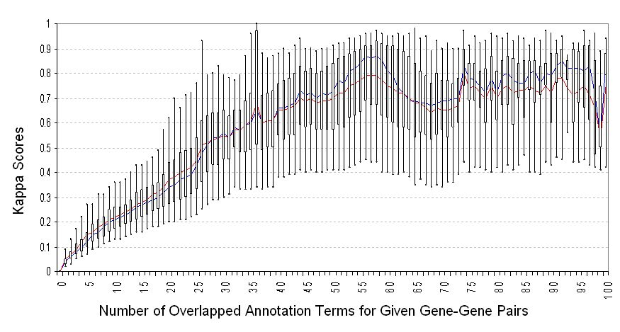

B.
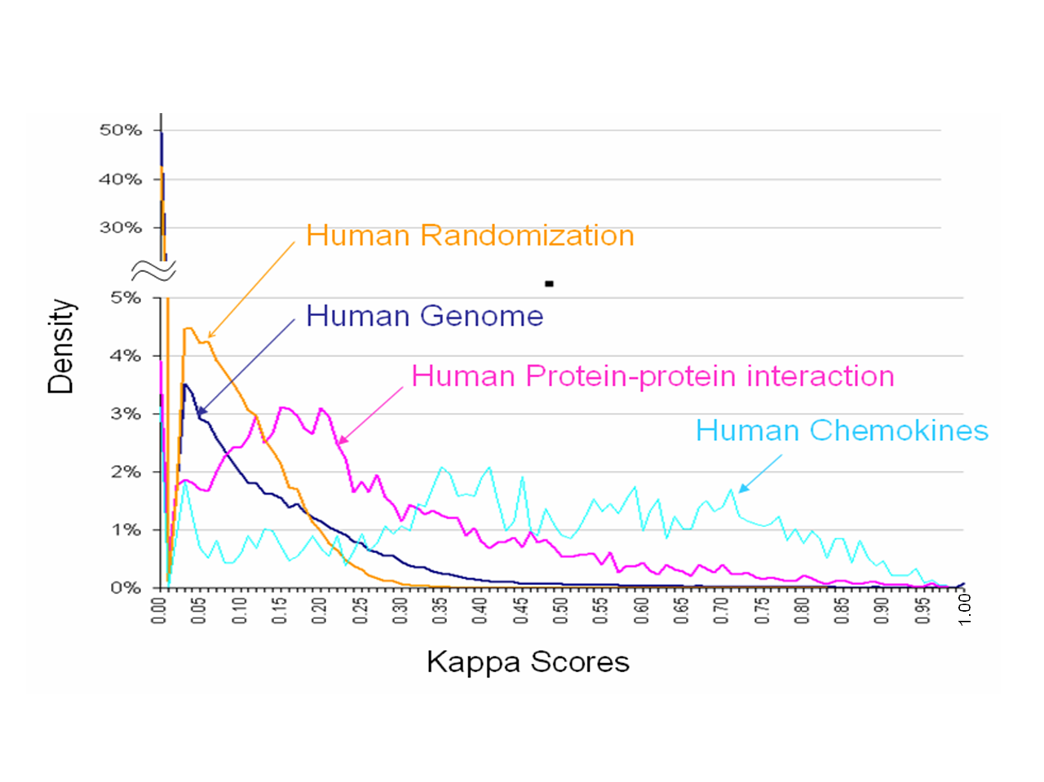

Figure 3. The gene-gene functional relationship can be specifically detected by kappa statistics. A. Kappa scores were calculated for all possible combination of human gene-gene pairs (~300 million). Only gene-gene pairs with a higher number of annotation terms in common possibly have good kappa values. B. Kappa scores were calculated for all possible human gene-gene pairs, gene-gene pairs with randomized annotation terms, all collected protein-protein interacting pairs, and all chemokine gene pairs respectively. The distributions of those kappa scores from protein-protein interacting pairs (pink) and chemokine gene pairs (light blue) significantly shift to the high value end compared to human total (blue); conversely, the kappa score distribution (yellow) of gene pairs with randomized annotation terms remains in the lower value end below 0.35. Interestingly, for the human genome (blue), over 50% of the kappa scores equal 0 (no detectable relationships) and >95% are lower than 0.35. All together, this indicates that kappa statistics can specifically detect the functional relationship of gene-gene.
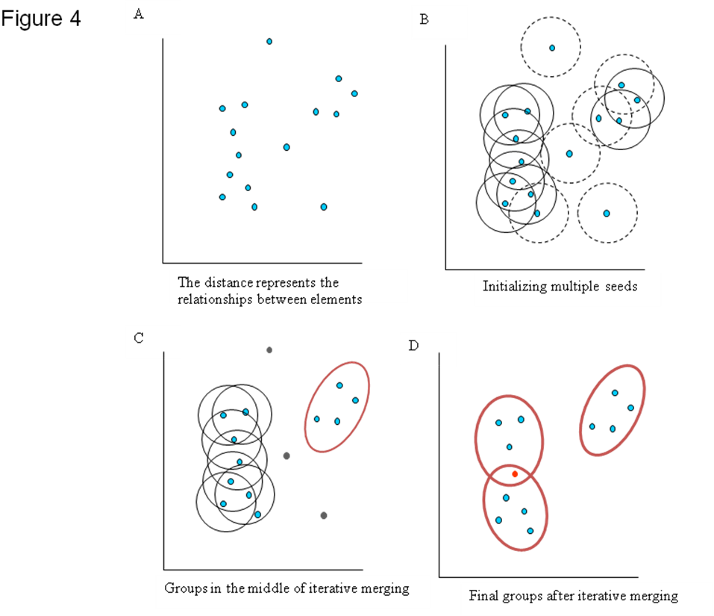
Figure 4. Graphic illustration of the heuristic fuzzy partition algorithm. A. Hypothetically, each element (gene) can be positioned in a virtual two-dimensional space, based on its characters (annotation terms). The distance represents the degree of relationship (kappa score) among the genes. B. Any gene has a chance as a medoid to form an initial seeding group. Only the initial groups with enough closely related members (e.g., members >3 and kappa score >= 0.4) are qualified (solid-line circle). Conversely, unqualified ones are in dash-line circles. Importantly, the genes not covered by any qualified initial seeding group are considered as outliers (in gray), which are carried along, but do not participate in the next steps. C. Every qualified initial seeding group is iteratively merged with each other to form a larger group based on the multi-linkage rule, i.e., sharing 50% or more of memberships, until all secondary clusters (thicker oval) are stable. D. Finally, three final groups (thicker oval) are formed because they can no longer be merged with any other group. One gene (in red) belonging to two groups represents the fuzziness capability of the algorithm. And outliers (in gray) are removed for clearer presentation.

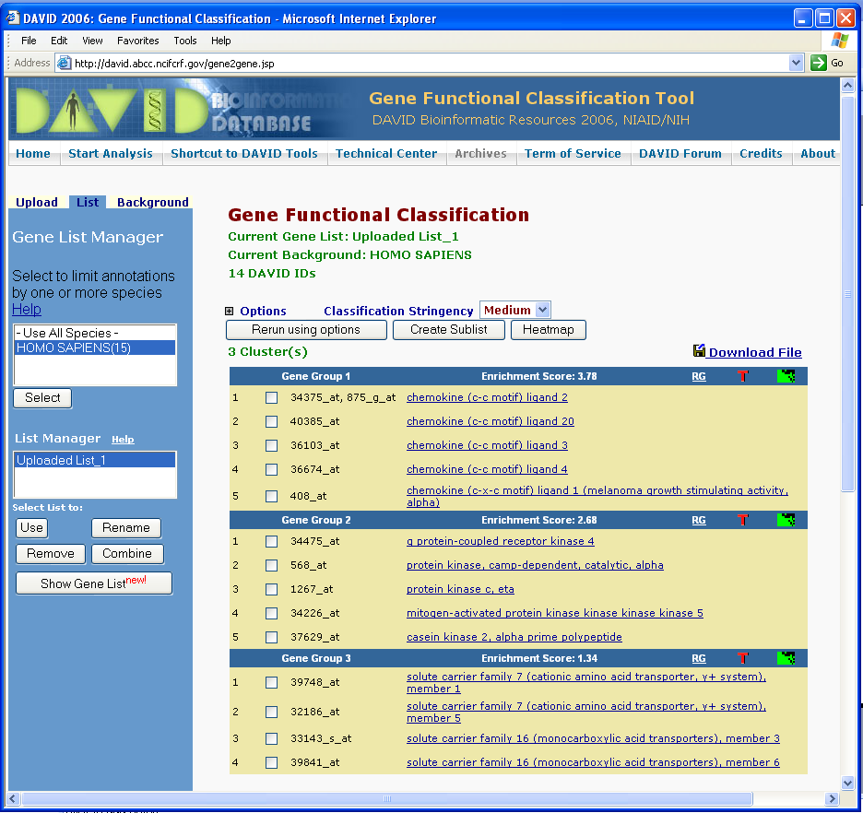
Figure 5. A text format report from the Gene Functional Classification Tool. The example shows the output of 16 genes (additional file 1) analyzed by the tool with default setting. Without prior knowledge, the tool is able to classify genes into three gene functional groups. On each group header, a set of buttons is provided for in-depth exploration of the annotation for the group. “T” reports the major enriched annotation terms associated with the group. The “Heat Map” symbol provides a detailed graphic view of gene-term relationships. “RG” searches other related genes in the genome but not in the list.

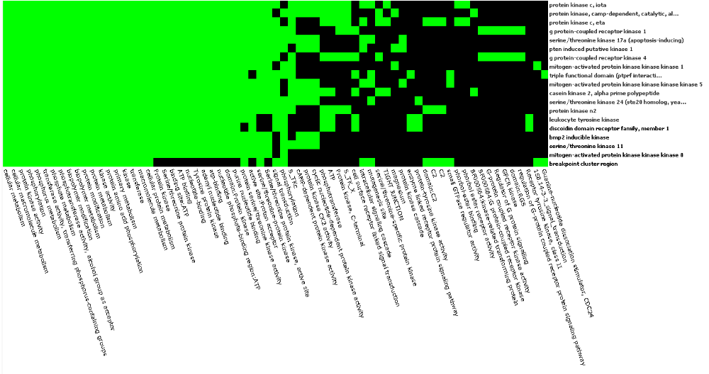

Figure 6. An example of genes-to-terms 2-D view. All the related 23 kinase genes and their associated annotation terms from gene group 3 (kinase group) for demo list 2 are displayed in a 2-D heat map-like interactive graphic view. Green represents the positive association between the gene-term; conversely, black means the unknown relationship. The annotation terms are ordered based on their enrichment scores associated with the group. The kinase commonly related annotations (big green block) are shown on the left side, and the scattered pattern (green and black) on the right side shows the functional difference.
TABLES

Table 1
Rank | GOMiner | DAVID | GOstat
1 | inflammatory response | response to pathogenic bacteria | cell-cell signaling
2 | clathrin coat of coated pit | chemokine activity | response to pest, pathogen or parasite
3 | viral genome replication | cell migration | response to stress
4 | morphogenesis | clathrin-coated vesicle | response to external biotic stimulus
5 | cytokine activity | clathrin vesicle coat | response to wounding
6 | establishment of spindle localization | clathrin coated vesicle membrane | negative regulation of biological process
7 | cell communication | receptor binding | negative regulation of physiological process
8 | establishment of mitotic spindle localization | response to other organism | cytoplasmic vesicle membrane
9 | regulation of cellular process | kinase activity | cytoplasmic vesicle membrane
10 | regulation of biological process | RNA polymerase II transcription factor activity | negative regulation of cellular process
11 | development | clathrin coat | regulation of biological process
12 | signal transduction | establishment of cellular localization | cell proliferation
13 | viral infectious cycle | cell differentiation | phagocytic vesicle
14 | positive regulation of protein metabolism | cell death | calpain inhibitor activity
15 | regulation of protein-nucleus import | regulation of isotype switching | cell adhesion
16 | immune cell migration | membrane-bound vesicle | negative regulation of cellular physiological process
17 | organ development | cell cycle | vesicle membrane
18 | organogenesis | membrane fraction | inflammatory response
19 | chemotaxis | angiogenesis | cell communication
20 | taxis | cell communication | cell differentiation

Table 1. The top 20 enriched terms for demo list 2 by various functional annotation tools. The example gene list was analyzed by GoMiner, DAVID, and Gostat, respectively. The annotation data coverage was set to GO terms of all levels, and all other parameters are used by the tool’s default setting. Only the top 20 terms from each tool are selected in the table. Many of the terms are in redundancy.
Table 2.
Functional Group # | Associated Biology | Group Enrichment Score
Gene Functional Group 1 | Chemokine/cytokine | 3.37
Gene Functional Group 2 | Transcription regulation | 2.89
Gene Functional Group 3 | Signal transduction/membrane receptors | 2.68
Gene Functional Group 4 | Kinase activity | 2.54
Gene Functional Group 5 | DNA damage/repair | 2.23
Gene Functional Group 6 | Iron binding | 2.05
Gene Functional Group7 | RNA processing/splicing factors | 1.81
Gene Functional Group 8 | Organic acid transport | 1.71
Gene Functional Group 9 | Cation/ion transport | 1.69
Gene Functional Group 10 | DNA metabolism/chromosome organization | 1.53
Gene Functional Group 11 | Cellular macromolecule catabolism | 1.41
Gene Functional Group 12 | Metalloprotease | 1.34
Gene Functional Group 13 | Macrotubule | 1.24
Gene Functional Group 14 | Protein localization/fusion | 1.17
Gene Functional Group 15 | Amine metabolism | 1.1
Gene Functional Group 16 | RAS small GTPase | 1.03

Table 2. Gene functional groups identified by the Functional Classification Tool. The genes of demo list 2 were analyzed by the Functional Classification Tool. The major biology terms associated with each group are manually summarized based on gene-term enrichment buttons provided for each functional group.
Table 3
Annotation Cluster | Representative Annotation Terms | Enrichment Score
Annotation Cluster 1 | negative regulation of biological process | 5.38
Annotation Cluster 2 | signal transduction | 4.36
Annotation Cluster 3 | inflammatory response | 3.75
Annotation Cluster 4 | extracellular region | 3.69
Annotation Cluster 5 | cytokine/chemokine activity | 3.12
Annotation Cluster 6 | viral genome replication | 2.23
Annotation Cluster 7 | cell death/apoptosis | 2.19
Annotation Cluster 8 | regulation of biological process | 2.18
Annotation Cluster 9 | organ morphogenesis | 2.06
Annotation Cluster 10 | regulation of cell cycle | 2.01
Annotation Cluster 11 | positive regulation of biological process | 1.87
Annotation Cluster 12 | biological process unknown | 1.76
Annotation Cluster 13 | physiological interaction between organisms | 1.69
Annotation Cluster 14 | antimicrobial humoral response | 1.52
Annotation Cluster 15 | transcription cofactor activity | 1.46
Annotation Cluster 16 | integral to plasma membrane | 1.44
Annotation Cluster 17 | coated vesicle membrane | 1.42
Annotation Cluster 18 | DNA repair/DNA metabolism | 1.38
Annotation Cluster 19 | kinase activity | 1.3
Annotation Cluster 20 | myoblast differentiation | 1.27

Table 3. Annotation clusters identified by the DAVID Functional Annotation Clustering Tool. The genes of demo list 2 were analyzed by the Functional Annotation Clustering Tool. The representative biology terms associated with the top 20 annotation clusters are manually selected, showing a much clearer and non-redundant view of the annotation terms associated with the study.

ADDITIONAL FILES

Additional Files can be found at http://david.abcc.ncifcrf.gov/manuscripts/fuzzy_cluster/
Additional File 1 (in Excel format; ~800 KB): Genes used in the paper: 409 Affymetrix IDs of demo list 2; 84 chemokine genes; ~17,000 pairs of protein-protein interactions; and 16 Affy IDs.
Additional File 2 (in Excel format; ~40 KB): Complete output in text format for demo list 2 analyzed by the DAVID Gene Functional Classification Tool.
Additional File 3 (in Excel format; ~80 KB): Complete output in text format for demo list 2 analyzed by the DAVID Functional Annotation Clustering Tool.
Additional File 4 (in PowerPoint format; ~150 KB): Fuzzy Heat Map visualization of biological modules. The genes in demo list 2 were analyzed by DAVID Gene Functional Classification Tool. The identified biological groups/modules were displayed by the Fuzzy Heat Map.
Additional File 5 (in PowerPoint Format; ~300 KB): The novel fuzzy heuristic partitioning method compared with other clustering methods. The binary gene-term matrix (like figure 2 A) was compiled and submitted to different clustering engines, including SOM, Hierarchical clustering, and K-mean. The results were visualized by the traditional heat map view. The same data was also analyzed by the DAVID Gene Functional Annotation Tool and visualized by the Fuzzy Heat Map Visualization.
Additional File 6 (in PowerPoint format; ~30 KB): An example of the group enrichment score calculation used for the Functional Annotation Clustering Tool.
Additional File 7 (in MS Word format; ~40 KB): 14 annotation categories used in the DAVID Functional Classification Tool.
Additional File 8 (in MS Word format; ~1.4 M): Graphic instruction and tutorial how to use the DAVID Functional Classification Tool and the DAVID Functional Annotation Clustering Tool.
Additional File 9 (in MS Word format; ~0.5 M): The output examples for the Related Gene Search and Related Term Search. A. Related Gene Search for “Interleukin 8” in the scope of demo list 2. B. Related Term Search for “Inflammatory Response” in the scope of all annotations. C. Related Gene Search for a group of genes, group 1 for demo list 2, identified by the DAVID Gene Functional Classification Tool.
Additional File 10 (in MS Word format; ~0.6 M): The default setting for minimum overlapped annotation in kappa score calculation. A. Significant kappa scores (>= 0.35 based on randomization study on figure 3) only can be obtained for gene-gene pairs with higher overlapped annotation terms (>= 10). Thus, there is no reason to calculate kappa scores, in an attempt to save the calculating time for DAVID Functional Classification, for the large number of those gene-gene pairs with fewer annotation terms overlapped. A conservative default filter is 4. B. Such default filer (blue curve) has somewhat greater impact on the significant kappa scores in the higher end, compared to that in the lower end. However, it will skip a significant amount of kappa calculation of gene-gene pairs.
Additional File 11 (in MS Word format; ~0.4 M): The effect of Kappa statistics on biased annotation data.
Additional File 12 (in MS Word format; ~0.2 M): A hypothetical example to measure the relationships of gene-gene pairs by Kappa statistics with annotations organized in a 'flat' matrix.
Additional File 13 (in MS Word format; ~0.2 M): A hypothetical example to show the general procedure of heuristic multiple-linkage fuzzy clustering.

Additional Files can be found at http://david.abcc.ncifcrf.gov/manuscripts/fuzzy_cluster/

