

ORNL’s Mentored Thesis on “Linking Supercomputing and Systems Biology for Efficient Bioethanol Production” Led High-School Students to Win Siemens Competition National Finals

A team of Oak Ridge high school seniors, Steven Arcangeli, Scott Horton, and Scott Molony, mentored by Oak Ridge National Laboratory (ORNL) scientists, became national finalists at the Siemens Competition in Math, Science and Technology, which is considered the premier research competition for high-school students. Their research project entitled “Linking Supercomputing and Systems Biology for Efficient Bioethanol Production” has earned them $100,000 in scholarship money. The team used ORNL supercomputers to analyze biological networks, looking at tens of thousands of genes and their biological pathways to discover clues for engineering direct biofuel production by microorganisms.

The Secretary of Education, Margaret Spellings, presented the Siemens awards, indicating the level of respect with which the awards are viewed nationally. The importance of this achievement was also mentioned by Senator Lamar Alexander on the floor of the Senate during his speech in support of the National Competitiveness Investment Act. The award was cited as an example of the kind of impact to be gained by creating similar programs between national laboratories and local schools. The exposure has been on a national level and has been of a degree that stands out nationally. This has in turn led to a number of benefits to the community and resulted in a considerable amount of positive publicity for DOE and ORNL.

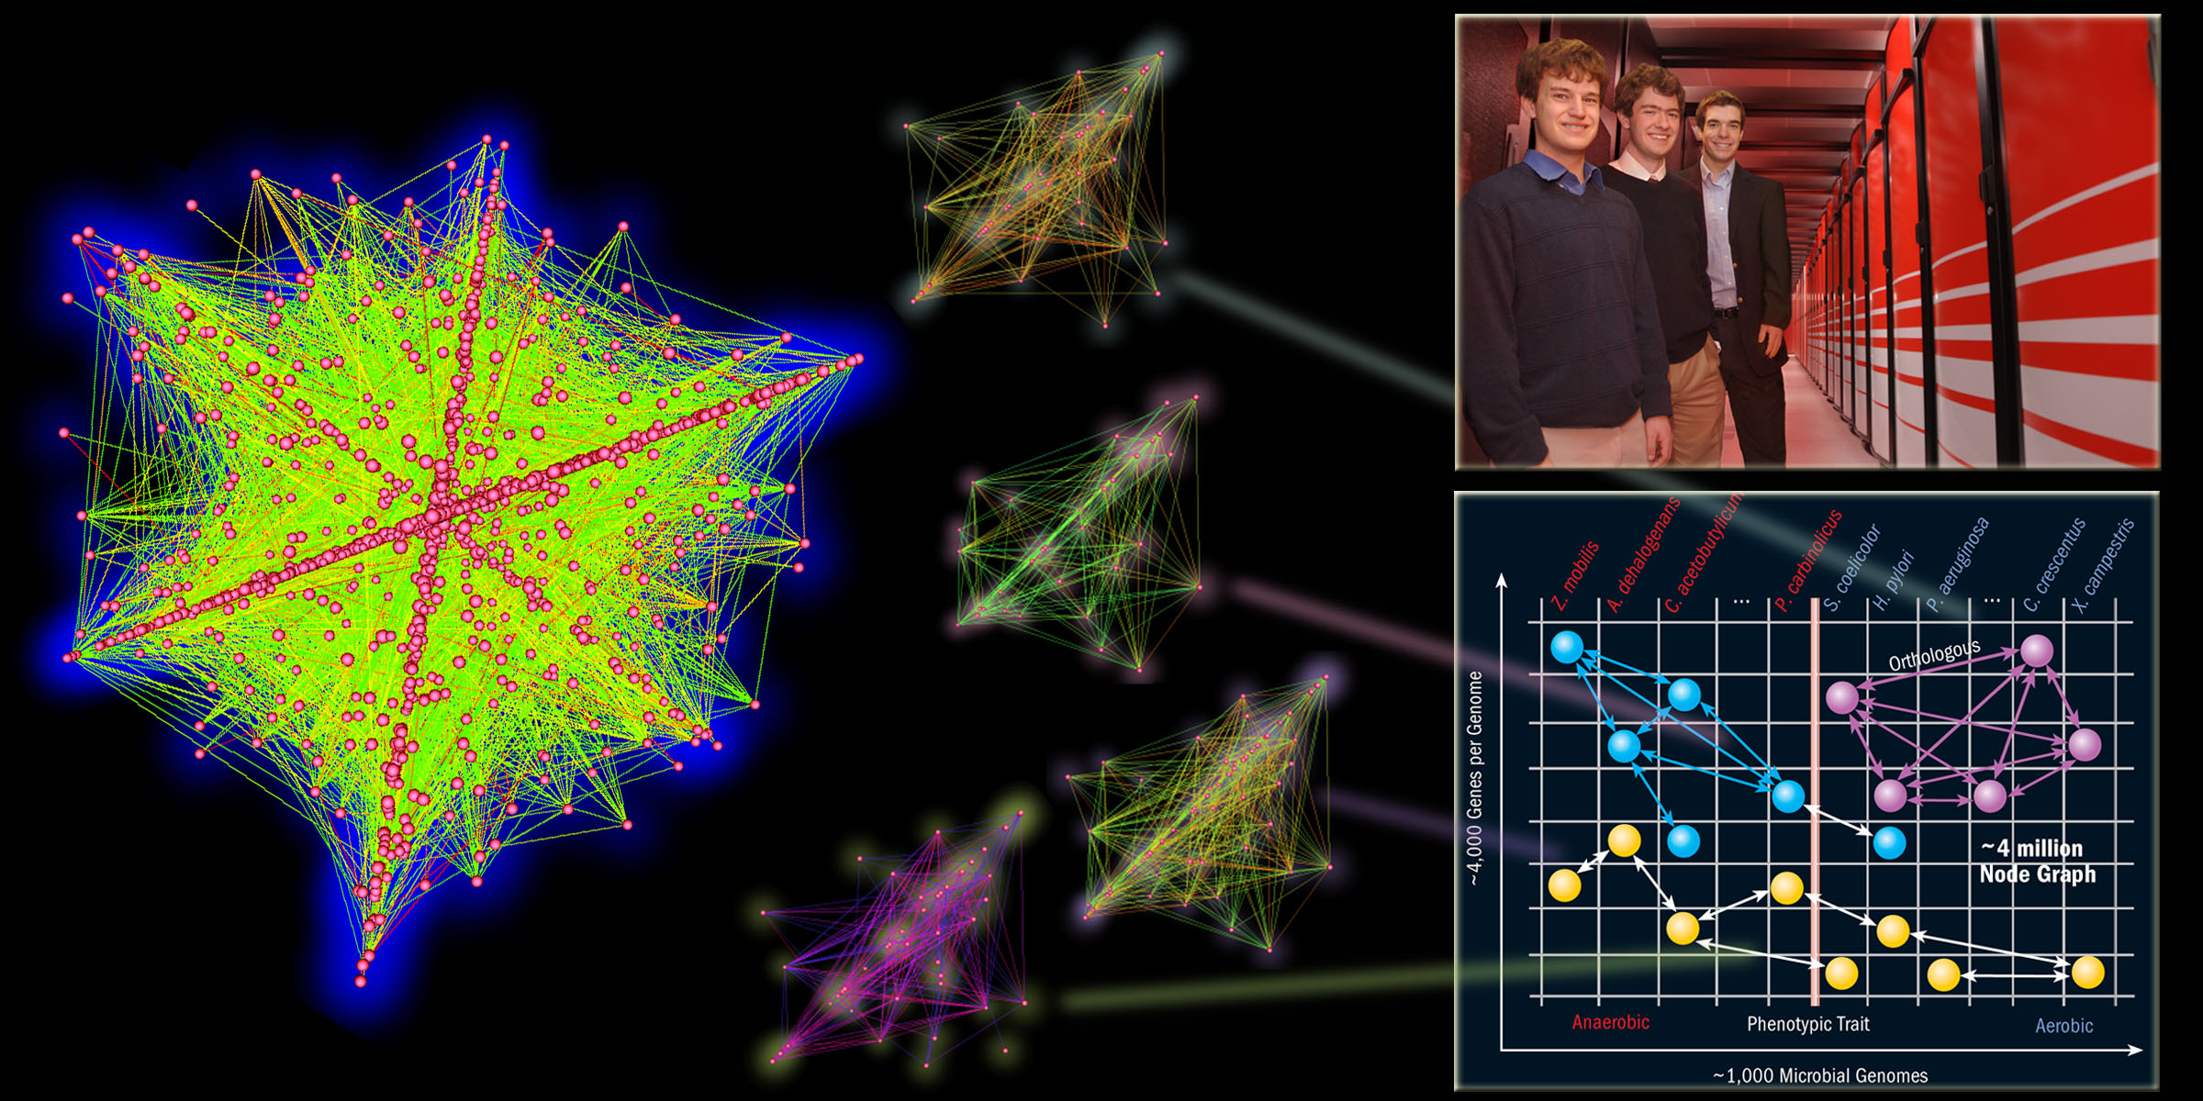
Figure Caption. One of the students’ innovations was the linking of desirable microbial traits—such as resistance to high temperature, multi-sugar uptake, and high ethanol yield—with specific genes and biochemical pathways that are likely to be important for these traits. To find these genes, they divided the organisms according to the presence or absence of a trait. Their underlying intuition was that if a gene was critical to a trait, then Mother Nature would preserve it, and it therefore would be conserved by evolution. Hence, genes that are crucial to the trait will cluster on one side of the divide. They formulated the problem as a graph-theory problem of finding the cliques of genes (pair-wise connected) that are conserved throughout evolution among the organisms that possess a beneficial trait.

