Docket: APHIS 2008-0094

Docket title:
Pioneer Hi-Bred International, Inc.; Availability of Petition and Environmental Assessment for Determination of Nonregulated Status for Corn Genetically Engineered for Tolerance to Glyphosate and Acetolactate Synthase-inhibiting Herbicides

January 21, 2009

Dear Sir or Madam:

The South Dakota Corn Growers Association (SDCGA) advocates for technology tools and resources for our 14,000 growers in the state. It’s vitally important that producers have timely access to new technology – including seeds with biotech traits – to remain competitive in today’s marketplace. For that reason the SDCGA requests the USDA’s expedient review of Pioneer Hi-Bred’s Optimum GAT trait.

Currently, corn producers have limited options in herbicide tolerance for corn; the Optimum GAT trait from Pioneer Hi-Bred would offer growers a new choice in the marketplace.

South Dakota has the highest adaptation rate of biotechnology with 93 percent of our acres being planted to biotech traits. Biotech crops allow our South Dakota producers to better manage herbicide and insecticide needs and control their farming costs. We believe the availability of the Optimum GAT would allow growers to use an environmentally-friendly herbicide, a priority for producers and consumers alike. Clearly our producers not only embrace biotechnology tools, but they rely on these traits to compete as least cost and environmentally conscious producers.

We understand this product contains a unique approach not found in the marketplace today. In addition to glyphosate tolerance, the Optimum GAT trait enables more ALS-inhibiting herbicides which provide growers with more choices and broader-spectrum weed control.

There are currently no commercially available corn products that are both glyphosate and ALS herbicide tolerant. This new Pioneer offering will be the first commercial corn product to contain both traits. Its availability will allow growers greater ability to manage weeds and weed resistance, which is becoming increasingly important.

The SDCGA supports new corn technologies and increased choices for producers. The USDA should review the registration in a timely manner and move forward with the application without delay.

Sincerely,
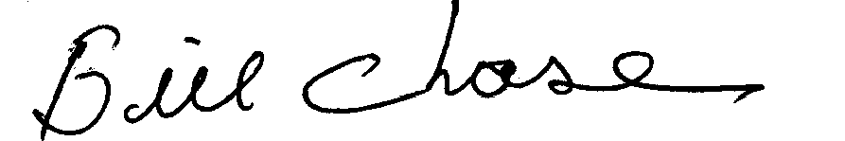

Bill Chase, President
South Dakota Corn Growers Association

