USDA Foreign Agricultural Service
GAIN Report

Global Agriculture Information Network
Template Version 2.07

Required Report - public distribution
Date: 2006/7/28
GAIN Report Number: TW6029
TW0000
Taiwan
Solid Wood Products
Annual
2006

Approved by:
Hoa Van Huynh, ATO Director
American Institute in Taiwan
Prepared by:
Jeff Miller, Reports and Marketing Officer

Report Highlights:
Taiwan’s solid wood product imports held roughly steady during 2005. Growth was relatively strong (5~15%) in softwood plywood and composite woods, used in construction and as structural material in furniture and interior design. The domestic investment in interior design services grew a healthy 9% in 2005 is expected to continue in 2006 and 2007, as mild growth in the real estate sector and strong growth in home refurbishing is expected to continue. The US remains a relatively minor player in Taiwan’s wood market, which is dominated by Southeast Asian suppliers. Taiwan’s long-delayed approval of a standardized fire code for wood frame construction continues to rule out a strong uptick in lumber and engineered wood in the near term. With a fire code on the books, opportunities for US suppliers exist for higher value engineered wood solutions used in wood / timber frame construction and for lumber needs that, due to performance requirements, demand performance measures (e.g., decay resistance) ensured through proper product certification.

Includes PSD Changes: Yes
Includes Trade Matrix: Yes
Annual Report
Taipei ATO [TW2]
[TW]
Production

FOREST RESOURCES

The island of Taiwan is cloaked in forest over nearly 60 percent (2.0 million hectares) of its land mass. For much of the 20th century, both the logging industry and wood exports contributed significantly to the island’s GDP. Felled virgin stands of cypress, fir, camphor, and oak helped fund Japan’s development up through the Second World War (Taiwan was under Japanese rule from 1895 to 1945) and provided essential hard currency exports for the Nationalist Chinese regime after their retreat from Mainland China to the island in 1949. Although virtual elimination of high-value virgin stands eventually ground the island’s logging industry to a halt, Taiping Shan, Taiwan’s last major logging district, managed alone to generate 93,000 m³ of felled timber as late as 1959.

Over-harvesting of virgin timber, escalating labor costs, and growing appreciation of the importance of forests in the ecosystem have diminished Taiwan’s commercial forestry industry to its present output of around 50,000 m³ per year and re-targeted government initiatives to sustainable management of all forest land. In 1992, Taiwan authorities banned all logging in "natural" timber stands (whether virgin or regrowth). The ban is believed effective apart from cases of illicit felling / removal of individual logs of high-value wood (e.g., camphor, red and yellow cypress, and Taiwan zelkova, among others).

In light of the harvest ban on non-plantation timber and current economic disincentives against logging (low market prices, high labor costs, aging labor force), only 500 hectares in Taiwan are now formally engaged in the production of commercial timber. The peacock pine (willow fir or cryptomeria japonica), China fir (cuninghamia laceolata), and Taiwan acacia (acacia confusa) are three commonly cultivated species.

From a commercial standpoint, the quality of both natural and plantation stands in Taiwan is considered generally poor - testimony to the unbridled exploitation of formerly rich forest resources during the past century and to a recent history of reforestation efforts that, in many cases, selected species poorly suited to existing soil and climate conditions. A recent Taiwan Forestry Research Institute (TFRI) study estimated that 70 percent of all plantation trees in Taiwan had trunks measuring between 10 and 30 cm in diameter. Most of the annual harvest is currently channeled into low value applications, with over 1/4 of output volume used as firewood. TFRI continues to conduct research into using Taiwan wood in higher value applications (including oriented strand fiber boards, plywood backing, and plastic/wood composite materials) although results are not expected to spur significant expansion of land under commercial cultivation.

In spite of its large reserve base of standing timber, the potential for Taiwan to increase production of wood much beyond current levels is minimal due to a diverse set of factors, including environmental regulations, low import prices, labor flight to higher paying sectors (in a recent survey of the forestry industry in Taipei county, only 20 percent of those employed in the sector were below the age of 40), and the long-term investment required (78 percent of privately held commercial forest land in Taipei County was inherited by the current owners).

SOLID WOOD PRODUCTS SITUATION and OUTLOOK

Although most timber is now off limits to commercial exploitation, supporting industries in Taiwan which once processed local wood remain strong, with many Taiwan-based companies now important players in the Asia regional and global trade in lumber and lumber products. Initially, Taiwan firms manufacturing lumber, paper, furniture, and decorative wood products, shifted from using locally-sourced to using imported raw materials. As labor and other operating costs rose steadily through the 1980s and 1990s, most shifted some or all production offshore. The most common destinations now for Taiwanese investments in wood processing is China (focused on Guangdong Province), followed by Vietnam, the Philippines, and other Southeast Asian countries.

Asia Wood Purchase Decisions Still Centered in Taiwan: While much production has relocated offshore, key operational decisions in Taiwan-invested factories (regarding such issues as installed equipment, order receipt / scheduling, changes to capacity, and raw material purchases [including wood]) tend to remain in the hands of Taiwan-based executives. Based on this practice, and estimating that roughly 1/3 of China, Vietnam, and Philippine furniture exports benefit from Taiwan investment, the power of Taiwanese log and semi-finished wood buyers greatly exceeds the value derived by considering only Taiwan’s wood furniture production or wood import / export figures.

Taiwan Wood and Wood Product Imports and Exports (HS44): 1998 – 2004
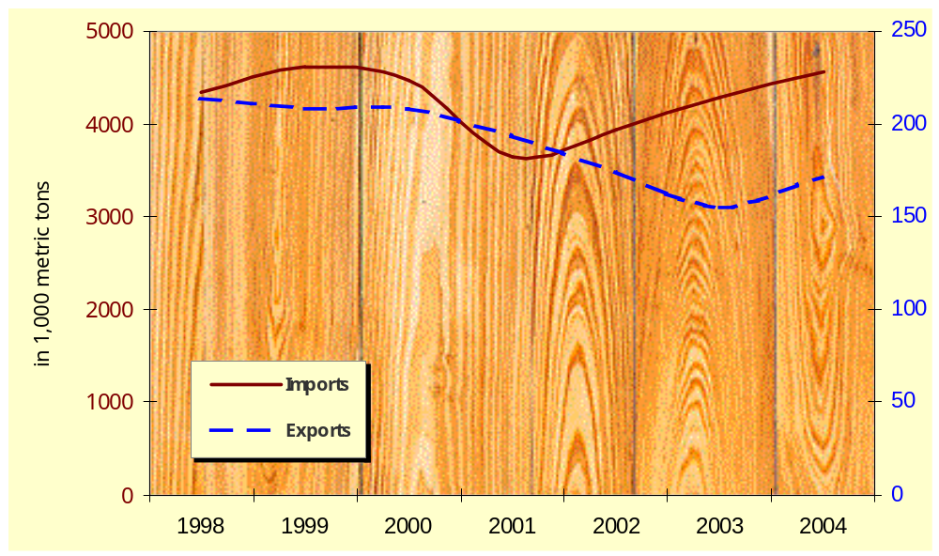
According to survey data last updated in 2001, nearly 2,500 firms are licensed to operate wood processing / production facilities in Taiwan. Most are small (for example, approximately 2/3 of all furniture makers employ 10 staff or less) and many likely have most or all production overseas. In terms of numbers, Taiwan has 752 furniture manufacturers, 490 lumber manufacturers, 187 plywood manufacturers, 47 "composite" wood products manufacturers (e.g., flooring, special-use composite woods), 84 wood container manufacturers (e.g., crates, jewelry boxes, storage boxes), and 908 firms manufacturing "other" wood products.

TRADE

Overview and Outlook
Slightly over US$1.22 billion worth of wood and wood products (under HS code 44 [excluding furniture]) cleared Taiwan Customs during 2005, nearly the same amount by value as in 2004.
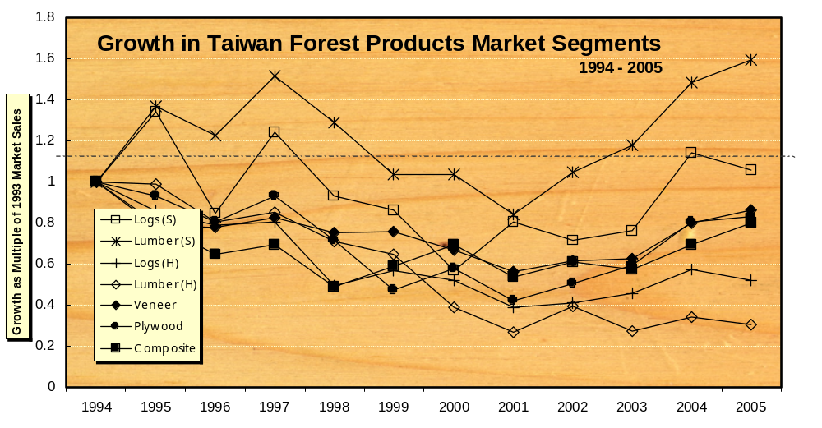
Wood imports across most subcategories are continuing to claw their way back from lows hit around 2000, with increases largely driven by a rebounding domestic economy, continued investment in the island’s “recreational” infrastructure, and rising demand for home remodeling materials. While opportunities for sales growth continue to be attractive in certain subcategories (engineered wood and softwood lumber in particular), Taiwan imports today represent just over half of the $1.9 billion in wood that arrived in 1993. A general preference toward relocating wood processing operations offshore, coupled with continued anxieties about the domestic economy (which is highly dependent upon income from IT product exports), rule out any serious rise in broad-based demand for either finished or raw material wood products in the coming 2~3 year period.
However, it seems clear that the depressed market for wood “bottomed out” and began recovering in 2000-2001. Key segments such as softwood lumber (used for packing material, cement construction braces, interior design framing, and wood frame structures), plywood, and temperate hardwood lumber (mostly used in furniture, flooring, and wood product manufacturing) have returned to modest to a pattern of moderate year-to-year growth due to improvement of the general economy.
Exports of furniture and wood consumer products continue to drop precipitously. Furniture exports during 2005 rose slightly (5%) due to economic conditions in southern China (the target of furniture investment) and improved demand from European and US customers for Taiwan furniture exports. The latter accounts for slightly less than 3/4 of Taiwan’s wood furniture exports, although Taiwanese furniture manufacturers have already largely evolved into transnational enterprises and most have primary production facilities located in southern China, Vietnam, the Philippines or elsewhere.
The bulk of Taiwan’s wood imports continue to be low-value softwood lumber and plywood destined for industrial uses and hardwood paneling and veneers used for decorative purposes. This is expected to remain true through at least the coming several years.
Hardwoods: Both Taiwan and Chinese cultures appreciate the aesthetic value of hardwoods and, as incomes rise and quality of life issues increase in importance, families are increasingly likely to purchase hardwood interior decoration products including parquet flooring, wall panels, solid wood dining tables, and other decorative items. Temperate and tropical hardwood species seem to be equally well received by consumers.

For most segments of the hardwood market, consumer preferences should be researched and addressed prior to pursuing market opportunities. For example, more than 90 percent of dining tables sold in Taiwan are round, while the market for rectangular wood tile parquet flooring is particularly hungry for tiles made of unique species (i.e., not currently sold in volume in Taiwan) or in unique configurations. Also please note that general demand for do-it-yourself (DIY) remains shallow - extending little beyond assembling simple furniture out of a box or laying down flooring tiles from a kit. DIY demand is still expected to become more sophisticated gradually and US suppliers of hardware materials and more sophisticated DIY kits may see increased opportunities over the coming years. The time for market contact and development work, however, is now.

A Note on Flooring: The profitable local parquet flooring industry manufactures wood flooring tiles to a standard 1.5cm (finished) thickness. Flooring lumber exporters able to offer rough hardwood lumber in approx. 1.7cm (unfinished) thickness specifications will help minimize processor waste and provide an important edge over competing suppliers. The 1.5cm (finished) standard is also widely used in China, Japan, and other Asian markets for domestic consumption.

With a well-developed regional wood processing network and growing demand for wood furniture and decorative products (particularly designed to Chinese/Asian-specifications), the highest value sector should continue to be semi-processed wood products, such as hardwood dimension lumber and hardwood veneer. Such intermediate products can be final processed at facilities in Taiwan or elsewhere, ensuring products meet local market expectations and leveraging lower labor costs.

Softwoods: Much of the softwoods imported into Taiwan continue to come in as plywood and dimension lumber. A significant percentage of dimension lumber is consumed by the construction industry to create the temporary supports and casts around which cement is poured to form building foundations, frames, and walls. Around 95 percent of new buildings, both residential and commercial are constructed of reinforced concrete (RC). Plywood sheets are used in many applications including interior decoration, as backing for billboards and signs, and as facing on temporary structures. This is a high volume and low unit-value segment.

The market for wood frame and timber frame homes remains in its infancy. However, changes in consumer attitudes and government policies offer good potential for growth in this sector over the coming years. Note that the ferocious Formosan termite and Taiwan’s humid climate underscore a need for pressure treated wood in nearly all outdoor / structural applications. Laminated wood imports from the US grew slightly in 2003 and 2004 and held steady in 2005 (specific figures are unavailable). Growth is attributed largely to increased imports of higher value glue-laminated (glulam) beams. With concerted effort on the part of industry, this positive trend is likely to continue.

Stable economic growth coupled with a rising income base can be expected, over the coming 3 - 5 years, to return healthy growth in demand for imported finished wood products (including the "high end" furniture, DIY, hardwood flooring, and other decorative products where US makers have competitive strength) and for treated softwood lumber for wood-frame construction (single and multiple dwelling homes, small business / academic office buildings, glulam long-span structures, and park / recreational area structures). Imports of items in these categories have grown significantly in value over the past decade in comparison with other forest products industry items. Demand for plywood and second-grade softwood lumber should pick up with any re-ignition of the traditional (reinforced concrete) construction sector.

Import Regulations

On 1 January 2005, Taiwan began requiring that phytosanitary certificates accompany imported wood in response to the risk of Asian Longhorned Beetle (Anoplophora glabripennis). At present, Taiwan requires that an appropriate phytosanitary certificate accompany the following wood products imported from the United States and other countries (see table below):

Table of Commodities Subject to Legal Animal & Plant Quarantine

CCC (Taiwan Tariff) Code |  |  | Description of Goods
44 01 |  |  | Fuel wood, in logs in billets, in twigs, in faggots or in similar forms; wood in chips or particles; sawdust and wood waste and scrap, whether or not agglomerated in logs, briquettes, pellets or similar forms.
44 01. 10.00
 | 90 | 6
44 01. 21
44 01. 21. 00 | 00 | 2
44 01. 22
44 01. 22. 00 | 00 | 1
44 01. 30
44 01. 30. 00 | 90 | 2
44 03 |  |  | Coniferous wood in the rough, whether or not stripped of bark or sapwood, or roughly squared
44 03. 20. 10 | 00 | 9
44 03. 20. 90 | 11 | 9
 | 12 | 8
 | 13 | 7
 | 14 | 6
 | 15 | 5
 | 16 | 4
 | 17 | 3
 | 18 | 2
 | 19 | 3
44 03 |  |  | Other wood (tropical and temperate deciduous) in the rough, whether or not stripped of bark or sapwood, or roughly squared, including: various tropical, Oak, Beech, Garoowood, Sandalwood, Maple, Ash, etc.
44 03. 91
44 03. 91. 00 | 00 | 5
44 03. 92
44 03. 92. 00 | 00 | 4
44 03. 99
44 03. 99. 11 | 00 | 4
44 03. 99. 12 | 00 | 3
44 03. 99. 19 | 00 | 6
44 03. 99. 90
44 03. 99. 90 | 10 | 6
 | 20 | 4
 | 30 | 2
 | 90 | 9
44 04 |  |  | Hoopwood; split poles; piles, pickets and stakes of wood, pointed but not sawn lengthwise; wooden sticks, roughly trimmed but not turned, bent or otherwise worked, suitable for the manufacture of walking-sticks, umbrellas, tool handles or the like; chipwood and like
44 04. 10
44 04. 10. 00 | 00 | 2
44 04. 20
44 04. 20. 00 | 00 | 0
44 06 |  |  | Railway or tramway sleepers（cross-ties）of wood
44 06. 10
44 06. 10 00 | 00 | 0
44 07 |  |  | Coniferous wood sawn or chipped whether or not planed, sanded or finger-jointed, of a thickness exceeding 6 mm
44 07. 10
44 07. 10. 10 | 00 | 7
44 07. 10. 90
44 07. 10. 90 | 11 | 7
 | 12 | 6
 | 13 | 5
 | 14 | 4
 | 15 | 3
 | 16 | 2
 | 17 | 1
 | 18 | 0
 | 90 | 1
44 07. 24 ~ 29 | 00 | 2 | Various tropical woods, sawn or chipped lengthwise, sliced or peeled, whether or not planed, sanded or finger-jointed, of a thickness EXCEEDING 6 mm
44 07. 91 |  |  | Various temperate woods, including Oak, Beech, Garoowood, Sandalwood, Maple, Ash, etc, sawn or chipped lengthwise, sliced or peeled, whether or not planed, sanded or finger-jointed, of a thickness EXCEEDING 6 mm
44 07. 91. 00 | 00 | 1
44 07. 92
44 07. 92 | 00 | 0
44 07. 99
44 07. 99. 11 | 00 | 0
44 07. 99. 12 | 00 | 9
44 07. 99. 19 | 00 | 2
44 07. 99. 90
44 07. 99. 90 | 10 | 2
 | 20 | 0
 | 90 | 5
44 15 |  |  | Packing cases, boxes, crates, drums, pallets, and similar packings, of wood
44 15. 10
44 15. 10. 00 | 00 | 9
44 15. 20
44 15. 20. 00 | 00 | 7

COMPETITION

As with many sectors in Taiwan, price is frequently the key driver in purchasing decisions. US competitiveness has been boosted recently due to a decline in value of the dollar vis a vis key competitors in Europe for softwoods (veneers, framing lumber, etc.) and cost increases for some tropical hardwoods.

Taiwan importers tend to be familiar with the range of wood products available and major supplier countries. End-users typically rely upon importers for such information. This makes the importer the principal "gatekeeper", determining which wood species to promote and from which suppliers to purchase. While Taiwan/Chinese preferences tend toward darker tropical hardwoods, availability concerns, rising prices, and recent fashion trends toward lighter / brighter wood colors have helped diversify applications for US hardwoods such as maple, cherry, oak, and others.

Competition to supply traditional market segments (such as logs, plywood, veneer, furniture, decorative, etc.) focuses heavily on relationship-building and price negotiations due to the strength of Taiwan importers and Taiwan’s open trade policies (unlike many product categories, most wood and wood products may be imported from Mainland China). However, in new product areas, such as wood frame housing and wide-span structural (glulam) wood construction, education and promotional efforts not only present opportunities to develop significant new export revenue but are absolutely essential to address local market constraints including architect/builder unfamiliarity with wood construction principles and consumer concerns regarding the longevity and safety of wood frame vs. concrete structures (e.g., performance against termites, rot, fire, and other elements).

Market Development Strategies

Manage customer relations well and know your competition: Taiwan remains a price competitive market for both business-to-business and retail consumer transactions. A well-developed relationship with your Taiwan buyer should help secure for your business some price buffer against competing suppliers, but in general, unless you supply a unique product or have other specific supplier advantages, purchase price is likely to be a recurring topic of discussion. To address price concerns effectively, maintain a good understanding of what competitors can (and cannot) provide in terms of products and services as well as of your own products and services.

A small circle of a dozen or so importers handles most log and lumber imports. Most have historical roots in Taiwan’s early logging industry and are typically private, family-controlled enterprises. This makes relationship building and responsiveness to client requests exceptionally valuable tools in building your log/lumber exports into this market (and - as noted above - to China, Vietnam, and other markets) and to secure a steady sales relationship.

Education: Use of structural wood is expected to continue to increase, under its own inertia, slowly over the coming 5-year period, fueled by individual developers’ exploitation of niche opportunities. International industry and association support of promotion and basic skill training programs will be, however, essential to position wood as an effective challenge to reinforced concrete (rc) and steel in the large number of proposed and ongoing recreation infrastructure projects (100s of projects of varying sizes at national, county, and local levels), in the market for single home / low-rise apartment community developments (10~30 per year), and in the market for vacation hotel / retreat construction.

In interior design and furniture production segments, US suppliers are encouraged to assist Taiwan buyers (agents and importers) to better understand the range of temperate hardwoods available and wood performance characteristics.


Due to the "local" nature of most wood end-users in Taiwan (and Greater China), exporters and associations are encouraged to prepare and print promotion and education materials in Chinese for broadest coverage. When limited to preparing materials in one Chinese character format only, traditional Chinese (rather than simplified) is still deemed the format most widely accepted in both Taiwan and China.
US suppliers and associations can do more to educate local architects and officials on how to use wood, instead of concrete, in the 100s of beautification and recreational infrastructure projects budgeted each year.

Ecolabeling: At present, consumer awareness / concern regarding ecolabeling and sustainable forest management practices end, in the main, when product cost increases as a result. While there exists future potential for selling premium-valued wood products based on ecolabeling/environmental concepts, such will require significant up front investment in brand development. The government does not have an active certification or labeling program to recognize wood harvested from well-managed sources. To date, the international home products chain B&Q (UK) is the only supplier of wood products (lumber, outdoor furniture, parquet floor tiles, etc) into the market reportedly requiring suppliers to certify that wood used is sourced from well-managed forests (as certified by the Forest Stewardship Council). Their success with sales to date is believed attributable as much to their unique position in the marketplace (the only DIY superstore) as to consumer preference for the FSC label.

Market Segment Analyses

Construction Sector

Overview

Spending by central, county, and local governments was a principal factor that helped Taiwan find a base and then see some lift in demand for solid wood products. Successful beautification projects completed during the late 1990s in places like Hualien, I-Lan, and Nantou are now being replicated around the island, spurring demand for treated SYP and western species for outdoor applications. The trend seems set to continue through the coming several years, with local governments securing and implementing budgets for civic improvement projects in the run-up to local and national elections.

Continued concerns regarding the stability of the current economic recovery, a relatively high rate of multiple home/apartment ownership, and the large inventory of available housing in the suburbs of major metropolitan areas are factors which currently weigh upon the construction sector at large and promise to continue doing so through the foreseeable future. The single bright spot is the flurry of construction, which is now going up near the future stops of Taiwan’s high-speed rail (currently under construction). Public and private construction linked to the high-speed rail project, coupled with several particularly large single-building projects in Taiwan’s metropolitan areas, accounted for upwards of 1/2 of building licenses issued during 2002.

Uncertainties regarding the long-term value of real estate holdings, an uptick in the number of mortgage defaults, and a relatively high level of multiple residence ownership (i.e., family owns more than one house or apartment) continues to weigh upon real estate and depress transaction prices. In general, there is nothing on the foreseeable horizon that would spur a sustainable rise in property prices. Prices may be expected to see further drops or remain the same over the coming several years.

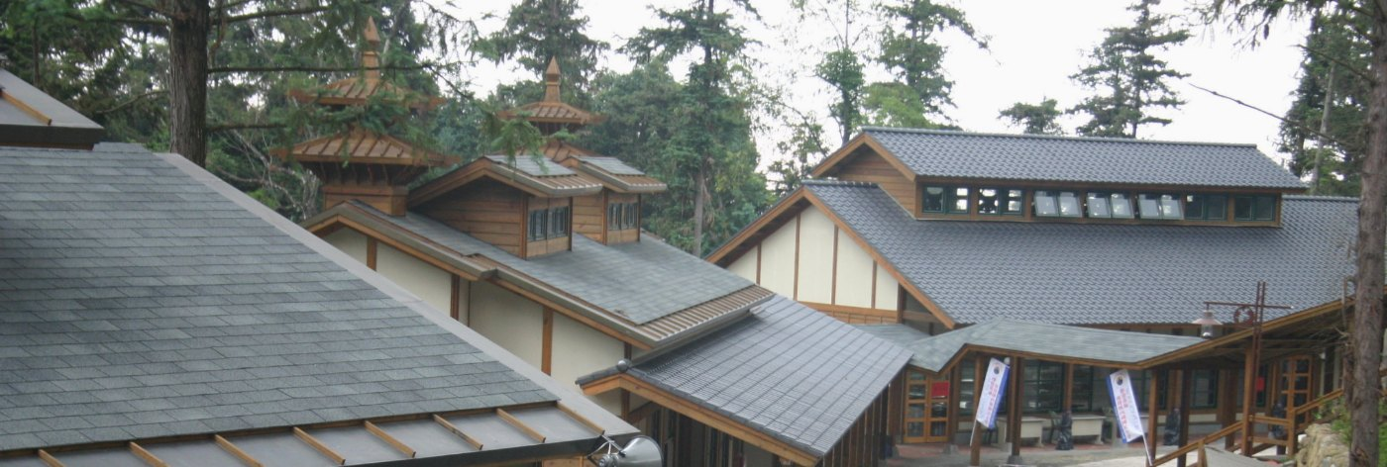
The combination of lower prices and attractive interest rates is likely to help primarily sales of apartments in already-constructed reinforced concrete (RC) / steel girder buildings and to improve slightly demand for new high-rise construction in suburban areas. While wood used in interior design should benefit as a result, structural wood should not experience any particular benefit from these trends.
Newly Opened Primary School in Central Taiwan fuses 2x4 structural design with distinctive Asian styling.

Taiwan’s generally improving economy is boosting overall construction and raising orders for wood frame homes, D-log cabins, glulam wide-span structures, and outdoor recreational and park facilities. Wood construction should continue to show positive growth, based on reports from Taiwan wood construction industry sources. Wood frame home starts were roughly estimated at 875 in 2003 and 870 in 2004. Wood frame construction is expected to benefit in the near term from policy changes, some already implemented, that put structural wood on an equal footing with concrete and steel in the regulations.

Marketing

Due to the generally high price of land, a predilection toward urban living, and a host of entrenched builder and consumer suspicions about wood structures, Taiwan holds little prospect of becoming a huge export market for wood frame construction. However, convergence of several factors highly favorable to wood frame construction makes prospects bright for steady and healthy growth. These positive growth factors include (1) increasing awareness regarding earthquake resistance / safety of wood frame versus reinforced concrete structures, (2) the glut of unimaginative, cookie-cutter residential complexes of reinforced concrete currently on the market, (3) quality-of-life expectations amongst the top 5-10% of Taiwan society that may include consideration of a vacation or second home constructed of wood, and (4) the successful approval and construction of wood-frame homes and other buildings based on building codes recently altered to accommodate wood frame structures.

Demand for wood frame single family and multi-story townhouse dwellings is greatest in three principal market segments, namely (1) vacation homes for those in Taiwan’s top income bracket, (2) residential developments executed on the outskirts of major urban centers (designed in wood for a particular purpose such as earthquake resistance or practical appeal to an overseas-educated middle class), and (3) principal homes for families in rural areas. If these three opportunity areas were aggressively developed, the resulting market potential is estimated to be an additional 1,750 housing units built within a 3 to 4-year time frame with steady market growth afterward.

To realize the above market potential requires that material suppliers and their Taiwan partners provide initial development projects with practical technical and educational support. Lack of general architect and builder familiarity with wood frame construction techniques is the key supply-side constraint and consumer unfamiliarity with structural wood "products" is the key demand-side constraint to stronger market growth. The latter includes consumer concerns regarding structural wood covering fire safety ("wood burns, concrete does not"), rot and insects ("wood homes deteriorate quickly in Taiwan’s environment"), typhoon resistance, and so on. Concerns can be minimized, and contrasted with the many problems associated with reinforced concrete, through appropriately designed education and promotion programs.

Policy

The Ministry of Interior’s Construction and Planning Administration (CPA) is responsible to draft and implement construction regulations and standards. Revisions to building codes published in 1996 and revised in 2003 permit construction of wood and timber frame structures of 4 stories (14 meters) or less. Structures of greater height can be built, but plans require special CPA review and approval.

Inspection and approval of completed structures fall under the jurisdiction of the county (or municipality) in which a building has been constructed.

Bringing Wood to the Masses: Underscoring commitments to make Taiwan a "greener" island and less vulnerable to frequent tremors, Taiwan authorities have partially completed an update of building codes with the stated objective of classifying wood as a "normal" construction material -- on a par with steel and concrete. While long approved, in practice, for constructing single-family homes, structural wood was proscribed from use in multi-family or scale developments without special central government committee approval. This was due to fire code regulations which forbad the use of any "flammable" material as a load-bearing member.

The revised building code was approved in the spring of 2003, albeit without a finalized methodology for determining fire resistance. As of the new code’s date of announcement (1 May 2003) builders in Taiwan are permitted to proceed with construction of multiple home residential communities and townhouse developments provided that individual residential units are separated either by a suitably wide open space or a non-wood fire barrier (firewall). The as yet unresolved issue of calculating fire resistance for either 2x4 or timber frame structures continues to require that plans for public buildings (such as office / shopping structures, auditoriums, and other such enclosed structures) must be approved by the central government’s construction committee prior to construction and use.

The current fire code permits developers to construct legally multiple home wood frame developments and should gradually remove the previous reluctance (due to lack of legal framework) of banks to finance such projects and insurance companies to cover residences approved under the new code.

Taiwan construction industry officials are in the process of researching fire code revisions to incorporate wood structures. Research and draft code submissions to the CPA continue to be anticipated.

The slow economy and newness of the regulations are expected to hinder any burst of activity with multi-home developments in wood. However, a number of developers already have draft plans to use structural wood for both townhouse and single home residential communities when the economic situation again warrants.

Passage of the Agriculture Development Act in January 2000 opened the door to convert around 160,000 hectares of working farmland to non-agricultural (including residential) use. This new regime eliminates the long-standing ban on farmland re-zoning and should open up substantial tracts of prime real estate around the island to commercial development. Officials have paced conversion work initially at around 6,000 ha. per year. Already many recreational farm developments (nong she) have been set up to attract domestic tourism. Most use wood (treated SYP, redwood, etc.) in outdoor facilities and some are using structural wood in their main buildings. Opportunities are significant in this sector for both wood suppliers and architects able to provide consulting services on optimal landscaping and structural designs.

Furniture and Interiors Sector

Overview

As noted previously, Taiwan has 752 firms registered to manufacture furniture and related products in Taiwan. Many specialize in certain woods, styles, or furniture items. In addition to local manufacturing, Taiwan has investment interests in furniture and wood products production overseas worth many times the value of domestic production.

An improved economy that is lifting general consumer spending and a continued reduction in domestic production is driving domestic furniture product sales, which were up by another 7 percent in 2005 to US$110 million. Anticipated moderate economic growth should see continued moderate growth for furniture sales through the coming few years. The predilection of Taiwan consumer products manufacturers to set up production operations offshore will similarly continue to reduce furniture export volumes. Exports of wood furniture and chairs rose a healthy 10% in 2005 to US$926 million.

Marketing

The furniture business, along with other well-established wood processing industries, relies on importers for information on wood species, performance characteristics, and availability. As nearly all are small-scale producers in Taiwan, few (if any) firms purchase wood directly from exporters; relying instead on importers for supplies of lumber and other semi-finished wood products.

Therefore, supporting importer efforts to provide furniture-maker customers with information on species, production techniques, and design trends has proven an effective approach to expanding furniture, and interior design segment, sales.

Policy

The combination of high relative labor costs and tightening environmental protection conditions will continue to encourage Taiwan’s furniture makers to send production overseas. Less impacted by labor costs, the higher value categories of furniture will continue to be produced in Taiwan and Taiwan will continue to have a broad base of furniture "manufacturers" that focus principally on assembling furniture components manufactured overseas.
Materials Handling Sector

Overview

The materials handling sector in Taiwan is not formally tracked by production or consumption statistics. Based on an estimate from the Taiwan Lumber Association that over half the imports of second-grade spruce, pine, and fir (SPF) are used in material handling, market consumption during 2005 totaled roughly 150,000 m³. The industry is expected to grow moderately over the next 2~3 years due to an improving export outlook. Future growth will depend on solidification of an economic recovery.

Wooden pallets are still preferred in the market due to low cost, despite the fact that Taiwan’s humid climate and termite problems make wood a less than ideal material. Damaged wooden pallets are not generally repaired due to Taiwan’s relatively high cost of labor. Wooden pallet scrap is either recycled as support / repair material or disposed of as garbage.

Tables and Statistics

Tariff Rate Schedule for Wood and Wood Products

FOREST PRODUCT TARIFFS AND TAXES (percent) |  | Tariff | Tariff | Other
TAIWAN | Product Description | 2001 | 2002 | Import  Taxes/Fees | Total US$ Cost of Import (d) | Export  Tax
4401 | stems and roots, fuel wood, chips, bark, sawdust, and waste | 0.0 | 0.0 | 0.4 | 0.4 | 0
4403 | wood in the rough (all varieties) | 0.0 | 0.0 | 0.4 | 0.4 | 0
4404 | hoopwood, split poles, piles, pickets, and stakes | 0.0 | 0.0 | 0.4 | 0.4 | 0
4405 | sandalwood and other wood flours | 0.0 | 0.0 | 0.4 | 0.4 | 0
4406 | railway sleepers | 0.0 | 0.0 | 0.4 | 0.4 | 0
4407 | wood sawn or chipped lengthwise | 0.0 | 0.0 | 0.4 | 0.4 | 0
4408 | veneer and sheets for plywood | 0.0 | 0.0 | 0.4 | 0.4 | 0
4409 | edge/face shaped wood (as for parquet flooring, molding, etc.) | 0.0 | 0.0 | 0.4 | 0.4 | 0
4410 | wafer/particle board of wood | 3.0 | 3.0 | 0.4 | 3.4 | 0
4411 | fiberboard | 3.0 | 3.0 | 0.4 | 3.4 | 0
4412a | 4412 subcategories of UNFINISHED plywood or veneered/laminated wood panels, excepting subcategories 1910, 9221,and 9910 | 12.5 | 10.0 | 0.4 | 12.9 | 0
4412.1910 | 4412a with coniferous wood on both faces, each ply not exceeding 6mm | 7.5 | 7.0 | 0.4 | 7.9 | 0
4412.9221 / 9910 | other 4412a with coniferous wood on both faces | 5.0 | 5.0 | 0.4 | 5.4 | 0
4412b | 4412 subcategories of FINISHED plywood or veneered/laminated wood panels, excepting subcategories 1920, 9222,and 9920 | 17.0 | 15.0 | 0.4 | 17.4 | 0
4412.1920 | 4412b with coniferous wood on both faces, each ply not exceeding 6mm | 10.0 | 9.2 | 0.4 | 10.4 | 0
4412.9222 / 9920 | other 4412b with coniferous wood on both faces | 7.5 | 7.5 | 0.4 | 7.9 | 0
4413 | densified/compressed wood blocks, plates, strips, other shapes | 2.5 | 2.0 | 0.4 | 2.9 | 0

TARIFFS AND TAXES (percent) -- CONTINUED |  | Tariff | Tariff | Other
 | Product Description | 2001 | 2002 | Import  Taxes/Fees | Total US$ Cost of Import (d) | Export  Tax
4414 | wooden frames for painting, photography, etc. | 2.5 | 2.0 | 0.4 | 2.9 | 0
4415 | wooden crates, drums, boxes, pallets, other | 2.5 | 2.0 | 0.4 | 2.9 | 0
4416 | staves, casks, barrels, vats, tubs, etc. | 2.5 | 2.0 | 0.4 | 2.9 | 0
4417 | wood handles, tools, etc. | 2.5 | 2.0 | 0.4 | 2.9 | 0
4418 | fitted wood structural products (doors, windows/frames, parquet panels, shuttering, shingles, cellular panels, other joinery/carpentry) | 2.5 | 2.0 | 0.4 | 2.9 | 0
4419 | bamboo chopsticks, wood kitchen/tableware | 2.5 | 2.0 | 0.4 | 2.9 | 0
4420 | wood statues/ornaments, marquetry, ornamental boxes, other furniture | 2.5 | 2.0 | 0.4 | 2.9 | 0
4421 | 4421 subcategories covering wood clothes hangers, ships, braille boards, moulds/dies, and "other" articles of wood | 2.5 | 2.0 | 0.4 | 2.9 | 0
4422 | this category omitted from Taiwan tariff code | 2.5 | 2.5 | 0.4 | 2.9 | 0
4423 | this category omitted from Taiwan tariff code | 2.5 | 2.5 | 0.4 | 2.9 | 0
4424 | this category omitted from Taiwan tariff code | 2.5 | 2.5 | 0.4 | 2.9 | 0
4425 | this category omitted from Taiwan tariff code | 2.5 | 2.5 | 0.4 | 2.9 | 0
9406 | prefabricated buildings | 8.0 | 8.0 | 0.4 | 8.4 | 0

(d) based on CIF landed value of US$100

PRODUCTION, SUPPLY and DEMAND (PSD) MATRICES
by Product Group

SOFTWOOD LUMBER

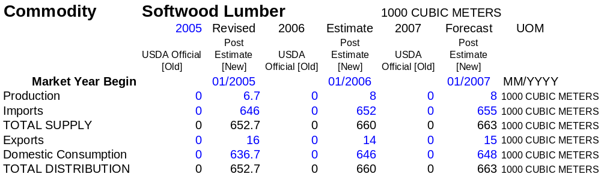

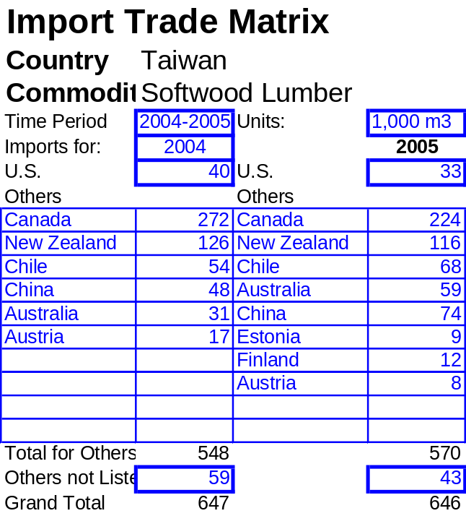
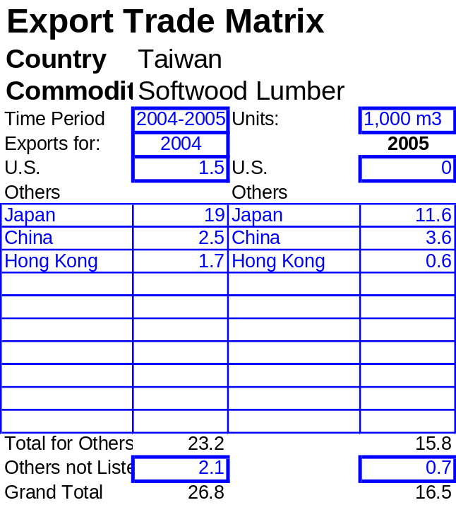
SOFTWOOD LUMBER IMPORTS SOFTWOOD LUMBER EXPORTS
HARDWOOD LUMBER (TEMPERATE)

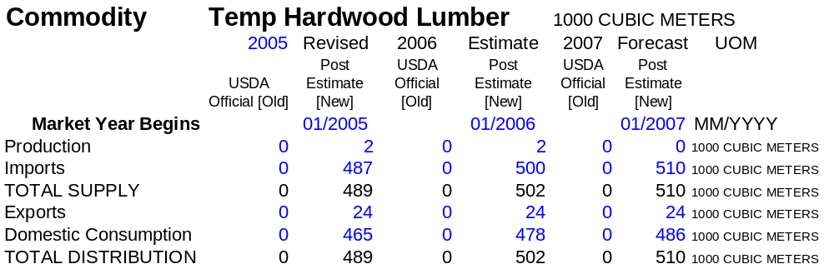

TEMP HWD LUMBER IMPORTS TEMP HWD LUMBER EXPORTS
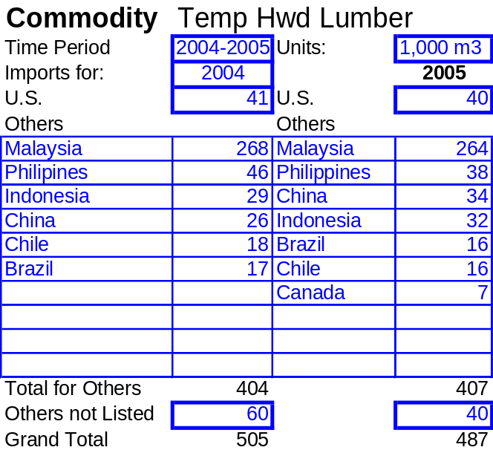
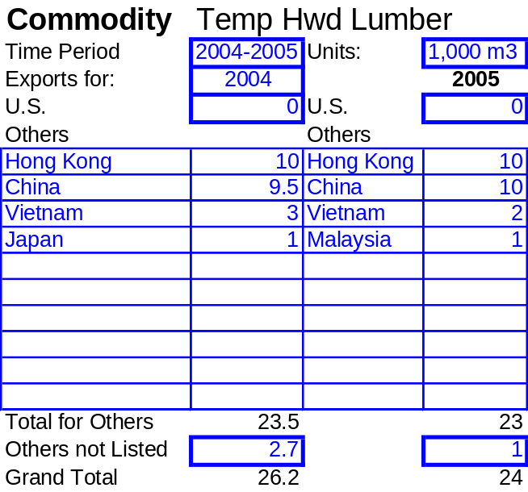
HARDWOOD LUMBER (TROPICAL)

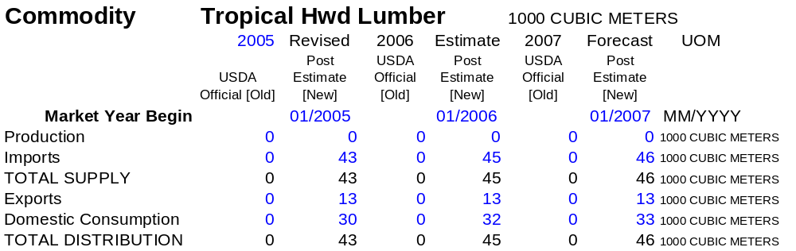

TROPICAL HWD LUMBER IMPORTS TROPICAL HWD LUMBER EXPORTS

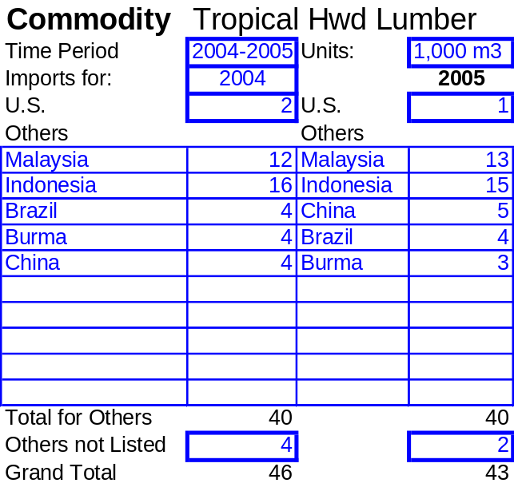
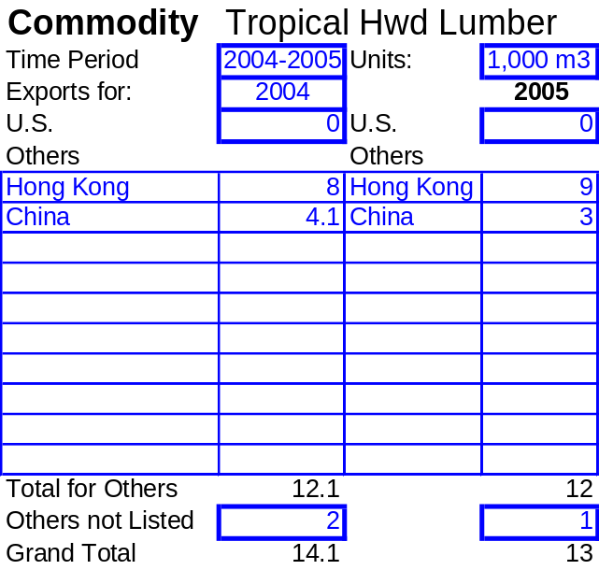
HARDWOOD VENEER

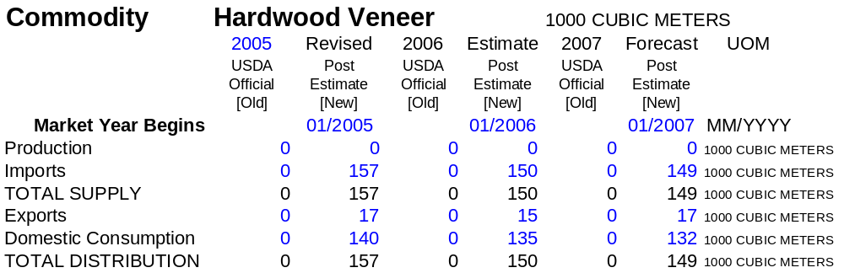

HARDWOOD VENEER IMPORTS HARDWOOD VENEER EXPORTS
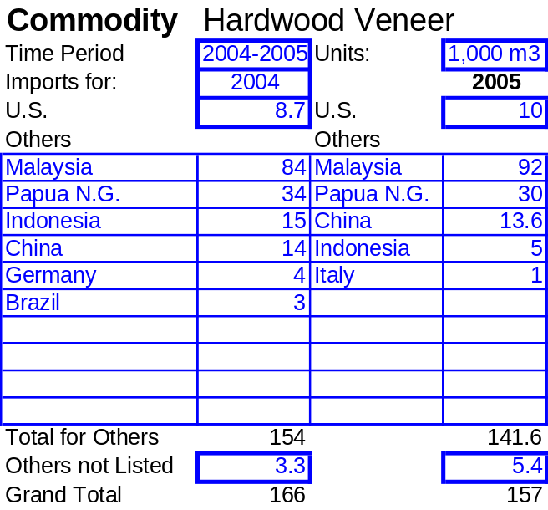
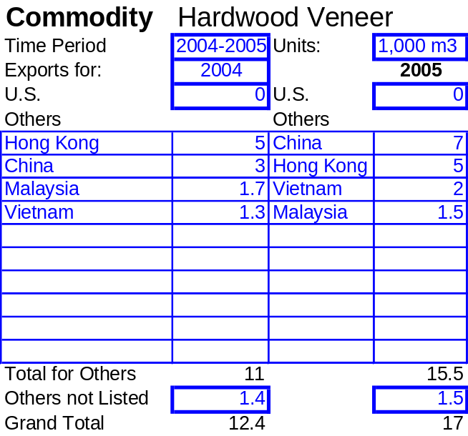

SOFTWOOD PLYWOOD

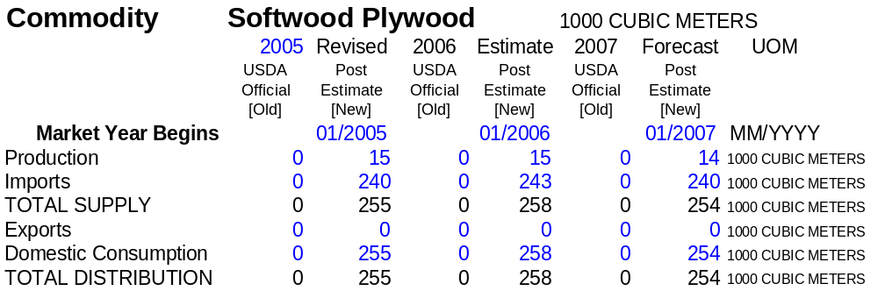

SOFTWOOD PLYWOOD IMPORTS SOFTWOOD PLYWOOD EXPORTS

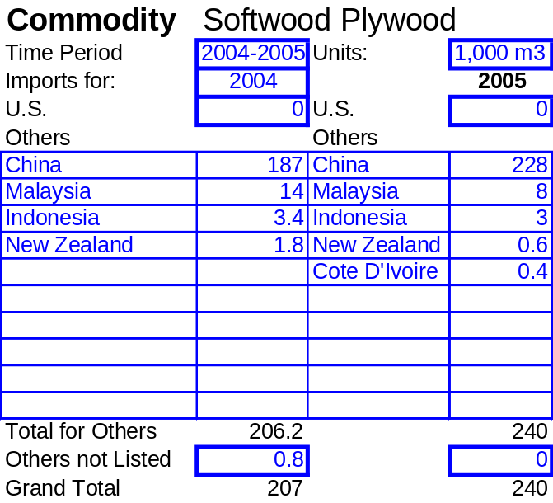
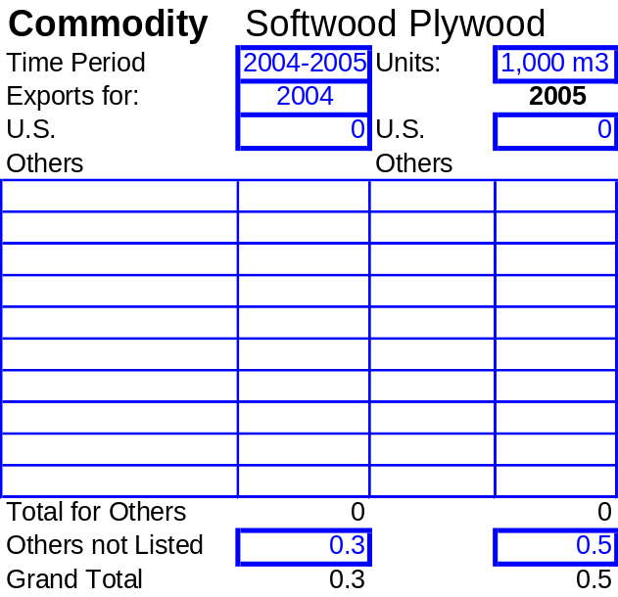
HARDWOOD PLYWOOD

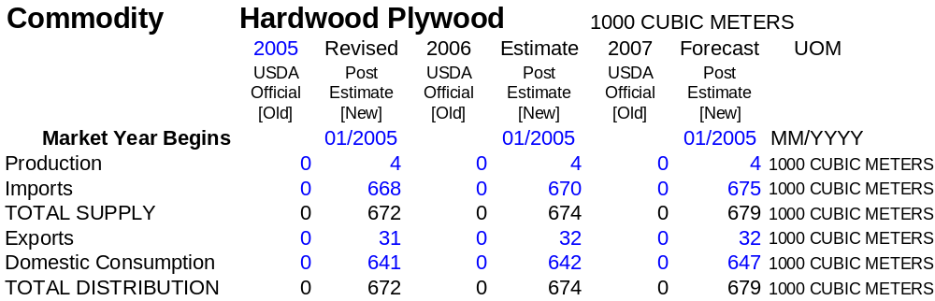

HARDWOOD PLYWOOD IMPORTS HARDWOOD PLYWOOD EXPORTS
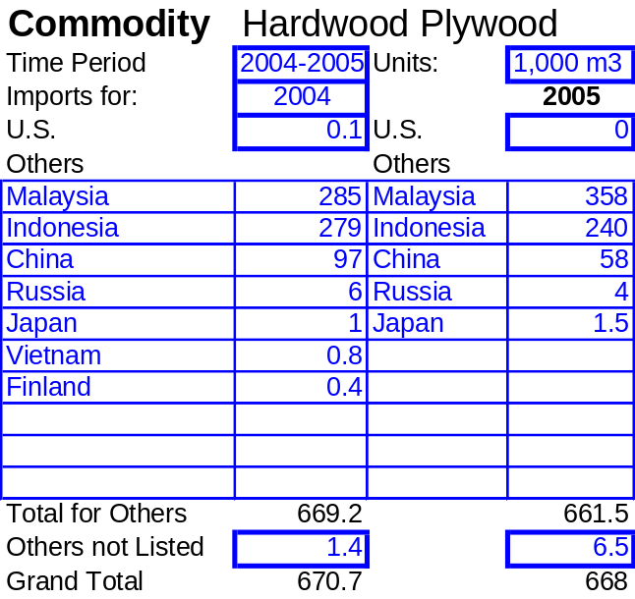
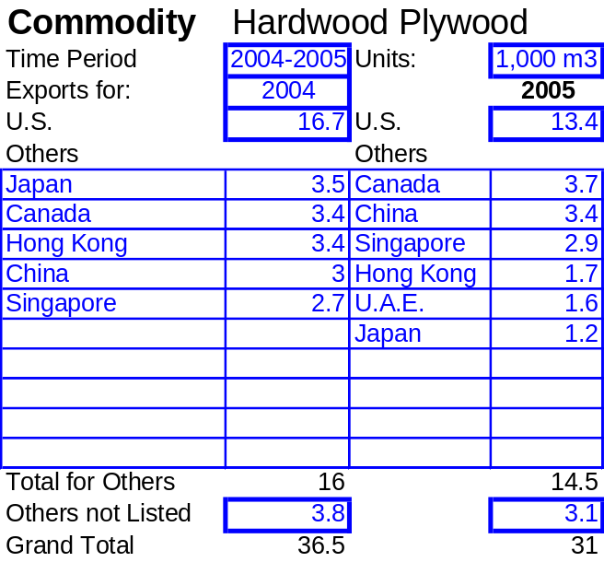

Ten China fir trees, all around 30 years of age, felled for a separate 1999 study revealed an average trunk diameter of 25 cm and an average ring growth rate of 5.5mm per year.
Relevant regulatory documents include "Technical Construction Code" (CPA, January 2000 revision) and "Technical Standards for Wood Frame Building Design and Construction" (CPA, May 2003 revision)
The Council of Agriculture was reported to have set this number as a target.

