LANSCE Isotope Production Facility—
Shield Wall Evaluation

Kenneth A. Van Riper
White Rock Science Report 99–11

November 30, 1999

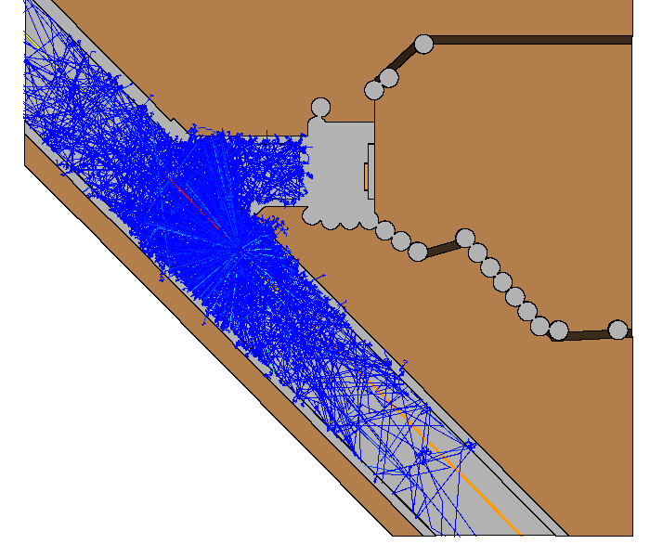
Tracks of neutrons and photons resulting from a beam spill in the existing LANSCE beam tunnel. The IPF construction area is at the top right.

Summary
We have carried out Monte Carlo radiation transport calculations for the LANSCE IPF to investigate the shielding provided by various concrete structures and the tuff outside of those structures. The thickness of tuff outside the main tunnel is sufficient to limit the dose equivalent rate (DER) to less than 1 mrem/hour for a 10 amp beam spill in the main tunnel and to much less than 25 rem/hour for a 1500 amp spill. The base of the shield wall, at tunnel level, also provides adequate protection. There are regions near the cut out for the existing electrical duct where the DER in the shield surface could be as high as 10 mrem/hour. Enhancement of the shielding by the concrete in the duct and additional poured concrete could ameliorate concerns in this area. An operational phase model in which a 500 amp beam is directed at a 20” long RSS beam plug results in a DER in the upstream end of the IPF tunnel of 35 mrem/hour.

Introduction
The Isotope Production Facility (IPF) project will build a new beam line on the north side of the existing LANSCE accelerator building at Los Alamos National Laboratory. One part of this construction, to be carried out during a scheduled beam outage, will involve building a shield wall between the existing accelerator tunnel and the new beam tunnel. This wall will serve two purposes. The first will be to provide radiation shielding to protect construction workers involved in building the new facility, which will require construction activities while the accelerator is operating. The second will be to allow for personnel access into the new tunnel at times when the accelerator is providing beam for delivery to other experimental areas.
We have made radiation transport calculations to evaluate the effectiveness of the proposed shield wall during both the construction and operation phases. For the construction phase, we consider beam spills at three locations in the mean beam line and examine the attenuation of the Dose Equivalent Rate (DER) in the concrete walls and tuff surrounding the beam tunnel as well as in the shielding wall. For the operation phase, we assume a 500-microampere beam spill on the last RSS beam plug, immediately in front of the beam line hole in the shield wall.

Calculation Models

MCNPX Code
All calculations were made with the Monte Carlo transport code MCNPX from LANL group XTM. We used the latest version, MCNPX2.1.5, which was released on May 21, 1999. MCNPX transports protons, neutrons, photons, and other particles simultaneously. A number of evaluated data files provide accurate neutron cross sections for neutron energies up to 150 MeV. The calculations were run on a Silicon Graphics Inc. INDY workstation running IRIX 6.5.
The MCNPX distribution comes with approximately 30 test problems designed to verify proper installation and operation of the code. Our installation exactly duplicated the results of all the test problems. As a further check, we used MCNPX2.1.5 on a model we had previously calculated in the IPF design phase. That model calculates the transport of radiation from a beam spill in the IPF target room up a vertical access shaft and through a 2 foot plug at the top of the shaft.
The previous calculation used LAHET2.83 and MCNP4B. LAHET calculated the transport of protons, high-energy ( 20 MeV) neutrons, and a number of nuclear particles. A log of events was written to a history file that was processed to obtain tallies for the high-energy neutron contribution to the DER and a low energy neutron and photon source for MCNP. Transport of those particles by MCNP yielded the remainder of the neutron DER and the photon DER.
For both neutrons and photons in the MCNPX2.1.5 results, F4 volume tallies in the air spaces surrounding the spill are 2% larger than in the previous run. Elsewhere, tallies were from 0% to 7% larger than in the previous run. There is a suggestion of more attenuation through the concrete, by a few %, in the MCNPX run, but the statistics rule out a definite statement (we used 1/2 the number of histories in the MCNPX run as in the LAHET–MCNP model).
As a final check, we wrote a surface source file with MCNPX at selected surfaces in a model of a 110 MeV beam spill (described below), and then used that file as a source in both MCNPX2.1.5 and MCNP4B to look at neutron and photon penetration into concrete and tuff. The results agreed within their statistical uncertainties.
The small differences we saw between MCNPX2.1.5 and MCNP4B are not unexpected because of the more accurate neutron cross sections and improved charged particle (proton) transport in the former. We consider MCNPX2.1.5 to be performing properly and an appropriate code to use for the IPF shielding studies.
We used MCNPX to transport protons, neutrons, and photons. In runs that read a surface source file, protons were omitted. A test run with pion transport enabled produced the same results as a run without pions. We neglected pions for the models reported here.

Materials
The major materials are tuff (Pajarito Plateau soil), ordinary concrete (4000 psi mix), and air. The beam line is made of SS–304 stainless steel and contains a vacuum at 1.510⁻¹² atom b⁻¹ cm⁻¹. The beam obstruction for the 110 MeV spill and the RSS beam plug are made of copper of natural isotopic composition.
The concrete and tuff compositions are based on those given in LANL memorandum ESH–12:99–100 from Russ Durrer to Richard Heaton. This document specifies the elemental composition, not the isotopic composition. For most elements, there is only a single naturally occurring isotope or an MCNPX cross section table is available for the natural isotopic composition of the element. We divided the given fractions for Hydrogen and Oxygen into ¹H, ²H, ¹⁶O, and ¹⁷O based on the natural abundance of these isotopes. We increased the ¹⁶O fraction by 0..000080286 and 0.0000105203 for tuff and concrete, respectively, to cause the fractions of all isotopes to sum to unity.
Table 1 through Table 5 list the compositions of the materials. Table 6 gives their densities.
Element | A | Weight Fraction | MCNPX ZAID
Hydrogen | 1 | 0.0066489 | 1001
Hydrogen | 2 | 1.01410⁻⁶ | 1002
Oxygen | 16 | 0.5178777860 | 8016
Oxygen | 17 | 0.0002023 | 8017
Sodium | 23 | 0.0280 | 11023
Aluminum | 27 | 0.0594 | 13027
Silicon | nat | 0.344 | 14000
Potassium | nat | 0.0337 | 19000
Iron | 54 | 0.01017 | 26054
Table 1—Tuff composition by weight fraction.

Element | A | Weight Fraction | MCNPX ZAID
Hydrogen | 1 | 0.0035794415 | 1001
Hydrogen | 2 | 0.0000005584 | 1002
Oxygen | 16 | 0.4947570990 | 8016
Oxygen | 17 | 0.0001934211 | 8017
Sodium | 23 | 0.00938 | 11023
Magnesium | nat | 0.00561 | 12000
Aluminum | 27 | 0.03356 | 13027
Silicon | nat | 0.33525 | 14000
Phosphorus | 31 | 0.00028 | 15031
Sulfur | nat | 0.00175 | 16000
Potassium | nat | 0.01154 | 19000
Calcium | nat | 0.08607 | 20000
Titanium | nat | 0.0014 | 22000
Manganese | 55 | 0.00021 | 25055
Iron | nat | 0.01641948 | 26000
Table 2—Concrete composition by weight fraction.

Element | A | Fraction for Air | Fraction for Vacuum | MCNPX ZAID
Hydrogen | 1 | 1.7596710-10 | 1.2033410-7 | 1001
Hydrogen | 2 | 2.6399210-14 | 3.6077910-11 | 1002
Helium | 3 | 1.5054510-16 | 6.2981910-13 | 2003
Helium | 4 | 1.0753210-10 | 5.9702810-7 | 2004
Carbon | 12 | 5.9874410-9 | 1.7342110-1 | 6012
Carbon | 13 | 6.6594710-11 | 2.0901410-3 | 6013
Nitrogen | 14 | 3.1937410-5 | 6.2034610-1 | 7014
Nitrogen | 15 | 1.1860710-7 | 2.4678410-3 | 7015
Oxygen | 16 | 8.6119110-6 | 1.9104710-1 | 8016
Sulfur | 32 | 1.3430110-13 |  | 16032
Argon | nat | 1.9172410-7 | 1.0623810-2 | 18000
Krypton | 78 | 8.1851710-14 | 8.8468810-9 | 36078
Krypton | 80 | 5.2618910-13 | 5.8329610-8 | 36080
Krypton | 82 | 2.7127910-12 | 3.0823610-7 | 36082
Krypton | 83 | 2.6894110-12 | 3.0931310-7 | 36083
Krypton | 84 | 1.3330210-11 | 1.5515610-6 | 36084
Krypton | 86 | 4.0458110-12 | 4.8213010-7 | 36086
Xenon | nat | 1.7939910-12 | 3.2671910-7 | 54000
Table 3—Air and Vacuum composition by number fraction.

Element | A |  | Weight Fraction |  | MCNPX ZAID
Copper |  | nat |  | 1.0 |  | 29000
Table 4—Copper composition

Element | A | Number Fraction | MCNPX ZAID
Carbon | 12 | 3.1512910-4 | 6012
Carbon | 13 | 3.5050010-6 | 6013
Silicon | nat | 1.7033410-3 | 14000
Phosphorus | 31 | 6.9502710-5 | 15031
Sulfur | 32 | 4.4759110-5 | 16032
Chromium | nat | 1.7481010-2 | 24000
Manganese | 55 | 1.7415710-3 | 25055
Iron | nat | 5.8118410-2 | 26000
Nickel | nat | 8.1514510-3 | 28000
Table 5—Stainless Steel composition by number fraction.

Material | Mass Density | Number Density
 | g cm-3 | atom b-1 cm-1
Concrete | 2.34
Tuff | 1.69
Stainless Steel | (7.944) | 8.7628710-2
Air | (9.87240010-4) | 4.0866010-5
Vacuum |  | 1.510-12
Copper | 8.89
Table 6—Material densities (values in parentheses were not used in model).

Dose Response Functions
MCNPX surface (F2) and volume (F4) tallies are stored internally in units of particles cm⁻². Dose response functions convert from these units to a DER in rem/hour.
For neutrons (Table 7), we used values from NCRP–38, also known as ANSI/ANS-6.1.1-1977 (kindly supplied by Jeffrey Bull). The photon response function (Table 8) is also from ANSI/ANS-6.1.1-1997 (also supplied by Bull).

Energy (MeV) | (rem hr⁻¹) / (n cm⁻² s⁻¹) | Energy (MeV) | (rem hr⁻¹) / (n cm⁻² s⁻¹) | Energy (MeV) | (rem hr⁻¹) / (n cm⁻² s⁻¹)
2.510-8 | 3.6710-6 | 0.5 | 9.2610-5 | 20.0 | 2.2710-4
10-7 | 3.6710-6 | 1.0 | 1.3210-4 | 40. | 2.49710-4
10-6 | 4.4610-6 | 2.5 | 1.2510-4 | 60. | 2.2710-4
10-5 | 4.5410-6 | 5.0 | 1.5610-4 | 100. | 1.7835810-4
10-4 | 4.1810-6 | 7.0 | 1.4710-4 | 200. | 1.92110-4
10-3 | 3.7610-6 | 10.0 | 1.4710-4 | 300. | 2.2710-4
10-2 | 3.5610-6 | 14.0 | 2.0810-4 | 400. | 2.49710-4
10-1 | 2.1710-5
Table 7—Neutron dose response function

Energy (MeV) | (rem hr⁻¹) / ( cm⁻² s⁻¹) | Energy (MeV) | (rem hr⁻¹) / ( cm⁻² s⁻¹) | Energy (MeV) | (rem hr⁻¹) / ( cm⁻² s⁻¹) | Energy (MeV) | (rem hr⁻¹) / ( cm⁻² s⁻¹)
0.01 | 3.9610-6 | 0.4 | 9.8510-7 | 1.8 | 2.9910-6 | 5.35 | 6.0110-6
0.03 | 5.8210-7 | 0.45 | 1.0810-6 | 2.2 | 3.4210-6 | 5.75 | 6.3710-6
0.05 | 2.9010-7 | 0.5 | 1.1710-6 | 2.6 | 3.8210-6 | 6.25 | 6.7410-6
0.07 | 2.5810-7 | 0.55 | 1.2710-6 | 2.8 | 4.0110-6 | 6.75 | 7.1110-6
0.1 | 2.8310-7 | 0.6 | 1.3610-6 | 3.25 | 4.4110-6 | 7.5 | 7.6610-6
0.15 | 3.7910-7 | 0.65 | 1.4410-6 | 3.75 | 4.8310-6 | 9 | 8.7710-6
0.2 | 5.0110-7 | 0.7 | 1.5210-6 | 4.25 | 5.2310-6 | 11 | 1.0310-5
0.25 | 6.3110-7 | 0.8 | 1.6810-6 | 4.75 | 5.6010-6 | 13 | 1.1810-5
0.3 | 7.5910-7 | 1 | 1.9810-6 | 5.0 | 5.8010-6 | 15 | 1.3310-5
0.35 | 8.7810-7 | 1.4 | 2.5110-6
Table 8—Photon dose response function

Variance Reduction
Deep penetration models are a difficult problem for Monte Carlo transport. We need to tally radiation levels at the level of a millirem or less from the attenuation of a megarem source. In an analog Monte Carlo model, in which there is no variance reduction, one particle in approximately 10⁹ would contribute to the tally. Such a model would require an unreasonable long computation time.
We use the technique of importance splitting to concentrate the population of neutrons and photons in cells that contribute the tallies. (Splitting was not applied to protons.) Each cell is assigned an importance value. When a particle enters a cell with twice the importance as the cell it has left, the particle is split into two particles, each with ½ the original particle weight. Going the other way, ½ of the particles, on average, are terminated while preserving the total weight of particles. A careful adjustment of importances with depth into absorbing layers of tuff and concrete will increase the particle concentration enough to balance the particles lost by absorption and ensure that sufficient particles arrive at the tally to achieve good statistics. If the importance does not increase greatly enough with depth, the particle population will fall off and few, if any, will reach the tally. On the other hand, when the importance function grows too rapidly with depth, the particle population will increase exponentially as will the computer time required to follow those particles.
In a good Monte Carlo model, the importances should be matched so that they vary by not more than a factor of two from cell to cell. Because of the complex geometry of the full IPF model, described, below, we were unable to construct a global importance function that would provide for optimum transport through the tuff opposite the 110 MeV beam spill and through the shield wall while maintaining good importance matching. We instead made several calculations modeling different shielding regions.
Point detectors are a variance reduction technique that uses attenuation along a ray to estimate the tally at the detector. Following each collision of a Monte Carlo particle, the detector tally is incremented by the weight the Monte Carlo particle would contribute if it were to travel in a straight line to the detector attenuated by the material in between. We used several point detectors in the excavated area of the full IPF model. The use of the point detectors increased the calculation time by hundreds of percent and did not provide tallies with good statistics. Because of these limitations, we did not use them in subsequent calculations.
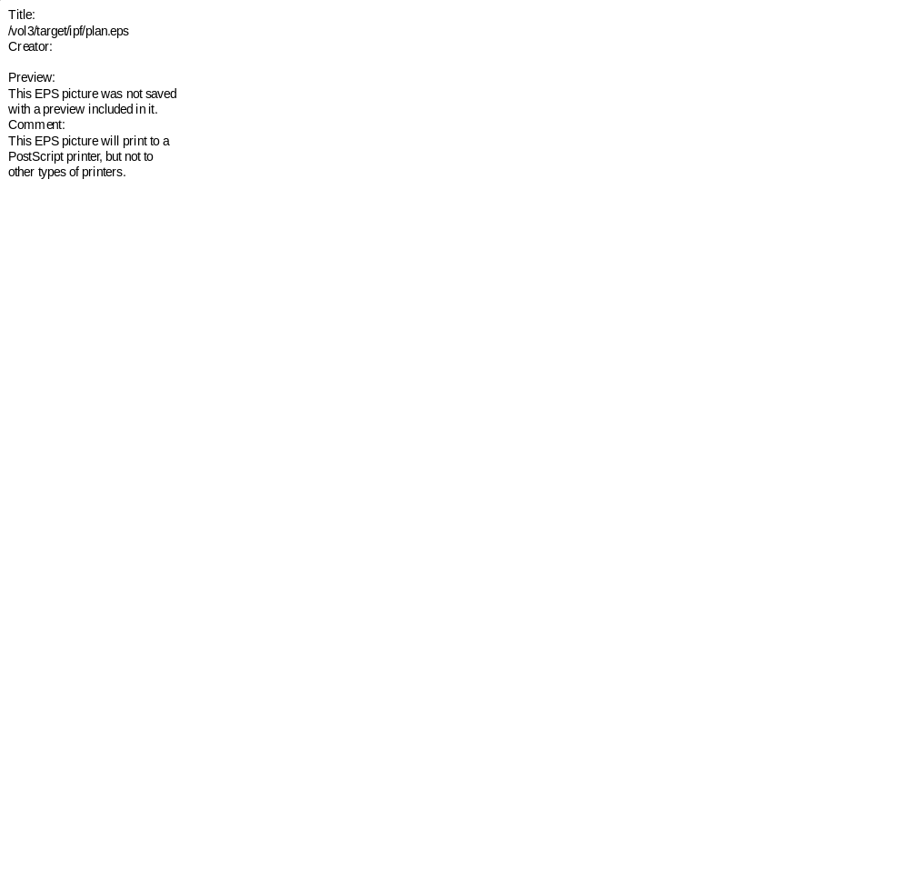
Figure 1—Floor plan of the complete IPF model showing the location of beam spills (red circles) and surfaces on which the flux was saved to a surface source file.

Tally Results
For most models, we present tables of the DER at various positions through the model. In addition to the total DER, we also give the neutron and photon components. The Monte Carlo accuracy is given by the Relative Error (RE). The MCNP manual characterizes tallies with REs as “generally reliable”, those with REs between 0.2 and 0.5 as within a “factor of a few”, and any with a larger error as “garbage”.
Because we used a computer program to process the results for the Tables, most tally values carry more digits than are significant. In most cases, 2 or 3 significant digits would be appropriate. The Tables should be viewed with this proviso in mind.

Construction Phase

Full IPF Model
Construction of the IPF will require excavation of an area beyond the existing beam line stubout. A number of drilled concrete piers will provide shoring and support additional shoring. Following excavation, the shield wall will be built at the end of the stubout. We constructed a model of the IPF construction phase (Figure 1, Figure 2 shows more detail in the stubout and shield wall) consisting of a portion of the existing LANSCE tunnel and beam line, existing stubout, shield wall, concrete piers, and surrounding tuff. The excavated area extends from the top of the model, coincident with the top of the piers, to the bottom of the tunnel floor level.
The shield wall and tuff layers must provide sufficient shielding so that the DER in the excavated area is less than 1 mrem/hour for a 10 amp beam spill and less than 25 rem/hour for a 1500 amp spill. Because the results scale with beam current, the 1 mrem/hour limit is the more stringent. The results below, in mrem/hour for a 10 amp spill, are, when multiplied by 0.15, the DER in rem/hour for a 1500 amp spill.
We assumed the area labeled Back Filled in Figure 1 would be filled with soil, to at least to the level of the top of the lower shield, following construction of the shield wall. We did not include two piers that will be drilled directly adjacent to the external stubout end wall and fully incorporated in the shield. We assume the spaces between the existing wall and piers will be filled with concrete in this and other shield models.
Because of the difficulties in achieving good variance reduction as described above and hence obtaining meaningful tallies, we did not pursue calculations using the full model. Instead, we did a number of calculations focusing on specific regions.

Beam Spills
The (draft) Isotope Production Facility (IPF) Radiological Summary describes the two worst case beam spills in the existing beam line during operations while IPF construction is ongoing:
5.1 Source Terms for the Construction Phase
The construction phase of the project applies up to the point at which installation of beam line components in the new portion of the lower level of the facility begins. At this point the construction of the lower facility is completed and the penetrations in the shield wall have been opened to allow installation of the beam pipe. Thus, the configuration after this point more closely resembles that of the completed facility than that during construction.
During the construction phase it is not possible to propagate beam into the new beam line, since the kicker magnet will not be activated. Therefore, beam spills are limited to the existing beam line. Furthermore, because there will be no users of H⁺ beam for the immediate future, beam spills will be limited to the H⁻ leg of the transition region.
5.1.1 Beam Spills during Normal Operations. During tuning operations it is customary to deliberately spill small amounts of beam until the beam is located and properly steered through the beam line. These beam spills can occasionally amount to 10 microamperes of beam current. The location of the spill and the direction of the beam at that point are important in determining the radiation dose rates, both inside and outside the tunnel.
There are two cases that must be considered. The first is beam spillage in the transition region (TR), while the second is beam spillage in module 5 downstream of the transition region where the dirt region between the beam tunnel and the excavated construction area will be the thinnest.
5.1.1.1 Low-Power Beam Spill in the TR Region. Most of the possible beam spill locations in the H⁻ side of the TR are within magnet yokes or in regions in which the beam is directed away from the north wall of the beam tunnel. However, there is one location at which the beam is directed toward the north wall and a magnet failure could allow the beam to propagate toward the beam tunnel wall without encountering the magnet yoke or any other metallic structure besides the beam pipe itself. This constitutes the worst location for such a beam spill.
This is the case in which bending magnet BM04 fails, allowing the beam to impinge on the beam pipe at an angle of 20 degrees relative to the beam line axis. The beam pipe at this location is constructed of stainless steel with 0.035 in. walls, oriented at 20 degrees in the opposite direction to accommodate H⁺ beam from the opposite side of the TR. Most of the beam will pass through the stainless steel beam pipe, propagate across the space between the beam line and the wall, and then impinge on the concrete wall at a 20 degree angle.
5.1.1.2 Low-Power Beam Spill Downstream of the TR Region. This is the case of a low-power beam spill within the side coupled linac downstream of the TR. In this portion of the accelerator the beam is never off axis; a beam spill would always be at a very small angle to the beam axis. The side coupled linac is constructed largely of copper. The energy of the beam will increase gradually with increasing distance from the TR. Therefore, the worst case will consist of a 10 microampere beam spill on a stopping length of copper at beam line center. The incidence angle of the beam will be zero degrees with respect to the tunnel axis, and the beam energy will be 110 MeV.
5.1.2 Worst-Case Design Basis Beam Spills. The worst-case design basis accident consists of a full-power beam spill at a location chosen to result in the maximum dose rate outside of the shielded area. In this analysis a full-power beam spill corresponds to 1.5 milliamperes of beam current, which is the maximum current that the accelerator is capable of delivering.
There are two cases that must be considered. The first is beam spillage in the transition region, while the second is beam spillage in module 5 downstream of the transition region where the dirt region between the beam tunnel and the excavated construction area will be the thinnest.


Figure 2—Detail of the floor plan of the complete IPF model showing relevant dimensions.
The document goes on to describe the same locations for the worst case high power spills as for the lower power spills. The Monte Carlo analysis is independent of the beam power. An overall multiplier converts the per proton results to reflect the beam current.
We refer to the spill in the TR region resulting from failure of the BM04 magnet as the 100 MeV spill and the spill further downstream as the 110 MeV spill. The locations of both spills are shown in Figure 1, and that of the 100 MeV spill in Figure 2. In the 100 MeV case, most of the spill radiation is generated when the beam strikes the concrete wall. Radiation from the beam striking a metal target may have a harder spectrum and be more penetrating. To assess such effects, we considered a 100 MeV on-axis spill onto a stainless steel plug in the beam line centered between the stubout walls.
For all spills, we modeled the beam tube as a 6 inch OD stainless steel tube (SS–304) with wall thickness 0.035” containing vacuum.

110 MeV Beam Spill
We choose the location of the 110 MeV spill opposite the smallest thickness of tuff. This thickness is about 16 ½ feet. Because we did not model penetration in the full IPF model, that the maximum dose rate occurs a bit further downstream does not matter. The 17.375’ dimension in Figure 1 marks the position of the start of a copper beam obstruction that simulates the spill. The obstruction downstream of the spill location is a solid cylinder the same diameter as the beam line. A pencil beam of 110 MeV protons at the center of the beam line impinged upon the obstruction. We viewed the tracks of particles from several histories to verify the placement of the beam.
(The figure on the cover of this document does not represent this spill. The spill in this figure is further upstream, and a photon beam was substituted for the proton beam.)
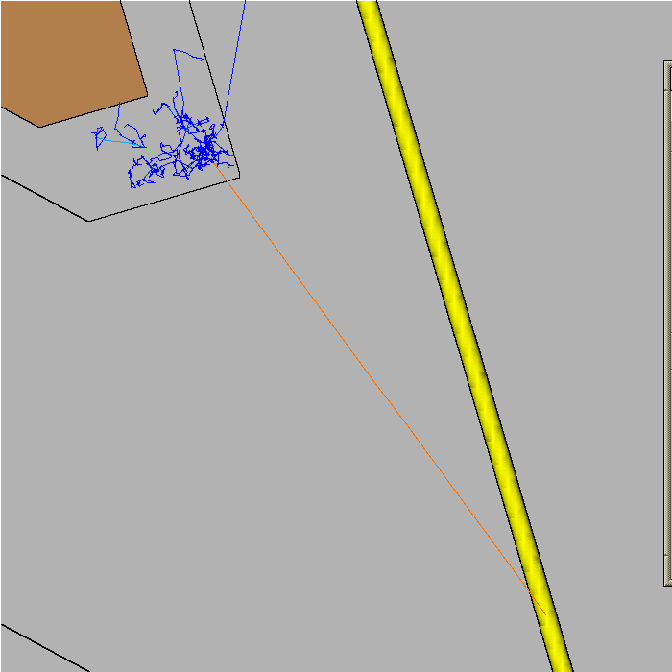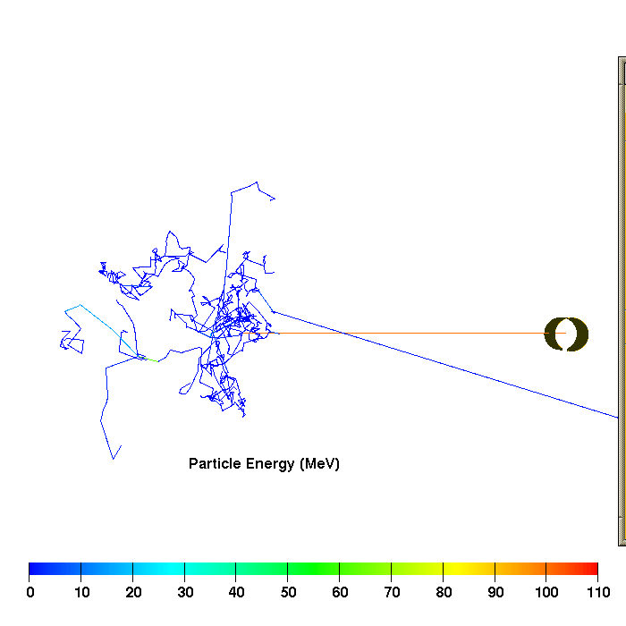

Figure 3—Particle tracks used to verify the placement of the 20 100 MeV beam spill.

100 MeV Beam Spill
The location of the 100 MeV spill was determined from measurements on a blue print showing the location of the H⁻ line and the magnets. A pencil beam of 100 MeV protons was directed 20 from the beam axis in the same vertical plane. To verify the beam placement, we substituted a photon beam for the proton beam to eliminate deflection of the beam by the beam tube wall and examined the tracks of Monte Carlo particles with the Sabrina graphics code. Figure 3 shows the tracks from one such history. The angle between the beam and the beam tube in the left panel is 20. The view in the right panel is nearly down the axis of the beam tube. That the primary beam (orange) may not appear horizontal is an optical illusion.

Surface Source Write Runs
For both beam spills, we calculated the radiation in a model consisting of the tunnel and stubout walls, floor, ceiling, beam tube, and interior air and wrote a surface source file of neutrons and photons crossing two surfaces. These surfaces are shown as heavy green lines in Figure 1. All surfaces extend from floor to ceiling. Surface 1 extends for 10 feet on either side of the 110 MeV spill location. Surface 2 is the interior of the end wall of the stubout that is also the upstream face of the shield wall. We made a separate surface source write run, with only the 100 MeV spill, for surface 3 which is the oblique section of tunnel wall on which the 100 MeV spill impinges. The latter run included only that interior airspace indicated by the gold cross-hatching in Figure 1.

Tuff Penetration Model 1
We constructed a simple model, shown in Figure 4, to model the penetration of radiation into the tunnel wall and tuff opposite the 110 MeV beam spill location. The model extends 10 feet on either side of the spill location, from the far inner tunnel wall to 20.4 feet into the tuff on the near IPF side, and from top of the ceiling to the bottom of the floor. The heavy green line shows the surface corresponding to surface 1 in the surface source write runs. This file served as the source.
We made tallies at a number of depths into the tuff; the depth is measured from the inner wall surface. To account for the forward streaming effect of the 110 MeV spill, we divided into seven segments along the beam direction; the Distance Along Wall values are the locations of the midpoints of these segments relative to the spill location; a positive value is downstream of the spill.
We show here the results from the 110 MeV spill. The DERs resulting from the 100 MeV spill are much smaller (the rates in the first few tuff layers are down by a factor of 35, the 100 MeV statistics in deeper layers are too large for meaningful comparison). The results are given in mrem/hour for a 10 amp beam current. To obtain rem/hour for a 1.5 milliamp spill, multiply the DERs by 0.15.
Table 9 through Table 15 list the DERs as a function of depth for each distance. The tables list the neutron and photon contributions the DER and the Total, and the relative errors for each. Figure 5 shows the total DER as a function of depth for each distance, while Figure 6 shows the variation with distance for each depth.
At a depth of 16.3 feet, the largest DER is 0.2 mrem/hour in the segment 5.7 feet downstream of the spill location. The closest distance to the excavated area, measured from the inner tunnel wall surface to the plane through the center of the concrete piers (Figure 1), is approximately 16 ½ feet. The DER in the excavated area due to a 10 amp 110 MeV beam spill downstream of the stubout will be less than a mrem/hour. The concrete piers, for which we do not account, will provide additional shielding.
Depth  (feet) | Neutron |  | Photon |  | Total
Depth  (feet) | DER (mrem/hr) | RE | DER (mrem/hr) | RE | DER (mrem/hr) | RE
3.76 | 475.07098 | 0.159 | 194.74899 | 0.038 | 669.81995 | 0.113
5.15 | 78.63010 | 0.325 | 25.12670 | 0.053 | 103.75680 | 0.247
6.54 | 20.29270 | 0.400 | 3.70799 | 0.086 | 24.00069 | 0.339
7.94 | 3.73113 | 0.366 | 0.68704 | 0.119 | 4.41817 | 0.310
9.33 | 1.26475 | 0.329 | 0.13747 | 0.148 | 1.40222 | 0.297
10.72 | 0.37316 | 0.335 | 0.02886 | 0.168 | 0.40203 | 0.311
12.12 | 0.10330 | 0.324 | 0.00732 | 0.188 | 0.11062 | 0.302
12.81 | 0.06292 | 0.349 | 0.00319 | 0.225 | 0.06611 | 0.333
13.51 | 0.03061 | 0.450 | 0.00169 | 0.260 | 0.03230 | 0.427
14.21 | 0.01578 | 0.414 | 0.00083 | 0.288 | 0.01661 | 0.393
14.90 | 0.00904 | 0.421 | 0.00037 | 0.287 | 0.00941 | 0.405
15.60 | 0.00518 | 0.379 | 0.00024 | 0.298 | 0.00543 | 0.362
16.30 | 0.00361 | 0.422 | 0.00013 | 0.325 | 0.00374 | 0.408
Table 9—Dose Equivalent Rates, as a function of depth from tunnel wall surface, centered 8.57 feet upstream of the 10 amp 110 MeV beam spill in tuff penetration model 1.

Figure 4—Tuff penetration model 1 geometry.
Depth  (feet) | Neutron |  | Photon |  | Total
Depth  (feet) | DER (mrem/hr) | RE | DER (mrem/hr) | RE | DER (mrem/hr) | RE
3.76 | 1534.6699 | 0.091 | 448.92102 | 0.028 | 1983.5909 | 0.071
5.15 | 252.04500 | 0.145 | 63.25500 | 0.036 | 315.29999 | 0.116
6.54 | 61.30920 | 0.193 | 9.55624 | 0.051 | 70.86544 | 0.168
7.94 | 12.38810 | 0.237 | 1.57402 | 0.075 | 13.96212 | 0.211
9.33 | 3.89622 | 0.244 | 0.31290 | 0.097 | 4.20912 | 0.226
10.72 | 1.30094 | 0.297 | 0.07426 | 0.144 | 1.37520 | 0.281
12.12 | 0.31203 | 0.330 | 0.01811 | 0.200 | 0.33014 | 0.312
12.81 | 0.16512 | 0.350 | 0.00819 | 0.223 | 0.17330 | 0.334
13.51 | 0.08779 | 0.311 | 0.00442 | 0.246 | 0.09221 | 0.296
14.21 | 0.04677 | 0.299 | 0.00205 | 0.242 | 0.04882 | 0.286
14.90 | 0.02605 | 0.275 | 0.00113 | 0.229 | 0.02718 | 0.264
15.60 | 0.01635 | 0.300 | 0.00059 | 0.248 | 0.01694 | 0.290
16.30 | 0.00990 | 0.328 | 0.00034 | 0.261 | 0.01023 | 0.317
Table 10—Dose Equivalent Rates, as a function of depth from tunnel wall surface, centered 5.71 feet upstream of the 10 amp 110 MeV beam spill in tuff penetration model 1.
Depth  (feet) | Neutron |  | Photon |  | Total
Depth  (feet) | DER (mrem/hr) | RE | DER (mrem/hr) | RE | DER (mrem/hr) | RE
3.76 | 3898.2199 | 0.064 | 805.03406 | 0.022 | 4703.2539 | 0.053
5.15 | 617.73102 | 0.113 | 108.06500 | 0.029 | 725.79602 | 0.096
6.54 | 138.60501 | 0.155 | 17.90360 | 0.044 | 156.50861 | 0.138
7.94 | 30.36850 | 0.179 | 3.01574 | 0.065 | 33.38424 | 0.163
9.33 | 10.12760 | 0.176 | 0.65377 | 0.092 | 10.78137 | 0.166
10.72 | 2.71567 | 0.167 | 0.15046 | 0.106 | 2.86613 | 0.158
12.12 | 0.74095 | 0.182 | 0.03863 | 0.131 | 0.77958 | 0.173
12.81 | 0.43170 | 0.222 | 0.01852 | 0.139 | 0.45022 | 0.213
13.51 | 0.24339 | 0.229 | 0.01060 | 0.171 | 0.25400 | 0.219
14.21 | 0.14672 | 0.242 | 0.00604 | 0.212 | 0.15275 | 0.233
14.90 | 0.08408 | 0.290 | 0.00322 | 0.214 | 0.08730 | 0.280
15.60 | 0.05224 | 0.336 | 0.00182 | 0.256 | 0.05406 | 0.325
16.30 | 0.03074 | 0.351 | 0.00112 | 0.265 | 0.03186 | 0.339
Table 11—Dose Equivalent Rates, as a function of depth from tunnel wall surface, centered 2.86 feet upstream of the 10 amp 110 MeV beam spill in tuff penetration model 1.
Depth  (feet) | Neutron |  | Photon |  | Total
Depth  (feet) | DER (mrem/hr) | RE | DER (mrem/hr) | RE | DER (mrem/hr) | RE
3.76 | 6705.4697 | 0.060 | 906.29797 | 0.020 | 7611.7675 | 0.052
5.15 | 1284.4000 | 0.086 | 137.84601 | 0.031 | 1422.2460 | 0.077
6.54 | 291.71399 | 0.106 | 23.23630 | 0.045 | 314.95029 | 0.098
7.94 | 79.33130 | 0.128 | 5.10123 | 0.070 | 84.43253 | 0.121
9.33 | 20.83480 | 0.161 | 1.13128 | 0.088 | 21.96608 | 0.153
10.72 | 6.26615 | 0.199 | 0.28507 | 0.130 | 6.55122 | 0.191
12.12 | 2.03901 | 0.282 | 0.07993 | 0.173 | 2.11894 | 0.271
12.81 | 1.30489 | 0.301 | 0.04471 | 0.222 | 1.34960 | 0.291
13.51 | 0.72078 | 0.342 | 0.02417 | 0.236 | 0.74495 | 0.331
14.21 | 0.46214 | 0.354 | 0.01386 | 0.265 | 0.47600 | 0.344
14.90 | 0.26296 | 0.347 | 0.00810 | 0.288 | 0.27107 | 0.337
15.60 | 0.15795 | 0.379 | 0.00477 | 0.303 | 0.16272 | 0.368
16.30 | 0.09282 | 0.379 | 0.00283 | 0.318 | 0.09565 | 0.367
Table 12—Dose Equivalent Rates, as a function of depth from tunnel wall surface, centered on the 10 amp 110 MeV beam spill in tuff penetration model 1.
Depth  (feet) | Neutron |  | Photon |  | Total
Depth  (feet) | DER (mrem/hr) | RE | DER (mrem/hr) | RE | DER (mrem/hr) | RE
3.76 | 9146.9902 | 0.055 | 782.92999 | 0.023 | 9929.9199 | 0.051
5.15 | 2126.4199 | 0.076 | 141.39499 | 0.034 | 2267.8149 | 0.072
6.54 | 524.04999 | 0.095 | 28.46150 | 0.053 | 552.51147 | 0.090
7.94 | 148.21100 | 0.115 | 6.53480 | 0.075 | 154.74580 | 0.110
9.33 | 44.19120 | 0.149 | 1.70747 | 0.093 | 45.89867 | 0.143
10.72 | 13.64380 | 0.188 | 0.46263 | 0.130 | 14.10643 | 0.182
12.12 | 4.26194 | 0.212 | 0.14000 | 0.159 | 4.40195 | 0.205
12.81 | 2.37945 | 0.237 | 0.07572 | 0.190 | 2.45517 | 0.230
13.51 | 1.31890 | 0.247 | 0.04190 | 0.202 | 1.36080 | 0.240
14.21 | 0.74022 | 0.263 | 0.02355 | 0.229 | 0.76377 | 0.255
14.90 | 0.42373 | 0.294 | 0.01317 | 0.241 | 0.43690 | 0.285
15.60 | 0.25874 | 0.306 | 0.00755 | 0.254 | 0.26630 | 0.297
16.30 | 0.14415 | 0.311 | 0.00431 | 0.274 | 0.14846 | 0.302
Table 13—Dose Equivalent Rates, as a function of depth from tunnel wall surface, centered 2.86 feet downstream of the 10 amp 110 MeV beam spill in tuff penetration model 1.
Depth  (feet) | Neutron |  | Photon |  | Total
Depth  (feet) | DER (mrem/hr) | RE | DER (mrem/hr) | RE | DER (mrem/hr) | RE
3.76 | 9014.6992 | 0.058 | 573.02197 | 0.029 | 9587.7207 | 0.055
5.15 | 2214.5798 | 0.075 | 116.78600 | 0.041 | 2331.3657 | 0.071
6.54 | 573.69299 | 0.090 | 25.85470 | 0.055 | 599.54767 | 0.086
7.94 | 156.57300 | 0.102 | 6.63922 | 0.070 | 163.21222 | 0.098
9.33 | 45.84890 | 0.113 | 1.77265 | 0.085 | 47.62155 | 0.109
10.72 | 14.38030 | 0.131 | 0.49997 | 0.103 | 14.88027 | 0.127
12.12 | 4.67226 | 0.159 | 0.15648 | 0.122 | 4.82873 | 0.154
12.81 | 2.62220 | 0.170 | 0.08394 | 0.138 | 2.70614 | 0.165
13.51 | 1.39616 | 0.174 | 0.04536 | 0.147 | 1.44152 | 0.169
14.21 | 0.79244 | 0.185 | 0.02513 | 0.159 | 0.81757 | 0.180
14.90 | 0.45719 | 0.196 | 0.01405 | 0.172 | 0.47124 | 0.190
15.60 | 0.26652 | 0.209 | 0.00806 | 0.183 | 0.27458 | 0.203
16.30 | 0.15573 | 0.225 | 0.00454 | 0.201 | 0.16027 | 0.219
Table 14—Dose Equivalent Rates, as a function of depth from tunnel wall surface, centered 5.71 feet downstream of the 10 amp 110 MeV beam spill in tuff penetration model 1.
Depth  (feet) | Neutron |  | Photon |  | Total
Depth  (feet) | DER (mrem/hr) | RE | DER (mrem/hr) | RE | DER (mrem/hr) | RE
3.76 | 5633.8598 | 0.076 | 291.46399 | 0.042 | 5925.3237 | 0.073
5.15 | 1436.3200 | 0.089 | 61.33320 | 0.053 | 1497.6533 | 0.085
6.54 | 356.63800 | 0.100 | 14.53500 | 0.066 | 371.17300 | 0.096
7.94 | 107.36500 | 0.112 | 3.83805 | 0.080 | 111.20305 | 0.108
9.33 | 33.14850 | 0.118 | 1.10724 | 0.096 | 34.25574 | 0.114
10.72 | 9.69567 | 0.135 | 0.28438 | 0.107 | 9.98005 | 0.131
12.12 | 2.95637 | 0.140 | 0.08944 | 0.126 | 3.04581 | 0.136
12.81 | 1.61854 | 0.144 | 0.04636 | 0.128 | 1.66490 | 0.140
13.51 | 0.86568 | 0.150 | 0.02613 | 0.133 | 0.89181 | 0.146
14.21 | 0.50703 | 0.160 | 0.01484 | 0.140 | 0.52186 | 0.156
14.90 | 0.30426 | 0.166 | 0.00822 | 0.148 | 0.31248 | 0.162
15.60 | 0.17554 | 0.176 | 0.00475 | 0.158 | 0.18028 | 0.171
16.30 | 0.09770 | 0.186 | 0.00263 | 0.166 | 0.10033 | 0.181
Table 15—Dose Equivalent Rates, as a function of depth from tunnel wall surface, centered 8.57 feet downstream of the 10 amp 110 MeV beam spill in tuff penetration model 1.


Figure 5—Total dose equivalent rate as a function of distance from the tunnel wall surface in tuff penetration model 1 for a 10 amp 110 MeV beam spill. The various curves represent the DER in 2.86 foot wide segments perpendicular to the wall.

Tuff Penetration Model 3
We constructed a simple model, shown in Figure 7, to model the penetration of radiation into the tunnel wall and tuff beyond the wall struck by the 100 MeV beam spill. The model extends 6 feet on either side of the 4 foot long original wall, from the far inner tunnel wall to 16.3 feet into the tuff, and from bottom of the ceiling to the top of the floor. The heavy green line shows the surface corresponding to surface 3 in the surface source write run. This file served as the source for the model.
We made tallies at a number of depths into the tuff; the depth is measured from the inner wall surface. We divided the tallies into three segments perpendicular to the wall. The center segment lies beyond the original wall. The two side segments occupy the adjoining four feet.
We show here the results from the 100 MeV spill. Because the penetration of the 100 MeV spill is greater than the penetration of the 110 MeV spill in Model 1, the diminished radiation from the 110 MeV spill at surface 3, in comparison to surface 1, should result in even less penetration beyond surface 3.
Figure 6—Total dose equivalent rate as a function of distance, parallel to the beam line, from the 10 amp 110 MeV beam spill at several depths into tuff from the tunnel wall surface.

The results are given in mrem/hour for a 10 amp beam current. To obtain rem/hour for a 1.5 milliamp spill, multiply the DERs by 0.15.
Table 16, Table 17, and Table 18 list the DERs as a function of depth for each segment. Table 19 is the DER averaged over all three segments. The tables list the neutron and photon contributions the DER and the Total, and the relative errors for each. Figure 8 shows the total DER as a function of depth for each distance.
The average over all segments, which has the best statistics, shows that the DER is below 0.1 mrem/hour for depths beyond 16 feet. The path length through tuff and/or concrete from the wall coincident with surface 3 is at least 19 feet. Tuff penetration at this location is thus not a concern.

Figure 7—Tuff penetration model 3 geometry.
Depth  (feet) | Neutron |  | Photon |  | Total
Depth  (feet) | DER (mrem/hr) | RE | DER (mrem/hr) | RE | DER (mrem/hr) | RE
1.57 | 62603.500000 | 0.060 | 1663.540039 | 0.057 | 64267.039063 | 0.059
3.79 | 13348.299805 | 0.066 | 512.108032 | 0.056 | 13860.408203 | 0.063
8.46 | 500.420990 | 0.119 | 16.413700 | 0.097 | 516.834717 | 0.115
10.79 | 59.592800 | 0.144 | 2.020760 | 0.141 | 61.613560 | 0.140
11.96 | 18.340799 | 0.171 | 0.729458 | 0.147 | 19.070257 | 0.165
13.12 | 8.938240 | 0.233 | 0.324080 | 0.201 | 9.262320 | 0.225
14.29 | 2.651570 | 0.253 | 0.090366 | 0.199 | 2.741936 | 0.245
15.46 | 0.960709 | 0.281 | 0.037371 | 0.261 | 0.998080 | 0.271
16.62 | 0.330838 | 0.418 | 0.011348 | 0.255 | 0.342186 | 0.405
17.79 | 0.121133 | 0.585 | 0.004103 | 0.293 | 0.125236 | 0.566
18.96 | 0.039997 | 0.447 | 0.000673 | 0.333 | 0.040669 | 0.439
Table 16—Dose Equivalent Rates, as a function of depth from tunnel wall surface, centered 4 feet downstream of the 10 amp 100 MeV beam spill in tuff penetration model 3.
Depth  (feet) | Neutron |  | Photon |  | Total
Depth  (feet) | DER (mrem/hr) | RE | DER (mrem/hr) | RE | DER (mrem/hr) | RE
1.57 | 1511530.0000 | 0.012 | 40252.80078 | 0.013 | 1551782.7500 | 0.012
3.79 | 90707.804688 | 0.028 | 3813.489990 | 0.022 | 94521.296875 | 0.027
8.46 | 987.098999 | 0.090 | 34.355099 | 0.067 | 1021.454102 | 0.087
10.79 | 106.161003 | 0.140 | 3.790810 | 0.105 | 109.951813 | 0.135
11.96 | 42.727097 | 0.161 | 1.213600 | 0.124 | 43.940697 | 0.156
13.12 | 14.058400 | 0.239 | 0.486530 | 0.153 | 14.544930 | 0.231
14.29 | 3.088240 | 0.206 | 0.148678 | 0.166 | 3.236918 | 0.197
15.46 | 1.511730 | 0.266 | 0.055680 | 0.227 | 1.567410 | 0.256
16.62 | 0.401269 | 0.278 | 0.015183 | 0.261 | 0.416452 | 0.268
17.79 | 0.123544 | 0.303 | 0.006437 | 0.311 | 0.129981 | 0.288
18.96 | 0.020109 | 0.381 | 0.000516 | 0.446 | 0.020625 | 0.371
Table 17—Dose Equivalent Rates, as a function of depth from tunnel wall surface, centered on the 10 amp 100 MeV beam spill in tuff penetration model 3.
Depth  (feet) | Neutron |  | Photon |  | Total
Depth  (feet) | DER (mrem/hr) | RE | DER (mrem/hr) | RE | DER (mrem/hr) | RE
1.57 | 292280.00000 | 0.026 | 11668.10058 | 0.023 | 303948.09375 | 0.025
3.79 | 25584.900391 | 0.047 | 1296.989990 | 0.031 | 26881.890625 | 0.044
8.46 | 353.237976 | 0.134 | 13.752199 | 0.090 | 366.990173 | 0.129
10.79 | 44.965500 | 0.158 | 1.877620 | 0.152 | 46.843121 | 0.152
11.96 | 18.507900 | 0.227 | 0.536676 | 0.172 | 19.044577 | 0.220
13.12 | 6.410131 | 0.253 | 0.183219 | 0.190 | 6.593349 | 0.246
14.29 | 1.671640 | 0.250 | 0.055288 | 0.240 | 1.726928 | 0.242
15.46 | 0.918801 | 0.255 | 0.035566 | 0.251 | 0.954367 | 0.246
16.62 | 0.244518 | 0.359 | 0.012233 | 0.280 | 0.256751 | 0.342
17.79 | 0.135789 | 0.435 | 0.002617 | 0.319 | 0.138406 | 0.426
18.96 | 0.027684 | 0.499 | 0.000669 | 0.403 | 0.028353 | 0.487
Table 18—Dose Equivalent Rates, as a function of depth from tunnel wall surface, centered 4 feet upstream of the 10 amp 100 MeV beam spill in tuff penetration model 3.

Depth  (feet) | Neutron |  | Photon |  | Total
Depth  (feet) | DER (mrem/hr) | RE | DER (mrem/hr) | RE | DER (mrem/hr) | RE
1.57 | 57767.000000 | 0.011 | 1667.719971 | 0.011 | 59434.718750 | 0.011
3.79 | 4083.949951 | 0.024 | 177.287994 | 0.019 | 4261.237793 | 0.023
8.46 | 59.865002 | 0.073 | 2.095640 | 0.056 | 61.960640 | 0.071
10.79 | 6.881070 | 0.101 | 0.250874 | 0.088 | 7.131944 | 0.098
11.96 | 2.577680 | 0.126 | 0.081172 | 0.100 | 2.658852 | 0.122
13.12 | 0.964513 | 0.165 | 0.032629 | 0.124 | 0.997142 | 0.160
14.29 | 0.245708 | 0.163 | 0.009632 | 0.144 | 0.255340 | 0.157
15.46 | 0.111350 | 0.189 | 0.004231 | 0.188 | 0.115581 | 0.182
16.62 | 0.032338 | 0.230 | 0.001280 | 0.185 | 0.033618 | 0.221
17.79 | 0.012675 | 0.291 | 0.000431 | 0.250 | 0.013106 | 0.282
18.96 | 0.002987 | 0.297 | 0.000062 | 0.263 | 0.003050 | 0.291
Table 19—Dose Equivalent Rates, as a function of depth from tunnel wall surface, averaged over the segments of Table 16, Table 17, and Table 18 in tuff penetration model 3 for a 10 amp 100 MeV beam spill.

Figure 8—Total dose equivalent rate as a function of distance from the tunnel wall surface in tuff penetration model 3 for a 10 amp 100 MeV beam spill. The various curves represent the DER in 4 foot wide segments perpendicular to the wall.

Shield Wall Penetration—20° Off Axis Spill
We used a surface source on surface 2, the inside wall of the stubout end from floor to ceiling and wall to wall, to investigate penetration of the beam spill radiation through the shield wall. Figure 9 shows a vertical cut through the shield wall. Figure 10 and Figure 12 are horizontal cuts through the thicker lower portion of the shield. Figure 13 and Figure 14 are horizontal cuts through the middle and upper shield, respectively. The middle shield contains a cut out to accommodate electrical utility ducts. The figures represent the extent of the construction phase shield wall model. There are no penetrations of the shield in this model.
We show here the results from the 100 MeV spill. The penetration from the more distant 110 MeV spill is lower (the rates in the first few shield layers are lower by factors from 66 to 137, the 110 MeV statistics further into the shield are too large for meaningful comparisons). The results are given in mrem/hour for a 10 amp beam current. To obtain rem/hour for a 1.5 milliamp spill, multiply the DERs by 0.15.
We made tallies in a number of cells throughout the shield and on the outside surfaces of the middle and upper shields. The figures show the location of the tallied cells and surfaces. The divisions through the shield represent importance layers as well as cell boundaries.
We made tallies over several vertical segmentations of the cells in the lower shield. These cells are shown in Figure 10. Segment A (see Figure 9) from floor to ceiling contains the largest DER. Table 20 gives the results for this segment. Table 21 lists the tally results for segment B between the floor surface and shield bottom, and Table 22 for segment C, the upper 1 foot of the lower shield.
Figure 11 plots the DER in the middle portion of segment A as a function of distance from the upstream wall (Figure 10 shows a typical distance). The total DER is nearly a straight line given by log₁₀ DER = -0.4 d + 5.38, where d is the distance into the shield in feet. The total DER decreases by a factor of 10 for every 2.5 feet of concrete.
The DER at the downstream face of the shield is 0.33 mrem/hour for a 10 amp beam spill, a factor of 3 below the desired limit of 1 mrem/hour. The corresponding DER for a 1500 amp spill is 0.05 rem/hour, much below the desired 25 rem/hour. The cells in the left side [marked (L)] of the shield are adjacent to the region marked in Figure 1 as “Back Filled”. The large DER in these cells shows the importance of filling this region with soil following construction of the shield wall.
We introduced additional vertical importance splitting to improve the statistics at the junction of the lower and middle shields. To focus on the radiation levels at the uncovered top of the lower shield, we introduced a layer of cells extending 6.86 inches below the top surface (extent D in Figure 9). Figure 12 shows the cells in this layer in which tallies were taken along with the total DER in those cells. Table 23 lists the tallies.
Table 24 lists tallies in those cells in the middle shield that are shown, along with the total DER, in Figure 13. Table 25 lists tallies in those cells in the upper shield that are shown in Figure 14. Table 26 gives tallies on the outer surfaces of the middle and upper shields.


Figure 9—Cross section of the shield wall showing vertical dimensions, the vertical extent of cell tallies, and locations of surface tallies.
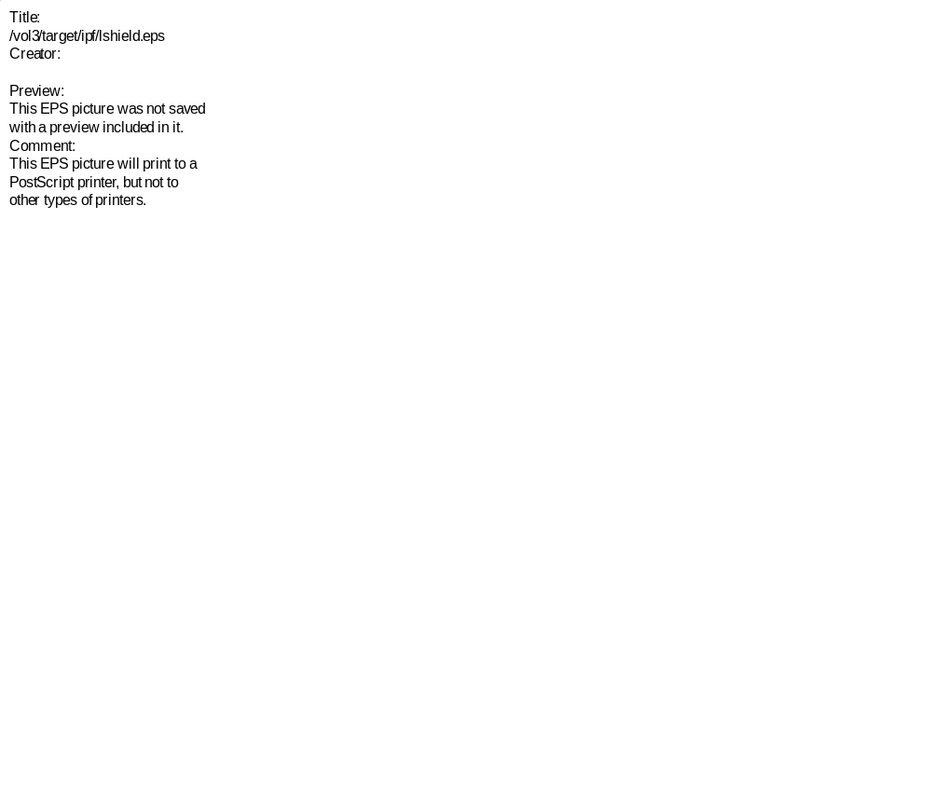
Figure 10—Cut through the lower shield showing the cells in which tallies were taken.

The DER near the junction of the lower and middle shields is a concern. Several cells near the surface have rates of several mrem/hour, larger than the desired limit of 1 mrem/hour for a a 10 amp beam spill. The DER in the air outside of and near these surfaces will also have a higher DER. This region will be occupied by utility duct enclosed in concrete. If the DER decreases an order of magnitude for every 2.5 feet of concrete, as it does through the center of the shield, 2 ½ feet of concrete in the duct and in additional concrete should provide adequate shielding. Note also that we did not account for radiation entering the shield through the tunnel ceiling; we have thus underestimated the DER somewhat in this region.
The DERs in the left cells in the middle shield, adjacent to the back filled region, are 1 mrem/hour or less. If possible, the back filling should extend to at least the top of the middle shield.

Cell | Distance into Shield (feet) | Neutron |  | Photon |  | Total
Cell | Distance into Shield (feet) | DER  (mrem/hr) | RE | DER (mrem/hr) | RE | DER  (mrem/hr) | RE
238 | 1.79 | 44815.89844 | 0.029 | 1470.85010 | 0.022 | 46286.75000 | 0.028
237 | 2.37 | 22538.20117 | 0.035 | 748.43201 | 0.025 | 23286.63281 | 0.033
235 | 3.53 | 5724.86035 | 0.046 | 184.61700 | 0.034 | 5909.47754 | 0.044
233 | 4.68 | 1468.78003 | 0.056 | 47.01390 | 0.044 | 1515.79395 | 0.054
231 | 5.84 | 399.88000 | 0.067 | 11.99160 | 0.055 | 411.87161 | 0.065
229 | 7.00 | 110.73300 | 0.075 | 3.28302 | 0.065 | 114.01602 | 0.073
228 | 7.58 | 58.56370 | 0.080 | 1.75701 | 0.070 | 60.32071 | 0.078
227 | 8.16 | 31.02850 | 0.086 | 0.92975 | 0.074 | 31.95825 | 0.083
226 | 8.73 | 16.60890 | 0.090 | 0.48671 | 0.079 | 17.09561 | 0.088
225 | 9.31 | 8.70516 | 0.095 | 0.25791 | 0.085 | 8.96307 | 0.092
224 | 9.89 | 4.54024 | 0.101 | 0.13460 | 0.090 | 4.67484 | 0.098
223 | 10.47 | 2.42756 | 0.104 | 0.07088 | 0.094 | 2.49844 | 0.101
222 | 11.05 | 1.27236 | 0.107 | 0.03755 | 0.098 | 1.30991 | 0.104
221 | 11.63 | 0.68281 | 0.112 | 0.01942 | 0.103 | 0.70223 | 0.109
261 | 12.25 | 0.32200 | 0.116 | 0.00874 | 0.106 | 0.33074 | 0.113
217 | 2.37 (L) | 2356.19995 | 0.144 | 96.39690 | 0.086 | 2452.59692 | 0.139
257 | 2.37 (R) | 3706.89990 | 0.103 | 125.75800 | 0.071 | 3832.65796 | 0.100
213 | 4.68 (L) | 191.14301 | 0.205 | 6.13977 | 0.146 | 197.28278 | 0.198
253 | 4.68 (R) | 629.92902 | 0.126 | 17.67370 | 0.097 | 647.60272 | 0.122
209 | 7.00 (L) | 17.10410 | 0.198 | 0.46077 | 0.170 | 17.56487 | 0.193
249 | 7.00 (R) | 67.21740 | 0.133 | 1.89022 | 0.119 | 69.10762 | 0.129
206 | 8.73 (L) | 2.43558 | 0.208 | 0.07532 | 0.199 | 2.51090 | 0.202
246 | 8.73 (R) | 10.12600 | 0.146 | 0.29078 | 0.130 | 10.41678 | 0.142
203 | 10.47(L) | 0.31475 | 0.207 | 0.01046 | 0.201 | 0.32521 | 0.201
243 | 10.47(R) | 1.51269 | 0.158 | 0.04428 | 0.141 | 1.55697 | 0.154
Table 20—Dose Equivalent Rates between tunnel floor and ceiling levels (tally segment A) in selected shield cells due to a 10 amp 100 MeV 20 off axis beam spill.

Figure 11—Total dose equivalent rate and the neutron and photon components as a function of distance from the upstream shield surface due to the 100 MeV 20 off axis beam spill.

Cell | Distance into Shield (feet) | Neutron |  | Photon |  | Total
Cell | Distance into Shield (feet) | DER  (mrem/hr) | RE | DER (mrem/hr) | RE | DER  (mrem/hr) | RE
238 | 1.79 | 5347.75000 | 0.141 | 161.10001 | 0.104 | 5508.85010 | 0.137
237 | 2.37 | 3015.91016 | 0.131 | 97.66900 | 0.103 | 3113.57910 | 0.127
235 | 3.53 | 1029.64001 | 0.147 | 32.96410 | 0.110 | 1062.60413 | 0.142
233 | 4.68 | 284.33200 | 0.146 | 9.17338 | 0.117 | 293.50537 | 0.141
231 | 5.84 | 94.86420 | 0.166 | 2.72827 | 0.131 | 97.59247 | 0.161
229 | 7.00 | 29.23910 | 0.187 | 0.83274 | 0.153 | 30.07184 | 0.182
228 | 7.58 | 15.17160 | 0.195 | 0.46799 | 0.170 | 15.63959 | 0.189
227 | 8.16 | 8.44214 | 0.200 | 0.26407 | 0.169 | 8.70621 | 0.194
226 | 8.73 | 4.32029 | 0.206 | 0.13358 | 0.182 | 4.45387 | 0.200
225 | 9.31 | 2.45833 | 0.207 | 0.06995 | 0.185 | 2.52828 | 0.202
224 | 9.89 | 1.23390 | 0.211 | 0.03711 | 0.181 | 1.27101 | 0.205
223 | 10.47 | 0.66030 | 0.215 | 0.02009 | 0.191 | 0.68039 | 0.209
222 | 11.05 | 0.33988 | 0.225 | 0.01026 | 0.200 | 0.35014 | 0.218
221 | 11.63 | 0.18232 | 0.236 | 0.00532 | 0.202 | 0.18764 | 0.229
261 | 12.25 | 0.08649 | 0.230 | 0.00264 | 0.211 | 0.08913 | 0.224
217 | 2.37 (L) | 141.65500 | 0.388 | 6.01589 | 0.377 | 147.67088 | 0.373
257 | 2.37 (R) | 702.02600 | 0.437 | 21.04760 | 0.286 | 723.07361 | 0.424
213 | 4.68 (L) | 5.88512 | 0.496 | 0.77114 | 0.349 | 6.65626 | 0.440
253 | 4.68 (R) | 122.58800 | 0.389 | 3.39148 | 0.259 | 125.97948 | 0.379
209 | 7.00 (L) | 3.52392 | 0.579 | 0.08299 | 0.522 | 3.60691 | 0.565
249 | 7.00 (R) | 11.84650 | 0.329 | 0.37471 | 0.249 | 12.22121 | 0.319
206 | 8.73 (L) | 0.56617 | 0.590 | 0.01596 | 0.487 | 0.58213 | 0.574
246 | 8.73 (R) | 2.20574 | 0.302 | 0.07183 | 0.264 | 2.27757 | 0.293
203 | 10.47(L) | 0.12999 | 0.451 | 0.00297 | 0.436 | 0.13296 | 0.441
243 | 10.47(R) | 0.35034 | 0.280 | 0.01017 | 0.259 | 0.36051 | 0.272
Table 21—Dose Equivalent Rates in between tunnel floor level and shield bottom (tally segment B) in selected shield cells due to a 10 amp 100 MeV 20 off axis beam spill.

Cell | Distance into Shield (feet) | Neutron |  | Photon |  | Total
Cell | Distance into Shield (feet) | DER  (mrem/hr) | RE | DER (mrem/hr) | RE | DER  (mrem/hr) | RE
238 | 1.79 | 7387.31982 | 0.136 | 274.22702 | 0.097 | 7661.54688 | 0.131
237 | 2.37 | 4802.93018 | 0.145 | 155.06200 | 0.099 | 4957.99219 | 0.141
235 | 3.53 | 1640.00000 | 0.183 | 45.99120 | 0.134 | 1685.99121 | 0.178
233 | 4.68 | 362.43402 | 0.187 | 13.74660 | 0.156 | 376.18063 | 0.180
231 | 5.84 | 105.21700 | 0.188 | 3.37775 | 0.157 | 108.59474 | 0.182
229 | 7.00 | 33.37060 | 0.202 | 0.89742 | 0.169 | 34.26802 | 0.197
228 | 7.58 | 16.60000 | 0.218 | 0.48772 | 0.178 | 17.08772 | 0.212
227 | 8.16 | 8.42734 | 0.216 | 0.25867 | 0.180 | 8.68601 | 0.210
226 | 8.73 | 4.55360 | 0.196 | 0.13858 | 0.183 | 4.69218 | 0.190
225 | 9.31 | 2.27254 | 0.199 | 0.06899 | 0.176 | 2.34153 | 0.193
224 | 9.89 | 1.22882 | 0.211 | 0.03685 | 0.183 | 1.26567 | 0.205
223 | 10.47 | 0.63113 | 0.213 | 0.02041 | 0.190 | 0.65154 | 0.207
222 | 11.05 | 0.33983 | 0.215 | 0.00987 | 0.204 | 0.34970 | 0.209
221 | 11.63 | 0.16681 | 0.218 | 0.00513 | 0.189 | 0.17194 | 0.211
261 | 12.25 | 0.08091 | 0.213 | 0.00255 | 0.194 | 0.08346 | 0.206
217 | 2.37 (L) | 128.12500 | 0.805 | 8.00375 | 0.453 | 136.12875 | 0.758
257 | 2.37 (R) | 1134.13000 | 0.523 | 28.64730 | 0.310 | 1162.77734 | 0.510
213 | 4.68 (L) | 33.15750 | 0.452 | 1.87862 | 0.358 | 35.03612 | 0.429
253 | 4.68 (R) | 50.36780 | 0.353 | 2.84597 | 0.329 | 53.21377 | 0.334
209 | 7.00 (L) | 6.72232 | 0.515 | 0.21969 | 0.368 | 6.94201 | 0.499
249 | 7.00 (R) | 5.51645 | 0.420 | 0.22711 | 0.261 | 5.74356 | 0.404
206 | 8.73 (L) | 1.27703 | 0.442 | 0.04084 | 0.387 | 1.31787 | 0.429
246 | 8.73 (R) | 2.05112 | 0.650 | 0.05698 | 0.366 | 2.10810 | 0.633
203 | 10.47(L) | 0.19186 | 0.517 | 0.00704 | 0.478 | 0.19890 | 0.499
243 | 10.47(R) | 0.29114 | 0.624 | 0.00921 | 0.488 | 0.30035 | 0.605
Table 22—Dose Equivalent Rates between tunnel ceiling level and 1 foot below the top of the lower shield (tally segment C) in selected shield cells due to a 10 amp 100 MeV 20 off axis beam spill.

Cell | Neutron |  | Photon |  | Total
Cell | DER  (mrem/hr) | RE | DER (mrem/hr) | RE | DER  (mrem/hr) | RE
8230 | 8.22440 | 0.212 | 0.26743 | 0.173 | 8.49183 | 0.205
8229 | 4.66552 | 0.228 | 0.13841 | 0.174 | 4.80393 | 0.222
8228 | 2.51312 | 0.228 | 0.07126 | 0.183 | 2.58438 | 0.222
8227 | 1.40419 | 0.239 | 0.03875 | 0.196 | 1.44294 | 0.232
8226 | 0.82247 | 0.238 | 0.02063 | 0.196 | 0.84309 | 0.232
8224 | 0.24109 | 0.256 | 0.00628 | 0.215 | 0.24737 | 0.249
8213 | 1.29375 | 0.454 | 0.11245 | 0.399 | 1.40620 | 0.419
8212 | 1.34652 | 0.423 | 0.06322 | 0.382 | 1.40974 | 0.405
8211 | 0.79562 | 0.366 | 0.04899 | 0.307 | 0.84461 | 0.346
8210 | 0.52623 | 0.344 | 0.01991 | 0.306 | 0.54613 | 0.332
8208 | 0.35612 | 0.318 | 0.01226 | 0.286 | 0.36838 | 0.308
8250 | 2.22854 | 0.368 | 0.08236 | 0.306 | 2.31090 | 0.355
8249 | 1.20733 | 0.332 | 0.04623 | 0.294 | 1.25356 | 0.320
8248 | 0.75018 | 0.365 | 0.02019 | 0.276 | 0.77037 | 0.356
8247 | 0.41686 | 0.320 | 0.01097 | 0.261 | 0.42782 | 0.312
8246 | 0.23836 | 0.281 | 0.00653 | 0.248 | 0.24489 | 0.274
8244 | 0.08394 | 0.339 | 0.00233 | 0.275 | 0.08626 | 0.330
Table 23—Dose Equivalent Rates in selected cells in the upper 6.86 inches of the lower shield (tally segment D) due to a 10 amp 100 MeV 20 off axis beam spill.

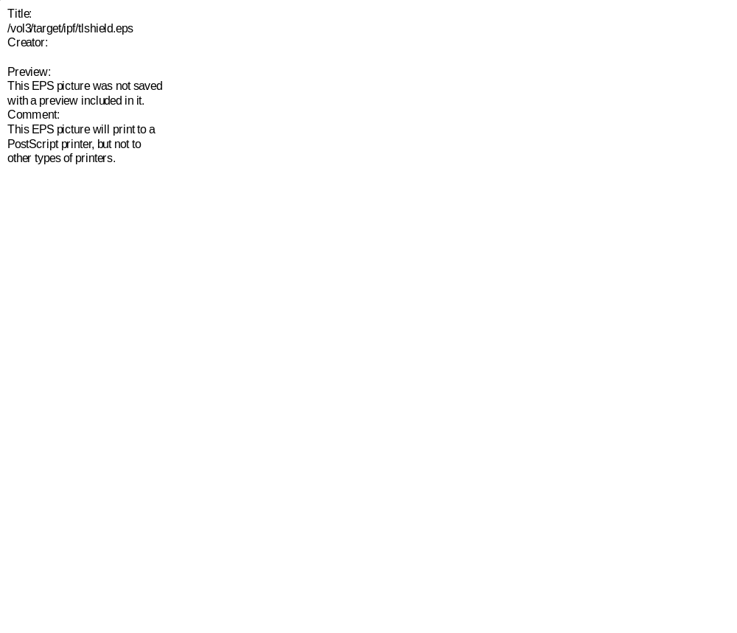
Figure 12—Cut through the upper layer of the lower shield showing the cells (red) in which tallies were taken and the total DER (blue) in those cells due to a 10 amp 100 MeV beam spill. The dashed green line is the position of the middle shield surface.
Cell | Neutron |  | Photon |  | Total
Cell | DER  (mrem/hr) | RE | DER (mrem/hr) | RE | DER  (mrem/hr) | RE
300 | 0.61646 | 0.380 | 0.01911 | 0.348 | 0.63557 | 0.380
301 | 0.33647 | 0.401 | 0.01328 | 0.341 | 0.34975 | 0.386
302 | 0.39662 | 0.447 | 0.01376 | 0.367 | 0.41038 | 0.432
305 | 0.98863 | 0.625 | 0.05443 | 0.428 | 1.04306 | 0.625
307 | 0.31794 | 0.954 | 0.02014 | 0.416 | 0.33808 | 0.954
310 | 1.08391 | 0.228 | 0.02863 | 0.198 | 1.11254 | 0.222
311 | 1.83730 | 0.208 | 0.05309 | 0.185 | 1.89039 | 0.202
321 | 0.51771 | 0.364 | 0.01669 | 0.331 | 0.53440 | 0.352
320 | 0.24900 | 0.339 | 0.00860 | 0.323 | 0.25760 | 0.328
312 | 2.57405 | 0.192 | 0.08474 | 0.172 | 2.65879 | 0.186
322 | 0.98064 | 0.340 | 0.02946 | 0.305 | 1.01009 | 0.331
316 | 9.86515 | 0.208 | 0.35011 | 0.183 | 10.21526 | 0.201
326 | 3.75090 | 0.373 | 0.18012 | 0.315 | 3.93102 | 0.356
319 | 15.64020 | 0.305 | 0.75239 | 0.264 | 16.39259 | 0.305
329 | 4.66611 | 0.591 | 0.28139 | 0.372 | 4.94750 | 0.558
Table 24—Dose Equivalent Rates in selected cells in the middle shield due to a 10 amp 100 MeV 20 off axis beam spill.
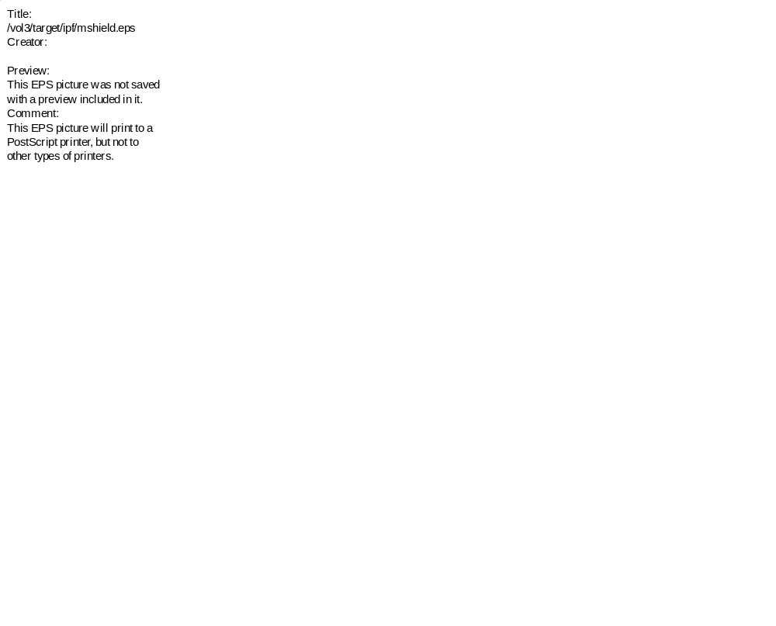
Figure 13—Cut through the middle shield showing cells (red) in which and surfaces (magenta) on which tallies were taken. The blue numbers are the total DER in the tallied cells due to a 10 amp 100 MeV beam spill. Dimensions describing the duct cut out are in green, and the outline of the lower shield below is shown in gold.


Figure 14—Cut through the upper shield showing cells in which and surfaces on which tallies were taken.

Cell | Neutron |  | Photon |  | Total
Cell | DER  (mrem/hr) | RE | DER (mrem/hr) | RE | DER  (mrem/hr) | RE
330 | 0.00000 | 0.000 | 0.00003 | 1.000 | 0.00003 | 1.000
340 | 0.00374 | 0.618 | 0.00011 | 0.319 | 0.00385 | 0.600
350 | 0.00268 | 0.767 | 0.00003 | 0.491 | 0.00271 | 0.759
342 | 0.01253 | 0.306 | 0.00056 | 0.269 | 0.01310 | 0.293
344 | 0.01242 | 0.538 | 0.00104 | 0.372 | 0.01345 | 0.497
346 | 0.05329 | 0.487 | 0.00166 | 0.427 | 0.05495 | 0.472
349 | 0.30476 | 0.766 | 0.01796 | 0.707 | 0.32272 | 0.725
Table 25—Dose Equivalent Rates in selected cells in the upper shield due to a 10 amp 100 MeV 20 off axis beam spill.
Surface | Neutron |  | Photon |  | Total
Surface | DER  (mrem/hr) | RE | DER (mrem/hr) | RE | DER  (mrem/hr) | RE
X  Upper Shield Face | 0.00132 | 0.399 | 0.00005 | 0.324 | 0.00138 | 0.384
Z  Lower Shield Face | 0.49793 | 0.228 | 0.01309 | 0.200 | 0.51102 | 0.222
Y  Lower Shield Cutout | 0.15231 | 0.274 | 0.00473 | 0.236 | 0.15705 | 0.266
Table 26—Dose Equivalent Rates on outer surfaces of the middle and upper shields due to a 10 amp 100 MeV 20 off axis beam spill.

Shield Wall Penetration—On Axis Spill
A second beam spill in the 100 MeV region was modeled by the beam impinging on a stainless steel plug in the beam line. The plug spans the full diameter of the beam tube and is two inches thick. The upstream face of the plug at the beam tube center is equidistant between the planes of the stubout walls. A pencil beam of 100 MeV protons struck the center of the plug. The spill and shield penetration were calculated in a single run without intervening surface source read and write. The shield model is the same as described above for the 20° spill. The remainder of the model is as shown in Figure 1 with the following exceptions: The concrete piers were not included, the model was terminated at the downstream surface of the shield, the left dimension of 42.5’ changes to 8.9’, and the right dimension of 71.6’ changes to 19.12’. External tuff was included from the levels of the shield top to shield bottom.
Table 27 shows the results, scaled to a 10 amp current, through the center section of the shield between the tunnel floor and ceiling. The right-hand column is the ratio of the total DER for this spill to that for the 100 MeV 20 off axis beam spill. The DERs for this spill are lower, by as much as a factor of 0.2 at the upstream face of the shield. The results in other volumes of the shield and in the middle and upper shields are similar.

Cell | Neutron |  | Photon |  |  | Total |  | Ratio: Table 20
Cell | DER  (mrem/hr) | RE | DER (mrem/hr) |  | RE | DER  (mrem/hr) | RE | Ratio: Table 20
238 | 33758.79688 | 0.016 |  | 1608.48999 | 0.010 | 35367.28516 | 0.015 | 0.764
237 | 14624.39941 | 0.021 |  | 706.12500 | 0.012 | 15330.52441 | 0.020 | 0.658
235 | 2939.31006 | 0.031 |  | 131.26500 | 0.019 | 3070.57495 | 0.030 | 0.520
233 | 662.24298 | 0.042 |  | 26.67110 | 0.028 | 688.91406 | 0.041 | 0.454
231 | 159.44701 | 0.056 |  | 5.76628 | 0.040 | 165.21329 | 0.054 | 0.401
229 | 38.50370 | 0.070 |  | 1.35106 | 0.054 | 39.85476 | 0.068 | 0.350
228 | 19.12440 | 0.075 |  | 0.66665 | 0.062 | 19.79104 | 0.072 | 0.328
227 | 9.29796 | 0.083 |  | 0.32204 | 0.067 | 9.62000 | 0.080 | 0.301
226 | 4.55473 | 0.089 |  | 0.15646 | 0.073 | 4.71119 | 0.086 | 0.276
225 | 2.23230 | 0.097 |  | 0.07658 | 0.082 | 2.30888 | 0.094 | 0.258
224 | 1.10469 | 0.103 |  | 0.03752 | 0.090 | 1.14221 | 0.100 | 0.244
223 | 0.54200 | 0.113 |  | 0.01847 | 0.097 | 0.56047 | 0.109 | 0.224
222 | 0.26573 | 0.128 |  | 0.00912 | 0.106 | 0.27485 | 0.124 | 0.210
221 | 0.13541 | 0.141 |  | 0.00441 | 0.116 | 0.13982 | 0.136 | 0.199
261 | 0.06047 | 0.151 |  | 0.00189 | 0.126 | 0.06236 | 0.146 | 0.189
Table 27—Dose Equivalent Rates between tunnel floor and ceiling levels (tally segment A) in selected shield cells due to a 10 amp 100 MeV on axis beam spill.

The lower DERs result from a smaller high-energy neutron flux at the downstream shield face. The ratio of neutron fluxes in the 100 MeV 20 off axis beam spill to the fluxes in this model increases from 1.1 at 0.01 MeV to 1.3 at 40 MeV and then to 11 at 95 MeV. The fluxes are nearly equal below 0.01 MeV.

Operation Phase—Beam Spill on RSS Beam Plug
Once completed, personnel access to the IPF tunnel can be permitted when the LANSCE main beam is on if the Radiation Safety System (RSS) beam plug is in place and if the dose within the IPF tunnel resulting from a beam spill on the RSS plug does not result in large doses in the tunnel. To assess the DER from such a spill, we constructed an RSS model as shown in Figure 15, Figure 16, and Figure 17. The model includes a section of the LANSCE main tunnel, the shield wall with penetrations, a foot-long section of the IPF tunnel, and a section of the IPF branch beam line and RSS plug. The main beam line is not included.
The beam line is a 4 inch OD cylinder with wall thickness 0.065 inches. The interior is vacuum upstream of the plug, and air downstream of the plug through the shield. In most operational scenarios, the interior will be vacuum for the entire length of the beam line; our substitution of air for the vacuum should not increase the DERs significantly. The solid copper plug is 4.5 inches OD coaxial with the beam line and 20 inches long. The downstream face of the plug is coincident with the upstream face of the shield wall.
In addition to the beam tube, the shield wall is penetrated by 18 4 inch diameter utility ducts filled with air. The ducts contain two 45 bends to prevent direct shine of radiation.
We directed a 100 MeV proton pencil beam, located at the center of the beam tube, onto the RSS plug. We used particle tracks to verify correct placement of the beam. We assume a current of 500 amp and give the results in rem/hour.
Table 28 gives the DERs in several positions in the IPF tunnel. The DER in the lower volume opposite the beam line is larger than in the upper volume opposite the ducts. We also made tallies through the beam line and through two of the ducts. Duct 1 was chosen because it is closest to the beam line, duct 18 because it is furthest away. Table 29, Table 30, and Table 31 give the tallies in the beam line, duct 1, and duct 18, respectively. Figure 18 plots the total DER, together with the neutron and photon contributions, as a function of depth into the shield for the beam line and duct 1.

Cell | Neutron |  | Photon |  | Total
Cell | DER  (rem/hr) | RE | DER (rem/hr) | RE | DER  (rem/hr) | RE
20 Shield Recess | 0.03378 | 0.090 | 0.00084 | 0.077 | 0.03461 | 0.087
14 Lower | 0.02788 | 0.101 | 0.00067 | 0.091 | 0.02855 | 0.099
15 Upper | 0.00554 | 0.060 | 0.00013 | 0.051 | 0.00567 | 0.058
Table 28—Dose Equivalent Rates in air volumes downstream of the shield due to a spill on the RSS beam plug.

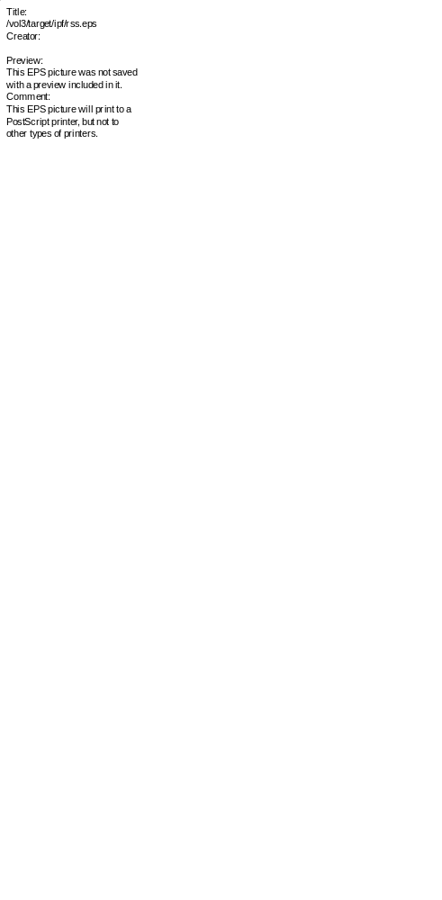
Figure 15—Floor plan of the RSS beam spill model.
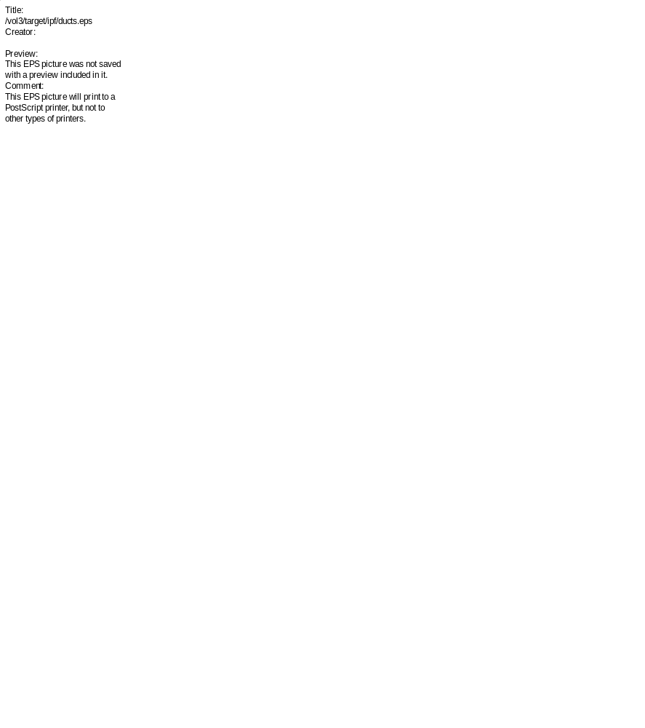
Figure 16—Vertical cut through the shield wall in the RSS beam spill model showing the beam line, RSS beam plug, utility ducts, and air volumes downstream of the shield in which tallies were taken.

Figure 17—The upstream face of the shield showing the beam and utility duct penetrations. The middle box represents the tunnel walls, floor, and ceiling.

Distance into Shield (feet) | Neutron |  | Photon |  | Total
Distance into Shield (feet) | DER  (rem/hr) | RE | DER (rem/hr) | RE | DER  (rem/hr) | RE
0.38 | 336491.00000 | 0.027 | 8567.79980 | 0.027 | 345058.81250 | 0.026
1.79 | 85518.89844 | 0.041 | 3649.82007 | 0.027 | 89168.71875 | 0.039
2.95 | 19772.69922 | 0.079 | 871.42499 | 0.035 | 20644.12500 | 0.076
4.10 | 5164.00000 | 0.088 | 196.99699 | 0.062 | 5360.99707 | 0.085
5.26 | 1388.63000 | 0.178 | 53.83270 | 0.185 | 1442.46265 | 0.172
6.42 | 316.23099 | 0.118 | 11.01260 | 0.084 | 327.24359 | 0.114
7.58 | 87.55380 | 0.136 | 3.02916 | 0.100 | 90.58296 | 0.132
8.73 | 23.28090 | 0.176 | 1.08462 | 0.219 | 24.36552 | 0.168
9.89 | 9.81087 | 0.326 | 0.74802 | 0.354 | 10.55889 | 0.304
10.47 | 7.04965 | 0.444 | 0.27855 | 0.426 | 7.32820 | 0.428
11.05 | 4.31898 | 0.522 | 0.12766 | 0.438 | 4.44664 | 0.507
11.96 | 3.04762 | 0.701 | 0.07775 | 0.682 | 3.12537 | 0.684
Table 29—Dose Equivalent Rates in the beam tube through the shield due to a spill on the RSS beam plug.

Distance into Shield (feet) | Neutron |  | Photon |  | Total
Distance into Shield (feet) | DER  (rem/hr) | RE | DER (rem/hr) | RE | DER  (rem/hr) | RE
0.38 | 68137.89844 | 0.059 | 1733.90002 | 0.056 | 69871.79688 | 0.058
1.13 | 11905.00000 | 0.090 | 865.91699 | 0.061 | 12770.91699 | 0.084
1.79 | 3390.12012 | 0.137 | 354.85001 | 0.082 | 3744.97021 | 0.124
2.37 | 1093.26001 | 0.136 | 183.96400 | 0.098 | 1277.22400 | 0.117
2.95 | 434.57401 | 0.153 | 81.07970 | 0.132 | 515.65369 | 0.130
3.53 | 170.80299 | 0.158 | 36.74250 | 0.179 | 207.54550 | 0.134
4.10 | 126.60200 | 0.226 | 16.34040 | 0.157 | 142.94240 | 0.201
4.68 | 53.89640 | 0.217 | 7.13070 | 0.159 | 61.02710 | 0.193
8.73 | 3.37653 | 0.130 | 0.10446 | 0.102 | 3.48098 | 0.126
9.31 | 1.99927 | 0.118 | 0.06047 | 0.101 | 2.05974 | 0.115
9.89 | 0.97404 | 0.113 | 0.03438 | 0.101 | 1.00842 | 0.109
10.47 | 0.48524 | 0.115 | 0.01799 | 0.085 | 0.50323 | 0.111
11.05 | 0.25831 | 0.109 | 0.00896 | 0.110 | 0.26727 | 0.105
12.59 | 0.06696 | 0.115 | 0.00221 | 0.078 | 0.06917 | 0.111
Table 30—Dose Equivalent Rates through utility duct 1 due to a spill on the RSS beam plug.

Figure 18—Total dose equivalent rate, along with the neutron and photon components, as a function of the distance from the upstream shield face, in the beam line and utility duct 1.

Distance into Shield (feet) | Neutron |  | Photon |  | Total
Distance into Shield (feet) | DER  (mrem/hr) | RE | DER (mrem/hr) | RE | DER  (mrem/hr) | RE
0.38 | 42268.10156 | 0.065 | 1336.96997 | 0.066 | 43605.07031 | 0.063
1.13 | 8118.45996 | 0.105 | 621.41302 | 0.073 | 8739.87305 | 0.097
1.79 | 2325.00000 | 0.128 | 228.00101 | 0.089 | 2553.00098 | 0.116
2.37 | 763.13397 | 0.195 | 117.03700 | 0.099 | 880.17096 | 0.169
2.95 | 247.36400 | 0.203 | 40.69220 | 0.119 | 288.05621 | 0.175
3.53 | 96.78970 | 0.314 | 19.31830 | 0.156 | 116.10800 | 0.263
4.10 | 27.60450 | 0.308 | 8.49309 | 0.163 | 36.09759 | 0.238
4.68 | 11.47510 | 0.275 | 3.63528 | 0.269 | 15.11038 | 0.218
8.73 | 0.12879 | 0.198 | 0.00528 | 0.280 | 0.13407 | 0.190
9.31 | 0.35488 | 0.214 | 0.01722 | 0.165 | 0.37211 | 0.204
9.89 | 0.22771 | 0.159 | 0.00929 | 0.199 | 0.23700 | 0.153
10.47 | 0.12879 | 0.198 | 0.00528 | 0.280 | 0.13407 | 0.190
11.05 | 0.04617 | 0.168 | 0.00420 | 0.335 | 0.05037 | 0.156
12.59 | 0.01781 | 0.147 | 0.00084 | 0.157 | 0.01865 | 0.140
Table 31—Dose Equivalent Rates through utility duct 18 due to a spill on the RSS beam plug.

NCRP Scientific Committee 4 on Heavy Particles ,k H. H. Rossi, chairman, Protection against neutron radiation, NCRP-38, National Council on Radiation Protection and Measurements (January 1971).

