Veterans Health Administration Warning System
Published by Central Office

07/13/01

ITEM: Bed Rail Entrapment

SPECIFIC INCIDENT SUMMARY: A patient experienced a close call event when his head became wedged in the bed rail opening while having a coughing episode. The patient was found by the nursing staff with a partially obstructed airway and was released without injury. This alert patient with a right side CVA (cerebrovascular accident) was trapped while laying on his left side.

For additional information see the 1995 FDA Alert and links to current bed safety information, at http://www.fda.gov/cdrh/beds/index.html. The dimensions and measurement procedures to evaluate the risk of entrapment related to hospital bed rails, bed frames, and mattresses have been submitted to the FDA for consideration as a guidance document. These dimensions were developed by the Hospital Bed Safety Workgroup, of which the VA is a member.

A. Measurements:

1. The horizontal distance (gap) between the mattress and the bed rail MUST be, according to the International Bed Safety Group, less than 60 mm (2 3/8 inches) when the mattress is pushed to the opposite side of the mattress deck.

If standard bed mattresses have been replaced with narrower mattresses or smaller specialty mattresses are used on top of existing bed mattresses an excessive gap may be created between the mattress and the side rail. This distance was previously (and incorrectly) identified as 5 inches in the December 20, 2000 Alert. The new 60 mm (2 3/8 inch) dimension (1) takes into account that the side of the mattress may deflect laterally allowing a space that could pose a risk of entrapment to the head or chest (see Figure A for entrapment in this area); (2) is based on the neck diameter for the fifth percentile for small nationalities; (3) is consistent with IEC, an international standard on electrically-operated hospital beds – IEC 60601-2-38, amendment 1, 1999; and (4) allows a safety factor for neck compressibility. The gap between the bed rail and mattress must be less than 60 mm (2 3/8 inches) when the mattress is pushed toward the opposite side of the bed. Newly purchased mattresses and beds must meet this less than 60 mm (2 3/8 inch) requirement. Existing equipment is addressed in paragraph B.

- The openings within a side rail should be smaller than 120 mm (4 ¾ inches).

In the December 12, 2000 VA Safety Alert, the maximum size for the openings between bars within a side rail was specified at 127 mm (5 inches). Since that time, the FDA Hospital Bed Safety Workgroup revised this dimension to 120 mm (4 ¾ inches) to be consistent with the existing IEC standard. Figure B shows entrapment between bars in a side rail. Bed rails on equipment purhased after receipt of this Alert must meet this less than 120 mm (4 ¾ inch) requirement.

B. Existing Equipment

Bed rails on existing beds used for high risk (frail, elderly, confused, physically impaired) patients will be upgraded to meet the opening requirements for new bed assemblies through the installation of retrofit kits available from the bed manufacturer or third party vendors, bed rail netting, or clear padding. Staff’s visibility of the patient must not be obstructed.

Gaps between the bed mattress and bed side rail in beds occupied by high risk patients (frail, elderly, confused, physically impaired) will be limited to those permitted for new bed assemblies. In the interim all bed assemblies that have gaps that do not conform to the requirements for new beds will be filled or covered with suitable materials to reduce the risk of entrapment. Suitable materials include high-density, fire retardant foam wedges that do not obstruct staff’s visibility of the patient. Velcro or anti-skid mats may be used to position the mattress on a bed frame in lieu of foam wedges provided the opening (between the mattress and side rail) on each side of the mattress is limited to, and maintained at, less than 60 mm (2 3/8 inches). When replacement mattresses are purchased for existing bed frames the mattresses must be of a sufficient length, width, and thickness to meet or exceed requirements for new assemblies.

Figure A. Entrapment between a bed side rail and a mattress (limit the maximum horizontal gap to

60 mm or 2 3/8 inch)
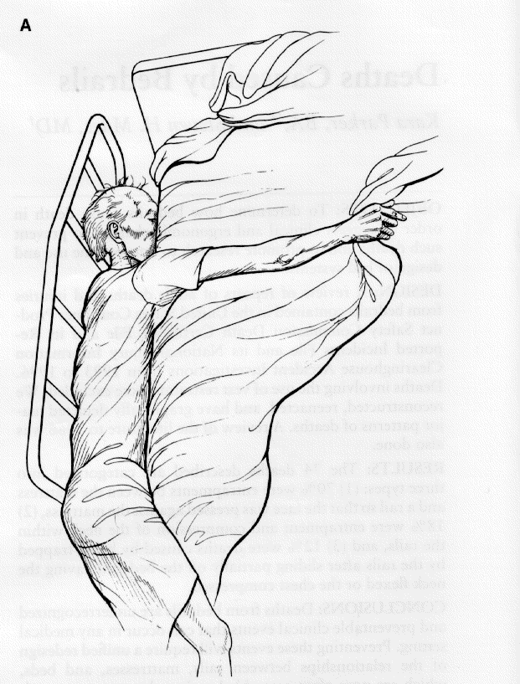

Figure B. Entrapment between bars of a bed side rail (limit the maximum vertical gap to less than
120 mm or 4 ¾ inches)

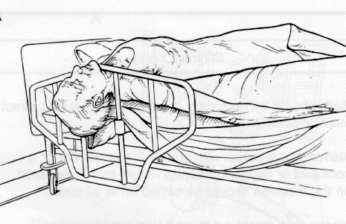

Recommended Actions

- Within 120 calendar days of the date of this Alert, complete an inventory of all existing beds and identify those that do not meet the dimensions specified in this Alert (60 mm or greater for bed gaps, 120 mm or greater for bed rail openings).
- Within 120 calendar days of the date of this Alert, permanently mark all non-complying bed assemblies using a method that clearly communicates the bed entrapment risk to staff.
- Immediately fill gaps created between the mattress and bedrail that are equal to or wider than 60 mm (2 3/8 inches) used for high risk patients (frail, elderly, confused, physically impaired) with suitable materials (e.g. high-density fire retardant foam wedges) to reduce the risk of entrapment.
- Immediately reduce the openings within the bed rails to less than 120 mm (4 ¾ inches) in size for beds used for high risk patients (frail, elderly, confused, physically impaired). Depending upon the bed side rail type this opening may exist between horizontal bars (bars parallel to mattress) or vertical bars (bars perpendicular to the mattress as shown in Figure B). Suitable materials include bed rail netting or clear padding or bed rail retrofit kits.
- When new bed assemblies or replacement mattresses are purchased openings within the bed side rails and gaps between the mattress and the side rail shall not exceed the dimensions specified in this Alert.

This Alert was prepapred based on information available as of June 2001. Additional bed safety guidelines are currently under development by the FDA Bed Safety Hospital Workgroup. Professional judgement is needed to assure safety of patients.

