PART 3. TECHNOLOGY VALIDATION

1. INSTRUMENT TECHNOLOGY OVERVIEW

1.1 Introduction
The Earth Observing-1 (EO-1) mission is flying three advanced technology verification land imaging instruments. They are the first Earth-observing instruments to be flown under NASA’s New Millennium Program. The three instruments are the Advanced Land Imager (ALI), the Hyperion hyperspectral imager, and the Linear Etalon Imaging Spectrometer Array (LEISA) Atmospheric Corrector (LAC). These instruments incorporate revolutionary land imaging technologies that will enable future Landsat and Earth observing missions to more accurately classify and map land utilization globally.

1.2 Advanced Land Imager (ALI)
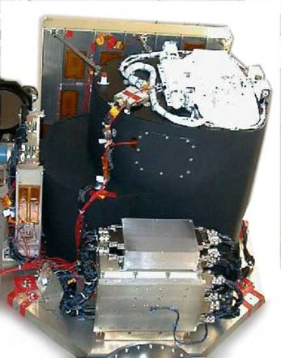
The ALI is designed to produce images directly comparable to those of the Enhanced Thematic Mapper Plus (ETM+) of Landsat 7. It employs novel wide-angle optics and a highly integrated multispectral and panchromatic spectrometer. The focal plane is partially populated with four sensor chip assemblies (SCA). Operating in a push-broom fashion at an orbit of 705 km, the ALI provides Landsat type panchromatic and multispectral bands. The multispectral bands have been designed to mimic six Landsat bands with three additional bands covering 0.433-0.453, 0.845-0.890, and 1.20-1.30 µm. The multispectral/panchromatic (MS/Pan) array therefore has 10 spectral bands in the visible and near infrared (VNIR) and short wave infrared (SWIR). The Pan covers the visible portion of the VNIR spectrum (0.480-0.690 µm) and has a 10 m spatial resolution. The MS detectors have a 30 m spatial resolution. With a partially populated focal plane, the ALI wide-angle optics produces a ground swath image width of 37 km.

The following key technologies are incorporated in the ALI instrument to achieve its dramatic cost, weight and performance advantages.

- Silicon Carbide Optics
- Wide Field of View Optics
- Multispectral Imaging Capability

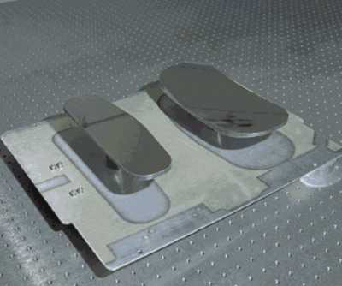
1.2.1 Silicon Carbide Optics
The telescope design incorporates Silicon carbide mirrors and an Invar truss structure with appropriate mounting and attachment fittings. Silicon carbide (SiC) offers the advantage of very high stiffness to density ratio and very high conductivity to heat capacity ratio. These characteristics are superior to currently used materials for reflective optical systems. The high stiffness to density ratio of SiC allows mirrors of very low weight to be designed and still maintain the necessary surface figure to provide the performance required for high-resolution optical imaging. Lightweight optics lead to lightweight optical metering structures required to support them. This in turn leads to lighter instruments and therefore lighter payloads. The high thermal conductivity, with relatively low thermal heat capacity, property allows minimum thermal gradients for a given heat load. This is an advantage for an optical system in a low Earth orbit that experiences a change in thermal boundary conditions on a regular basis.

1.2.2 Wide Field of View Optics
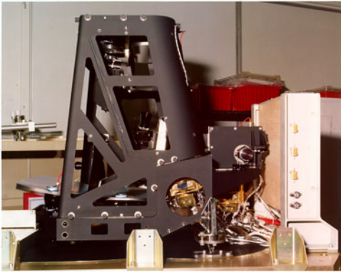
The telescope is a f/7.5 reflective triplet design with a 12.5-cm unobscured aperture diameter and a FOV of 15 degrees cross-track by 1.256 degrees in-track. It uses reflecting optics throughout to cover the fullest possible spectral range. The design uses four mirrors: the primary is an off-axis asphere, the secondary is an ellipsoid, the tertiary is a concave sphere; and the fourth mirror is a flat folding mirror. The optical design features a flat focal plane and telecentric performance, which greatly simplifies the placement of the filter and detector array assemblies. When the focal plane is fully populated, the detector arrays will cover an entire-185-km swath on the ground, equivalent to Landsat 7, in a "push-broom" mode.

1.2.3 Multispectral Imaging Capability
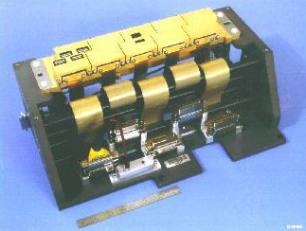
The Multispectral Imaging Capability (MIC) consists of the multispectral and panchromatic components of the ALI’s Focal Plane System (FPS) and the ALI’s calibration capability. Although the ALI optical system supports a 15º wide FOV, only a 3º FOV segment within the focal plane is populated with detectors, giving a cross-track coverage of 37 km. The intent was to provide adequate flight validation of the imaging technologies, but within the program cost and schedule constraints. The MS/Pan arrays use silicon-diode VNIR detectors fabricated on the silicon substrate of the Readout Integrated Circuit (ROIC). The SWIR detectors are mercury-cadmium-telluride (HgCdTe) photo-diodes that are indium bump-bonded onto the ROIC that services the VNIR detectors. These SWIR detectors promise high performance over the 0.9 to 2.5-µm-wavelength region at temperatures that can be reached by passive or thermoelectric cooling. The nominal focal plane temperature is 220K and is maintained by the use of a radiator and heater controls. Application of detectors of different materials to a single ROIC enables a large number of arrays covering a broad spectral range to be placed closely together. This technology is extremely effective when combined with the wide cross-track FOV optical design being used on the ALI. This is due to the fact that although the ALI optical design provides a large FOV in the cross-track dimension, the FOV in the in-track dimension is much smaller.

1.3 Hyperion
The focus of the Hyperion instrument is to provide high quality calibrated data that can support evaluation of hyperspectral technology for Earth observing missions. The Hyperion is a “push broom” instrument. Each image frame taken in this "push broom" configuration captures the spectrum of a line 30 m long by 7.5 km wide (perpendicular to the satellite motion). It has a single telescope and two spectrometers, one visible/near infrared (VNIR) spectrometer and one short-wave infrared (SWIR)) spectrometer. The instrument consists of 3 physical units: (1) the Hyperion Sensor Assembly (HSA); (2) the Hyperion Electronics Assembly (HEA); and (3) the Cryocooler Electronics Assembly (CEA). The HSA includes the telescope, the two grating spectrometers and the supporting focal plane electronics and cooling system. The HEA contains the interface and control electronics for the instrument and the CEA controls the cyrocooler operation.
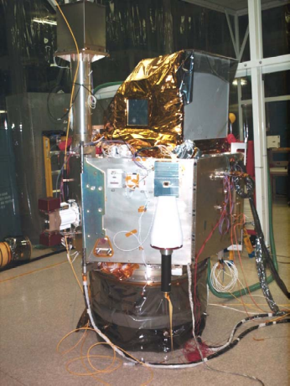
The Hyperion telescope (fore-optics) is a three-mirror astigmate design. The telescope images the Earth onto a slit that defines the instantaneous field-of-view which is 0.624° wide (i.e., 7.5 km swath width from a 705 km altitude) by 42.55 m radians (30 meters) in the satellite velocity direction. This slit image of the Earth is relayed at a magnification of 1.38:1 to two focal planes in the two grating imaging spectrometers. A dichroic filter in the system reflects the band from 400 to 1,000 nm to one spectrometer (VNIR) and transmits the band from 900 to 2,500 nm to the other spectrometer (SWIR). The SWIR overlap with the VNIR from 900 to 1000 nm will allow cross calibration between the two spectrometers. Both spectrometers use a JPL convex grating design in a 3 reflector Offner configuration and provide a spectral resolution of 10 nm. The HgCdTe detectors in the SWIR spectrometer are cooled by an advanced TRW cryocooler and are maintained at 110 K during data collections. Therefore, the Hyperion provides earth imagery at 30 m spatial resolution and with a 7.5 km swath width in 220 contiguous spectral bands at 10 nm spectral resolution.

1.4 LEISA Atmospheric Corrector (LAC)
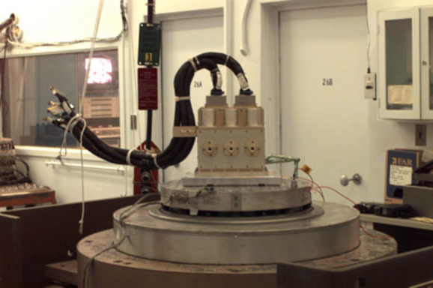
The third EO-1 instrument is the LEISA Atmospheric Corrector (LAC). The LAC uses three 256 x 256 pixel InGaAs IR detector focal plane subassemblies in a single module. Each array is placed behind a lens covering a 5° x 5° field of view to obtain a swath width of 185 km (15 degrees). A state-of-the-art wedged dielectric film etalon filter (a linear variable etalon) is placed in very close proximity to a two-dimensional IR detector array. This produces a 2-D spatial image that varies in wavelength along one dimension. The filter is 1.024 cm x 1.024 cm and covers the 890 to 1580 nm spectral region at a resolution of approximately 35 to 55 cm⁻¹, with a linear dependence of wavenumber on position. Reflective ¼-wave stacked layers placed on both sides of one, or more, ½-wave etalon cavity(s) provide the spectral resolution. Order-sorting of the etalon is accomplished with lower resolution filter layers. In operation, the two-dimensional spatial image is formed by a small, wide field of view lens. Unlike the grating spectrometer that captures the spectra at a point "instantaneously", the spectrum for the LAC is obtained as the orbital motion of the spacecraft scans the image across the focal plane in wavelength, thereby creating a three-dimensional spectral map. The spatial resolution is determined by the spatial resolution of the imaging optic, the image scan speed, and the readout rate of the array. For the EO-1 application, the single pixel spatial resolution is 360 x 360 mradian², corresponding to a single pixel field of view of 250 m x 250 m (at nadir) from a 705 km orbit and a readout rate of approximately 28 Hz. Because the spatial resolution is relatively coarse (250 meters) and the wedge uses light efficiently, the optical system is compact. This design simplicity is offset by the need to build up the spectral image over a series of frames, increasing the satellite attitude control system requirements. For LAC, the large pixel size minimizes this impact. Therefore, the LAC is a high spectral (256 bands)/moderate spatial (250 m) resolution wedged filter imager.

The primary purpose of the LAC, from a technology validation standpoint, is fourfold: 1) to validate the use of the wedged filter method for obtaining hyperspectral images, 2) to validate the use of a multi-array, multi-telescope system to synthesize a wide-field imager, 3) to validate the use of non-cryogenic InGaAs IR arrays for high resolution spectroscopy and, 4) to validate the use of lunar and solar measurements (in conjunction with ground-based measurement campaigns) to provide calibration. The science validation objective is to provide a demonstration of the ability of moderate spatial resolution hyperspectral measurements to provide real-time atmospheric water vapor correction information to high-spatial resolution multispectral sounders. The imaging data will be cross-referenced to the Hyperion data where the footprints overlap.

