Abstract-- The proposed Next Linear Collider (NLC) will require over 1400 adjustable quadrupoles between the main linacs’ accelerator structures. These 12.7 mm bore quadrupoles will have a range of integrated strength from 0.6 to 132 Tesla, with a maximum gradient of 135 Tesla per meter, an adjustment range of +0 –20% and effective lengths from 324 mm to 972 mm. The magnetic center must remain stable to within 1 micrometer during the 20% adjustment. In an effort to reduce estimated costs and increase reliability, several designs using hybrid permanent magnets have been developed. All magnets have iron poles and use either Samarium Cobalt or Neodymium Iron to provide the magnetic fields. Two prototypes use rotating rods containing permanent magnetic material to vary the gradient. Gradient changes of 20% and center shifts of less than 20 microns have been measured. These data are compared to an equivalent electromagnet prototype. (See High Reliability Prototype Quadrupole for the Next Linear Collider by C.E Rago, C.M SPENCER, Z. Wolf submitted to this conference.)
Adjustable Permanent Quadrupoles Using Rotating Magnet Material Rods for the Next Linear Collider
J.DiMarco (1), G.W. Foster (1), W. Fowler (1), V.S. Kashikhin (1), A. Makarov (1), C.E. Rago (2), A. Ringwall (2), C.M. Spencer (2), V. Tsvetkov (1), J.T. Volk* (1), Z. Wolf (2)

I. Introduction

The Next Linear Collider [1] (NLC) is a future electron/positron collider that is based on copper accelerator structures powered with 11.4 GHz X-band RF. It is designed to begin operations with a center-of-mass (cms) energy of 500 GeV or less, depending on the physics interest, and to be adiabatically upgraded to 1 TeV cms with a luminosity of 2~3 x 10³⁴ cm⁻²s-¹. The facility is roughly 30 km in length and supports two independent interaction regions. For the main linac there will be over 1400 quadrupoles between the accelerator structures. To reduce costs and increase reliability, adjustable permanent magnets are considered for these structures. Based on Fermilab’s experience with permanent magnets used in their Recycler, collaboration between SLAC and Fermilab is exploring designs and prototypes.

Manuscript received September 24, 2001
*Volk@fnal.gov
Work supported by the U.S. Department of Energy under contract No. DE-AC02-76CH03000 and DE-AC03-76SF00515.
- Fermi National Accelerator Laboratory PO Box 500, Batavia IL, 60510 USA
- Stanford Linear Accelerator Center 2575 Sand Hill Road, Menlo Park CA, 94025 USA

II. Magnet Requirements

The general linac magnet requirements are the same for all styles of magnets and are given in Table 1 for a 1 TeV machine. The temperature stability, harmonics, and field accuracy do not pose a problem based on the experience from the Fermilab Recycler [2]. To achieve the required pole tip field rare earth permanent magnets are required. Samarium Cobalt (Sm₂ Co₁₇) was chosen for its high residual B field (B_{r}) and small temperature variation of the field. Neodymium Iron was also tested in the wedge type quadrupole. For the quadrupoles with lower gradient and integral field the amount of magnetic material or the length of the steel pole can be reduced.

Table I
Magnet Requirements for a 1TeV NLC

Item | Value
Aperture | 12.7 mm
Quantity Length | 288 324 mm  399 432mm  576 965mm
Pole tip field | 0.62 Tesla for 324mm  0.86 Tesla for other
Adjustment | +0 to –20%
Temperature stability | 0.5% at 25 ± 1 ºC
Sextupole | b₃/b₂ < 0.02 at r=5mm
Field accuracy | ±0.5% at any field
Center location | To Fiducial ± 0.1mm
Magnetic Center stability | ± 0.001 mm over range of adjustment

The Beam Based Alignment (BBA) process for these quads drives the magnetic center stability requirement of ±0.001 mm. When a beam position monitor detects movement of the beam the position of the related quadrupole will be adjusted to bring the beam back on the correct trajectory. The BPM to quadrupole center calibration process requires that the quad strength be lowered by 20% in five steps over several seconds during which the magnetic center must not shift by more than 1 micrometer. This calibration will be done monthly.

III. Corner Tuner Quadrupole

Four prototypes of adjustable permanent magnets were designed and built. This paper reports of two of those four. The first is a corner tuner and the second is a wedge quadrupole. All measurements were made at the Fermilab magnet test facility with a stretched wire system. The resolution of the center shift was ±1 micrometer and the gradient error ±20 Gauss.

The corner tuner is a hybrid permanent magnet quadrupole. The magnet uses precision-machined poles (1008 carbon steel) to form the gradient field and permanent magnet material (Sm₂ Co₁₇) behind each pole to drive the gradient. To adjust the gradient there are rotating permanent magnets in each of the four corners behind the poles. Figure 1 is a PANDRIA flux plot showing a cross section of the magnet the outer dimensions are 165 by 165-mm.

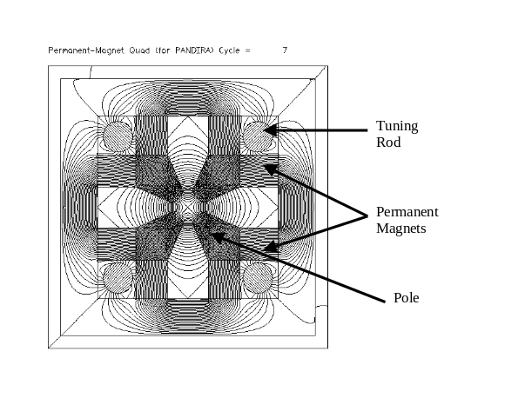
Fig. 1. Corner tuner cross section showing the poles, magnet material and tuning rods. The field lines are also shown in this plot.

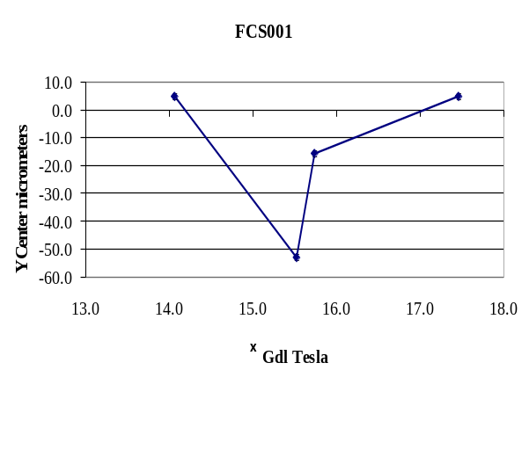
Fig. 2. Center shift vs intergrated gradient for the corner tuner model.

This design is similar to the Fermilab Recycler quadrupoles. Figure 2 shows the center shift versus the gradient strength for the prototype quadrupole. The center is seen to move more than 50 micrometers for a full rotation of the tuning rods. Studies using PANDRIA indicate that the quadrupole center is dependent on the balance in the strength of the tuning rods and the precision in the support bearings. Further work on this prototype was stopped in favor of the wedge quadrupole.

IV. Wedge Tuner Quadrupole

The next type of quadrupole also used precision-machined poles to shape the field. The Samarium Cobalt magnets were placed behind the poles and wedged in between the poles to provide higher field hence the name wedge quad. (Figure 3) The outer dimensions of the flux return were 101.6 by 101.6 mm. Variation in the gradient was accomplished by the use of rotating magnetic material behind each pole. The advantage of this design is that the tuning rods were placed in a region of parallel field. This reduced the dependence of the precision of the bearing and strength balance of the tuning rods. All prototype magnets had a pole length of 203 mm. This fit the Electric Discharge Machine (EDM) at the Fermilab Shops. All the pole pieces were made on an EDM to provide precise dimensions for optimal field shaping. MANAQUENCH of Valparaiso Indiana [3] supplied the Samarium Cobalt magnetic material and the Nd-Iron cylinders were supplied by Dexter magnetics [4].

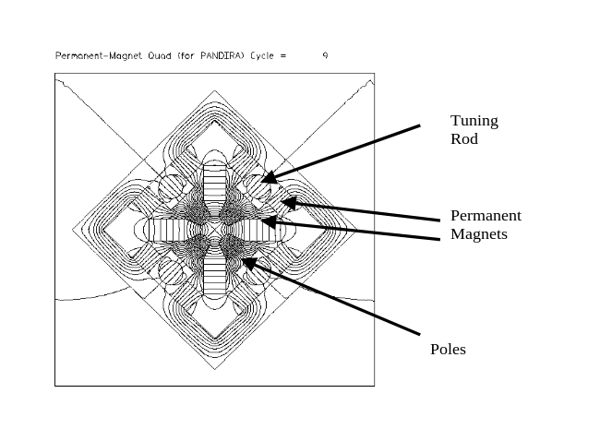
Fig. 3. Wedge quadrupole cross section showing the poles, magnet material and tuning rods. The field lines are also shown in this plot.

The first version of the wedge quad (FWSQ001) had wedge magnets dimensions of 12.7 mm by 10.2 mm by 25.4 mm and pole magnets of 9.25 mm by 9.25 mm by 25.4 mm. Six magnets were arranged along the length of the pole for a total magnet length of 152 mm. This generates an integrated field of 20 Tesla. The tuning rods were made of 6 cylindrical magnets each 8.3 mm in diameter and 25.4 mm long, magnetized through the diameter. These magnets were glued in an aluminum tube with spacers between each magnet. As the glue set up an external magnet field was applied to keep the field orientation aligned through the diameter of the tube.

Strips of high Nickel steel between each of the pole magnets accomplished temperature compensation. These strips were in contact with the pole and the flux return. The Curie point of these strips is 45 C. When the magnet is cold and the field is strong these strips act as shunts to the field. As the magnets warms the shunts release field into the gap. By balancing the volume of magnets to strips of steel a temperature variation of less than one part in 10⁴ was achieved.

To allow for rotation of the tuning rod aluminum disks were attached to the ends of the rods. Holes were drilled in each disk at 15-degree intervals. As the rods were rotated a pin in each disk held the rod at a given angle. Figure 4 shows the variation of the quad center as a function of gradient. Each curve is generated when the rods are shifted to different holes. The different curves indicate an imbalance in the strength of each tuning rod.

A fixture of parallel steel plates was fabricated. Each tuning rod was inserted into this fixture and a Hall probe was used to measure the relative strength of each rod. A variation of 5% in the strength of the rods was found. Modeling this variation in PANDRIA indicates that a 5 to 10 micrometer center shift could be caused by this imbalance.
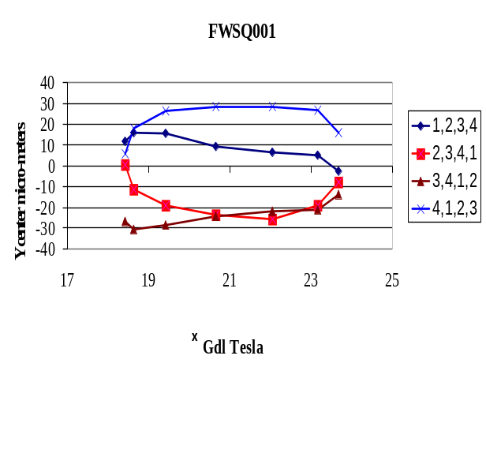

Fig. 4. Y center vs. integrated gradient strength in Tesla for a 200-mm pole length. Each curve represents a different position of the tuning rods. The different paths indicate an imbalance in the strength of the rods.

This magnet was rebuilt using Neodymium Iron magnets of the same dimension. There was an increase in gradient of 20%. The center shift as a function of change in field was similar.

A second wedge type quad was made. The permanent magnets in this version were 50% larger to increase the gradient, the cross section is the same as Figure 3. The pole magnets were 12.7 by 12.7 mm and the wedge magnets were 12.7 by 20.3 mm. This gave a gradient increase of 30%. The arrangement of the magnets was similar to the first wedge quadrupole.

For this magnet all of the individual magnets were selected for field uniformity and matched to balance the strength of the poles. The time of flight for each magnet falling through an aluminum tube was measured. Longer time of flight corresponded to stronger magnets. The magnets were matched with a strong magnet next to a weak magnet. The sum of the strengths for each row of magnets was then matched to be the same. A similar method for the rotating rods was used. A similar rotating mechanism was used to rotate the rods. In addition, custom fitted carbon fiber bearings were made for each tuning rod. This eliminated any wobble in the rods. Figure 5 shows the center shift vs. gradient for this magnet for the tuning rods in different positions. The overall center shift was less than 20 micrometers. This is still too large for the NLC requirements. Measurements of the tuning rods with a hall probe showed a 2% imbalance in the strength of the rods. There is a need to improve the balance in the strengths of the tuning rods; different schemes are being developed.
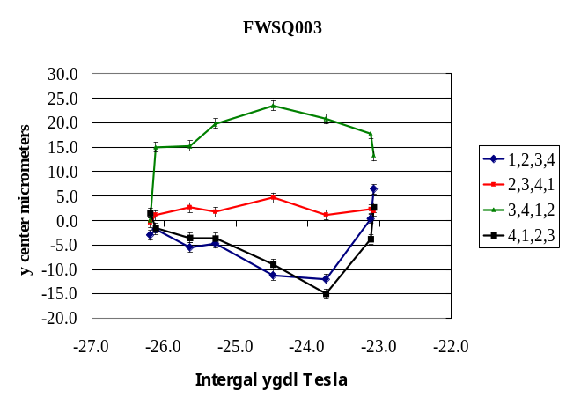

Fig. 5. Y center motion vs. integrated gradient strength in Tesla for a 200 mm pole length. Different curves are for tuning rods in different positions

V. Radiation Damage Issues

Radiation damage in permanent magnet material has been a concern since the early 1980's. There have been many studies done on both Samarium Cobalt and Neodymium Iron. Many of the pertinent papers have been collected on a web site hosted at SLAC [5]. Luna [6] et al. has a summary table that gives values of demagnetization for various materials and particles. In general Samarium Cobalt does not show significant loss in magnetization up to 10⁹ rads for neutrons or protons. Neodymium Iron shows no significant loss of magnetization up to 10⁷ rads. Gamma rays appear to have little to no effect on either type of rare earth permanent magnets.

The paper by Kähkönen [7] et al. gives a parameterization for the change in magnetization of

ΔM/M = 2 V_{grain}/V_{sample} nLn_{p}

Where n is the ion density,  is the cross section, and L is the sample thickness. It is clear that the preparation of the magnet material, in particular the grain size of the material, has a direct effect on the coercivity and the radiation hardness of the magnets. This could explain the wide variation in the amounts of demagnetization in material made by different manufacturers.

For the design of the NLC quads it is important to understand the expected radiation exposure of the magnets both due to normal beam loss and possible accidents. For the NLC quads it will also be important to control the manufacturing process used for the magnet material in order to achieve the higher coercivity and hence radiation hardness.

VI. Other Styles of Magnets

Cherrill Spencer and Carlo Rago at SLAC have built a prototype electromagnet [8]. This is a conventional water-cooled copper conductor quadrupole with a current of up to 133 amps. The magnet meets all the specifications given in table 1. The center stability of 1 micrometer is achieved by always increasing the current from a lower to a higher value.

Vladimir Kashikhin reported on two other styles of permanent adjustable. [9] The first is a sliding shunt magnet where the outer flux return slides longitudinally. Portions of the poles are raised to come into contact with the flux return. This allows for flux to be shunted from the gap to the flux return. The range of adjustment is 13% the center stability is less than 20 micrometers.

A second type of permanent magnet quadrupole using counter rotating magnets. Two quadrupoles rotate in opposite direction thereby reducing the integrated gradient. The total range of adjustment is 20% and the center stability is 1 micrometer.

VII Conclusions

This paper reports on two styles of permanent magnet adjustable quadrupoles for the NLC. Of the two types the wedge tuner is closest to meeting all the requirements for NLC. The strength of the gradient and higher harmonics are within specifications. Further work on balancing the strength of the tuning rods is required to meet the specification of a center shift of 1 micrometer. The effects of radiation exposure to the particular material used in the magnets needs to be understood. With the proper selection of material and shielding permanent magnet quadrupoles should be viable for the life of the NLC.

[1] Next Linear Collider, Tor. O. Raubenheimer “Overview of the X Band R&D Program”, and “Progress in the Next Linear Collider Design”, SLAC-PUB-8672, October 2000

[2] Stephen D. Holmes, ”Status of the Fermilab Main Injector and Recycler”, PAC1997 Conf 97-47

[3] MAGNEQUENCH 405 Elm Street Valparaiso IN 46383

[4] Dexter Magnetic 1050 Morse Ave. Elk Grove Village IL 60007

[5]http://www-project.slac.stanford.edu/lc/local/notes/dr/ Wiggler/wiggler_rad.html

[6] H.B. Luna Nuclear Instruments and Methods in Physics Research A285 (1989) 349

[7] O-P Kähkönen J. Phys. Condensed Matter 4, 1007 (1992)

[8] Cherrill Spencer MOPO1A1-14 this confernece

[9] V Kashikin MOPO1A1-06 this conference

