
United States
Department of
Agriculture

World Agricultural

Production

Foreign
Agricultural
Service

Circular Series
WAP 11-03
November 2003

Argentina 2003/04 Crop Forecast Substantially Revised:

Drought Reduces Corn and Wheat Production;
Soybean Production Forecast Raised on Higher Planted Area;
Producers Wait for Rain

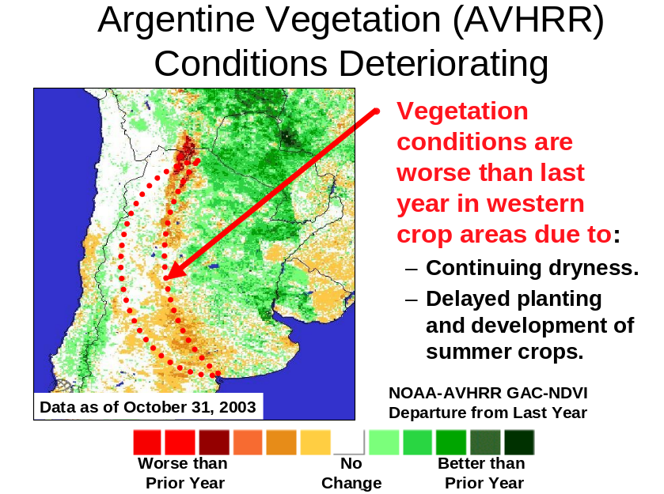Argentina’s 2003/04 corn production is forecast at 14.0 million tons, down 2.0 million or 13 percent from last month and down 10 percent from last season’s estimate of 15.5 million. Harvested area is forecast at 2.4 million hectares, down 0.2 million or 8 percent from last month, and lower than last season. Yield is forecast at 5.83 tons per hectare, down 5 percent from last month.

Drought in the western provinces of Cordoba and La Pampa delayed corn planting and lowered yield potential. Roughly one-quarter of Argentina’s corn crop is in soil moisture deficit areas where moisture content is below 20 percent. Corn planting progress reached 47 percent by October 31, the slowest pace in the last 7 years. The most severe planting delays, and where the drought is most severe, are in Rio Cuarto delegation in Cordoba Province. Farmers in drought-affected areas may plant corn later. Late-planted corn is likely to be used for silage for the recovering dairy sector.

In contrast, rainfall in central Argentina has been near normal. Corn planting occurred on time in these high-yielding areas. Recent FAS field travel confirmed good conditions, and high yields are expected if the drought does not shift eastward. (For more information, contact Robert Tetrault at 202-690-0130.)
Argentina: Drought Reduces 2003/04 Wheat Production, Crop Still Higher than Last Year

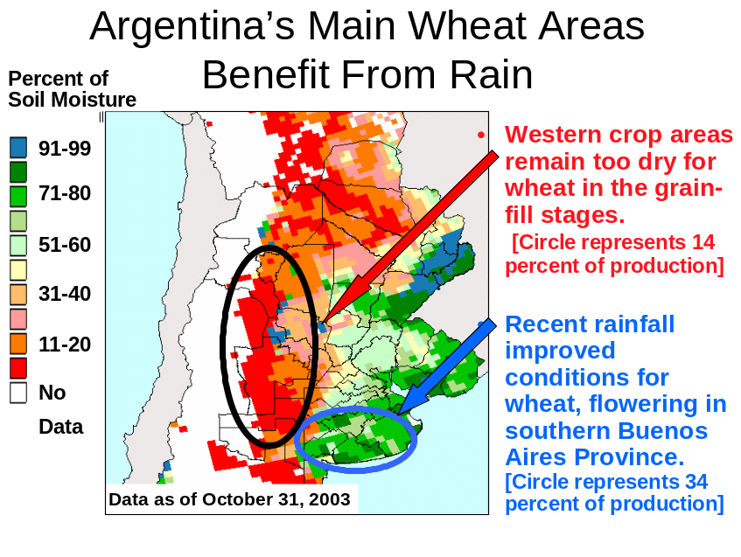Argentina’s 2003/04 wheat production is forecast at 13.0 million tons, down 0.5 million or 4 percent from last month, but up 6 percent from last season’s weather-reduced crop of 12.3 million tons. Harvested area is forecast at 5.8 million hectares, unchanged from last month, but down 2 percent from last season. Yield is forecast below average at 2.24 tons per hectare.

The same dry conditions affecting corn in parts of La Pampa, Cordoba, and Buenos Aires Provinces are affecting wheat crops. Drought will affect the wheat crop less than the corn crop, because no more than one-fifth of Argentina’s wheat crop is in soil moisture deficit areas where moisture content is below 20 percent. Rainfall has been below normal in the west, significantly below last year’s rainfall amount. Rainfall in October stabilized yield potential in southern Buenos Aires Province, that accounts for 34 percent of production. Rainfall was timely because wheat typically flowers in the first part of November.

Argentina’s wheat yield in 2003/04 is expected to be below the 5-year average, but much better than last year’s yield, which was 2.09 tons per hectare—the lowest in 6 years. Wheat harvest begins in late October in Argentina and is 50 percent complete by mid-December. (For more information, contact Robert Tetrault at 202-690-0130.)

Argentina: 2003/04 Soybean Area Increases as Corn and Sunflower Reduced

Argentina’s 2003/04 soybean production is forecast at a record 38.0 million tons, up 1.0 million or 3 percent from last month and up 7 percent from last season’s output of 35.5 million. Harvested area is forecast at a record 13.6 million hectares, up 0.4 million or 3 percent from last month and up 8 percent from last season. Yield is forecast at 2.79 tons per hectare, above average but below trend. Soybean area has increased as farmers switch away from corn and sunflowers. Delays in corn and sunflower planting may mean lower yield potential for those crops, providing incentive to switch to soybeans. Soybeans have become more profitable with the recent run-up in international prices following a decline in prospects for the U.S. crop.

Soybean planting has just begun, reaching 8 percent as of November 1, 2003. Planting is typically 50 percent complete by early December. The drought in the western crop areas includes Cordoba Province, an important soybean producer. About one-quarter of the soybean crop is in
soil moisture deficit areas where moisture content is below 20 percent. If drought persists, soybean farmers in drought-affected areas may plant corn later. Late-planted corn is likely to be used for silage for the recovering dairy sector.

Argentina’s 2003/04 sunflower production is forecast at 3.7 million tons, down 12 percent from last month, with harvested area forecast at 2.1 million hectares, down 9 percent from last month. Roughly one-third of the sunflower crop is in areas with a soil moisture deficit below 20 percent. Sunflower planting is 36 percent complete as of October 31, 2003, slower than average. (For more information, contact Robert Tetrault at 202-690-0130.)

Ukraine: Bumper Corn Crop for 2003/04

Ukraine corn production for 2003/04 is estimated at 6.5 million tons, up 1.0 million or 18 percent from last month, and up 2.3 million or 55 percent from last year. This would be the highest corn crop since 1989/90, when 7.0 million tons were gathered. Planted area for 2003/04 rose significantly this year: almost 2.3 million hectares were planted, compared to about 1.5 million last year. The year-to-year jump was due in part to the replanting of destroyed winter grains with corn (and other summer crops, like sunflowers). The crop benefited from generally good weather throughout the growing season and dry harvest weather. As of November 4, over 6 million tons had been harvested from roughly 75 percent of the sown area. (For more information, contact Mark Lindeman at 202-690-0143.)

Romania: 2003/04 Wheat Production Estimated Lower

Wheat production in Romania for 2003/04 is at a record low 2.0 million tons, down 0.6 million tons or 23 percent from last month. This season’s total production is down 2.3 million tons or 53 percent from last year’s weather-affected crop. Area remains unchanged from last month at 1.5 million hectares, but down 700,000 hectares or 32 percent from last year. Yield is estimated to be a 40-year record low at 1.33 tons per hectare.

Wheat producers faced a shorter planting window than normal in fall 2002, wedged between an unusually late summer harvest, heavy October rains, and the early onset of winter. These events delayed and may have prevented autumn sowing activities resulting in reduced seeded area. Winter 2003 was harsh with record lows that created high winterkill. A cold spring caused frost damage on re-emerging plants. Finally, the continuous dryness and high temperatures wreaked further havoc on crops during late spring and summer. (For more information, contact Bryan Purcell at 202-690-0138.)

Hungary: 2003/04 Corn Lowered by Drought

Hungarian corn production is estimated at 4.6 million tons, down 700,000 tons or 13 percent from last month and down 1.4 million or 23 percent from last year. Area is unchanged at 1.0 million hectares. Yield is forecast far below the 5-year average of 5.31 tons per hectare and last year’s 5.22 tons per hectare.

Since Winter 2002, drought has continued to lower expectations for 2003/04. While soil quality is excellent in Hungary, the region’s continental climate is largely responsible for wide
harvest fluctuations each year. Summer rainfall, as in 2003, can often be scarce and ill-timed. Irrigation is almost non-existent in Hungary’s cornfields. The combination of this year’s low rainfall and high temperatures depleted soil moisture supplies below adequate levels, severely reducing yields. (For more information, contact Bryan Purcell at 202-690-0138.)

Australia: 2003/04 Rice Production Increases

Australia's 2003/04 rice production is forecast at 644,000 tons (milled basis), up 286,000 or 80 percent from last month and up 365,000 or 131 percent from last year’s drought-reduced crop. Australia rice area is forecast at 100,000 hectares, up 40,000 or 67 percent from last month and up 62,000 or 163 percent from last year. Sowing began in October and will continue through November in the major growing areas of Murrumbidgee and Murray River catchments in southern New South Wales. Sowing conditions are more favorable as a result of beneficial rainfall amounts received during September and October. This has also helped to recharge the local reservoirs critical for irrigated rice. (For more information, contact Jim Crutchfield at 202-690-0135.)

China: 2003/04 Cotton Production Hurt by Poor Weather

China’s 2003/04 cotton production is estimated at 22.0 million bales (4.79 million tons), down 3.5 million or 14 percent from last month, and down 3 percent from last year. Area is estimated at 5.1 million hectares, unchanged from last month, but up 22 percent from a year ago. High prices for the 2002/03 crop and rising cotton demand encouraged farmers to expand cotton area in 2003. Cotton area increased in all provinces, with the largest year-to-year area increase in the North China Plain (up 20 to 30 percent). The 2003/04 forecast yield of 939 kilograms per hectare is down 20 percent from last year’s record yield and the lowest since 1996/97.

Periods of excessive rainfall and cool temperatures from mid-August through mid-October resulted in damage to the vulnerable maturing crop. Incidents of flooding, water logged soils, low boll counts, boll shedding, wilting, late development, pests and diseases, and low quality were widely reported. Some of the most serious losses were in Henan, one of China’s most important cotton-growing provinces. Crops in parts of Shandong and Hebei Provinces were also damaged by the poor autumn weather. According to recent crop surveys, yields are down 10 to 50 percent from last year in most cotton-producing areas. Only Xinjiang, Gansu, and cotton areas south of the Yangzte River are forecasting near-normal yields in 2003/04. Harvesting and procurement started 10 to 20 days behind schedule this year, but mostly dry and warm weather since mid-October has accelerated harvest progress.

China’s 2003/04 cottonseed production is estimated at 8.62 million tons, down 1.38 million or 14 percent from last month and lower than last year despite the 22 percent increase in planted area. The estimated yield of 1.69 tons per hectare is down 20 percent from last year and the lowest yield in 8 years. (For more information, contact Paulette Sandene at 202-690-0133.)

China: Higher Estimated Area Boosts 2003/04 Peanut Production

China’s 2003/04 peanut production estimate was raised this month to 15.1 million tons, up 0.6 million or 4 percent from last month and up 1 percent from last year due to higher estimated area. According to China’s Ministry of Agriculture, planted area for peanuts continued its upward trend in 2003/04 and reached a record 5.1 million hectares. The forecast yield of 2.96 tons per hectare is similar to last year and slightly above the 5-year average. About 50 percent of China’s peanuts are produced in the provinces of Hebei, Shandong, and Henan on the North China Plain. Rainfall and temperatures were generally favorable on the North China Plain for most of the growing season, but unusually wet weather after mid-August may have caused local crop losses and slowed harvest progress, particularly in Henan province. (For more information, contact Paulette Sandene at 202-690-0133.)
This report uses information from the Foreign Agricultural Service’s (FAS) global network of agricultural attachés and counselors, official statistics of foreign governments and other foreign source materials, and the results of economic and satellite imagery analysis. Estimates of foreign area, yield, and production are from the Production Estimates and Crop Assessment Division, FAS, and are reviewed by USDA’s Inter-Agency Commodity Estimates Committees. Estimates of U.S. area, yield, and production are from USDA’s National Agricultural Statistics Service. Numbers within the report may not add to totals because of rounding. This report reflects official USDA estimates released in the World Agricultural Supply and Demand Estimates (WASDE-404), November 12, 2003.

Printed copies are available from the National Technical Information Service. Download an order form at http://www.ntis.gov/products/specialty/usda/fas_a-g.asp, or call NTIS at 1-800-363-2068.

The Production Estimates and Crop Assessment Division, FAS, prepared this report. The next issue of World Agricultural Production will be released after 9:00 a.m. Eastern Time on December 11, 2003.

Conversion Table

Metric tons to bushels

Wheat, soybeans = MT * 36.7437
Corn, sorghum, rye = MT * 39.36825
Barley = MT * 45.929625
Oats = MT * 68.894438

Metric tons to 480-lb bales

Cotton = MT * 4.592917

Metric tons to hundredweight

Rice = MT * 22.04622

Area & weight

1 hectare = 2.471044 acres
1 kilogram = 2.204622 pounds

For further information, contact:
U.S. Department of Agriculture
Foreign Agricultural Service
Production Estimates and Crop Assessment Division
Ag Box 1045, Room 6541, South Building
Washington, DC 20250-1045
Telephone: (202) 720-0888 Fax: (202) 720-8880

GENERAL INFORMATION
Division Director Allen Vandergriff 202-720-0888 vandergriff@fas.usda.gov
Administrative Assistant Mary Jackson 202-720-0888 jacksonma@fas.usda.gov
Deputy Director Eric Wenberg 202-720-0873 wenberge@fas.usda.gov
Remote Sensing Specialist Brad Doorn 202-690-0131 doorn@fas.usda.gov
Contract Representative Theresa Wright 202-720-8887 wrightt@fas.usda.gov
Imagery Archive Coordinator Judy Goldich 202-720-1572 goldich@fas.usda.gov
USDA Remote Sensing Advisor Glenn Bethel 202-720-1280 bethel@fas.usda.gov

COMMODITY SPECIFIC INFORMATION
Cotton & Rice Chairperson Ron Roberson 202-720-0879 roberson@fas.usda.gov
Grains Chairperson Michelle Greenberg 202-720-7339 greenberg@fas.usda.gov
Oilseeds Chairperson Paul Provance 202-720-0881 provance@fas.usda.gov
Production Database Manager Marnet Whittington 202-720-0886 whittington@fas.usda.gov

COUNTRY AND REGION SPECIFIC INFORMATION
Argentina, Uruguay, Paraguay, Bob Tetrault 202-690-0130 tetrault@fas.usda.gov
& Chile
Brazil Michael Shean 202-720-7366 shean@fas.usda.gov
Mexico, Central America,
& Caribbean Ron White 202-690-0137 whiter@fas.usda.gov
Canada & Western Europe Jim Tringe 202-720-0882 tringej@fas.usda.gov
Central Europe & North Africa Bryan Purcell 202-690-0138 purcellb@fas.usda.gov
Turkey, Middle East,
& Southwest Asia Maria Anulacion 202-690-0139 anulacion@fas.usda.gov
Russia, Ukraine,
& other FSU States Mark Lindeman 202-690-0143 lindeman@fas.usda.gov
China, Koreas, Japan, & Paulette Sandene 202-690-0133 sandene@fas.usda.gov
Southeast Asia
Australia, Bangladesh, Jim Crutchfield 202-690-0135 crutchfield@fas.usda.gov
India, & Pakistan
Central & Southern Africa Curt Reynolds 202-690-0134 reynoldsc@fas.usda.gov
United States Rao Achutuni 202-690-0140 achutuni@fas.usda.gov
United States & Int’l Weather Carl Gernazio 202-690-0136 gernazio@fas.usda.gov

