PUBLIC NOTICE
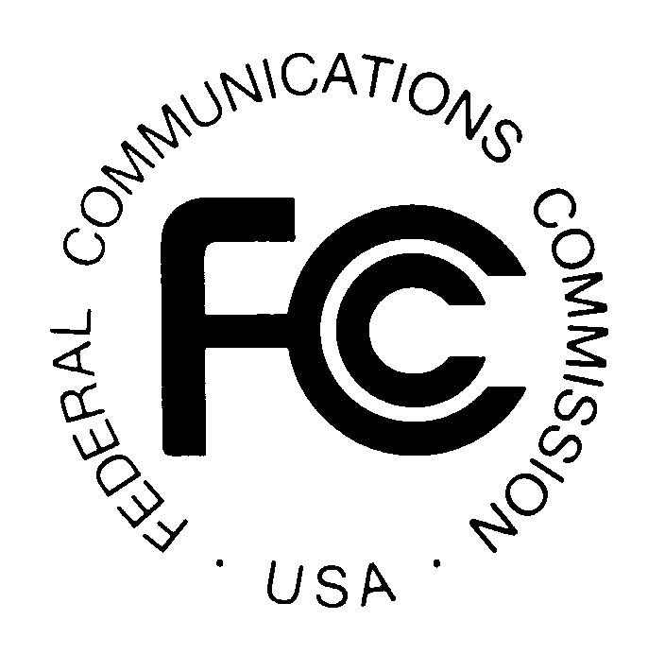

FEDERAL COMMUNICATIONS COMMISSION
445 TWELFTH STREET, S.W.; TW-A325
WASHINGTON, D.C. 20554
News Media Information: 202 / 418-0500
FCC’s Fax Information Sys: 202 / 418-2830
TTY 202 / 418-2555
Internet: http://www.fcc.gov
ftp.fcc.gov

DA 04-1408

Released: May 19, 2004

WIRELESS TELECOMMUNICATIONS BUREAU PROVIDES
ADDITIONAL GUIDANCE ON HOW TO FILE IN UNIVERSAL LICENSING SYSTEM

Late Filing of Renewal Applications
To file a renewal request electronically for a single call sign after the license expiration date, go to the ULS homepage at http://wireless.fcc.gov/uls, select Online Filing and login. The License At A Glance Page will appear upon login for filers who hold only one license. If you hold multiple licenses, display this page by clicking on the call sign you want to renew. Select Renew from the Work on This License Menu. The instructions will indicate when to upload a waiver request attachment. (Late-filed renewal applications must be submitted with the appropriate waiver request and, if applicable, waiver fee.) Continue to follow the onscreen prompts and instructions until your renewal request is completed. The information provided here updates a previous Public Notice regarding late filing of renewal applications.

Attachments Should Be Standard Letter-Size
Filers should submit only standard letter-size attachments when filing online. Documents of any other size will be converted to letter-size, which may result in the loss of information.

Enhanced Update and Renew
License Manager simplifies updates of license-related information. The Update and Renew functions allow you to update licensee name and address, contact information, and control points, all in one application filing. Prior to License Manager, multiple applications were required to renew a license and update this information. License Manager also provides the ability for you to update your administrative data, such as licensee name and address, when you file most applications.

In addition, when a license is within the 90 day renewal window, a message to renew the license appears on the License At A Glance Page. To renew a single license, select the link that says “Begin the renewal process,” or select “Renew” from the Work on This License Menu. To renew multiple licenses, select Renew Licenses from the left-hand menu. All call signs eligible for renewal will appear under Select Licenses. When renewal is completed, look for an application purpose of “RO” or “RM” on the confirmation screen to verify license renewal.

Automatic Saving of Applications
If you begin an application, but do not submit the application and receive a confirmation, ULS automatically saves the application for you. To access all applications, including those that were automatically saved, click My Applications in the left-hand navigation menu. Then click Saved to access all saved (and not yet submitted) applications.

Filing Required Notifications
To file a notification in ULS, click on the link "Notify the FCC,” in the Work on This License menu on the License At A Glance page. Use this link when notifying the FCC that (1) a transfer of control or an assignment of authorization has been consummated or (2) a construction or coverage requirement has been met. Each required notification must be filed in accordance with the appropriate rules. See 47 C.F.R. 1.948(d) regarding the notification requirement for a transfer of control or an assignment of authorization and 1.946(d) for the notification of a construction or coverage requirement.

Guidance Regarding the Need to Hold an FCC License
For applicants in the Aircraft or Ship services who file a license renewal or request a duplicate of an active license, ULS prompts them with guidance regarding the need to continue to hold an FCC license. This enhancement allows affected applicants to avoid filing unnecessary applications.

For additional information or assistance, you may visit the web at http://esupport.fcc.gov or e-mail questions to ULSHELP@fcc.gov. You may also call the FCC Support Center at (877) 480-3201 (TTY 202-414-1255) and select Option #1) Password Re-set; Option #2) Forms or Licensing Assistance; Option #3) Electronic Filing Assistance; Option #4) FCC Registration (FRN) Assistance; or Option #9) for someone to direct your call. Hours are from 8 a.m. to 5:30 p.m. Eastern Time, Monday through Friday (except Federal holidays). To provide quality service and ensure security, all telephone calls are recorded.

See Waiver Requests Required for Late-Filed Renewal Applications in Most Wireless Services, Public Notice, DA 03-2729 (rel. August 22, 2003).

