USDA Foreign Agricultural Service
GAIN Report

Template Version 2.09

Global Agriculture Information Network

Required Report - public distribution
Date: 12/14/2005
GAIN Report Number: CA5065
CA5065
Canada
Solid Wood Products
Annual
2005

Approved by:
Lisa Anderson
U.S. Embassy
Prepared by:
Christina Patterson

Report Highlights:
Softwood lumber production is forecast to increase in 2006 as a result of the increase in allowable annual cut in several timber supply areas in British Columbia, due to the Mountain Pine Beetle infestation. Exports of softwood lumber are forecast to increase slightly as production increases and demand remains strong. The pace of housing starts in Canada is expected to decline slightly in 2006, but the demand for softwood products, furniture, millwork products, kitchen cabinets, structural wood products and many other wood products is still expected to be strong. Increased third country competition, especially from China, is forcing major changes and consolidations in the Canadian forestry and furniture industries.

Includes PSD Changes: No
Includes Trade Matrix: No
Unscheduled Report
Ottawa [CA1]
[CA]
Table of Contents
SECTION 1. SUMMARY 4
SECTION 2. PRODUCTION 4
2.1 Forest Situation & Outlook 4
2.11 Issues Facing the Forestry Industry 4
2.11.1 Mountain Beetle Infestation in British Columbia and Alberta 4
2.11.2 Certification of Canada’s Forests 6
2.11.3 Changes to Quebec’s Forestry Industry 6
2.11.4 Wood Packaging Regulations 7
2.2 Solid Wood Products Situation & Outlook 7
2.21 Consolidation in the Canadian Lumber Industry 7
2.22 Impacts on the Canadian Forestry Sector 8
2.23 Softwood Lumber Dispute 8
SECTION 3. TRADE 9
3.1 Overview 9
3.2 Competition and Markets 10
3.21 United States 10
3.22 China 11
3.23 Japan 11
SECTION 4. MARKET SEGMENT ANALYSIS 12
4.1 Construction Sector 12
4.11 Overview 12
4.12 Structural Wood Building Components 13
4.13 Other Millwork Products 15
4.14 Prefabricated Wood Buildings 15
4.15 Wood Window and Door Products 16
4.2 Furniture & Interiors Sector 16
4.21 Overview 16
4.22 Issues Facing the Canadian Furniture Industry 17
4.22 Policy 17
4.23 Shipments 18
4.23 Trade 18
4.23.1 Furniture and Related Products 18
4.23.2 Office Furniture 19
4.23.3 Kitchen Cabinets 19
4.24 Market Opportunities 20
4.3 Material Handling Industry 20
Importers of Wood Products for Manufacturing 20
SECTION 5. STATISTICAL INFORMATION 26
5.1 Softwood Log Situation/Outlook 26
Table 1: Softwood Log Supply and Distribution 26
5.2 Softwood Lumber Situation/Outlook 26
Table 2: Softwood Lumber Supply and Distribution 26
5.3 Softwood Plywood Situation/Outlook 27
Table 3: Softwood Plywood Supply and Distribution 27
5.4 Hardwood Log Situation/Outlook 27
Table 4: Hardwood Log Supply and Distribution 27
5.5 Hardwood Lumber Situation/Outlook 28
Table 5: Hardwood Lumber Supply and Distribution 28
5.6 Hardwood Plywood Situation/Outlook 28
Table 6: Hardwood Plywood Supply and Distribution 28
5.7 Oriented Strandboard Situation/Outlook 29
Table 7: Oriented Strandboard Supply and Distribution 29
APPENDIX 1. 29
Find FAS on the World Wide Web: 32
Recent Reports from FAS/Ottawa: 32

SECTION 1. SUMMARY

The Canadian lumber industry continued the trend of consolidation and mergers throughout 2004 and 2005, in order to better position itself to compete on the world market. In addition, the industry continued to seek out new markets and attempted to expand in existing ones. The forest industry is focused on taking advantage of the rapid growth in China. As the output of finished wood products from China continues to increase, Canadian wood exporters are looking to be primary suppliers. The only problem this creates is that while the forestry industry increases raw wood exports to China, the finished products are returning to Canada and competing and sometimes displacing wood products produced in Canada, like furniture. But as the amount of products from China continues to increase in Canada, some of the larger furniture markers are looking to take advantage of that growing economy by outsourcing some of the production to China. As a result, the furniture industry is going through another major change, in which it is attempting to survive and thrive in the face of new market realities.

The U.S. continues to be a primary market for most Canadian forestry and value-added wood and manufactured products, but Canadian producers, processors and industries are losing market share in the U.S., due to increased competition from places like China and some of the other Asian Pacific countries. Issues like the ongoing softwood lumber dispute with the U.S. and the infestation of the Mountain Pine Beetle in British Columbia (B.C.), continue to plague Canada’s forest industry. Despite this, the industry is making efforts to adjust and deal with the issues head on and continues to be a producer and exporter of Canadian wood products.

SECTION 2. PRODUCTION

2.1 Forest Situation & Outlook

On an annual basis, Natural Resources Canada publishes The State of Canada’s Forests found at the following link:

http://www.nrcan-rncan.gc.ca/cfs-scf/national/what-quoi/sof/latest_e.html

The report provides a comprehensive overview of Canada’s forests and forest industry, including production, allowable annual cut per province, trade statistics and industry information.

2.11 Issues Facing the Forestry Industry

2.11.1 Mountain Beetle Infestation in British Columbia and Alberta

The ongoing Mountain Pine Beetle epidemic in B.C. has, as of 2004, infected more than seven million hectares of forest in the B.C. interior, killing more than 283 million cubic meters of timber. This area is roughly the size of New Brunswick and is continuing to increase. Five of the seven million hectares are lightly to severely infected, while the remaining two million have trace amounts of infection. The estimation is that more than 90 million cubic meters of pine per year could die and that the epidemic is likely to last another 10 years, affecting more than 80 percent of merchantable lodgepole pine in the interior. In 2003, B.C. and Alberta accounted for approximately 33.8% and 12.5% of the total area harvested for industrial roundwood in Canada.

In response, the B.C. provincial government developed and is implementing its 2005-2010 Mountain Pine Beetle Action Plan, which sets out both the short- and long-term steps to mitigate the beetle’s impact on forest values, communities and the provincial economy. In addition, the province has committed $101 million CDN ($86 million USD) over the next three years to reforestation of beetle and fire-damaged areas and to mitigate the economic impact to communities. As the spread of the beetle infection is not limited by provincial boundaries, the governments of B.C. and Alberta signed a five-year renewable Memorandum of Understanding (MOU) to share a one-year cost of $1.65 million CDN ($1.42 million USD) to take measures to slow the spread along the B.C.-Alberta border. At the request of B.C.’s government, the Government of Canada contributed $100 million CDN ($85.6 million USD) in financial assistance to help with the impact of the beetle infestation. As a result, the Mountain Pine Beetle Emergency Response: Canada-B.C. Implementation Strategy was developed to outline how these federal funds will be used over the next three years to help deal with the economic, environmental and social challenges created by the pine beetle infestation. The funding provided by the federal government is expected to target certain areas such as:

- Fuel management treatments for communities and First Nations located in the mountain pine beetle infested areas.
- Controlling the beetle’s spread in parks and areas along the outer edges of the infestation.
- Research and development of new wood products and markets, and research to assist forest management decision-making.
- Forest cover data to assist forest management decision-making.
- Ecosystem restoration.
- Management of range issues.
- Co-ordination and administration.

In addition to the monetary contributions to fighting the beetle infestation, B.C.’s Chief Forester continues to review the allowable annual cuts on an as-needed basis for affected timber supply areas. In 2004, the B.C. government had increased the allowable annual cut in the Prince George and Quesnel timber supply areas by 4.7 million cubic meters. The increase resulted in the awarding of four forest licenses to CH Anderson and Partners. The licenses are for 10 years and 10.5 million cubic meters of timber, and requires CH Anderson to construct or significantly expand timber-processing facilities that produce something other than dimensional softwood timber. CH Anderson is planning on investing $110 million in building four plants to manufacture industrial wood pellets for use as sustainable biofuels in European thermal power plants. In addition to the four licenses granted to CH Anderson, two other 15-year forest licenses, totaling 21 million cubic meters will be awarded in the near future.
In 2005, the allowable annual cuts in the Merritt, the Cranbrook and Invermere timber supply areas were increased by 1.3 million, 33,000 thousand, and 17,000 thousand cubic meters respectively. Currently, an increase of 400,000 thousand to 1 million cubic meters in the Okanagan timber supply area is under review. The increase in allowable annual cuts in the various timber supply areas is being used to help manage the mountain beetle infestation.

Next to controlling and ending the beetle infestation, salvaging the beetle-damaged wood before the wood loses commercial value is one of the major hurdles faced by B.C.’s government and lumber industry. One of the goals of B.C.’s pine beetle action is to create new markets for beetle-killed timber, thereby utilizing the large volumes of damaged wood that would otherwise become worthless. The provincial government introduced and passed a bill in 2004 that allowed it to designate an area of Crown land as a mountain pine beetle salvage area. Two non-replaceable forest licenses totaling 1.25 million cubic meters of wood and roughly 2.5 million cubic meters of beetle-damaged wood have and will be advertised for tenures through a competitive bid process. In order to meet that challenge some of the major lumber producers in B.C. are investing money to expand the capacity of their sawmills to process the beetle-damaged wood. Canfor Corporation announced plans to spend $104 million to expand its Vanderhoof, B.C. mill in order to process millions of cubic meters of beetle-damaged wood. The expansion will increase the mill’s annual production capacity to 620 million board feet. West Fraser Timber Co. Ltd. has also announced plans to invest hundreds of million of dollars to expand the capacity of their sawmills. The provincial government is offering new harvesting licenses to companies who are willing to invest in plants that will produce commodities from the beetle-damaged timber. Ainsworth Lumber Co. Ltd. is investing $400 million to build two oriented strandboard (OSB) plants, which will use logs from the beetle-killed pine stands that have degraded to such a state that makes them undesirable for lumber production. The two plants will increase Ainsworth’s production capacity by 43 percent from 3.5 billion square feet of OSB panels annually to 5 billion square feet. Additional uses for the beetle-damaged wood are blue-stained wood furniture and biomass as a source of energy. The increased production capacity could possibly lead to higher lumber exports to the United States in the short-term, but the long-term affect of the beetle destruction will result in a decrease in both production and exports from B.C.’s interior region.

The investment of money into expansion of mills, increased lumber processing capacity, increased OSB production and other product utilization of beetle-damaged wood will provide increased employment opportunities in the short-term. Unfortunately, as the beetle-damaged wood runs outs and B.C. timber supply is dramatically reduced due to the beetle infestation, the lumber industry will be forced to scale back and possibly shut down production at certain mills in order to remain viable. The investment in new mills and plants and the encouragement by the provincial government to identify new markets for the beetle-damaged wood, has created a short-term economic boom for B.C.’s lumber industry. However, over the next 15 years, additional plans will have to be developed to help the industry deal with the new reality of a dramatically reduced timber supply.

2.11.2 Certification of Canada’s Forests

The increasing demand for certified forest products in the marketplace has resulted in an increase in the area of certified forests in Canada. Certification of forest products indicates that those products have originated from sustainably managed forests. As of April 2005, Canada had the largest certified area of sustainably managed forests in the world, with approximately 113.2 million hectares out of a total of 402 million ha of forest and other wooded land certified under one of the three forest-specific certification systems available in Canada. This represents an annual allowable cut of over 94 million cubic meters. The distribution under the three certification systems are – Canadian Standards Association (CSA), 67.3 million ha; Sustainable Forestry Initiative (SFI), 37.2 million ha; and Forest Stewardship Council (FSC), 9.7 million ha. The total amount of certified forested area in Canada is 80 percent higher than what was reported last year and almost five times what it was three years ago, due to broad industry commitment to sustainable forest management in order to meet customer needs. At this pace, Canada is expected to achieve and exceed the January 2002 commitment, which was agreed to by the Forest Products Association of Canada (FPAC), to have 136 million ha certified by 2006. As forest certification is occurring in both Canada and the United States, the increasing supply of certified forest products in North America should be able to meet demand from consumers. The FAO has indicated that there is a shortage of supply in certified sawn hardwood. As Canada relies on imports of sawn hardwood from the U.S., any increase in the production of certified sawn hardwood in the U.S. could result in an increase in imports of sawn hardwood from the U.S. to meet Canadian consumers demands for certified hardwood.

http://www.forestinformation.com/newenvironmentalism/certification_art1.asp

Certification Status in Canada (million hectares)

 | September 15, 2005 | June 06, 2004 | June 1, 2002
CSA | 67.3 | 32.9 | 8.8
FSC | 9.7 | 4.2 | 1.0
SFI | 37.2 | 21.4 | 8.4
Total | 113.2 | 57.7 | 18.2

Source: Natural Resources Canada

2.11.3 Changes to Quebec’s Forestry Industry

In December 2004, the final report on the Commission for the Study of Public Forest Management in Quebec was made public. The mandate of the Commission was to examine the management of public forests and make recommendations in response to the needs of the population of Quebec. Some of the key findings of the Commission were that Quebec’s public forests are over-harvested and the methods used to assess them and to evaluate the maximum sustainable yields are inadequate. The report proposed five major changes: a move towards ecosystem based management and completion of the protected area network, allocations that consider tree quality and the accessibility of forest stands in given areas rather than volume-based wood allocations, better planned silviculture treatments, preparation for the inevitable consolidation of the wood products industry, and decentralized forest management. The Commission indicated that the recommendations be included in the next set of management plans and that the implementation of the plans be postponed until 2008 to allow this to be accomplished.

In order to accomplish the goals set out by the Commission, one component of the recommendations is to reduce the annual allowable cut for the main softwood species (fir, spruce, jack pine and larch) by 20% and to maintain this reduction until 2008. Although groups like the Quebec Forest Industry Council (QFIC) favorably view many of the recommendations, they firmly oppose the immediate 20% reduction of the allowable annual cut. Instead, the QFIC proposed that the government implement a gradual approach to the reduction in which the annual allowable cut would be implemented starting with a 10% reduction in 2005-06, a 15% reduction in 2006-07, and finally a 20% reduction in 2007-08. However, rather than heeding industry advice, the government of Quebec implemented the 20% reduction in a blanket approach across all regions of the province. The reduction took effect April 1, 2005. Quebec is the second largest producer of softwood products in Canada next to British Columbia. Although Quebec will be reducing its softwood production, this should be more than compensated for by the increase in production in B.C., due to the increase in annual harvest levels in several timber supply areas in the province as a result of the beetle epidemic. Although B.C. will most likely compensate for what is lost in production from Quebec, there is a possibility of tighter softwood lumber supplies as demand continues to be strong and is expected to increase with the rebuilding of the areas devastated by the hurricanes in the United States.

Quebec Forest Industry Council

http://www.cifq.qc.ca/html/english/index.php?PHPSESSID=817fab774f9c5b342b940398083566d5

Coulombe Commission Final Report Summary

http://www.commission-foret.qc.ca/rapportfinal/Report_Summary.pdf

2.11.4 Wood Packaging Regulations

On September 16, 2005, Canada began the first implementation phase of the new regulations of wood packaging under the International Standard for Phytosanitary Measures (ISPM) No. 15. During the first phase of implementation, which runs until January 31, 2006, shipments with wood packaging materials found to be infested will be refused entry. Notices of non-compliance will continue to be issued to importers where no pests are found, but where shipments are non-compliant. Post-entry treatment of infested wood packaging materials will be discontinued. From February 1, 2006, non-compliant wood packaging will be refused entry into Canada. However, Canada has established bilateral phytosanitary measures with the United States. Therefore, existing phytosanitary import measures applying to forest products produced in the U.S. provide sufficient phytosanitary protection for Canada. Any Canadian or U.S. untreated wood that has moved internationally is not eligible to enter or re-enter Canada without treatment.

The Canadian Food Inspection Agency Forestry Section:

http://www.inspection.gc.ca/english/plaveg/for/cwpc/wdpkge.shtml

2.2 Solid Wood Products Situation & Outlook

2.21 Consolidation in the Canadian Lumber Industry

In order to remain competitive in the global market, Canada’s lumber industry has been consolidating operations to become more efficient, reduce costs and enhance the industry’s ability to respond to market challenges. Increased competition from third countries, the stronger Canadian dollar, increasing energy costs and higher delivered wood costs have resulted in mill closures across Canada and numerous mergers and acquisitions of various lumber companies. Additionally, the ongoing softwood lumber dispute with the United States has also been a driving force for companies to significantly reduce costs through consolidation, enabling the Canadian lumber industry to remain competitive, in spite of tariffs on their products being exported to the United States. Another driver for the mergers of companies in the lumber industry has been the consolidation of buyers, who are demanding increased security of supply, better services and inventory management, and lower prices.

In 2005, mergers and consolidation continued in the lumber industry. Pope & Talbot Ltd. acquired the Canfor-Fort St. James Sawmill Division for $39 million CDN ($33 million USD) plus the value of inventory. Brascan Corporation purchased Weyerhaeuser Company, B.C. Costal Group for $1.2 billion CDN ($1.0 billion USD) plus working capital. Brascan acquired 5 sawmills and 2 remanufacturing facilities in the deal. Cambuim Group bought Bowater in Degelis, Quebec. Springer Creek Forest Products Ltd. purchased the Canfor-Slocan Sawmill in B.C. for $6.2 million CDN ($5.3 million USD) plus the value of inventory. The mergers and consolidation was not limited to lumber companies purchasing their competitors or their facilities within Canada. International Forest Products Limited purchased Floragon Forest Products Mollalla Inc., in the U.S. Pacific Northwest for $50 million (US) plus inventories. There have also been rumors speculating that Canfor Corp. and West Fraser Timber could be interested in purchasing U.S. forestlands and sawmills from International Paper, one of the founders of the U.S. Coalition for Fair Lumber Imports, which announced in July that it was changing its business direction away from lumber, to concentrate on two key platform businesses - uncoated papers, and consumer and industrial packaging. International Paper owns 6.8 million acres of U.S. forestlands and its wood products business produces 2.5 billion board feet of lumber, as well as plywood, utility poles and engineered wood products. The possible purchase of sawmills and forestlands by either or both of these Canadian companies could have a significant impact on the viability of the U.S. Coalition for Fair Lumber Imports and its standing in the softwood lumber dispute. In the continuing mergers and consolidation trend, Western Forest Products Ltd. is considering selling some of its assets as a follow-up to a restructuring of its B.C. sawmilling operations. By selling some of its assets, the company is attempting to reduce costs in the face of a high-interest debt. As with many companies, the impact of high lumber manufacturing costs, duty payments on softwood lumber exported to the U.S., falling realization on company pulp and lumber sales, as well as interest payments on its debt, has resulted in the company restructuring its sawmill operations through the closing of its Silvertree mill and an indefinite curtailment of its Saltair mill. The restructuring is expected to improve productivity and lower costs.

2.22 Impacts on the Canadian Forestry Sector

High energy and wood delivery costs, the strong Canadian dollar and the ongoing U.S.-Canada softwood lumber dispute have all taken a toll on the Canadian lumber industry. In addition to consolidation and mergers, the Canadian lumber industry has turned to government assistance at both the provincial and federal levels for financial aid and tax breaks, which can help it survive and remain competitive.

Quebec’s forest industry has been hurt by the softwood lumber dispute, soaring wood fiber prices and a shrinking North American newsprint market. The mandatory harvest reduction is also expected to negatively impact the province’s forest industry. As a result, Quebec’s forest industry has received money from both the federal and provincial governments. For Quebec, the federal government announced a $50 million CDN ($42.8 million USD) investment plan over the next four years, expected to start within the 2005 fiscal year, but subject to many factors. The plan targets communities affected by the 20-percent reduction in logging of softwood timber and offers loans to businesses looking to diversify their operations. Quebec’s provincial government is providing the forestry sector with $450 million CDN ($385 million USD) over the next three years to help it cope with the 20-percent reduction in harvest. Of the money announced, only $140 million CDN ($120 million USD) is new. The money is allocated for use in job creation, worker training, research and development, and tax breaks.

The Ontario provincial government has provided its forestry sector with $330 million CDN ($283 million USD) over the next five years to help boost job creation. Increasing energy prices have had a significant impact on the industry in Ontario.

The Forest Products Association of Canada (FPAC) has recently called on the federal government to provide the forestry industry with tax breaks to help the industry become more energy self-sufficient through the use of wood waste products such as biomass instead of fossil fuels. The FPAC indicated that forestry companies lack the capital to make the investment to convert their boilers to run on biomass; this is a result of several factors including high energy costs, the soaring Canadian dollar and the duties companies have had to pay out in the softwood lumber dispute.

2.23 Softwood Lumber Dispute

A resolution to the ongoing softwood lumber dispute between the United States and Canada still seems be remote, due to continued challenges and appeals of the various and conflicting NAFTA and WTO rulings. Most recently, in August 2005, the NAFTA Extraordinary Challenge Committee (ECC) ruled against the U.S. in its determination that a previous NAFTA panel had acted correctly in arriving at its September 2003 and subsequent 2004 decisions that, unlike the U.S. International Trade Commission’s (ITC) threat of injury determination, there was in fact no injury to the U.S. industry. The resulting expectation by the Canadian government was that the duties on Canadian softwood lumber exports to the United States would be subsequently removed and the duties collected to date would be duly returned. However, the U.S. government then indicated that the ruling by the ECC would have no impact on its anti-dumping and countervailing duty orders and that the duties already collected would not be returned. Recently, in its fifth NAFTA ruling on the subject, a panel again ordered the U.S. to recalculate its duties on Canadian softwood lumber imports. The panel, which is comprised of three Americans and two Canadians, ruled unanimously that the U.S. Department of Commerce (DOC) erred in the way it calculated log seller profits in Quebec, Ontario, Manitoba and Saskatchewan and that it should recalculate the countervailing duty (CVD) level. The previous ruling resulted in the CVD dropping from 18.79 percent to 1.21 percent in July. As a result of this ruling, the DOC issued a fifth remand determination and found a new CVD rate of 0.80 percent. The DOC has also conducted an administrative review of its CVD and anti-dumping duties in this case and has announced these at http://w01.international.gc.ca/minpub/Publication.asp?publication_id=383532&Language=E. The Government of Canada and the industry will closely examine the administrative review results to determine the next step.

However, in a separate ruling in August 2005, the World Trade Organization (WTO) supported the 2004 ITC determination that Canadian lumber does indeed pose a threat of injury to the U.S. lumber industry and that the U.S. complied with international law when it implemented duties on Canadian softwood lumber exports.

These conflicting determinations seem to indicate that any resolution to this longstanding dispute will not be forthcoming any time soon. In the meantime, Canadian exports of softwood lumber to the U.S. continue to be strong and are expected to remain that way as the U.S. housing market continues to boom and the southern states rebuild from the disaster caused by several hurricanes.

SECTION 3. TRADE

3.1 Overview

In spite of increased global competition, Canada remains one the largest exporters of forest products in the world, accounting for roughly 16% of world trade. In 2004, Canada exported $44.6 billion CDN ($38.2 billion USD) in forest products, which includes softwood lumber, wood pulp, newsprint, wood-based panels (structural), other wood products, builder joinery and carpentry, wood-based panels (non-structural), and other paper and paperboard. This was an increase of 12.6% over 2003 forestry exports, due to the strong U.S. housing market. The United States remains Canada’s major export destination with exports totalling $35.5 billion CDN ($30.4 billion USD). Exports of Canadian forestry products also played a major role, contributing $34.5 billion CDN ($29.5 billion USD) to Canada’s trade balance in 2004.

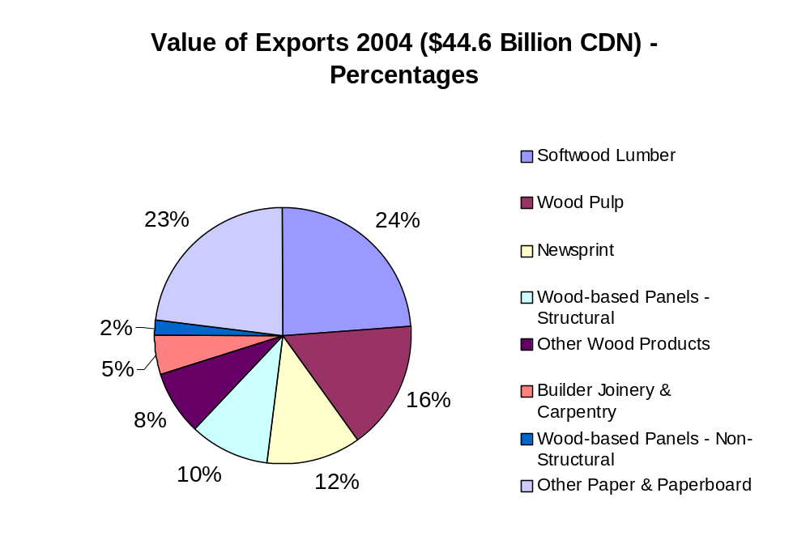
Source: Natural Resources Canada

2005 exports of major forestry products to the U.S. are expected to increase over 2004 exports as the demand for lumber remains strong due to the continued boom in the U.S. housing market and the additional need for lumber in order to rebuild from the hurricanes. Increased competition from Chinese imports into the U.S. is displacing some Canadian forestry exports to the U.S. and Post predicts this trend to continue in the 2005 and 2006 calendar years. In addition to increased competition from China, Russia and the Baltic States could also become major competitors of Canada’s forest industry. In order to maintain Canada’s position as the leading exporter of forest products, the federal, provincial and territorial governments are working with wood-product associations and the forestry industry to diversify Canada’s wood-product exports, and to expand overseas market opportunities. Particular emphasis is currently being directed towards China, a growing market that has now become Canada’s fourth most important wood-product customer.

3.2 Competition and Markets

3.21 United States

Despite various government and industry moves to seek out and establish new export markets for Canadian forest products, the U.S. is and will continue to be Canada’s primary export market. The booming housing market in the U.S. is showing very few signs of significantly slowing down, as seen by the number of building permits reaching a 32-year high. This is beneficial for Canadian forest products, as the demand for them will continue to be strong. Moreover, with the significant destruction caused by hurricanes in 2005 in the southern U.S., Canadian exports of softwood lumber, OSB, and plywood are also expected to increase.

The Canadian furniture industry and other value-added wood industries rely on imports of U.S. hardwood in order to produce for export. 2004 imports of hardwood lumber from the U.S. declined from 2003, as restructuring in the furniture industry reduced demand. In particular, the demand for oak has declined while demand for other U.S. hardwoods such as cherry, western red alder, and hard maple increased in 2004. This trend is expected to continue in 2005, as imports of oak lumber in the first nine months of 2005 have declined in comparison to the same 2004 time frame. Imports of beech have declined in 2004 and in the first nine months of 2005. Imports of other hardwoods have also benefited from the decline in oak and beech imports and may be indicating a trend away from beech and oak products towards cherry and maple products, within the Canadian industry. U.S. hardwood lumber imports account for approximately 98% of total hardwood lumber imports into Canada. The impact of increased foreign competition in traditional markets for Canadian products, the high Canadian dollar, and high energy costs, all of which have impacted Canadian furniture producers, is resulting in a lower demand for hardwood lumber products from outside Canada. U.S. hardwood lumber imports are expected to remain an integral part of Canadian furniture production in 2006, but imports are forecast to decline again, as the industry continues to restructure and tries to reduce costs by relying on domestically-produced lumber.

3.22 China

Through its recent trade missions and government consultations, the Canadian government has been promoting its forest industry products in China. With China’s large and growing population and the demand for forestry products continually increasing to meet the country’s manufacturing demands and domestic needs, Canadian officials and lumber companies see China as a new and substantial outlet for Canadian forestry products. With Russia and the Baltic States having a geographical advantage, and other major forestry products producers, including the United States, all attempting to take advantage of the significant opportunities presented by the Chinese market, competition is expected to be very strong.

Forestry Innovation Canada Ltd. (http://www.bcfii.ca/), a British Columbia government marketing agency, has been very active in trying to develop additional markets for B.C. lumber. The group works with lumber industry companies to:

- Increase access to the Chinese market through the introduction of a new Chinese building code that recognizes Canadian wood and construction standards for the first time
- Increase awareness of wood product opportunities and applications in China through the five-year $12 million Dream Home China demonstration project, phase 1 of which recently opened in Shanghai
- Increase acceptance of wood-frame 2x4 housing systems in Japan. B.C. is now the largest supplier to the 2x4 housing segment of the Japanese home building industry, the largest growing segment of the Japanese housing sector.

In addition, projects for 2005 are:

- Introduce a broader range of Coastal wood products, such as kiln-dried wood into the Japanese post and beam housing sector
- Strengthen the U.S. market against competing non-wood products
- Expand market opportunities for North American 2x4 construction in the fast growing Chinese marketplace
- Position B.C. structural lumber for expected greater demand in Korea
- Support research into structural properties of mountain pine beetle wood during different stages of attack and conducting a Chinese market analysis specifically for beetle wood

3.23 Japan

In addition to developing and increasing market presence in China, Japan continues to be a critical marketplace for Canadian forest products. This is especially true for B.C.’s Coastal forest industry. Coastal Forest, a regional industry advocate, has launched programs to market its products in Japan. Some of the initiatives taken by Coast Forest in the Japanese market are:

- Separation and differentiation of Canadian (BC Coast) Hemlock from the U.S. Hemlock lumber
- Establishment of a name (Canada Tsuga) and brand (stylized house) for Canadian Hemlock lumber that is now readily identified in Japan by all end-users of Canada Tsuga
- Initiation of research testing of Hemlock technical properties in Japanese building components
- Development and launch of a new Hemlock product line in October 2001, that is graded and grade-stamped as E 120, and approved by the Japanese government agencies, which identifies this product as being one of the strongest wood products in the Japan marketplace.

In addition, a second phase of lumber promotion in Japan has been launched. Coast Forest is also working with the other groups in B.C. to promote B.C. lumber in China.

SECTION 4. MARKET SEGMENT ANALYSIS

4.1 Construction Sector

4.11 Overview

According to Statistics Canada, 2004 was an outstanding year for residential construction, with the total value of investment reaching $70.4 billion CDN ($60.3 billion USD), the sixth consecutive year of increased investment. All three components of investment in residential construction (new housing, renovations and acquisition costs) recorded strong gains over 2003. Low mortgage rates, the strong employment situation, high consumer confidence and low apartment vacancies in a number of major centers all contributed to the strong demand for new housing. Investment in new housing construction reached $36.0 billion CDN ($30.8 billion USD) in 2004, a 14.6% over 2003. Not only was there an increase in investment in single-family homes, but there was also a significant increase in investment in new apartment/condominium units, due to an increase in housing starts and the rise in the average value of these starts. Expenditures on renovations jumped by 13.6% to $28.0 billion CDN ($24 billion USD) in 2004. A contributing factor to the increase was the high level of existing homes for resale in recent years. Acquisition costs increased by 14.7% to $6.3 billion CDN ($5.4 billion USD) in 2004. Residential construction investment continued to climb during the first two quarters of 2005. Residential investment increased 8.6% and 6.7% in the first quarter and second quarter of 2005, respectively. As was seen in 2004, low mortgage rates and their impact on affordability, higher disposable income and employment levels, and strong consumer confidence all helped to boost the housing market. Higher housing prices also contributed to the increase in residential construction outlays. Expenditures on new housing construction increased 6.6% in the first quarter and 4.3% in the second quarter in 2005, in comparison to the first and second quarters of 2004. In both the first and second quarter of 2005, an increase in spending on new apartments/condominiums was the largest contributor to the increase in new housing construction. Investment in single-family dwellings also increased in both quarters. Investment in renovations is showing no signs of slowing down as spending jumped 10.8% and 8.5% in the first and second quarter of 2005, respectively. Acquisition costs rose by 9.7% in the first quarter and 11.9% in the second quarter of 2005 over the same periods in 2004. Higher housing prices is expected to contribute to a forecast increase in residential construction outlays in 2006, despite the fact that housing starts are expected to decline.

However, despite the strong residential investment, Canadian housing starts in 2005 are starting to show signs of slowing down, decreasing 10% from 2004, due to a small increase in mortgage rates. The decline in housing starts in October is part of a general trend of gradual cooling in the housing sector from its red hot pace in 2004. Nevertheless, housing starts are still considered to be strong and are expected to continue to remain so for the rest of the year and into 2006. According to the Canadian Mortgage and Housing Corporation (CMHC), housing markets across Canada will continue to respond to low mortgage rates, but increased competition from the existing home market, rising mortgage carrying costs due to strong house price growth, and modest increases in mortgage rates will all contribute to the slight cooling in the pace of new home construction in 2006. Housing starts are forecast to remain over 200,000 units in 2006, the fifth consecutive year that starts will be over the 200,000 levels. The slow down in the housing sector can also be seen in the decline in reduction of number of residential building permits during the first nine months of 2005. According to Statistics Canada, the number of new units (seasonally adjusted) approved since the beginning of 2005 has declined 3.3% to 175,560 units from 181,498 units in the first nine months of 2004. Despite the decline in the number of units, the total value of the permits has increased by 4.1% to $28.4 billion CDN ($24.3 billion USD), as a result of the increase in the price of new dwellings. The strong value of residential permits has contributed to an overall increase in total value of building permits (both residential and non-residential) and has offset a decline in the value of non-residential permits. The total value of permits from January to September of 2005 was $45.2 billion CDN ($38.7 billion USD), a 10.7% increase over the first nine months of 2004. The increase in value of residential permits from August to September of this year is attributed to a rebound in the value of multi-family permits and a small increase in single-family permits.

The strong housing markets and renovation activity in both Canada and the U.S. is creating supply pressures on building materials. Lumber prices hit a 10-year high in 2004, as the active 2004 hurricane season and an already hot U.S. housing market further spurred demand. Price corrections are expected to reduce Canadian export earnings, as well as capacity constraints and transport bottlenecks. The strong demand for building materials is placing renewed strain on transportation capacity. Canadian mills, particularly in the west, have been experiencing railcar shortages in 2005. Increased lumber loadings and fewer railcars are creating problems moving product. Strong demand and supply constraints have helped keep lumber prices high in 2005. With the reduction in production in Quebec, the supply constraints situation may become worse if B.C. is not able to cover the loss in supply. This should cause lumber prices to stay at higher levels in 2005 and possibly into 2006.

4.12 Structural Wood Building Components

The strong growth in the construction sector in both the U.S. and Canada has fueled the demand for wood structural building components over the last 10 years. Production of glulam, trusses, arches, I-beams or I-joists, laminated veneer lumber (LVL) and other products used in the construction of building have been increasing at a rapid pace. Glulam, I-beams and LVL fall under the category of engineered wood products or EWP, but other structural products are also considered EWP. Glulam is a structural timber product manufactured by gluing together individual pieces of dimensional lumber and is used for headers, beams, girders, columns, and heavy trusses. It is often used where the structure of a building is left exposed as an architectural feature and offers architectural freedom without sacrificing structural requirements. Canadian glulam is manufactured in three species combinations: Douglas Fir-Larch, Hem-Fir and Spruce-Pine. According to the UNECE/FAO, glulam production in Canada reached a record high of 40,000 cubic meters in 2004, due to the strong housing market and stock beam capacity that was available to service increased demand. Production is forecast to decline slightly in 2005, as consumption and exports are forecast to drop slightly from 2004. The U.S. is the primary market for Canadian glulam.

I-beams are made by gluing sold sawn lumber or LVL flanges to a plywood or OSB panel web to produce a dimensionally stable light-weight product. I-beams are well suited for longer span joist and rafter applications for both residential and commercial construction. In some instances where large dimensions of solid sawn framing lumber is difficult to obtain, I-beams can be used as floor joists and as deep, insulated roof joists. In addition, I-beams are an economical alternative to open web steel joist. According to UNECE/FAO, I-beam production in Canada reached 122.5 million linear meters in 2004, as strong residential construction increased demand. Production is forecast to decline slightly in 2005 as the number of housing starts begins to slow down.

LVL is a layered composite of wood veneers and adhesive and can be cut into stock for headers and beams, flanges for I-beams or for other specific uses. Common species used for LVL are Douglas fir, larch, southern yellow pine and poplar. LVL is used for beams and headers where high strength, dimension stability, and reliability are required. LVL is used primarily as structural framing for residential and commercial construction and is well suited to applications where web steel joists and light steel beams might be considered. According to the UNECE/FAO, Canadian LVL production soared in 2004 to 220.9 thousand cubic meters as a result of the boom in the housing sector. In addition, the increased use of LVL by home design engineers also helped fuel the increase in production of LVL. Production of LVL in 2005 is forecast to remain around the same level as 2004 despite the fact that housing starts are slowing down. LVLs are being used more in beams and headers than on I-beam flanges, which should help maintain the demand.

Another EWP is parallel strand lumber (PSL), which is a high strength structural composite lumber product produced by gluing strands of wood together under pressure. In Canada, PSL is produced from Douglas fir. The product has consistent properties and a high load carrying ability. The creation of PSL enables smaller plantation and second growth timber to be utilized. PSL is used for beams, columns for post and beam construction, and for beams, headers and lintels for light framing construction. It is also used for large members in residential construction and as intermediate and large members in commercial building construction. Market acceptance of structural wood products, the shift from larger dimension lumber to EWPs and the shift from stick build homes to factory-built homes, have all contributed to the growth of the structural wood products industry.

The overall increase in production of fabricated structural wood products has been a result of the changing nature of the softwood fiber supply, a need to optimize wood products output from a changing timber resource and the prevalence of wood-frame construction within North America. As more and more lumber is being sourced from second and third cuts, which tend to be smaller diameter trees, the wood products industry has had to adjust. Structural wood products (SWP) utilize wood fiber from smaller trees very efficiently and in some instances can be manufactured from certain species that are underutilized and relatively inexpensive. The development of SWP is also a result of industry efforts to create products that perform better than traditional wood products. Solid sawn lumber is restricted by the size of the log from which it is cut and its strength is inherently variable due to natural characteristics of the log. In contrast, SWP can be manufactured in a variety of sizes and dimensions to match specific applications. According to the APA-The Engineered Wood Association, SWP have consistent, stable dimensions, a high strength to weight ratio, the ability to span long distances, and specific design values. In addition, SWP are easier to work with than traditional dimensional lumber, speed up the construction process, require less on-site labor, increase design flexibility by providing longer spans and wider spacing, reduce the need for skilled construction workers, require less cleanup of the job site, are less likely to be stolen, and reduce callbacks.

Structural wood building components have displaced dimensional lumber to some extent in certain residential construction applications. Roof trusses have replaced traditional roof framing, I-beams and floor trusses have taken market share from dimensional lumber in floor joist applications, and LVL and glulam have taken market share from dimensional lumber in beam and header applications. The result has been an overall increase in the demand for structural wood products in Canada. According to the Wood Products Council, the average amount of engineered wood used per housing start for single-family detached houses in Canada nearly tripled between 1995 and 1998 and the average amount of engineered wood used per housing start for townhouses and apartments in Canada more than tripled between 1995 and 1998. The demand and use of structural wood building products is expected to continue to remain strong in the coming years, but the demand for these products is expected to slow down in pace as many have already replaced traditional building components and products, thereby resulting in a more steady demand, rather than a fast paced increase in demand.

The development and growth of value-added woods products like structural wood products has been driven by changes in the industry and partially funded by the various levels of government in Canada. In addition to competing with traditional wood products, there is competition between the various structural wood products for use by the construction sector. The fluctuation in the production of the various products can be attributed to competition within the structural wood industry. But despite the competition, the overall production of structural wood products has been increasing the in last several years. Exports of structural wood products has also been increasing over the last ten years, with the U.S. being the primary export market for Canadian structural wood products. In many instances, exports of structural wood products from Canada to the U.S. are from plants in Canada that are owned and operated by companies in the United States. As a result, some of the exports coming from Canada to the U.S. are actually U.S. companies bringing their own products, typically made from Canadian wood, into the U.S. from their factories in Canada, not Canadian companies supplying the U.S. market. Exports of structural wood products are impacted by the strength of the Canadian dollar and by the Canadian housing market and domestic demand. This, in combination with the slight decline in pace of the housing industry, has resulted in a slight slow down in the pace of exports of structural wood products to the U.S. during in 2005. Increased competition from other countries is also expected to impact Canadian exports of structural wood products to the United States in 2005 and in 2006. Japan is the second largest market for Canadian structural wood exports.

Imports of structural wood products into Canada continue to remain relatively small, but are increasing. The U.S. is the primary source of structural wood imports into Canada, but imports from other countries have been increasing over the last 5 years, reducing the U.S. share of total imports of structural wood products.

As primary forest sources continue to change and the lack of skilled workers within the Canadian construction industry continues, the demand for structural wood products is forecast to continue to increase. The development of new uses and applications will continue to drive the demand for traditional and new structural wood products both in the in the residential and non-residential industries. Despite the slowing pace of housing starts, the continued expectation of growth in the new housing industry and the strong renovation market will all help drive demand for structural wood products. The demand for structural wood products is forecast to be strong in 2006, although not as strong as 2005, due to an expected decline in the number of housing starts.

4.13 Other Millwork Products

The production and shipment of products that fall under the Other Millwork category (see page 31 for definition) has increased over the last 10 years. The products that fall under this category are used in the construction of houses and other buildings. The boom in the housing market has driven up the demand and production of these products. Since 1994, the value in shipments from principal establishments has increased 250 percent to $3.5 billion CDN ($3.0 billion USD) in 2003. Exports accounted for approximately 16% of manufacturer shipments in 2003, indicating that a large portion of product is utilized within Canada. Manufacturer shipments for 2004 are expected to be higher than 2003 as a result of the record number of housing starts in 2004. Total exports increased in 2004 by 10.5% from 2003, with exports to the U.S. also increasing by 13.7% in 2004. Exports to the U.S. accounted for 93% of the total exports in 2004. Total Canadian exports of other millwork products have tapered off in the first eight months of 2005, falling approximately 5.0 percent and exports to the U.S. have declined by 7.0 percent, due to combined factors of the cooling housing market and increased competition from China. Exports of other millwork products are forecast to continue to decline in 2006, as the pace of housing continues to slow, competition from China remains strong and the strong Canadian dollar hampers exports.

Total imports of other millwork products increased 25% to $536 million CDN ($459 million USD) since 2003, due to an increase in 2004 housing starts. Imports from the U.S. in 2004 increased 3.5% over 2003 and accounted for approximately 40.6% of the total imports. The U.S. share of total imports has been declining over the last several years as imports from other sources like China and Austria have both increased dramatically. The rapid rise in Chinese imports and imports from other countries have been displacing imports of other millwork products from the United States over the last several years. During the first eight months of 2005, total imports have increased by 16.7% compared to the same period in 2004, with imports from China and Brazil increasing 72.1% and 60.7% respectively, reducing the U.S.’s market share in 2005 to 37.3 percent. In contrast, imports from the U.S. have only increased by 1.3% so far in 2005. Total imports are expected to be higher in 2005, compared to 2004, despite the slow down in the housing market, as the demand for these products continues to be strong for use in the renovations of older houses and the completion of the new houses. Imports for 2006 are forecast to continue to increase, as demand is expected to remain strong for renovations and the new housing market. Imports from China are forecast to continue increasing, taking a larger portion of the Canadian market, thereby further reducing the U.S. market share.

The strong housing market in the U.S. has helped maintain demand for Canadian manufactured wood products, including those that fall under the Other Millwork category. Some of these products are made from hardwood lumber and logs. Canada is limited in the volume of hardwood logs and lumber it produces and as a result, the manufacturers of these products import the lumber and logs primarily from the U.S. and export the finished products back to the United States.

4.14 Prefabricated Wood Buildings

2003 prefabricated wood building shipments declined 5.7% to $681.4 million CDN ($583.2 million USD) after peaking in 2002, due to a reduction in the number of principal establishments in 2003. In addition, exports dropped by approximately 10% as exports to Canada’s two largest markets, the United States and Japan, declined, due to a shift in preference for other forms of housing structures. Exports continued to decline in 2004 as the demand for prefabricated wood buildings further decreased due to the strong Canadian dollar and increased competition from countries like China. However, exports during the first eight months of 2005 have rebounded, mainly due to increased U.S. demand resulting from the natural disasters in the southern United States. 2006 exports of prefabricated wood buildings are forecast to remain at a similar level as 2005 exports, as the rebuilding efforts in the southern U.S. continue. If Canadian exporters are able to capitalize on the growing Chinese market, 2006 exports may even increase slightly above 2005 export levels.

Total prefabricated building imports jumped by 37% in 2004 to $151 million CDN ($129 million USD), as the housing market continued to boom in Canada. The U.S. accounted for approximately 85% of total imports. Prefabricated wood buildings accounted for roughly 4.2% of the total prefabricated building imports in 2004, with the U.S. prefabricated wood building imports accounting for the overwhelming majority. Prefabricated wood building imports are steadily accounting for a larger and larger percentage of the total prefabricated building imports. Imports of prefabricated buildings and wood buildings have increased dramatically in the first eight months of 2005, with increases of 20% and 32.8% respectively, mostly from the United States. Besides the U.S., Sweden, Finland and Belgium primarily supply the prefabricated wood building import market. Although there has been a reduction in the number of establishments producing prefabricated buildings in Canada, demand remains high and a result of the strong housing market – a trend that is expected to continue in 2006.

4.15 Wood Window and Door Products

Over the last ten years, there has been considerable growth in the production, and number of establishments and shipments of the Canadian wood window and door industry, with manufacturer shipments increasing 82% since 1993. That said, 2003 shipments in the wood window and door industry were unchanged from 2002, remaining at approximately $2.0 billion CDN ($1.7 billion USD), due to increased competition from metal windows and doors. However, in 2004, exports of wood windows and doors increased by 12.4% to $508 million CDN ($435 million USD) in 2004, with exports to the U.S. accounted for 97.4% of the total. The strong housing market in the U.S. is the primary driver behind this increase in exports. Exports to Japan, Canada’s second largest market, have steadily declined since 2000, but increased slightly in 2004, due to an increase in housing starts. Exports for the first eight months of 2005 increased over the same period in 2004, forecasting an overall increase in exports in 2005, due to an increase in demand from the U.S. and Japanese markets resulting from strong housing starts. Competition from other countries and from metal windows and doors, and the slow down in housing starts in the later half of 2005 and into 2006 are forecast to result in a decline in exports in 2006.

Total 2004 imports of wood windows and doors increased 15.6% to $156 million CDN ($133 million USD) from 2003 due to strong demand. The demand for products like wood windows and doors is strongly tied to housing starts. As housing starts remain strong, so does demand for wood windows and doors. The U.S. is the primary source of wood window and door imports, accounting for 77.4% of total 2004 imports. U.S. imports into Canada have been relatively stable over the last five years, but as total imports have continued to climb, the percentage of imports from the U.S. has been declining, due to increased competition from China. As a comparison, 2000 imports of wood windows and doors from China accounted for less than 1% of total imports, whereas, 2004 imports accounted for 9.3% of total imports. Imports from other countries like Brazil have also increased significantly since 2000. Total imports of wood windows and doors are forecast to decline in 2005 as housing starts have slowed. Imports in 2006 are forecast to decline in conjunction with the slower pace of housing starts.

4.2 Furniture & Interiors Sector

4.21 Overview

The demand for furniture tends to follow the trend in the housing markets. After several years of booming housing markets in both the U.S. and Canada, the demand for furniture remains high, despite the recent – albeit slight – cooling in the housing market. This, in combination with low interest rates and strong employment growth has resulted in increases in demand and purchasing of larger ticket items like furniture. Furniture sales are expected to remain strong for the next couple years as the purchase of furniture for new housing is typically spread over a few years. In addition, the strong renovation market is also spurring demand, as new furniture is expected to replace older furniture. Indoor furniture sales in Canada for the first two quarters of 2005, based on unadjusted retail numbers from Statistics Canada, have increased 6.4% from the same period in 2004, due to the strong demand. Indoor furniture sales includes mattresses and foundations, nursery furniture and equipment, and all other indoor furniture, including home office furniture. The forecast for the remainder of 2005 and for 2006 is for furniture sales to slow, mirroring the slight decline in the housing market. The U.S. continues to be the primary market for Canadian furniture exports, with 2004 furniture exports to the U.S. valued at approximately $5.0 billion CDN ($4.3 billion USD). This includes office furniture and household furniture.

4.22 Issues Facing the Canadian Furniture Industry

The increasing importation of Asian-manufactured furniture is forcing Canadian companies to become more efficient and competitive. For example, Shermag, Canada’s largest furniture manufacturer is in the process of undergoing changes to ensure it remains competitive on the global market. Shermag has worked towards differentiating its domestic production through the customization of its products while simultaneously using global sourcing to broaden its assortment and maintain a low cost position. Globally-sourced products represented approximately 20% of Shermag’s revenue in 2004/2005. In addition, Shermag will be undergoing significant consolidation in its domestic operating activities and a reduction of cost structures. Shermag is one of the few companies that acquired it’s own hardwood sawmills, which enables the company to utilize hardwood and veneer produced at its own facilities. The factors influencing Shermag’s market, namely interest rates, housing sales and house remodeling, and personal income growth, are not expected to change dramatically in the near term. The U.S./CDN exchange rate is expected to stabilize at current levels. Consequently, Shermag must continue to adapt to a changing North American economic environment for the furniture industry. Other large furniture companies like Palliser have also been making changes to the way they operate in order to continue to compete globally. Palliser also sources furniture from other markets, like Indonesia. In addition, the company’s leather furniture destined for the U.S. market will be produced in Mexico. Its production in Canada is focused on goods for the Canadian market and value-added products for the U.S. that tend not to be adversely affected by currency. The company is citing the weakness of the U.S. dollar, a very competitive environment, and inefficiencies within its own business as reasons for a decline in net earnings. Strong competition from Asia has seriously limited the possibility of increasing prices to compensate for the weaker U.S. dollar. Production of low-margin products has been shifted to Asia. Many Canadian factories are being converted from mass-market to made-to-order productions, which takes time.

China is a major competitor in the wood furniture industry. Low labor costs, low capital investment in manufacturing plants, and logs from Russia allow Chinese wood furniture manufacturers to produce furniture at lower cost and rapidly export it in large quantities to the U.S. market, thereby displacing Canadian furniture manufacturers. In addition to sourcing raw materials from Russia, China imports raw materials from Canada, utilizing them to produce wood furniture that then competes with Canadian wood furniture in the U.S. and Canadian markets. While the Canadian forest industry is actively promoting this and is attempting to increase raw material exports to China, the result is many of the products created out of Canadian wood are returning to compete and in some cases displace domestically-produced wood products, both within Canada and the United States. As a result, the Canadian wood furniture industry is undergoing major changes and, within the next five years, is not expected to look anything like it currently does. The signing of NAFTA in the 1990s resulted in the first series of major changes to the Canadian furniture industry; now this second series of major changes is required in order to effectively compete with lower-cost Chinese imports. However, despite the increased competition with Chinese imports, there is a recognition within the Canadian furniture industry that there is and will continue to be a demand for higher quality pieces of furniture produced by Canadian and U.S. furniture manufacturers. As a result, some Canadian furniture companies will continue to cater to the higher end market, thereby creating an exclusive market, which the lower quality imports will be unable to access.

4.22 Policy

In early November 2005, The Canadian Council of Furniture Manufacturers (CCFM) filed a complaint with the Canadian International Trade Tribunal (CITT), seeking an inquiry into household furniture imports from China. The CCFM is an umbrella organization, made up of the Quebec Furniture Manufacturers Association, the Ontario Furniture Manufacturers Association and Furniture West. The CCFM contends that the rapid increase in Chinese furniture imports has disrupted the Canadian furniture market, resulting in material injury to the Canadian industry. It maintains that Canadian manufacturers are losing market share and in order to adjust to the realities of the new market, Canadian manufacturers need more time to adjust, given the pace at which Chinese imports have been increasing. The CITT has 21 days (some time in December 2005) to decide if an investigation is warranted and then has 90 days (some time in March 2006) to make recommendation to the government. CCFM’s complaint to the CITT has met with resistance from some of the larger Canadian furniture importers, who maintain that duties on imported Chinese furniture would increase costs for retailers and decrease consumer demand for furniture in general.

4.23 Shipments

Shipments of furniture and related products from principal establishments (incorporated establishments with employees, primarily engaged in manufacturing and with sales of manufactured goods equal or greater than $30,000) fell 2.5% to $12.9 billion CDN ($11.1 billion USD) in 2003. Household furniture shipments accounted for 32.2% of total furniture and related products shipments, with a value estimated at $4.2 billion CDN ($3.6 billion USD). Wood furniture accounted for well over half of the household furniture shipments (61.9% in 2003). The wood furniture sector also accounted for 20.2% or one-fifth of shipments within the broader furniture industry.

4.23 Trade

4.23.1 Furniture and Related Products

Furniture and Related Products exports have increased by 1.4% in 2004 to $6.99 billion CDN ($5.99 billion USD). In 2004, the U.S. remained the primary destination for Canadian furniture and related products exports, with exports increasing marginally by 1.3% to $6.74 billion CDN ($5.78 billion USD). An increase in exports in the office furniture category – approximately half of total furniture and related products exports - helped offset the decline in exports in the household and institutional furniture and kitchen cabinets category. Overall household furniture exports declined by 4.5% to $1.79 billion CDN ($1.54 billion USD) in 2004, due to increased competition within the U.S. and in third markets, and a strong Canadian dollar. Within the household furniture category, overall wood furniture exports declined by 3.5% and by 3.2% to the United States for this same reason. Wood furniture accounted for 72.3% of total household furniture exports and approximately 20% of total furniture and related product exports in 2004. For the first eight months of 2005, exports of household furniture declined by 11.9% and wood furniture exports have declined by 11.2% in comparison to the same time frame in 2004. Reflecting this general decline, 2005 exports to the U.S. are down since 2004, but exports to the United Kingdom have rebounded and exports to Thailand continued to increase due to an increase in consumer demand in those countries and the efforts by the furniture industry to supply other markets. Canadian furniture exports are forecast to decline again in 2006, as the industry continues to adjust, competition remains strong, the Canadian dollar stays high and housing markets begin to cool. Despite the declining trend in Canadian furniture exports, Canada continues to be one of the leading furniture exporters in the world.

After declining in 2003, imports of furniture and related products imports increased by 22.2% to $4.5 billion CDN ($3.86 billion USD) in 2004, due to strong housing starts and the continued influx of Chinese furniture. Most of this increase was in household furniture imports, which accounted for 81.8% of total furniture and related products imports. Imports of household furniture from China continued to increase at a rapid pace in 2004, up 35.6 percent, from 2003 and increasing its share of total imports to 42% at the expense of imports from the United States. From 2000 to 2004, the U.S. share of total imports declined from 46% to 25%, while China’s share of total imports increased from 23% to 42 percent. Data for the first eight months of 2005 indicate that this trend will continue, with Chinese household furniture imports up 9.4% and U.S. furniture imports increasing very slightly over the same period in 2004. China had been gaining ground in household furniture imports since 2000, but only officially overtook the U.S. as the dominant household furniture supplier in 2003. Wood furniture accounted for 44.8% of household furniture imports in 2004. Wood furniture imports increased 21% in 2004 and are following the same trend as household furniture imports, with China becoming the dominant supplier and the U.S. continuing to lose ground. Imports of furniture in 2006 are forecast to increase slightly over 2006, as consumer demand continues to remain strong. Imports from China are forecast to increase again in 2006, unless a tariff is placed on Chinese furniture imports (see 4.22 Policy). The size of the tariff placed on Chinese furniture imports could negatively impact Chinese imports, but provide an opportunity for other countries, including the U.S., to increase furniture imports to meet market demand.

4.23.2 Office Furniture

Total office furniture (includes wood and non-wood office furniture) exports increased by 5.5% in 2004 to $3.46 billion CDN ($2.97 billion USD) since 2003, due to strong non-residential building starts. Office furniture exports to the U.S., which accounted for 96.5% of total office furniture export sales, increased by 5.4 percent. Wood office furniture exports accounted for 18.3% of total office furniture exports, but did not follow the upward trend of the industry, with exports dropping by 3.8% in 2004. Wood office furniture exports to the U.S. declined by 4.6% in 2004. Wood office furniture exports have been declining since peaking in 2000, due to increased competition in the U.S. marketplace and declining demand for wood office furniture. Total office furniture and wood office furniture exports have both declined in the first eight months of 2005, compared to the same period in 2004, as non-residential building starts have slowed. Exports of office furniture are forecast to decline again in 2006 as the Canadian dollar remains strong, competition from China continues to increase and the non-residential buildings starts continue to cool.

Office furniture imports into Canada also increased in 2004 to $2.21 billion CDN ($1.90 billion USD) from $1.72 billion ($1.48 billion USD) in 2003. Imports from the U.S. account for 56.8% of the total office furniture imports in 2004, which is a decline from 2000 when imports of U.S. office furniture accounted for 69% of the total. As with household furniture imports, office furniture imports from China are rapidly increasing and displacing U.S. imports, but not as rapidly. Although wood office furniture imports only made up 5.5% of total office imports in 2004, this represents an increase over 2005. For the first eight months of 2005, imports of U.S. wood office furniture have declined 10.1% and Chinese imports have increased 19.1 percent. Total office furniture imports for 2006 are forecast to remain at a similar level as 2005 imports, as demand remains relatively constant. Imports of Chinese office furniture are forecast to increase yet again in 2006, further displacing U.S. office furniture imports.

4.23.3 Kitchen Cabinets

Canadian kitchen cabinets shipments increased 5.2% in 2003 to $2.4 billion CDN ($2.1 billion USD) from 2002. Since 1993, manufacturer shipments of kitchen cabinets have increased approximately 167% to $2.4 billion CDN ($2.1 billion USD) in 2003. In addition, the number of principal establishments has increased from 698, with 9,981 employees in 1993, to 946, with 23,262 employees in 2003. Like many other value-added wood industries, the kitchen cabinet industry is primarily located in Ontario and Quebec, with a smaller, but growing, presence in British Columbia. The strong housing markets in the U.S. and Canada, plus the signing of NAFTA, has contributed to the steady growth of the kitchen cabinet industry. However, despite the strong demand, 2003 exports of kitchen cabinets declined 6.5% to $1.16 billion CDN ($0.99 billion USD) since 2002 and accounted for less of total shipments due to the rise in the Canadian dollar and increased competition. Exports of kitchen cabinets continued to decline in 2004, dropping slightly to $1.15 billion CDN ($0.99 billion USD), as increased competition from China and the high Canadian dollar negatively impacted export sales. For the first eight months of 2005, exports are 6.5% lower than in the same 2004 time period, due to the same reason. With exports to the U.S. accounting for 98.7% of total kitchen cabinet exports in 2004, the U.S. is by far the main market for Canadian kitchen cabinet exports. The kitchen cabinet industry has been attempting to increase exports to other countries, such as Bermuda and Japan, but these countries still represent less than 2% of total Canadian exports. Overall kitchen cabinet exports, including those to the U.S., are forecast to fall again in 2006, despite a forecasted increase in exports to markets outside the United States, due to strong competition from countries like China and the unfavorable exchange rate for Canadian goods.

Total kitchen cabinet imports for 2004 dropped 1.9% to $102 million CDN ($87 million USD) from 2003, as the reduction in exports provided more products for the Canadian market. In 2004, imports from the U.S. declined by 11%, but still accounted for 72% of total kitchen cabinet imports, while imports from China continued to increase in 2004, jumping 76% and accounting for approximately 14% of total kitchen cabinet imports. Imports of kitchen cabinets from China have been gaining a larger portion of the Canadian market, at the expense of U.S. imports. Overall kitchen cabinet imports have increased 9.1% in the first eight months of 2005 compared to 2004, as result of the strong housing and renovation market. Imports from the U.S. have also increased by 2.64%, but account for only 69% of total imports in 2005. In addition, imports from other sources, like China, Slovakia, Malaysia, Denmark and others, have increased significantly in the first eight months of 2005.

4.24 Market Opportunities

The Canadian furniture market is very similar to the U.S. market, both of which are driven by housing starts and house renovations. Both markets are facing a similar situation in terms of increased competition from Chinese imports. A possible tariff on Chinese furniture imports may help to stem the flow into the Canadian market, thereby also providing U.S. furniture manufacturers some relief and the opportunity to regain some of the Canadian market share. The demand for high-quality, high-end furniture, as well as customized furniture products, is always present and provides an opportunity for U.S. manufacturers to take advantage of this market.

4.3 Material Handling Industry

Canadian Wood Container and Pallet Manufacturing Industry:

http://strategis.ic.gc.ca/canadian_industry_statistics/cis.nsf/IDE/cis32192defe.html

Importers of Wood Products for Manufacturing

The importers list below comprises those companies that collectively account for the top 80 percent of all imports in terms of value. These importers are not necessarily the end users. The wood products imported by the companies listed below all originated in the United States, but do not account for the total imports of each product into Canada in 2004.

Major Canadian Importers for 2004, Source: Industry Canada

Product | Company Name | Province
440710-Lumber (Thickness >6mm) – Coniferous Wood
A D Bernier Inc |  | Quebec
AFA Forest Products Inc Ontario |  | Ontario
Allmar Distributors |  | Manitoba
B B Pallets |  | Quebec
Boccam Inc |  | Quebec
Bois Demers Lumber Inc |  | New Brunswick
Bois Omega Limitee |  | Quebec
Canadian National Railway Company |  | Quebec
Century Truss Company Canada |  | Ontario
City Lumber Sales and Services Ltd |  | British Columbia
Colonial Pillars Inc |  | Ontario
Dynamic Forest Products Ltd |  | Ontario
Futura Properties Ltd |  | British Columbia
Goodfellow Inc |  | Quebec
Great Lakes MSR Lumber Limited |  | Ontario
Green River Log Sales (1996) Ltd |  | British Columbia
Heatwave Technology Inc. |  | British Columbia
Interbois Inc |  | Quebec
Jacomau Inc |  | Quebec
Jeld-Wen of Canada Ltd Head Office |  | Manitoba
Keystone Forest Products Ltd |  | British Columbia
KML Windows Inc |  | Ontario
Les Industries P F Inc |  | Quebec
Les Sechoirs a Bois Rene Bernard Ltee |  | Quebec
Lighthouse Lumber Wholesalers Ltd |  | Nova Scotia
Loewen Windows |  | Manitoba
Marwin Industries Inc |  | British Columbia
Masonite International Corporation |  | Ontario
McIlveen Lumber Industries (Alta.) Ltd |  | Alberta
Moulure Alexandria Moulding Inc |  | Ontario
North Pacific Group Inc |  | Oregon
Northern Building Supply Ltd |  | British Columbia
Ontario Wholesale Lumber |  | Ontario
Phaze 2 Investments Ltd |  | Alberta
Radisson Design Inc |  | Quebec
Roland Boulanger & CIE Ltee |  | Quebec
Sawmills Division |  | New Brunswick
Sechoirs De Beauce Inc |  | Quebec
Shaw Wood Industries Ltd |  | Nova Scotia
Shy’s Forest Products Ltd |  | British Columbia
Stella-Jones Inc Westmount |  | Quebec
SWP Industries Inc |  | New Brunswick
Taiga Forest Products |  | British Columbia
Terminal Forest Products Ltd |  | British Columbia
TFL Forest Ltd |  | British Columbia
Tolko Industries Ltd |  | British Columbia
Trentonworks Limited |  | Nova Scotia
Triad Forest Products Ltd |  | British Columbia
West Bay Forest Products and Manufacturing Ltd |  | British Columbia
Western Whitewood |  | British Columbia
Weston Forest Corp |  | Ontario
Weyerhaeuser Company Limited |  | British Columbia
440391-Wood in the Rough - Oak
Bois Bohemia Inc |  | Quebec
Bois Franc Cyclone Inc |  | Quebec
Bois Francs Kingsey Inc |  | Quebec
Bois Hunting Inc / Hunting Lumber Inc |  | Quebec
Bois-Franc Cambium Inc / Cambium Hard Wood Inc |  | Quebec
Eloi Moisan Inc |  | Quebec
Foresbec Inc |  | Quebec
General Woods & Veneers Ltd |  | Quebec
Les Bois Francs St-Charles Inc |  | Quebec
Les Bois Poulin Inc |  | Quebec
Les Entreprises J M Champeau Inc / Enterprise J M Champeau Inc |  | Quebec
Malette International Inc |  | Quebec
Manufacture de Lambton Ltee |  | Quebec
Multibois F L Inc |  | Quebec
Norcraft Canada Corporation |  | Manitoba
Roland Boulanger & CIE Ltee |  | Quebec
Scierie Dion & Fils Inc |  | Quebec
Ste-Therese Div of Commonwealth Plywood Co Ltd |  | Quebec
Transylve Inc |  | Quebec
Vexco Inc |  | Quebec
440392 – Wood in the Rough - Beech
Albert Larocque Lumber Ltd |  | Ontario
Bois Franc Spec Inc |  | Quebec
Dalkeith Lumber Inc |  | Ontario
Groupe Pare-Brossel Ltee “En Faillite” |  | Quebec
Les Bois Jean-Pierre Ltee |  | Quebec
Les Bois Poulin Inc |  | Quebec
Les Produits Forestiers Becesco Inc |  | Quebec
Megabois (1989) Inc |  | Quebec
Sawmills Division |  | New Brunswick
Scierie West Brome Inc |  | Quebec
440399 – Wood in the Rough Nes and Logs for Pulping
Amex Bois Francs Inc |  | Quebec
Baronet Inc |  | Quebec
Bois Bohemia Inc |  | Quebec
Bois Franc Cyclone Inc |  | Quebec
Bois Hunting Inc / Hunting Lumber Inc |  | Quebec
Columbia Forest Products Ltd |  | Ontario
Domtar Inc / Wood Products Group |  | Quebec
Foresbec Inc |  | Quebec
Garant GP |  | Quebec
General Woods & Veneers Ltd |  | Quebec
Gibeault & Fils Limitee |  | Quebec
Industries Manufacturieres Megantic Inc |  | Quebec
Joseph Audet Ltee |  | Quebec
Les Billots Select Megantic Inc |  | Quebec
Les Bois Jean-Pierre Ltee |  | Quebec
Les Bois Poulin Inc |  | Quebec
Les Entreprises J M Champeau Inc / Enterprise J M Champeau Inc |  | Quebec
Megabois (1989) Inc |  | Quebec
Panneaux Maski Inc |  | Quebec
Produits Forestiers St-Armand inc |  | Quebec
Sawmills Division |  | New Brunswick
Scierie Arbotek Inc |  | Quebec
Scierie Dion & Fils Inc |  | Quebec
Scierie Leclerc Et Tremblay Inc |  | Quebec
Ste-Therese Div of Commonwealth Plywood Co Ltd |  | Quebec
Transylve Inc |  | Quebec
440791 – Lumber (Thickness > 6mm) – Oak
A & D Wood Turning |  | Ontario
Alpa Forest Products Inc |  | Ontario
Aurora Timberland Wholesale Hardwood Lumber Inc |  | Ontario
BFS 2002 Inc |  | Quebec
Craftsmen Hardwoods |  | Ontario
Cut Rite Lumber Limited |  | Ontario
Defehr Furniture Ltd |  | Manitoba
DZD Hardwood Export Inc / La Compagnie D’Exploitation du Bois |  | Quebec
Erie Flooring & Wood Products |  | Ontario
Foresbec Inc |  | Quebec
Formations Inc |  | Alberta
Goodfellow Inc |  | Quebec
Groleau Inc |  | Quebec
Hardwoods |  | British Columbia
Hardwoods Specialty Products LP BC Group |  | British Columbia
Herwynen Saw Mill Ltd |  | Ontario
Industrial Hardwood Holdings Ltd |  | Ontario
Interforest Lumber Inc |  | Quebec
Lancashire Saw Sales & Service (Canada) Ltd |  | Saskatchewan
Lauzon – Planchers de Bois Exclusifs Inc |  | Quebec
Les Bois Jean-Pierre Ltee |  | Quebec
Les Entreprises Exulon Inc |  | Quebec
Les Parquets Dubeau Ltee |  | Quebec
Les Produits Forestiers M E S Inc |  | Quebec
Master Woodworking Centre Ltd |  | Ontario
Moulure Alexandria Moulding Inc |  | Ontario
Nicholson and Cates Limited |  | Ontario
Ontario Hardwood Products Limited |  | Ontario
Pallan Timber Products (2000) Ltd |  | British Columbia
Peter Thomson & Sons Inc |  | Ontario
Planchers Des Appalaches Ltee / Appalachians Flooring Ltd |  | Quebec
Preverco Inc |  | Quebec
Reimer Hardwoods Ltd |  | British Columbia
Renyco Inc |  | Quebec
Satin Finish Hardwood Flooring Ltd |  | Ontario
Sauder Hardwoods Inc |  | British Columbia
Sechoirs J S Inc |  | Quebec
Ste-Therese Div of Commonwealth Plywood Co Ltd |  | Quebec
Taiga Forest Products Ltd |  | British Columbia
Tembec Industries Inc – Pulp Group Kraft Plant |  | Ontario
The Oliver Lumber Company of Toronto Ltd |  | Ontario
Upper Canada Forest Products Ltd |  | Ontario
Weston Forest Corp |  | Ontario
Woodland Supply & Mfg Co |  | Manitoba
440792 – Lumber (Thickness >6mm) – Beech
BOA-Franc Inc |  | Quebec
Bois Peladeau Inc |  | Quebec
C A Spencer Inc |  | Quebec
Chipco BWC Inc |  | Ontario
Erie Flooring & Wood Products |  | Ontario
Industries Bois Ditton Inc / Ditton Wood Industries Inc |  | Quebec
Lauzon – Planchers de Bois Exclusifs Inc |  | Quebec
Les Bois J M Arbour Inc |  | Quebec
Peter Thomson & Sons Inc |  | Ontario
Preverco Inc |  | Quebec
Societe en Commandite Prolam |  | Quebec
Tembec Forest Products Inc |  | Ontario
Upper Canada Forest Products Ltd |  | Ontario
440799 – Lumber (Thickness >6mm) – Birch, Maple, Poplar, Aspen and Other Nes
Alpa Forest Products Inc |  | Ontario
Aurora Timberland Wholesale Hardwood Lumber Inc |  | Ontario
Barco Materials Handling Limited |  | Ontario
BOA-Franc Inc |  | Quebec
Bois Franc Spec Inc |  | Quebec
Bois Peladeau Inc |  | Quebec
Brenlo Ltd |  | Ontario
Britannia Inc |  | Ontario
C A Spencer Inc |  | Quebec
Carlwood Lumber Ltd |  | British Columbia
Corporation de Bois Rimprex |  | Quebec
Cut Rite Lumber Limited |  | Ontario
Durham Furniture Inc |  | Ontario
DZD Hardwood Export Inc / La Compagnie D’Exploitation du Bois |  | Quebec
Eldcan Forest Products Ltd |  | British Columbia
Erie Flooring & Wood Products |  | Ontario
Finmac Lumber Limited |  | Manitoba
Foresbec Inc |  | Quebec
Formations Inc |  | Alberta
Goodfellow Inc |  | Quebec
Hardwoods Specialty Products LP BC Group |  | British Columbia
Interforest Lumber Inc |  | Quebec
Jamie Boomhower Wood Finishing Inc |  | Quebec
Kamloops Forest Products Ltd |  | British Columbia
Kitchen Craft of Canada Ltd., KC Manitoba Ltd |  | Manitoba
Lauzon - Planchers de Bois Exclusifs Inc |  | Quebec
Les Bois J M Arbour Inc |  | Quebec
Les Entreprises Exulon |  | Quebec
Les Produits Forestiers M E S Inc |  | Quebec
Les Produits Forestiers P M S Inc |  | Quebec
Maritime Dimension Hardwoods Inc |  | New Brunswick
Maritime Lumber Limited |  | New Brunswick
Metric Woods Limited |  | Ontario
Nicholson and Cates Limited |  | Ontario
Olympic Forest Products Inc |  | Ontario
Ontario Hardwood Products Limited |  | Ontario
Ornamental Mouldings Company |  | Ontario
P.J. White Hardwoods Ltd |  | British Columbia
Peter Thomson & Sons Inc |  | Ontario
Planchers Des Appalaches Ltee / Appalachians Flooring Ltd |  | Quebec
Preverco Inc |  | Quebec
Primewood Lumber |  | Quebec
Reimer Hardwoods Ltd |  | British Columbia
Renyco Inc |  | Quebec
Sauder Hardwoods Inc |  | British Columbia
Sawmills Division |  | New Brunswick
Societe en Commandite Prolam |  | Quebec
Ste-Therese Div of Commonwealth Plywood Co Ltd |  | Quebec
Tembec Forest Products Inc |  | Ontario
Tembec Inc |  | Quebec
Tembec Industries Inc – Pulp Group Kraft Plant |  | Ontario
The Oliver Lumber Company of Toronto Ltd |  | Ontario
Upper Canada Forest Products Ltd |  | Ontario
Weston Forest Corp |  | Ontario
441214 – Plywood (Plies<6mm Thick) – At Least 1 Outer Ply of Non-Coniferous Wood
Bluelink Building Products Canada Ltd |  | British Columbia
Canwel Building Materials Ltd |  | Newfoundland and Labrador
Georgia-Pacific Building Materials Sales, Ltd |  | British Columbia
Gesco Industries Inc |  | Ontario
Goodfellow Inc |  | Quebec
Hardwoods |  | British Columbia
Hardwoods Specialty Products LP BC Group |  | British Columbia
Richelieu Hardware Canada Ltd |  | Ontario
Sauder Hardwoods Inc |  | British Columbia
Ste-Therese Div of Commonwealth Plywood Co Ltd |  | Quebec
Weyerhaeuser Company Ltd |  | British Columbia
441219 – Plywood (Plies <6mm Thick) – At Least 1 Outer Ply of Other Wood Nes
AFA Forest Products Inc Ontario |  | Ontario
Alpine Forest Products (2001) Ltd |  | Alberta
Bluelinx Building Products Canada Ltd |  | British Columbia
Canwel Building Materials Ltd |  | Newfoundland and Labrador
Georgia-Pacific Building Materials Sales Ltd |  | British Columbia
Goodfellow Inc |  | Quebec
Green River Log Sales (1996) Ltd |  | British Columbia
Griff Building Supplies Ltd |  | British Columbia
Les Fourgons Transit Inc |  | Quebec
Marwin Industries Inc |  | British Columbia
R.J. Millwork Co. Ltd |  | Manitoba
Silvaplex a Div of Forestply Ltd |  | Ontario
Skana Forest Products Ltd |  | British Columbia
Taiga Forest Products Ltd |  | British Columbia
Weston Forest Corp |  | Ontario
Weyerhaeuser Company Ltd |  | British Columbia
441021 – Particle Boards of Wood – OSB/Waferboards – Unworked, Sanded
Canwel Building Materials Ltd |  | Newfoundland and Labrador
Les Chantiers Chibougamau Ltee |  | Quebec
Louisiana-Pacific Canada ltd |  | Nova Scotia
Weyerhaeuser Company Ltd |  | British Columbia
441029 – Particle Boards of Wood – OSB/Waferboards – Other Nes
Goodfellow Inc |  | Quebec
Lamwood Products (1990) Limited |  | Ontario
Taiga Forest Products Ltd |  | British Columbia

The following table indicates the value of the imports of the listed products imported by the companies listed in the previous table. As is indicated by this table, the U.S. is either the only source or the primary source of the listed products.

Product | Value of U.S. Imports 2003 (CDN) | Value of U.S. Imports 2004 (CDN) | Total Value of Product Imports 2004 (CDN)
440710 – Lumber (Thickness >6mm) Coniferous Wood | $138.2 million | $138.3 million | $152.8 million
440391 – Wood in the Rough – Oak | $76.2 million | $86.2 million | $87.3 million
440392 – Wood in the Rough – Beech | $564,000 | $222,684 | $299,480
440399 – Wood in the Rough Nes and Logs for Pulping | $193.6 million | $197.3 million | $197.6 million
440791 – Lumber (Thickness >6mm) – Oak | $262.2 million | $234.9 million | $235.0 million
440792 – Lumber (Thickness >6mm) – Beech | $2.9 million | $2.2 million | $3.4 million
440799 – Lumber (Thickness >6mm) – Birch, Maple, Poplar, Aspen and Other Nes | $291.0 million | $305.1 million | $314.5 million
441214 – Plywood (Plies<6mm Thick) – At Least 1 Outer Ply of Non-Coniferous Wood | $39.7 million | $37.8 million | $95.3 million
441219 – Plywood (Plies <6mm Thick) – At Least 1 Outer Ply of Other Wood Nes | $33.5 million | $41.4 million | $52.0 million
441021 – Particle Boards of Wood – OSB/Waferboards – Unworked, Sanded | $27.1 million | $27.6 million | $27.9 million
441029 – Particle Boards of Wood – OSB/Waferboards – Other Nes | $10.7 million | $12.4 million | $14.8 million
TOTAL OF VALUE OF IMPORTED PRODUCTS | $882.1 million | $886.1 million | $983.3 million

SECTION 5. STATISTICAL INFORMATION

5.1 Softwood Log Situation/Outlook

Table 1: Softwood Log Supply and Distribution

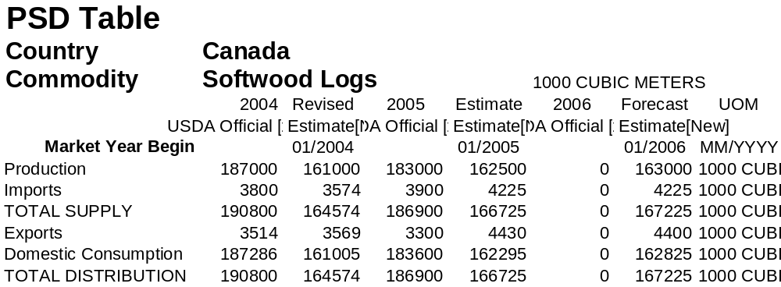

5.2 Softwood Lumber Situation/Outlook

Table 2: Softwood Lumber Supply and Distribution

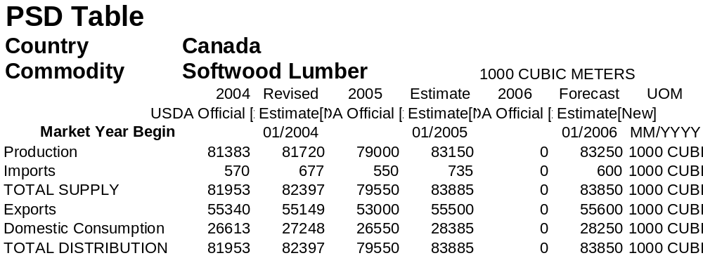

5.3 Softwood Plywood Situation/Outlook

Table 3: Softwood Plywood Supply and Distribution

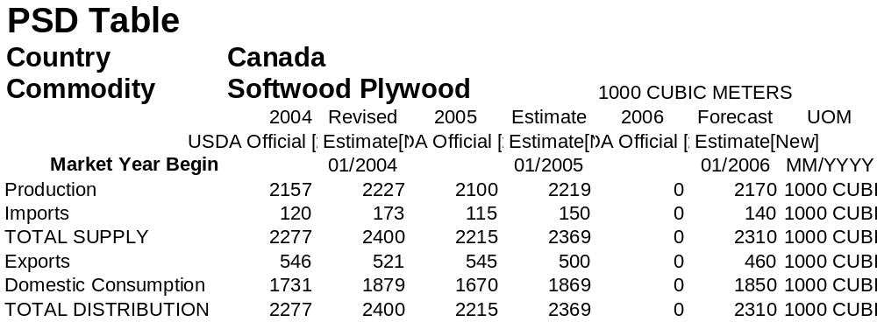

5.4 Hardwood Log Situation/Outlook

Table 4: Hardwood Log Supply and Distribution

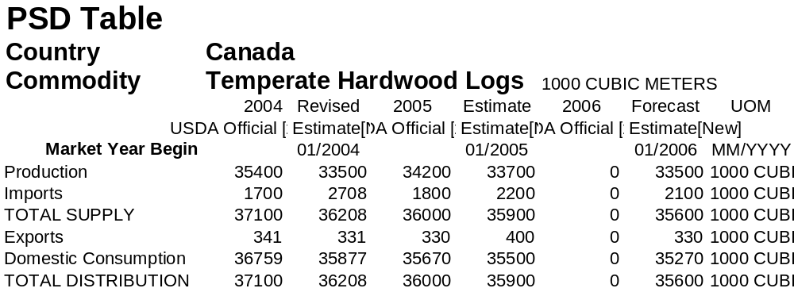

5.5 Hardwood Lumber Situation/Outlook

Table 5: Hardwood Lumber Supply and Distribution

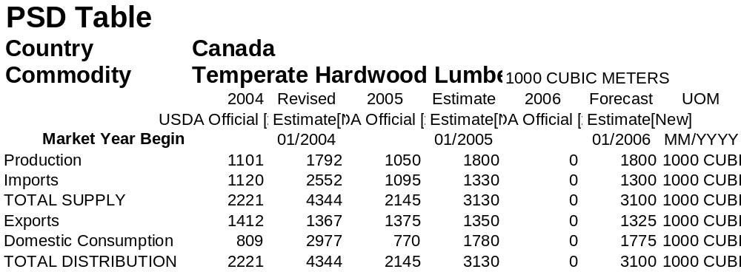

5.6 Hardwood Plywood Situation/Outlook

Table 6: Hardwood Plywood Supply and Distribution

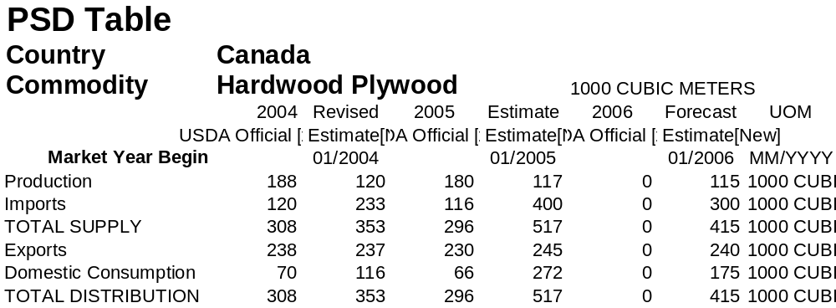

5.7 Oriented Strandboard Situation/Outlook

Table 7: Oriented Strandboard Supply and Distribution

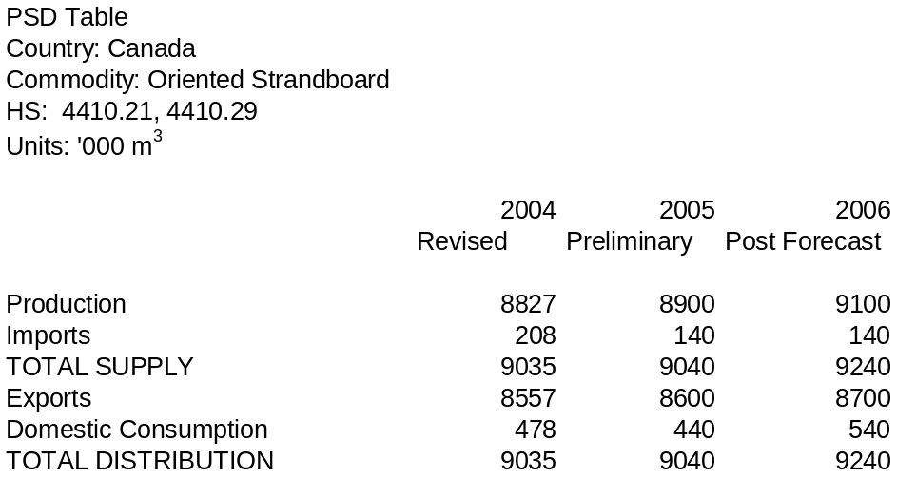

APPENDIX 1.

Definitions of Products

FURNITURE AND RELATED PRODUCTS:

- Household and Institutional Furniture and Kitchen Cabinets
- Office Furniture (including Fixtures)
- Other Furniture-Related Products

HOUSEHOLD FURNITURE:

- Upholstered Household Furniture

  - Chesterfields
  - Reclining chairs
  - Furniture
  - Sofas (including sofa beds)
  - Spring cushions

- Other Wood Household Furniture

  - Bedroom furniture, wood
  - Chairs, wood household (except upholstered)
  - Bookcases, wood household
  - Dining room furniture, wood
  - Cabinets, wood household (e.g., radio, television, stereo, sewing machine)
  - Furniture, wood household
  - Cedar chests
  - Kitchen cabinets, freed standing, wood
  - Living room furniture, wood

Excludes:
  - Manufacturing wood kitchen cabinets and bathroom vanities designed for permanent installation
  - Manufacturing upholstered household furniture

- Household Furniture (except Wood and Upholstered)

  - Baby seats for cars,
  - Rattan furniture
  - Brass furniture
  - Stools, household (except wood)
  - Card table and chair sets, metal
  - Wicker furniture
  - Kitchen cabinets (free standing), metal
  - Wrought iron furniture

INSTITUTIONAL FURNITURE:

  - Chairs, portable folding
  - Church furniture
  - Draughting tables (without attachments)
  - Factory furniture (e.g., stools, work benches, tool stands, cabinets)
  - Public building furniture
  - Restaurant furniture
  - School furniture

Excludes:

- Manufacturing laboratory and hospital furniture

WOOD KITCHEN AND COUNTER TOPS:

- Bathroom vanities, wood
- Kitchen cabinets (except free standing), wood
- Table or counter tops (e.g., kitchen, bathroom, bar), plastic laminated

RESIDENTIAL FURNITURE:

- Upholstered Household Furniture
- Other Wood Household Furniture
- Household Furniture (except Wood and Upholstered)
- Other Furniture-Related Products, such as Mattresses, Blinds and Shades

OFFICE FURNITURE (including Fixtures):

- Wood Office Furniture, Including Custom Architectural Woodwork

  - Bookcases
  - Cabinets
  - Chairs
  - Custom-designed office interiors (i.e., furniture, architectural woodwork and fixtures)
  - Desks
  - Modular furniture systems
  - Visible record equipment (e.g., filing cabinets, boxes)

- Office Furniture (except Wood)
- Showcase, Partition, Shelving and Lockers

OTHER MILLWORK:

  - Baseboards, floor, wood
  - Parquet flooring, hardwood
  - Flooring, hardwood
  - Planning mills (i.e., dressing purchased rough lumber)
  - Flooring, softwood
  - Prefabricated fences and fence sections, wood
  - Mantels, wood
  - Stair railings, wood
  - Molding, wood
  - Stairs, prefabricated wood
  - Paneling, wood
  - Wood squares, blanks
  - Woodwork, interior and ornamental (e.g., windows, doors, sash, mantels)

Excludes:

  - Carpentry, including installing prefabricated stairs in buildings
  - Manufacturing dressed lumber from logs

WOOD WINDOW AND DOOR:

- Door frames and sash, wood and covered wood
- Shutters, door and window, wood and covered wood
- Doors, wood and covered wood
- Window frames and sash, wood and covered wood
- Garage doors, wood
- Window units, wood and covered wood

Excludes:

- Installing prefabricated windows and doors in buildings
- Manufacturing metal windows and doors

PREFABRICATED WOOD BUILDING MANUFACTURING

- Comprised of establishments that engage in manufacturing prefabricated or pre-cut wood buildings, sections and panels
- Log cabins and log houses

Excludes:

- Constructing wood frame buildings on site

Find FAS on the World Wide Web:

Visit our headquarters’ home page at http://www.fas.usda.gov for a complete listing of FAS’ worldwide agricultural reporting.

Recent Reports from FAS/Ottawa:

Report Number | Title of Report | Date
CA5063 | Deciduous Fruit Annual | 9/15/2005
CA5061 | Kosher Report | 9/6/2005
CA5060 | Canada Connect Matchmaker Program | 9/1/2005
CA5059 | Poultry Annual | 9/12/2005
CA5058 | This Week in Canadian Agriculture, Issue 30 | 9/1/2005
CA5057 | This Week in Canadian Agriculture, Issue 29 | 8/26/2005
CA5056 | Livestock Annual | 8/26/2005

VISIT OUR WEBSITE: The FAS/Ottawa website is now accessible through the U.S. Embassy homepage. To view the website, log onto http://www.usembassycanada.gov; click on Embassy Ottawa offices, then Foreign Agricultural Service. The FAS/Ottawa office can be reached via e-mail at: agottawa@usda.gov

