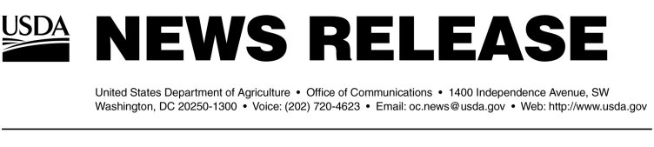
Release No. 0486.04
Julie Quick (202) 720-4623
Tim McNeilly (202) 690-0498

USDA LOAN GUARANTEE TO HELP OHIO SAWMILL EXPAND OPERATIONS, ADD JOBS

NELSONVILLE, Ohio, Nov. 1, 2004 -- Agriculture Secretary Ann M. Veneman today announced that a $1.7 million loan guarantee has been issued to Waldron Lumber Co. in McArthur, Ohio. The family-owned company, which is celebrating its 50th year in business, is an important source of jobs in Vinton County.

"The Bush administration is committed to assisting small businesses in rural America," Veneman said during a visit here to make the announcement. "This financing will help keep Waldron Lumber Company doing what it has done for half a century: providing quality, band-saw lumber to meet the nation's growing need for hardwood lumber."

The financing, offered under USDA Rural Development's Business and Industry (B&I) Guaranteed Loan program, will help save 36 existing jobs and allow the hardwood sawmill to add an additional 14 jobs over the next several years.

Waldron Lumber concentrates on production of hardwood veneers used for furniture, cabinetry and hardwood floors. It is owned and managed by the founder's daughter, Dana Eberts and her husband Mike, who have been running the business since 1989.

The loan will be used to refinance existing debt to improve the plant's cash flow and to add a second shift to meet increased demand for hardwoods. It will also help finance the purchase of new equipment for expanded operations.

The 12-year loan was issued by the Oak Hill Bank of Jackson, Ohio, with USDA Rural Development guaranteeing 80 percent of the total. For more information on the B&I program, visit: www.rurdev.usda.gov, or call (202) 720-4323.

#

