USDA Foreign Agricultural Service
GAIN Report

Global Agriculture Information Network
Template Version 2.09

Required Report - public distribution
Date: 6/24/2005
GAIN Report Number: DR5009
DR5009
Dominican Republic
Solid Wood Products
Caribbean Regional Report
2005

Approved by:
David Salmon, Ag Counselor; Paul Hoffman CBATO
U.S. Embassy, Santo Domingo
Prepared by:
Carlos Suarez, Sylburn Thomas and Joanna Apergis

Report Highlights:
This report is the first Foreign Agricultural Service effort to provide an overview of the market situation for U.S. wood products in the Caribbean. It will be updated on an annual basis.

Includes PSD Changes: No
Includes Trade Matrix: Yes
Annual Report
Santo Domingo [DR1]
[DR]

Executive Summary

Hurricane reconstruction is, of course, one of the chief factors driving demand for forest products in the Caribbean region. While recent data on overall demand is not available, it can only be assumed that, given the unusually high hurricane activity recorded in 2004 and predictions of a similarly active season for 2005, demand for forest products in the region will continue its upward momentum. All this tropical activity is leading to increased demand for imported wood products, particularly softwood lumber, panel products, and other wood products. Preliminary U.S. trade data for 2005 (Jan-Apr) indicate that U.S. exports of soft/treated lumber and panel/plywood products to the region are up 48 percent and 77 percent, respectively, for The Bahamas and Lesser Antilles.

PRODUCTION

Forest Situation and Outlook

The Dominican Republic has one of the highest population densities in Latin America. Of a total population of 8.6 million people, roughly half live in rural areas with a per capita income of US$2,100. The rural poor continue to depend heavily on forests for fuel wood, used both as firewood and charcoal. In addition, subsistence agriculture creates additional pressure to the Dominican Republic’s limited and decreasing forest resources.

Starting in the late 1800s, Dominican Republic’s forest resources were threatened mainly by land clearing for sugar production and other agricultural uses, commercial timber harvesting, and the collection of wood for fuel. Beginning in the 1960s, as supplies dwindled, the country became a net importer of wood. In an effort to preserve its remaining forests, the government banned the harvest of all forest products, however, enforcement of this ban is less than perfect. Today, the remaining forests tend to be found in small patches, with very few large expanses remaining beyond those in remote areas and/or under the protection of national parks.

In The Bahamas and Lesser Antilles¹ countries are focused on the tourism sector (some countries also depend on off-shore banking and oil/natural gas operations). Consequently, forestry is not a priority on these islands of limited land mass. Locally, only small sources of solid wood are found in Trinidad and Tobago, mainly in the form of teak production. Nevertheless, Trinidad and Tobago largely relies on imported wood products and supplies other Caribbean islands with minimal import of solid wood. Trinidad has some wood treating plants, which is uncommon among the smaller Caribbean islands.

Despite having an estimated 336,000 hectares classified as broadleaf forestry (248,000 disturbed and 88,000 undisturbed), there is only negligible commercial production and harvest of forestry products in Jamaica. The low forestry production is attributed to a general lack of private interest in commercial forestry activities and the inaccessibility of the forestry reserves. Further, Jamaica’s generally unmanaged forests are composed of mostly low yield and low demand species. However, as part of a national sustainable forestry development plan, the Forestry Department and the National Forestry Conservancy have, in recent years, been encouraging private investments and international donations in the establishment of forests, mainly teak, mahogany and Caribbean cedar. It is estimated that within another seven years, approximately 5,000 hectares of commercial forests will be added to the national reserve. Output of commercial forestry products is expected in the domestic market about 2012.

Although there are small pockets of forest degradation, Jamaica’s forestry reserve is in general sustainable at a “harvest” rate of only 0.1 percent per year. Unlike other Caribbean territories, where charcoal production accounts for a substantial proportion of deforestation, in Jamaica bauxite mining is the main contributor. National policies, however, make adequate legal provisions for the resuscitation of lands that are mined for bauxite production.

__________________
¹ The Office of Agricultural Affairs in Santo Domingo, Dominican Republic, has responsibility for the Dominican Republic, Haiti, and Jamaica. The Caribbean Basin Agricultural Trade Office based in Miami, Florida, covers Anguilla, Antigua & Barbuda, Aruba, The Bahamas, Barbados, Bermuda, British Virgin Islands, Cayman Islands, Dominica, Guadeloupe & Martinique, Grenada, Montserrat, Netherlands Antilles, St. Barthélemy, St. Kitts & Nevis, St. Lucia, St. Martin, St. Vincent & The Grenadines, Trinidad & Tobago, and Turks & Caicos.

Solid Wood Products Situation/Outlook

Dominican Republic

Limited forest resources and the ban on logging have made the Dominican Republic an important importer of wood products. The annual import value of softwood lumber into the Dominican Republic has varied widely in recent years, mostly due to reconstruction efforts after major disasters, such as hurricane Georges in late 1998. The year after the hurricane, 1999, was an all-time high in forest product imports, including plywood. After the initial surge in reconstruction, imports gradually leveled off and reached a low in 2004. The country’s current economic recovery, along with new resort construction, has created additional demand for wood product infrastructure. This trend is continuing in 2005, with the country’s overall wood product imports in the first quarter showing a ten percent increase over the same period last year.

Construction projects, which use mainly softwood and plywood, occupy an important role in Dominican economy. Although interest rates are high (18-20 percent per year), sixty percent of the construction is privately financed, while the rest are built as government projects. In the actual building though, the vast majority of urban construction is cement based, while wood is used extensively in roof base (joists for tin sheet roofing), doors, windows, and kitchen and bathroom cabinets and furniture making. The use of hardwoods other than mahogany is not significant. Although there is great potential in using less expensive hardwoods, very little has been done to explore and expand this market.

The Bahamas and Lesser Antilles

The import value of solid wood products into The Bahamas and the islands in the Lesser Antilles also varies widely from country to country. In these small economies, various factors contribute to the huge variations in annual imports. Large housing developments and resort construction explain some of the variation. However, the principal factor is the reconstruction efforts that take place after a major hurricane has passed through an island. In addition, re-exports from U.S. suppliers of some Honduran and Brazilian softwood products also create some bias in export statistics.

Large development projects in the region, including resorts, hotels, and condominiums, have boomed in recent years. Although development on some islands has leveled off, the islands of Turks and Caicos are an example of a housing and lodging industry that is gaining momentum. Refurbishment and reconstruction of these buildings also affects the long-term market for softwood and solid wood products. Another recent example of the destruction of a hurricane causing a spike in solid wood product imports was in September of 2004, with hurricane Ivan. In the first quarter of 2005, the import of solid wood to Grenada increased by 99 percent over the same quarter in 2004. The same hurricane also devastated areas of Grand Cayman, which saw a 166 percent increase for plywood products from the same three-month period in 2005.

Plywood demand is also directly related to the hurricane season, extending from June through November. Island importers usually stock up in anticipation of the crowds of island residents that inevitably turn up to purchase plywood used to board their windows just before a storm is forecast to pass through. Larger solid wood importers are purchasing mainly from solid wood consolidators in South Florida. The United States, particularly Florida, is preferred by these importers, since it is closer to many other Caribbean islands, which makes importing U.S. wood products simpler and less expensive.

The Bahamas are an important Caribbean import market for solid wood products, with total imports from the United States exceeding US$40 million in calendar (CY) 2004. The combination of a stable economy, stable supply and quality of U.S. products, the close proximity to the United States and ongoing resort development are the reason behind the success of U.S. softwood and other wood products. As a result, the Bahamas currently imports practically all of its softwood lumber and plywood from the United States.

While proximity and price does play a role in the preference of solid wood importers, Caribbean countries further south, such as St. Lucia, are still importing about 50 percent of their softwood lumber and 75 percent of their softwood plywood from the United States. Competing products from Honduras and Brazil have entered the market, but the reliability and high-quality reputation of U.S. products, especially Southern Yellow Pine (SYP), are keeping these markets accessible.

Jamaica

Jamaica’s construction sector experienced a major boom primarily in new building construction during the early to mid-1990’s. The plummet in construction during 1996 and the subsequent sustained contraction is attributed to the collapse of the Jamaican financial sector in the mid 1990’s and the resultant high interest rate environment, which depressed real estate prices. Corresponding with the upturn in the Jamaican economy, the construction sector recorded positive growth over the last four years and is expected to continue along that trajectory as economic conditions, including falling interest rates and increased foreign direct investments, continue to fuel increasing demand for commercial and residential buildings.

Backed by a relatively high net international reserve and stable exchange rate, the central bank has been gradually reducing interest rates over the last two years. This, in turn, has sparked increasing investor interest in the real estate market, particularly in the residential housing segment. Financial institutions, which have grown accustomed to the high interest rate environment of the 1990’s, have been aggressively marketing their loan and mortgage products to retail customer to offset the declining interest profits. This availability of capital helps to support the renewed buoyancy of the real estate market.

A significant proportion of the increasing foreign direct investment inflows into Jamaica are channeled into the expansion of bauxite plants and hotel and resort construction. Additionally, government projects, including air and sea port expansion, highways and other civil construction projects have also contributed to the growth in the construction sector.
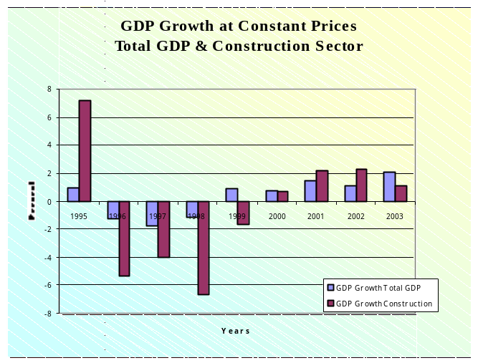

There are several well-organized programs that are operated by government agencies with the aim of providing and or supporting the development of affordable housing solutions to, primarily, the large middle and lower income segments of the population. The National Housing Trust (NHT), the National Housing Development Corporation (NHDC), the Jamaica Mortgage Bank (JMB), and the Ministry of Water and Housing (through joint venture arrangements) are the major public agencies involved in residential housing construction. In addition to construction, the NHT operates a mortgage facility (US$16,000/person) to qualified contributors for private purchase or individual construction. There are several building societies, commercial banks and credit unions that extend mortgage facilities independently, and in collaboration with the NHT. The JMB focuses on commercial customers, offering financing to developers for projects with ten or more housing units. Despite the availability of financing, a sizeable proportion of the population, typically with unstable employment, does not have access to mortgages and relies on remittances and state aid to finance building construction.

TRADE

Overview/Outlook

Dominican Republic

A large part of the forest product imports by the Dominican Republic (DR) originate in the United States. Total market size is about US$50 million and the United States holds a 65 percent market share. Dominican imports of forest products from the United States were estimated at US$32.5 million in CY 2004. By the first quarter of CY 2005, the DR ranked 24th in the world among importer of U.S. forest products. It is the fourth-largest export market in the Western Hemisphere after Canada, Mexico and the Bahamas. With US$23.5 million in purchases in 2004, the Dominican Republic was the third largest market for U. S. softwood and treated lumber in the world. It has a softer position as a panel product importer, with heavy competition from South America, but still imports US$2 million of these products.

Reliable data are not available, but major importers indicate that the wood market in the Dominican Republic is divided into 20 percent hardwood (mostly Mahogany and Cedar from Central and South America), 14 percent panel products (plywood), and 66 percent, softwood lumber (pine). The softwood market continues to be dominated by the U.S. products, with little competition from South and Central America (12 percent market share). U.S. panel products hold 25 percent of the Dominican market valued at US$ 2 million, with strong competition with less expensive South American (45%) and Asian (25%) products.

There are no restrictions on wood imports in the Dominican Republic. All woods (softwood, hardwood and plywood) have a basic tariff of 3 percent on CIF Value. Additional taxes include a 16 percent value-added tax (ITBIS) and a 5 percent foreign exchange fee on the CIF value.

The furniture industry in the Dominican Republic is not well developed or integrated. There are only a few organized furniture manufacture companies, such as COMUDID, S.A. (Constructora de Muebles, Diseños y Decoraciones), Decoraciones y Muebles, C x A, HECO Muebles and VON C x A.

Having very limited resources of natural forest devoted to wood production, most of the countries in the Caribbean region have no import restrictions on wood products, except for individual country phytosanitary concerns. Import taxes also vary from country to country anywhere between 3-40 percent.

Competition

The softwood market in the Dominican Republic continues to be dominated by the U.S. products with little competition from Chile, Brazil and Central America (12%). U.S. panel products hold only 25 percent of the Dominican market valued at US$2 million, with strong competition with less expensive Brazilian (20%), Chinese (40%) and Taiwanese (25%) products. The US$12 million hardwood market is evenly divided between Mahogany and Cedar coming from Brazil and Peru.

The Bahamas and Lesser Antilles

Hurricane reconstruction is, of course, one of the chief factors driving demand for forest products in the Caribbean region. While recent data on overall demand is not available, it can only be assumed that given the unusually high hurricane activity recorded in 2004 and predictions of a similarly active season for 2005, demand for forest products in the region will continue its upward momentum. The 2004 Atlantic hurricane season was the most active since 1950 and was in fact the deadliest and costliest in history, registering over 3,000 deaths (mostly in Haiti) and $42 billion in damages. The season produced an above average 16 tropical depressions, 15 named storms, and 6 major hurricanes (Category 3 or higher). Particularly destructive were hurricanes Charley, Frances, Ivan, and Jeanne, all of which took place in a two-month period. Ivan, which pummeled Grenada and the Cayman Islands, was the sixth strongest hurricane on record. Frances and Jeanne were also particularly hard on the Bahamas, as well.

All this tropical activity is leading to increased demand for imported wood products, particularly softwood lumber, panel products, and other wood products. The Caribbean islands are in fact the sixth largest regional export market for U.S. forest products, and the region actually ranks second in terms of U.S. exports of softwood lumber and fourth in terms of U.S. exports of panel products. In 2004 U.S. soft/treated lumber exports to the Caribbean increased by 27 percent reaching US$77 million, reversing a downward trend in U.S. exports to the region prevalent since the late 1990’s. Similarly, U.S. exports of panel/plywood products to the region reached US$39.7 million in 2004, a gain of 65 percent compared to 2003. Preliminary U.S. trade data for 2005 (Jan-Apr) indicate that U.S. exports of soft/treated lumber and panel/plywood products to the region are up 48 percent and 77 percent, respectively.

Jamaica
Total imports of plywood and veneer, softwoods and hardwoods into Jamaica recorded sizeable growth during 2003. The growth was influenced by a sharp increase in imports of plywood and veneer (sheet plywood < 6mm thickness. SITC 6343900000) from Brazil. The U.S. share of imports of plywood and softwood into Jamaica has declined over the last three years. However, the U.S. is a dominant player in the much smaller hardwood segment of the market. Honduras has increased its share of the softwoods market, while Brazil has displaced Indonesia as the dominant exported of plywood and veneer, including sheet plywood, to Jamaica.

MARKET SEGMENT ANALYSIS

For almost all Caribbean islands, the imported softwood lumber of choice is Southern Yellow Pine (SYP). In terms of volume, the Dominican Republic is the fourth largest importer in the world of U.S. SYP, with imports exceeding US$23 million in 2004. The Bahamas, holding the eight position, is one of the only countries in the Caribbean Basin that imports more Lodgepole Pine than SYP. Jamaica was twelfth with imports of US$7 million. The Dominican Republic imported softwood and treated lumber valued over US$23 millions last year. The Bahamas with almost US$12 million, Jamaica with US$9.3 million, Barbados with almost US$6 million are also important, while Bermuda also imports steady quantities of Lodgepole Pine, but SYP still leads the softwood lumber market in the top 25 markets.

Construction Sector

The Caribbean construction sector’s main use for SYP plywood in construction is formwork for casting concrete. SYP lumber is used in building roof structures and some smaller “temporary” housing in rural areas. Treated lumber is imported in most of the islands, but not as much in the Dominican Republic and Trinidad. According to industry sources, about 65 percent of the softwood and treated lumber is used in the construction of new facilities, particularly in the larger countries. There is also extensive use of SYP in less expensive interior sectors of housing constructions. The Dominican Republic and Trinidad have some of the few pressure treating facilities in the Caribbean.

Large-scale developers are more likely to have a distinct preference for SYP than other solid wood products, based on their quality. A good indicator of current and future major development plans is the Caribbean Hotel Association’s construction report. (Membership is required in order to access this report. Go to www.caribbeanhotels.org for more information.)

Retail outlets are often smaller versions of U.S. retailers like Home Depot but small hardware stores are popular in the Dominican Republic, Jamaica and some of the other major Caribbean Basin countries. However, since these stores mainly cater to individual homeowners and small businesses, they tend to carry more price competitive wood products, mainly Chilean, Honduran and Brazilian softwoods.

Some Caribbean construction companies attend annual trade shows in the Dominican Republic, Nassau, Bahamas and the United States (including CONEXPO in Las Vegas, Nevada and MIACON in Miami, Florida). Architects in the Caribbean Basin region are often members of a network called Periferia. This group is very active in holding meetings and participating in projects about architectural topics. Another source of indirect information on the market is the ASONAHORES (Dominican Association of Hotels and Restaurants), which represents 70 percent of the hotels with over 33,000 rooms in the Dominican Republic. An additional source is the Caribbean Hotel Association (CHA). The CHA compiles an updated database on current and future hotel and resort construction and refurbishment in the Caribbean. This is an important source since, as mentioned previously, larger contractors usually prefer U.S. products and SYP in their projects.

Furniture & Interior Sector

The softwood products used for furniture and cabinetry vary from 5 to 25 percent of the total imports from country to country or island to island. Some islands, such as the Dominican Republic, Jamaica or Trinidad and Tobago, have a larger base of manufacturers, whereas Barbados mainly imports manufactured, unassembled furniture. SYP products are also the softwood of choice in this interior manufacturing sector. About half of the hardwood imported by the Dominican Republic, such as Mahogany is imported from Brazil (40%) and Peru (60%), while the other half, cedar is all from Brazil. Hardwoods are used in furniture and interiors sector.

Material Handling Industry

Regulations to control the spread of pests in Solid Wood Packing Material (SWPM), such as crates and pallets, are not currently enforced, except for countries exporting to the United States. The association of foreign pests present in SWPM has become a worldwide problem that requires attention from the exporting nations, particularly now that international standards have been created to control these materials. These restrictions are making some of the larger exporting countries fumigate the SWPMs or consider alternative materials, such as plastic, for their export pallets.

Jamaica

Residential House Segment

There is a severe shortage of residential houses in Jamaica, particularly in the middle and lower income segments of the population. This is especially evident in the customary heavy over subscription of the modest NHT housing units, and the industry requirement of a pre-construction payment of up to 50 percent of the final price to secure properties. Several private contractors operate in the residential housing market, targeting the entire socioeconomic spectrum. Housing prices in the middle to lower end of the market are informed by the NHT’s mortgage policy. This gives rise to a proliferation of relatively smaller detached “starter” units, which are expanded and upgraded over time. The upper middle-income segment exhibits a preference for townhouses, while the upper quintile occupies detached units. The most recent government survey shows that 78.5 percent of dwelling types in Jamaica are detached units, followed by 15.5 percent being what is termed a "part of a house" and 3.5 percent being semi-detached.

Housing starts in Jamaica have rebounded during 2002, approaching the 1995 historic peak. The improvement was noticeably buoyed by heavy involvement in the market by the public sector entities. In fact, since the downturn in the sector in the mid-1990’s public sector entities have remained the major players in providing housing solutions in Jamaica. Majority of these housing would therefore be targeted at the mid to lower end of the market.
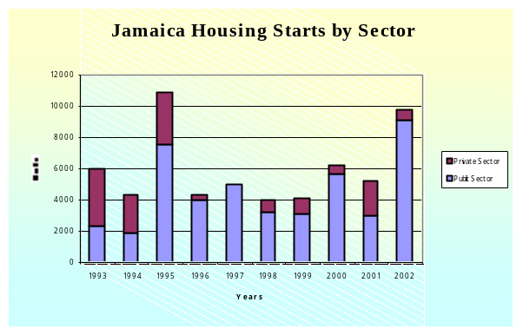
The positive economic outlook for Jamaica and the associated increase in business and consumer confidence has been slowly attracting financial and insurance institutions back to the real estate market, mainly to the lucrative residential housing segment. Housing starts, especially in the middle to higher end of the market, are projected to increase at an increasing rate over the medium term, eclipsing the 1995 peak by 2006/07.

With respect to construction materials, the overwhelming majority of residential houses in Jamaica are constructed with block and steel, followed by wood and concrete nog.
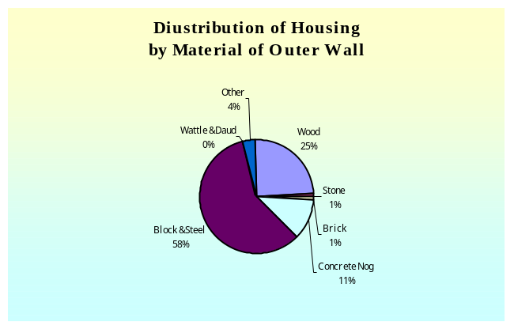

The choice of construction material in Jamaica is influenced by geological and psychological variables. The geographic location of Jamaica dictates the necessity to build with construction materials sufficiently durable to withstand repeated hurricanes and possibly flooding and earthquakes. In this regard, block and steel becomes the material of choice for outer wall construction. On the other hand, the prevalence of wooden dwelling structures among poorer parts of the population has created a negative view of the materials for outer wall construction of affordable dwellings. With increased emphasis on affordability and durability (hurricane and earthquake resistance) most lower and middle-income housing project are being constructed with prefabricated concrete walls. However, most of houses in Jamaica are constructed with wooden roof structures.

As expected, wooden structures account for a progressively lower proportion of residential houses across the social groups from the poorest to the wealthiest segments. However, within all segments there is a fair proportion of wooden structures, and consequently demand for wood products. While the proportion of wooden structures in the upper two quintiles is relatively small, they are the heaviest users of wood products in interior and exterior design (roofs, floors, windows, doors, rails, and decks) in residential construction and an important market for such products. Conversely, lower income houses make greater use of treated softwoods and plywood for the construction of outer walls and roofs. Since the majority of houses in Jamaica are constructed with wooden roofs, doors, and windows, the demand for wood products will grow proportionately with the residential construction sub-sector. Further, wood is used as a versatile interior and exterior decoration and design material in Jamaica.
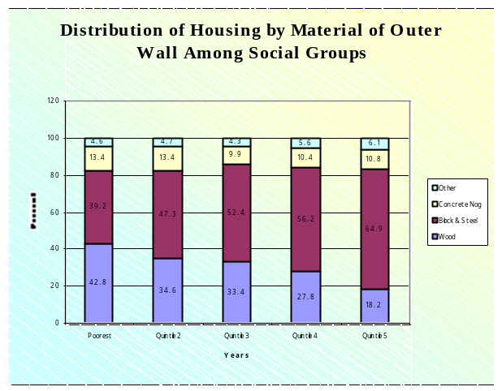

Hotel Construction

Within the hotel construction segment, hardwood products are used extensively in interior design and decorating. Softwoods (plywood and form wood) are used during the building construction process. The rapid expansion in the Jamaican hotel sector and the continued renovation of existing properties will create a respectable demand for both hardwood and softwood products over the short to medium term. Major hotel projects that are being undertaken or will be undertaken in the short-term that will increase Jamaica’s lumber wood products demand include:

- A 450-room RIU hotel,
- three 600-room and two 850-room hotels by Spanish investors,
- and a luxury shopping village and a government-backed luxury resort village on 1,400 acres of land, which is conceptualized to include four five-star hotels, three golf courses, 200 upscale villas and apartments, a marina and a private airport.

Government Infrastructure Development

The Government of Jamaica (GOJ) has been actively supporting a wide variety of projects in the construction sector. Generally these projects consume a reasonable volume of softwood and plywood products. The major GOJ projects that are currently been undertaken, or are advanced in conceptualization, include:
- A major highway linking Kingston (southeast) with Montego Bay (northwest) and St. Catherine (southeast) with Ocho Rios (north central).
- Development of a two major seaports in Eastern (port Antonio) and Western (Lucea) Jamaica.
- The privatization of operations at the Montego Bay Airport, which involves extensive renovation and expansion.
- A major residential high-income community in central Jamaica.
- An air transshipment port in south-central Jamaica.
- A new stadium in North Central Jamaica and the renovation and expansion of another stadium in Kingston in preparation for the 2007 world cup cricket.

STATISTICAL INFORMATION

U.S. Softwood Lumber Exports to the Caribbean in 2004

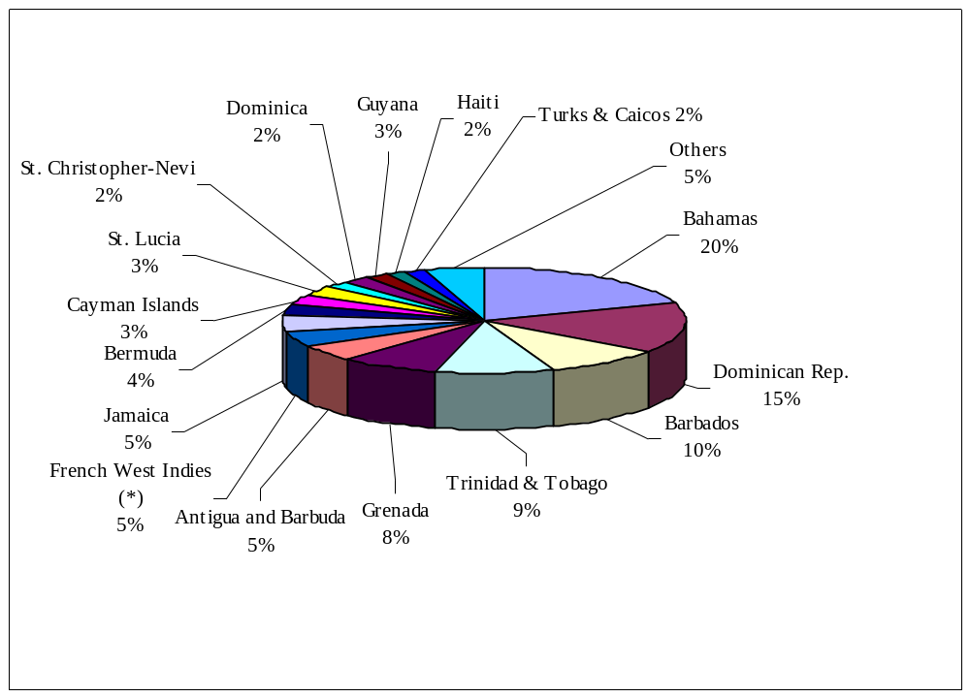Percent

Source: Department of Commerce, U.S. Census Bureau, Foreign Trade Statistics.

TRADE TABLES: Softwood Lumber
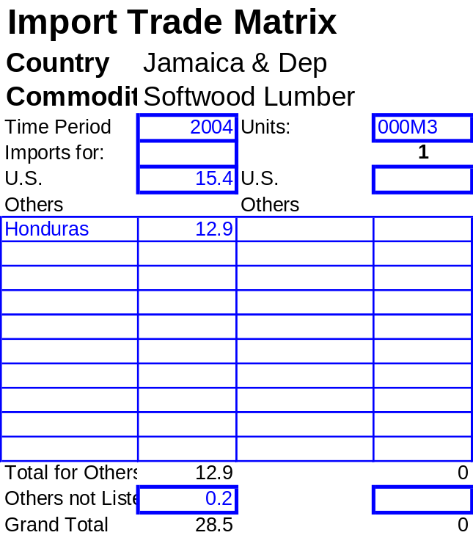Source: U.S. Census Bureau, Foreign Trade Statistics, and Post and industry estimates.
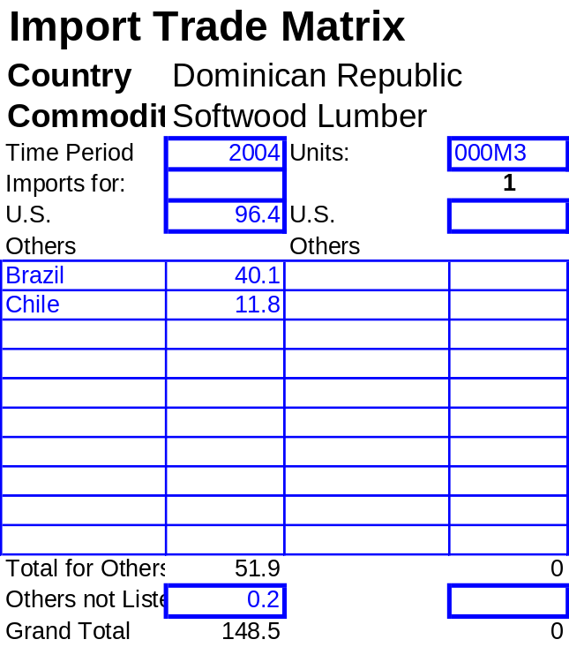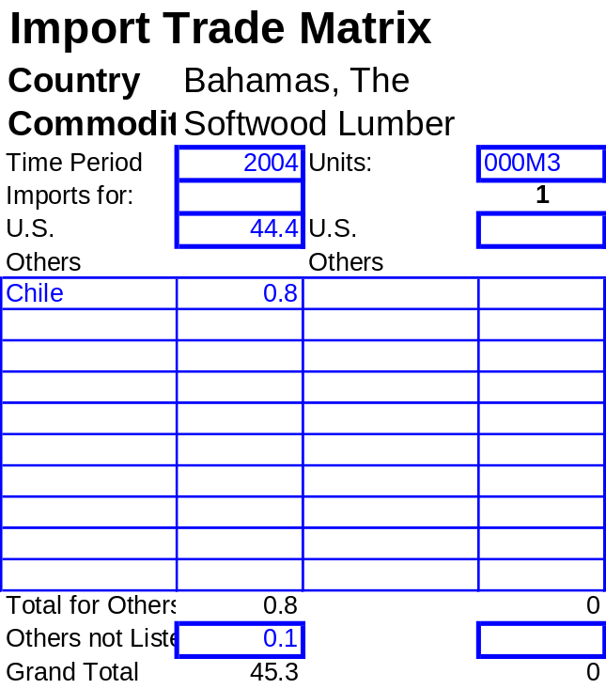

TRADE TABLES: Softwood Plywood
Source: U.S. Census Bureau, Foreign Trade Statistics, and Post and industry estimates.
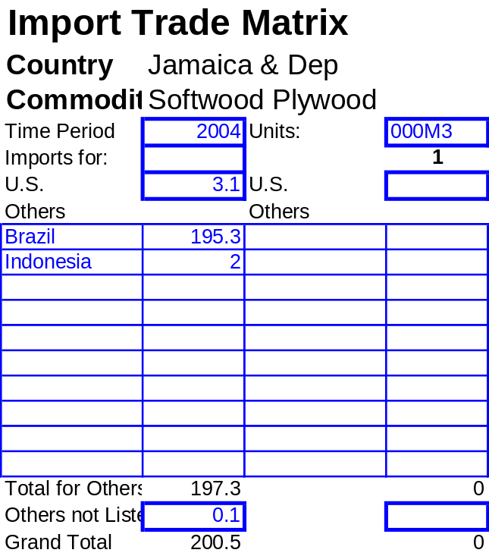
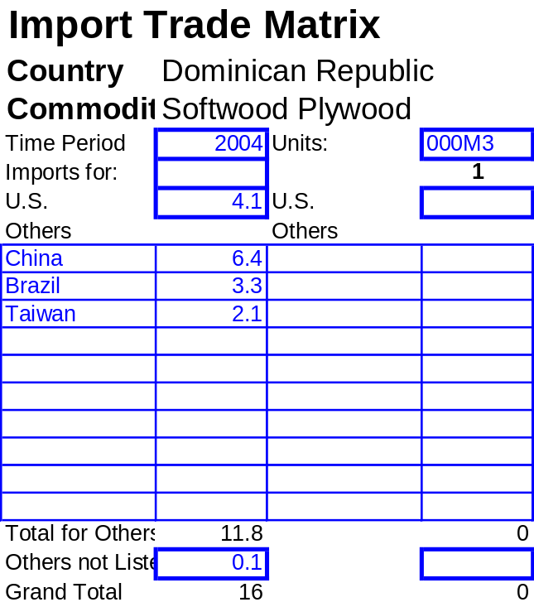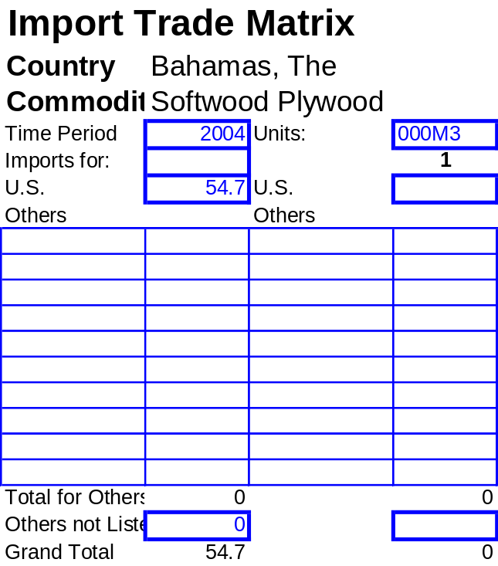

TRADE TABLES: Tropical Hardwood Lumber
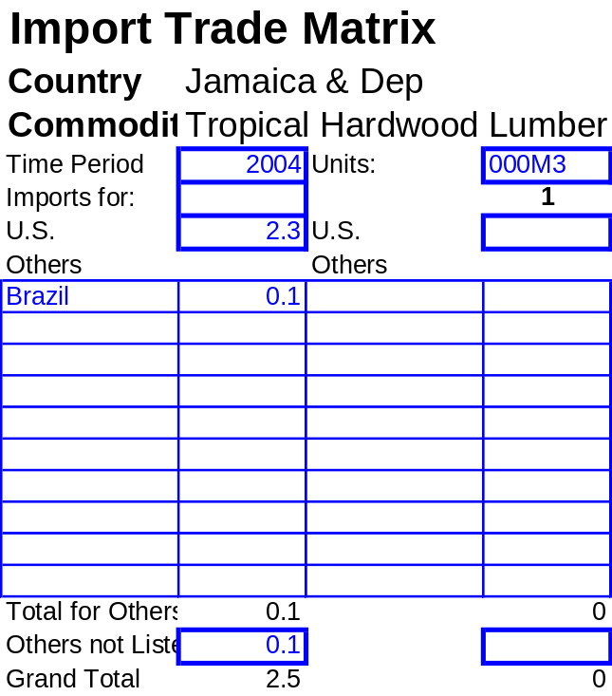Source: U.S. Census Bureau, Foreign Trade Statistics, and Post and industry estimates.
