U. S. Department of Education
Office of Postsecondary Education

Washington D. C. 20006-8501


TITLE V: THE HISPANIC SERVING INSTITUTIONS PROGRAM (84.031S)

PROJECT ABSTRACTS FOR FY 2003 NEW GRANTEES


TABLE OF CONTENTS
INTRODUCTION

NEW DEVELOPMENT GRANTS

ARIZONA

Arizona Western College

CALIFORNIA

California State University, Bakersfield
Cypress College
Mt. San Jacinto College
Porterville College
Riverside Community College District, Moreno
Riverside Community College District, Norco
Riverside Community College District, Riverside

COLORADO

Pueblo Community College

PUERTO RICO

Caribbean University, Ponce Branch Campus
Inter American University, Guayama Campus
Universidad Central del Caribe
University of Puerto Rico at Carolina

TEXAS

University of Texas Pan American
Victoria College

NEW COOPERATIVE ARRANGEMENT GRANTS

ARIZONA

Arizona Western College
Cochise College

CALIFORNIA

California State University, Bakersfield
California State University, Stanislaus
Rio Hondo College
Santa Ana College

NEW MEXICO

Eastern New Mexico University

PUERTO RICO

Pontifical Catholic University of Puerto Rico
University of Puerto Rico, Cayey
University of Puerto Rico, Rio Piedras

TEXAS

Houston Community College
Our Lady of the Lake University
University of Texas at El Paso
University of Texas at San Antonio

CROSS REFERENCES – WHO’S DOING WHAT NETWORK LIST

INTRODUCTION

The Developing Hispanic-Serving Institutions (HSI) program was introduced under Title V of the Higher Education Act, as amended, in 1998. This program was created to address the growing need for federal assistance to eligible HSIs to expand their capacity to serve Hispanic and low-income students. The goal of the HSI program is to expand educational opportunities for and improve the academic attainment of Hispanic students; and to expand and enhance the academic offerings, program quality, and institutional stability of low-income students attending Hispanic-serving colleges to enable them to complete postsecondary education.

Since FY 1999, the appropriation has increased dramatically from $28 million to $86 million in FY 2002. Of the amount awarded in FY 2003, $6,370,990 was awarded to 15 new Development grants and $8,205,917 for 14 new Cooperative Arrangement grants for a total of $14,576,907 for new HSIs. Approximately $70 million was reserved to support 157 continuation HSI awards. The HSI program has two types of grants:

- Development grant is a five-year grant award to assist an HSI carry out its comprehensive development plan to strengthen the institution’s program to improve and expand its capacity to serve Hispanic students and other low-income students.

- Cooperative Arrangements is a five-year grant award to encourage cooperative arrangements between an eligible HSI and other institutions in a combined effort to serve Hispanic students and other low-income students and to enhance the development of HSIs.

Funds for the HSI program may be used for activities such as the renovation of instructional facilities, faculty development, the purchase of scientific or laboratory equipment for educational purposes, funds for administrative management, development and improvement of academic programs, acquisition of equipment to strengthen funds management and academic program, joint use of facilities, academic tutoring, counseling programs, and support services.

The HSI program is the only discretionary grant program under the U. S. Department of Education’s Office of Postsecondary Education that provides federal funds to strengthen institutions that serve Hispanic students and other low-income students. More information about the HSI program is available on the Department’s web-site www.ed.gov/hsi.

NOTE: The data provided for the “Total Student FTE” and the “Total Percent Hispanic FTE” is based on the ED Form 851S-7 submitted with the new FY 2003 HSI grant award application.

Figure 1
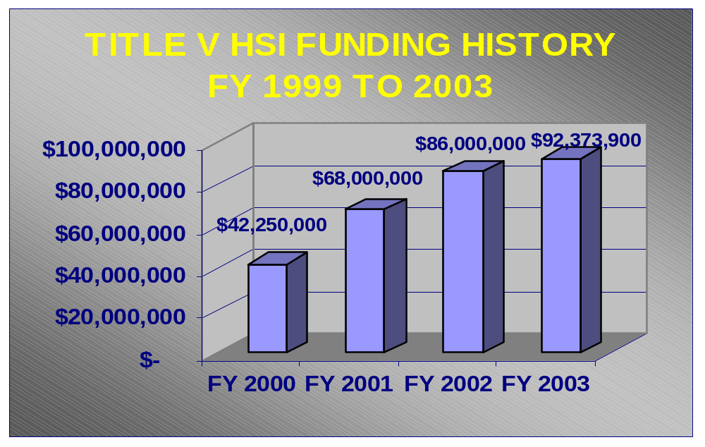

Figure 2
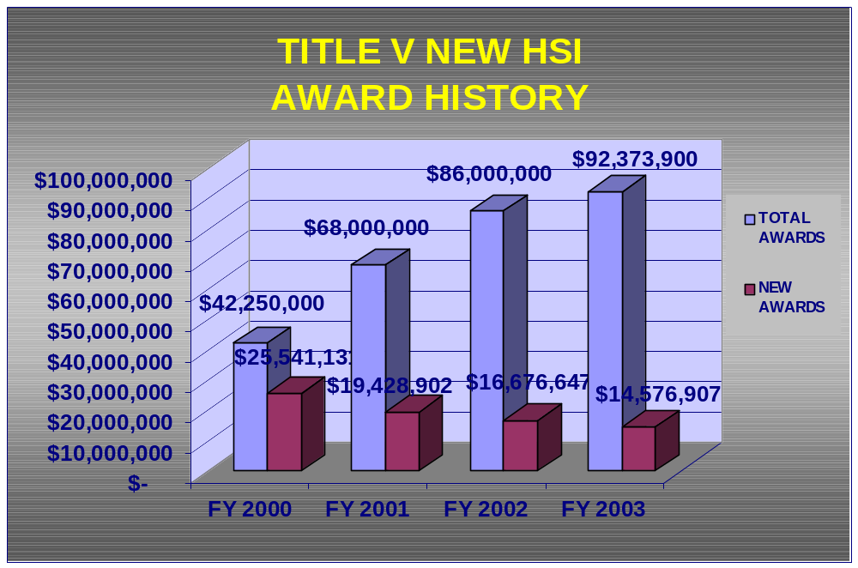

Figure 3

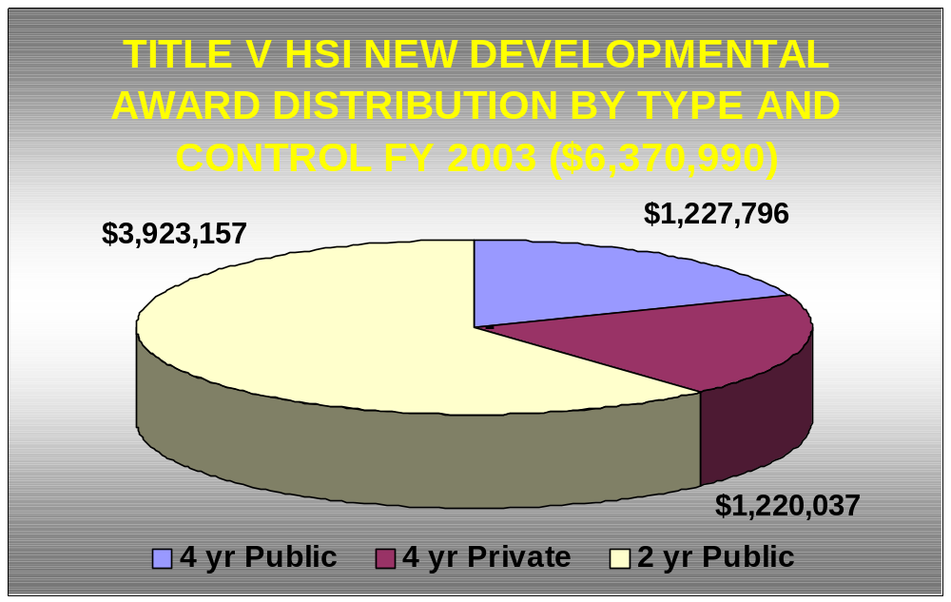

Figure 4

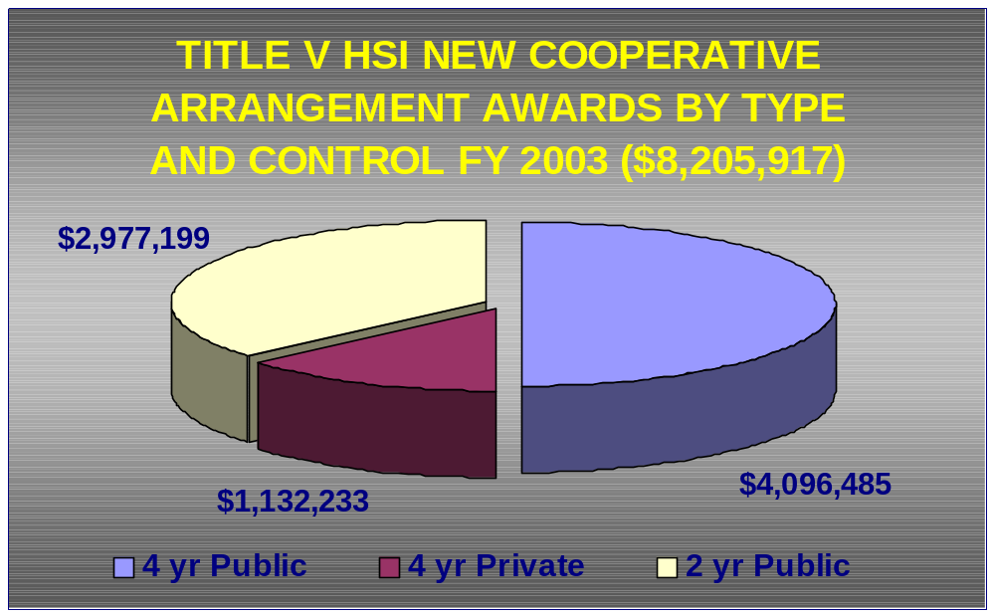
Figure 5

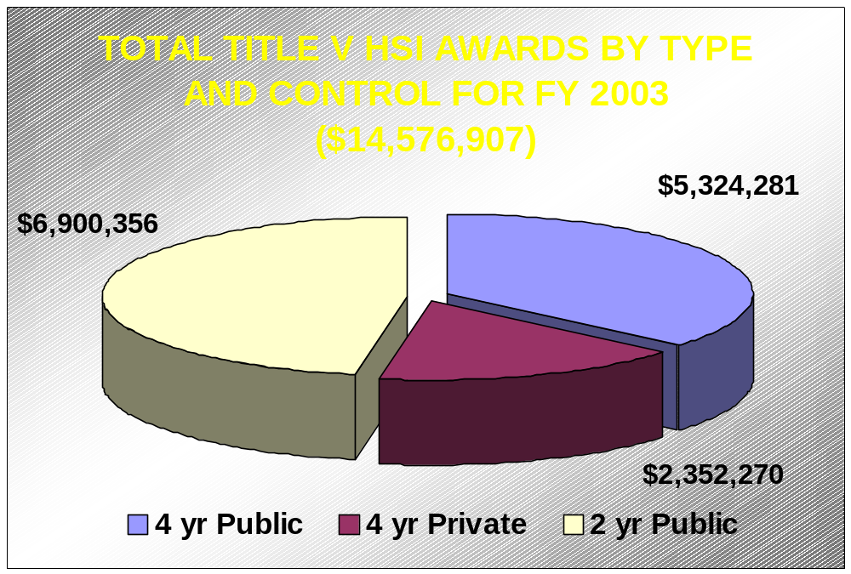

ABSTRACTS

ARIZONA

Arizona Western College
P.O. Box 929
Yuma, AZ 85366
Type/Control:2-year/Public
Project Director: Barbara Hanson
Phone: (928) 344-7519
Fax: (928) 344-7730
Email: Barbara.Hanson@azwestern.edu
Award Amount: $423,000
Total Student FTE: 3,596
Percent Hispanic Student FTE: 59%

Activity Description:

EXITO: Excellence Through Xcelerated Involvement, Teaching, and Organization – The purpose of this activity is to address the risk factors associated with high attrition and low completion at AWC by developing a learning model based on highly successful program with proven results. This model will combine intensive classroom time with competency-based curricula, distance strategies, and collaborative learning to concentrate the instructional time to completion. Faculty/staff development will also be implemented to improve instructional, support service, and cultural climate of the predominately Hispanic and low-income student population.

CALIFORNIA

California State University, Bakersfield
9001 Stockdale Highway
Bakersfield, CA 93311
Type/Control: 2-year/Public
Project Director: Janice Chavez
Phone: (661) 664-2231
Fax: (661) 664-3342
Email: jchavez@csub.edu
Award Amount: $448,693
Total Student FTE: 5,296
Percent Hispanic Student FTE: 32%

Activity Description:

Increasing the Persistence, Retention and Success of Hispanic and Other Low-Income Students for Baccalaureate Degree Completion – This activity consist of four components:

- One-stop Academic Success & Integrated Services (OASIS) – Designed to provide access to Hispanic and other low-income students in support services which include academic advisement, individualized assessment, tutoring, career development, faculty mentoring and technology.

- Enhancing Faculty Development Through Diversity Training – In collaboration with OASIS and the CSBU Teaching and Learning Center, will train faculty advisors and instructors to more effectively work with Hispanic and low-income students.

- Expanding Multicultural Library Resources and Internship Opportunities – Designed to strengthen CSUB’s library resource sin Hispanic, ethnic minority, and multicultural perspectives by providing texts and designating HSI grant funds towards an endowment for Hispanic and low-income librarians, internships, and Library Information Science .

- Gaining Technology and Information Resources Competency – Will provide Hispanic and low-income students with skills in computer and information resources literacy.

Cypress College
9200 Valley View Street
Cypress, CA 90630
Type/Control: 2-year/Public
Phone: (714) 484-7231
Fax: (714) 527-1044
Email: sdonley@cypresscollege.edu
Award Amount: $450,000
Total Student FTE:
Percent Hispanic Student FTE: 7,316
Percent Hispanic Student FTE: 26.1

Activity Description:

Closing Institutional Gaps to Enhance Instructional and Academic Support Programs, and Improve Hispanic Student Retention, Persistence, and Success – This activity has three components:

- The first component will provide a “Freshman Experience” and a summer “College Readiness” program. Both of theses programs will provide Hispanic and low-income students with instruction in basic skills in math and English.

- The second component will develop and implement an Academic Center for Teaching Excellence and Student Success which will include a coordinated tutoring program.

- The third component will provide faculty and staff development through the development of a Teaching Effectiveness Center. This center will improve institutional capabilities to address the needs of culturally diverse and under-prepared students.

Mt. San Jacinto College
1499 N. State Street
San Jacinto, CA 92583
Type/Control: 2-Year/Public
Project Director: Dona Alpert
Phone: (909) 487-6752
Fax: (909) 654-5191
Email: dalpert@msjc.edu
Award Amount: $447,819
Total Student FTE: 6,574
Percent Hispanic FTE: 29.6%

Activity Descriptions:

- Conduits for Students – This activity will implement a strategic faculty/curriculum development plan, establish a campus resource center, campus resource centers, and critical interventions for students including the creation of a case-management approach to student success.

- Conduit for Fiscal Stability – This activity is designed to strengthen the institution’s capacity to augment the state-funded budget by developing a Grants Office.

Porterville College
100 College Avenue
Porterville, CA 93257
Type/Control: 2-Year/Public
Project Director: Bill Andrews
Phone: (559) 791-2316
Email: (559) 782-8396
Award Amount: $443,752
Total Student FTE: 2,779
Percent Hispanic FTE: 39%

Activity Descriptions:

- Increasing Student Services – This activity has three components:

- Expanding Student Advising
- Math Lab (provide tutorial services in math)
- Assessing Student Outcomes

- Expand Vocational Programs – This activity has two components:

- Diesel Technology Program
- Distance Education Leading to Associated Degree

Riverside Community College District/Moreno Valley Campus
16130 Lasselle Street
Moreno Valley, CA 92551
Type/Control: 2-Year/Public
Project Director: Daria Burnett
Phone: (909) 571-6170
Email: Maureen.Chavez@rcc.edu
Award Amount: $436,095
Total Student FTE: 3,841
Percent Hispanic FTE: 34%

Activity Description:

An Integrated Approach to Instruction and Student Services and Learning Support Services – This activity is designed to develop alternative curriculum pathways for students and train faculty and staff to implement alternative teaching methodologies. This activity will also provide student support services which include career counseling, tutoring, special courses and workshops, and financial aid.

Riverside Community College District/Norco
2001 Third Street
Norco, CA 92860
Type/Control: 2-Year/Public
Project Director: Brenda Davis
Phone: (909) 372-7016
Fax: (909) 372-7090
Email: Brenda.davis@rccd.edu
Award Amount: $431,143
Total Student FTE: 4,721
Percent Hispanic FTE: 33%

Activity Description:

Improve Student Success of Low, High Risk and Hispanic Students – This activity is designed to provide an integrated approach involving instruction, student services, and learning support services. Through the development of alternative curriculum pathways and faculty and staff development training in alternative teaching methodologies student academic success will increase significantly.

Riverside Community College District/Riverside
4800 Magnolia Avenue
Riverside, CA 92506
Type/Control: 2-Year/Public
Project Director: Richard Keeler
Phone: (909) 222-8211
Fax: (909) 222-8055
Email: rkeeler@rccd.cc.ca.us
Award Amount: $429,749
Total Student FTE: 13,221
Percent Hispanic FTE: 30%

Activity Description:

Improving Student Success of Low-Income, High Risk and Hispanic Students – This activity is designed to provide an integrated approach to instruction, student services, and learning support services. Through identification and development of alternative teaching strategies and faculty/staff development training in alternative teaching methodologies, at-risk students will achieve academic success in basic skills needed for college level courses. Student support services will also include career counseling, tutoring, special courses and workshops, and financial aid.

COLORADO

Pueblo Community College
900 West Orman Avenue
Pueblo, CO 81004
Type/Control: 2-Year/Public
Project Director: Chip Nava
Phone: (719) 549-3430
Fax: (719) 549-3333
Email: Chip.Nava@pueblocc.edu
Award Amount: $411,775
Total Student FTE: 2,315
Percent Hispanic FTE: 36%

Activity Description:

Student Success Initiative – This activity has three components:

- Provides professional development designed to support faculty-driven efforts to increase retention to include teaching methodologies, theories and principals of learning, managing learning communities, increasing retention, meeting the learning needs of the special needs population, and integrating critical skills in the curriculum .

- Improve support services to individual students in each academic area of the college: incorporating educational advocates, a new advising model, tutoring and other learning supports.

- Increasing retention/academic success among specific groups of students via a learning communities initiative.

PUERTO RICO

Caribbean University Ponce Branch Campus
P. O. Box 7733
Ponce , PR 00732
Type/Control: 4-Year/Private
Project Director: Edgardo Rosaly
Phone: (787) 840-2955
Fax: (787) 840-3065
Email: dir.ponce@caribbean.edu
Award Amount: $424,600
Total Student FTE: 720
Percent Hispanic FTE: 100%

Activity Description:

Enhancement of Library Information, Technological Research and Educational Services – This activity is designed to increase access to technology, information science, and educational services not currently accessible to the majority of Hispanic students at the university-campus. It is anticipated that the newly acquired facilities will significantly impact the campus student, faculty, and administrative community.

Inter American University, Guayama Campus
Call Box 10004
Guayama, PR 00785
Type/Control: 4-Year/Private
Project Director: Daisy Irizarry
Phone: (787) 864-2222
Fax: (787) 864-8232
Email: dirzarry@inter.edu
Award Amount: $403,117
Total Student FTE: 1,597
Percent Hispanic FTE: 100%

Activity Description:

Improving Teaching and Learning Through Integration of Technology – This activity is designed to improve student learning outcomes by increasing the university’s instructional computing capacity, train faculty in the use of technology in instruction, increase student access to instructional technology and information literacy resources, and prepare students to succeed in certification tests.

Universidad del Caribe

P. O. Box 60327

Bayamon, PR 00960
Type/Control: 4-Year/Private
Project Director: Aristides Cruz
Phone: (787) 798-6732
Fax: (787) 740-4390
Email: acruz@uccaribe.edu
Award Amount: $392,320
Total Student FTE: 345
Percent Hispanic FTE: 100%

Activity Descriptions:

- To Help Improve Student Performance – This activity is designed to:
  - Create a culture assessment among faculty and staff
  - Develop English language modules and incorporate into health field and clinical skills context
  - Develop comprehensive exams as practice to assist students better prepare for standardized exams
  - Develop a comprehensive institutional assessment program geared towards institutional improvement and effectiveness
  - Provide intensive and extensive training activities and technical assistance to faculty and staff
  - Design, develop and offer Distance Education courses in Substance Abuse Counseling

- To Help Improve the University’s Fiscal Stability – This activity is designed to:
- Establish an Institutional Development Office that will coordinate all outreach and promotion efforts in the community
- Provide training to Board of Directors on their role in fundraising and building in the university’s image and develop an active alumni association
- Increase the number of fundraising activities sponsored by the Board and alumni
- Improve its publications and promotional materials and increase its web exposure

University of Puerto Rico at Carolina
P. O. Box 4800

Carolina, PR 00984
Type/Control: 4-Year/Private
Project Director: Maria del Pilar Toral
Phone: (787) 276-0226
Fax: (787) 750-7940
Award Amount: $445,140
Total Student FTE: 3,995
Percent Hispanic FTE: 100%

Activity Description:

Improving Academic Achievement and Development Skills Through the Establishment of the State of the Art University Comprehensive Center for the Enhancement of Student Success (SUCCESS) – This activity is designed to provide online developmental courses in English, Spanish, and mathematics to retain its at-risk students. Through this approach it is anticipated that persistence, retention, and graduation rates will increase. Renovation of existing laboratory facilities is a part of this activity.

TEXAS

University of Texas Pan American
1201 W. University Drive
Edinburg, TX 78541
Type/Control: 4-Year/Public
Project Director: Ann Maria Rodriguez
Phone: (956) 316-7919
Fax: (956) 292-7211
Email: amrodriguez@panam.edu
Award Amount: $333,963
Total Student FTE: 10,407
Percent Hispanic FTE: 87%

Activity Descriptions:

- Improve Student Retention and Time to Graduation Through Programmatic and Curricular Innovation – This activity will provide Freshman Success Seminars, Learning Communities, Academic Advisement, and Assessment of Entering Students. Key measures include improving first-year retention and reducing the time to graduation.

- Faculty and Staff Development – This activity will focus on instructional practices in the following areas: Learning Communities, Cooperative (Active) Learning, Academic Advisement, Critical Thinking, Learning Styles, Assessment, Writing Across the Curriculum, Technology Innovations and Web-based Instruction, and Curriculum Alignment K-16.

Victoria College
220 E. Red River

Victoria, TX 77901
Type/Control: 2-year/Public
Project Director: Jennifer Ortiz-Garza
Phone: (361) 582-2514
Fax: (361) 582-2525
Email: jgarza@victoriacollege.edu
Award Amount: $449,824
Total Student FTE:2,997
Percent Hispanic FTE: 28.9%

Activity Descriptions:

- Establishing a Center for Academic Achievement – This activity will establish a Center for Academic Achievement that will provide effective and coordinated academic support services through: a) Math and Learning Lab with Supplemental Instruction by Peer Mentors, b) Distance Education Opportunities, and
c) Interdisciplinary Learning Communities, and d) Faculty Effectiveness Program.

- Implementation of the Virtual College – This activity is designed to address the problems of unequal and inadequate access to student support services by developing online student support services via a virtual campus for online student services. Needed infrastructure will be purchased to allow online advising, admissions, registration, and career counseling.

NEW COOPERATIVE ARRANGMENT GRANTS

ARIZONA

Arizona Western College

P. O. Box 929

Yuma, AZ
Type/Control: 2-year/Public
Project Director: Tim Shove
Phone: (929) 928-344-7659
Fax: (929) 344-7751
Email: tim.shove@azwestern.edu
Award Amount: $621,599
Total Student FTE: 3,596
Percent Hispanic FTE: 59%

Activity Description:

Crossing the Educational Divide – Arizona Western College in partnership with Northern Arizona University/Yuma will address cooperatively through a shared system of delivery (1) improve access to degree programs for rural Hispanic and low-income students, (2 transform support services for these students, (3) strengthen faculty/staff development and distance learning services, and (4) strengthen the infrastructure for Distance learning. As a result of this activity it is anticipated that there will be an increase in enrollment, an increase in completion rates, and an increase in retention rates.

Cochise College
4190 West State Highway
Douglas, AZ 85635
Type/Control: 2-year/Public
Project Director: Doris Jensen
Phone: (520) 515-5491
Fax: (520) 515-5303
Email: jensend@cohise.edu
Award Amount: $600,125
Total Student FTE: 2,381
Percent Hispanic FTE: 30.9%

Description of Activity:

Improving Hispanic Students’ Attainment Through Collaboration – Cochise College in partnership with the University of Arizona (UA), South, will:

- Increase timely completion of AA/AS and transfer to UA, South by 30% over five years;
- Increase timely completion of BA/BS degrees by 40% over five years;
- Through magnet learning communities improve student readiness for transition to college and to transfer;
- Improve student persistence through comprehensive support: tutors, mentors, and internships; and
- Through faculty development strengthen faculty skills in curriculum development for Hispanic and low-income students in the magnet community.

CALIFORNIA

California State University, Bakersfield
9001 Stockdale Highway
Bakersfield, CA 93311
Type/Control: 4-year/Public
Project Director: Janice Chavez
Phone: (661) 664-2231
Fax: (661) 664-3342
Email: jchavez@csub.edu
Award Amount: $619,679
Total Student FTE: 5,225
Percent Hispanic FTE: 32.7%

Activity Description:

Cooperative Curriculum Alignment and Integration of Services and Systems to Improve Access to Higher Education for Hispanic and Other Low-income Students - California State University, Bakersfield (CSUB), in partnership with Bakersfield College (BC) will:

- Increase the number of transfer students through alignment of curriculum and systems at CSUB and BC;
- Expand faculty development by providing faculty development activities to address the needs of ESL and other culturally diverse students; and
- Expand ESL services.

California State University, Stanislaus
5151 Pacific Avenue
Stockton, CA 95207
Type/Control: 4-year/Public
Project Director: Marcella Rogers-Vieria
Phone: (209) 954-5543
Fax: (209) 954-5692
Email: mrogers.vieria@sjdccd.cc.ca.us
Award Amount: $600,00
Total Student FTE: 7,053
Percent Hispanic FTE: 25.2%

Description of Activities:

1. Increase Student Algebra Content Knowledge to Improve Student Performance in
Algebra and Selected Algebra Courses – California State University, Stanislaus, in
partnership with Merced College and Modesto College will increase course
retention, increase academic achievement, increase the completion rate of students
taking math remediation, and increase the academic achievement rate of first time
freshman students.

2. Reduce Inter-institutional Barriers that Inhibit Transfer – This activity will establish
a comprehensive database tracking system to evaluate the major goals of this project.

Rio Hondo College
3600 Workman Mill Road
Whittier, CA 90601
Type/Control: 2-Year/Public
Project Director: Judith Henderson
Phone: (562) 692-0921
Fax: (562) 562-7386
Email: jhenderson@rh.cc.ca.us
Award Amount: $586,592
Total Student FTE: 3,715
Percent Hispanic FTE: 69%

Activity Description: Teacher Education Program – Rio Hondo College in partnership with Whittier College will (1) develop a model articulation and admission agreement in order to provide more transfer opportunities to a four-year college, (2) increase retention and persistence rates by developing a structured series of lower division general education and teacher preparation classes, and providing “success teams” to assist students in achieving their goals, (3) increase retention, matriculation , and success between community colleges and four-year institutions through development of a “transfer shock” prevention plan, and (4) establish an endowment chair for teacher education.

Santa Ana College
1530 W. 17th Street
Santa Ana, CA 92706
Type/Control: 2-Year/Public
Project Director: Irene Malmgren
Phone: (714) 564-6078
Fax: (714) 564-6086
Email: malmgren.irene@rsccd.org
Award Amount: $644,239
Total Student FTE: 8,986
Percent Hispanic FTE: 50%

Description of Activity:

A Collaboration to Prepare Hispanic Students to Become Highly Qualified and Effective Teachers – Santa Ana College in partnership with Fullerton College and California State University, Fullerton, will develop Transfer Blended Teacher Education Program centers for future teachers at the partner institutions. Electronic tracking and educational planning tools will be developed to ensure successful intervention and retention strategies.

NEW MEXICO

Eastern New Mexico University
Station 2
Portales, NW 88130
Type/Control: 4-Year/Public
Project Director: Patrice Caldwell
Phone: (505) 562-2315
Fax: (505) 562-2244
Email: Patrice.Caldwell@enmu.edu
Award Amount: $563,805
Total Student FTE: 2,686
Percent Hispanic FTE: 29.6%

Description of Activities:

Eastern New Mexico University in partnership with Clovis Community College will address the following issues:

- Improving Completion and Transfer Success – This activity is designed to improve student success and retention to transfer and degree completion by expanding campuses’ ability to provide timely advising, academic support, and ease of transfer through coordinated curriculum, programs, and institutional practices.

- Enhancing Faculty/Staff Expertise – This activity is designed to enhance faculty awareness of issues of cultural fluency and distance learning technologies through professional development activities that will increase the success of Hispanic and low-income students.

- Effective Distance Education – This activity is designed to provide state-of-the-art video-conferencing for Hispanic and low-income students in rural and significantly under-served rural areas and to place support services to facilitate course delivery and two-campus faculty collaboration.

PUERTO RICO

Pontifical Catholic University of Puerto Rico
2250 Avenue Las Americas
Ponce, PR 00717
Type/Control: 4-Year/Private
Project Director: Mara Gautier
Phone: (787) 841-2000, ext. 1589/1590
Fax: (787) 651-0777
Email: mgautier@email.pucpr.edu
Award Amount: $562,553
Total Student FTE: 5,795
Percent Hispanic FTE: 100%

Description of Activity:

Pontifical Catholic University of Puerto Rico-Arecibo(PCUPR), Ponce, in partnership with PCUPR-Mayaguez, Inter-American University-Guyama, and Escuela de Artes Plastica will implement the following activity:

- Exploiting Technology to Provide Support for Students Relating to Core Curriculum and General Education – This activity has three sub-components and is designed to focus on technology to provide support for students as it relates to core curriculum and general education:

  - Develop an effective training program for faculty to utilize technology for teaching and related activities;
  - Develop and implement a curriculum and curricular support to improve retention;
  - Improve partnership technological infra-structure relating to those elements that support Internet use the first two sub-components.

University of Puerto Rico-Cayey
Antonio R. Barcelo Avenue
Cayey, PR 00736
Type/Control: 4-Year/Public
Project Director: Ram Lamba
Phone: (787) 738-2161
Fax: (787) 738-8510
Email: rlamba@cayey.upr.edu
Award Amount: $589,553
Total Student FTE: 4,796
Percent Hispanic FTE: 100%

Description of Activity:

University of Puerto Rico-Cayey in partnership with the University of Puerto Rico- Ponce, and the University of Puerto Rico-Bayamon will implement the following activity:

- Increasing Student Academic Achievement Through Curricular Revision, Integrated Academic Support Systems, and Faculty Development – This activity is designed to establish an Teacher Learning Center at each partner institution. Each center will provide professional development services to faculty and instructional staff and revise and implement twelve Language, Math and Science courses as leaning communities designed to develop and academic culture of achievement.

University of Puerto Rico-Rio Piedras
P. O. Box 23341
San Juan, PR 00931
Type/Control: 4-Year/Public
Project Director: Brad Weiner
Phone: (787) 765-5170
Fax: (787) 756-7717
Email: brad@adam.upr.pr
Award Amount: $562,995
Total Student FTE: 16,617
Percent Hispanic FTE: 100%

Description of Activity: University of Puerto Rico-Rio Piedras in partnership with University of Puerto Rico- Arecibo, and University of Puerto Rico-Humacao implement the following activity which has three sub-components:

- Improving Academic Outcomes for Science/Math Students Through a Technology-Based Consortium Program –

- Develop and implement a permanent training program for faculty to use technology for activities supporting math and science education;
- Develop and implement curricular support components to improve student retention and other student outcomes with emphasis on student-centered approaches to learning; and
- Improve the technological infrastructure of partner institution’s as related to the first two sub-components.

TEXAS

Houston Community College
HCCS-NW 1550 Fox Lake
Houston, TX 77084
Type/Control: 2-Year/Public
Project Director: Juan Carlos Reina
Phone: (713) 718-5841
Fax: (713) 718-5761
Email: Juan.Reina@hccs.edu
Award Amount: $524,644
Total Student FTE: 23,705
Percent Hispanic: FTE: 28.8%

Description of Activity: Houston Community College in partnership with the University of Houston-Downtown will implement the following activity:

- Faculty Leadership Program – This activity is designed to focus on the need to decrease remedial education for increasing numbers of low-income, first-generation minority students entering college, and to improve their retention, persistence, and transfer. This will be accomplished through a partnership Faculty Leadership Program which will combine professional development for public school teachers, counselors, and college faculty with shared follow-up and shared resources by Faculty Teams in key disciplines and subjects.

Our Lady of the Lake University
411 SW 24th Street
San Antonio, TX 78297
Type/Control: 4-Year/Private
Project Director: Yvette Benavides
Phone: (210) 434-6711
Fax: (210) 436-0824
Email: benay@lake.ollusa.edu
Award Amount: $569,680
Total Student FTE: 1,753
Percent Hispanic FTE: 70%

Description of Activity: Our Lady of the Lake University in partnership with St. Edward’s University will implement the following activity:

- Improve overall institutional effectiveness by improving instructional/student learning outcomes, improving student services outcomes, improving outcomes of administrative processes, improving public service outcomes, and improving research productivity.

- Increase undergraduate student retention and development of a joint web-site on retention of Hispanic students

University of Texas at El Paso
500 West University
El Paso, TX 79968
Type/Control: 4-Year/Public
Project Director: Maggy Smith
Phone: (915) 747-5151
Fax: (915) 747-5012
Email: msmith@utep.edu
Award Amount: $573,592
Total Student FTE: 12,910
Total Hispanic FTE: 73.3%

Description of Activity: The University of Texas at El Paso in partnership with El Paso Community College will implement the following activity:

- Development of a Joint Transfer Program – This activity has three components is designed to:

- Develop technology infrastructure to enable EPCC to students to self-direct their transfers to the UTEP’
- Develop a Transfer Center at EPCC and expand that center to UTEP; and
- Develop Transfer Seminars.

University of Texas at San Antonio
6900 North Loop 1604W
San Antonio, TX 78249
Type/Control: 4-Year/Public
Project Director: Blandina Cardenas
Phone: (210) 458-4370
Fax: (210) 458-4487
Email: bcardenas@utsa.edu
Award Amount: $586,590
Total Student FTE: 18,204
Percent Hispanic FTE: 46.8%

Description of Activity: The University of Texas at San Antonio in partnership with San Antonio College will implement the following activity:

- Improvement of Teacher Preparation Through Creation of an Academy for Teacher Excellence – This activity has four subcomponents and is designed to provide:

- Student academic support
- Faculty curriculum development
- School partnerships/field experience
- Research and dissemination of teacher preparation “best practices”

CROSS REFERENCES – WHO’S DOING WHAT NETWORK LIST

DEVELOPMENT GRANTS

Academic Achievement

Assisting Student Transfer Students

Counseling/Tutoring

Curriculum Development

Distance Education

Endowment

Faculty/Staff Development

Remediation Instruction

Student Retention/Persistence

Strengthening Fiscal Stability

