bearberry
Arctostaphylos uva-ursi (L.) Spreng
Plant Symbol = ARUV

Contributed by: USDA NRCS Plant Materials Program

Alternate Names
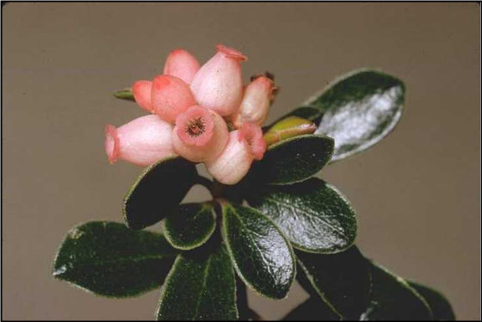
Charles Webber
© California Academy of Sciences
@ CalFlora

kinnikinnick

Uses
Bearberry serves a dual role on sandy soils, as both a beautification plant as well as a critical area stabilizer. The thick, prostrate, vegetative mat and evergreen character are what make bearberry a very popular ground cover. It is often planted around home sites, sand dunes, sandy banks, and commercial sites. The fruit it produces is eaten by a few species of songbirds and game animals. Deer will sometimes browse the foliage lightly.

Status
Please consult the PLANTS Web site and your State Department of Natural Resources for this plant’s current status (e.g. threatened or endangered species, state noxious status, and wetland indicator values).

Description
Pure stands of bearberry can be extremely dense, with heights rarely taller than 6 inches. Erect branching twigs emerge from long flexible prostrate stems, which are produced by single roots. The

trailing stems will layer, sending out small roots periodically. The finely textured velvety branches are initially white to pale green, becoming smooth and red-brown with maturity. The small solitary three scaled buds are dark brown.

The simple leaves of this broadleaf evergreen are alternately arranged on branches. Each leaf is held by a twisted leaf stalk, vertically. The leathery dark green leaves are an inch long and have rounded tips tapering back to the base. In fall, the leaves begin changing from a dark green to a reddish-green to purple.

Terminal clusters of small urn-shaped flowers bloom from May to June. The perfect flowers are white to pink, and bear round, fleshy or mealy, bright red to pink fruits called drupes. This smooth, glossy skinned fruit will range from 1/4 to 1/2 inch in diameter. The fruit will persist on the plant into early winter. Each drupe contains 1 to 5 hard seeds, which need to be scarified and stratified prior to germination to reduce the seed coat and break embryo dormancy. There is an average of 40,900 cleaned seeds per pound.

Adaptation and Distribution
Bearberry’s native range is from Labrador to Alaska, south to Virginia, Illinois, Nebraska, and in the mountains from New Mexico north through California to Alaska. This long-lived, low growing shrub is very cold tolerant. This plant prefers coarse well to excessively drained soils of forests, sand dunes, bald or barren areas. It does not tolerate moist or off-drained sites. Although bearberry is often found growing in the open on sand dunes, it grows well under partial shade of forest canopies.

For a current distribution map, please consult the Plant Profile page for this species on the PLANTS Website.

Establishment
Bearberry can be propagated from seeds, softwood cuttings or pre-rooted stem cuttings. It is difficult to root this plant from bare cuttings in the greenhouse. Scarified seed sown in early summer will improve germination the following spring, but this technique is not as reliable as cuttings. Softwood cuttings should be harvested in late summer, and rooted stem cuttings are most successful when harvested during the dormant season. Successfully grown seedlings or cuttings should be handled carefully in containers; bare root plantings are rarely effective.

Management
This shrub species requires very little maintenance once it has been established. Annual spring applications of 10-10-10 will increase the growth rate of bearberry, but will also increase weed growth. Weed growth must be controlled to sustain healthy stands of bearberry.

Cultivars, Improved, and Selected Materials (and area of origin)
There are no known varieties of bearberry available; local or regional selections are available from commercial nurseries.

Prepared By & Species Coordinator:
USDA NRCS Northeast Plant Materials Program

Edited: 31Jan2002 JLK; 31may06jsp

For more information about this and other plants, please contact your local NRCS field office or Conservation District, and visit the PLANTS Web site<http://plants.usda.gov> or the Plant Materials Program Web site <http://Plant-Materials.nrcs.usda.gov>

The U.S. Department of Agriculture (USDA) prohibits discrimination in all its programs and activities on the basis of race, color, national origin, sex, religion, age, disability, political beliefs, sexual orientation, and marital or family status. (Not all prohibited bases apply to all programs.) Persons with disabilities who require alternative means for communication of program information (Braille, large print, audiotape, etc.) should contact USDA's TARGET Center at 202-720-2600 (voice and TDD).
To file a complaint of discrimination write USDA, Director, Office of Civil Rights, Room 326-W, Whitten Building, 14th and Independence Avenue, SW, Washington, DC 20250-9410 or call 202-720-5964 (voice or TDD). USDA is an equal opportunity provider and employer.
Read about Civil Rights at the Natural Resources Convervation Service.

