Introduction
A Simulation Evaluation of a Human-Centered Approach to Flight Deck Procedures and Automation for En Route Free Maneuvering

Walter W. Johnson and Vernol Battiste
NASA Ames Research Center
Moffett Field, CA

Stacie Granada, Nancy Johnson, and Arik Quang Dao Dominic Wong and Anthony Tang
San Jose State University QSS Group Inc.
Moffett Field, CA Moffett Field, CA

A joint simulation was conducted by NASA Ames and Langley Research Centers. This paper presents flight deck performance and subjective data collected at the NASA Ames Research Center. During the simulation of en route free maneuvering, the presence and mixture of managed and autonomous aircraft was manipulated, as was the number of autonomous aircraft.. These manipulations allowed for an examination of the viability of both conducting mixed AFR-IFR operations, and of substantially increasing en route traffic through insertion of AFR aircraft. The Ames airside performance and pilot comment data support the safety and feasibility of the concept, with double en route capacity appearing to be easily achievable. This work was supported by NASA’s Advanced Air Transportation Technologies (AATT) project.
In June 2004, research teams at the NASA Ames and Langley Research Centers conducted a joint human-in-the-loop simulation investigating the feasibility and operational benefits of a free flight concept under consideration by NASA’s Distributed Air Ground Traffic Management (DAG-TM) effort. The goal of DAG-TM is the expansion of airspace capacity and, to this end, several concepts have been developed and evaluated as part of this effort. The concept evaluated in this simulation was called En Route Free Maneuvering. The premise was that greater efficiency and capacity could be gained through a redistribution of roles and responsibilities, and attendant decision-making, to the aircraft operators (e.g., flight crews) and the air traffic management system (e.g., air traffic controllers). The envisioned solution requires new human-centered operational paradigms enabled by advances in decision support tools: information sharing; communication, navigation, and surveillance; air traffic management technologies; and procedures supporting distributed separation responsibilities.
Simulation Overview
The simulation investigated the feasibility of an en route free maneuvering concept with respect to traffic scalability and airspace mixture. The free maneuvering concept assigned the en route autonomous aircraft two tasks. First, autonomous aircraft had the task of maintaining separation from other aircraft. Second, autonomous aircraft arrivals were responsible for arriving at a TRACON meter fix at a required time of arrival. Scalability refers to the ability to increase the density of en route aircraft by adding autonomous aircraft, while airspace mixture refers to the mixing of autonomous and managed aircraft in the same airspace. Autonomous aircraft are aircraft flying according to Autonomous Flight Rules (AFR) designed specifically for free maneuvering aircraft, while managed aircraft are aircraft flying according to standard Instrument Flight Rules (IFR) by which aircraft fly today. The simulation was manned by a team of certified professional controllers and commercial-rated pilots who operated within a simulated airspace similar to the northwest portion of the Fort Worth Air Route Traffic Control Center (ZFW). Traffic scenarios were created to simulate realistic traffic flow into and out of the Dallas-Ft.Worth (DFW) airport, and also overflights through the ZFW airspace. Varying traffic volume between scenarios was accomplished by altering only the number of overflights, and thus Scalability was manipulated only for en route (non-arrival) flight. The arrival problem, while demanding, remained relatively constant throughout all scenarios, but was impacted by the increased overflights passing near and around the arrival stream.
The DAG-TM simulation environment was distributed across two NASA facilities and several laboratories. At the Ames Research Center, the Airspace Operations Laboratory (AOL) provided aircraft target generation and ran the human-in-the-loop air traffic control (ATC) part of the simulation. The AOL utilized professional air traffic controllers and also provided “pseudopilots,” who were given specialized tools that allowed them to simultaneously control multiple background IFR aircraft. The use of IFR pseudopilots was necessary because the volume of traffic was such that it was impossible to assign one person for every aircraft in the airspace.
AFR human-in-the-loop flight deck simulation and evaluations were conducted at the NASA Ames Flight Deck Display Research Laboratory and the NASA Air Traffic Operations Laboratory. Both centers were responsible for gathering data on professional pilots serving as participants. Also, as with the AOL, these laboratories provided pseudopilots to control background AFR traffic.
The Ames and Langley AFR flight decks and pseudopilot stations were different and flew in separate areas of the airspace. Only the Ames AFR flight decks are examined in this report.
The entire scope of the DAG-TM En Route Free Maneuvering Simulation is far too large to describe in the present conference report. Those interested in greater detail are referred to the Joint NASA Ames/Langley Joint Simulation Final Report (Raytheon ATMSDI Team, 2004). The present report focuses solely on selected aspects the NASA Ames Flight Deck simulation evaluations.
Roles and Responsibilities
The DAG En Route Free Maneuvering concept placed a large number of new responsibilities on the AFR pilots, responsibilities that have previously been reserved to air traffic control. First, and foremost, the AFR pilots were assigned the responsibility for maintaining separation from all IFR (ATC managed) aircraft. In addition, they were responsible for maintaining separation from other AFR aircraft according to a set of “rules-of-the-road” (c.f., Johnson, Canton, Battiste, & Johnson, 2005). When responsible, or “burdened,” AFR pilots were required to resolve any impending loss-of-separation (LOS) prior to two minutes to the predicted time of the LOS. In addition, when attempting to resolve a conflict, AFR pilots were not allowed to create a predicted LOS that was less than four minutes in the future. Some AFR flights were solely overflights, but others flew arrivals. These AFR arrivals were given the responsibility for meeting a required-time-of-arrival (RTA) (+/- 15s) for the DFW Meter Fix BAMBE. The arrivals began the simulation during cruise ~200 NM from BAMBE, and were assigned their RTA when they were approximately 160 nm (~20 min) from BAMBE. In addition to the RTA restriction, AFR aircraft were required to cross BAMBE at 11000 ft (+/- 300 ft) and 250 kts (+/- 10 kts). If these crossing restrictions could not be met, then the TRACON controller could refuse the AFR aircraft permission to cross into the TRACON, or, at the controller’s discretion, new crossing restrictions could be given. At BAMBE, the status of aircraft transitioned back to that of an IFR aircraft.
NASA Ames Flight Deck Implementation
The NASA Ames flight deck implementation for the DAG-TM En Route Free Maneuvering work is based on the Airborne Management of En route Separation Display (AMES Display). The AMES Display was developed between 1995 and 2000 to support initial examinations of Free Flight by NASA’s Advanced Aeronautical Transportation Technologies Project (Johnson, Battiste, Delzell, Holland, Belcher, & Jordan, 1997; Johnson, Battiste, & Holland, 1999). The AMES Display was not only a display, but was an integrated approach to the display, manipulation, and management of flight path information required for free maneuvering in the en route environment. As such, a free maneuvering concept was actually embedded in its design, although the present DAG-TM work considerably surpasses this initial work in scope and requirements. Nevertheless, important design decisions made during the development of the AMES Display continued to inform the DAG-TM work. Perhaps the most important of these concerned the role of intent information.
Intent Information: Free maneuvering responsibilities could not be met using today’s flight deck resources. Specifically, conflict detection and resolution (CD&R) capabilities are required. In order to predict the “when” and “where” of conflicts, it is necessary to predict the flight paths of the surrounding aircraft, and this, in turn, requires information about the future flight path. There are two general approaches to this problem. One approach bases conflict predictions on the broadcast of aircraft state information (current position and 3-D velocity), or state information plus Mode Control Panel (MCP) commanded intent (in this case, the location at which an aircraft automatically levels off during a climb or descent also is broadcast). In other words, this first approach bases predictions solely on current-state variables. However, in order to insure detection of conflicts prior to a minimum time to LOS, this approach also requires restricting an aircraft from changing its flight path (i.e., state) until the pilot assures that it will not create a near-term conflict with other aircraft. If a pilot was trying to follow a flight plan using this approach, it would require the flight crew to monitor and ensure the safety of maneuvers at every trajectory change point. This could substantially increase the mental workload of the flight crew. The second general approach is to share intent information based on flight plans (e.g., broadcasting state plus future trajectory change points in the flight plan). Recently, the broadcast of partial flight plan information, in the form of the next four trajectory change points, has been embraced by the RTCA (2002). However, if flight intent information is represented by a finite number of trajectory change points (e.g., as in the four points suggested by the RTCA), the time and area represented by the information could vary greatly (from representing a great amount of time/airspace to representing very little amount of time/airspace). Thus new conflicts could appear with little warning. Therefore, a different approach was utilized in the development of the AMES Display. Specifically, the AMES Display uses information regarding the entire flight plan. By incorporating the entire flight plan, the information presented on the AMES Display ensures (at the design level) that the flight crew has an adequate look-ahead time and eliminates abbreviated flight plans as the cause of alerts that “pop-up” with insufficient time to resolve.
Flight Deck Tools: The tools that supported CD&R, along with pilot situation awareness, were all integrated into a PC-based Cockpit Situation Display (CSD) shown in Figure 1. This display was built on the AMES Display and should be considered an extension of that display. Many of these tools were also integrated into an aircraft simulator based on the Multi-Aircraft Simulator (MACS) developed by the NASA Ames Airspace Operations Laboratory (Raytheon ATMSDI Team, 2004).
The CSD was a 3D perspective display that allowed the pilot to display the 4D flight plans of traffic, see traffic conflicts, and manipulate the viewing angle. Graphical path replanning capabilities of the 3D CSD were integrated with the Flight Management System (FMS), such that a pilot could graphically design a conflict-free 3D route, then load and execute it from the CSD interface. Thus all conflict resolutions and replanned flight paths depended on these human-centered tools (see Canton, Refai, Johnson, & Battiste, 2005, for a fuller discussion of the CD&R implementation). In addition, the CSD also incorporated a tool for the management of RTAs that allowed the pilot to enter, execute, and monitor RTA conformance, all from the CSD. This display is described more fully by Granada, Dao, Wong, Johnson, and Battiste (2005), and in a users manual that can be found at: http://human-factors.arc.nasa.gov/ihh/cdti/download.html.
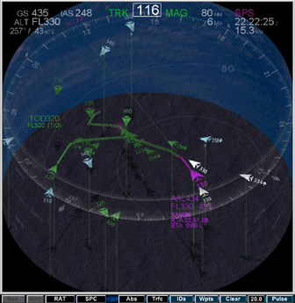
Figure 1. 3D CSD. To view pictures in color or to download a demo (http://human-factors.arc. nasa. gov/ihh/cdti/ download.html).

The MACS simulator emulated a Boeing 757, and included an FMS emulation. The pilot was able to use the FMS in the standard fashion to design new routes, but these would show up on the CSD and be tested for conflicts. If the CSD showed them to be conflict free, the pilot could then execute these routes from the FMS. In addition to the FMS capabilities, the pilots could take their aircraft off of the flight plan and onto a 3D vector using the MCP. Again, the vector would be probed for conflicts, with the pilot executing the vector only if there was at least four minutes of clear path ahead of the aircraft. Finally, the system allowed the pilots to use the FMS to recapture their flight plan by using the FMS to take them directly to any subsequent waypoint in their flight plan.
Method
Experimental Design
The experimental design was a comparison of four conditions (Figure 2). These conditions compared four levels of AFR/IFR Scalability/Mixture in the en route ZFW Center airspace. “T0” represents a traffic threshold that approximates the current-day monitor alert parameter for the simulated airspace. “T1” is a projected threshold above which managed-only operations cannot be achieved. T0 and T1 levels were determined in a prior controller-in-the-loop study at NASA Ames. “C1” represents a high IFR traffic volume that can be handled using normal ATC operations. “C2” is the same traffic volume but with 25% of the aircraft AFR, and 75% IFR. “C3” maintained the same number of IFR aircraft as in “C2”, but added AFR aircraft to increase the total traffic by an average of 60%, while in “C4” this increase was approximately 100%. While these factors changed the density and mix of traffic in the en route airspace, the rate/mix of arrivals into DFW remained constant, with 20%-25% of them being AFR in conditions C2-C4.
This design allows two critical comparisons. First, by comparing C1 and C2 we can determine if introducing mixed operations alone enhances or degrades performance and workload/acceptability. Second, comparisons of C2-C4 test scalability. That is, can AFR aircraft be used to increase traffic load by approximately 50% and 100% without significantly degrading overall operations?
Participants
Ten current or retired airline pilots flew nine Ames experimental aircraft in the simulations. Eight flew desktop single-aircraft MACS flight deck stations, and two served as captain and first officer in the Advanced Concepts Flight Simulator (ACFS), a high fidelity reconfigurable simulator with full window visuals. The total number of flight hours for these pilots ranged from 4,500 to 22,000, with a mean of approximately 11,000 hours. All the Ames pilots had glass cockpit experience ranging from 85 to 8,000 hours, with a group mean of approximately 4,000 total hours. All participants had previous experience with the DAG-TM project, having participated in several previous studies.
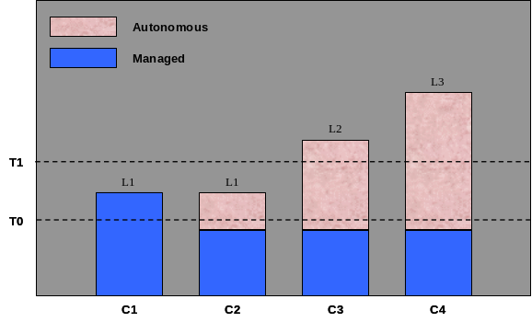
Figure 2. En Route Traffic Load and Mix by Condition

Procedure
The simulation was conducted over eight days. The first two days were used for orientation and final training. Initial pilot training had taken place during two previous dry run and dress rehearsal simulations. Four simulation scenarios per day were conducted on days 3-7, with day seven reserved to replace scenarios if there were unanticipated problems (there were none). The eighth day was used for extensive debriefing. On each of the days 3-6, all of the four conditions (C1-C4) were presented. Across these days, all eight single station pilots flew two arrivals and two overflights for each of the four conditions. The two pilots in the ACFS Simulator always flew arrivals. For half of the scenarios, the Ames aircraft began in the ZFW Ardmore airspace, while on the other half they began in the ZFW Amarillo High/Wichita Falls High airspace.
The overflights had no special requirements other than to maintain separation from other aircraft. All of the arrivals began between 160 NM and 200 NM from the BAMBE arrival meter fix. As the arrivals approached 160NM from BAMBE, they were given RTAs by ATC. These RTAs were designed to require a substantial delay relative to the aircraft’s present estimated time of arrival (ETA) at BAMBE. This delay was large enough that the pilots could not accommodate it through a speed change alone, but required the pilots to modify their flight plans by “stretching” them using their path replanning tools. The arrival aircraft were at various en route altitudes above FL300, and reached their top of descent approximately 80 NM from BAMBE. Data collection ceased for an aircraft when the aircraft reached the BAMBE meter fix (at 11000 ft).
Results and Discussion
Single Pilot AFR Meter Fix Conformance: There was no significant difference in objectively measured performance as a function of any of the conditions. Therefore, from the Ames flight deck perspective, neither mixed operations, nor increased en route traffic load had any effect on the ability of the arriving flights to meet the meter fix constraints. Among the AFR flights, one failed to meet the speed constraint, and one failed to meet the altitude constraint, but all met the RTA constraint.
Single Pilot AFR Self-Separation Performance: There were no LOS incidents for the Ames AFR aircraft. There were 139 conflicts resolved. Of these, 122 were detected prior to four minutes to conflict. The concept requires that AFR aircraft detect conflicts at least four minutes prior to the expected LOS, that no aircraft maneuver such that they create conflicts with expected losses of separation under four minutes, and that the AFR aircraft resolve conflicts prior to two minutes to LOS. Figure 3 shows 17 late alerts (less than four minutes to LOS). Consistent with the increased traffic load, the majority (11 late conflicts) occurred in the C4 condition. All 17 were due to an aircraft executing a maneuver which brought about the late alert. However, a maneuver by an Ames single piloted AFR aircraft was responsible for these late conflicts (concept violations) in only four instances. Furthermore, in three of the four cases, this was due to a flaw in the conflict resolution software (indicating to the pilot that the maneuver was conflict free, when it was not). The reason for the remaining apparent procedural error remains to be determined.
Figure 4 shows a total of two conflicts with late resolutions (under two minutes to LOS), with one of them due to a software flaw in which the conflict detection did not function properly. The other instance was associated with the aforementioned incident where the pilot maneuvered into a conflict at some point between two and four minutes to LOS, with the result being that the pilot was not able to resolve the conflict until there was less than two minutes until the projected LOS.
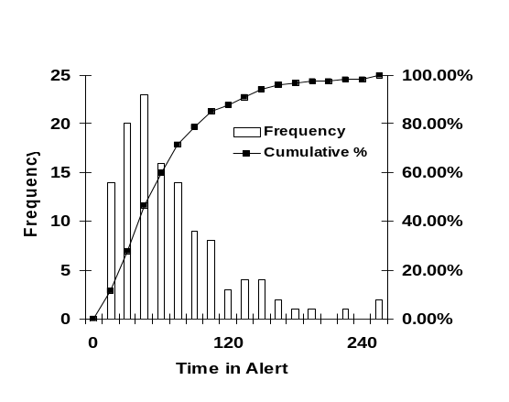Figure 5. Distribution of times required to resolve burdened conflict alerts
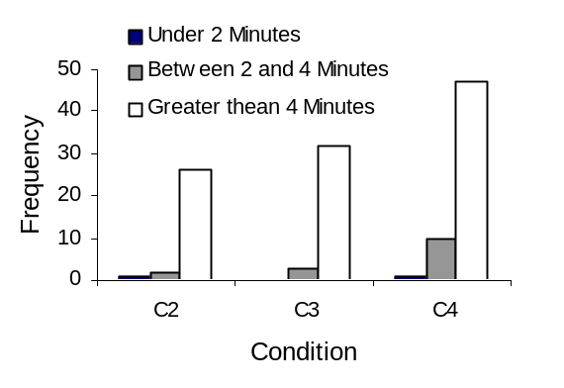Figure 4. Number of conflicts resolved prior to 4 minutes to LOS, 2 minutes to LOS, & under 2 minutes to LOS, as a function of condition
Figure 5 shows the amount of time needed to resolve burdened conflicts. While not an integral part of the concept, the Ames AFR pilots were asked to resolve all burdened conflicts within two minutes (120 sec) of receiving a conflict alert. Figure 5 shows that this criterion was met approximately 89% of the time.
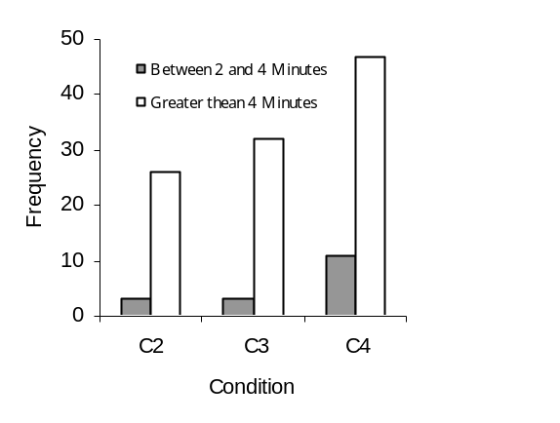Figure 3. Number of conflicts detected 2-4 minutes to LOS, and beyond 4 minutes to LOS
Finally, Figure 6 shows the number of times Ownship and Intruder resolved the conflict as a function of burdening. While the IFR aircraft almost never resolved a conflict (it was never burdened), it is noteworthy that almost 1/3 of the non-burdened aircraft resolved the conflicts in AFR-AFR conflicts.
Subjective Assessments: The subjective assessment of pilot workload was measured following each run using the Modified Cooper Harper (MCH) workload scale. The MCH allows for ratings between 1 (Very easy/workload insignificant) and 10 (Impossible/task abandoned, unable to apply sufficient effort). Pilot responses across all simulation trials ranged from 1 to 6. However, approximately 98 percent of responses ranged from 1 to 3. In order to receive a rating between 1 and 3, it must be possible to complete the task, and workload must be perceived as tolerable and satisfactory. Ratings from 4 to 6 suggest that task workload is high but not high enough to impact performance on the primary task.
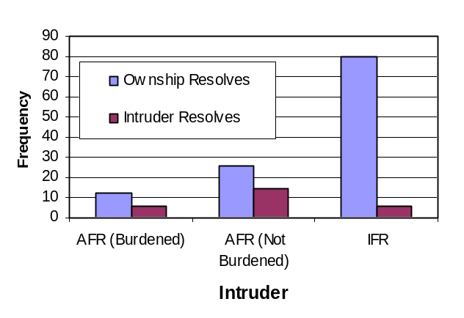Figure 6. Number of conflict resolutions for Ownship and Intruder as a function of burdening
Figure 7 shows the average workload ratings of arrivals and overflights in each condition (±1 SD). Not surprisingly, workload ratings were higher for the arrival flights than for overflights in all conditions. Pilots also responded unanimously with the lowest possible workload rating (1) for the managed overflight runs (C1). In addition, Figure 7 shows an increase in perceived workload from all managed (C1) to mixed (C2-C4) operations for both flight types, but workload remained acceptably low.
Nine of the ten pilots completed post-simulation questionnaires that elicited their opinion of the viability of the DAG-TM Free Flight concept and of the implementation. Figure 8 shows that the majority preferred AFR (Free Flight) for Safety, Workload, Ease of Meeting RTA, and Situation Awareness.
Conclusions
The results support the viability of the En Route Free Maneuvering concept. Not only were the concept requirements met, but the subjective data show that the implementation resulted in low workload, and a high degree of pilot acceptance. While these results must be considered as very preliminary, especially given the near perfect nature of the information exchanged between aircraft. Also, the lack of disruptive events (e.g., weather and emergencies) also limits the generality of the study.
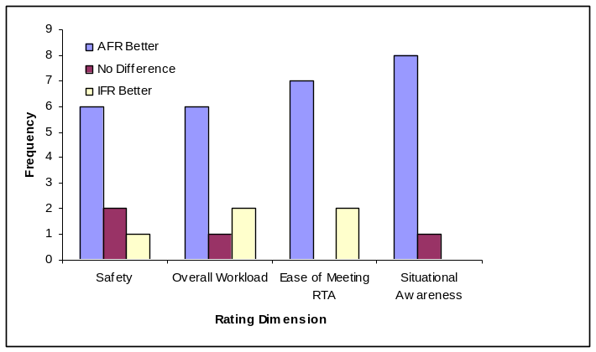
Figure 8. Number of pilots prefering AFR or IFR flight rules as a function of safety, workload, RTA, and situational awareness
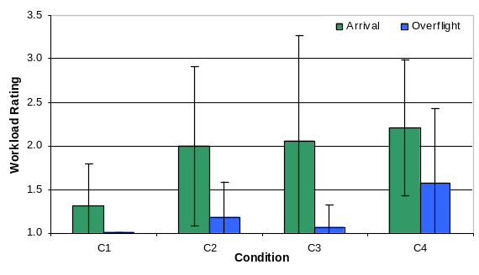Figure 7. MCH workload ratings as a function of flight phase and condition
That said, the excellent performance of the pilots, along with the low workload, suggests that the design of the tools and procedures was very successful, both in terms of software design and human factors design. The high ratings given to situation awareness and ease in meeting RTA also bear this out. That this was achieved while intimately involving the pilot in the resolutions of conflicts, and in other critical decision-making, shows the viability of a human-centered approach to free flight.
References
Canton, R., Refai, M., Johnson, W. W., Battiste, V. (2005). Development and integration of human-centered conflict display and resolution tools for airborne autonomous operations. Submission to the 2005 International Symposium on Aviation Psychology, Oklahoma City, OK
Granada, S., Dao, A., Wong, D., Johnson, W.W., Battiste, V. (2005). Development and integration of a human-centered volumetric cockpit situational display for distributed air-ground operations. Submission to the 2005 International Symposium on Aviation Psychology, Oklahoma City, OK
Johnson, N. H., Canton, R., Battiste, V., and Johnson, W. W. (2005). Rules of the Road: Requirements and Implementation for a Simulation of En-route Self-Separation. Submission to the 2005 International Symposium on Aviation Psychology, Oklahoma City, OK
Johnson, W. W., Battiste, V., and Holland, S. (1999). A cockpit display designed to enable limited flight deck separation responsibility. Proceedings of the 1999 World Aviation Conference, Anaheim, CA.
Johnson, W., Battiste, V., Delzell, S., Holland, S., Belcher, S., and Jordan, K. (1997). Development and demonstration of a prototype free flight CDTI. Proceedings of the SAE/AIAA World Aviation Congress, Anaheim, CA.
RTCA. (1995). Free flight implementation (RTCA Task-Force 3 Report). Washington, D.C.: RTCA Inc.
RTCA. (2002). Minimum Aviation System Performance Standards for Automatic Dependent Surveillance Broadcast. RTCA/DO-242A. RTCA, Inc. Washington, DC.
Raytheon ATMSDI Team. (2004). Joint NASA Ames/Langley DAG-TM Simulation Final Report NASA Ames Research Center. Moffett Field, CA.

