LIVINGSTONE
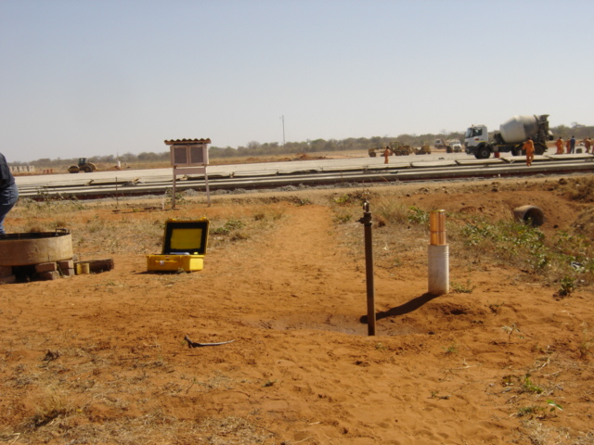
Temporary instruments site and construction of the apron ongoing in the background. Picture taken facing North. Livingstone Air Port.

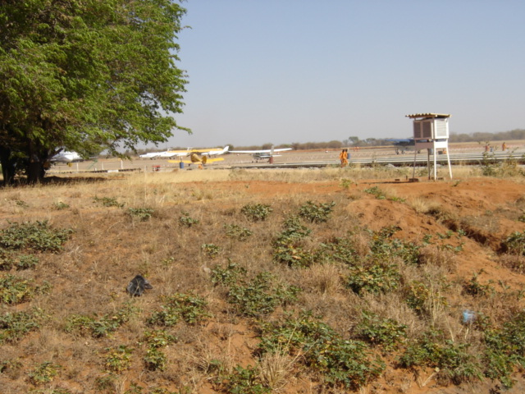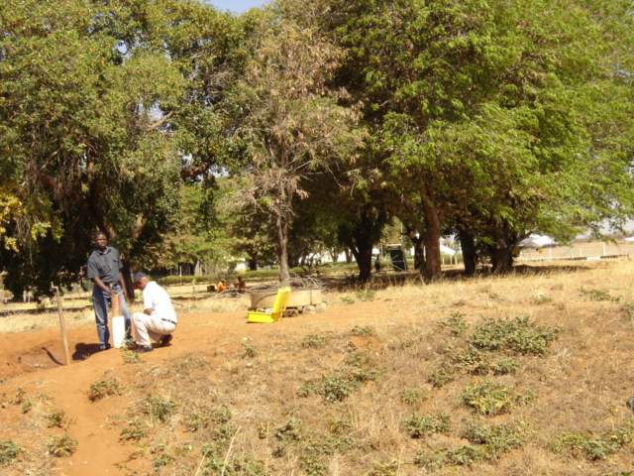
Picture taken facing West. Livingstone Air Port,

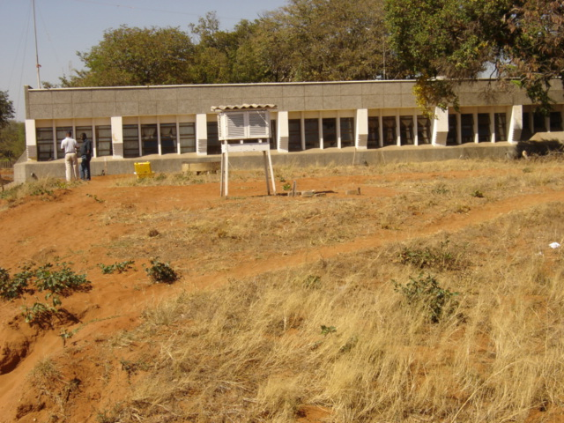
Picture taken facing South. Office building in the background Livingstone Air Port.

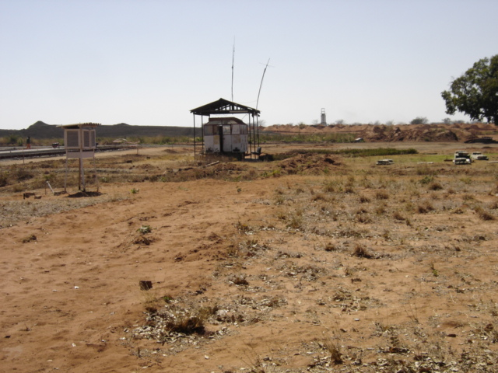
Picture taken facing East. The instruments are scattered between the apron and office building on this temporary site. Livingstone Air Port.
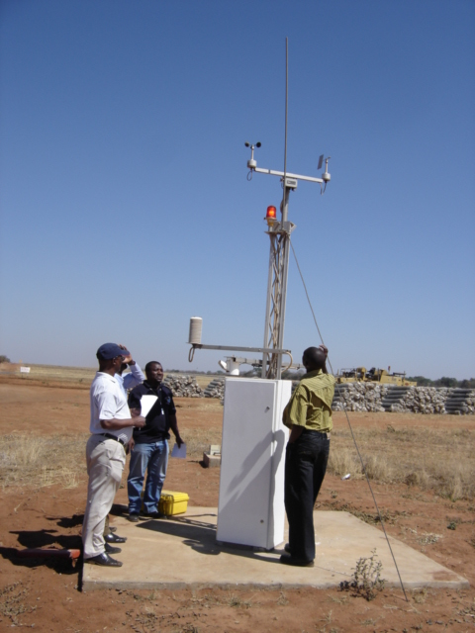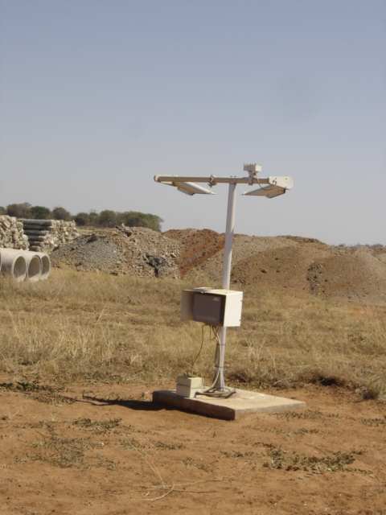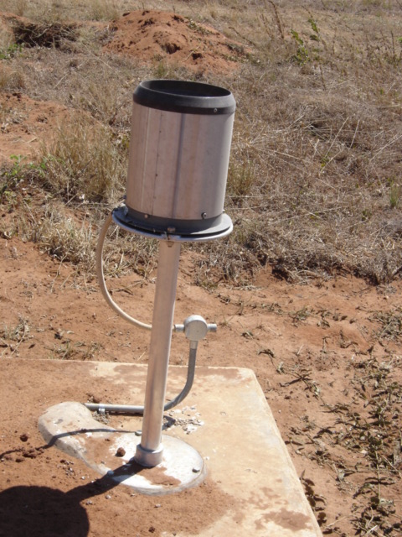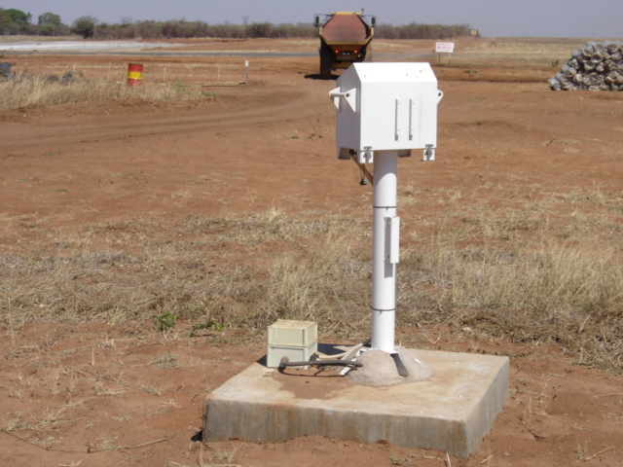
ALMOS Automatic Weather Station with Visibility sensors, Rainfall gauge and Cloud searchlight.

