

Chief Engineer

Office Work Instruction

Lead & Manage PAPAC Process

Original Approved by: Mr. W. Brian Keegan, Chief Engineer

DOCUMENT HISTORY LOG

Status  (Baseline/  Revision/  Canceled) | Document  Revision | Effective  Date | Description
Baseline |  | 12/10/99
Revision | a | 5/3/00 | Modified flowcharts and narratives to enhance clarity (no substantive changes). Changed flowchart symbology to align with recommendations in HCP 1400-1. Changed some quality records for clarity. Revised the Review PCAs flowchart to clarify role of Headquarters Correspondence Management Office. Clarified quality records.
Revision | b | 8/15/00 | Added quality records: Draft Update of PAPAC Goals and Objectives, PAPAC Performance Plan Targets, and Code AE Input to the Performance/Accountability Report. Added step 6.1a for clarity. Corrected actionee in step 6.6a. Renamed a quality record and added a quality record in flowchart G.
Adminis-trative Update | b | 10/25/00 | Administrative Update to change the record owner of two quality records (Strategic Plan and PAPAC NPD and NPG). Code Z and J have always been official owner of these records.

Purpose
The purpose of this procedure is to document the process used by the Office of the Chief Engineer (Code AE) to lead and manage the Provide Aerospace Products and Capabilities (PAPAC) crosscutting process, as described in NPG 1000.2.

Scope and Applicability

2.1 Scope
The process used by Code AE to lead and manage the PAPAC crosscutting process is documented in this OWI. Separate flowcharts are provided for the sub-processes implemented within Code AE. The activities Code AE performs to lead and manage the PAPAC process are to update the PAPAC strategic goals & objectives, revise the PAPAC policy and guidelines (NPD and NPG), develop performance targets for the NASA Performance Plan and report performance against the targets. Code AE also manages PMC meetings for evaluation: IAs, NARs, and IARs, and PMC meetings for quarterly status review. In addition, Code AE is responsible for reviewing all PCAs for recommendation for the Administrator’s signature.

2.2 Applicability
This OWI applies to Code AE.

Definitions
  - AA. Associate Administrator
  - CIC. Capital Investment Council
  - Deputy AE. Deputy Director of Code AE
  - IA. Independent Assessment
  - IAR. Independent Annual Review
  - IPAO. Independent Program Assessment Office
  - NAR. Non-Advocate Review
  - NODIS. NASA On-line Directives Information System
  - NPD. NASA Policy Directive
  - NPG. NASA Procedures & Guidelines
  - PAPAC. Provide Aerospace Products and Capabilities; One of the NASA Cross-Cutting Processes
  - PCA. Program Commitment Agreement – signed contract between the Administrator and an Associate Administrator to provide specified goods or services in a given time with specified resources
  - PCC. Program Cost Commitment
  - PMC. Program Management Council
  - PMCWG. Program Management Council Working Group
  - PRC. Program Review Center
  - Purple Package. Code A Review Package (as defined in NHB 1450.10)
  - QSR. Quarterly Status Review
  - SMC. Senior Management Council

References
NPD 1000.1 | NASA Strategic Plan
NPG 1000.2 | NASA Strategic Management Handbook
NHB 1450.10 | NASA Concurrence Package
NPD 7120.4 | NASA Policy Directive for Program/Project Management
NPG 7120.5 | NASA Procedures and Guidelines for Program/Project Management
The correct version of the NPD and NPG documents cited above may be obtained from the NODIS Directives Library at <http://nodis.hq.nasa.gov/Library/processes.html>

5.0 Flowchart
(a) Update PAPAC Goals & Objectives for Strategic Plan

(b) Revise PAPAC NPD and NPG
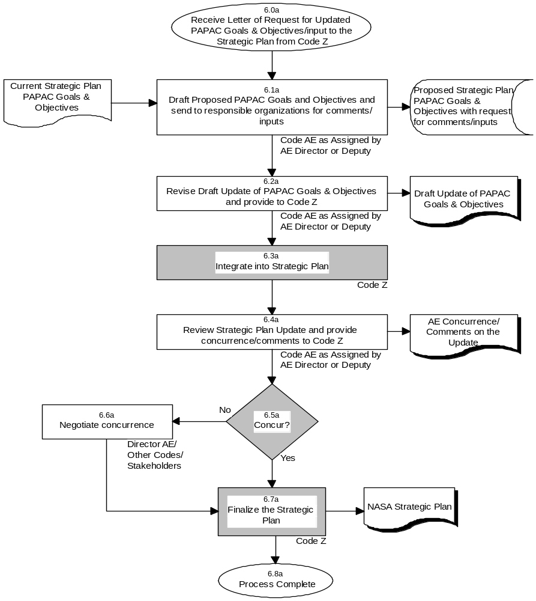
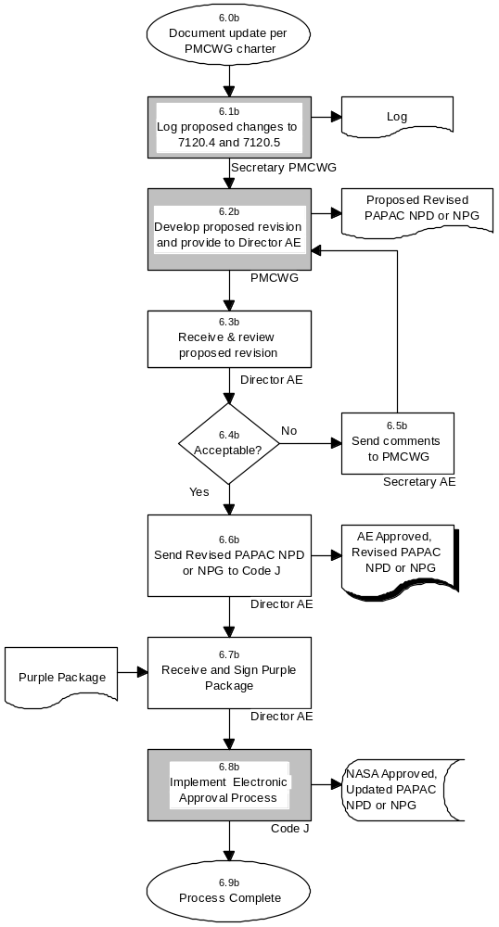

(c) Develop PAPAC Performance Plan Targets
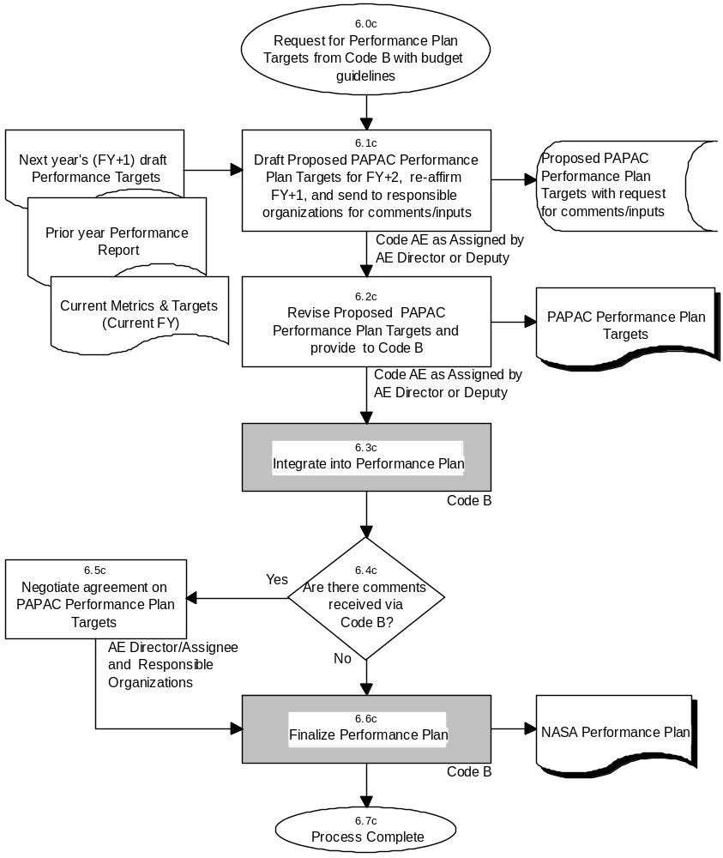
(d) Performance Reporting
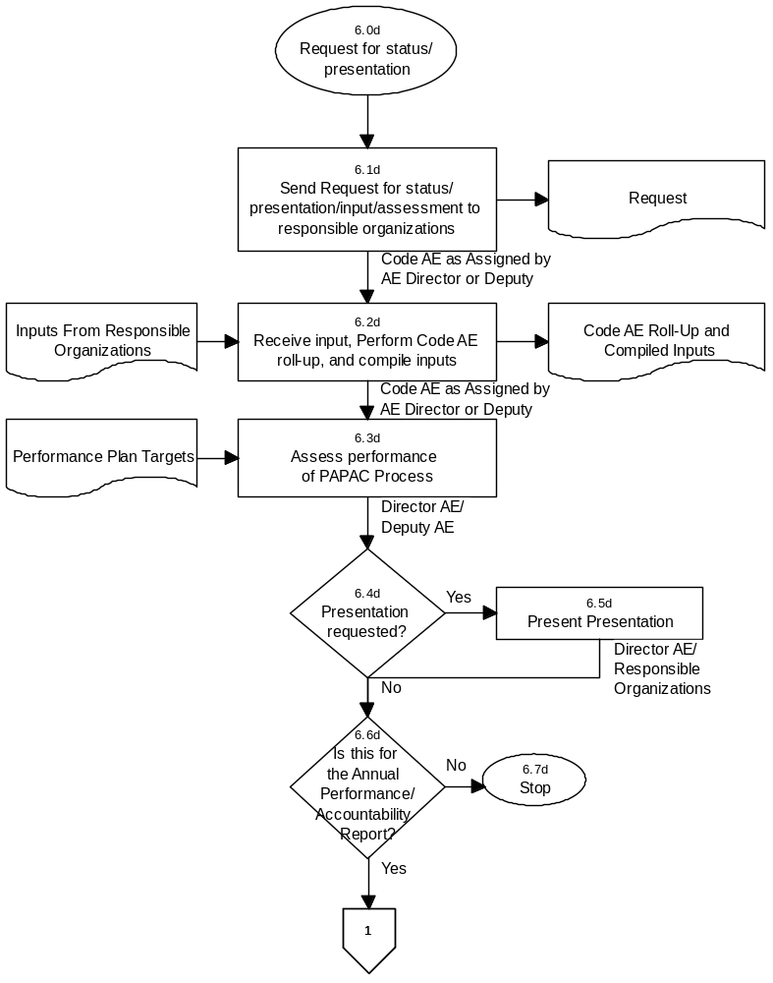
(d) Performance Reporting - continued
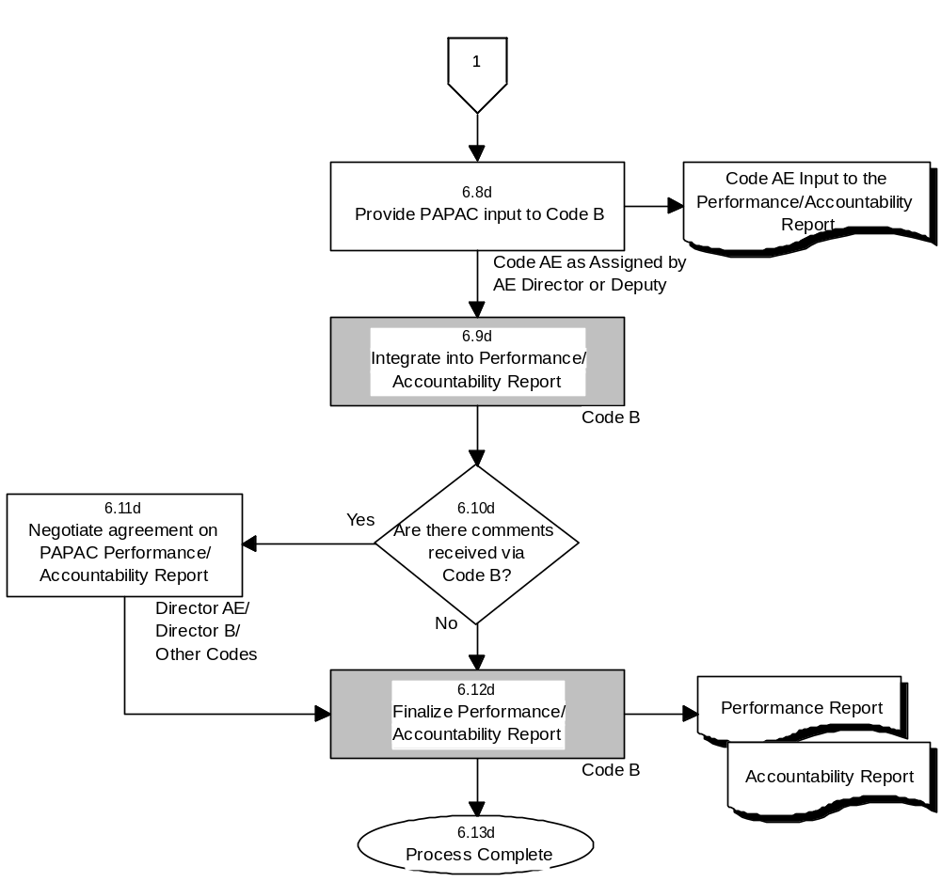
(e) Manage PMC Meetings for Program Evaluation: IAs, NARs, IARs
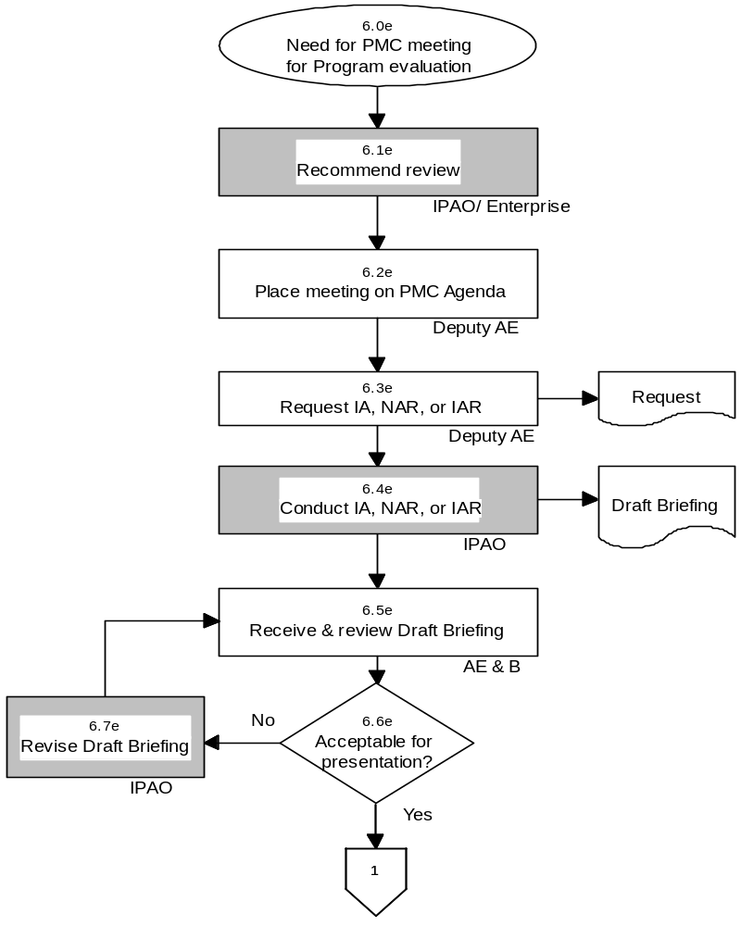

(e) Manage PMC Meetings for Program Evaluation: IAs, NARs, IARs - continued
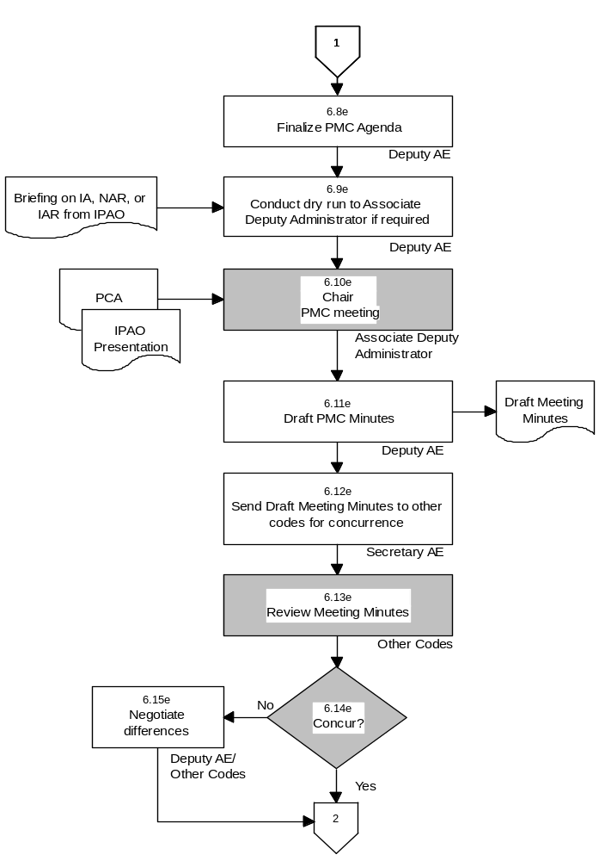

(e) Manage PMC Meetings for Program Evaluation: IAs, NARs, IARs - continued
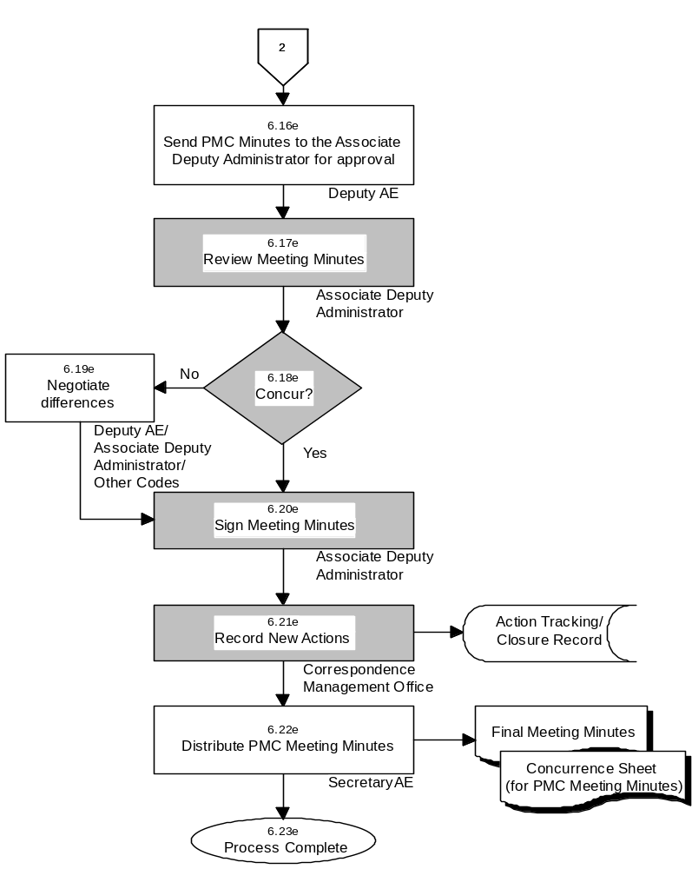

(f) Manage PMC Meetings for Quarterly Status Review
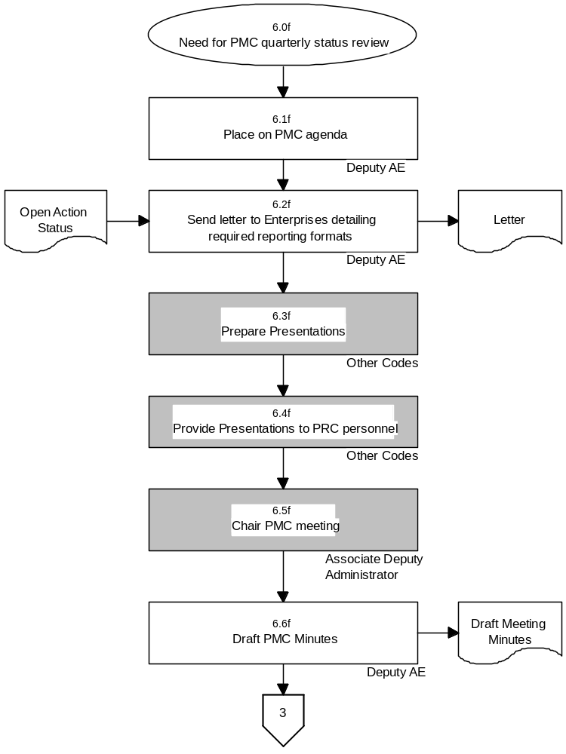

(f) Manage PMC Meetings for Quarterly Status Review - continued
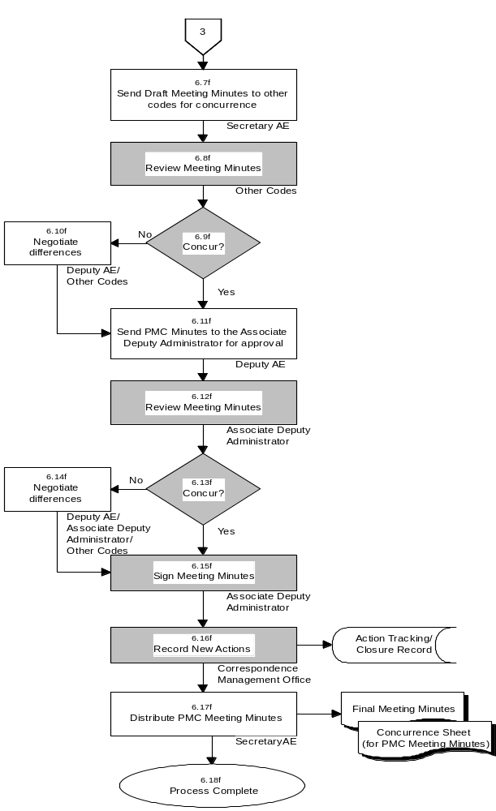

(g) Review PCAs
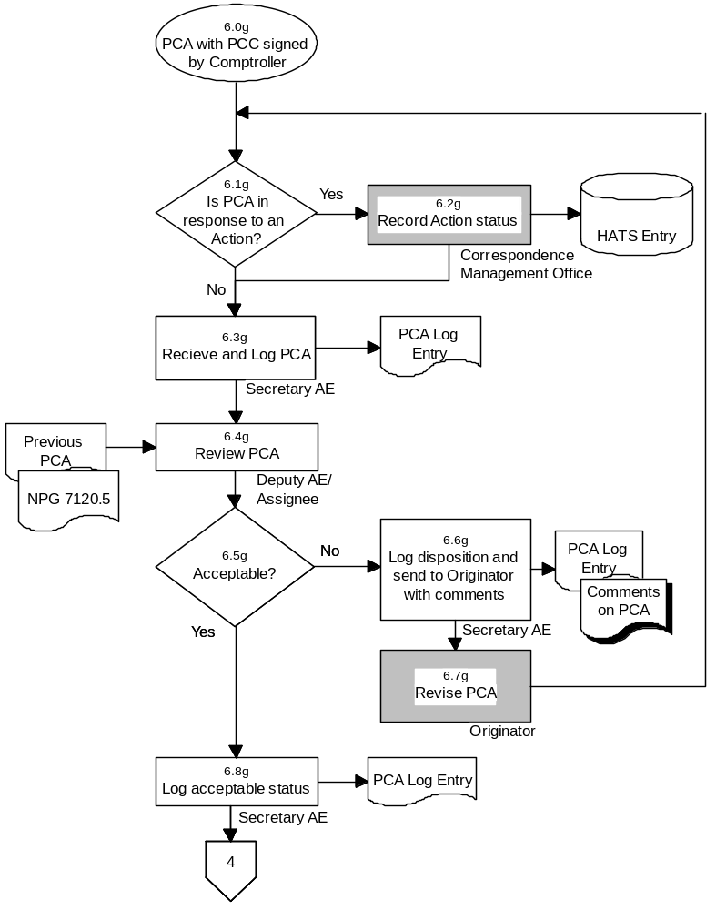

(g) Review PCAs - continued
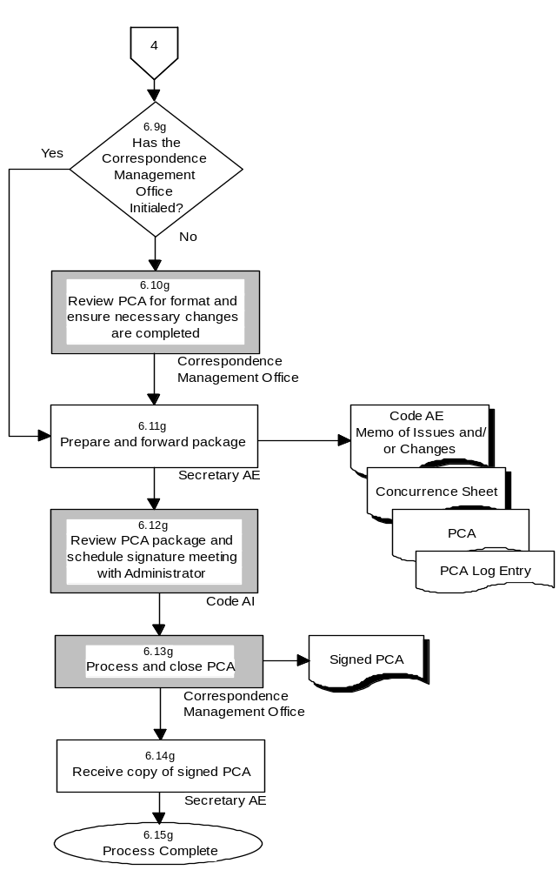

Procedure
(a) Update PAPAC Goals & Objectives
Step | Actionee | Action
6.0a |  | Receive a letter of request for Updated PAPAC goals & objectives/input to the Strategic Plan sent by Code Z.
6.1a | Code AE as assigned by AE Director or Deputy | Review current goals & objectives. Taking into account prior PAPAC goals & objectives, and internal and external influences develop a draft update of the PAPAC goals & objectives in coordination with Director AE. Send the proposed targets via email or memo to the responsible organizations for input/comments.
6.2a | Code AE as assigned by Director or Deputy | Compile the input/comments supplied by the responsible organizations, and revise the PAPAC Performance Plan targets, in coordination with Director AE. Send the draft update (electronic or hardcopy) to Code Z.
6.3a | Code Z | Integrate into Strategic Plan.
6.4a | Code AE/ Other Codes | Taking into account internal and external influences, review update of goals and objectives/Strategic Plan and develop comments/concurrence.
6.5a | Code Z | Code Z next step based on concurrence input.
6.6a | Director AE/ Other Codes/ Stakeholders | Discussion between Code AE, other Codes, and stakeholders, such as the Administration and Congressional representatives to negotiate concurrence.
6.7a | Code Z | Incorporate PAPAC goals and objectives into the Strategic Plan. This final version includes any changes developed in the negotiations.
6.8a | Code Z | Process complete.

(b) Revise PAPAC NPD and NPG
Step | Actionee | Action
6.0b |  | The PMCWG charter calls for an update of NPD 7120.4 and NPG 7120.5
6.1b | Secretary PMCWG | The Secretary of the PMCWG logs in all proposed changes. Changes may arrive via the NODIS system or other comments provided to the Secretary.
6.2b | PMCWG | Develop a proposed update, including the proposed changes as input and provide (hardcopy) to Director AE.
6.3b | Director AE | Receive and review the proposed update from the PMCWG.
6.4b | Director AE | Determine if the proposed update is acceptable in that it improves the process, and, in the professional judgement of the Director AE, consistent with good program/project management practices.
6.5b | Secretary AE | Send the Deputy AE comments (electronic) to the PMCWG for them to incorporate into a revised proposed update.
6.6b | Director AE | Send the revised PAPAC NPD or NPG (hardcopy) to Code J.
6.7b | Director AE | Receive and sign the NPD/NPG Purple Package.
6.8b | Code J | Implement Code J Approval process. The result is a NASA Approved, Updated version of the PAPAC NPG/NPD.
6.9b | Director AE | Process complete.

(c) Develop PAPAC Performance Plan Targets
Step | Actionee | Action
6.0c |  | Code B requests Performance Plan targets for FY+2 and last minute changes to FY+1. The request is issued (hardcopy) with the budget guidelines.
6.1c | Code AE as assigned by AE Director or Deputy | Based on last year’s Performance Report, next year’s Draft Performance Plan targets and the current year metrics & targets, draft, in coordination with Director AE, the Proposed PAPAC Performance Plan targets for FY+2 and/or develop any necessary changes to FY+1 targets. Send the proposed targets via email or memo to the responsible organizations for input/comments.
6.2c | Code AE as assigned by AE Director or Deputy | Compile the input/comments supplied by the responsible organizations, and revise the PAPAC Performance Plan targets, in coordination with Director AE. Provide electronic copy or hardcopy with cover sheet to Code B.
6.3c | Code B | Integrate PAPAC Performance Plan Targets into the Performance Plan.
6.4c | Code AE as assigned by AE Director or Deputy | Are comments received via Code B?
6.5c | Director AE/ Assignee and Responsible Organizations | Discussion between Code AE and other Codes to negotiate concurrence.
6.6c | Code B | Finalize PAPAC Performance Plan Targets in the Performance Plan. This final version includes any changes developed in the negotiations.
6.7c | Code B | Process complete.

(d) Performance Reporting
Step | Actionee | Action
6.0d |  | A request for status, presentation, input and/or assessment against Performance Plan targets is received from Code B or initiated within Code AE. The material is requested for a variety of purposes, including mid-year status, CIC or SMC presentation, Performance Report
6.1d | Code AE as Assigned by AE Director or Deputy | Send request for performance information to responsible organizations. The secretary AE issues a memo (hardcopy) with the request and targets to the responsible organizations for concurrence, with Director AE signature.
6.2d | Code AE as Assigned by AE Director or Deputy | Receive input (hardcopy or email) from responsible organizations. Code AE assigned person performs roll-up of target(s) assigned to AE for roll-up. Code AE assigned person compiles input corresponding to each target.
6.3d | Director AE/ Deputy AE | Assess the performance of the PAPAC Process, by comparing the compiled inputs with the Performance Plan targets.
6.4d | Code AE as Assigned by AE Director or Deputy | A presentation may be requested, such as for CIC review of SMC briefing.
6.5d | Director AE/ Responsible Organization | Present the performance information.
6.6d | Code AE as Assigned by AE Director or Deputy | Is this for the Annual Performance/Accountability Report?
6.7d | Code AE as Assigned by AE Director or Deputy | The process is complete.
6.8d | Code AE as Assigned by AE Director or Deputy | In coordination with Director AE, provide the PAPAC input to Code B in the requested format. Provide electronic copy or hardcopy with cover sheet to Code B.
6.9d | Code B | Integrate into Performance/Accountability Report.
6.10d | Code AE as Assigned by AE Director or Deputy | Are comments received via Code B?
6.11d | Director AE/ Director B/ Other Codes | Discussion between Code AE and B Directors and other Codes to negotiate concurrence.
6.12d | Code B | Incorporate PAPAC Performance/Accountability Report input into the Performance/Accountability Report. This final version includes any changes developed in the negotiations.
6.13d | Code B | Process complete.

(e) Manage PMC Meetings for Program Evaluation: IAs, NARs, IARs
Step | Actionee | Action
6.0e |  | Each Program/Project/Initiative review process is documented in the PCA. For Programs that report to the HQ PMC, the results of IAs, NARs, and IARs are presented to the PMC.
6.1e | IPAO/ Enterprise | Both the Enterprise and the IPAO recommend the type of review that should be performed (IA, NAR, IAR) to Code AE.
6.2e | Deputy AE | Place the PMC meeting on the Agenda. The Agenda is maintained and distributed by the Secretary AE.
6.3e | Deputy AE | Request IPAO to perform the appropriate review type. This request is a written memo signed by the Deputy AE
6.4e | IPAO | Conduct the requested review. Produce a draft briefing of the review results.
6.5e | Code AE/ Code B | Receive the draft briefing (hardcopy) from IPAO and review.
6.6e | Code AE/ Code B | Determine if the draft briefing is acceptable for presentation. Acceptability is based on the completeness and accuracy of the briefing, and its compliance with the requirements given in NPG 7120.5. If not, send comments to the IPAO for them to revise the briefing.
6.7e | IPAO | Revise the draft briefing based on comments from Code AE and Code B. Negotiate with Code AE and Code B as necessary.
6.8e | Deputy AE | The PMC Agenda is changed if necessary. The Agenda is maintained and distributed by the Secretary AE (hardcopy). If changes are made, the Agenda is redistributed.
6.9e | Deputy AE | Table discussion of presentation viewgraphs with Associate Deputy Administrator
6.10e | Associate Deputy Administrator | Conduct PMC meeting. The PCA and the briefing are presented by the IPAO.
6.11e | Deputy AE | Draft the PMC meeting minutes.
6.12e | Secretary AE | Send draft meeting minutes to other codes for concurrence via memo signed by Deputy AE.
6.13e | Other Codes | Review the meeting minutes.
6.14e | Other Codes | Develop comments/concurrence.
6.15e | Deputy AE/ Other Codes | Discussion between Deputy AE and other Codes to negotiate differences.
6.16e | Deputy AE | Send revised draft PMC minutes (hardcopy) and concurrence sheet to the Associate Deputy Administrator for approval.
6.17e | Associate Deputy Administrator | Review the meeting minutes.
6.18e | Associate Deputy Administrator | Develop comments/concurrence.
6.19e | Associate Deputy Administrator/ Deputy AE/ Other Codes | Meet as necessary to discuss the reasons for non-concurrence. Negotiate differences.
6.20e | Associate Deputy Administrator | Sign PMC minutes.
6.21e | Correspondence Management Office | Receive signed PMC minutes. Record actions for tracking and closure in the HATS system (see Code CIC HQOWI 14509-C009 for information on the handling of HATS records), and forward to Code AE. The Deputy AE approves action closures and notifies Correspondence Management Office of any changes to the actions/action schedules.
6.22e | Secretary AE | Send (hardcopy) to Administrator and Codes.
6.23e |  | Process Complete.

(f) Manage PMC Meetings for Quarterly Status Review
Step | Actionee | Action
6.0f |  | The HQ PMC reviews Agency Program/Projects/Initiatives quarterly.
6.1f | Deputy AE | Place the PMC meeting on the Agenda. The Agenda is maintained and distributed (hardcopy) by the Secretary AE.
6.2f | Deputy AE or assignee | Approximately 3 weeks prior to the meeting, a memo (hardcopy) is sent to the Enterprises detailing the required reporting formats for the upcoming QSR, including the status of open PMC actions.
6.3f | Other Codes | Prepare QSR presentations.
6.4f | Other Codes | Provide presentations on computer disk to Program Review Center.
6.5f | Associate Deputy Administrator | Conduct PMC meeting. Overdue open actions may be addressed by the Associate Deputy Administrator.
6.6f | Deputy AE | Draft the PMC meeting minutes.
6.7f | Secretary AE | Send draft meeting minutes to other codes for concurrence via memo signed by Deputy AE.
6.8f | Other Codes | Review the meeting minutes.
6.9f | Other Codes | Develop comments/concurrence.
6.10f | Deputy AE/ Other Codes | Discussion between Deputy AE and other Codes to negotiate differences.
6.11f | Deputy AE | Send revised draft PMC minutes (hardcopy) and concurrence sheet to the Associate Deputy Administrator for approval.
6.12f | Associate Deputy Administrator | Review the meeting minutes.
6.13f | Associate Deputy Administrator | Develop comments/concurrence.
6.14f | Associate Deputy Administrator/ Deputy AE/ Other Codes | Meet as necessary to discuss reasons for non-concurrence. Negotiate differences and Deputy AE makes necessary changes (hardcopy).
6.15f | Associate Deputy Administrator | Sign PMC minutes.
6.16f | Correspondence Management Office | Receive signed PMC minutes. Record actions for tracking and closure in the HATS system (see Code CIC HQOWI 14509-C009 for information on the handling of HATS records), and forward to Code AE. The Deputy AE approves action closures and notifies Correspondence Management Office of any changes to the actions/action schedules.
6.17f | Secretary AE | Send (hardcopy) to Administrator and Codes.
6.18 |  | Process complete.

(g) Review PCAs
Step | Actionee | Action
6.0g |  | PCA has been generated, signed by the Comptroller, and is ready for review.
6.1g | Secretary AE | Determine if PCA is in response to an Action.
6.2g | Correspondence Management Office | Log status into HATS.
6.3g | Secretary AE | Receive the PCA and log its receipt. This log file (electronic) is kept by the Secretary AE.
6.4g | Deputy AE, or Assignee | Review the PCA for recommendation for Administrator signature. Review changes from previous PCA and for consistency with requirements in NPG 7120.5.
6.5g | Deputy AE | Determine that the PCA is acceptable, or develop comments for the originating office.
6.6g | Secretary AE | Log the PCA disposition and send it (hardcopy) with comments to the originating office.
6.7g | Originator | Revise the PCA per the comments from the Deputy AE.
6.8g | Secretary AE | Log the acceptable status of the PCA.
6.9g | Secretary AE | Has the Correspondence Management Office initialed the PCA?
6.10g | Correspondence Management Office | Review the PCA for format. If changes are identified, facilitate changes with the originating office. Forward to Code AE Secretary.
6.11g | Secretary AE | Prepare the concurrence sheet and the PCA (hardcopy) to Code AI. If changes were made, the Deputy AE or assignee may check these changes. A cover memo is generated and signed by the Chief Engineer to note changes from the previous PCA and any outstanding issues. Forward package to Code AI.
6.12g | Code AI | Receive and review PCA package and schedule meeting for Administrator’s signature. Meet as necessary/direct responsible offices to resolve issues. After signature, forward to the Correspondence Management Office.
6.13g | Correspondence Management Office | Headquarters Correspondence Management Office receives and processes the original PCA (signed by the Administrator). Hardcopies are sent to Code AE, Code AI, and the originating office.
6.14g | Secretary AE | Receive copy of signed PCA from Correspondence Management Office.
6.15g | Secretary AE | Process Complete.

- Quality Records
Record ID | Owner | Location | Record Media | NPG 1441.1 Schedule and Item Number | Retention/Disposition
Draft Update of PAPAC Goals and Objectives | Sec AE | Code AE File | hardcopy | Schedule 1, Item 24 | Destroy when 3 months old or when no longer needed, whichever is sooner.
AE Concurrence/ Comments on the Update | Sec AE | Code AE File | hardcopy | Schedule 1, Item 78C | Destroy or delete when no longer needed.
NASA Strategic Plan | Code Z | Code JM Suite | electronic | Schedule 7, Item 4a | Permanent. Transfer to FRC 1 year after obsolete of superseded. Transfer to NARA in 5-year blocks when 20 years old.
AE Approved Revised PAPAC NPD or NPG | Code AE | Code J File | hardcopy | Schedule 1, Item 72A | Retire to FRC 1 year after becoming obsolete or superseded. Transfer to NARA in 5 year blocks when 20 years old.
PAPAC Performance Plan Targets | Sec AE | Code AE File | hardcopy | Schedule 1, Item 24 | Destroy when 3 months old or when no longer needed, whichever is sooner.
NASA Performance Plan | Code B | Code B File | hardcopy | Schedule 9, Item 2A | Permanent. Transfer to NARA when 35 years old.
Code AE Input to the Performance/ Accountability Report | Sec AE | Code AE File | hardcopy | Schedule 1, Item 24 | Destroy when 3 months old or when no longer needed, whichever is sooner.
Performance Report | Code B | Code B Library | hardcopy | Schedule 9, Item 2A | Permanent. Transfer to NARA when 35 years old.
Accountability Report | Code B | CFO web page | electronic | Schedule 9, Item 3A | Delete/destroy when obsolete or superceded or when 5 years old.
Final Meeting Minutes | Sec AE | Code AE File | hardcopy | Schedule 1, Item 14B1a | Retire to FRC when 2 years old. Transfer to NARA when 20 years old, whichever is sooner.
Concurrence Sheet (for PMC Meeting Minutes) | Sec AE | Code AE File | hardcopy | Schedule 1, Item 78C | Destroy or delete when no longer needed.
Comments on PCA | Sec AE | Code AE File | hardcopy | Schedule 1, Item 26 | Destroy when two years old.
Code AE Memo of Issues and/or Changes | Sec AE | Code AE File | hardcopy | Schedule 1, Item 26 | Destroy when two years old.
Concurrence Sheet | Sec AE | Code AE File | hardcopy | Schedule 1, Item 78C | Destroy or delete when no longer needed.
Signed PCA | Correspond-ence Management Office | Correspond-ence Management Office | hardcopy | Schedule 7, Item 10A | *Permanent*  Retire files by fiscal year to FRC when no longer needed for active reference or when 8 years old, whichever is sooner. Transfer to NARA when 25 years old.

