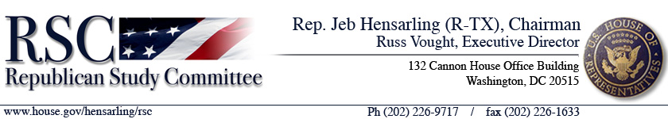
Legislative Bulletin…………………………….………December 5, 2007

Contents:
S. 2371—A bill to amend the Higher Education Act of 1965 to make technical corrections

S. 2371 — A bill to amend the Higher Education Act of 1965 to make technical corrections (Kennedy, D-MA)

Order of Business: S. 2371 is scheduled to be considered on Wednesday, December 5, 2007 under a motion to suspend the rules and pass the bill.
Summary: S. 2371 makes technical corrections to the Higher Education Act of 1965.
S. 2371 determines that the definition for untaxed income and benefits shall not include: the amount of additional child tax credit claimed for federal income tax purposes; welfare benefits, including assistance under a state program aiding dependent children; amount of earned income credit claimed for federal income tax purposes; amount of credit for federal tax on special fuels claimed for federal income tax purposes; the amount of foreign income excluded for purposes of federal income taxes; or untaxed Social Security benefits.
S. 2371 includes a provision regarding income-based repayment for married borrowers filing separately, stating that in the case of a married borrower who files separately, the Secretary shall calculate the amount of the borrower’s income-based repayment based solely on the borrower’s student loan debt and adjusted gross income.
S. 2371 also makes technical changes to the Teach Grant program. S. 2371 ensures that the same financial standard is applied to institutions that participate in this program as are applied to institutions that are eligible to participate in the Title IV programs. S. 2371 makes clarifications to ensure that the Department of Education is able to address over-awards with Teach grants in the same manner as they address over-awards in other grant programs. In addition, clarifies that a student is able to receive one grant per year.
Background: All of these provisions (plus a few others) were passed by the House prior to the Thanksgiving recess (H.R. 4153, the College Cost Reduction and Access Act Technical Amendments of 2007). The Senate stripped the provisions down to two provisions and sent it back. According to the House Education and Labor Committee, the Department of Education is requesting that the third provision be added and sent back to the Senate for their approval.
Committee Action: S. 2371 was introduced on November 15, 2007 and was passed unanimously by the Senate on the same day.
Cost to Taxpayers: No CBO estimate was available at press time.

Does the Bill Expand the Size and Scope of the Federal Government?: No.

Does the Bill Contain Any New State-Government, Local-Government, or Private-Sector Mandates?: No.

Does the Bill Comply with House Rules Regarding Earmarks/Limited Tax Benefits/Limited Tariff Benefits?: No Committee Report is available.

Constitutional Authority: No Committee Report is available.

RSC Staff Contact: Sarah Makin; sarah.makin@mail.house.gov; 202-226-0718.

