Distributed Hydrogen Production via Steam Methane Reforming

Distributed production of hydrogen from natural gas utilizes small scale steam methane reforming technology. The advantages of distributed hydrogen production are the production unit can be located at the consumer refueling site, the unit capacity can be tailored to the site’s fueling requirements, and this approach eliminates the need for an extensive hydrogen delivery infrastructure. This process may be the most viable for introducing hydrogen as an energy carrier since it requires less capital investment for the smaller hydrogen volumes needed initially in the transition phase of the hydrogen economy.

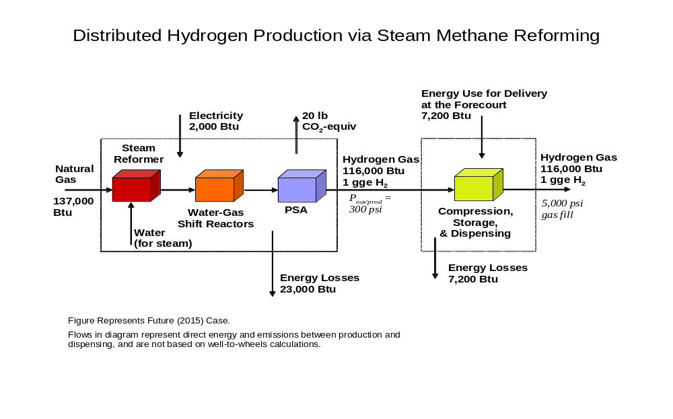

Well-to-Wheels Energy and Greenhouse Gas Emissions Data
 | Current (2005) Gasoline ICE Vehicle | Current (2005) Gasoline Hybrid Electric Vehicle | Current (2005) Distributed SMR - FCV | Future (2015) Distributed SMR - FCV
Well-to-Wheels Total Energy Use (Btu/mile) | 5,900 | 4,200 | 3,700 | 2,800
Well-to-Wheels Petroleum Energy Use (Btu/mile) | 5,300 | 3,800 | 40 | 40
Well-to-Wheels Greenhouse Gas Emissions (g/mile) | 470 | 340 | 260 | 200
Cost of Hydrogen ($/gge, Delivered) |  |  | 3.10 | 2.00
This analysis is based on the best available technology in the laboratory. Currently, it has not been validated through demonstration.
Notes: Distributed Hydrogen Production via Steam Methane Reforming
- Source: Well-to-wheels energy, petroleum and greenhouse gas emissions information from the Argonne National Laboratory GREET model, Version 1.7. Well-to-wheels values represent primary fuel production, electricity production, hydrogen production, hydrogen compression, and hydrogen dispensing. Fossil resource exploration and equipment manufacture is not included.
- Source: Cost, resource requirements, energy requirements, all fuel and feedstock energy contents, and efficiency values for the Current (2005) case is from the H2A model cases modified to reflect the Department of Energy’s Hydrogen Fuel Cells, and Infrastructure Technologies Program 2005 cost goals as of November 2005. Capacity of plant represented here is 1,500 kg/day.
- Source: Cost, resource requirements, energy requirements, all fuel and feedstock energy contents, and efficiency values for the Future (2015) case is from the H2A model cases modified to reflect the Department of Energy’s Hydrogen Fuel Cells, and Infrastructure Technologies Program 2015 cost goals as of November 2005.
- Basis is 1 kg of hydrogen, dispensed from filling station for 5,000 psi fills. A kg of hydrogen contains approximately the same amount of energy as one gallon of gasoline, or one gallon of gasoline equivalent (gge).
- Diagram is for future (2015) case, showing feedstock and energy consumption levels required to meet technology cost goals. Flows in diagram represent direct energy and emissions between production and dispensing, and are not based on well-to-wheels calculations.
- Costs include hydrogen production, compression, storage, and dispensing to vehicle. Cost assumes that small-scale steam methane reforming technology is added to an existing fueling station.
- Efficiency results are presented in terms of lower heating value (LHV) of hydrogen.
- The efficiency of the electric forecourt compressor, which raises the pressure of gaseous hydrogen for 5,000 psi fills, is 94%.
- The operating capacity factor of the forecourt station is 70%. This value accounts for on-stream availability as well as consumer demand variations between week days/weekends and winter/summer.
- Natural gas feedstock prices are based on the 2015 projections for industrial natural gas by the Department of Energy’s Energy Information Administration Annual Energy Outlook 2005 High A case. Prices shown in table are in 2005 $. Feedstock is inflated at 1.9%/year for the 20 year operating life of the plant.
- Electricity is consumed by the process for production and compression operations. Electricity prices are based on the 2015 projections for commercial-rate electricity by the Department of Energy’s Energy Information Administration Annual Energy Outlook 2005 High A case. Prices shown in table are in 2005 $. Electricity is inflated at 1.9%/year for the 20 year operating life of the plant.
- Capital cost of current (2005) and future (2015) cases are $1.40/kg hydrogen and $0.60/kg hydrogen, respectively.
- Cost of hydrogen is the minimum required to obtain a 10% internal rate of return after taxes on the capital investment.
- The data relevant to the Distributed SMR technology diagram above is provided in the table below.

 | Current (2005) Distributed SMR - FCV | Future (2015) Distributed SMR - FCV
Natural Gas Feedstock Price ($/million Btu LHV) | 5.24 | 5.24
Natural Gas Feedstock Price ($/thousand scf) | 5.15 | 5.15
Energy in Natural Gas Feedstock (Btu) | 165,000 | 137,000
Electricity Price ($/kWh) | 0.076 | 0.076
Electricity to Process (Btu) | 2000 | 2000
Energy Losses from Process (Btu) | 51,000 | 23,000
Pressure of Hydrogen from Production (psi) | 300 | 300
Energy Use for Delivery at the Forecourt (Btu) | 7,200 | 7,200
Energy Use for Delivery Transport (Btu) | N/A – Forecourt Production | N/A – Forecourt Production
Hydrogen Dispensing Fill Pressure (psi) | 5,000 | 5,000
Plant Gate Energy Use Including Feedstock (Btu) | 167,000 | 139,000
Production Process Efficiency | 69% | 83%
Pathway Efficiency | 66% | 79%
Greenhouse Gas Emissions from Production (lb/gge of hydrogen produced) | 24 | 20

Understanding Effects of Feedstock Volatility

Distributed natural gas/renewable liquid reforming and on-site electrolysis (promoting renewable electricity) strategies are advantageous for the transition to the hydrogen economy because they obviate the need for a new delivery infrastructure. Current delivery methods (high pressure tube trailers and “liquid” trucks) are very energy intensive and not cost effective for distances over 100 miles. The distributed reforming approach is an enabling technology to produce hydrogen not only from natural gas, but from a portfolio of options such as methanol, ethanol and other renewable liquids. In a steady state hydrogen economy, where diverse domestic resources are used, volatility of hydrogen price should not be an issue. However, natural gas prices are known to be volatile and this is an important consideration for planning the transition. The chart below shows this sensitivity:

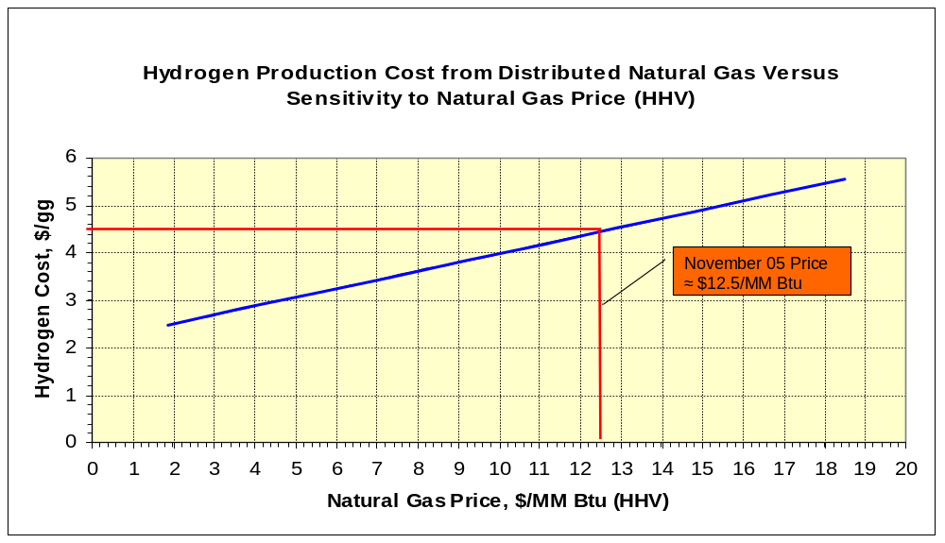

For example, using a data point in November 2005 for an industrial natural gas price of $12.50 per million Btu, hydrogen would currently cost $4.50 per gallon-gasoline-equivalent (gge). This cost is calculated using the H2A financial model which calculates hydrogen costs based on the current technology development status. The H2A model is a cash flow model that allows us to understand the cost of various hydrogen production and delivery pathways on a consistent basis. This portfolio analysis tool provides a levelized cost of hydrogen for a given rate of return (input) and accounts for capital costs, construction time, taxes, depreciation, O&M, inflation, and feedstock prices. See http://www.hydrogen.energy.gov/h2a_analysis.html. As shown in the chart below, hydrogen at $4.50/gge would make hydrogen fuel cell vehicles competitive on a cents per mile basis with gasoline vehicles (ICE) at gasoline prices of $1.90/gge (untaxed) and gasoline hybrid-electric vehicles at gasoline prices of $2.70/gge (untaxed).

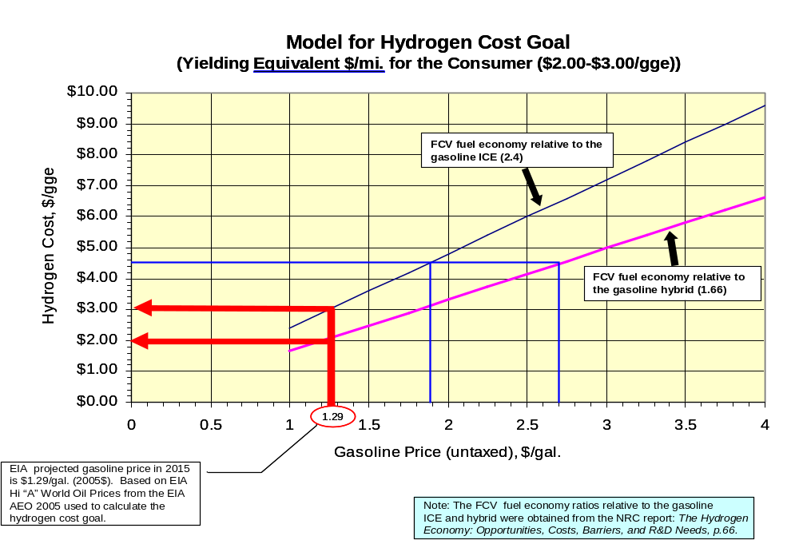

The impact of the volatility of natural gas prices will continue to be evaluated to ensure the viability of this hydrogen production pathway. Feedstock price volatility will significantly influence investment decisions.

The chart below shows the major variables that influence natural gas-based hydrogen costs.

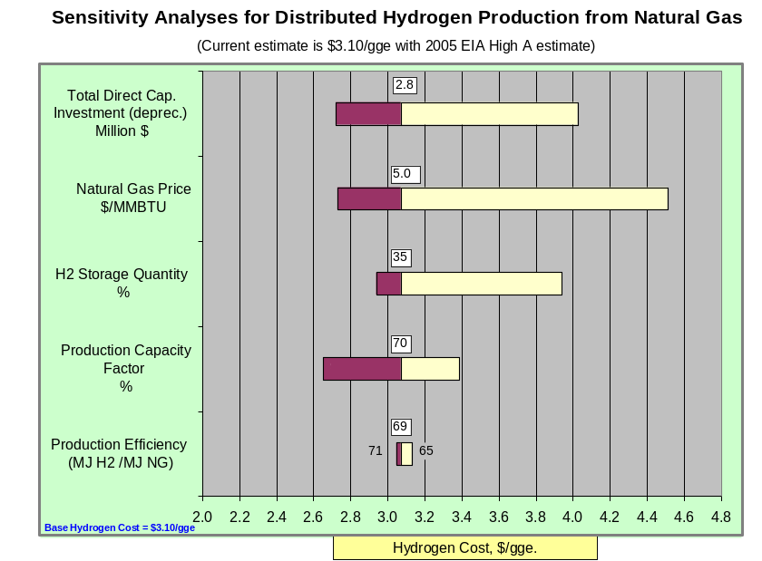

The pie chart below shows the composition of costs contributing to the current estimate of producing hydrogen from distributed natural gas. This estimate is based on the best available research, projected to high volume, but not yet validated under real-world operating conditions by the Program’s Technology Validation Sub-Program. This estimate is based on the 2005 EIA High A estimate for natural gas in 2015.

