Distance-Based Vehicle Insurance
A Practical Strategy for More Optimal Pricing

By Todd Litman
Victoria Transport Policy Institute

Abstract. A significant portion of vehicle expenses are fixed, and therefore not marginal. This is economically inefficient and results in excessive automobile travel. Insurance premiums are particularly appropriate for converting to distance-based charges. Newly available data indicate that distance-based insurance pricing is more actuarially accurate, and therefore more equitable and economically efficient than current pricing. Distance-based insurance provides specific benefits including reduced accidents, traffic congestion, and pollution, facility cost savings, insurance affordability, and increased consumer welfare. Vehicle travel foregone consists of low-value trips that consumers willingly give up in exchange for financial savings. This paper evaluates different distance-based insurance pricing options. Per-Mile Premiums is found to provide the greatest net benefits. It would use “odometer audits” to provide accurate mileage data, which is estimated to have incremental costs averaging $7.50 per vehicle year. Total benefits are predicted to be many times greater than costs.

Note: A more comprehensive and technically detailed version of this paper is available from the author.

What would be the consequences if gasoline were sold like vehicle insurance?
With gasoline sold by the car-year, vehicle owners would make one annual advance payment allowing them to draw gasoline unrestricted at their company’s fuel stations. Prices would be based on the average cost of supplying gasoline to vehicles with similar user profiles.

Unmetered fuel would cause a spiral of increased fuel consumption, mileage, and total vehicle costs, including externalities such as accident risk, congestion, pollution and infrastructure costs. Low mileage (particularly lower income) drivers would simply drop out of the system because their costs per mile would be excessive, leaving them with fewer travel options. Of course, above average fuel users would defend this system because they enjoy benefits.

Such a system would be irrational. It is comparable to current insurance pricing.

Introduction
There is growing interest in pricing instruments to address various transport problems. Although most proposals focus on internalizing externalities, converting fixed costs into variable costs provides benefits of equal magnitude. Nearly a third of automobile costs are external, and another quarter are internal but fixed, as illustrated in Figure 1.

Figure 1 Distribution of Automobile Costs
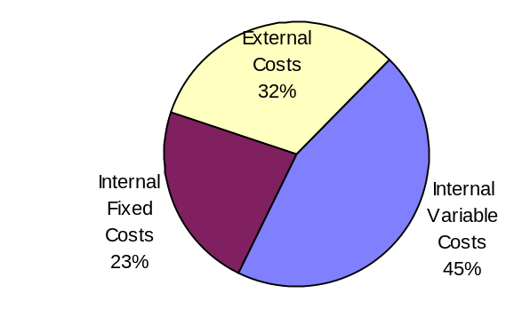
This figure shows that a majority of automobile costs are either fixed or external.

Figure 2 shows the distribution of motor vehicle expenses (financial costs). Most are considered fixed with respect to vehicle travel. This price structure encourages excessive driving since vehicle owners perceive minimal savings when they reduce their mileage.

Figure 2 Typical Financial Costs of an Intermediate Size Car
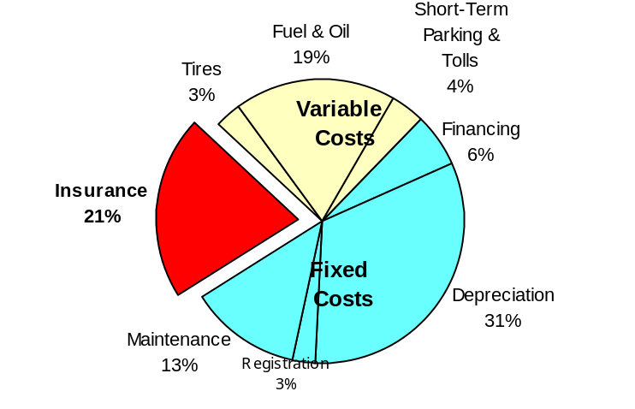
This figure illustrates the distribution of financial costs for an intermediate size car.

Although fixed vehicle expenses have increased during the last three decades, variable costs have decreased in real terms. As a result, variable costs as a portion of total costs have declined significantly over the last several decades, as indicated in Figure 3.

Figure 3 Variable Automobile Costs as a Portion of Total Costs
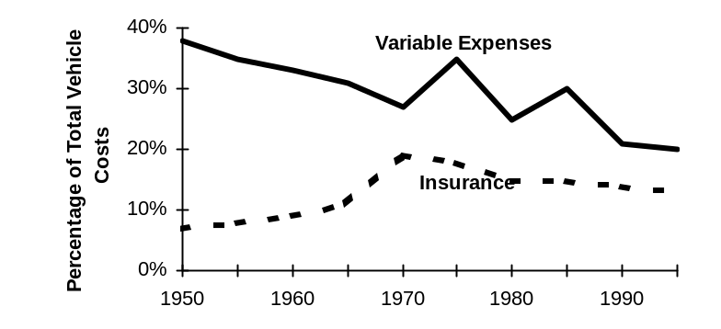
Variable costs have declined as a portion of total vehicle expenses, from almost 40% in 1950 to just over 20% in 1995.

Current insurance pricing fails to effectively represent marginal crash costs. This creates a number of problems:
- It is economically inefficient. It does not convey to drivers the true costs they impose, and deprives drivers of a chance to save money by avoiding costs. This reduces consumer choice.
- It is unfair. It significantly overcharges low mileage vehicles and undercharges high mileage vehicles relative to their true crash risk costs.
- Since lower income households tend to drive their vehicles less than average, it is regressive.
- In order to provide “affordable” but unlimited (in terms of mileage) insurance coverage, low-risk drivers are overcharged while higher-risk drivers are undercharged their true costs. This fails to provide efficient rationing of travel risk.
- The excessive driving that results from fixed insurance pricing (about 10% of vehicle travel) increases crashes, congestion, road and parking facility costs and pollution. Thus, the total economic inefficiency is several times greater than just the direct harm to insurance buyers.

Distance-based pricing converts insurance from a fixed cost into a variable cost with respect to vehicle travel. This “marginalizes” crash compensation costs, making premiums more actuarially accurate. Distance-based insurance provides a positive financial incentive to reduce mileage by returning to individual vehicle owners a greater share of the insurance cost savings that result when they drive less. These insurance savings are currently dispersed among all vehicles in a rate class.

Relationship Between Vehicle Travel and Crashes
Common sense indicates that a vehicle’s crash risk is related to how much it is driven. All else being equal, increased driving increases crash risk. There is considerable empirical evidence indicating this relationship. Insurance actuaries recognize it.

A given reduction in vehicle travel can cause proportionally larger declines in crashes, since it reduces each vehicles’ chances of both causing a crash and being hit by another vehicle. About 70% of crashes involve multiple vehicles. An average driver is culpable (at-fault) in less than 50% of the crashes they are involved in. As a result, a 10% reduction in a vehicle’s mileage reduces that vehicle’s claim rate by 10%, and total claims, by as much as 17%, since it reduces risks to other road users, including accidents caused by another driver’s error.

Available data on the relationship between mileage and crash rates is almost entirely based on comparisons between different vehicles, which underestimates the true crash reduction that results when individual vehicles reduce their annual-mileage, since most factors that influence crash rates are held constant. This further implies that crash reductions and insurance claim cost savings should exceed travel reductions, although how much is difficult to predict with available data.

Low-mileage vehicles as a group tend to have higher crash rates per mile than higher-mileage vehicles for the following reasons:
- People with specific high-risk attributes related to age and physical disability tend to limit their annual mileage, while high-mileage drivers are likely to be relatively capable drivers.
- Newer, mechanically safer vehicles tend to be driven more each year than older vehicles.
- Urban drivers tend to have higher crash rates and lower annual vehicle-mileages.
- High vehicle-mileage drivers tend to do a greater share of their travel on safer, grade-separated highways.
- There may also be other types of offsetting behaviors, by which higher-mileage drivers take more precautions to limit their risk.

In the past, insurers and other road safety experts actually had little information on the relationship between individual vehicles’ annual mileage and crash rates. The data were simply not available. Since 1993, motor vehicles in the Greater Vancouver region have been required to undergo emission tests prior to their annual registration. These odometer readings have been matched to the insurance claim records of specific vehicles, providing a unique database of the relationship between crashes and claims.

Figure 4 Distribution of Annual Vehicle Kilometres
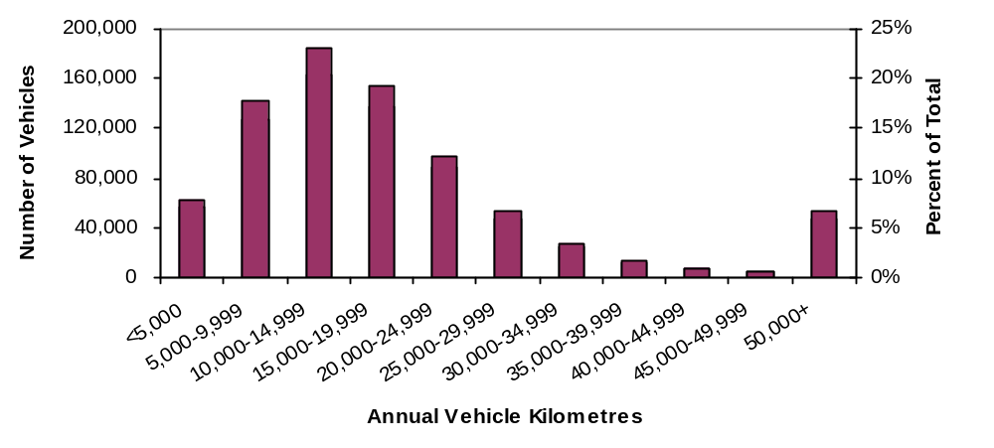
This figure shows the distribution of vehicle-kilometres.

Figure 5 illustrates the relationships between annual vehicle kilometres and crash rates for all vehicles in aggregate. It shows that both culpable and non-culpable crashes tend to increase with vehicle use in the most common annual-kilometre ranges (0-40,000 km/yr).

Figure 5 Crash Rates by Annual Vehicle-mileages¹⁰
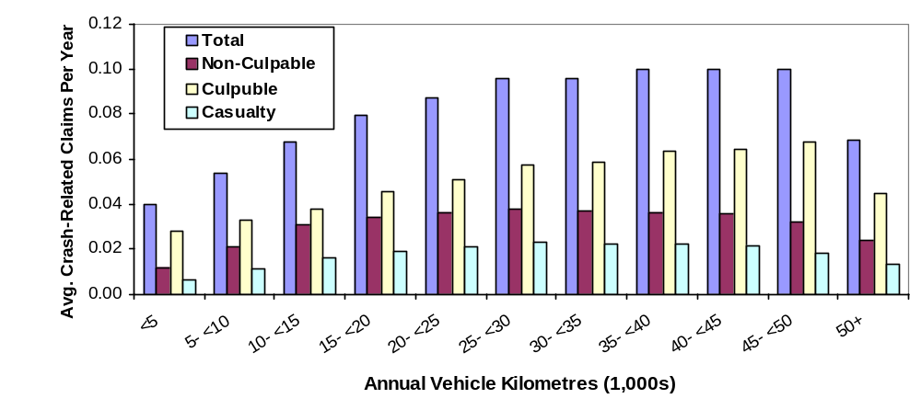Crash rates tend to increase with annual kilometres at the aggregate level.

Figure 6 shows the crash rates for various major categories. Figure 7 illustrates crash rates for individual “RoadStar” rate classes (RoadStar refers to vehicles with at least nine continuous years without a culpable claim). Crash rates tend to increase with annual vehicle use in all categories.

Figure 6 Crashes Per Year By Major Category and Annual Kilometres¹⁰
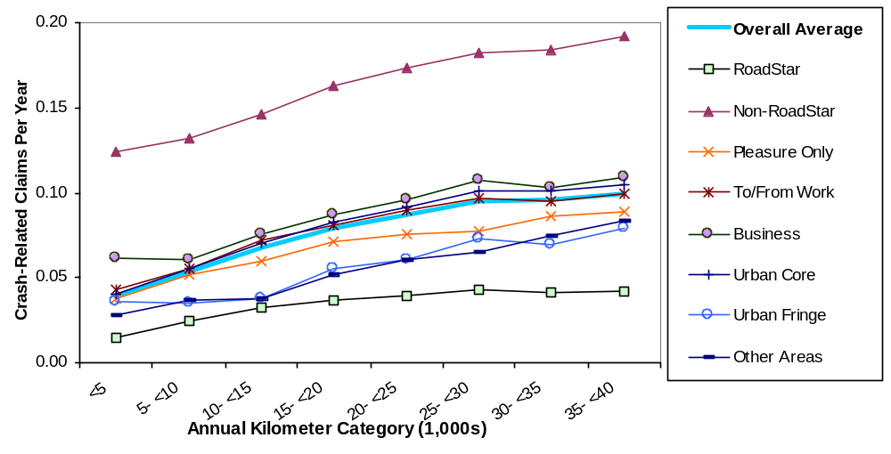All categories show a positive relationship between crashes and vehicle travel.

The evaluation by rate class is particularly important for this study because it represents actuarial analysis. These graphs show clearly that within specific pricing categories there is a strong positive relationship between vehicle travel and crashes. This indicates that distance-based pricing is essential for actuarial accurate pricing.

Figure 7 Crashes Per Year By Individual Rate Classes¹⁰
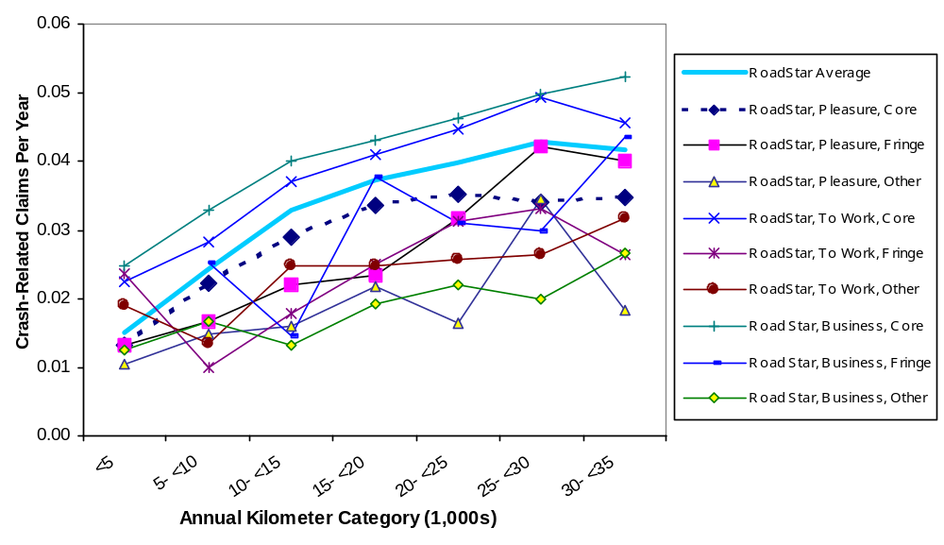This figure shows that crash rates increase with annual vehicle travel within rate classes.

Distance-Based Insurance Pricing Options
Three distance-based insurance pricing strategies are described in this section.

Mileage Rate Factor (MRF)
Vehicle insurance could become more distance-based by placing greater weight on mileage in existing rate structures, based on drivers’ self-reported estimates of future travel. However, vehicle owners cannot predict with certainty how many miles they will drive, and most vehicle owners significantly underestimate their annual mileage if this reduces their annual premiums. As a result, Mileage Rate Factor is inaccurate and can only apply a small portion of the actuarially justified weight on mileage.

Pay-at-the-Pump (PATP)
Pay-at-the-pump uses a surcharge on fuel sales, vehicle registrations and drivers licenses to fund basic insurance coverage. Proposed fuel surcharge range from 15-50¢ per gallon, depending on coverage. Collision and comprehensive coverages, non-gasoline vehicles, and driving in other jurisdictions requires insurance purchased as it is now. Various administrative systems have been proposed. Some establish government insurance agencies, others have insurance companies bid on blocks of vehicles, or funds distributed to private firms based on the number of policies they sell.

A major disadvantage with PATP insurance is that it does not directly incorporate drivers’ risk factor. Low-risk drivers with fuel-intensive vehicles would overpay their actuarially-justified insurance costs, while high-risk drivers with fuel-efficient vehicles would underpay. To address this, most proposals also include surcharges on higher-risk drivers and vehicles to incorporate various risk factors.

A second disadvantage of PATP is that it would only cover about half of total insurance premiums, only part of which would be distance-based. It would encourage high mileage drivers to shift to non-gasoline vehicles, resulting in mixed emission and energy consumption impacts.

Another disadvantage of PATP it that it could cause significant revenue “leakage” from cross-borders and illegal fuel purchases. This would introduce a new inequity, since drivers who have the opportunity and inclination to purchase fuel across borders or illegally would have their insurance costs subsidized by drivers who have less opportunity or inclination.

PATP provides universal liability coverage (at least for gasoline vehicles) which makes it attractive in jurisdictions with high rates of uninsured driving. However, there are other ways to address this problem. For example, uninsured driving is not a significant problem in British Columbia due to the integration of vehicle insurance and licensing transactions (vehicle owners must pay for insurance to obtain license tabs). Distance-based insurance addresses a major cause of uninsured motoring by making insurance more affordable. The added cost recovery of uninsured motoring is expected to be more than offset by losses through cross-border and illegal fuel purchases in many jurisdictions.

Per-Mile Premiums (PMP)
This strategy means that vehicle insurance is sold by the vehicle-mile or -kilometer rather than the vehicle-year. Other rating factors are incorporated into this price unit, so higher-risk vehicles would be charged more per mile than would lower-risk vehicles. Table 1 shows an example of this price structure.

Table 1 Per-Mile Premiums for Selected Rate Classes
 | Pleasure Use,  Urban Core | Pleasure Use, Urban Fringe | To Work, Urban Core | To Work, Urban Fringe | Business Use, Urban Core | Business Use, Urban Fringe
Lower-risk | $0.020 | $0.016 | $0.027 | $0.016 | $0.026 | $0.017
Higher risk | $0.125 | $0.094 | $0.111 | $0.087 | $0.108 | $0.088
Premiums vary depending on factors such as driver history, rate class and territory.

Per-Mile Premiums requires “odometer auditing” to collect accurate vehicle-mileage data. Odometer audits would be performed when a vehicle’s insurance is renewed, in most cases once a year. Odometer audits involve five steps:
- Check speedometer and instrument cluster for indications of tampering.
- Record tire size and check that it is within the specified range.
- Attach a small seal to the ends of mechanical odometer cables to indicate if it is removed. This is unnecessary on most newer vehicles that have electronic speedometers.
- Check odometer accuracy and calibrate with a dynamometer. (This step is optional, or could be performed on a spot-check basis.)
- Record odometer reading and forward results to the vehicle licensing agency.

Odometer audits typically require 5 to 10 minutes, or less if performed with other vehicle servicing, with incremental cost of $5 to $10 (assuming chargeout rates of $60 per hour). Governments would establish odometer auditor certification programs and incorporate odometer data into the vehicle registration database. Like many other certification programs, odometer auditing could be self-supporting through fees. Odometer auditors would typically be existing vehicle service stations and emission inspection stations, and some insurance agencies might become certified as a marketing strategy.

Most odometer fraud could be detected by auditing, through physical evidence or by discrepancies in readings. Odometer audits should provide data comparable in accuracy to what is used in other commercial transactions, and far more accurate than self-reported information currently used for insurance pricing. It would provide additional benefits, including accurate mileage information to used vehicle buyers, and data for transport planning. Other vehicle fees could become distance-based and therefore more equitable and economically efficient at minimal cost. Vehicle registration fees and taxes, which average about $150 per vehicle year in the U.S., would be particularly appropriate.

Comparison of Distance-Based Insurance Options
This section compares the impacts of the distance-based pricing options.

Actuarial Accuracy
Both Mileage Rate Factor and PATP are significantly constrained in their ability to accurately price crash risk. Mileage Rate Factor is constrained by the weight that can be placed on mileage before self-reported Estimated Future Travel is unacceptably understated. PATP is constrained because it uses fuel consumption as a surrogate for vehicle travel and then incorporates rating factors through fixed (not distance-related) surcharges on vehicle registration fees and drivers’ licenses, resulting in a trade-off between actuarial accuracy and distance-related pricing.

Per-Mile Premiums is unconstrained in incorporating risk factors. Virtually any rating factor can be incorporated into the vehicle-mile price unit. It is inherently superior to other alternatives in terms of actuarial accuracy.

Implementation Costs
Mileage Rate Factor using self-reported estimates of future travel has the lowest implementation costs. PATP would have moderate to high transition costs, since it requires establishing a new system to fund basic insurance. It could reduce administrative costs for vehicles with only basic insurance, but most drivers would need at least some additional coverage, resulting in little overall savings.

Per-Mile Premiums requires a new rate plan and an odometer auditing system. The majority (85-95%) of audits would probably be performed with other scheduled servicing with an estimated incremental cost of $5.00 per vehicle year, while a minority (5-15%) would pay a $10 fee plus another $10 in travel and time costs, resulting in an average incremental cost of $7.50 per vehicle year.

Travel Impacts
Distance-based insurance pricing provides vehicle owners with a new opportunity to save money by reducing their driving. The magnitude of these savings varies, from an average of about 0.7¢ per mile for Mileage Rate Factor, to 1.7¢ per mile for PATP; up to about 5.6¢ per mile for Per-Mile Premiums, or 6.9¢ if registration fees are also prorated. This increase in potential savings effectively increases the variable cost of driving (offset by a reduction in fixed costs) as indicated in Figure 8.

Figure 8 Distance-Based Insurance Impacts On Variable Vehicle Costs
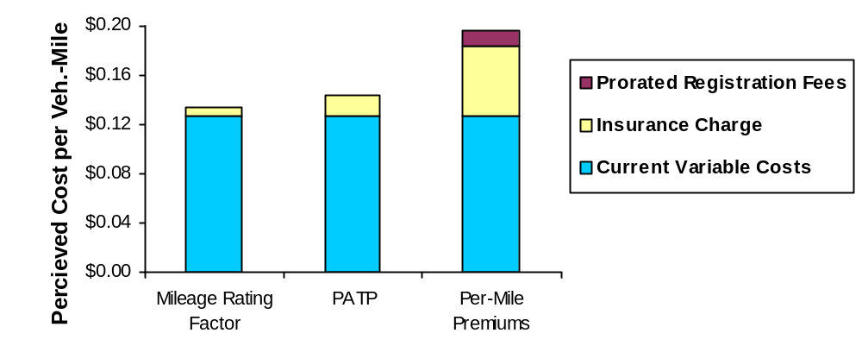
This figure compares how each option increases the variable cost of driving.

Figure 9 illustrates how the strategies increase perceived variable costs. This would reduce vehicle travel. Drivers respond to financial incentives by consolidating trips, shifting destinations, changing modes, and foregoing lower-value travel.

Figure 9 Variable Costs Compared
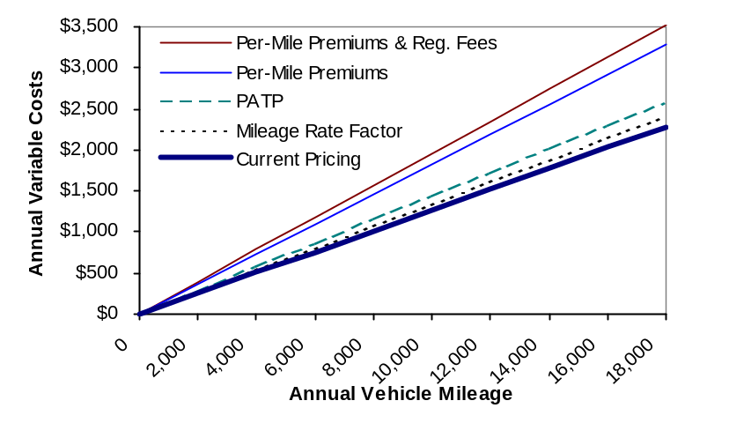
This figure compares how perceived variable costs are affected by the different options.

Distance-based insurance could increased vehicle ownership since it reduces fixed costs. However, vehicle travel would probably not increase significantly. Most additional vehicles are likely to be second vehicles, such as an old truck or a collector car. These would substitute for, rather than add to, existing travel. Only drivers who purchase their first vehicle due to low fixed insurance costs would increase vehicle travel, and their annual mileage should be low – otherwise they would perceive no savings.

Some people suggest that Per-Mile Premiums may have little impact on travel because payments are infrequent, resulting in several months separating a typical trip and its incremental insurance cost. However, total charges are large, involving hundreds of dollars per year, and therefore highly visible to consumers. In a similar pricing situation, there is little evidence that households using oil or wood fuel purchased annually are less motivated to conserve heat than homeowners using gas or electric heat which is paid monthly or bi-monthly. Most drivers are likely to respond to this financial incentive, although perhaps somewhat less than a more frequent fee.

Table 2 Travel Reductions Estimates
 | Mileage Fee | Vehicle Travel Reduction |  | Mileage Fee | Vehicle Travel Reduction
 | 1¢ | -2.3% |  | 6¢ | -12.6%
 | 2¢ | -4.5% |  | 7¢ | -14.5%
 | 3¢ | -6.6% |  | 8¢ | -16.3%
 | 4¢ | -8.7% |  | 9¢ | -18.0%
 | 5¢ | -10.7% |  | 10¢ | -19.7%

Using standard elasticity values, such as those in Table 2, the travel impacts of these price changes can be estimated, as summarized in Table 3.

Table 3 Predicted Travel Impacts
 | Mileage Rate Factor | PATP | Per-Mile Premiums (PMP) | PMP & Prorated Registration
Increased variable cost | 6% | 13% | 44% | 54%
Travel reduction | 1% | 6% | 10% | 12.5%
Avg. annual vehicle-miles reduced | 125 | 750 | 1,250 | 1,563

Crashes and Crash Costs
As previously described, vehicle travel reductions can provide proportionally greater crash reductions by reducing each vehicles’ chances of causing a crash and being hit by others. Crash reductions of 1.2% are predicted for Mileage Rate Factor, and 7.2% for PATP. Per-Mile Premiums provides even greater crash reductions because it gives higher-risk drivers extra incentive to reduce mileage, resulting in a 14% crash reduction alone, and as much as a 15% reduction if implemented with prorated registration fees.

Energy and Emission
Mileage Rate Factor would provide little reduction in energy consumption or emissions. PATP would reduce fuel consumption, and fuel related emissions such as CO₂, by up to 15% (depending on fuel switching and fuel sale “leakages”), but other emissions (such as NOx and particulates) would decline by smaller amounts. Per-Mile Premiums would reduce energy consumption and all emissions by 10-12%.

Congestion and facility cost savings
Reductions in vehicle travel tend to reduce traffic congestion, and road and parking facility costs. One major pricing study found that a 2¢ per mile mileage charge would reduce total vehicle travel by about 3.9-4.2%, but congestion delays would decline by 7.5-10.5%. In other words, congestion delay reductions were approximately twice as large as vehicle travel reductions. Mileage Rate Factor would provide little benefit. PATP would reduce vehicle travel by about 6%, providing modest benefits. Per-Mile Premiums would reduce travel by 10-12%.

Consumer Benefits and Costs
Marginal pricing benefits consumers by allowing them to purchase just the quantity of goods they want. For example, consumers benefit if they can purchase pizza by the slice, rather than being forced to buy an entire pizza pie. Distance-based insurance allows consumers to purchase just the amount of crash risk they can afford. Figure 10 shows how total costs vary with mileage under the different pricing strategies. Impacts on total vehicle costs are modest since insurance is just one of many expenses.

Figure 10 Comparison of Total Costs By Annual Mileage
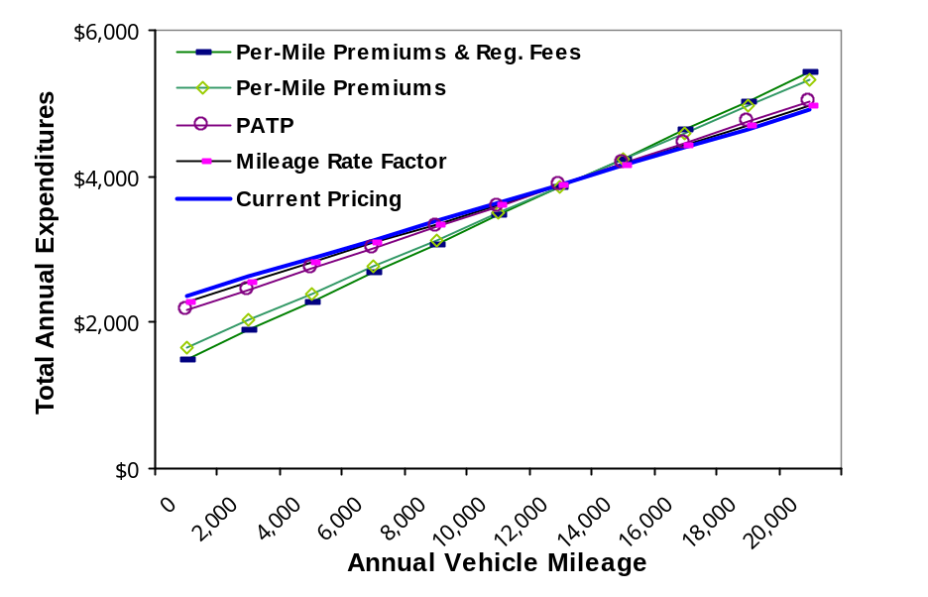
This graph illustrates the effects different pricing options would have on total costs of an intermediate-size automobile by annual vehicle-mileages.

Most consumers would benefit under Distance-Based Insurance. Motorists who drivers their vehicles less than the current average for their rate class (about 10,000 annual miles for urban motorists and 15,000 miles for rural motorists) would save insurance costs.

Figure 11 Comparison of Costs For Various Mileage Vehicles
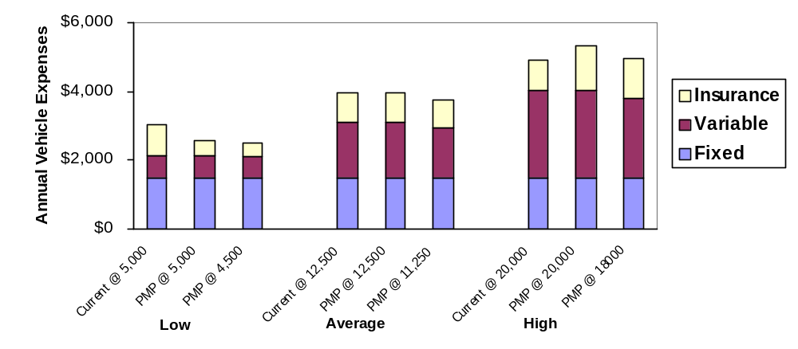
This figure illustrates total annual costs for low-, average-, and high-mileage vehicles. Numbers refer to annual mileage. PMP=Per-Mile Premiums.

Motorists are expected to reduce their average mileage by about 10% under distance-based pricing, providing net savings to the vast majority of consumers. Even high mileage drivers experience virtually increase in total vehicle costs if they reduce their mileage as predicted. Higher-mileage drivers would also benefit most from reduced traffic congestion, accident risk, and pollution.

Equity
Current insurance pricing is unfair (horizontally inequitable) since premiums are not actuarially accurate, and regressive (vertically inequitable) since lower income households tend to drive less than average. Mileage Rate Factor slightly improves equity. PATP replaces current inequities with new inequities: overcharging lower-risk drivers with fuel inefficient vehicles who do not have access to untaxed fuel. PATP is likely to be regressive as lower income households end up with higher fuel consumption vehicles. Per-Mile Premiums is most equitable because it accurately reflects crash costs (horizontal equity) and provides the greatest savings to lower income households (vertical equity).

Affordability and Uninsured Driving
Distance-based insurance increases affordability by allowing consumers to purchase just as much accident risk as they can afford. This reduces the need for distortive cross-subsidies in current pricing to provide “affordable” unlimited insurance even to high-risk drivers. Mileage Rate Factor converts only a small portion of fixed costs to variable costs and so provides minimal affordability benefits. PATP provides moderate benefits since more than half of insurance costs would still be fixed. Per-Mile Premiums shifts the most fixed costs to variable charges and so offers the greatest affordability benefits. PATP reduces uninsured driving by providing coverage for all gasoline vehicles. Per-Mile Premiums reduces uninsured driving by making insurance affordable, and could be particularly effective if matched with better enforcement of insurance requirements.

Economic Efficiency, Productivity and Development
Distance-based insurance directly increases economic efficiency by making prices more accurately reflect marginal costs. It can also increase economic productivity indirectly by reducing motor vehicle externalities (congestion, crashes, roadway costs, etc.) and by shifting consumer expenditures to goods that have greater employment generation.

Mileage Rate Factor provides little economic benefit. PATP does not reflect marginal crash costs, and so does not increase economic efficiency directly, but moderately reduces vehicle externalities. However, PATP imposes significant economic costs to a particular jurisdiction by increasing cross-border and illegal fuel sales. Per-Mile Premiums provides the greatest economic benefits by most accurately reflecting marginal costs and providing the greatest reduction in vehicle externalities.

Public Acceptability
There appears to be a modest majority of support for distance-based insurance pricing as a TDM strategy. Of the three options there appears to be least support for PATP. Mileage Rate Factor requires the least change from current practices, but consumers may be uncomfortable with pricing based on unverified data. Public acceptance of Per-Mile Premiums appears to depend on policy makers’ ability to demonstrate that incremental costs (including consumer inconvenience) are significantly smaller than benefits, and that it is equitable. If this is done there is evidence that the public would accept this option.

Summary of Benefits
Table 4 evaluates the three strategies in terms of the twelve criteria. Mileage Rate Factor has the lowest implementation costs and ties for public acceptability. PATP ties for reducing energy consumption, and pollution emission and uninsured driving. Distance-Based Pricing is best for eleven criteria.

Table 4 Summary of Impacts (= Best )
 | Mileage Rate Factor | PATP | Per-Mile Premiums
Actuarial Accuracy |  |  | 
Implementation Costs | 
Travel Impacts |  |  | 
Crash Reduction |  |  | 
Energy Use & Emission Reduction |  |  | 
Congestion & Facility Cost Savings |  |  | 
Consumer Surplus |  |  | 
Equity |  |  | 
Affordability |  |  | 
Uninsured Driving |  |  | 
Economic Efficiency |  |  | 
Public Acceptability |  |  | 
Total Bests | 2 | 2 | 11

Figure 12 summarizes estimated monetized benefits and costs in British Columbia. This analysis indicates that all three options provide benefits that exceed incremental costs. Per-Mile Premiums has the greatest net benefits, with an estimated Benefit/Cost ratio greater than 50. This indicates that even if actual costs were significantly higher than predicted, and benefits were lower, it is still a worthwhile policy. Any one of the five monetized benefits would justify the incremental costs of this strategy.

Figure 12 Summary of Total Benefits and Costs
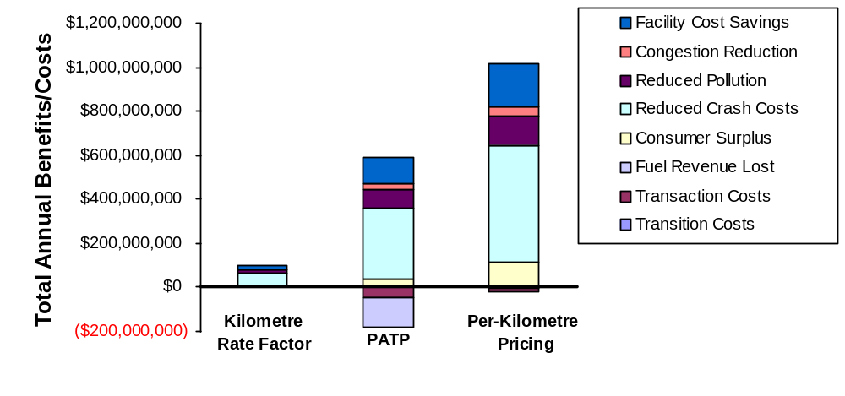 This figure illustrates the total estimated benefits (above the line) and costs (below the line). Only easily quantified benefits are incorporated.

Conclusions
Distance-based insurance has many benefits: increased horizontal and vertical equity, reduced crashes, increased economic efficiency and productivity, and various TDM objectives. It achieves insurance affordability by allowing consumers to purchase just as much accident risk as they can afford, reducing the need for highly distortive cross-subsidies from low- to high-risk drivers. Of the three strategies considered:
- Mileage Rate Factor is easiest to implement but is highly constrained. Only a small portion of the actuarially accurate weight can be placed on mileage before self-reported estimates of future vehicle travel become unacceptably distorted.
- Pay-at-the-Pump has several problems. It is not actuarially accurate because payments are based on vehicle fuel efficiency, not risk factors. Less than half of insurance payments would be distance-based, and cross-border and illegal fuel purchases could become major problems. It reduces fuel consumption, but causes smaller vehicle travel reductions. It is almost as regressive as current pricing. It reduces uninsured driving, but there are more effective ways to address this problem. Although PATP is claimed to reduce administrative costs, most vehicle owners would need to purchase additional coverage, providing little true savings.

- Per-Mile Premiums is the most effective strategy for achieving most objectives because it is most actuarially accurate and has the greatest impact on prices and vehicle travel. Virtually any risk factor can be incorporated into this price structure. It causes about twice the vehicle travel reduction as other distance-based insurance strategies, providing twice the reduction in traffic congestion, roadway and parking costs, and much greater consumer welfare benefits. It approximately equals PATP in pollution reduction. It is most effective at reducing vehicle crashes. It is the most fair (horizontal equity) and would provide the greatest financial benefit to lower income households (vertical equity). Odometer auditing could provide additional benefits, including a mileage record for used vehicle buyers, data for transport planning, and the ability to implement other distance-based pricing at virtually no added cost.

Since Per-Mile Premiums is theoretically best for achieving most objectives, the question is whether it is technically, economically and politically feasible. Our research indicates:
- The only additional technical requirement is the collection of accurate vehicle-mileage data. Odometer audit accuracy could be comparable to other common commercial transactions if it includes reasonable measures to prevent and detect fraud. Much larger average financial transactions are currently based on odometer readings. By creating an accessible database of each vehicle’s annual odometer readings, total odometer fraud should decline.
- The incremental cost of an odometer audit is about $10 when performed alone, or about $5 when performed in conjunction with other scheduled vehicle maintenance, such as an oil change or emission inspection. The majority of vehicles (85-95%) would probably have audits integrated with other scheduled servicing. Total incremental costs, including vehicle owners’ travel and time cost, are likely to average $7.50 or less per vehicle year. The incremental costs of Per-Mile Premiums are much less than that of typical vehicle Inspection/Maintenance programs while providing much greater benefits.
- There appears to already be willingness by consumers to consider distance-based pricing, despite the fact that most have only a vague idea of how it could be implemented, excessive estimates of implementation costs, and underestimates of total benefits. Since it has a number of favorable features that would result in net benefits to most households there seems to be considerable political potential if the full benefits can be effectively communicated to citizens.

Appendix

Answers to Common Concerns About Distance-Based Insurance

“But vehicle travel is already incorporated in insurance pricing.”
Although some insurance companies incorporate mileage factors in their pricing, none begins to approach actuarially accurate, marginal pricing. Current pricing is unfair, since lower-mileage drives overpay, while higher-mileage drivers underpay their true insurance costs. Current pricing also fails to encourage efficient travel. Nobody wakes up in the morning and says, “I’ll take the bus today rather than drive to work this morning to save insurance costs.” Per-mile premiums would provide a significant additional financial incentive to reduce driving.

“Shouldn’t automobile insurance reform should focus on affordability and safety?”
Distance-based insurance does significantly improve insurance affordability and safety. It allows motorists to reduce their insurance costs by limiting their vehicle use. It can reduce traffic crashes, casualties and related costs by as much as 17%%, making it one of the most effective traffic safety programs currently under consideration. Per-mile premiums provides accurate crash rate information which will allow more effective crash prevention programs and more precise insurance pricing.

“Wouldn’t distance-based insurance unfairly increase costs to high-mileage drivers (rural drivers, business drivers, etc.)?”
High mileage motorists tend to have relatively low per-mile crash rates, so their per-mile fees would be low. Drivers would only pay more for insurance if they drive more than average for their class. For example, a rural motorists who currently pays $300 annually for insurance would only pay 2¢ per mile, assuming that vehicles in their class are driven an average of 15,000 miles annually. They would save if they drove “only” 14,000 per year, even though that is greater than the provincial average.

Even very high-mileage drivers would pay only slightly more in total vehicle costs under distance-based insurance, since their other vehicle expenses are relatively high. For example, although total vehicle costs for a low-mileage (5,000 miles per year) driver would decline an average of 14-17%, total costs for a high-mileage vehicle would increase just 1% on average, due to the relatively small portion of total costs that insurance represents for high-mileage vehicles, and the expected reduction in mileage. Incremental costs would be even lower as a percentage of costs for businesses, which pay wages and per diem in addition to vehicle expenses.

Per-mile premiums more accurately reflect individual motorists’ crash risk than is possible with current pricing. Any price increase that does result from a shift to distance-based insurance indicates that higher-mileage drivers are currently being subsidized at the expense of lower-mileage motorists in their rate class. Since vehicle use tends to increase with income, distance-based insurance is progressive. It is therefore inaccurate to argue that price increases for higher mileage drivers are “unfair.”

“Wouldn’t it require an enormous increase in administrative costs to insurers, and inconvenience to vehicle owners?”
Per-mile premiums require odometer audits, which are predicted to have an average incremental cost of about $7.50 per vehicle year. Most audits are expected to be performed in conjunction with other vehicle servicing at minimal extra cost. This represents an incremental cost of only about 1%, and a net savings of $62.50 for average drivers who reduce their mileage the expected 10%. Similarly, incremental administrative costs to insurance companies should be more than offset by the predicted 10-15% reduction in claim costs.

To put this cost into perspective, vehicle emission inspections typically cost $10-20 plus drivers’ travel and time costs, to achieve a reduction in tailpipe emissions that is approximately the same as what would be provided by Per-Mile Premiums. Thus, current inspection programs impose incremental cost three to four times greater than what is predicted for Mileage Pricing, while providing only a small portion of the total benefits, since they do nothing to reduce accidents, traffic congestion, infrastructure costs, or consumer costs.

“Won’t odometer fraud will become a major problem.”
A number of financial transactions already depend on odometer readings, including warranty determinations, rentals and leasing charges, vehicle resale value, and expense reimbursement. Vehicle owners can often gain thousands of dollars by rolling back odometers, but most would never do so. The benefits are simply not worth the risks. Odometer fraud is primarily a problem among used car dealers, particularly when selling high-mileage, late model vehicles. Fraud is likely to be significantly lower for distance-based insurance, because:
- New vehicle odometers are increasingly tamper-resistant. Within a few years the majority of new vehicles sold are likely to have digital odometers that are extremely tamper resistant.
- Vehicle owners would have a relatively small incentive for fraud, a tenth of what vehicle dealers typically gain.
- Private vehicle owners don’t have ready access to professional “clockers.” Amateurs often damage equipment or leave marks, resulting in high costs and penalties.
- Discovery of odometer fraud would void insurance coverage. Most forms of fraud can be detected during a crash investigation, voiding the coverage. This would discourage odometer tampering and reduce insurance company’s risk of losses.
- Annual odometer audits would provide a database that would allow used vehicle purchasers to identify discrepancies, making tampering easy to spot. It should virtually eliminate odometer tampering by vehicle sellers, so total odometer fraud is likely to decline.

Although some odometer fraud is likely to occur under distance-based pricing, it is not expected to occur at a particularly high rate, and the overall rate of odometer fraud is expected to decline due to regular odometer audits. Even if as many as 2-4% of vehicle owners altered their odometers to disguise half their true mileage each year (actual fraud rates are likely to be lower), only 1-2% of mileage charges would be “stolen,” and if the tampering is discovered during a claim investigation, insurance coverage would be void, resulting in no theft at all. Fraud rates are likely to be within the range of other common consumer transactions, and far lower than with current insurance pricing, which is based on self-reported estimates of annual mileage or commute distance, and other factors that are seldom verified and which have minimal penalties.

“Isn’t vehicle insurance an inappropriate way to address transportation problems?”
There are compelling insurance fairness, affordability and safety reasons to implement distance-based insurance. The current insurance pricing system is less fair, less affordable, and results in significantly more crashes than would occur under distance-based pricing. Society has long recognized that it has an interest in regulating vehicle insurance for a variety of objectives, virtually all of which are achieved by implementing distance-based insurance.

“But this type of pricing has never been used before.”
It is true that distance-based vehicle insurance has not been implemented exactly as proposed here, but there is nothing unique or new with such pricing. Most goods are priced based on some measure of consumption. Imagine what would happen if electricity, fuel or food were sold with a fixed price that allowed virtually unlimited consumption. Vehicle insurance is unusual among major consumer goods for having pricing that allows unlimited consumption. In fact, a portion of vehicle insurance is already distance-based: Insurance rates for vehicle fleets and commercial vehicles are commonly based on annual mileage. Insurance companies have tried various forms of distance-based pricing in the past. However, they have found that self-reported mileage data is unreliable. The unique feature of this proposal is the use of verified mileage readings using an odometer audit.

“Drivers will not actually respond to this incentive.” “There will be no reduction in vehicle use or crashes.” “It is paid too infrequently to affect travel decisions.”
Per-mile premiums would significantly increase marginal vehicle costs, approximately equivalent to a doubling of fuel prices. There is extensive evidence that price incentives affect consumption patterns, particularly over the long term. Consider how consumers respond to advertised sales, the various measures that homeowners take to insulate their homes to save heating costs, and the enthusiasm for marketing strategies such as frequent-flyer benefits. Standard estimates of the effects of price changes on vehicle travel indicate that per-mile insurance pricing should reduce vehicle use by about 10%.

“If it makes vehicle ownership more affordable, won’t that lead to increased traffic?”
Distance-based insurance would significantly reduce vehicle ownership costs, allowing some households to own more vehicles, but this is not expected to increase total vehicle travel. Since most drivers in North America already own a vehicle, most of the increased vehicles are likely to be second vehicles that are owned for special uses, such as an old truck used occasionally to haul gardening supplies, or a sport vehicle that is only used for recreational travel. Most of this driving will therefore substitute for other vehicle use, rather than add to total household automobile travel.

A small number of households may use this opportunity to purchase their first vehicle, but these will receive little use. After all, if they are used more than a moderate amount, households would perceive no savings over current insurance pricing. Thus, the total increase in vehicle travel that results from reduced vehicle ownership costs should be overwhelmed by the total reduction in vehicle use from higher vehicle operating costs.

“Wouldn’t odometer auditing be an invasion of privacy?”
Odometer auditing simply records odometer readings. It does not identify when or where a vehicle has been used. Odometer readings are already collected on vehicle sales, during emission inspections, and by vehicle service businesses.

“Consumers may dislike not knowing their total insurance charges in advance.”
Distance-based insurance would be like most goods, the more you use, the more you pay. While this makes insurance bills slightly less predictable, it allows consumers to control their expenditures. Consumers could easily calculate and predict their annual insurance bill based on their odometer readings.

“Such a radical change will face too much political opposition to be implemented.”
Virtually any innovation is bound to face political opposition from those who benefit from existing practices, regardless of how beneficial overall. However, political opposition to distance-based insurance should be minimal once citizens learn about the proposal, because it offers so many benefits. Per-mile insurance is fairer than current pricing, and reduces a broad range of problems. It benefits consumers, drivers, local governments, businesses and the environment. Low mileage drivers would benefit directly, and high mileage drivers would benefit from reductions in congestion, accident risk and pollution. It can gain support from a broad range of stakeholders and political groups.

Towards Fair and Efficient Pricing In Transport, European Commission (Brussels; http://europa.eu.int/en/record/green/gp9512/ind_tran.htm), 1997.
Todd Litman, Socially Optimal Transport Prices and Markets, Victoria Transport Policy Institute (Victoria; www.islandnet.com/~litman), 1998.
Todd Litman, Transportation Cost Analysis; Techniques, Estimates and Implications, Victoria Transport Policy Institute (Victoria; www.islandnet.com/~litman), 1998.
Jack Faucett Asso., Cost of Owning and Operating Automobiles, Vans & Light Trucks, 1991, FHWA.
Facts and Figures 95, Motor Vehicle Manufacturers Association, 1995, p. 58.
William Vickrey, “Automobile Accidents, Tort Law, externalities, and Insurance: An Economist’s Critique,” Law and Contemporary Problems, 33, 1968, pp. 464-487.
Aaron Edlin, Per-Mile Premiums for Auto Insurance, Dept. of Economics, University of California at Berkeley (http://emlab.berkeley.edu/users/edlin), 1998.
Foundations of Casualty Actuarial Science, 3rd Edition, Casualty Actuarial Society (Arlington; www.casact.org), 1996, p. 35. Also see p. 242 and 250.
Mary Janke, “Accidents, Mileage, and the Exaggeration of Risk,” Accident Analysis and Prevention, Vol. 23, No. 3, 1991, pp. 183-188; Gerald Wilde, Target Risk, PDE Publications (Toronto), 1994.
Data from the Insurance Corporation of British Columbia (North Vancouver), 1998.
Lyn Hundstad, Robert Bernstein, and Jerry Turem, Impact Analysis of Weighting Auto Rating Factors to Comply with Proposition 103, California Dept. of Insurance (Sacramento), 1994.
Andrew Tobias, Auto Insurance Alert, Fireside (New York), 1993; Stephen Sugarman, “Pay at the Pump” Auto Insurance, Institute of Government Studies Press (Berkeley), 1993; Tom Wenzel, Analysis of National Pay-as-you-Drive Insurance Systems and other Variable Driving Charges, Energy & Environment Division, Lawrence Berkeley Laboratory (Berkeley), July 1995.
Patrick Butler, Operation of an Audited-Mile/Year Automobile Insurance System Under Pennsylvania Law, National Organization for Women (Wash. DC; www.now.org), 1992; Todd Litman, “Distance Based Vehicle Insurance as a TDM Strategy,” Transportation Qrtly, Vo. 51, No. 3, Summer 1997, pp. 119-138.
Olof Johansson and Lee Schipper, “Measuring the Long-Run Fuel Demand for Cars,” Journal of Transport Economics and Policy, Vol. 31, No. 3, 1997.
Elizabeth Deakin and Greig Harvey, “The STEP Analysis Package,” in Guidance on the Use of Market Mechanisms to Reduce Transportation Emissions, USEPA (Washington DC; www.epa.gov/omswww/market.htm) Sept. 1997, Appendix B.
Elizabeth Deakin and Greig Harvey, Transportation Pricing Strategies for California: An Assessment of Congestion, Emissions, Energy, and Equity Impacts, Calif. Air Resources Board (Sacramento), 1996. 7-16.
Viewpoints Research, “A Comprehensive Overview of TDM Public Opinion Research,” Greater Vancouver Regional District (Burnaby), 1995.
Many used vehicles purchasers pay as much as U.S.$29.95 for vehicle odometer data (www.autocritic-us.com/autofacts.htm).

