Automated Business Systems: The Myth, Mystery, and Magic
Marc Montgomery, May 23, 2002
“Story on the Story” by Susan Hendrickson

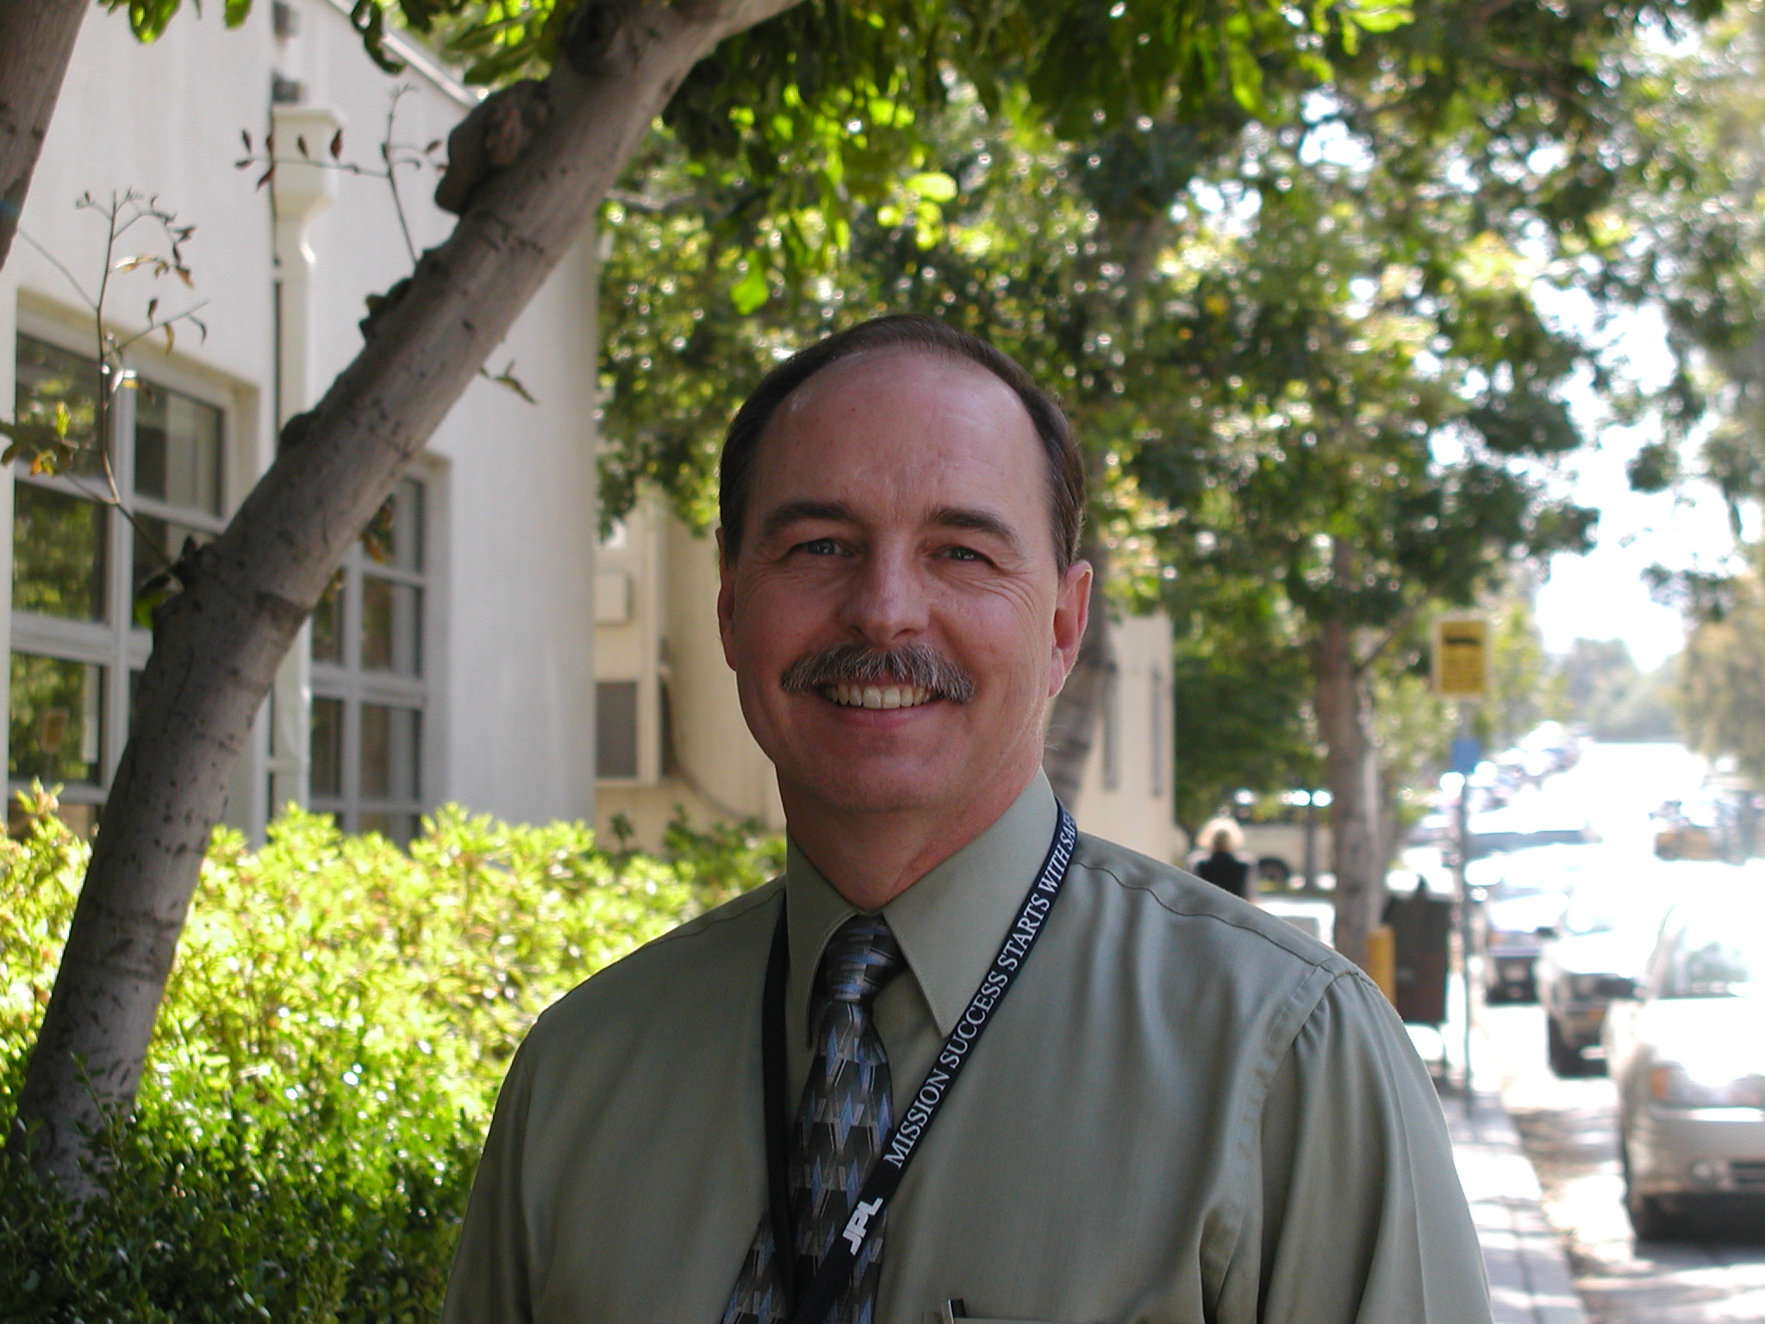

Marc Montgomery is Manager of Institutional Business Systems division and the project manager for the original New Business Systems (NBS) implementation project, and the recent NBS upgrade. Marc started out at JPL 23 years ago as a buyer in the Acquisition Division.

Marc stated that his thoughts do not necessarily represent those of management. The story is, instead, “Marc’s random thoughts about the challenges and pleasures of business systems.”

In answer to the soul-searching question, “Why do I do this kind of job?,” Marc’s reply is “I don’t know!” The nature of business systems is that there are a number of challenges. Marc quoted Machiavelli: “There is nothing more difficult to take in hand, more perilous to conduct, or more uncertain in its success than to take the lead in the introduction of a new order of things;” which is exactly what the introduction of a new business system is all about. Consequently, the natural reactions of those who will be affected by such major changes to their work lives is at least trepidation, sometimes fear, and often resistance.

In 1998 the Standish Group analyzed the success rate of new business system implementations and found that 34% are complete failures; 52% are “challenged” (over scheduled, over budget, or didn’t deliver what they planned to deliver in the first place); and 16% are considered a success. Why would one pursue something where there is only a 16% chance of “exciting folks on a regular basis?” Marc replied that he
is fascinated with the concept that productivity can be increased with the same amount of resources by changing the processes and tools people have to work with. (As a teenager, he first read about this concept in an article about Frank Gilbreth, time-motion study guru, of Cheaper by the Dozen fame). That fascination seems to be behind most of his career choices ever since.

With tongue-in-cheek, Marc noted the characteristics of a good project manager of business systems: A nice mix of ignorance and naivete (a complete ignorance of what lies ahead); complete, unexplainable optimism in the face of overwhelming facts; teflon skin; hearing impairments; and a wife who will put up with anything. A case of Tylenol PM is also helpful.

The first two attempts at creating automated business tools at JPL started before Marc became involved in the world of business systems; these were unsuccessful. First Myth: What sounds good on paper often doesn’t work out well in practice. Like the idea that, “All we need is to define a good database of all the business data elements. It can’t be that hard to get the elements into the database once we have that defined.” (This was the basis for unsuccessful attempt Number 2.)

The third attempt sort of jelled: In January 1986 (this is where Marc comes into the picture), Frasier Draper in Acquisitions developed the requirements for an automated procurement system. Two weeks were spent off-site at the Balboa Bay Club developing the requirements. A short time later a Human Resources team went through a similar session to develop requirements for an HR system.

Separately, the Procurement and HR teams issued requests-for-proposal for commercial, off-the-shelf software that met the requirements. In August 1987, within two weeks of each other, the two teams independently announced that they had selected McCormick & Dodge software and Andersen Consulting as the implementation consultants. This was the beginning of an integrated business system. Since both Procurement and HR had selected the same software and integrator, it seemed to make sense that the financial system software should come from the same vendor. Soon a program was born, called the Management and Administrative Support System (MASS), under the direction of Jay Schmuecker. The first component of MASS to go live was the procurement system (called SAS) on July 24, 1989.

One of the myths of the MASS Program was: We will change the way we do business to match the software. Within two weeks of going live with the procurement system, management was shoveling that idea out the door, and they began modifying the system like crazy to recreate in an automated way the same processes that were being done on paper.

One of the important decisions of the MASS Program was to go with commercial off-the-shelf (COTS) software, which turned out to be the key to JPL’s first business system success. JPL had tried to build its own system in the past but had failed because developing business software is not our core competency. There are a lot of capabilities and constraints with COTS, however, and you don’t really find out what a system can and cannot do until you turn it on and discover what creative users can do with it. From that point it is a mad scramble to enhance and enable the things that are working right, and trying to fix, eliminate (or at least minimize the impact of) things that aren’t working. When you throw in the fact that you have just completely jerked the rug out from under the comfortable world the users have been enjoying, you don’t find a lot of accolades and excitement surrounding your well-intentioned efforts.

Marc spent five years working on the MASS Program. In April 1992, Marc decided he was “running out of steam.” As he departed, he wrote the poem below to capture his thoughts and experiences of his SAS days, and to reflect on his future with business systems:

FAREWELL TO SAS
April 9, 1992

I arrived at work that fateful day

Seemingly without a care
I had my lunch, I had my smile
I had a lot of hair.

July the second 1986
Dawned bright and blue and clear
And my boss said, “You’re gonna love this job.
It should last just a couple of years.”

“What we want you to do is build us a car
To take us on to the future.
Here’re some specs and a few old parts.”
I discovered what I needed was sutures.

But I launched right in and got me a team
Some good souls, brave and true.
I said, “Guys, we’re gonna build us a car.”
And they eagerly asked what to do.

So we got us some wheels and a frame and some seats.
And we hammered and banged and we polished.
The work was hard, with some honest sweat,
With an occasional weekend demolished.

But finally we said, “She’s ready to tow.
To bring her up to the line.
She ain’t nothin’ fancy, just solidly built
And I think she’ll really do fine.”

So some managers piled in and they waved and they smiled
And said “We’re ready to go.”
So they set the brake and chocked the wheels
And said, “OK, SAS Team, you can tow.”

“We finally made it,” our team did shout,
“It’s all downhill from here.
It’s July the 24th at last.”
We opened champagne and beer.

So we started to roll, to pick up speed
With friends and supporters around
But we’d barely gone a hundred feet
When we heard a funny sound

It was people bailing, jumping overboard
Like rodents from a ship
I looked at Carol, I looked at Bob
“This could be an interesting trip.”

That’s when we noticed some funny things
A moment to realize
That wheels and seats were part of the deal
But brakes were customized.

“Minimize customization;
Put it in with little change.”
Those words were starting to haunt me now
My stomach felt a bit strange.

Now it’s hard to transform a speeding car
To add on many new features.
But we had lots of help as the users shouted
Suggestions from the bleachers.

It took me a while to figure out
Why our reception was so sorry.
We were given the parts for a Volkswagen bug
What was expected was a Ferrari.

But slowly things began to change,
For out of the cheering hoard

In spite of suggestions from their friends
Some brave souls jumped on board.

And with their help we started to add
A few things that were needed.
Like a windshield and doors, and a rearview mirror.
Even the brakes are almost completed.

Now it wasn’t so long ago I got the news

As a brave soul stepped up from the rear
“We lost something on that last curve, Sir.
We think it was your career.”

“That so?” said I. (I took a draught from the bottle)
Must be a sign to leave SAS.
A call from above, a swift kick as it were
That landed right on my…..pants.

So I’m handin’ the reins to the next generation
Some wiry and tough young fellows.
And I’m going to move to Division Staff
And quietly graze through the meadows.

But I’ve been thinking, when Jay departs
That I might like his job
And a bed of nails, and a horsehair shirt
And T.P. like corn on the cob.

Marc Montgomery

JPL got into TQM [Total Quality Management] right around this time, and Marc worked with John Heie on that for three years. And although many think of TQM with some distain as just another fad, people now talk about “process improvement” and “customer satisfaction” as if it was always that way; the TQM principles have just become a part of the JPL landscape.

One of his TQM tasks was to facilitate the “Fast Start” reengineering team that eventually came up with the design for the Just-In-Time purchasing system. Dennis Horgan then led the team that implemented the JIT design. Following the success of JIT, Marc’s boss asked him to work with Dennis Horgan and PriceWaterhouse on “Team ELAN,” and five months were spent doing studies to determine where the next reengineering investments should be made. In September 1995 the group recommended that new financial and purchasing systems be created to meet the needs of an environment that was changing from one or two long-term flagship projects to many short-duration projects. And since Human Resources data was critical to any business system, it was decided to launch into a complete reengineering of the business processes, and a replacement of the legacy MASS systems.

Dennis Horgan was a wonderful change agent – that was his genius, according to Marc – but in February 1996, Dennis departed JPL. A few months later Pat Monahan, the line manager for JIT, became the project manager for this as-yet-unnamed project. This time, after going through weeks of on-Lab demos by various proposers, JPL chose Oracle software to be the basis for the new systems. Shortly thereafter, a team from Ernst & Young and Oracle was selected to help guide JPL through the process reengineering and system implementation.

Myth: Implementation consultants have the processes and templates for process reengineering and system implementation all set and ready to go. Much to our surprise, we seemed to be developing the needed processes and templates along with our consultants as we went along. Also of mythic proportions is the consultant’s compensation. At the time the market was very tight, and we paid some “interesting” sums to people who really had good business system experience. Another mystery about consultants: Their ability to disappear soon after the system is turned on.

At the conclusion of reengineering and just prior to the start of the implementation phase (September 1997-December 1998), Pat Monahan left JPL, and Marc was asked to assume management of the New Business Systems (NBS) Project.

Now in the middle of all of the chaos, Marc found a rather unique way to get a bit of time off. He discovered that a slight hearing loss that he had noticed for several months was due to a small brain tumor. So in March and early April 1998 he got some forced down time while he recovered from surgery.

The “Big Bang” took place on Thursday, October 8, 1998. The system was turned on at 6:44am, and when the first transaction was entered into the system it actually worked. The first “issue” was discovered 30 minutes later, and the team worked until 11pm that night to fix it, so that it would be working the next day.

The team was actually able to relax for one day due to an interesting phenomenon: users typically spend one day just getting up the nerve to actually try this new thing out. Consequently, things are surprisingly quiet on Day One. All the rest that follow are filled with turmoil and panic. On Saturday, October 10, the team had a celebration party “that will live in the annals of JPL celebration parties.” It was good that it was scheduled for two days after go-live because for the next ten months the team seldom came up for air.

At the NBS Launch Party, Marc waxed poetic again on his latest business system experiences:

NBS: A Personal Journey
Subtitle: “ If You Ever Do This Again.....” -a quote from Peggy Montgomery

In May ‘95 I was quietly working
When the boss said, “There’s a team you’re now on.
The team will decide what we should reengineer
They’re calling the thing ‘ELAN’.”

So I joined six others, all hearty and hale
And we set out on an incredible journey
Little did I know where the dang thing would lead
I’m lucky I’m not on a gurney.

We started with Dennis, but he had places to go,
And for a while there was no one to lead.
Then Pat was selected and the project was whole.
We continued to pick up some speed.

In 96-AUG we picked Oracle.
In December we signed on E&Y.
And we continued to build with great people
From Krystal and CSI.

Now the teambuilding session was something unique.
That’s where we learned how to cope.
By climbing a wall and embracing other women,
While hanging in mid-air on a rope.

And Pat’s fortieth birthday was really quite special.
It’s something I’ll never forget.
Especially since they never stop showing
That picture all over the Net.

Then one day Pat said, “I’m leaving the project.”
“You’re what?!” “You’re kidding!” “But why?!”
The answer was fuzzy, but one thing was clear,
It was clear we were all going to die.

Then Karl turned and said, “Let Marc take the job.”
And I said, “Are you insane?!
No way; Not ever; I like what I’m doing.
On this point I must be quite plain.”

So I took the job, and in the following months
I learned quite a lot about scope.
Primarily that you need lots of money,
And lots of tequila to cope.

But in March I discovered a really unique way
To get relief from the stress and the strain.
They just opened my head and they reached right inside
And took out a small piece of my brain.

Well the doctor told Peggy, “We’ve got bad news and good
‘Cause we took a little more than we thought.
When he walks he’ll tend to list to the left,
But no matter what happens he’ll smile and he’ll hum quite a lot.

So we worked and we worked and we worked some more,
And we added the weekends for sport.
And although the days seemed incredibly long
The calendar seemed incredibly short!

Then Timekeeping came up and the thing worked quite well
HR had shown us the way.
And when “Buddy” went live I started to think
We just might make the BIG day.

Then suddenly it came, October the eighth,
A day I spent pacing the floor.
We pulled the switch, the lights went dim,
And it was alive at 6:44!!

And now you may ask, “So what have you learned?
From all of this what did you glean?”
Well, it helps if you’ve had a lobotomy,
But what it takes is a really great team!!

Marc Montgomery

October 10, 1998

The next major milestone in the life of NBS was to upgrade the system to the latest versions of the Oracle applications and database. One of the lessons learned from the MASS Program was not to customize the vendor’s code. It eliminates any possibility of upgrading the software as the vendor comes out with enhancements and fixes. So, they tried not to do any customization on NBS that would mess with the Oracle code, and they were successful.

An upgrade involves taking a copy of the current production system, and then doing a practice upgrade, find out what’s broken, fix it, do another practice run, etc, etc. The challenge is to do the upgrade in a time frame that the users can live with. The target for the upgrade was nine days: two weekends and one work week, 24 hours a day, 7 days a week. They did six test upgrades; the first test upgrade took eight weeks. Not an auspicious start.

The dress rehearsal, which was the first time they practiced the full 24-hour schedule and all of the associated hand-offs among team members, took place in November 2001. Based on their experience from five prior test upgrades, the best they thought they could do was 13 days, but it was completed in 9 days, which was amazing because of the number of applications they had to deal with (over 60). The actual upgrade took place in December and took 6 days, 1 hour and 30 minutes, which the team considered a miracle. That has to set some sort of national record for Oracle implementations. Marc noted that the success was due to the perseverance of the team members, which is what the Magic of business systems is all about.

Marc ended his story with the following poem, which captures the challenges of an upgrade:

The Miracle

It was early November in ’99 when I sat up in bed with a start
My eyes were wide, the sweat was streaming, a hammer was pounding my heart.
We’d just finished our first year-end close,
In five terrible weeks we had made it.
“Oh, my God! I cried out in the dark of the night,
Now we have to upgrade it!”

So I mentioned to Fred this dream that I’d had and his face went white as a sheet.
“I’ve only been here for ten weeks now, and my career’s flashing before me complete.
Who should we get to lead the affair?
Would you consider doing it again?”
“Thanks” said I, “But I like to think of
My spear-catching days at an end.”

But Fred resorted to flattery to convince me to take the job and give it a shot.
He said, “You still look young, like you could take this one on, and you didn’t lose as much hair as you thought.
So I finally agreed. “I think we can do it.
An upgrade must different to do
‘Cause if it’s not, Peggy will make like a Skywalker fan
With a cry of, “May the divorce be with you!”

So CSA arrived to be our consultants and guide us swift through the maze.
And Jamie was meeting and cajoling and beating until everyone’s eyes were glazed.
I can’t take much more the managers cried
This planning is not for the lazy
“Wow!” said I, “Who would have thought
The first day could have been so crazy!”

So we started with Test Upgrade #1, with Stouffer and Holt in the lead
And eight weeks later we had it complete, “We’re dead if we run at this speed.”
But this was the first, “They always go slow.”
Our consultants wiped sweat from my brow.
And I quietly wondered if a better career
Might be milking or herding a cow.

But soon the developers were re-writing the code to make it work like it should
The code was succumbing, their fingers were humming; Man the developers were good.
I said to George, “Your team’s goin’ great.”
The consultants said they never would make it.
“Bring it on” he replied, “We’ll handle it all,
Whatever you throw we can take it.”

So the months flew by fast with Upgrades two, three and four and each one was met with a cry,
“I was just making it work, Why’d you take it away? It’d be better with Captain Blye.
But the teams hung in tight and they tested away
They worked hard until late in the night.
And the harder they worked, the better it got
We were actually getting it right.

Then finally came time for the big Dress Rehearsal, it was time to give it a go
With nine days in mind we planned and we squeezed, but thirteen was the answer – Uh-oh!
How can we do this? Our users will kill us.
What we need is a giant diversion.
I said, “I’ll talk to Sue. I’ve got an idea.
Let’s have a cafeteria conversion!”

But when that didn’t fly, we forged on ahead, and then a miracle occurred.
The time flew right by, the team moved so fast it was hard to believe what we heard.
“Nine Days!” was the cry, the final result
And you could see the confidence growing.
There lies the grass, and we are the mower!
11i’s <bleep> we are mowing!

And then, there it was, it loomed up before us, the time had come to excel.
So we set our alarms for the most ungodly hour, and awoke to the clang of the bell.
“Goodbye my dear, I shall return” we said,
“In a blaze of fire and glory.”
(‘Cause if you’re going to spend the holidays at work
You’d better have a great story.)

But who would have thought the story could come true, that we would actually do it.
In our wildest dreams we never would guess, SIX DAYS, ONE HOUR THIRTY MINUTES, to get through it!
“We did it,” we said. At first we were stunned.
Could there be a team that’s much stronger?
The tough we will do in a pretty short time
The impossible takes just a bit longer.

So occasionally I’m asked, “Why do you take those jobs? Is it something you feel that you ought to?
And I reply, “When I can work with this Team, I know I’d be crazy not to.”

Marc Montgomery

