

Medical-Surgical Services Newsletter
April 2004

A Publication of Medical - Surgical Services

Message from the Medical – Surgical Services Office

Greetings from the Chief Consultant Medical/Surgical Services (111)
Michael J. Kussman, MD, MS, MACP

As you may have heard the Associated Press announced Monday, April 5, 2004 that Dr. Robert Roswell, Under Secretary for Health, resigned. On April 6, 2004, Jonathan B. Perlin, MD, PhD, MSMA, FACP was designated Acting Under Secretary for Health. Also, effective immediately, I, was designated Acting Deputy Under Secretary for Health. (This is in addition to my role as Chief Consultant, Medical/Surgical Services (111 and Acting Chief Operating Officer Patient Care Services.) This is a lot of responsibility and my plate is full, however, I will do what needs to be done to deliver the best patient care to veterans. I encourage all of you to do the same. The players may change, but the mission continues to be: taking care of the veteran.

This newsletter is the first volume of what we hope is news worthy information concerning Medical-Surgical news. The MAP newsletter, which focused on Primary and Ambulatory Care issues, has been expanded to include articles and issues from all of Medical Surgical Services.

It is my intent to re-institute a Field Advisory Committee for Primary Care. This group will identify and make recommendations to the Chief Consultant for future initiatives. As our plans develop we will ask volunteers if they are willing to work on task forces, ad hoc committees. Thank you all for your continued support and dedicated commitment to our veterans. I look forward to working with and for you to achieve our mutual goals.

PS: Effective May 1, 2004, Dr. Madhulika Agarwal, Associate Chief of Staff/Ambulatory Care, VAMC, Washngton, DC, is detailed to the position of Acting Chief Consultant, Medial/Surgical Services and Acting Deputy Chief Patient Care Services Officer, Office of
Patient Care Services.

Pages- Inside This Issue
1-2 | Message: Medical – Surgical Services Office | 12 | Toni Lawrie Honored
2-5 | Medical-Surgical Services Survey Results | 13 | 2004 Conference Call Schedules
6 | Primary Care Welcomes Dr. Gerald Cross, MD. | 14 | Schedule for M-S News Articles
6-11 | Improving The Quality of Care Through Improving Colorectal Cancer Screening | 15 | Editorial Board

Medical-Surgical Services Survey Results
Mildred Eichinger, RN, MPH
Clinical Program Manager
Medical/Surgical Services Office
Primary Care

On November 8, 2003, Dr. Michael Kussman, Chief Consultant for the Medical/Surgical Services Office in Patient Care Services, sent out two memos to the field. The first asking who would be interested in holding leadership positions and the second, who would volunteer to serve either as Chairman or member on a newly established Primary Care Field Advisory Committee? Furthermore, we asked that deterrents be identified and what could the Medical-Surgery Office do to help. A survey was sent out to the field asking for input to identify the significant issues that this office should address. Our thanks to those of you who took the time from your busy schedules to respond. Based on key word searches some of the major issues were: Advanced Clinic Access (59), Advance Access (12), Access (44), Scheduling (11), for a total of 126. In addition, Quality (30), Specialty Care (27), Tele-health (11), Telemedicine (9), along with Education (15), Resources (15), Inpatient (11), Integration (10), Satisfaction (9), CPRS (9), Productivity (8), and Care Coordination (8) were also identified.

Approximately 125 responses were sent in electronically. The intent of the survey was to let Dr. Kussman and the Med/Surgery staff know what the field staff was coping with and what the deterrents there were to practicing good quality care primary care service and perhaps more importantly what the Med/Surgical Services Office could do to help.

The following is a summary of the deterrents and issues that were identified. This was not a scientific survey-but the results provided a great deal of information that will be used to set the agenda for the coming months. My thanks to all who took the time to answer our questions.

There were three questions asked, the following are some quotes from the responses.

Primary Care Projects

Question 1. : Would you be willing to take the lead or serve as a member of a task force focusing on a particular project? If so, what project?
Answers:
- “… utilizing telemedicine for specialty clinics at other facilities within the VA so patient does not have to travel so frequently.”
- Projects of interests:
  - Advanced Access for both Primary Care and Specialty Care.
  - Development of the interface between Primary and Specialty Care Services especially as it concerns access, waits and delays.
  - Finding ways to improve EPRP performance measure scores and the implementation of clinical reminders.
- “Subspecialty clinic access and methodology for primary care budget allocation.”
- Clinical staff doing clinical jobs.

- Development of schedule management guidelines which address equitably incorporated ACA high leverage changes, provider ownership of assigned panels, processes for overbooks, contingency planning, equitable administrative time, PCMM assignments and clinical cancellations. Also … clinical operations Primary Care Maintenance Manual.

Primary Care Deterrents
Question 2. : What, from your view, are the deterrents that hinder providing the best quality care in a timely manner to our veteran patients along with recommendations to remove or alleviate those deterrents?
Answers:
- I feel there are too many pharmacy restrictions for medications … Why should a patient have to wait for an appointment with mental health for sleeping medication? Why does a patient have to see a cardiologist to receive plavix? I suggest that the primary care provider at least should be able to give the initial prescription while the patient is waiting for his appointment. Another suggestion is to have a template for the medication like we have for viagra and the cox-2 inhibitors.
- One challenge is thinking about managing our demand differently from the traditional way in which we separate care into urgent and routine. The principles associated with ACA when implemented enable us to not only improve access, but also improve efficiency, decrease cost, improve satisfaction and improve quality. There is much yet to be done to change our traditional way of delivering care in the outpatient setting and cementing it is not our culture. There is much to be gained.
- Communication of results to patients. Lack of Office Manager staff to manage a large Primary Care Clinic. We need to start streamlining what our providers do and let them spend more time with the patients and less time on paper.
- The scheduling package is a great deterrent. A commercial package that interfaces with VISTA would be helpful in making the appointment process more modern to address the needs for flexibility without losing the patient in the process.
- How to best provide clinical and administrative support for the providers to be their most productive. The mix of staff to support PC is very diverse across the nation. Best practices should be explored and staffing patterns that include a patient acuity system should be explored. There was a VA doing this, but it has fizzled out.
- Lack of money and a continued emphasis on a hospital based system.
- As part of IHI initiative we have addressed the primary care wait times in most of our clinics. I would like to see this aggressively pursued in subspecialty clinics as well. Long waits in certain subspecialty clinics such as GI, Derm, Ortho clinics remain a significant barrier to delivery of timely and comprehensive care for our patients. Limited subspecialty access calls for innovative approaches to train and develop mid levels or internists with subspecialty interests to collaborate and deliver some of this care. Scope of utilizing telemedicine at our remote sites to deliver subspecialty care remains to be further explored.
- I would also like to formulate a strategy to address growing demand for primary care services in light of very limited resources. It would be nice to analyze how resource allocation for Primary care is taking place and if a planning tool could be developed for such purposes for broad application.
- Lack of adequate support staffing remains a problem in many of our primary care and subspecialty clinics. Even though we have established standards, they are not met in many instances. Improving clinic efficiencies through improving support staffing and patient flow also remain an area that could be improved upon.
- The main hindrances involve waits times in specialty clinics, radiology to get MRI/CAT scans done, wait times in elective and urgent but not emergent operations.
- A prime example is the time it takes to work up malignancies within our system. Even with case managers shepherding patients through the process...it takes a week or two to get someone into pulmonary clinic then another 2 weeks to get the bronch then 2 weeks for the ct scans, then two weeks for the ct guided biopsy, two weeks to see ct surgery, two weeks for mediastinoscopy then another month for the resective surgery. I count 12-13 weeks at BEST.
- Part of our problem is that many specialties only meet 1 time per week (sometimes 1 session q 2 weeks).

- Many of our surgical specialists are only part time committed to the VA (pay and volume are issues embedded in this).
- The lack of specialty clinic support staff--primary care has done a better job of building efficient systems of care delivery.
- Lack of a single physician leader for the outpatient specialty clinics--vocal advocating voice.

Lack of radiologists due to pay scale issues.
- The first front line contacts with our veteran patients are often clinic clerks. Those positions are high turnover positions because of low pay and no incentives to stay in the position. Clinic clerks are a valuable resource that can positively impact both patient and provider satisfaction. It would be beneficial to create a means to improve pay and educational requirements for those front line positions.
- Lack of cutting edge technology at times. all endoscopic ultrasound has to be fee based to Yale due to lack of this technology here (same with laser Rx for diabetic retinopathy).
- Would like to see development programs for junior faculty to keep them here and keep them interested/engaged. Development programs for mid-levels that get burnt out doing high stress/high complexity work. Competitive salaries for mid-levels that do primary care similar to nurse anesthetists.
- Development programs for nursing in outpatient ambulatory care--triage assessment, nursing care of the cardiovascular patient, wound care, etc.
- Lack of leadership commitment and staff knowledge and skills in clinical system improvement.

- Build awareness and skills for improving primary care clinical Microsystems.
- Foster improvement collaboratives to accelerate clinical improvement and promote learning and sharing across the VA.
- Some limitation on copying and pasting, or at least some way to identify what text has been transferred into a note. This has medico-legal implications, and, in some instances, is a significant deterrent to patient care, particularly for consultants, PAs, ARNPs or peer reviewers who must wade through the charts trying to decide what is germane to a specific visit. Numerous suggestions have been made, including book-marking individual items in the chart for copying and pasting or using a different colored font for pasted material to distinguish from the visit note, none acted upon. I do think that limited copying and pasting is critical to the survival of Primary Care Physicians who are, at least in VISN 8 swamped by the continuing growth of requirements (which is made worse by the VERA lag, and the yearly caps on increases in budget).
- One of the drawbacks in the past to management and patient care in the non-VAMC outpatient clinics that are remote to the VAMC, and that in NF/SG provide 2/3 of the Primary Care services, is the tendency of the leadership, usually located in a VAMC, to make decisions without the input of the remote clinics. This pattern of decision usually leads to dysfunction and both angst and unhappiness.
- Deterrents that hinder providing the best quality of care in a timely manner are variable and can depend on many factors. I believe that most everyone comes to work wanting to do they best job they can. However, systems issues and staff not having access to the right tools may cause delays. I believe that systems can be streamlined through establishing minimum standards and processes that allow some modification by local Medical Centers & VISNs in order to meet specific outcomes.
- Teaching the veteran about his illness, upcoming procedures, surgery’s , medications effects. Too many veterans walk out the door not knowing the next step in their care and what can they do to maintain better health. Providers are pushed to see more patients and with the responsibilities of computerized entry has required the provider to do more clerical type work. Solutions: Time to study the flow of patients and what each team member is currently doing and what can be done to improve customer service. Increase telemedicine appointment instead of veteran needing to travel long distances.
- Clinic cancellations, support staff clinical staff doing non-clinical jobs.

Medical/Surgery Initiatives

Question 3. : What do you think or would want the Medical/Surgery Services in VACO to pursue as major initiatives?

Answers:
- Diet and Exercise education for prevention of prevalent diseases like diabetes and heart disease.
- I would like to see them continue to support the work on ACA implementation and spread.
- Improving patient satisfaction, efficiency of ordering tests and discharging patients on the inpatient service.
- Shift the focus of Quality review to Specialist Services.
- Office Manager positions to help with the day to day running of the PCC clinic
- Better ways to seek advice on specialty care concerns.
- I would like Med/Surgery to be a true linkage from inpatient to outpatient care. We continue to be fragmented and separate in our goals and treatment plans.
- Two areas of focus should be the lack of specialty care beds and the long waits for elective surgery.

- Improving outpatient access to subspecialty care needs attention. Most Medicine and Surgery
Chiefs have their attention primarily focused on inpatient care and medical education and research.
Establishing standards for productivity for sub specialists remains relatively unexplored.
- Major initiatives-competitive salaries so we could recruit the best and the brightest in specialties/ surgery.
- Build leadership and action for clinical micro-system improvement in ambulatory care, using a balanced set of measures (access, clinical performance, patient satisfaction, staff satisfaction, efficiency).
- Develop, test and implement a model of regionalized, integrated Eye Care.
- In collaboration with VA ACA Steering Committee, improve access to care using the ACA Ten Key Changes.

- The absence of a standardized way in which a Primary Care Provider can speak with a Specialist to ascertain whether the patient problem with which he/she is considering for referral is something that can be dealt with over the telephone, or V-tel, rather than sending the patient for a face-to-face visit. In addition, some of the consultation requirements are clearly built to protect the specialty service from considering the patient, and this is one of the difficulties with these contracts when Primary Care Providers are not involved intimately in their development.
i. Access and prevention of complications related to chronic diseases. I would like to see the continued pursuit to monitor the provider's role in Health care.
ii. Information Services. To include the time
spent in completing encounters, coding, progress notes and non-direct patient care administrative matters. In addition, the enhancement of Surgical Services provided to veterans at the facility level verses downtown consults in an attempt to provide a better service at less cost.
iii. Another area that continues to be addressed at the facility level is the clarification of the co-managed care policy and the availability of medications to NSC and SC veterans a like. We should continue to identify, review and process data enhance available medicine and specialty care services to our veterans.
iv. Improve clinical care through innovative methods, such as group visits.
v. Expanded use of technology (i.e., telemedicine and tele-home care).
vi. Improve care coordination for veterans being seen by community providers and VA providers.

15. Succession Planning Telemedicine and Tele-home care
Partner with other VA’s in or across VISN’s to do more telemedicine clinics. Look at several VA’s working together to hire a scarce medical such as Dermatology or Cardiology. Implement more group clinics.

Truly be a patient centered organization.



Primary Care
welcomes Dr. Gerald Cross

The Medical/Surgical Services Office is pleased to announce the appointment of Dr. Gerald M. Cross as the National Director for Primary Care. Dr. Cross graduated from Loma Linda University Medical School. He has completed Residency and two Fellowships. He is Board Certified in Family Medicine.

Dr. Cross has extensive experience in primary care, managed care, Joint Commission compliance, risk management, employee training, and strategic planning. He has been in DoD leadership positions serving in command at four facilities. In addition, he was deputy commander of the European region. Dr. Cross also has been very involved with health care education. He was responsible for training programs including Internal Medicine, Family Medicine, Emergency Medicine, OB/GYN, Physician Assistants, Nurse Anesthetists. He has supervised health care providers from LPNs to Neurosurgeons.

Dr. Cross has served on many national committees. He served as a Consultant to the Surgeon General and served either as a member or leader of committees for diverse organizations including the American Academy of Family Physicians and the Food and Drug Administration. He has been called upon to brief senators, representatives and congressional staff.

He has educated audiences in both the United States and overseas on topics of health promotion, quality assurance, and substance abuse prevention. Please join us in welcoming Dr. Cross! He may be reached through the Global Address Book or at 202-273-8558.

Improving the Quality of Care Through Improving Colorectal Cancer Screening Compliance in an Ambulatory Care Clinic
March 15, 2004
A Fellow Project Prepared for the Credentials Committee In partial fulfillment of the Requirements for Fellow Status In the College of Healthcare Executives

By: Brent A. Armstrong M.D., M.S.H.A., F.A.C.P., C.H.E.
ACHE# 716884
Chief of Ambulatory Care
Department of Veterans Affairs
Amarillo VA Health Care System
6010 Amarillo Blvd. West
Amarillo, TX 79106

“Improving the Quality of Care Through Improving Colorectal Cancer Screening Compliance in an Ambulatory Care Clinic”.

Organizational Information:

The organization discussed in this case report is a Healthcare System, established in 1939, which offers general medical and surgical inpatient care, day surgery, extended nursing home care, primary and specialty care, mental health services and substance abuse treatment to a population of 75, 000 veterans in Texas, New Mexico, Oklahoma, Colorado and Kansas. The center of the service area is a small city of 175, 000 with a technological and agricultural economic base. The areas surrounding the satellite clinics (CBOCs) are mainly agricultural, with many of these areas designated as medically underserved. The organization has transitioned from a stand-alone hospital and satellite outpatient clinic to a multi-facility health care system through the placement of community based outpatient clinics (CBOCs) in medically underserved areas. The organization discussed is part of the Department of Veterans Affairs and subsequently operates in a political environment subject to the Congressional budget cycle, national priorities and changes in administration. This environment routinely affects short and long-term planning, budgeting, and staffing in the organization since the Congressional budget cycles are only one year and planning for service changes and capital investment often span 2 years or more (Source #1).

Brief Summary of the Problem and Role of the Author:

This case report looks at how we improved the quality of care we delivered to our patients through improving our compliance with colorectal cancer screening. By using a performance improvement model for colorectal cancer screening we were able to significantly improve the quality of care delivered to our patients. The author, the Chief of Ambulatory Care, worked with nursing, physician, mid-level providers, and the performance improvement and medical media departments to put into place a performance improvement model which improved the screening of our patients for colorectal cancer from a compliance score of 37% in December 2002 to a compliance score of 74% in December 2003.

Description of the Problem:

Colorectal cancer is the 2nd leading cause of cancer death in the Untied States. The VA Healthcare system, like other healthcare systems has been attempting to appropriately screen patients for colorectal cancer. In December of 2002 our compliance score for colorectal cancer screening was 37%. During the latter half of the decade, specific monitors “performance measures “were developed to quantify effectiveness of primary care screening. First, external reviewers were invited into every VA facility to audit medical records for performance on a wide variety of chronic disease and prevention performance measures.

This program, known as the External Peer Review Program (EPRP) tabulates performance measures selected by VA leadership as being important parameters to evaluate quality of care for the primary care provider and team. Medical charts are manually audited monthly at our facility by the EPRP reviewers, allowing an estimate of facility performance for most measures, such as colorectal cancer screening. The measurement data for the performance measures can be found on the VA’s Office of Quality and Performance website (Source #4). Benchmarks have been established for each of these performance measures, such as colorectal cancer screening. The goal is set at 72% for a fully satisfactory score and 75% for an exceptional score for colorectal cancer screening (Source #3). The VA Healthcare system is graded at the level of the director, the Chief of Staff and the service level, in this case the Chief of Ambulatory Care, on the quality of preventative care for our veteran enrollees. As of December 2002 we were falling short of this mark for colorectal cancer screening at our facility.

The aim of this project was to design and implement a performance improvement model to increase the EPRP compliance scores for colorectal cancer screening in the Ambulatory Care clinic in order to improve the quality of care delivered to our veterans. Clinicians can use data to improve daily clinical practice (Source #2).

Administrative Decisions and Results:

Through use of a performance improvement model the Ambulatory Care clinic was able to improve the compliance scores for colorectal cancer screening in the Ambulatory Care clinic as can be seen in the graph below:

Plan:

The first step was to increase the awareness of the patients, nurses, providers and mid-level providers of the importance of colorectal cancer screening. The next step was to screen the patients and capture the screening done into the computerized patient record system, thus documenting that the screening for colorectal cancer had been done.

Do:

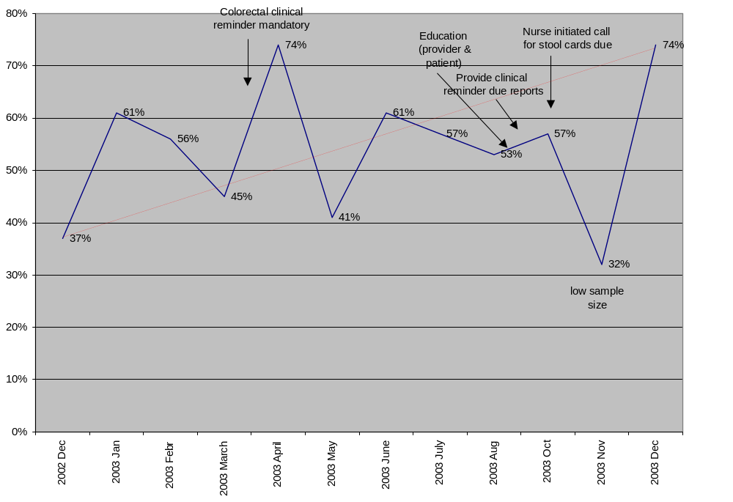
Medical media assisted in creation of both a poster (Appendix A) and a patient education pamphlet for colorectal cancer screening. The use of a clinical reminder, based on accepted clinical practice guidelines and EPRP performance measure criteria, was mandated in order to document in the computerized patient record system (CPRS) that the patient had been screened appropriately for colorectal cancer, thus employing a method to document the compliance (Appendix B). Nurses, physicians and midlevel providers were then educated about the importance of colorectal cancer screening in staff meetings. The staff was also instructed that appropriate screening for colorectal cancer included either stool cards (done yearly) or screening flexible sigmoidoscopy (done every 5 years) or screening colonoscopy (done every 10 years). The posters and patient education pamphlets were placed in all the clinical areas in the Ambulatory Care clinic used by nurses, physicians and midlevel providers.

The nurses were instructed to emphasize the importance of colorectal cancer screening to the patients and how to instruct the patient on collection of fecal occult blood testing (FOBT) specimens for testing. The physicians and mid-level providers were instructed how to use the clinical reminder in the CPRS to document that either they or the nurse had given the patient stool cards or had ordered a screening flexible sigmoidoscopy or screening colonoscopy. The plan was then put into action.

Check:

EPRP reviewers audit the patients' medical records monthly in order to ensure that performance measures such as colorectal cancer screening are being done. Monthly compliance scores of colorectal cancer screening were shared at the Ambulatory Care staff meeting with all staff. The CPRS ADPAC to created a clinical reminders due report for the colorectal cancer screening clinical reminder. The clinical reminders due report drills down to the level of the provider and can demonstrate by percentage the colorectal cancer screening clinical reminders completed by each provider (Appendix C).

Act:

Review of the EPRP data showed that for the colorectal cancer screening performance measure compliance with the above performance improvement model showed scores that averaged around 50%. Discussion with nurses and providers showed that stool cards (FOBT) cards were not being returned. Further partnering with nursing service led to the development of a system whereby the nurse would continue to emphasize the importance of colorectal cancer screening to the patient and give the patient a packet of FOBT cards which contained patient instructions and had the proper postage on the cards. The nurse also began to phone the patient if the stool cards were not returned within a 2-week period. The follow-up phone calls by the nursing staff, combined with the other steps in the performance improvement model increased our compliance rate with colorectal cancer screening to 74% as of December 2003. Additionally at the same time the medicine department started a flexible sigmoidoscopy and colonoscopy education class and increased their capacity to do flexible sigmoidoscopies to help increase the capacity of their services in colorectal cancer screening.

In summary, utilizing a performance improvement model and listening to feedback from the front line staff in the Ambulatory Care clinic we were able to increase our compliance rate with colorectal cancer screening from 37% in December 2002 to 74% in December 2003. Performance measures such as colorectal cancer screening are important because central VA leadership expects fully satisfactory ratings from the regional networks, which are composed of VA facilities like ours, and require explanations and action plans from networks not achieving their performance goals. For sub-optimal performance ratings related to primary care, facility leadership would task primary care leadership to implement action plans at the clinic level to improve quality of care.

Source Materials:

- Amarillo VA Health Care System Organizational Profile

- Nelson, E. “Building Measurement and Data Collection into Medical Practice” Annals of Internal Medicine 1998;128:460-466.

- FY2004 VHA Performance Measures Technical Manual.

- http://vaww.oqp.med.va.gov

Appendix A: Colorectal Cancer Screening Poster

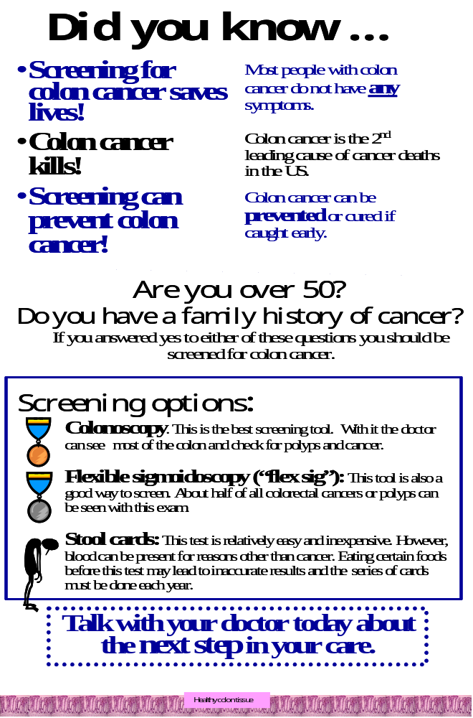
Appendix B: Colorectal Cancer Screening Clinical Reminder in CPRS

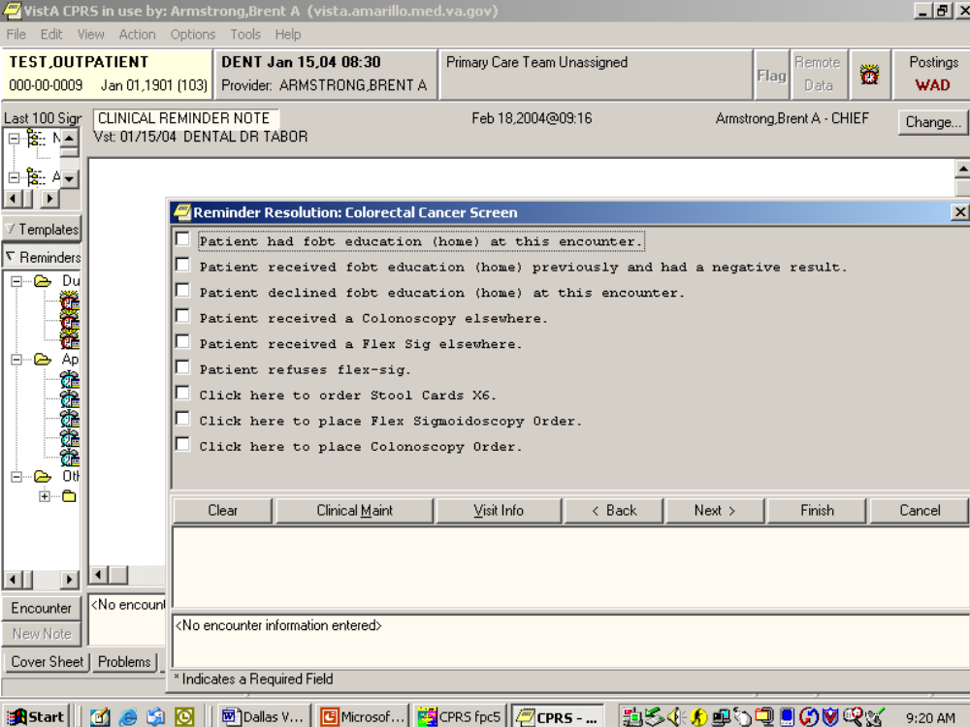

Appendix C: Clinical Reminder Due Report For Colorectal Cancer Clinical Reminder

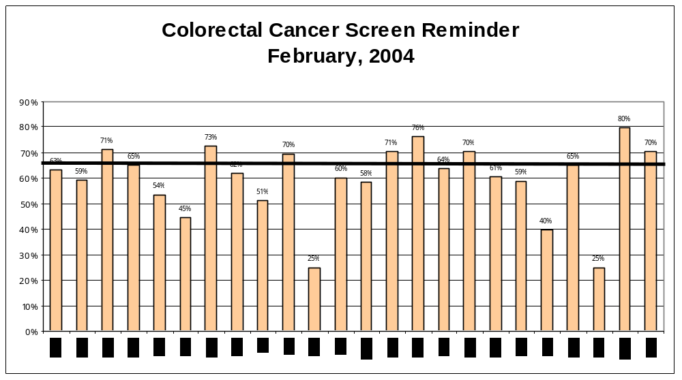

TONI LAWRIE HONORED

Authors: Sara McVicker, Joan Furey, Peggy Mikelonis, and Carol O'Brien

Mary A. (Toni) Lawrie, now retired, was the Women Veterans Program Manager at Bay Pines VAMC and Lead Women Veterans Coordinator for VISN 8, was recently honored for her many years of service to veterans.

On January 16, 2004 Ms. Lawrie was informed that the Women Veterans Clinic at Bay Pines would be named “The Mary A. Lawrie Clinic for Women”. Joy Easterly, ACOS/Patient Care Services, Ms. Lawrie’s immediate supervisor, was instrumental in gaining approval for the naming of the clinic. Ms. Easterly, Carol O’Brien, PhD, the Psychologist in the Women’s Clinic and Peggy Mikelonis, Women Veterans Program Manager at the Tampa VAMC, presented her the engraved plaque that will be placed at clinic entrance. The official naming ceremony and ribbon cutting will be held after Ms. Lawrie recuperates from major surgery.

On January 21, 2004 Ms. Lawrie received The Secretary’s Commendation, which read:
In recognition of your pioneering efforts, professional leadership, and selfless dedication in advancing the provision and delivery of health care and benefits to women veterans. Your commitment, integrity and compassion for veterans have ensured that the Department of Veterans Affairs successfully carried out its mission: To provide the highest quality care to the men and women of the United States who served in defense of our freedoms. You have discharged this trust and responsibility in a manner that has brought exceptional credit to yourself, the Department and the United States Government.

Before joining VA, Ms. Lawie served two years in the Peace Corps with assignment in Malaysia. She then joined the US Air Force and served at the 12th Air Force Hospital in Cam Ranh Bay, Republic of Vietnam from 1968-1969 and at Keesler AFB, Biloxi, MS from 1969-1970. She arrived at Keesler from her assignment in Vietnam just in time for Hurricane Camille. She joined VA in 1981 as Head Nurse in the Nursing Home Care Unit and was promoted to Associate Chief Nurse for Ambulatory Care in 1983. While at Bay Pines, she served for many years as the planner and coordinator for the annual hurricane drill because of her experience with Camille.

In 1987 Ms Lawrie accepted the collateral duty of Women Veterans Coordinator (WVC) at Bay Pines, and assumed the position full-time in 1993. During her early years as WVC, she began the Well Women’s Clinic at Bay Pines, a pilot program offered only on Saturday mornings, where women could receive preventive health care such as breast exams, pap smears, and gender specific health counseling. In the ensuing years, under her direction and guidance, this half day Saturday clinic evolved into a comprehensive women’s clinic serving over 3500 women. The clinic now operates 5 days a week in dedicated space providing Primary Care, Breast Care, Well Women’s Services, Gynecology, Nutrition, Social Work, Psychological, and Psychiatric services. In collaboration with Carol O’Brien, PhD, the Psychologist in the Women’s Clinic, Ms. Lawrie pioneered the Sexual Trauma Treatment program at Bay Pines, which was selected as a gold award winner of the 2001 Wyeth-Ayerst HERA Award for improvement in women’s health outcomes.

Ms. Lawrie and her colleague, Peggy Mikelonis, ARNP, Women Veterans Program Manager (WVPM), Tampa, established the women veterans’ program manager mini-residency. The mini-residency was developed to assist newly appointed WVPMs in assessing and developing women’s programs and services at their facilities. Since its inception in 1995, the week-long program has afforded over 100 new WVMPs, Vet Center Counselors, and personnel from Veterans Benefits Administration the opportunity to gain an understanding of the scope of the WVPM role and inspired them to meet the challenges of the position. As of the fall of 2003, 73 of the trainees remained in their positions. The National Women Veterans Health Program is now replicating parts of this training program across the country in order to continue this innovative program that Ms. Lawrie and Ms. Mikelonis have so successfully presented for over 8 years. The last mini-residency program was held at Tampa/Bay Pines September 22-28, 2004.

In 2001, Ms. Lawrie received the Women Veterans Coordinator of the New Millennium Award for her multiple contributions and her creative and innovative approaches to providing services to women veterans.

Ms. Lawrie is highly regarded by her co-workers and colleagues as both a skilled provider and committed mentor. We wish her a speedy recovery from her surgery and happiness in her retirement.

2004 CONFERENCE CALL SCHEDULES

Dial in number is 800-767-1750

Medical-Surgical Service Conference Calls: are held every other Monday @ 1:30 p.m. ET. ACCESS CODE: 18523 Dates are announced. (May 10, 24, June 7, 21, July 5, 19,)

Field Advisory Committee Chair Conference Calls: are held every third Tuesday of each month @ 3:00 p.m. ET. ACCESS CODE: 39186

April 20 | July 20 | October 19
May 18 | August 16 | November 16
June 15 | September 21 | December 21

Primary Care Conference Calls: are held every third Wednesday @ 1 p.m. ET.

ACCESS CODE: 28097
April 21: Dr. Michael Mayo-Smith: Panel Size Directive

May 19: Dr. Gordon Schectman: Return Visit Intervals
July 21: Primary Care Issues
August 18: Primary Care Issues

September 15: Adam Darkins/Bonnie Rudolph: Care Coordination/Telemedicine
October 20: Primary Care Issues
November 17: Primary Care Issues
December 15: Primary Care Issues
January 19, 2005: Primary Care Issues

Schedule for M-S News Articles
FLOW | 3rd Q/2004 |  |  | 4th Q/2004 |  |  | 1st Q/2005
 | April | May | June | July | August | Sept | Oct | Nov | Dec
Articles Submitted |  | 8 |  | 15 |  |  | 27
Distribute to Board Members |  | 29 |  |  | 5 |  |  | 17
Comments to PC |  |  | 10 |  | 23 |  |  |  | 1
Final Presentation |  |  | 17 |  |  | 17 |  |  | 8
Electronic & Hard Copy Distribution |  |  | 30 |  |  | 24 |  |  | 15
M-S NEWSLETTER EDITORIAL BOARD

Editorial in-Chief Mildred Eichinger, RN, MPH VA Central Office
Editorial Board Lois Katz, M.D. VA NY Harbor Healthcare System
Rivkah Lindenfeld, PhD Northport EERC
Leonard Pogach, MD East Orange, New Jersey
David C. Aron, MD Cleveland, OH

Editorial Assist. Angela Young, Designer VA Central Office

Thank you to the MAP editorial board members who served, some, for several years: Dr. Arnold Gass, Rebecca Goldsmith, PA-C ,Dr. Wendel Jones, Dr. Lois Katz, Rivkah Lindenfeld, PhD, Andrea Van Horn, CNP, Windy Kennedy HHS.

Medical/Surgical Services websites:
http://www.va.gov/kidney
http://vaww.va.gov/primary
http://www.health.gov/nhic/pubs/http://www.va.gov/diabetes
http://www.va.gov/cancer

welcomes your articles related to any current Issues in the area of healthcare in general or specifically in the field of Medical-Surgical Services including Primary and Ambulatory Care. Contact Mildred Eichinger at 202-273-8552 if you have any questions. Since we will be expanding our coverage please limit articles to no more than two pages including any graphics, pictures, or chart. Thank you.

M-S News

Resident Supervision VHA Handbook 1400.1

Mary Stout, Chief, VHA Forms, Publications and Records Management announced that the
Resident Supervision VHA Handbook 1400.1 has been approved for distribution. It is
available on the following websites:

http://www.va.gov/pub/direc/health/

http://vaww.va.gov/pub/direc/health/

