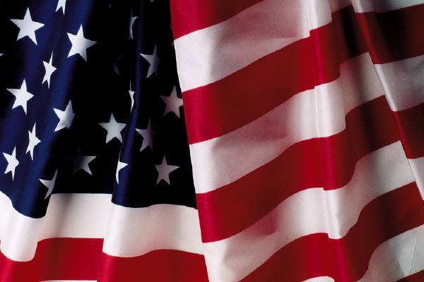
COLORADO
FEDERAL FORUM

PURPOSE
Recent national events have underscored the importance of communication and coordination between Federal, State and Local Officials. This Colorado Federal Forum is for Colorado local Elected Officials to meet with Federal Officials to discuss issues like Emergency Preparedness, Pandemic Flu, and Alternative Energy Sources.

Event Information:

Date: May 12, 2006
Time: 8:00 a.m. to 1:30 p.m.
Location: Sheraton Denver West
Hotel
Registration: www.denver.feb.gov
Address: 360 Union Blvd., Lakewood, Colorado
Cost: $39 per person. (Includes breakfast and lunch)
Not Open to the Public or the Press

Program Questions: Michael L. Bieda, Special Advisor, U.S. GSA, (303) 236-2814
Registration Info: CJ Beasley, Executive Assistant, DFEB, (303) 676-7009

Administration Invitees:
- Reuben Barrales and Toby Burke, Deputy Assistants to the President on Intergovernmental Affairs;

Federal Participants

U.S. Department of Homeland Security & FEMA;
U.S. Department of Education;
U.S. Department of Housing & Urban Development;

U.S. Department of Labor;
U.S. Environmental Protection Agency
U.S. General Services Administration
U.S. Small Business Administration
U.S. Congressional Representatives or Staff

Local Government Invitees

County Commissioners & Staff from 64 Colorado Counties
Mayors and Elected City Councils & staff from Colorado Municipalities

State of Colorado Participants

Colorado Department of Local Affairs

REGISTER EARLY, SPACE IS LIMITED

Hosted by:
Denver Federal Executive Board,
Federal Regional Agency Heads, Region VIII,
U.S. General Services Administration, Region VIII,
Colorado Municipal League,
Colorado Counties, Inc.

