2007-2008 Winter Drought Outlook
November 2007 Assessment from NOAA’s National Weather Service Office in Raleigh and the North Carolina State Climate Office issued November 29, 2007

The month of November provided no relief from drought conditions across central North Carolina as 85 out of 100 counties are now experiencing extreme to moderate drought. Most of the area received less than a half inch of rain while just a few locations around the western Triad, including Winston-Salem and Lexington, received as much as one inch of rain (Figure 1). In fact, November 2007 was the driest November on record at the Raleigh-Durham International Airport (RDU), reporting only 0.48” for the entire month. The previous driest November was 0.50” set in 2001. 2007 November rainfall averaged less than 25 percent of normal for most of the area (Figure 2), as our normal rainfall for November is around 3 inches.

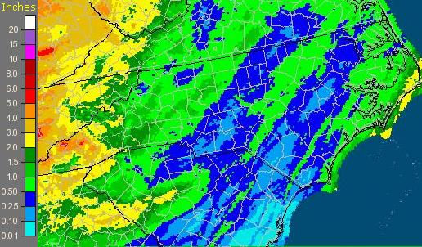
Figure 1: Accumulated Rainfall, Nov 1 – Nov 29

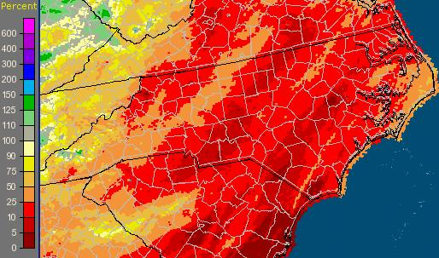
Figure 2: Percent of Normal Rainfall, Nov 1 – Nov 29
As it typical during La Nina patterns in the fall and winter, much of the heavy rain in November fell to the north and west of the mid Atlantic states. As much as 3 to 6 inches of rain fell from the Gulf Coast north across portions of Tennessee and into Pennsylvania, New York and New England, all bypassing North Carolina and some of the most drought riddled areas (Figure 3).

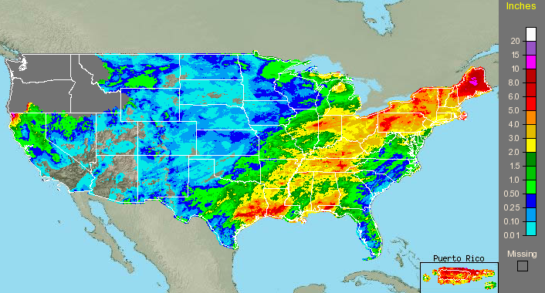
Figure 3. Observed rainfall across for November 2007.

Through the end of November, there have been only 81 days of measurable precipitation (0.01” or more) at RDU this year, 11 days less than the record of 92 days, most recently set in 1969. Similarly, the Piedmont Triad International Airport (GSO) has reported 76 days of measurable precipitation through the end of November, 9 days less than the record of 85 days set in 1986 (Figure 4). Both RDU and GSO are on track to break the record for the fewest days of measurable precipitation in a calendar year, even if both locations receive the “normal” 9 days of measurable precipitation during December. The normal number of days with measurable rainfall in a year is around 113 for both stations meaning RDU and GSO have experienced over a months worth of fewer rain days than normal.

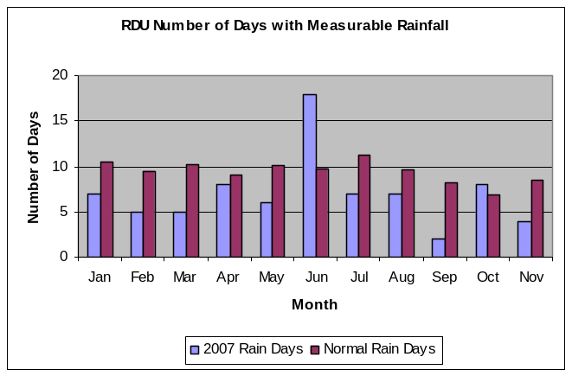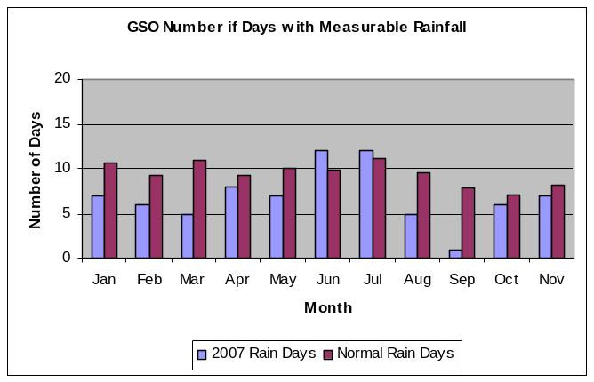
Figure 4. Number of days with measurable rain at RDU and GSO.

In addition to a decreased frequency of rainfall both RDU and GSO have experienced observed monthly rainfall deficits over the last 11 months (Figure 5). Below normal rainfall has been observed at RDU for 7 of the last 11 months resulting in a rainfall deficit of nearly 8.50 inches below normal for the year. At GSO below normal monthly rainfall was recorded 9 out of the last 11 months with a year to date rainfall deficit of over 11.50 inches below normal. Year to date rainfall at both RDU and GSO is currently running as the second driest ever recorded and given the lack of forecast rainfall for December these records may hold to the end of the year.

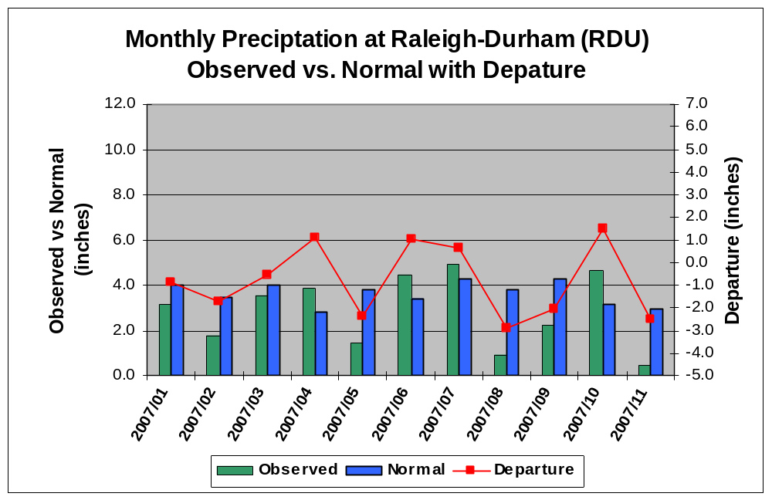
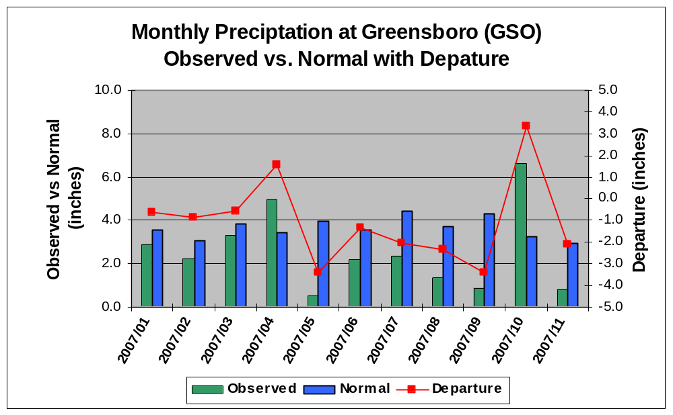
Figure 5. Observed rainfall and departures from normal.

Stream Flow and Reservoirs

As of November 29th, nearly 90 percent of the stream gages on unregulated streams in the state were recording flows at or below the 25th percentile, and about 65 percent of the gages were in the 10th percentile (Figure 6).

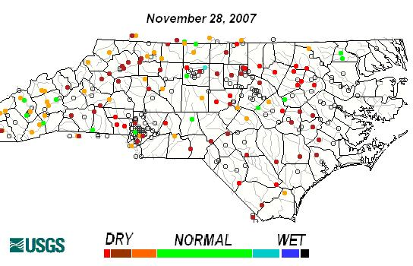

Figure 6. Stream flow at long-term stream flow gaging stations. Graphics courtesy of the USGS.

Of particular note are the very low flows on streams in the headwater regions of the Cape Fear, Neuse, and Tar Rivers. A number of these streams are flowing at 1 to 2 percent of normal which translates to very low inflows into the major water supply reservoirs. For example, inflow into Falls Lake in Wake County is less than 1 percent of normal and the inflow into Lake Jordan in Chatham County is 13 percent of normal.

The water supply in Falls Lake has fallen to about 30 percent, which translates to about a 120 day water supply for the city of Raleigh. Raleigh has begun to transfer water from smaller reservoirs south of the city into the Neuse River, which allows more water to be retained in Falls Lake. This effort will slow the lake’s fall and extend the water supply. In addition the Flat River which runs into Lake Michie, the water supply reservoir for the city of Durham, currently has a flow near zero. Lake Michie continues to fall, and is about 14 feet below normal, which translates to about a 60 day water supply for Durham.

How Drought Conditions Continue to Worsen
The expansion of drought conditions accelerated across North Carolina during the mid and late summer (Figure 7). Following the hottest and one of the driest Augusts on record across the state, extreme drought conditions took hold to nearly the entire state by September. September, like August set, records as second hottest on record at both RDU and GSO. Rainfall events have remained sparser than normal through the Fall, with Central North Carolina experiencing only two significant rain events since the record-breaking summer. Approximately 70 percent of the state is currently in either extreme or exceptional drought according to the latest National Drought Monitor (bottom right image of Figure 7).
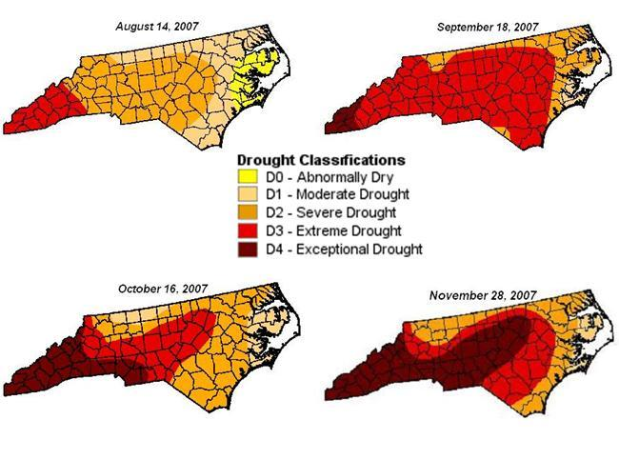
Figure 7 – Progression of the Drought, August through November.

Precipitation Outlook and La Niña
Looking ahead to this winter, the above normal rainfall needed to end the drought appears unlikely as moderate La Nina conditions have developed over the past few weeks. Anomalously cold sea surface temperature have expanded across the equatorial Pacific (Figure 8) and several climate models indicate further strengthening to a strong La Nina is possible. La Niña, the cold phase of the ENSO cycle, occurs when cooler than normal sea surface temperatures over the central Pacific Ocean persist for several months. The El Niño/ La Niña phenomena are one of the main sources of year-to-year variability in weather and climate for many areas of the United States and even the world.
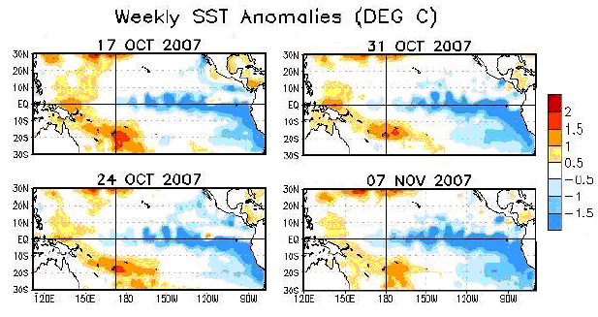
Figure 8. Sea surface temperature anomalies. Graphic provided by NOAA’s Climate Prediction Center.

La Niña conditions tend to influence wintertime atmospheric flow across the eastern North Pacific and North America. La Niña can shift the jet stream which helps to drive weather systems across North America. During La Niña the southern stream of the upper level jet, which typically brings moisture and enhanced storm systems into the mid Atlantic during the winter months is weakened. At the same time a “blocking” ridge of high pressure develops over the northern Pacific forcing many storm systems to remain over the northern half of the U.S as we have seen over the past month. These factors combine to bring fewer storms and less moisture to the Carolinas. (Figure 9).

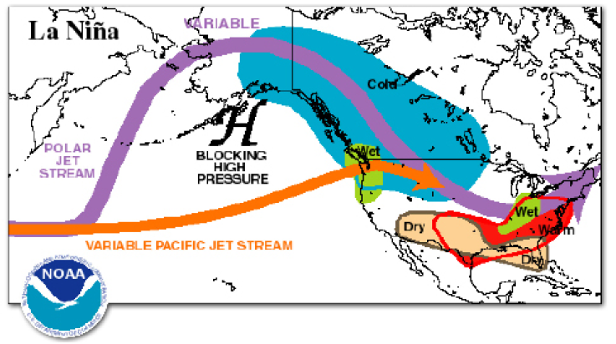
Figure 9. La Niña’s influence on jet stream provided by NOAA’s Climate Prediction Center.

During La Niña winters, portions of the Pacific Northwest, Midwest and Northeast experience increased storminess, while southern and eastern states including North Carolina typically experience less storminess and precipitation. Along the mid Atlantic there are generally fewer coastal storms. The displacement of the jet stream due to La Niña results in fewer coastal storms limiting precipitation. La Niña typically results in more Alberta Clipper (fast eastward tracking storms across the mid Atlantic) type winter systems which are drier in nature. The latest precipitation outlook from NOAA’s Climate Prediction Center reflects the La Niña trend of an increase likelihood of receiving below normal precipitation across the southeast (Figure 10).

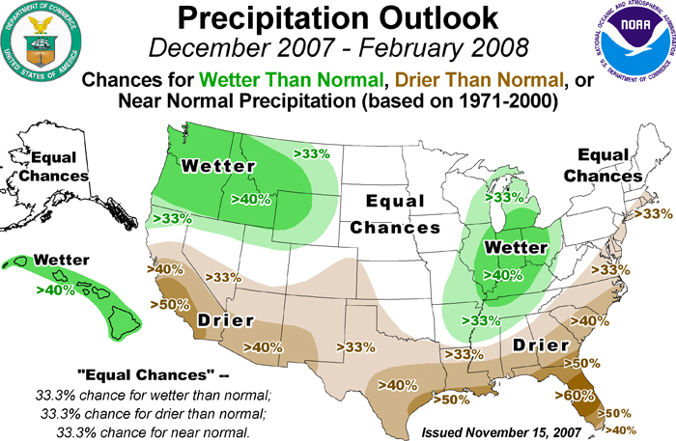

Figure 10. Winter precipitation outlook provided by NOAA’s Climate Prediction Center
When the influence of moderate to strong La Niña is combined with precipitation trends observed over the past 15 years, we find precipitation typically averages 3 inches below normal during the winter months for nearly all of Central North Carolina. Given the current pattern a significant rainfall deficit is expected to continue through the winter. In contrast a 5 to 7 inch surplus in rainfall is needed this winter in order to ease the current drought conditions.

A local study of winter precipitation at 5 sites across North Carolina during 20 past cases of weak, moderate and strong La Niña episodes, indicates below normal precipitation can be expected 60% of the time during any La Niña. The occurrence of below normal precipitation increases to 70% when examining only the moderate and strong La Niña events. More importantly, central North Carolina has received above normal precipitation only 1 out of 12 winters (8%) during moderate to strong La Niña winters (Figure 11).

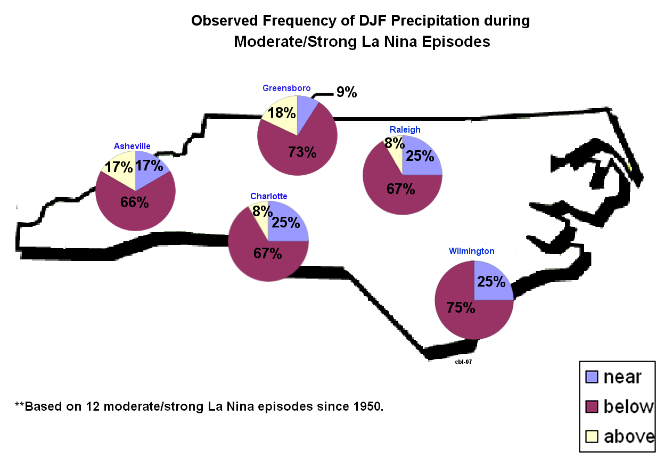
Figure 11. Data provided by the National Climatic Data Center. Graphic created by the Raleigh National Weather Service Office

Increased Fire Danger…
The drought conditions continue to increased the risk of wildfires. Fall is one of the peak fire seasons in North Carolina and given the dry conditions and the amount of dry fuels on the ground. Fuel moisture values are running low due to the prolonged dry conditions. According to the Keetch-Byram Drought Index (KBI), designed as a drought index for fire potential assessment, the state is ranked in a moderate category for fire danger (Figure 12). Such values of the KBI are often associated with dry conditions and an increase in dry fuels. During prolonged severe droughts intense, deep burning fires with significant downwind spotting can be expected and live fuels are expected to burn actively. Combining the dry conditions with windy fall days and low humidity creates a very dangerous fire potential. Fires on such days spread rapidly becoming extremely dangerous in very little time.

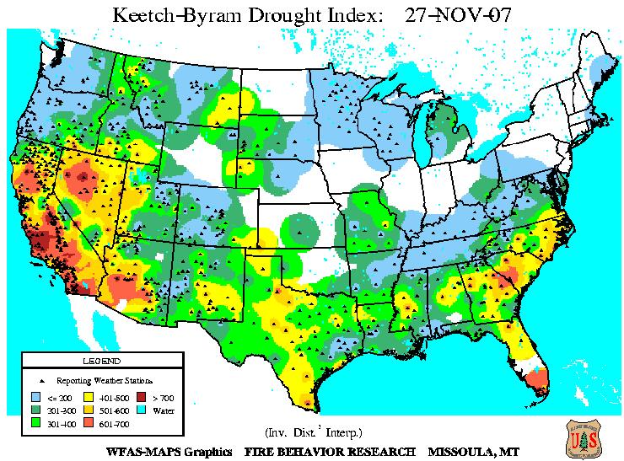

Figure 12. Keetch-Byran Drought Index. Graphic courtesy of the US Forest Service. This graphic is updated daily and may be found at: http://www.fs.fed.us/land/wfas/kbdi.gif

Current drought compared to past droughts…
Drought is a naturally occurring extreme in climate variability. Extreme droughts by definition occur about 4 percent or less of the time through the climatological record. This means in any given year there is only a 4 percent chance of an extreme drought. Even during extreme droughts, the impacts can vary based on the duration and time of year. According to the North Carolina State Climatologist, the drought conditions through the months of August, September and October reached new levels not experienced since 1925, surpassing the drought of 2002. By the end of October and into November North Carolina was experiencing the worst drought conditions ever recorded going back as far as 1895 when drought indices were first calculated and archived (Figure 13).

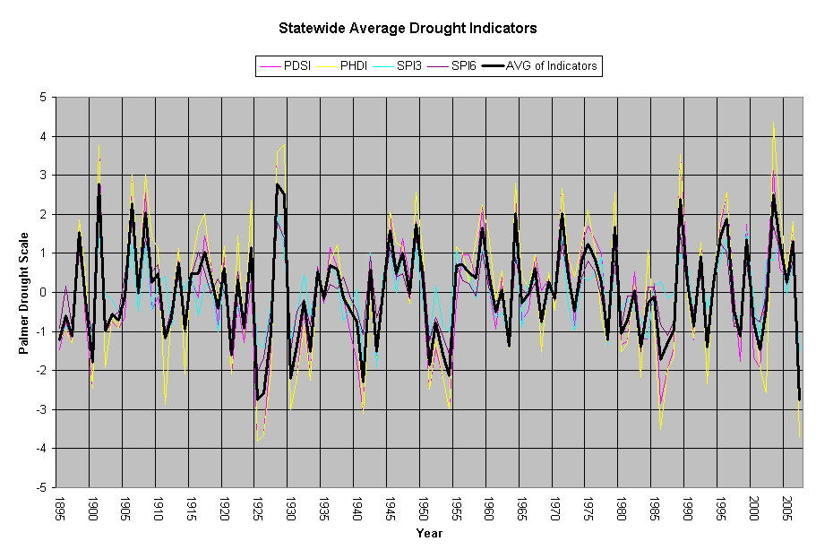
Figure 13. Drought data and graph courtesy of the NC State Climate office.
Rainfall needed to end the drought…
Based on the current Palmer Drought Severity Index (PDSI), in order to ameliorate the drought, much of the state still needs 14 to 18 inches of rain over the next 3 months and 25 to 30 inches over the next 6 months (Figure 14). These values are 5 to 7 inches above the normal rainfall expected during an average winter and spring. In the winter, (December through February), rainfall totals average 9 to 11 inches. When combined with Spring (December through March), these normal rainfall totals reach 20 to 23 inches. Ameliorating the drought conditions would not bring an end to the drought impacts on North Carolina, but rather reduce the exceptional drought conditions to moderate.

Based on climatology, the probability of receiving the 14 to 18 inches of rainfall necessary to ameliorate the drought over the next 3 months is approximately 10 to 15 percent. The probability of ameliorating the drought in 6 months is less than 15 percent.

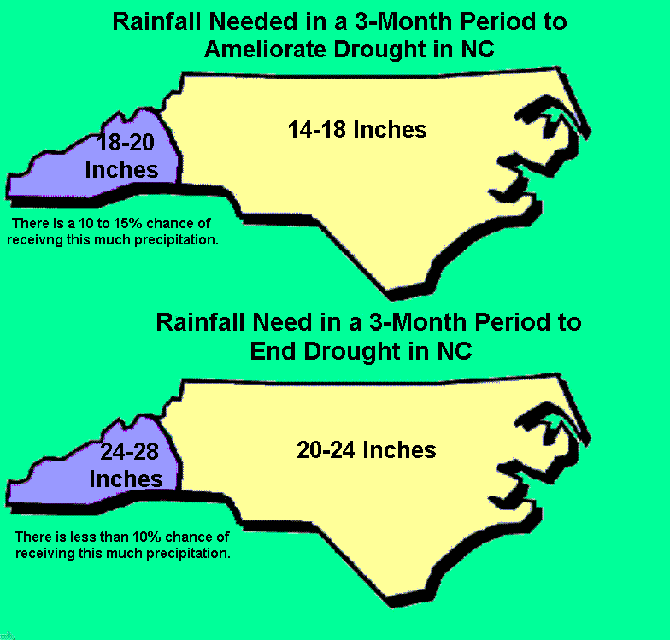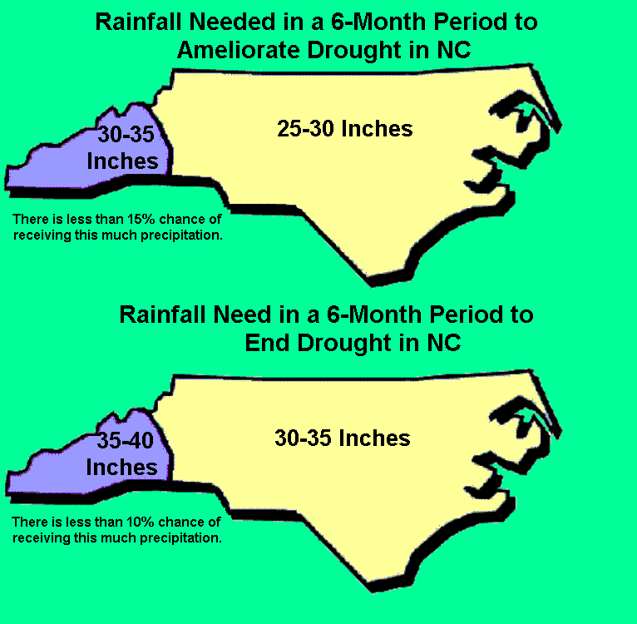

Figure 14. 3 and 6 month rainfall and probabilities calculated data from the National Climatic Data Center based on rainfall deficits as of October.

In order to completely end the drought this winter, the state needs as much as 24 inches of rain over the next 3 months (35 inches over 6 months) and the chances of that occurring are less than 4 percent. The PDSI is a meteorological drought index which responds to abnormally dry or wet weather conditions and is calculated based on precipitation and temperature data, as well as the local available soil moisture. It is one of many indicators used to determine drought severity. To find out more about drought indices, access the Raleigh National Weather Service drought webpage at http://www.erh.noaa.gov/rah/drought/

North Carolina stands to miss out on the frequent large scale rain and snow events necessary to end the drought, leaving the state relatively dry heading into the growing season and months of increased water needs next spring (Figure 15).

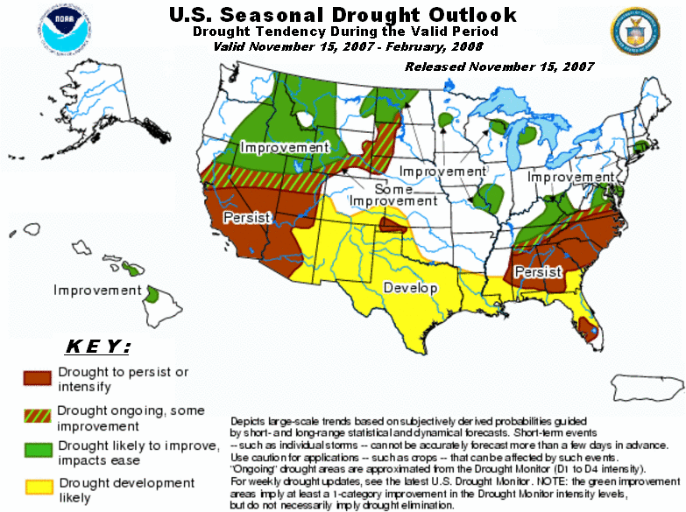
Figure 15. Season Drought Outlook provided by NOAA’s Climate Prediction Center

It is possible for above normal precipitation and major snow storms to occur during La Niña episodes. In the winter of 1973-1974, during a moderate to strong La Niña, much of the state experienced a precipitation surplus of 3 to 5 inches. Additionally, the record breaking snowstorm of January 25, 2000 occurred during a moderate to strong La Niña phase.

It is important to understand that due to exceptionally low lake levels and water shortages, even a return to near normal rainfall over the next three to six months may not bring an end to the current drought. If climate predictions come to fruition and the rains and snows of the winter and spring remain below normal, farms, cities and residences will be facing ongoing water shortages as we move into the summer months next year. Water shortages of some degree will likely remain into the high water usage months next summer as demands for water increase with the heat. With the prospects of a dry winter providing minimal relief from the current exceptional drought conditions, residents and officials are urged to examine and develop long term plans to address water availability, needs and resources.

Websites

NC Drought Monitor
http://www.ncdrought.org

State Climate Office of North Carolina
http://www.nc-climate.ncsu.edu/

National Weather Service Raleigh, NC
http://www.erh.noaa.gov/rah/

Climate Prediction Center
http://www.cpc.ncep.noaa.gov

Acknowledgments & Contacts

National Weather Service, Raleigh
Contact: Jeff Orrock
Warning Coordination Meteorologist
Jeff.orrock@noaa.gov
(919) 515-8209 ext. 223

North Carolina State Climate Office (NC SCO)
Contact: Dr. Ryan Boyles
North Carolina State Climatologist
ryan_boyles@ncsu.edu
919-515-3056

Climate Prediction Center (CPC)
National Climatic Data Center (NCDC)

