USDA Foreign Agricultural Service
GAIN Report

Global Agriculture Information Network
Template Version 2.09

Voluntary Report - public distribution
Date: 11/3/2005
GAIN Report Number: BR5629
BR5629
Brazil
Grain and Feed
Update
2005

Approved by:
Alan Hrapsky, Agricultural Counselor
U.S. Embassy
Prepared by:
Oliver Flake, Agricultural Attaché

Report Highlights:
On October 24, Brazil published Normative Instruction Number 29 allowing for the importation of wheat from Russia though immediate imports are very unlikely given current market conditions. However, recent rains during harvest in southern Brazil will increase import demand for Argentine wheat and possibly non-Mercosul supplies. As Argentine prices increase there is the possibility that U.S. and Russian wheat could be imported later this marketing year.

Includes PSD Changes: No
Includes Trade Matrix: No
Unscheduled Report
Brasilia [BR1]
[BR]
After months of negotiations between the Brazilian and Russian governments, Brazil published Normative Instruction number 29 (attached below) on October 24 allowing for the importation of wheat from Russia. The allowance of Russian wheat imports is believed to be a concession resulting from a meeting last month in Russia between President Putin and President Lula. In exchange for wheat access, Russian officials most likely promised more lenient treatment for Brazilian meat imports.

Current market conditions make Russian imports in the near-term highly unlikely. However, abundant rain during the harvest of the crop in Parana last month significantly reduced the quality of wheat. Some sources estimate that up to one million tons could be of feed quality. However, given very low corn prices, the feed wheat/corn price spread would not dictate the incorporation of wheat in feed rations at this time. Therefore, imports from Argentina or higher quality wheat from Northwestern Parana are likely to be mixed and milled with this poorer quality wheat damaged by rain. Reports also suggest that at least some of the feed quality wheat could be exported in the next several weeks.

While harvest is nearly complete in Parana, the crop is just beginning to be harvested in Rio Grande do Sul and reports suggest the quality of the crop could also be down due to heavy rains and sprouting in October. The next several weeks will be critical as dry weather would facilitate harvest and diminish the amount of feed quality wheat. Nevertheless, lower quality overall for the Brazilian crop this year combined with a much lower Argentine crop, could lead to imports from outside of Mercosul later in the marketing year, including from Russia and the United States. However, for that to occur Argentine prices will need to increase significantly and/or Russian prices will need to fall.

Exports and Export Shares of the Brazilian Wheat Market
2000/01–2004/05 (October/September)
(1,000 Metric Tons)
 | 00/01 | 01/02 | 02/03 | 03/04 | 04/05 | 5-year  Average | 5-year  Share
Argentina | 7,080 | 5,950 | 5,721 | 4,637 | 4,501 | 5,578 | 90.4
USA | 94 | 652 | 487 | 107 | 19 | 272 | 4.4
Paraguay | 94 | 68 | 80 | 101 | 317 | 132 | 2.1
FSU and E. Europe | 0 | 37 | 520 | 0 | 0 | 111 | 1.8
Canada | 101 | 58 | 102 | 68 | 0 | 66 | 1.1
Uruguay | 12 | 11 | 9 | 0 | 30 | 62 | 1.0
Total | 7,381 | 6,776 | 6,919 | 4,913 | 4,867 | 6,171
Source: Brazilian Ministry of Agriculture & U.S. Customs Service

As the chart above illustrates, Argentina is the dominant player in the Brazilian market. However, when both Argentina and Brazilian supplies are tight, exporters outside of South America have supplied significant amounts of wheat. For example, Eastern Europe and the Former Soviet Union (Ukraine, Russia, and Kazakhstan) entered the market in 2002/03 when supplies were needed and phytosanitary restrictions eased. U.S. wheat is also competitive at times, particularly in the Northeast and shipments from May to November can occur at the proper price spread (see chart below).
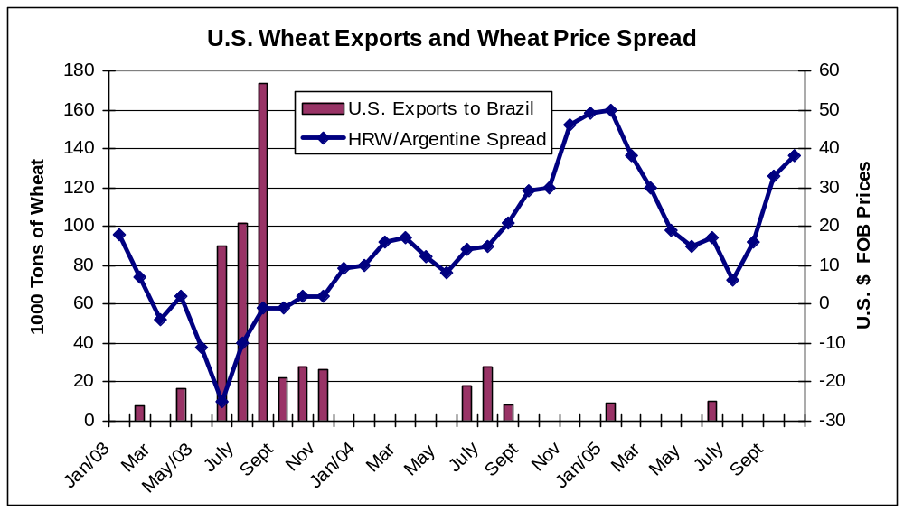

Normative Instruction Number 29/05- Informal Translation
Title: Phytosanitary Requirements for Wheat Imports from Russia

MINISTRY Of AGRICULTURE, LIVESTOCK, AND FOOD SUPPLY
OFFICE OF AGRICULTURAL PROTECTION
NORMATIVE INSTRUCTION Nº 29, of 11 OF OCTOBER of 2005.

The SECRETARY OF AGRICULTURAL PROTECTION, of the MINISTRY of AGRICULTURE, LIVESTOCK, and FOOD SUPPLY in the use of the attributions conferred to him by art. 42, Annex I, of the Decree nº 5,351, 21 of January of 2005, in view of the dispositions of Ministerial Directive nº 641, of 3 of October of 1995, in the Decree nº 318, of 31 of October of 1991, in art. 2º, of Directive nº 127, of 15 of April of 1997, the made use one in Chapters I and II, of the Plant Health Regulations, approved by the Decree nº 24,114, of 12 of April of 1934,

Considering the result of the Pest Risk Analysis of grains of Triticum aestivum, produced in Russia, and rulemaking number nº 21000,000898/2003-47, decides:

Art. 1º. To approve the Phytosanitary requirements for the importation of grains type wheat Triticum aestivum (category 3, class 9) produced in Russia.

Art. 2º. Grains of Triticum aestivum according to Art. 1º above will have to be accompanied by a Phytosanitary Certificate issued by ONPF of the exporting country with the following additional declaration:
I - DA1: The shipment is free of Orobanche spp

Art. 3º the shipments of wheat from Russia will be inspected at the port of entry, after the fumigation with bromide of metila for Acarus siro and Penthaleus major, and will be collected samples for phytsanitary analysis.

The costs of the shipments and phytosanitary analysis will be responsibility of the exporter.

Art. 4º. The port of entry for shipments of wheat from Russia will be in those states of the Brazilian Federation whose mills are located in the port zone and in which they possess system of thermal treatment for by-products of the wheat (meal, impurities and sweepings). The shipments of Russian wheat will be processed exclusively in these mills, and it will be prohibited the domestic transit of this product in natura. The entry of Russian wheat is prohibited in the states of Parana, Santa Catarina and Rio Grande do Sul.

Art. 5º Fumigation must be done at the point of entry before landing, with bromide of metila, under normal atmospheric pressure, under the following for pest control:

Doses (g/m³) | Time of Exposure (h) | Temperature (ºC)
40 | 12 | 32ºC ou mais
56 | 12 | 26,5 - 31,5ºC
72 | 12 | 21 - 26ºC
96 | 12 | 15,5 - 20,5ºC
120 | 12 | 10 - 15ºC
144 | 12 | 4,5 - 9,5º

Art. 6º. The Plant Health Authority of Russia – ONPF (in Portuguese) will have to inform the ONPF of Brazil any alteration in the Phytosanitary conditions of the production area.

Art. 7º. This Normative Instruction enters into force on the date of its publication.
Signed by GABRIEL ALVES MACIEL, Secretary for Agricultural Protection (SDA).

Note: THIS TEXT DOES NOT SUBSTITUTE the one PUBLISHED in FEDERAL OFFICIAL GAZETTE OF 10/24/2005, SECTION 1, PAGE 2.

