Available on CMS information server CMS NOTE 2001/???
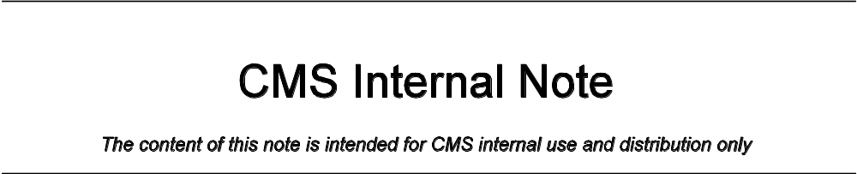November 19, 2001
Version 4.0

ISR 2000 EMU Alignment Test Results Using COCOA Reconstruction

D. Eartly, R. Lee, K. Maeshima

Fermi National Accelerator Laboratory

Abstract

COCOA (CMS Object oriented Code for Optical Alignment) is an Object Oriented software program designed to study optical components in the CMS Position Monitoring system by geometrical approximation. The Endcap Muon Alignment group has utilized COCOA to reconstruct and simulate measurements made during the June, August, and September 2000 ISR tests with DCOPS (Digital CCD Optical Positioning System) sensors. In this note we discuss the results of the 2000 ISR test using a simple COCOA model with static reference sensors and fixed orientations.

Software Design
COCOA was designed by Pedro Arce (arce@ifca.unican.es) for the study and use in the CMS Optical Position Monitor System. The software allows the user to reconstruct the position and angles of optical objects in a given system as well as propagate associated (RMS) errors. Calculations in COCOA are based on a non-linear least squares fit model and allow the user to provide estimations of errors on a model system as well as a set of actual measurements taken by the system. COCOA then reconstructs the system based on the errors provided by making variations in the positions of the modeled components corresponding to how well the errors are known. The final output of the software supplies the user with the optimal solutions for the input parameters such that the ideal measurements modeled by the program come as close as possible to the real measurements. Errors can be defined as fixed, calibrated, or unknown. Components set to be fixed are not moved at all, those set to calibrated are free to be moved within the range of the error, and unknown quantities are completely free to be moved as the software sees fit.

Endcap Muon Position Monitoring System (EMPMS) Reconstruction at CERN ISR Test Hall

The primary goal of the CERN ISR tests is to reconstruct a full scale mock-up of a Cathode Strip Chamber (CSC) SLM (Straight Line Monitor) Line and connecting Transfer Line with DCOPS sensors and monitor the position of the sensor brackets to within 200μm of their expected positions. The Endcap Muon test project outline describing the principles of the Endcap Muon Position Monitoring System (EMPMS) can be found at http://home.fnal.gov/~maeshima/alignment/outline/outline.html.

The implementation of the EMPMS in the CMS detector will allow for the transfer of Tracker system coordinate information from the Barrel and LINK alignment system. This transfer is accomplished across the Module for the Alignment of the Barrel Muon (MAB) interface. Since the location of the MAB units are referenced to the Tracker coordinate system by the LINK system, the location of the DCOPS sensors mounted on the MABs is known. By using these DCOPS sensors as references, the location of other DCOPS sensors located along the Transfer laser line can be determined. DCOPS sensors along the SLM line must also be determined from the location of at least two known DCOPS sensors. The location of the reference DCOPS sensors in the SLM line are provided by rigidly connecting these DCOPS sensors to DCOPS sensors located in the Transfer line. Once the positions of the connecting Transfer line sensors are determined, the reference sensors on the SLM line become known and the remaining sensors in the SLM line can be determined. Of course, since the DCOPS sensors only measure directions perpendicular to the laser lines, a host of proximity sensors and inclinometers are employed to determine the spacing between the DCOPS sensors and their angular orientations.

A full scale model of this arrangement was implemented at the CERN ISR tunnel which included one Transfer line and SLM line. A sketch approximating the arrangement of the DCOPS sensors in the ISR tunnel is shown below in Figure 1. In the figure, DCOPS et2 and et3 are located on the MABs and sensors et1 and es1 are rigidly connected by a transfer link plate. Since only one of the MABs (et2) was constructed for the ISR tests, reference sensors et3 and es10 must be given by photogrammetry. Reference sensor et2 is specified by the location of the MAB while es1 is found by determining et1 and making a translation across the known geometry of the transfer plate. The angular orientation and spacing between the DCOPS sensors along their respective laser lines are given by photogrammetry.

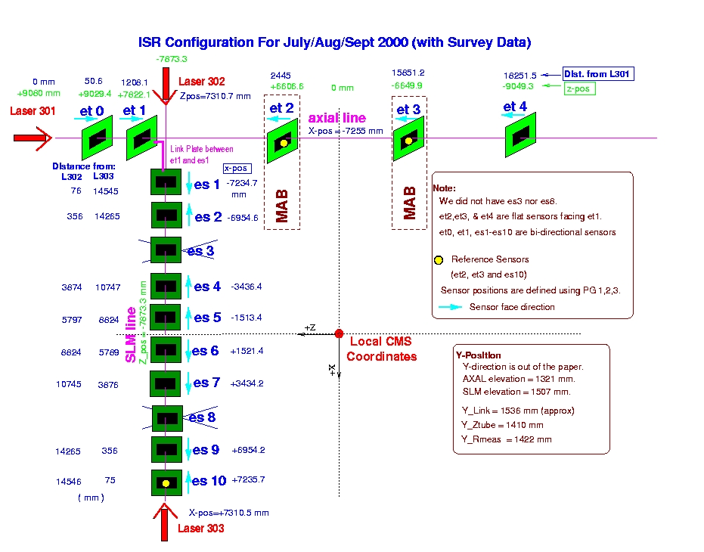
Figure 1: A Schematic Representation of the ISR Setup

For each of the sensors mounted in the ISR tunnel, the brackets on which the DCOPS sensors are mounted are defined by three photogrammetry targets. The photogrammetry targets have a relationship (as established by FNAL CMM measurements) to the dowel pins upon which the DCOPS sensors mount. The DCOPS sensors, in turn, have their CCD pixel arrays calibrated to the mounting points of the dowel pins (See Fig. 2). The calibration of the first pixel position in each sensor’s CCD to the local dowel pin hole on the sensors circuit board was done by Northeastern University prior to the start of the ISR tests. The calibration was done in a manner so that only one measurement was given per CCD array in the direction of the pixel array. Transverse measurements were not considered (i.e. the offset of the pixel array from the axis of the dowel). Figure 2 (below) shows the parameters calibrated for a flat CCD sensor window. Calibration for bi-directional CCD windows are identical, however each bi-directional CCD also has an unmeasured component coming out of or into the page. Errors arising from the uncalibrated parameters in the dimensions perpendicular to the pixel array are thought to be negligible (esp. for bi-directional CCD offset along the beam axis).

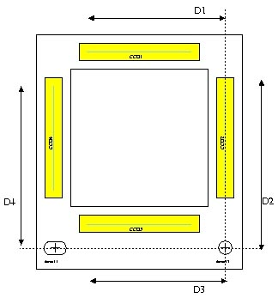
Figure 2: NEU DCOPS Calibration Parameters D1, D2, D3, and D4

By knowing these calibration parameters, the angular orientation of all the sensors, the distance between the sensors and the absolute position of two sensors in each line, all remaining spatial information of the sensors can be determined and monitored.

Implementation of COCOA for EMPMS ISR Testing

The DCOPS sensor configuration for EMPMS used in the ISR tests was implemented with help from Pedro Arce in COCOA version 1.4.0.

The software was essentially used to accomplish two tasks:

- Determine the location of the reference dowel positions and orientations in the ISR hall for each DCOPS sensor bracket from available CERN Photogrammetry and FNAL CMM (Coordinate Measuring Machine) data.
- Reconstruct the reference dowel positions for each of the DCOPS brackets in the laser line based on actual measurements taken by the sensors during the ISR test.

The EMPMS employed in the CMS Muon Endcap will not be able to rely on a photogrametric survey of components in the system. Although the initial positions and orientations of the DCOPS sensors will be determined by photogrametery prior to installation of the Endcap into the Barrel, it is expected that the CSC chamber orientations (and hence the orientation of the DCOPS) will change significantly in the high magnetic fields generated by the solenoid. These shifts in sensor orientations will have to be determined by the EMPMS system. The present COCOA reconstruction model (Task #2) detailed in this note does not attempt to reconstruct potential shifts in the orientation of the DCOPS sensors. Rather these orientations are determined directly from the survey data (Task #1). Additional studies with COCOA will be needed to understand how these orientations will be handled.

Determination of ISR Dowel Positions from Survey Information

To do a complete reconstruction of the optical sensors, the positions and orientations of at least two reference sensors in each laser line have to be known completely as well as the spacing of all the remaining sensors to be reconstructed. COCOA was used to determine the location and orientation of every sensor in the ISR test system (Task #1 above) from survey data. Deriving the location and orientation of all the dowel pins allows us to establish our two reference sensors for each line as well as to establish the separation and angular orientation of the remainder of the sensors. In addition, by specifying all dowel locations and orientations, we have created a set of reference dowel locations with which we can compare all future reconstructed measurements.

COCOA was employed to determine the location and orientation of the sensors by mapping the location of the three Photogrammetry targets on the bracket as seen by the CERN Survey Group in the ISR hall to the corresponding CMM measurements measuring the distance between those targets and the dowel pins. CERN Photogrammetry was done by determining the relative coordinates the specified targets within a local assembly area and then patching the assembly coordinates into the global ISR coordinates using reference socket targets. Initial uncertainties in CERN Photogrammetry (June 2000) in the ISR hall were quoted as < 90 μm within the global ISR coordinate system and < 30 μm for local assembly measurements. CMM Measurement uncertainties were quoted as < 12.7 μm. An analysis (August 2000) of the distances between individual photogrammetry targets has shown that the distances are preserved between CMM and CERN Photogrammetry measurements within understood errors. The uncertainties estimates provided by the CERN Photogrametry Group for the placement of the assemblies in the global ISR coordinate systems were later revised (Dec 2000) to incorporate the relative uncertainty and correlation of uncertainties within the survey grid. Final estimations of the uncertainty in SLM sensor placement within the global ISR grid were generally estimated as < 180 μm in Y and < 160 μm in Z.

Sensor | X CMS (mm) | Y CMS (mm) | Z CMS (mm)
et0 | -7334.75 | 1370.08 | 9028.48
et1 | -7256.93 | 1300.19* | 7822.29
et2 | -7327.37 | 1360.43 | 6606.56
et3 | -7268.81 | 1288.83 | -6649.45
et4 | -7262.87 | 1291.97 | -9049.56
es1 | -7235.11 | 1485.99 | 7914.87
es2 | -6954.62 | 1474.07 | 7903.23
es4 | -3436.21 | 1475.80 | 7905.06
es5 | -1512.8963 | 1476.70 | 7908.22
es6 | 1521.42 | 1478.33 | 7842.00
es7 | 3434.77 | 1477.26 | 7840.27
es9 | 6953.99 | 1476.56 | 7839.43
es10 | 7234.93 | 1545.31 | 7909.75
* Location of et1Y was broken by unrecorded adjustment on transfer plate. See Section VI.D for a discussion of the et1 Y CMS location
.

Table 1: Dowel Locations of DCOPS Sensor Brackets (CMS Coordinates) in ISR Hall

The results from COCOA were checked independently on one sensor by the CERN survey group (by an unknown commercial software package) and on all sensors by hand calculations (to first order). COCOA matched the CERN survey group measurements exactly and matched two independent hand calculations (done by NEU and FNAL) within 50 μm.

 | X ISR  (mm) | Y ISR (mm) | Z ISR (mm) | X, Y Error (mm)* | Z Error  (mm)*
COCOA | -7268.81 | 1288.83 | -6649.45 | < 152 | < 158
CERN Survey Group | -7268.81 | 1288.83 | -6649.45 | unk | unk
FNAL Hand Calc. | -7268.81 | -1288.83 | -6649.50 | < 155 | < 164
NEU Hand Calc. | -7268.81 | -1288.83 | -6649.50 | unk | unk
* Errors in Z are slightly higher since CMM measurements are given in only local X, Y while CERN PG
are given as global (X, Y, Z).

Table 2: Comparison of Dowel Locations in ISR Hall for Sensor et3

The results from dowel et3 were typical of the other sensors, except for those assemblies around the transfer plate where CERN photogrammetry resolution was degraded to < 90 μm (local). The total (global) error in the dowel locations for sensors in this area is typically < 168 μm.

One of the key advantages of using COCOA to derive the location of dowel pins in the ISR hall is the accurate determination of the angular orientation of the sensor. For example, in the Transfer Line all sensors are placed by COCOA in the ISR hall with their planar normals pointing along the ISR Z-axis and rotations always performed (in this order) about the X, Y, and Z ISR axes. Since the sensors are mounted on the dowels in a manner which matches the sensor face with that of the bracket and puts the normal of the sensor in line with the dowel pin, the orientation of the dowel pin is identical with that of the sensor. Table 2 shows the angular orientation for sensor et3 as determined by COCOA. Errors in a sensor’s angular orientation are determined by the quadrature of local photogrammetry errors and global rotation of the photogrametry targets.

 | X Angle (mrad) | Y Angle (mrad) | Z Angle (mrad) | Error X,Z (mrad) | Error Y (mrad)*
Sensor et3 | -3.93 | -6.51 | .691 | < 1.77 | < 4.84
* Errors about Y are slightly higher for reasons similar to those found in the position along Z in Table A

Table 3: Dowel Orientations for Sensor et3 as derived by COCOA

COCOA Reconstruction of ISR Test Setup

To reconstruct the Transfer and SLM lines within the framework of COCOA, the location of reference sensors et2, et3, and es10 were completely specified by the previously determined survey data. The remaining sensors had only their angular orientations and positions along the laser line specified. Variations of sensors et1 and es1 were bound together by a simulated transfer plate allowing es1 to become a reference sensor in the SLM line once the position of sensor et1 has been established by a complete reconstruction of the Transfer line. Laser sources were only specified by a single coordinate corresponding to the beginning of the laser line. No objects placed in the simulation were specified as ‘fixed’, but rather their positions and orientations were set within calibration limits or specified as unknown. COCOA was then set to recalculated and/or determine the location and orientations of all components based on a supplied set of measurements taken by the sensors. Our primary interest in the reconstruction was the determination of the unknown coordinates marking the sensor positions – those parallel to the X and Y ISR axes for sensors in the Transfer line and parallel to the Y and Z axes for sensors in the SLM line.

Several of the CCDs on the DCOPS sensors were not illuminated by the crosshair laser or suffered from poor fits due to highly unsymmetrical charge distributions and poorly defined signals across the CCD pixel arrays. These CCDs were not included in the fitting algorithms employed by COCOA. Often, conditions in our system would change in a manner which allowed some CCDs to be included in our reconstruction while excluding others. A First Level Analysis Program was written to determine the centroid of the charge distribution in all the CCDs. The determination as to whether a CCD measurement was usable within the reconstruction was done through a careful examination of the FLAP data and study of FLAP fit sigma, how closely the FLAP fit matched the raw CCD distribution, and the actual value of the FLAP fitted mean. A more detailed discussion of the FLAP program and study of the raw CCD data can be found in a separate note.

Approximately 2100 measurement events (Transfer + SLM Line measurements) were processed utilizing this reconstruction method with 750 events being taken from a July/August run and 1350 events taken from a September run. In each test period, the number of events using Laser 302 was roughly equal to the number of events utilizing Laser 303. During the initial examination of the data, some anomalous events were removed from the dataset. These single events were typically separated by several hundred microns to more than a millimeter from the main body of data points. For the following analysis, approximately 10-30 events total were cut from both the original July and September data sets.

A. COCOA Reconstruction with References et2, et3, and es10

The results presented here summarize the reconstruction of Transfer and SLM Line sensors in the manner described previously. A complete set of plots detailing the reconstruction of all events taken during the two test periods can be found separately in Appendix A, Figures 1-21. Sensors in both the Transfer and SLM laser lines were reconstructed and plotted as the deviation between their COCOA reconstructed location and surveyed location as a function of real UNIX time. These distributions were then projected into histograms and fit with an appropriate function to obtain a mean location for each test period.

1. July/August Results

The COCOA reconstructed location of sensors with et2, et3, and es10 references in the July/August are shown in Appendix A, Figures 1-10. Figures 3 and 4 show a distribution of reconstructed sensor locations which was typical of this test period. [Note: The binning in these figures is much finer than the actual resolution of the distribution. This causes the nonphysical banding of data in the Figures. This will be corrected in an updated report.]

The distribution of sensor locations along the SLM line reconstructed from Laser 302 typically fell inside of a 150-180 μm range in Y and a 50-80 μm range in Z. The Laser 302 Y and Z distributions fell within the systematic errors of the reconstruction. Although the distribution of reconstructed values of the sensors’ Y coordinates seems to indicate a slight upward drift in several sensors, scaling downward from approximately 100μm in es2-es5 to 50μm in es6 and es7, the systematic error associated with each event precludes any definitive correlations.

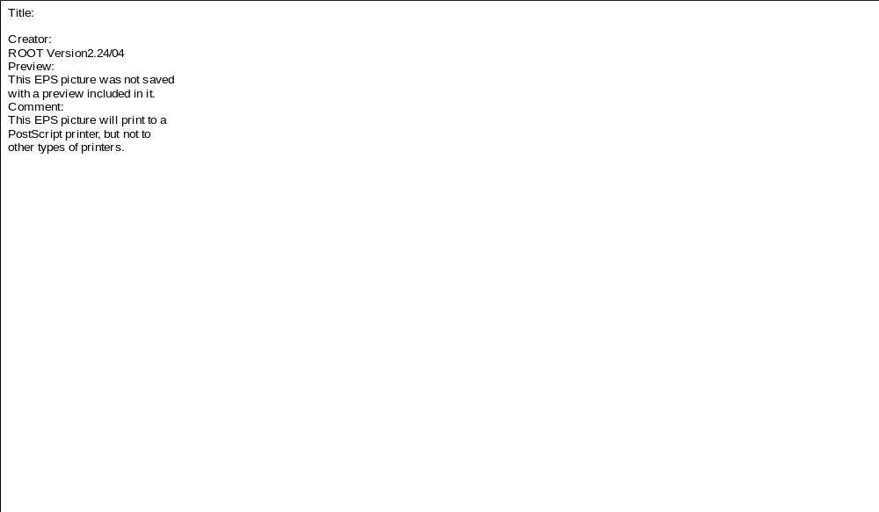
Figure 3 : Typical Distribution of Reconstructed Positions for an SLM sensor in July/August for Laser 302 Using es10 as the Final Reference Sensor. (Bands are non-physical)

Figure 4 : Typical Distribution of Reconstructed Positions for an SLM sensor in July/August for Laser 303 Using es10 as the Final Reference Sensor. (Bands are non-physical)

The characterization of the Laser 303 SLM data in this period is very similar to that of the Laser 302 data. All events contained in the distribution of reconstructed values with Laser 303 typically fall within the systematic errors associated with the reconstruction. The only exception occurs in a single cluster of events in the Y distributions near the end of the test period. This apparent ‘jump’ in the sensor Y-coordinate locations increases in magnitude with the distance of the sensor from the transfer plate. The Y coordinates of et1 or the transfer plate (es1) does not show any apparent shift in position which corresponds to the ‘apparent’ jump in these sensor positions. Aside from this extraneous cluster of events, reconstructed sensor locations typically well inside a 100μm range in Y and 20-40μm range in Z.

Transfer Line distributions typically fell inside a 60μm range for both the X and Y coordinate reconstructions with the exception of et4X, which has a range of 150 μm. The systematic errors exceeded the range of these distributions in all cases.

2. September Results

The complete set of plots showing the reconstruction of all events in the September test period can be seen in Appendix A, Figures 12-21. Figures 5 and 6 show a distribution of reconstructed sensor locations which was typical of this test period.

The reconstruction of sensors in the SLM line using Laser 302 appears to be unstable for all the events in both Y and Z coordinates for the beginning of the test period. Rather than a tight distribution of points contained within the systematic error of the reconstruction, these initial events are not clustered about any particular value and scatter randomly across several hundred microns (>600 μm). This behavior terminates for all the sensors further into the test period with the values of the Y reconstruction falling into a 100μm range and Z reconstruction values into a 100-150μm range for sensors es2-6 and 150-200μm range for sensors es7 and es9. The end of the erratic behavior in these distributions coincides with the introduction of a new Laser 302 module. With the exception of the Z distributions of sensors es7 and es9, these distributions fall roughly within the range of values encompassed by the systematic error.

Figure 5: Typical Distribution of Reconstructed Positions for an SLM sensor in September for Laser 302 Using es10 as the Final Reference Sensor. (Bands are non-physical)

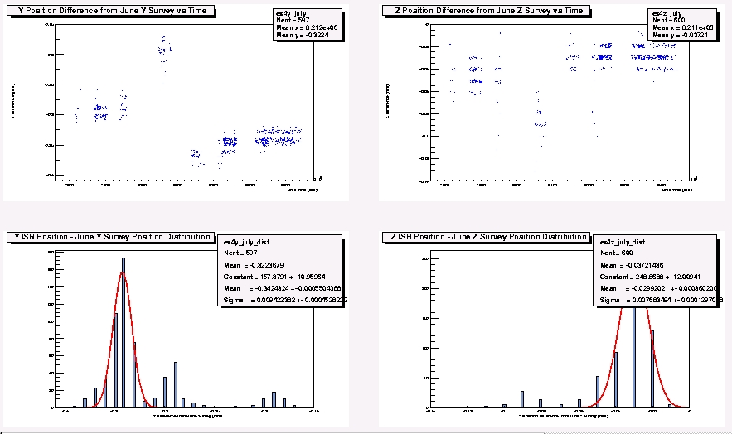

Figure 6: Typical Distribution of Reconstructed Positions for an SLM sensor in September for Laser 303 Using es10 as the Final Reference Sensor (Sensor es4). (Bands are non-physical)

Events reconstructed with Laser 303 do not show any of the erratic behavior associated with the Laser 302 events in the beginning of the test period. However, like the earlier reconstruction of the July Laser 303 events, the Y distributions of reconstructed events features a cluster of approximately 50 events which show an apparent jump in the positions of the SLM sensors. As before, the magnitude of this jump increases in magnitude with the distance from the transfer plate. Excluding this cluster of events, the distribution of reconstructed events in Y is confined within a 120μm region. Events in the distribution of Z coordinates also fall inside a 100μm range. Both of the main bodies of these distributions lie well within the systematic errors.

Reconstruction of events on the Transfer Line show distinct patterns in X and Y for all sensors except et4 Y. The sensors seem to track each other in both coordinates, though the entire distribution for both coordinates (across 150μm in X and Y) fall almost completely inside the systematic error. As in July, the et4 Y distribution of events is slightly smeared over wider range (200μm) and slightly exceeds the systematic error on the sensor reconstruction. It is also entirely possible that miscalibration of the CCD-dowel relationship or survey errors could contribute substantially to this deviation.

3. Discussion of et2, et3, and es10 Reference Sensor Reconstruction

A summary of the results for all sensors from each test period are given in Table 4 and Figures 7-9. The reconstruction of SLM Y coordinates is consistent for both lasers during the two test periods. Furthermore, both lasers seem to track the locations of the SLM sensor Y locations in the same manner as the errors on the reconstructed positions overlap (see Appendix A, Figure 24). A slight drift in the sensor Y locations can be seen in all four sets of reconstructed data. The fact that the same drift is evident for both lasers suggests that the placement of the es10 reference sensor or transfer plate may be different from the surveyed value.

Reconstruction of SLM sensor Z coordinates with Laser 302 is inconsistent between the July/August and September test periods. The Laser 302 September Z coordinate reconstruction matches almost exactly with the Z coordinate reconstructions done with Laser 303 for both test periods. An examination of the raw FLAP data from July indicates the Laser 302 peak in the es10 CCD which should track motions along the Z coordinates does not respond to small shifts in the orientation of the laser in the same manner as preceding sensors. Since es10 is a reference sensor, its inability to track Laser 302 in Z inhibits an accurate reconstruction of any SLM sensor Z coordinates. Impact on the Laser 302 July/August Y coordinate reconstruction from the inability to track the Z coordinate is presently being reviewed, though it is thought to be a second or third order effect. The effect does not appear in the September data as Laser 302 was replaced early in the test period. Sensor Z coordinate locations were found to be very close to their surveyed location, though es5 and es9 show somewhat higher deviations that the other sensors. No drift is evident in these distributions.

The reconstruction of sensors on the Transfer Line yields the expected results, with only the X position of et 4 being reconstructed well away from the surveyed location. Measurements on sensor et4 were restricted to two CCDs only with the peak on the CCD tracking the laser along the X axis suffering from a low signal to background ratio. As noted in the discussion of individual et4 events during the test period, the distribution of X coordinate reconstructions as a function of time was slightly more dispersed than those in the Y coordinate indicating some instability in the signal. The elevated location of the sensor et1 Y reconstruction can be seen to correspond exactly to the elevation of the es1 sensor Y location. The calibration of the Transfer Plate was broken during the photogrametry survey of the system in the ISR hall by moving the et1 sensor in Y, so this sensor was expected to significantly deviate from the surveyed location. Since the location of es1 was unchanged, a series of mechanical measurements between the et1 and es1 brackets was made to establish the new et1-es1 relationship and es1 expected location. These measurements have an estimate error of 500 μm. Deviations of this measurement from the actual separation of es1 and et1 are therefore expected to show the reconstructed Y coordinate location of et1 as being different from the calculated Y position of the sensor and the location of es1 as being askew since the et1-es1 relationship would be incorrectly specified. Section VI.D. details the problems with the calibration of the transfer plate.

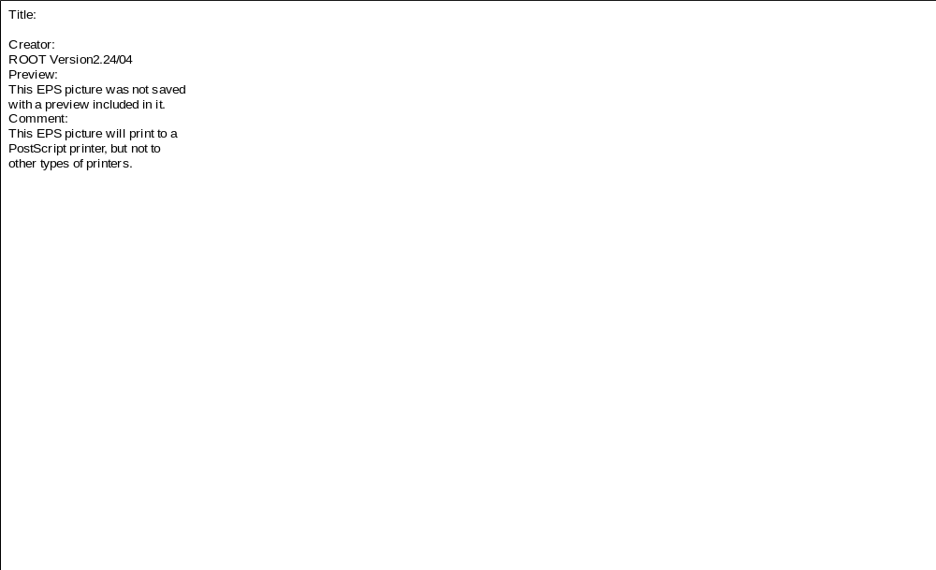
Figure 7: Transfer Line Results of COCOA Reconstruction for July/August and September Runs Using es10 as the Final Reference Sensor. Error bars indicate total uncertainty in sensor location as determined by COCOA.

Sensor | July/Aug  Laser 301 |  | Statistical Error (July) |  | Sept°  Laser 301 |  | Statistical Error (Sept) |  | Systematic Error
Sensor | Xmean (μm) | Ymean (μm) | Xerror (μm) | Yerror (μm) | Xmean (μm) | Ymean (μm) | Xerror (μm) | Yerror (μm) | Xerror  (μm) | Yerror  (μm)
et0 | -54 | 39 | 9 | 9 | -168 | 32 | 8 | 21 | 133 | 168
et1 | 26 | 274 | 7 | 7 | -125 | 259 | 15 | 13 | 133 | 165
et4 | 435 | -47 | 28 | 10 | 445 | -49 | 23 | 13 | 170 | 158

Sensor | July/Aug Laser 302 |  | Statistical Error (July) |  | Sept°  Laser 302 |  | Statistical Error (Sept) |  | Systematic Error
Sensor | Ymean (μm) | Zmean (μm) | Yerror (μm) | Zerror (μm) | Ymean (μm) | Zmean (μm) | Yerror (μm) | Zerror (μm) | Yerror  (μm) | Zerror  (μm)
es1 | 276 | 13 | 7 | fixed | 258 | 13 | 15 | fixed | 165 | 53
es2 | 143 | 79 | 59 | 5 | -25 | -453 | 26 | 6 | 198 | 125
es4 | 72 | 330 | 28 | 7 | 20 | -56 | 13 | 10 | 158 | 110
es5 | 136 | 569 | 22 | 11 | 74 | 245 | 13 | 17 | 158 | 107
es6 | -328 | 494 | 12 | 9 | -255 | 191 | 9 | 23 | 117 | 109
es7 | -366 | 524 | 11 | 15 | -281 | 322 | 11 | 26 | 110 | 116
es9 | -383 | 638 | 9 | 35 | -170 | 380 | 14 | 36 | 114 | 137

Sensor | July/Aug Laser 303 |  | Statistical Error (July) |  | Sept°  Laser 303 |  | Statistical Error (Sept) |  | Systematic Error
Sensor | Ymean (μm) | Zmean (μm) | Yerror (μm) | Zerror (μm) | Ymean (μm) | Zmean (μm) | Yerror (μm) | Zerror (μm) | Yerror  (μm) | Zerror  (μm)
es1 | 276 | 13 | 7 | fixed | 263 | 13 | 12 | fixed | 165 | 53
es2 | -262 | 0 | 12 | 8 | -300 | 2 | 21 | 9 | 228 | 145
es4 | -324 | -30 | 9 | 8 | -245 | -27 | 18 | 10 | 188 | 122
es5 | -211 | 214 | 15 | 8 | -252 | 215 | 9 | 7 | 147 | 112
es6 | -369 | -15 | 8 | 8 | -404 | -8 | 5 | 7 | 120 | 104
es7 | -446 | -18 | 9 | 6 | -457 | -24 | 5 | 5 | 111 | 104
es9 | -605 | -271 | 7 | 7 | -475 | -247 | 4 | 4 | 117 | 117

Table 4: Deviation of COCOA Reconstruction of DCOPS Dowel Pin Positions from Expected Survey Location with es10 Survey as Final Reference

° Events fitted in Sept Data correspond to introduction of new laser diode in SLM line (525+ events). September events taken prior to the introduction of the new laser (100 events) where typically within 20-150μm of July positions.
* Transfer plate Y definition was broken by at 1.71 mm ± .5 mm. This is survey position with estimated movement of transfer plate components. See Section IV.C for detailed description of problem.

Figure 8: SLM Line (Laser 302) Results of COCOA Reconstruction for July/August and September Runs Using es10 as the Final Reference Sensor. Error bars indicate total uncertainty in sensor location as determined by COCOA.
Figure 9 : SLM Line (Laser 303) Results of COCOA Reconstruction for July/August and September Runs Using es10 as the Final Reference Sensor. Error bars indicate total uncertainty in sensor location as determined by COCOA.

B. COCOA Reconstruction with References et2, et3, and es9

In an attempt to further study the principles and operation of the system, a second reconstruction with COCOA was done using the final reference sensor as es9 rather than es10. Since es9 is only 85mm ahead of es10 in the SLM line, it is the logical choice for the final reference sensor to check es10 reconstruction results. Appendix B offers the output of all COCOA reconstructed points for all sensors in the ISR hall using es9 as the final reference sensor. Reconstruction of sensors using es9 as the final reference was done using an incorrect rotation on es10, hence the reconstructed value of es10 do not match the value of es10 as it was used in Section V.A for the final reference sensor in the SLM line. The misorientation in es10 has been shown to have no significant influence on other SLM sensors in the laser line. A discussion of the problems encountered with the rotations of es10 is discussed in Section VI.A.

1. July/August Results

All the sensors were reconstructed with COCOA in the manner described previously. All of the reconstructed sensors in the ISR tunnel had their mean reconstructed positions in the tunnel plotted as a function of real UNIX time to examine the characteristic behavior of the system. These plots detailing the distributions of COCOA reconstructed positions are reproduced in their entirety in Appendix B, Figures 1-10. Samples of characteristic plots for each SLM laser are given below in Figures 10 and 11.

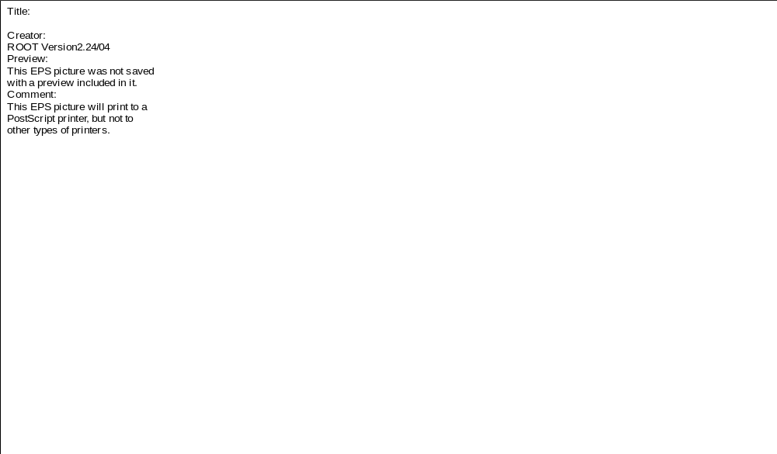

Figure 10: Typical Distribution of Reconstructed Positions for an SLM sensor in July for Laser 302 Using es9 as the Final Reference Sensor. (Bands are non-physical)

Figure 11: Typical Distribution of Reconstructed Positions for an SLM sensor in July for Laser 303 Using es9 as the Final Reference Sensor. (Bands are non-physical)

The distribution of reconstructed means along the CSC layer SLM typically fell within a 100-140 μm range in Y and a 40-80 μm range in Z for both lasers 302 and 303. Though both lasers appear to show a slight drift in the Y distributions, any apparent drift in the data cannot be resolved outside the systematic errors. All of the distributions appear to look very similar, with the exception of es10. As discussed in the review of the COCOA reconstruction of the SLM using es10 as a reference sensor (Section V.A.), the raw and fitted pixel distributions from FLAP were found to not track the distributions in the other SLM sensors, so this result in not unexpected.

The reconstruction of the Transfer line sensors yielded a distribution of the sensors’ mean ISR positions that fell within the systematic error involved in the COCOA reconstruction. Though no correlations could be drawn out due to the systematic error, the resulting distributions (in X and Y) for sensors et0 and et1 looked fairly similar. The distribution of positions for sensor et4 seemed to mirror those of the other sensors in Y, but looked random in X. It should be noted that sensor et4 had only two CCDs (lower and far X ISR) illuminated by the laser and the preceding reference sensor, et3, did not have its upper CCD (which tracks X motions) illuminated, thus it was expected that et4’s resolution would be degraded.

2. September Results

These plots detailing the distributions of COCOA reconstructed positions are reproduced in their entirety in Appendix B, Figures 11-21. Sample plots from the September data set showing the position of a typical sensor are shown in Figures 12 and 13. The distribution of COCOA reconstructed positions of the SLM sensors as a function of time all seem to be continuation of the previous July/August data until there is a large jump in the Laser 302 Y and Z and Laser 303 Y data. This apparent jump in sensor positions is most prevalent when the sensors were reconstructed with Laser 302, though a smaller apparent jump is observed along the Y axis when the reconstruction was done with Laser 303. The jump appears to coincide exactly with the replacement of Laser 302 and matches a jump in the raw and pixel distributions from FLAP. The amplitude of the jumps appears to gradually decrease in magnitude from es2 to es7 as the sensor distance from laser 302 increases. The Z positions of the SLM sensors do not appear to undergo any significant changes when reconstructed with Laser 303. Indeed, an examination of Figures 1-20 in Appendix B shows significant changes between the July/August SLM sensor positions and September SLM sensor positions - except in the Z positions associated with Laser 303. Such shifts could potentially have been caused by disturbing the position or orientation of the transfer plate during the replacement of the laser; however it is not yet clear if this was the case. Raw FLAP data is presently being correlated with the September COCOA reconstruction to further study this phenomenon. Since the jump in apparent sensor positions was so significant and occurred early in the September test period, the time period prior to the jump (containing approximately 120 of 1300 events) was excluded from the analysis and the July/August test period was examined separately from the September test period.

Figure 12: Typical Distribution of Reconstructed Positions for an SLM sensor in Sept for Laser 302 Using es9 as the Final Reference Sensor. (Bands are non-physical)

Figure 13: Typical Distribution of Reconstructed Positions for an SLM sensor in Sept for Laser 303 Using es9 as the Final Reference Sensor. (Bands are non-physical)

An examination of the remaining September SLM data after the jump shows that the range of the entire distribution of mean positions for all sensors (and all lasers) typically fall within the systematic error of each sensor. The distributions appear to be much tighter than those in July as reflected by the smaller statistical errors associated with these events. The Transfer line sensor distributions (again they fall within the systematic error) appear very similar to those taken in July/August, though the September distributions are slightly more spread out. There is no apparent jump in the location of any Transfer line sensors.

3. Discussion of et2, et3, and es9 Reference Sensor Reconstruction

COCOA Reconstruction of the test setup using es9 as the final SLM reference show the Transfer Line, Laser 302 Z September, and all Laser 303 Z reconstructions remain essentially unchanged from the es10 reconstruction results. The drift in the Y coordinate reconstruction of the SLM sensors evident in Figure 4 for the es10 reconstruction is no longer visible. Rather, all of the sensor Y locations now lie roughly within 200 μm of their surveyed locations (es10 excluded). A slight shift in the sensor Y reconstructions is now observed between the July/August and September data and is more prevalent with the Laser 302 reconstruction. A summary of the results for all sensors from each test period are given in Table 5 and Figures 14-16.

Sensor | July/Aug  Laser 301 |  | Statistical Error (July) |  | Sept°  Laser 301 |  | Statistical Error (Sept) |  | Systematic Error
Sensor | Xmean (μm) | Ymean (μm) | Xerror (μm) | Yerror (μm) | Xmean (μm) | Ymean (μm) | Xerror (μm) | Yerror (μm) | Xerror  (μm) | Yerror  (μm)
et0 | 54 | 39 | 9 | 9 | -168 | 31 | 8 | 22 | < 132 | < 168
et1 | 25 | -237* | 7 | 7 | -123 | -257* | 15 | 16 | < 133 | < 500
et4 | 435 | -48 | 27 | 11 | 447 | 49 | 24 | 12 | < 170 | < 158

Sensor | July/Aug Laser 302 |  | Statistical Error (July) |  | Sept°  Laser 302 |  | Statistical Error (Sept) |  | Systematic Error
Sensor | Ymean (μm) | Zmean (μm) | Yerror (μm) | Zerror (μm) | Ymean (μm) | Zmean (μm) | Yerror (μm) | Zerror (μm) | Yerror  (μm) | Zerror  (μm)
es1 | 276* | 1 | 8 | fixed | 254 | 13 | 17 | fixed | < 166 | < 53
es2 | 205 | 67 | 44 | 6 | -18 | -471 | 17 | 12 | < 211 | < 125
es4 | 202 | 162 | 53 | 7 | 56 | 157 | 6 | 5 | < 167 | < 110
es5 | 282 | 312 | 27 | 11 | 124 | 101 | 13 | 5 | < 146 | < 107
es6 | -80 | 106 | 22 | 18 | -153 | -42 | 10 | 6 | < 121 | < 109
es7 | -68 | 58 | 21 | 17 | -156 | 39 | 21 | 17 | < 112 | < 116
es10** | 985 | -932 | 8 | 46 | 771 | -684 | 16 | 28 | < 114 | < 137

Sensor | July/Aug Laser 303 |  | Statistical Error (July) |  | Sept°  Laser 303 |  | Statistical Error (Sept) |  | Systematic Error
Sensor | Ymean (μm) | Zmean (μm) | Yerror (μm) | Zerror (μm) | Ymean (μm) | Zmean (μm) | Yerror (μm) | Zerror (μm) | Yerror  (μm) | Zerror  (μm)
es1 | 276* | 1 | 7 | fixed | 257 | 13 | 15 | fixed | < 167 | < 53
es2 | -183 | -40 | 38 | 8 | -231 | -41 | 22 | 15 | < 147 | < 146
es4 | -21 | 6 | 17 | 9 | 198 | -2 | 10 | 8 | < 188 | < 123
es5 | 58 | 291 | 11 | 8 | -36 | 284 | 8 | 6 | < 146 | < 113
es6 | 19 | 129 | 11 | 9 | -102 | 121 | 7 | 6 | < 120 | < 105
es7 | 17 | 177 | 10 | 17 | -96 | 148 | 10 | 17 | < 112 | < 105
es10** | 1211 | -266 | 7 | 6 | 1082 | -287 | 4 | 5 | < 117 | < 117

Table 5 : Deviation of COCOA Reconstruction of DCOPS Dowel Pin Positions from Expected Survey Location with es9 Survey as Final Reference

° Events fitted in Sept Data correspond to introduction of new laser diode in SLM line (525+ events). September events taken prior to the introduction of the new laser (100 events) where typically within 20-150μm of July positions.
* Transfer plate Y definition was broken by at 1.71 mm ± .5 mm. This is survey position with estimated movement of transfer plate components. See Section IV.C for detailed description of problem.
** The orientation of Sensor es10 was found to be incorrect. Subsequent reconstruction of single events using the corrected orientation indicates the (Y,Z) location of es10 is closer to (182, -419) in July and (162, -439) in Sept
Figure 14: Transfer Line Results of COCOA Reconstruction for July/August and September Runs Using es9 as the Final Reference Sensor. Error bars indicate total uncertainty in sensor location as determined by COCOA.
Figure 15: SLM Line (Laser 302) Results of COCOA Reconstruction for July/August and September Runs Using es9 as the Final Reference Sensor. Placement of es10 is exaggerated by the misorientation of the es10 sensor. The corrected orientation was used for the reconstruction of the SLM shown in Section V.A. See Section VI.A for a more detailed description of the problem. Error bars indicate total COCOA uncertainty.

Figure 16: SLM Line (Laser 303) Results of COCOA Reconstruction for July/August and September Runs. Placement of es10 is exaggerated by the misorientation of the es10 sensor. The corrected orientation was used for the reconstruction of the SLM shown in Section V.A. See Section VI.A for a more detailed description of the problem. Error bars indicate total uncertainty in sensor location as determined by COCOA.

As with the es10 reference sensor reconstruction, a comparison of Figure 15 and 16 shows that the reconstructed Z coordinate positions of several of the sensors do not overlap (an overlay of Figures 8 and 9 is given in Appendix B, Figure 24). In particular, the reconstructed means of the Laser 302 es2, es5, and es10 Z coordinates in September show some disagreement with corresponding reconstructions using the other lasers. The discrepancy is, however, much less than with the es10 reconstruction since most error bars now overlap between the two lasers and test periods. Since sensor es10’s operable CCDs monitoring changes along the Z axis were found not to track the CCDs in preceding sensors, the es10 result was expected.

4. Conclusions

Reconstruction of all DCOPS sensors within 200 μm of the June survey positions was achieved for most of the sensors in both reconstructions for both test periods if the errors in the CERN Photogrametry are considered. The elimination of the drift in the es10 reference sensor Y coordinate reconstruction by choosing es9 as the reference indicates the surveyed location of orientation of es10 is incorrect. The shifted location of es7’s Y coordinate between the two reconstructions suggests the misplacement or impact of an incorrect orientation of es10 is on the order of 250-350 μm.

Figure 17 indicates that the reconstruction of sensors utilizing es9 as the final reference indicates that resolution of the entire ISR system (excluding es10) can be generalized as ∼223µm for the July test period, ∼150µm for the September test period, and ∼187µm across both test periods. This again compares favorably to the uncertainty in the photogrammetric location of the dowel pins (σ_{y} =180 μm, σ_{z} =160μm) with which the reconstructed location of the dowel pins are compared.

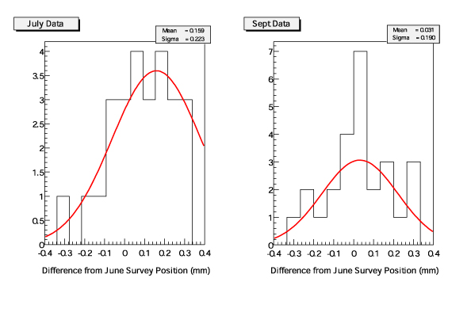
Figure 17: Summary of Reconstructed SLM and Transfer Sensor Locations for es9 Reference Reconstruction. Histograms represent the deviation of all reconstructed sensor locations from their initial photogrammetry survey location. Both Laser 302 and 303 reconstructions are included in the data. The averaged σ for both test periods is 187µm.

The most basic test as to whether or not the system works in a self consistent manner has been met: the apparent location and relative positioning of most sensors can be said to remain roughly within the projected error of the reconstruction independent of the choice of laser used along the SLM line. This test is much more critical than matching the reconstructed position of the sensor dowel pins to their surveyed location since survey errors can be large (>150 μm along SLM line, perhaps more in the case of the es10 Y coordinate). Some discrepancies between reconstructions based on the laser choice are expected since the sensors participating in the measurements may gain or lose CCDs or see completely different signal to background ratios. Perhaps more significantly, the active CCDs on the SLM reference sensors are switched with choice of lasers due to shadowing effects by preceding sensors. Thus, two sets of measurements utilizing each laser with the same reference CCDs on the endpoints are not available.

There is also ample evidence to suggest that the reconstructed positions of the sensors are independent of small variations in the orientation of the laser. An analysis of the individual CCDs used in the reconstruction shows several cases in which the angle of the laser seems to suddenly shift. Figure 18 (below) shows the July distribution of raw centroid measurements in each CCD of sensor es4. Three distinct jumps in the location of the laser centroid can be clearly seen. The first jump in the distribution is approximately 30 pixels (30 pixel = 420μm). Figure 19 (below) shows the reconstructed location of sensor es4 over the same period of time. There is no indication of any breaks or jumps in the distribution to suggest any sort of correlation with the jumps in CCD centroids in Figure 18 (σ_{y} = 10 μm, σ_{z} = 8 μm).

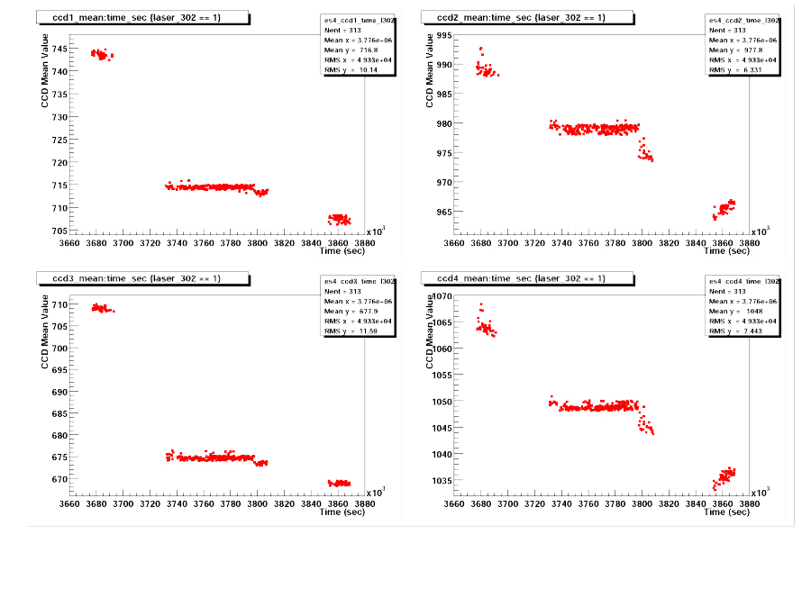
Figure 18 : Distribution of raw CCD means in es4 during the July/August Run. Three distinct jumps in the pixel distributions can be seen.

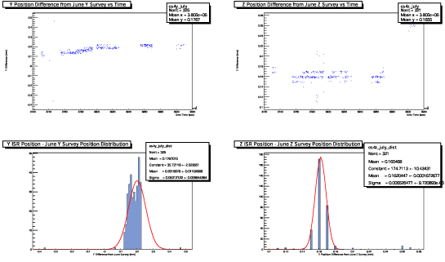

Figure 19 : Distribution of COCOA Reconstructed location of es4 in the ISR hall during the July/August Run. No jumps in the data are evident. (Bands are non-physical)

As previously discussed, there does seem to be a clear correlation with the introduction of a replacement Laser 302 in September with a large jump in the es9 reconstructed positions of the sensor and the ending of erratic behavior from those reconstructed with the es10 reference sensor (see Appendix A, Figure 16). This effect is not entirely understood and presently under review.

Limitations of Reconstruction

Not all sensors in the test hall could be reconstructed within the desired 200μm. Furthermore, the systematic errors were significant. Several factors which may have contributed to errors in the COCOA reconstruction are now addressed.

A. Determination of Angular Orientations

As discussed, the results presented were determined by fixing the angular orientation of the unknown sensors in COCOA to their surveyed orientation. This cannot be done in the final CMS system. Additional studies are underway to understand how well these angles can be determined from the COCOA reconstruction of actual CCD measurements and the impact on this has on the spatial resolution of the system.

COCOA determines the angular orientation of the dowel pins be finding the minimum error associated with the inverse of the matrix used to determine the best fit of the CMM data with the CERN survey data. In the case of es10, two local minima’s to this fit occurred unusually close to each other. Although both minima’s yielded slightly different dowel orientations (<1.5 degrees), they had identical dowel locations. Reconstructing with the larger of the two rotations introduced significant errors in the entire SLM line when es10 was used as the final SLM reference (see Appendix A, Figure 24) The larger rotation on es10 introduced errors in only the reconstructed location of es10 when es9 was used as the final SLM reference. Upon discovery of the second minima, the reconstruction of all events using the new (smaller rotation) orientation of es10 as the SLM reference was performed. The location of es10 in the reconstruction using es9 as the final reference is the original (larger rotation) value.

B. Reference et2 MAB Motions

The absolute establishment of the positions of the reference sensors et2, et3, and es10 are the most critical parameters of the reconstruction. In the present COCOA simulation, the locations of et3 and es10 are given by photogrammetric measurements taken in June. These sensors were not moved or repositioned from their mounts until the end of the September tests. The et2 sensor, however, was installed just prior to the July tests on a simulated MAB. Though a series of photogrammetry measurements were taken just prior to the beginning of the test periods, the MAB could have undergone small shifts in position and orientation. These small motions of the MAB (if any) were monitored by the LINK Alignment group. Test data from the EMU and LINK groups are presently being correlated to better understand possible motions. The ISR data can be reconstructed with a new COCOA simulation using a non-static MAB model if motions are supplied by the LINK group.

C. Calibration of DCOPS Sensors

In principle, the calibration of the sensors taken before the June ISR tests was to be compared to a recalibration of the sensors upon completion of the September tests. This measurement was to estimate both the stability of the sensors during the ISR tests as well as reconfirm the validity of the original calibration. However, serious problems with the original calibration and the recalibration were uncovered upon careful examination of the data, making any definitive estimation of the sensor calibration at the time of installation impossible. The sensors have since been recalibrated a third time and this data is being examined. However, the new set of calibrated data is being estimated as valid with a maximal uncertainty of 100 μm.

Instability in the mount points of the CCDs in each sensor is clearly insignificant in the flat CCD windows by construction. The bi-directional sensor windows may exhibit some instability, particularly after handling and installation of filter tapes on the window. Errors in the Reconstruction due to these instabilities have not yet been investigated.

It is expected that a better understanding of the calibration process in the coming months will significantly drop the error associated with the calibrated parameters. A calibration of the parameters perpendicular to the pixel arrays is also planned.

D. Calibration of Transfer Plate

The transfer plate fixes the relationship of sensors et1 and es1 and allows for the reconstruction of the SLM line (which uses es1 and es10 as reference sensors). Since et1 is determined from the Transfer line reconstruction (using et2 and et3 as reference sensors), it is essential that relationship on the transfer plate is specified precisely - as errors in the definition of this relationship will be compounded with errors from the derived position of et1.

Unfortunately, after the CERN photogrammetry of the transfer plate components, the relationship between es1 and et1 was accidentally broken by someone making an unrecorded adjustment to plate. It is assumed that such adjustments were only made to the slide which mounts the et1 sensor. This difference appeared after the survey of the photogrammetry targets on these sensors was done. Based on the subsequent measurements with a micrometer, it is thought that the et1 sensor was lowered approximately 1.71 mm ± .5mm in Y CMS only. The transfer plate was secured in its final position and sent to FNAL for additional CMM measurements to determine the precise magnitude of the displacement.

The transfer plate was measured again at FNAL by CMM on February 6, 2001. It was determined at this time that the vertical (Y CMS) separation between the et1 and es1 reference dowel pins was 187.198 mm ± .030 mm. Since the adjustable slide on the transfer plate moves only the et1 sensor, the ‘true location’ of et1 can be inferred from the CERN Photogrammetry location of es1 and the CMM separation of the dowel pin to be 1298.792 mm ± .153 mm in Y CMS.

E. Additional Fit Parameters (Shadowing, Poor Centroids)

Not all sensors in the ISR tunnel were able acquire usable data from all four of their CCDs due to either a malfunction on the DCOPS board or the shadowing of the laser line by preceding sensor windows. As a result, COCOA reconstructed the laser lines using only two or three CCDs on these particular sensors. Fortunately, sensors with two unusable CCDs had at least one vertical and horizontal CCD operable allowing for a reconstruction of the dowel location in the requisite two dimensions. Reference sensors et2, et3, and es10 had three usable CCDs and reference sensor es1 had all four CCDs working. However, July Run 458 showed sensor et2 with only two operable CCDs. This introduced significant errors in the Reconstruction. For example, the et1 sensor reconstructed positions along the X axis showed very large deviations exceeding 200μm between successive events. This error was propagated across the transfer plate and introduced significant variations between events on the SLM line as well. By contrast, with the more typical readout of three CCDs on et2, reconstructed positions of et1 typically fell well within a range of 100 μm. Fit and reconstruction problems were also induced by very poor laser distributions in individual CCDs.

Since reference sensors et2, et3 and es10 each had a shadowed CCD, it seems plausible that successfully illuminating all four CCDs on these reference sensors would improve the accuracy and precision of the overall reconstruction. This issue is presently being studied with an idealized simulation model of the EMU system.

F. Redundancy of Second Measurements in SLM Line

Events reconstructed thus far have utilized SLM Laser 302 (with the beam running toward the es9 reference) or Laser 303 (with the beam running toward reference sensor es1) separately. Since data with either SLM laser is taken synchronously with the Transfer line, events reconstructed with Laser 302 have no direct correlation to those reconstructed with Laser 303. If SLM Laser 302 and 303 data could be taken very close in time, the tracking and resolution of the sensors within short time frames could be greatly improved by incorporating both sets of SLM data into a single reconstruction of the system. Simulations modeling the reconstruction of single events using both Laser 302 and 303 data as near simultaneous measurements are underway.

G. First Level Analysis of CCD Data

The processing of raw data from the DAQ included the determination of the mean pixel location of the charge distribution formed by the incident laser. This mean was later entered into COCOA as a starting point for a reconstructed measurement. A detailed study of the raw charge distribution in the CCDs and the determination of the mean value have been presented separately. The conclusion of this study is that the mean value of the charge distribution can be determined in the ISR within 1 pixel (<14 μm of rms error) under repeated, short term measurements. The studies examining medium and long term resolutions are thought to be limited by the stability of the laser diode. It should be emphasized that the spatial stability of the laser lines for time periods exceeding the integration time of the CCDs is not a requirement for a successful Reconstruction of the system. However, abnormalities in raw CCD data have not yet been correlated to the abnormalities in the reconstructed data.

Additional work has been done carefully refitting several of the raw CCD charge distributions ‘by hand’. The reconstructed position of the sensors was found to remain in essentially the same location as when reconstructed with the original FLAP automated fits. We have concluded that the fitting of the centroids performed by FLAP is more than adequate for reconstruction of alignment positions within the required performance specifications.

Acknowledgements for ISR Testing and DCOPS Prototype Development

We especially thank our collaborators of Northeastern University (J. Moromisato, Eb vonGoeler, R. Terry) who built the mechanical parts, calibrated and filtered the DCOPS sensors, and worked with us in the development, setup, and some execution of the tests.

We also thank S. Hanson, E. Cowden, J. Lofgrin, R. Martin (Fermilab PPD Electronics group) and V. Sknar, E. Orischin (Petersburg Nuclear Physics Institute) for their development, construction, testing, DSP programming, etc. of the DCOPS sensor and electronics for the ISR I4 tests. P. Arce’s help and effort adapting COCOA for use with DCOPS sensors is also appreciated.

We thank the CERN Laboratory EP/CMS (A. Ball, D. Arevalo, R. Riberio) for establishing the ISR I4 test area, utilities, supports; for survey services and Photogrammetry (C.Lasseur, C. Humbertclaude, D. Mergelkuhl, R. Goudard, J.Noel. Joux and crew- CERN Geodesy). We also thank the Fermilab Geodesy (J. Greenwood and crew) for Photogrammetry measurements of our sensor assemblies; and the Fermilab Technical Division for CMM measurements of brackets and the transfer plate.

