8.3 Aviation Personnel Selection, Training and Proficiency:
Flight crew issues
Cabin crew issues
Air traffic controller issues
Maintenance personnel issues
Selection

Philosophically, obtaining the right people for aviation jobs is not different than obtaining the right people for other highly technical occupations in which successful individuals need to have an acceptable set of personal traits, many of which were discussed above. It is vitally important that any attempt to select individuals into, or exclude individuals from a particular type of job, be preceded by an accurate job task analysis (JTA). The fact that a selection process is necessary assumes that the job cannot be performed by everyone likely to apply and that there will be more applicants than there are positions available. The challenge then is to determine what screening processes result in the selection of candidates who ultimately achieve success in the

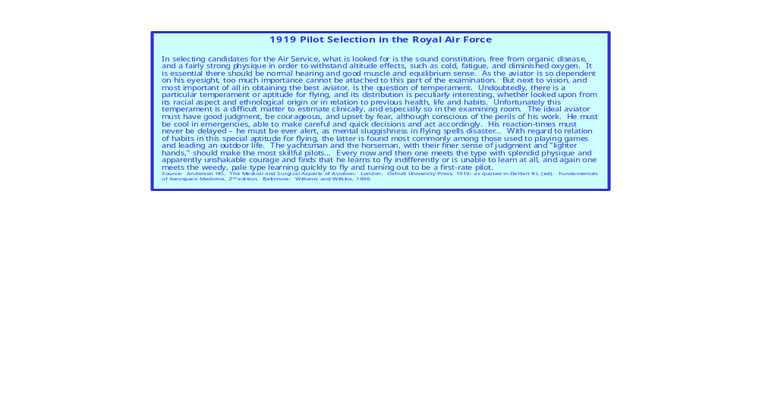
job. This usually begins with the establishment of certain objective criteria, such as physical requirements, attained education, previous experience, and often one or more “psychological selection procedures.” These psychological procedures have three primary measurements to establish:
Attainment – what the applicant has done before and knows when applying.
Aptitude – assessment of the applicant’s potential or latent capacity.
Personal qualities – motivation, stability, dependability, etc.
These parameters may be assessed with objective or semi-objective test batteries, however, more often the data relevant to these three dimensions is sought through much more subjective means, as noted in the following example.

When the need arises to perform selection of personnel for military, commercial, and even private aviation operations, physicians will be directly or indirectly involved. The classic example of this is the Adaptability Rating for Military Aviation (ARMA), initially developed by Major Raymond F. Longacre, in 1930. The ARMA has evolved continuously over many decades, and while originally intended for military aircrew selection, can be adapted for civilian use and can be modified to aid in the selection of a broad range of other workers, such as law enforcement and nuclear power plant operators.

By its nature the ARMA and similar survey instruments are more subjective than objective. The ARMA as practiced early in World War II was a list of about 40 specific questions administered rigidly to prospective pilots. During the ensuing decades, no specific edition or revision of the ARMA has ever been shown to be a valid and reproducible assessment of an applicant’s motivation to fly or likelihood of success in aviation operations. However, the ARMA does allow the examiner to assess the individual’s thought processes leading to their apparent desire to participate in flying activities. This is most often done through a series of informal questions, almost a conversation, with the applicant during the flying duty medical exam. The questions probe the applicant’s motivation for flying, previous aviation activities, their perception of the dangers, and how they plan to overcome the difficulties associated with an aviation career. Other indirect questions about past achievement, how they react to supervision and discipline, their feelings about individual and group (team) tasks, and anger control may give indications relevant to aircrew selection. One should always determine what the applicant will do if not selected – occasionally an applicant has been known to reveal at this point that they indeed have a “fallback” plan that is of more interest to them than is flying, and that the application for aircrew duty is really to satisfy someone else’s desire (typically a father who has had or longed for a successful aviation career). Finally, the examiner should pay close attention to the way the applicant behaves and reacts during the exam and interview process, i.e., nervous habits, eye contact, and so on. In the end, the examiner must subjectively assess whether the applicant exhibits an acceptable blend of many different attributes which can enable success in aviation activities. Traditionally, these have been thought to include motivation, independence, demonstrated success in groups, intelligence, and ability to learn complex subjects, abstract reasoning capability, energy, alertness, responsibility, aptitude, and so forth. (Aptitude, aptitude testing, motivation, and intelligence were discussed above)

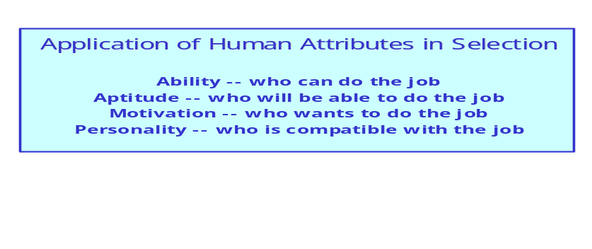

The usefulness of the ARMA and similar interviews depends upon the skill of the examiner. Ultimately, many successful aviators have proven that motivation and determination often make up for lack of innate ability. This is particularly true with the growing trend in aviation automation, which demands a much different set of innate abilities than has traditionally been thought necessary. For many decades a significant proportion of the civilian airline pilots came from the military, many who spent their formative years, or even an entire military career (20 years) in high performance single seat aircraft. The single seat aircraft almost always were fighter or high performance reconnaissance aircraft, and typically pilots involved in those missions were at the top of the pecking order of their military pilot communities – conveying a subtle unspoken confirmation that one had become one of the best of the best. These individuals had been specifically selected and trained to achieve success, which was heavily dependent on individualistic skills coupled to the notion that those skills represented the pinnacle of piloting ability. The transition to civilian airline flying was difficult for many such pilots, learning to successfully participate and execute team-based skills was slow and painful; often it involved learning a whole new “culture.” For this, and other reasons, the selection process for airline pilots now includes significant effort to identify individuals who are likely to adapt and function well in team situations while developing leadership qualities compatible with team success.

Training

“Training is the systematic modification of behavior through instruction, practice, measurement, and feedback. Its purpose is to teach the trainee to perform tasks not previously possible or to a level of skill or proficiency previously unattainable. Flight training involves [the] use of resources that may include instructional personnel, operational aircraft, simulators and other representations of aircraft, printed and graphic media, classrooms and practice areas, and a variety of other specialized aids and devices, depending on the tasks to be trained.”⁴

Effective training programs tend to have similar generic elements, including:
Properly selected students.
A rational syllabus of instruction.
Knowledgeable, motivated training staff with adequate resources.
Appropriate methods of assessment and feedback.
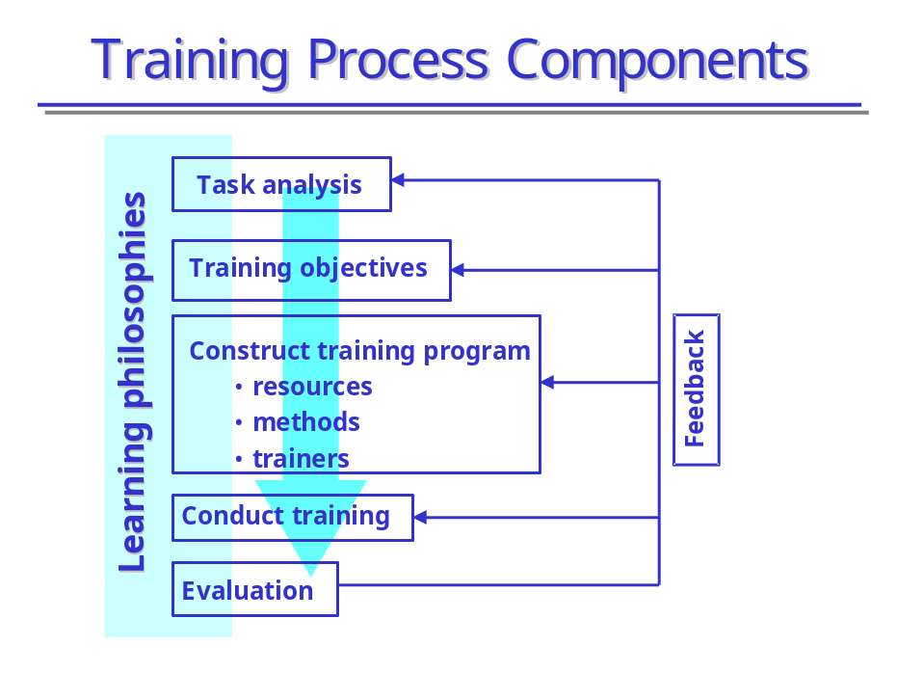
Creating an effective and efficient training syllabus requires a deliberate process to thoroughly analyze the goals for training, the best means to achieve those goals, appropriate methods to analyze the outputs to assure trainees achieve the desired outcomes, and to continuously improve the program. Although several steps in such an analysis may be described separately, in reality they tend to overlap significantly; many occur in parallel rather than linear sequence. The primary steps / analyses performed for most training programs are as follows:
Task analysis to determine the intellectual tasks and the behaviors required to perform any associated psychomotor tasks.

Training objectives are linked to the task analysis. These are primarily statements delineating expectations for the trainees following training. This includes not only what the person is expected to do, but determines the conditions in which it will be performed, the objective standard to which it must be performed, and so on.
Training objectives must be detailed, specific, and precise in order to properly focus the training process for trainees and trainers alike. It is critical that all involved clearly understand both the intent and the content of the training objectives.

Construction of the training program, including what method of instruction is best suited for each training task / objective. Adequate resources must be assured and maintained. Each step in training must be properly sequenced and interfaced in accordance with terminal or outcome objectives. Where appropriate, intermediate or enabling goals may be integrated to assure overall success.

Precise methods and criteria for evaluation of individual trainees, trainers, and program effectiveness must be created and implemented. The outcomes from this evaluation process then serve as feedback to modify the program. It is also wise to include subsequent measures of individual job performance after the trainee has entered the job mainstream, to assure the training program has produced the desired behavior for successful job performance.

Throughout the training process, there are several principles of learning that should be kept in mind by trainees, trainers, and system managers. Examples of the learning principles include:
The trainee must learn for himself, no one can learn for him.
Each trainee learns at a different pace / rate from all other trainees.
Positively motivated trainees tend to learn faster – to a point (see previous discussion of workload), “negative motivation” is rarely useful.

Assessment / feedback are critical to the learning process.
Active participation achieves a more thorough, longer lasting result than passive learning; for many aviation training tasks, hands-on practice and repetition is essential.
When a training objective requires team success, training should occur as a team.

Real world aerospace operations occur in a very complex environment, using very sophisticated hardware and software. Over the past 20+ years there has been a trend toward expanded / extensive use of sophisticated, high fidelity, motion-based simulators for both individual and collective (team) training in aviation. Many advantages have been documented and recognized by the training organization (e.g., airline companies) and regulatory agencies (e.g., FAA). The level of sophistication in simulation now available essentially replicates virtually anything that can occur in an actual aircraft in aerospace operations, with one major exception – the simulator will not crash. Currently available technology faithfully achieves full mission simulation involving intact crews in Line Oriented Flight Training (LOFT).

Line Oriented Flight Training

In a typical LOFT scenario, the crew enters the simulator and completes a one- or two-leg trip, encountering a number of malfunctions and restricted visibility landings. The purpose is to simulate, as closely as possible, an actual line trip that a crew might encounter. After the flight is over, the instructor reviews individual and crew performance… There is no “right” way for the crew to perform during LOFT. The objective is to see how the crew handles each situation using resource management principles… The use of LOFT-type training has changed the texture of airline training.

