IN SITU SURVEYING OF SATURN’S RINGS. P.E. Clark¹, M.L. Rilee¹ , S.A. Curtis², and C. Cheung² ¹Affiliation: L3 Communications, Government Services, Inc., 3750 Centerview Drive, Chantilly, VA 20151, Correspondence: Code 695, NASA/GSFC, Greenbelt, MD 20771, Email: Pamela.clark@ gsfc.nasa.gov.²Affiliation: Code 695, NASA/GSFC, Greenbelt, MD 20771.

Introduction: The Saturn Autonomous Ring Array (SARA) mission concept [1] is a new application for the Autonomous Nano-Technology Swarm (ANTS) architecture [2,3], a paradigm being developed for exploration of high surface area and/or multi-body targets to minimize costs and maximize effectiveness of survey operations [4,5,6,7,8,9,10]. Systems designed with ANTS architecture are built from potentially very large numbers of highly autonomous, yet socially interactive, specialists, in approximately ten specialist classes. Here, we analyze requirements for such a mission as well as specialized autonomous operations which would support this application [11,12,13].
SARA [1] would perform in situ observations of Saturn’s rings, both from the individual particle and collective plasma standpoints. This population is of great interest from the standpoint of solar system origin However, such in situ observations of spacecraft-scale targets with high density distribution in a large gravity well represents a challenge unachievable by conventional (direct control of single spacecraft from Earth) or even evolutionary (direct control of multiple spacecraft from Earth surrogate) mission designs (Figure).
Each nanocraft would be on the order of kilograms in mass, and thus require gossamer structures for all subsystems. Onboard power requirements, met by small nuclear batteries, would be constrained to milliwatts. The hundreds or even thousands of individual specialists include Workers, the vast majority, that acquire scientific measurements, as well as Messenger/Rulers that provide communication and coordination.
Methodology: The patented model of bilevel intelligence which supports this architecture is described in detail elsewhere [1,2,3]. Detailed formulation of requirements and operational scenarios for SARA is underway [1] and the aspects of this application which drive requirements in a different direction than other applications and their implications are examined here.
Discussion: Potential science goals for SARA (Table).provide the context for this discussion. The high density distribution of particles on the scale of particles size, combines with the high intensity gravity and magnetic field environment to produce dynamic plasmas. Although composition is essentially cometary with high volatile abundances, great variations remain in the dust/gas ratio and the composition of dust component for individual particles. Thus, a broad spectrum of in situ instruments, with very different requirements, are required, with specialists developing strategies to obtain in situ measurements as individuals, teams, in a highly dynamic environment, as appropriate. Plasma, particle, wave, and field detectors will probably fly just above or below the ring plane to observe the result of particle interactions. Imagers and spectrometers will need to develop a strategy for serial rendezvous with individual particles through the ring. The high density of particles, some nanocraft-scale, makes collision avoidance a problem that must also be solved autonomously in situ. The numbers and distances of these particles, as well as anticipated high attrition rate, require large numbers of each specialist class,
What would the structure and size of a swarm of specialists need to be? According to our design for the neural basis function, a minimum of five specialists are needed for collective decision making [1,2,3], and we allow for ten instrument specialist teams (Table). That means a minimum size of 50 in a subswarm. Allowing for a high attrition over the couple of years required for a survey, numbers of specialists should initially be 100 in a subswarm. The use of ten to twenty of such subswarms should allow for the characterization of thousands of particles and ring features over the course of the traverse of the rings.
The SARA concept includes assembly of self-packaging, self-deploying, self-similar components at facilities built on ANTS architecture [1,2,3] as described for the ANTS Prospecting Asteroid Mission (PAM). Transportation requirements and capabilities are being considered as part of a propulsion system trade-off study for SARA, which combines navigating in low gravity with maneuvering in the high gravity regime of Saturn’s rings, demanding hybrid propulsion.
Conclusions: ANTS mission architecture is ideally suited for in situ surveys such as SARA. The ANTS approach allows simultaneous survey of many interesting targets by teams of flexible instrument specialists, which can be configured for optimal operation. Redundancy allows for planned high attrition of individual workers without compromising ongoing survey work.
References: [1] Curtis et al (2003) Saturn Autonomous Ring Array, NASA RASC Proposal; [2] Curtis et al (2004) The Autonomous NanoTechnology Swarm, NASA RASC Final Report (in preparation); [3] Clark et al (2004) 35th LPSC; [4]Curtis et al (2000) Abstracts of IAF, 51st Congress; [5] Clark et al (2001) AAS/DPS, BAAS, vol. 33, no. 3; [6] Clark et al (2001) EOS Trans. AGU, 82 (47), 2001; [7] Clark et al (2002) LPSC XXXIII, 1394; [8] Clark et al (2002) EOS Trans AGU, P521-01, [9] Curtis et al (2003)Abstracts of Third International Workshop on Satellite Constellations and Formation Flying, Pisa, Italy; [10] Clark et al (2003) 34th LPSC; [11] Rilee et al [2002] IEEE Aerospace Conference, Big Sky, MT, 209; [12] Curtis et al (2003) IEEE Aerospace Conference, Big Sky, MT; [13] Curtis et al (2003), Large Autonomously Reconfigurable Antennas for Space-based Radio Astronomy, NASA MSMT Proposal;
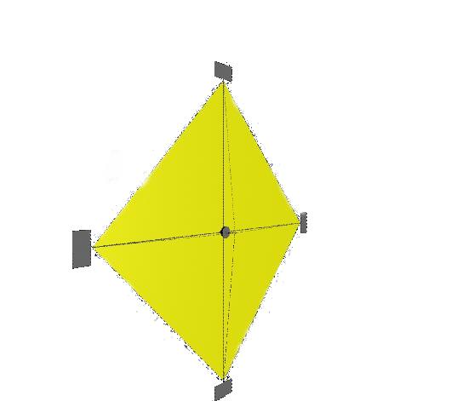

Acknowledgment: Support for this work has been provided through NASA contract NAS5-99189, subcontract 0299189EER, with ITMI.
Hierarchical Swarm/Constellation
Communications, Control, Cohesion
Revolution: Autonomous, Optimized Science Operations
Multi-S/C,
Global Scope, e.g.
Ad hoc GPS”
Multi-S/C,
Local Scope,,e.g. Imaging
Workers
Messenger/Rulers
Workers
Convention
Remotely controlled directly from Earth
Evolution
Earth Surrogate/Children
Remotely Controlled
deployed from Earth
Figure: Beyond Conventional and/or Evolutionary to ANTS Revolutionary approach of independent autonomous, distributed, redundant, collaborative, interactively organized agents.
Return to or visit ANTS home or SARA web page:
http://ants.gsfc.nasa.gov/pamtest/website.html
http://ants.gsfc.nasa.gov/pamtest/sara.html
Science Context Table for SARA
Modes of Study | Particle populations, view from above or below ring planes |  |  |  |  |  | individual particles, collect thru ring
Measurements | Electrodynamics: plasma, particles waves |  | Electrodynamics: fields | Ring thickness, density | Emissivity, reflectivity, size, and  volatility distribution |  | Refractory element abundances | mineral assemblages | volatiles, organics
Specialists | Particle/Plasma | Search Coil | Magnetometer/E Field | UV/Visible imaging | Mid to Thermal IR | Radio Sounder | APX,laser ablation MS | UV/Vis/IR reflectance | Mass Spectrometer

