Title: | Micro-Opto-Electro-Mechanical Systems (MOEMS) Interconnects Reliability
 |  New Proposal □ Continuing NEPP Work
Total $ Requested
FY 02:
Technology Type: |  Newly Available □Emerging/Advanced
Project Area: | □Parts  Packaging □Radiation
Proposing Centers: | Jet Propulsion Laboratory
33.3% GSFC
57.8% JPL 8.9% JSC
Collaborators | SIM optical mirror project, NGST using micromirrors (FY01 funding), MDL (Optics/deformable micromirror), JPL led consortium under MEMS aspect of SIP, West Virginia University (NSF/NASA).
Point of Contact: | Dr. Reza Ghaffarian/JPL  818-354-2059 (Tel)  818-393-5245(FAX)  reza.ghaffarian@jpl.nasa.gov
Investigator: | Dr. Reza Ghaffarian
Objectives: | - Characterize in process test methodology and quality assurance guidelines for commercial-off-the-shelf micro-opto-electromechanical systems (MOEMS).  - Provide selection criteria for COTS sensors especially targeted for space-flight applications.  - Provide information dissemination for various aspects of MOEMs technology..
Task Description | Opto MEMs device and package interconnections will be test validated to determine their quality and reliability and develop inspection methodologies. The MOEMS have potential of replacing many large and massive electrical, mechanical, and optical systems. For example, for NGST mission, at least three independent proposals recommended the use of MOEMS. These included the use of micromirrors and deformable mirrors, and microshutters. In this task, in addition to commercially available packages, devices developed by NASA and other industry team will be selected for generating statistically meaningful test results on interconnections and will develop inspection procedures for manufacturing defect detection by inspection. Test results will provide as standard/inspection criteria guidance. Knowledge and experience gained by this task will be used to effectively support NASA’s projects in MOEMS areas.
Task Approach to meeting NEPP Objectives | All four objectives of NEPP are met by this task. Quality and reliability of commercially available MEOMS will be test validated to generate statistically meaningful test results. Additional MOEMS package developed for high reliability including NASA missions will be also characterized to define their package interconnect failure mechanisms. The MOEM system interconnects will be subjected to environmental tests as needed and damage progress with time will be identified to provide criteria for early failures. Destructive failure analyses will be performed to establish failure type and bound critical parameters and to establish the most effective testing approaches. Results will be disseminated and will be published as a guidelines document. Knowledge and experience gained will be used to effectively support the projects in these areas.
Technical Background | Microelectromechanical Systems (MEMS) offer a powerful new technology for mechanical, optical, RF, and integrated systems. The integration of optics and MEMS has created a new class of MOEMS devices and integrated circuits that are smaller, faster, more accurate and rugged, and consume less power than macro scale devices. MEMS allow moveable micro-mechanical parts to be integrated with micro-optical elements and 3-D structures, enabling miniaturized free-space optical systems to be mass-produced at low cost by batch fabrication processes. Since the physical effect caused by mechanical movement is usually larger than conventional electro-optic or free-carrier effects, very efficient light modulators, switches, broadly tunable semiconductor lasers, detectors, and filters can be realized with the optical MEMS technology. Applications of optical MEMS include fiber optic switches, optical crossconnect, display, optical data storage, modulators, and fiber optic sensors. Interconnect technology for integrated microoptics and micromechanical devices are complex and is not well understood. Test and validation quality and reliability, characterization techniques are needed for packaging and interconnection. Commercial-off-the-shelf (COTS) technology are required to be used to test validate interconnect failure with statistically meaningful reliability data. Data generated could be used for future standardization of reliability test methodology for optical MEMS interconnects. Therefore, understanding of optical MEMS reliability and technology assurance issues are key to their wider acceptance towards high reliability applications as well as technology transfer their commercialization. Optical MEMS interconnect reliability is one of the most difficult questions to answer since they are still in their infancy, developed for specific applications, and reliability requirements vary and which frequently depend on the user requirements. In spite of these differences, similar common methodologies could be developed for assessing qualification and reliability for those with similar failure mechanisms.
Technical Approach | Review methodologies for characterization of second level optical MEM systems to provide selection approaches since there are no industry specification on how to perform the system characterization for the integrated MOEMS technology and packaging. Representative COTS MOEMS will be selected to investigate quality and reliability of their interconnects. Additional package will be included for high reliability application. Candidate devices will be characterized and a few will be packaged and used as benchmark. Additional testing for NASA’s missions will be also performed on both high reliability and COTS MOEMS by NASA centers. Modeling will be performed to optimize package configuration and further project interconnect reliability. Methodologies similar to those developed under four JPL-led consortia in characterization of advanced electronics packaging and MEMS interconnects will be adapted for the MOEMS with inclusion of specific needs for integration of optics and MEMS and their interconnections. Packages and attachments will be subjected to non-destructive evaluation to characterize manufacturing defect types and frequencies. The MOEMS system interconnects will be subjected to environmental tests as needed and damage progress with time will be identified to provide criteria for early failures. Destructive failure analyses (DPA) will be performed to establish failure type and bound critical parameters and to establish the most effective testing approaches. Results will be disseminated as standard/inspection criteria guidelines. We will use knowledge and experience gained during this task to effectively support NASA’ projects in MOEMS areas.
NASA Customers: | CISM, X-2000, X-33, NGST, Gossamer Telescope, SIM, TPF (Terrestrial Planet Finder), SRTM, HEDS, Space Shuttle/Station, Collaborate with the MDL Lab.
Deliverables: | - Report on test methodologies procedures with quality and reliability data  - Test vehicle assemblies with quantifiable test data  - Quality and reliability indicators and plots  - Quality assurance guidelines  - Technical papers in NASA EEE Links, industry-wide conferences and trade magazines
Schedule:

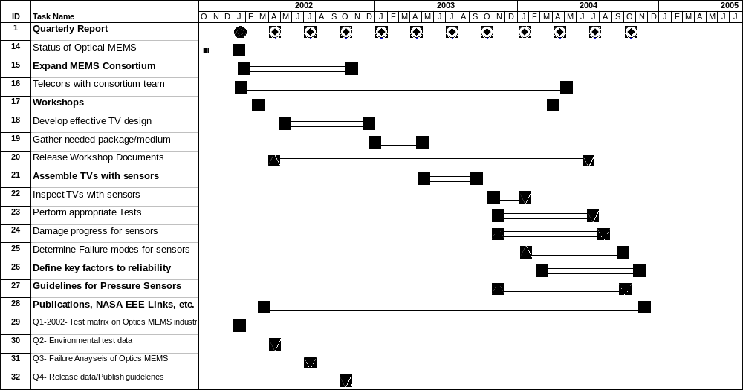

- List of Procurements
Package /PWB/Assembly
Inspection and failure characterization
Unique testing
MDL entrance fees $8,500

Manpower Loading Average Heads (FTEs)

 | Q1 | Q2 | Q3 | Q4
NASA | .54 | .54 | .54 | .54
JPL | .16 | .57 | .51 | .61
Contractor |  |  | .1
Consultant/ University

Leveraging | Will leverage from the NASA centers and several consortia for microelectronics and MEMS. These include: collaboration with NGST micromirror and microshutter MOEMS project, MDL deformable mirror, SIM/Terrestrial Planet Finder for MOEMS and optical switches. Will extend current collaboration between JPL/Aerospace/JSC to evaluate COTS MOEMS, NASA-Wide consortium concentrating on teaming and understanding needs of different centers and knowledge exchange, and will closely monitor West Virginia on development of an optical approach for quality and reliability assurance of package. All activities are designed such to have a coherent work among various tasks on this subject within JPL and other NASA centers.  JPL (506)/Dr. Reza Ghaffarian: Organize NASA/industry-wide consortia activities to meet the objectives of the program at NASA centers as well as industry partners. Perform environmental data correlation to failure to establish link between control parameters and life for package system level interconnects. Coordinate release of NASA/IPC interconnect reliability guidelines for this technology.  JPL (SIM-383)/Dr. A. Azizi: Support in the area of optics specifically perform optical characterization of micromirrors supplied by GSFC and leveraging the SIM optical facility. Review two aspects of optical MEMS (micrmirrors and optical switching) for implementation into current SIM and future planet finder projects. Suppoet in preparation of MOEMS guidelines document in the area of optics.  GSFC/Dr. S. B. Dutta Provide support on definition of test matrix design of experiment and reliability requirement for micromirror devices proposed for NGST program. Provide samples and perform reliability test for comparison to those commercially available. Leverage through cold electronic task to perform cryogenic thermal exposure to meet requirement. Provide inputs into guidebook.  GSFC/H. Shaw/A. Sharma: Provide support on test matrix design of experiment and package characterization and modeling for high reliability applications of micromirrors in coordination with Dr. Dutta. Provide inputs into guidebook.  JSC/Alice Lee: Provide support through this program. Similar to COTS MEMS program solicit JSC’s internal fund to collaborate with industry for MOEMS use for Space Shuttle and Space Station. Initially, identify areas of potential application by review of current optical applications. Based on the results, further identify potential applications through interface with projects at JSC. Provide a report for internal use and inclusion in NASA/IPC guidelines document.  Dr. Rajeshuni Ramesham: Provide technical support in the areas of selection of COTS MOEMs package/assembly and qualification approaches. Support in preparation of guidelines document for NASA and industry use.  Information Management and Dissemination Project: Collaborate with NASA’s project/mission assurance leaders and disseminate information as needed.  NASA Training course. Collaborate with the JPL and GSFC training centers to develop a training course for effective NASA-wide training and another vehicle for information dissemination.  Association Connecting Electronics Industries (IPC) : Collaborate to release NASA/IPC guidelines for this technology

