STAR-LITE 2007: NOAA Ship David Starr Jordan
Weekly Science Report

Eric Archer, Cruise Leader
25 November 2007

Science Summary: 18-24 November 2007

This past week has proven to be a fitting close to what has turned out to be a very successful cruise. Early in the week we finished passing and closing mode on the final two transects, thus fully completing all eight transects of our two diamonds. This left us with three days to burn before we had to begin our five day transit back to San Diego. We decided to use this time to repeatedly survey the last transect in closing mode, which would give us five consecutive days on the same 90nm stretch of the ETP, four of which were in closing mode. What a great opportunity to examine variation in the distribution of marine mammals as well as oceanographic heterogeneity on an even finer scale!

OK, so that might have been a minority opinion. It just so happened that on that last transect we only had six sightings on the first closing mode day. The prospect of a Groundhog Day scenario with no sightings brought its share of groans. In the immortal words of Juan Carlos Salinas on his first rotation, “I think I’ve got my numbers for the day.”

It looked like the prophecies of doom would come true when we finished Wednesday, the second closing mode day, with only three sightings. Thursday started off slowly as well, but as the day was winding down, a tall blow was spotted. This turned out to be our first blue whale sighting on a closing mode day and it was of a mother/calf pair which we ended up snapping copious photos of until we ran out of sunlight. We were in for surprise midday on Friday, when we bumped into the same mom and calf heading down our trackline again. As if that wasn’t enough, our last sighting of the day and of the cruise was of two adult blue whales. They were very cooperative for photos, but managed to stay just out of range of our biopsiers.

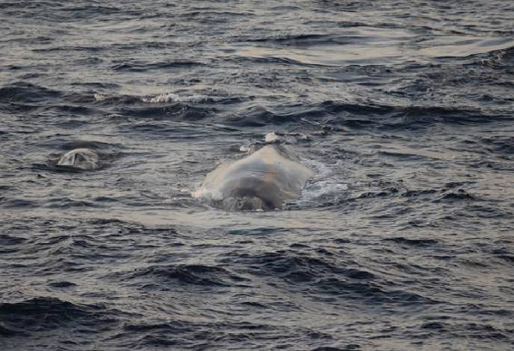
Blue whale (Balaenoptera musculus) mother and calf pair seen on Thanksgiving. Photo: Adam Ü.

Our stewards - Art, Orcy, and Luke – took care of us in grand style by serving up a very tasty Thanksgiving meal. We also want to thank our oceanographers and everyone involved in sending hordes of decorated cups down on the CTD only to bring them back in their new pocket-sized form. They’ll make excellent mementos and gifts, and also serve to sow much confusion among the creatures of the deep. Finally, congratulations to Chief ET Jimmy Kintzele for landing a beautiful (and yummy) 8’ sailfish off the fantail.

And so we begin our five day transit back to San Diego. This has been the finest group of people I’ve ever had the pleasure to sail with. Command, crew and scientists alike have worked as a seamless team and morale has remained high. Projects like these are impossible without the coordinated efforts of countless people. My deepest thanks go to everyone onboard and back at shore who have helped to put this survey together. Most important of all has been the tireless work done by our Survey Coordinator, Annette Henry. It’s hard to imagine how we’d ever leave the pier without her.

Sightings and Effort Summary for Marine Mammals (Richard Rowlett, Juan Carlos Salinas, Suzanne Yin, Ernesto Vázquez, Adam Ü, and Dawn Breese)

Date | Start/  Stop Time | Position | Total nm | Average Beaufort | Mode of Operations
111807 | 0655 | N14:59.11 W104:29.55 | 57.6 | 1.2 | Closing
111807 | 1723 | N14:04.29 W105:17.43 | 57.6 | 1.2 | Closing
111907 | 0710 | N14:49.97 W105:23.98 | 99.8 | 3.1 | Passing
111907 | 1710 | N16:13.91 W106:20.22 | 99.8 | 3.1 | Passing
111807 | 0655 | N14:59.11 W104:29.55 | 57.6 | 1.2 | Closing
111807 | 1723 | N14:04.29 W105:17.43 | 57.6 | 1.2 | Closing
111907 | 0710 | N14:49.97 W105:23.98 | 99.8 | 3.1 | Passing
111907 | 1710 | N16:13.91 W106:20.22 | 99.8 | 3.1 | Passing
112007 | 0701 | N14:50.24 W105:23.51 | 88.9 | 3.6 | Closing
112007 | 1721 | N16:10.23 W106:15.64 | 88.9 | 3.6 | Closing
112107 | 0657 | N14:50.17 W105:23.97 | 82.8 | 4.0 | Closing
112107 | 1655 | N16:02.49 W106:17.31 | 82.8 | 4.0 | Closing
112207 | 0705 | N14:50.10 W105:24.14 | 84.2 | 3.5 | Closing
112207 | 1616 | N16:03.39 W106:13.86 | 84.2 | 3.5 | Closing
112307 | 0700 | N14:50.17 W105:23.95 | 66 | 2.9 | Closing
112307 | 1638 | N15:56.02 W106:07.80 | 66 | 2.9 | Closing

Code | Species | Number of Sightings
001 | Mesoplodon peruvianus | 4
002 | Stenella attenuata (offshore) | 14
010 | Stenella longirostris orientalis | 1
013 | Stenella coeruleoalba | 10
015 | Steno bredanensis | 4
018 | Tursiops truncatus | 3
021 | Grampus griseus | 4
033 | Pseudorca crassidens | 4
048 | Kogia sima | 2
049 | Ziphiid whale | 5
051 | Mesoplodon sp. | 6
061 | Ziphius cavirostris | 2
070 | Balaenoptera sp. | 2
075 | Balaenoptera musculus | 3
077 | Unid. dolphin | 9
177 | Unid. small delphinid | 16
Total |  | 89

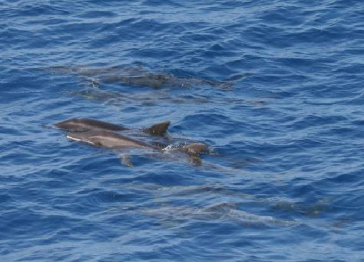
Photography (Adam Ü)

Given how this week went, I should say something like “we were saving the best for last” or “it was the grand finale” or “it all came down to the last minute” for the photographic effort of STAR-LITE 2007. Whichever cliché you prefer, the simple fact is that, photographically speaking, this past week has been the busiest by far. This is probably due to the fact that every day of effort except for one has been in closing mode and we were actually able to approach animals for photographs.
Rough-toothed dolphins. Steno bredanensis, observed during Leg 4. Photo: S. Webb.
For instance, last week we were barely able to squeeze off nine frames on a blue whale that swam by us as we surveyed in passing mode. This week, thanks to closing mode and an army of trigger-happy photographers, we added 727 frames of four distinct individuals from three sightings, including re-sighting a mom/calf pair on consecutive days. And that was just the blue whales! We took approximately ¾ of our striped dolphin, 2/3 of our Steno (including a mahi mahi predation event), and 1/3 of our Grampus and Pseudorca images for the entire cruise in this past week.

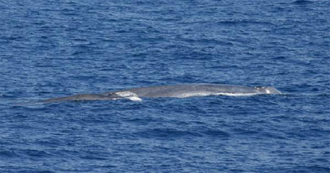
Blue whale, Balaenoptera musculus, the grand finale for STAR-LITE 2007. Photo: Adam Ü

Species | Common Name | Weekly photographs |  | Total photographs
Species | Common Name | Individuals | Schools | Individualss | Schools
Stenella attenuata (offshore) | Offshore pantropical spotted dolphin |  | 46 |  | 491
Stenella longirostris orientalis | Eastern spinner dolphin |  |  |  | 203
Stenella coeruleoalba | Striped dolphin |  | 60 |  | 80
Steno bredanensis | Rough-toothed dolphin |  | 210 |  | 316
Tursiops truncatus | Bottlenose dolphin |  |  |  | 76
Grampus griseus | Risso's dolphin |  | 66 |  | 193
Feresa attenuata | Pygmy killer whale |  |  |  | 327
Pseudorca crassidens | False killer whale |  | 44 |  | 133
Balaenoptera musculus | Blue whale | 727 |  | 736
Total |  | 727 | 426 | 736 | 1819

Biopsy (Juan Carlos Salinas, Ernesto Vásquez, and Suzanne Yin)

Species | Common Name | Weekly |  | Total
Species | Common Name | Samples | Takes | Samples | Takes
Pseudorca crassidens | False killer whale | 1 | 3 | 4 | 14
Stenella attenuata | Pantropical spotted dolphin | 0 | 0 | 5 | 19
Tursiops truncatus | Bottlenose dolphin | 2 | 2 | 4 | 10
Total |  | 3 | 5 | 13 | 43

Acoustic Squeakly (Eric Archer with assistance from Suzanne Yin and Sophie Webb)

We want to thank Shannon Rankin for leaving us with such a solid hydrophone setup. We were able to deploy the acoustic array and record on every passing mode day of this leg without a hitch, which means a lot when you realize that none of us even resemble an acoustician. Without Shannon’s easy-to-follow instructions, I’m sure we would have just been surrounded by piles of parts and sparking wires.

Seabird Report (Michael Force and Sophie Webb)

Displaced migrants are a feature of late fall, even out here in the eastern tropical Pacific. They have been very much in evidence the past three to four weeks, and this week is no exception. Lost southbound migrants boosted our weekly total to 28 species. A confused American Pipit circled the ship several times during a blue whale sighting. The ocean certainly qualifies as an open, treeless area, descriptors usually applied to American Pipit habitats. But, with respect to pipits, their habitat is more aptly described as alpine tundra, barren fields and coastal dunes. Equally out of habitat was a Barn Owl, circling the ship during an evening net station. As for seabirds, who would have thought that Juan Fernandez Petrels, one of the commonest seabirds when we began the survey in late August, would be completely absent in the final nine days? Their place in feeding flocks has been taken by Sooty Tern, now much more common than it was two months ago. Two seabirds seen this week were new for the cruise: Markham’s Storm-Petrel and Sandwich Tern. In total, we found 56 species of birds, 16 of which were lost passerines while an additional eight were raptors, shorebirds and other non-marine species.
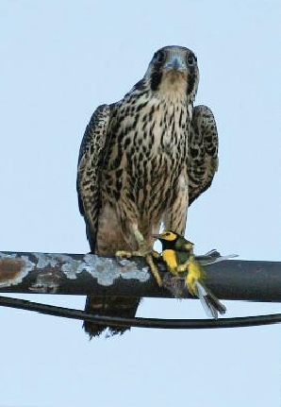
The immature Peregrine Falcon reported last week remained with us for five days feeding primarily on storm-petrels and phalaropes. Meanwhile, the adult male Hooded Warbler that arrived the same day as the falcon quickly became a crowd favourite and, unfortunately for the warbler, a falcon favourite as well.

We want to thank all those who provided assistance to the seabird survey: marine mammal observers calling out feeding flocks and distant birds well outside our 300 metre strip transect; and everyone else—crew, officers and scientists alike—for reporting lost, confused and stranded birds found on board.

Oceanographic Operations (Candice Hall and Ryan Driscoll with assistance from Siri Hakala, Heather Judkins and Lisa Schwarz)

As mentioned above, STAR-LITE 2007 scientific operations have ceased and we are on the transit home. As much as we all love being out here (just the sunsets are worth it!), everyone is definitely looking forward to spending the upcoming holiday season with our loved ones. And the holidays have hit the ship in a big way – our always entertaining Chief Bosun initiated and carried out a day of decorating the Quarterdeck with holiday cheer. We have our very own life-size Santa Klaus and North Pole scene – including Charlie Brown!
Adult male Hooded Warbler with juvenile Peregrine Falcon 22 hours after its arrival. Photo: JC Salinas.

As we end this cruise, this report allows for a recap of data gathered over the last three and a half months. Our average sea surface temperatures (SST) have not varied greatly (see the table below). Leg 2s temperatures were recorded at half a degree warmer that the other legs, although the mean sea surface salinity (SSS) remained constant. The deepest average mixed layer depths were documented during leg one, with the shallowest means recorded this leg. The 20°C isotherm was, on average, nearer the surface during leg three and deepest during leg one. However, it is important to note that these last two variables are contingent on location and it is not entirely correct to represent them via their means. A definite deepening trend is noticeable in these mixed layer and thermocline depths with travel towards the northwest. Once data quality control has been implemented more vertical depth information will be available.

Variable | Leg 1 | Leg 2 | Leg 3 | Leg 4
Mean SST | 28.81 | 29.62 | 28.77 | 28.82
Mean SSS | 33.69 | 33.43 | 33.44 | 33.52
Average mixed layer depth | 30.08 | 25.97 | 26.03 | 25.72
Average thermocline depth (20 °C isotherm) | 58.71 | 54.08 | 46.30 | 47.08

In total this cruise we have completed 137 CTD casts (including test salinity casts); 4 Yo-Yo CTD stations (approximately 13 casts per session); 1315 water column chlorophyll samples; 262 surface chlorophyll samples; 98 water column salinity samples; 270 XBT drops (including eight comparative XBT/CTD drops); 62 Oblique Bongo and 61 Manta net tows; deployed four ARGO buoys; recorded continuous acoustic backscatter (0 – 500m deep) and pCO₂ levels in the surface water and atmosphere. And this list does not include all the myriad meteorological data that the ship gathers as per normal operations.

This is obviously a good haul for our time out here and we’ve had plenty of help. Firstly, thanks go to our Super Survey Tech, Lacey O’Neal, who operated the CTD with his usual dry wit. We had the normal CTD teething issue but his perseverance paid off. This leg our visiting scientists were Heather Judkins, Siri Hakala and Lisa Schwarz, and huge thanks go to them for their irreplaceable help. To all the visiting scientists who joined our team this cruise; thank you for the XBTs in the rain (leg’s one and two) and the heat (this leg); especially for allowing us to rely on you during the Yo-Yo marathon aftermaths. Um, any of you busy next year this time? Lastly, to the Command, Officers, Chief ET and crew on the MacII, thank you so much for everything. It was an absolute pleasure to sail with you again. Happy holidays to all!

Date | CTD | XBT | Surface Chlorophylls | Bongo tow | Manta tow
111807a | 2 | 4 | 4 | 1 | 1
111907 | 2 | 4 | 4 | 1 | 1
112007 | 2 | 4 | 4 | 1 | 1
112107 | 2 | 4 | 4 | 1 | 1
112207ª | 2 | 4 | 4 | 1 | 1
112307 | 2 | 5 | 4
Total | 12 | 25 | 24 | 5 | 5
* Extra XBT drop to compare with CTD

Dipnet Report (Juan Carlos Salinas, Ernesto Vázquez, Adam Ü, Ryan Driscoll, Suzanne Yin, Sophie Webb and Heather Judkins)

This is our final report for the STAR-LITE cruise. Thanks to everybody for your effort.

Fish collected | Weekly total | Grand total
Two-winged flyingfish (Exocoetus sp.) | 7 | 347
Four-winged flyingfish (Cheilopogon, Hirundichthys, Prognichthys) | 6 | 180
Short-winged flyingfish (Oxyporhamphus) | 1 | 151
Lantern fish (Myctophidae) | 2 | 13
Unidentified fish | 9 | 21
Total | 25 | 712

Stomach samples collected | Weekly total | Grand total
Two-winged flyingfish (Exocoetus sp.) | 6 | 231
Four-winged flyingfish (Cheilopogon, Hirundichthys, Prognichthys) | 2 | 115
Short-winged flyingfish (Oxyporhamphus) | 0 | 35
Total | 8 | 387

107°W
106°W
105°W
104°W
107°W
106°W
105°W
104°W
12°N
13°N
14°N
15°N
16°N
17°N
12°N
13°N
14°N
15°N
16°N
17°N
Effort & Oceanographic Samples: Passing Mode
107°W
106°W
105°W
104°W
107°W
106°W
105°W
104°W
12°N
13°N
14°N
15°N
16°N
17°N
12°N
13°N
14°N
15°N
16°N
17°N
Effort & Oceanographic Samples: Closing Mode
CTD
CTD / Dipnet / Bongo / Manta
XBT
