Tools to Models: Some Applications of Automated Resource Analysis Tools for Ecosystem Management.

by Jacek Blaszczynski
Physical Scientist
BLM NARSC

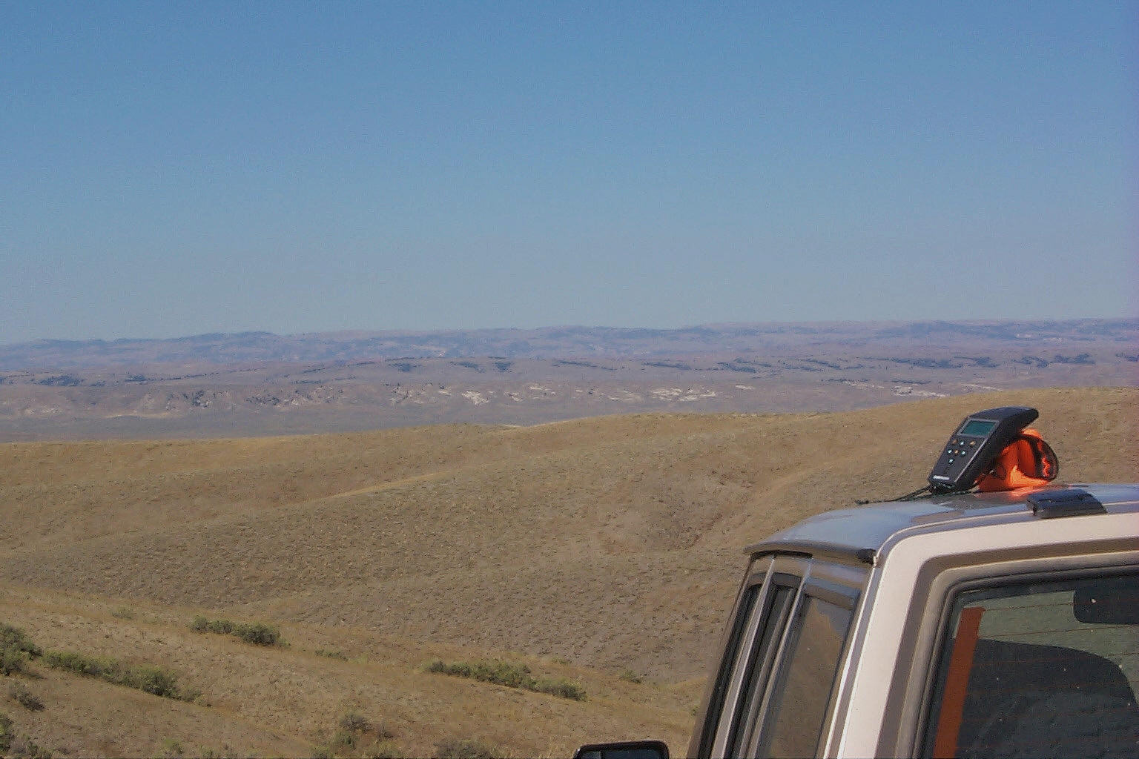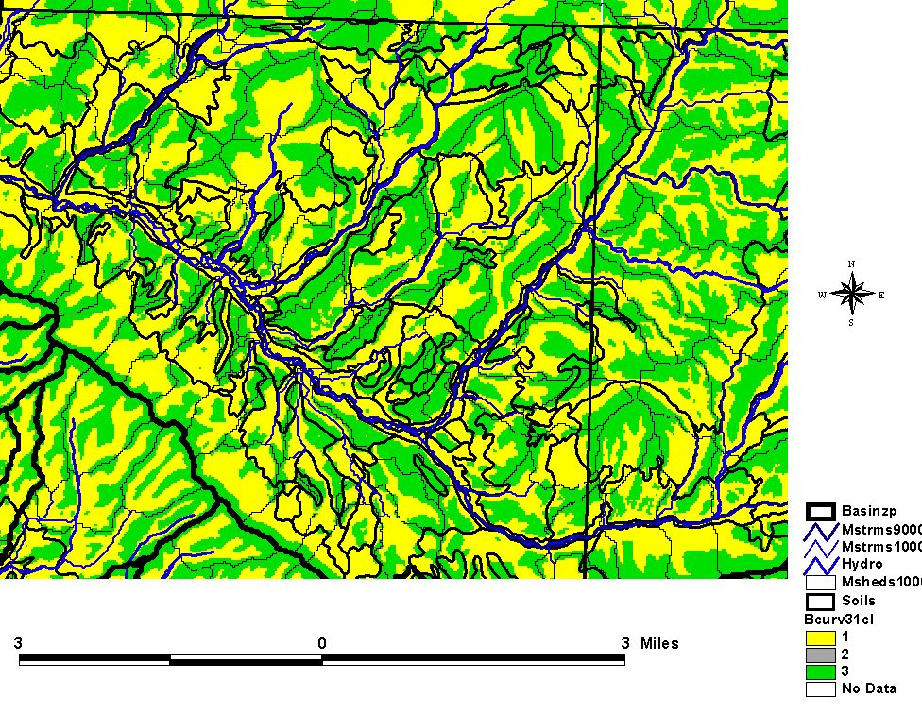

Models are essentially simplified views of the processes that we know to occur in Nature. They often rely on several important environmental parameters relevant to the process being analyzed and a simple “engine” which relates these parameters to each other. For example, the Universal Soil Loss Equation (USLE) model relies on six primary parameters which reflect the influence on sheet and rill erosion of rainfall intensity; soil erodibility; slope gradient; slope length; surface cover; and erosion control practice factors. The values for each of the factors are either measured or calculated and fit into an equation developed from statistical analysis of 10 plot years of cropland studies. The USLE model was also modified for rangeland applications to create the RUSLE, or the Revised Universal Soil Loss Equation. The
USLE and the RUSLE are empirical models because their “engine” is generated from statistical analyses
of a large number of actual experimental results. Other model “engines” might work differently;
for example, calculating runoff values based on hydrologic equations. Since models are essentially nothing
more than their “engine” and environmental data, they are uniquely adaptable to being automated on computers. Then they can be used to analyze large amounts of data that otherwise could not be easily reviewed.

Whoever utilizes models has to be aware that they probably will not predict unique ecological circumstances that can be found on a specific parcel of land but provide knowledge-based predictions of the magnitude of the likely processes that should be occuring in that area. The accuracy of these predictions
is directly dependent on the jjhmjjquality of data. The most honest description of modeled information
is to present it as a result of a certain logic and environmental data combined using this logic even in choosing our sampling methods we are already modeling because we are conceptualizing what and how specific parameters should be measured. A model can be understood as a painting of reality done with a limited number of colors which should not be confused with reality itself. Taking account of these facts,
NARSC is currently engaged in combining various GIS functions and tools into models to aid following
ecosystem analysis efforts.

1. Identification of Similar Terrain Units (STUs)
This project is combining watershed delineation and watershed morphometric parameter analysis technology to derive similar areas based on shape of terrain. It is understood that particularly in
high relief locations the shape of terrain has profound impact on geomorphic, hydrologic, and other
ecosystem processes. Therefore, subdivision of the land surface according to terrain characteristics
should aid in finding transitional zones in terrain and local ecosystems. The methods involve division
of the project into mini-watersheds associated with individual reaches of a stream network.
The morphology of each mini-basin is analyzed using morphometric parameters that describe each
basin. The basin morphometric parameter values are then grouped to indicate which of the miniwatersheds
are morphologically similar to each other. Morphologically similar watersheds are grouped in clusters that represent similar terrain characteristics within the project area. The morphologically similar areas outlined by groups of analogous watersheds can be used to study ecologic processes influenced by terrain shape. These include the ecosystem processes of soil erosion and sediment yield, surface and subsurface hydrology, solar irradiation, and evapotranspiration.

2. Automated Erosion, Runoff, and Sediment Yield Models

Terrain analysis tools are directly utilizable in development of GIS interfaces to erosion, runoff, and
sediment yield models to aid prediction of the patterns of these processes on large areas. One of
the main difficulties with application of soil erosion prediction tools such as the RUSLE has to do with
being able to adequately account for terrain variability in the modeled area. Various terrain analysis
capabilities, including basic watershed and flow delineation methods, can be utilized to improve the
predictive capability of RUSLE by permitting measurement of this variability. Beyond that data inte-gration capabilities of GIS permit rapid analysis of terrain, soil, and vegetation data together to develop basin and Hydrologic Response Unit (HRU) statistics required for running of the National Resource Conservation Service Curve Number (NRCS CN) watershed runoff model and Modified Universal Soil Loss Equation (MUSLE) for watershed sediment yield prediction. All of these models help us to identify land management measures required to protect soil and water quality, both major indicators of ecosystem health.

3. Soil survey enhancement methods

Terrain analysis tools are important for identification of various components of the geomorphic surface of the landscape, including the geometry of segments of hillslopes, locations of stream reaches within drainage networks, and the morphology of watersheds. Terrain variability is one of the central factors influencing the development and evolution of soils, so the soils developed on different facets of hillslopes differ from each other and from soils developed in terrain depressions or in the floodplains of streams. Combining terrain information with soil and other multidisciplinary data permits further refinement of existing soil surveys which often contain two or more related types of soils within a single mapping unit. Mapping the distribution of these components and inclusions will permit enhancement of existing soil surveys to a higher degree of resolution. For more information on soil survey enhancement contact Mr. Alan Amen, Soil Scientist, BLM NARSC.

4. Linked watershed modeling

Streams, channels, and hollows form drainages which are organized into drainage networks, or linked systems of streams and watersheds usually identified by their order in the network. A network includes streams and watersheds all the way from a major topographic divide to the river delta as it enters the ocean. Processes within any watershed or reach within a network can be modeled independently, and as part of a linked watershed system. In this way it is possible to subdivide and aggregate the effects of various watershed processes (e.g. erosion and sediment yield) throughout the network and calculate their cummulative impact on the landscape within the network. An example of this type of analysis is provided by the watershed data preparation AMLs for the Hydrologic Modeling System (HMS) of the U.S. Army Corps of Engineers which will be described in future editions of Resource Notes.

We invite further suggestions as to possible applications of resource analysis tools and models to your own projects. For futher information on the efforts describe above contact:

Jacek Blaszczynski
Physical Scientist
BLM National Science and Technology Center
Denver Federal Center, Bldg. 50
Lakewood, Colorado
(303) 236-5263
jblaszcz@blm.gov

