Evaluate Tangle Nets for Selective Fishing

Geraldine Vander Haegen
Erik White
Larry LeClair

Washington Department of Fish and Wildlife
Fish Program, Science Division
600 Capitol Way North
Olympia, WA 98501-1091

Grant Number: NA06FD0278

ABSTRACT 2
EXECUTIVE SUMMARY 3
PURPOSE 3
APPROACH 4
General Methods 4
Budd Inlet -2000 7
Budd Inlet - 2001 7
Miller Bay - 2000 8
Puyallup River - 2000 9
FINDINGS 9
Budd Inlet - 2000 9
Budd Inlet 2001 11
Miller Bay - 2000 13
Willapa River - 2000 14
Puyallup River - 2000 17
EVALUATION 17
General Conclusions 17
Objective 1 18
Objective 2 18
Objective 3 19
Objective 4 19
REFERENCES 20
ACKNOWLEDGEMENTS 21

ABSTRACT

Live capture, selective harvest may be one method to reduce the impacts of commercial salmon fishing on weak stocks, while enabling fishers to continue to harvest salmon from strong stocks. In fall 2000 and 2001, we contracted local gill net fishers to fish nets that were half tangle net and half conventional gill net to evaluate the merits of the tangle net for harvesting coho salmon (Oncorhynchus kisutch) and fall chinook salmon (O. tschawytscha). We compared the catch efficiency, immediate mortality, post-release mortality, and capture of non-target species in each net. Results were mixed between test sites. The tangle net showed lower catch efficiency for fall chinook than the gill net, with little improvement in immediate survival. However, the tangle net was as efficient at capturing coho salmon as the gill net, and the immediate mortality and capture of by-catch were similar. Tangle nets require further testing as a live capture, selective harvest gear, but show promise for capturing salmon.

EXECUTIVE SUMMARY

Protecting week salmon stocks in the Pacific Northwest has required unprecedented restrictions of the commercial fishing industry. In a mixed stock fishery, gear restrictions and time and area closures are effective management techniques for avoiding non-target species, but when many weak stocks are present, these strategies can restrict all fishing. A possible alternative strategy is the use of live capture, selective harvest techniques that would allow fishers to release non-target species or stocks with a reasonable expectation for survival after release. This technique, known as “selective fishing” would reduce impacts to weak stocks that may be listed as threatened or endangered under the Endangered Species Act, while allowing harvest on strong stocks. We evaluated tangle nets as an alternative gear to the gill net for selective harvest of coho salmon and fall chinook salmon in the Pacific Northwest.

In fall 2000 and 2001, we contracted local gill net fishers to fish nets that were half tangle net and half conventional gill net to evaluate the merits of the tangle net as a commercially selective technique for harvesting coho salmon (Oncorhynchus kisutch) and fall chinook salmon (O. tschawytscha). We compared the catch efficiency, immediate mortality, post-release mortality and capture of non-target species in each net.

In our test fisheries, the tangle nets were an unsatisfactory substitute for capturing fall chinook salmon. Their catch efficiency was low compared to the gill net, and we encountered many more non-target species in the tangle net than in the gill net. Due to poor tag recoveries, our estimates of post-release survival from each net are inconclusive, but suggest an advantage to fish released from the tangle net. This aspect merits further studies, and positive results might be obtained using different net configurations in different locations.

The tangle net did show promise for capturing coho salmon. On the Willapa River, the tangle net was as effective at capturing coho salmon as the gill net, with a slightly improved condition at capture. Further research about the post-release survival of coho is necessary to determine whether the released fish survive to complete their migration and successfully spawn.

PURPOSE

Effective management of mixed-stock salmon fisheries in the Pacific Northwest relies on the ability to maximize the harvest of strong stocks while preventing the overexploitation of weak stocks, some of which may be listed as threatened or endangered under the Endangered Species Act. Achieving escapement goals for weak stocks often requires the implementation of more restrictive harvest regulations that result in a surplus escapement of fish from strong stocks. The development of methods that enable fishers to selectively harvest strong stocks without jeopardizing weak stock recovery efforts is a key element in Pacific salmon conservation strategy. If non-target stocks can be returned to the water with reasonable certainty that their spawning migration will not be affected through capture and release, then restrictions governing the spatial and temporal limitations of the fishery may be relaxed, enabling more opportunity for harvest from strong stocks. In this study, we explored the feasibility of using a tangle net to decrease the capture-related mortality of non-target stocks. In Washington, hatchery coho and chinook salmon have been marked by removal of the adipose fin, allowing fishers to visually distinguish them from the unmarked natural populations.

Conventional gill nets are routinely constructed from single-strand monofilament web and the mesh is sized to capture targeted fish by the gill plates or body. Capturing fish by the gills or body often results in extensive tissue damage and bleeding that may kill the fish, or constriction of the gill plates that leads to death through suffocation. Tangle nets are constructed from multi-strand webbing with reduced mesh size. Rather than capturing fish by the gills or body they are designed to ensnare fish by the maxillary and teeth, thus enabling the fish to continue to respire while in the net, facilitating live release of the unharvestable fish (Figure 1). Despite their differences in material and construction, both nets are fished in the same manner.

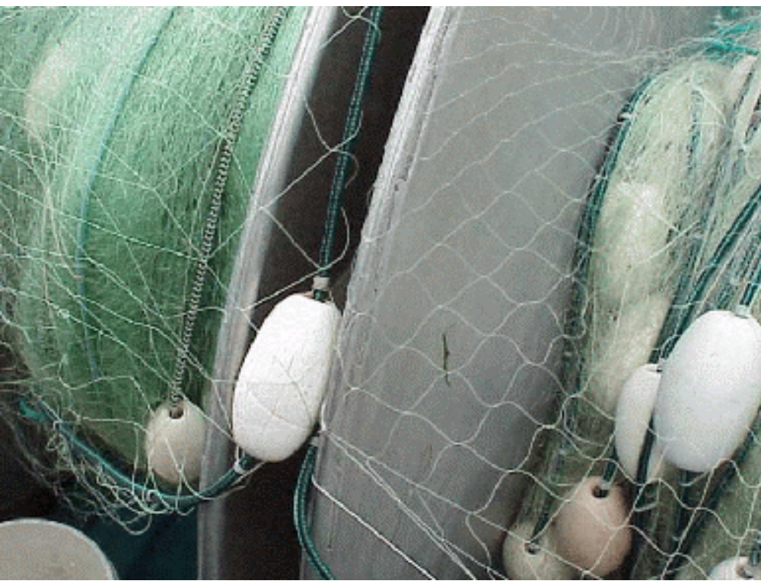
Figure 1: Conventional monofilament gill net (left) and the multi-strand tangle net (right).

In our evaluation, we simultaneously fished the tangle net with a conventional gill net to compare characteristics of the two. We had four objectives: 1) Estimate the catch per set for the tangle net and conventional gill net; 2) Estimate the proportion of fish caught in the tangle net and in the conventional gill net that is brought aboard dead; 3) Estimate the percentage of fish released from the tangle net and conventional gill net that survived to complete their migration; and 4) Coordinate our activities with fishery co-managers and fishers.

APPROACH

General Methods

Fishing sites in Budd Inlet, Miller Bay, the Willapa River, and the Puyallup River were selected for testing the nets (Figure 2). These sites were chosen primarily based on historic run size and timing, proximity to hatcheries, and cooperation from local fishers. At each site, we compared immediate mortality, by-catch and catch efficiency of the tangle net to a conventional gill net appropriate for that site. In Budd Inlet, we cooperated with the Squaxin Island Tribe targeting fall chinook salmon returning to Tumwater Falls Hatchery and released tagged fish to estimate post-release survival. In Miller Bay, we cooperated with the Suquamish Tribe, targeting fall chinook salmon returning to Grovers Creek Hatchery, and released tagged fish to estimate post-release survival. We cooperated with the Puyallup Tribe targeting coho salmon returning to the Puyallup River. Finally, we worked with non-treaty fishers on the Willapa River targeting coho salmon returning to Forks Creek Hatchery.

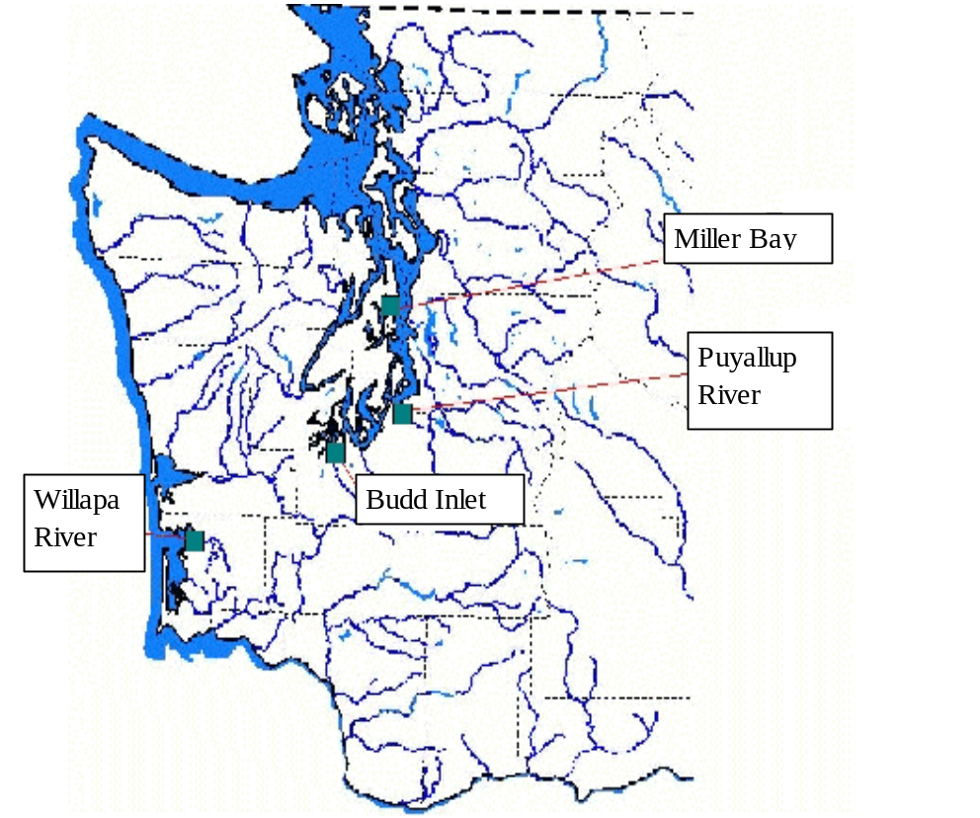
Figure 2: Test fishing locations.

Local fishers familiar with each area and with gillnetting techniques tested nets that consisted of one panel of tangle net, and one panel of conventional gill net, with each panel the same length. The panels were connected with shackles at the top and bottom, so that an opening formed between the two net types in the center. The opening ensured that fish attempting to avoid one panel could escape without being directed toward, and possibly captured by, the other, biasing catch rate estimates. In Budd Inlet, Miller Bay, and the Willapa River, we contracted local fishers, and paid them on a per day basis so that we could release all live fish. On the Puyallup River, members of the Puyallup Tribe volunteered to fish dual panel nets and kept the fish as compensation. In Budd Inlet and Miller Bay, dead fish were donated to the cooperating tribe, and on the Willapa River, dead fish were sold to a local buyer.

Fishers were responsible for selecting the time and location within sites. Washington Department of Fish and Wildlife and tribal observers were on board fishing vessels to tag fish, take biological data and record other observations. Each vessel was equipped with a recovery box made from ¾” plywood painted black (Figure 3). The recovery boxes were built with two compartments for holding fish. Each compartment was about 42” long, 16” high and 7.5” wide. The compartments of the recovery box were wide enough to allow a salmon to fit with its head facing the fresh water flow but narrow enough to prevent the fish from turning around. A 12 V, 3800 gallon/h submersible bilge pump was connected to a 1.5” discharge hose which supplied fresh water through pipes located at the bottom of the box. Overflow outlets were located at the opposite end of the recovery box. When the fish was judged ready for release, it was gently lifted out of the box and placed overboard.

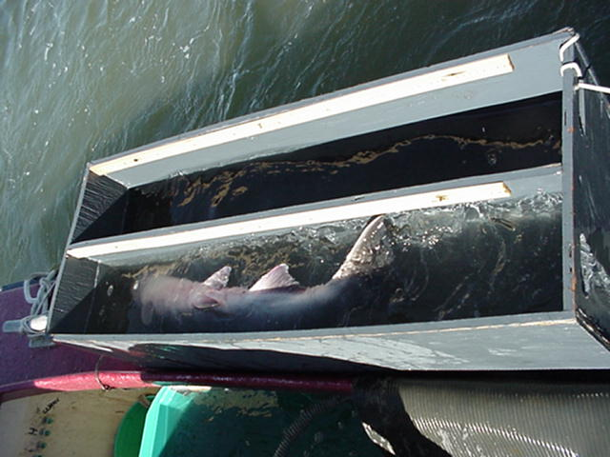
Figure 3: Recovery box used for reviving fish after capture. The fish is oriented with its mouth into the flow of fresh water.

For each set, observers recorded the skipper, time, set length (the time between when the first float entered the water and the last float was removed), location (using a handheld GPS unit), weather conditions, water temperature, and noted the presence of seals. For each fish captured, we recorded the species, fork length, sex, net type where it was captured and the condition of fish at capture and release. We used numbers to represent the condition at capture as follows: 1 (vigorous), 2 (vigorous and bleeding), 3 (lethargic), 4 (lethargic and bleeding), or 5 (no visible movement or apparent ventilation). In Budd Inlet and Miller Bay, fish receiving scores of 1 or 2 were immediately tagged with colored, numbered jaw tags and released. The net type was associated with a specific tag color, and the number referred to a specific fish. Fish receiving scores greater than 2 were transferred to a recovery box in an attempt to revive them. If revival was successful, the condition of the fish was re-scored, then the fish was tagged and released. The total time in the recovery box was recorded. No fish were tagged during the Willapa River and Puyallup River test fisheries and lengths were not taken for fish captured from the Puyallup River, otherwise, data collection and handling was the same among sites (after revival, all live fish captured on the Willapa River were released, and all coho salmon captured on the Puyallup River were harvested).

Budd Inlet -2000

To target fall chinook salmon in Budd Inlet in 2000, we used a net consisting of one 300 foot panel net of 3.5” tangle net shackled to one 300 foot panel of 6.5” gill net. Both panels fished to a depth of 32 feet. The overall length, depth and color were similar to that ordinarily used by commercial fishers in this fishing area. A Squaxin Island Tribe fisher was contracted to fish the nets south of a line extending from Cooper Point, east to Dover Point. The fisher had extensive local knowledge and experience commercial fishing in the test fishing area. The net was deployed and retrieved by hand from an open, gas-powered skiff. Deploying the net typically took fewer than 5 minutes. Because the net had to be pulled by hand, it was impractical to keep the sets short. Rather, once the net was fully deployed, the float line was monitored from one end for cork line movement that would indicate the presence of a fish. The entire net was also periodically patrolled from end to end to remove debris and check for captured fish that might otherwise have gone unnoticed. We recorded the time at which each fish was captured. Fishing occurred on 11 nights between August 18 and September 8 from 1900 h to 0400 h, except one time when we fished from 0200 h to 0700 h.

Most of the Budd Inlet chinook run is presumed to be bound for Tumwater Falls Hatchery on the Deschutes River, approximately one river kilometer upstream of the mouth at the extreme south end of the inlet. Tag recovery efforts included daily checks of salmon returning to the hatchery throughout the duration of the run and weekly surveys on the Deschutes River between the hatchery and the river mouth. Additionally, other hatcheries in the south Puget Sound region, commercial and recreational fishers, and spawning ground surveyors were alerted to potential encounters with jaw tagged fish and were asked to report tag numbers along with the date and location of capture.

Budd Inlet - 2001

In 2001, we repeated our work in Budd Inlet, but attempted to increase the number of tags we would recover by increasing our fishing effort and tag recovery searches. We contracted with two Squaxin Island Tribe fishers to fish in Budd Inlet in the same area and in the same manner as in 2000. One fisher had a net with a 300-foot tangle net panel (4.5” mesh) shackled to a 300-foot panel of 6.5” mesh gill net while the other used 7.5" mesh gill net. We changed to the 4.5” tangle net to attempt to improve catch efficiency and reduce bycatch. The tangle net was lighter in color than the gill net.

As in 2000, the net had to be pulled by hand, so once the net was fully deployed, the float line was monitored from one end for cork line movement that would indicate the presence of a fish. The entire net was also periodically patrolled from end to end to remove flotsam and check for captured fish that might otherwise have gone unnoticed. When multiple sets were made, alternate ends of the net were deployed first, in order to ensure approximately equal fishing time for each net type. All fishing occurred between dusk and dawn over 32 boat-nights between August 6 and September 8, 2001 with two boats fishing concurrently on 10 nights. On all but one occasion, the nets were allowed to drift with the current. During the exception, the tangle net panel was made fast to the beach and the net was held perpendicular to the shore for the duration of the set. Fish were handled and tagged in the same way as in 2000.

Tag recovery efforts included daily checks of salmon returning to Tumwater Falls Hatchery throughout the duration of the run and weekly surveys on the Deschutes River between the hatchery and the river mouth. Additionally, other hatcheries in the south Puget Sound, commercial and recreational fishers, and spawning ground surveyors were alerted to potential encounters with jaw tagged fish and were asked to report tag numbers along with the date and location of capture. We expanded recovery survey effort to include surveys on Percival Creek, a tributary to Budd Inlet. A barrier installed at the mouth of the creek was in place until October 16, 2001 when it was removed and fish could access the creek. Stream surveys were done on the Deschutes River one hour each week for 6 weeks and for 2 hours on three occasions on Percival Creek.

Miller Bay - 2000

To target chinook salmon returning to Grovers Creek Hatchery, we net with a 150-foot panel of 7.5” mesh gill net shackled to a 150-foot panel of 3.5” mesh tangle net. The net fished to a depth of about 60 feet. The overall length, depth and color were similar to that ordinarily used by local commercial fishers to harvest chinook.

A Suquamish Tribe commercial gill netter was contracted to fish the net within 1 mile of the mouth of Miller Bay. The net was fished from a 30' commercial fishing vessel equipped with a single deck-mounted hydraulic reel used to deploy and retrieve the gear. Set length ranged from 25-80 minutes. Deployment generally took fewer than five minutes and the net was usually allowed to drift freely. However, during inclement weather the net was anchored. Between sets, the ends of the net were reversed so that each net type would be fished equally in each location. Fishing occurred between 1800 h and 0100 h over 9 boat-nights between August 17 and October 5, 2000.

A salmon hatchery located on Grover's Creek near the head of Miller Bay was monitored for tag recoveries. Additionally, the tidal flats at the mouth of Grover's Creek were surveyed for tagged chinook salmon each week during low tide.

Willapa River - 2000

On the Willapa River, we evaluated a net consisting of a 540-foot of 3.5" mesh tangle net shackled to a 540-foot panel of 5.75" mesh gill net to target coho salmon returning to Forks Creek Hatchery. Experienced local fishers using commercial vessels equipped with deck mounted hydraulic reels fished the nets. The nets were laid out across the river in a typical curved pattern, and were retrieved to collect fish. The ends of the nets were switched between sets so that each net type was fished equally in each location. The overall length, depth, and color of the net were similar to that ordinarily used by local fishermen to harvest coho from the Willapa River. Each day, we fished with one skipper in the morning and the other in the afternoon between September 11 and 15, then with one boat October 17 and 18, and one boat November 8 and 9.

Puyallup River - 2000

On the Puyallup River, we evaluated a net consisting of a 50-foot panel of 5” mesh gill net shackled to a 50-foot panel of 3.5” mesh tangle net to target coho salmon. The net fished to a depth of about 14 feet. The overall length, depth, and color of the net were similar to that ordinarily used by local fishers to harvest coho from the Puyallup River. The net was fished from an open 23' power skiff. Set length ranged from 5-60 minutes. Deployment generally took less than 2 minutes and the net was allowed to drift freely downstream with the current for the duration of the set. All fishing occurred between 0900 h and 1600 h from river mile 5.8 to 1.8. This site was fished on 4 days, September 28, October 3, October 18, and November 3.

FINDINGS

Budd Inlet - 2000

A total of 130 adult chinook salmon were captured, with 102 (73.4%) in the gill net and 37 (26.6%) in the tangle net. An additional 9 jacks (immature males) were captured in the tangle net, of which 3 died before release. The immediate mortality (fish which could not be revived for release) of adult chinook salmon was not significantly different between the gill net (40.2%, N=41) and the tangle net (21.4%, N=6; Chi-square=2.60, df=1, P=0.11). In each case, 22% of the dead adult fish showed evidence of having been killed by seals (major tissue trauma, particularly bites in stomach and gill areas). Seals were observed hunting in the vicinity of the nets each time we fished, and were seen actively removing fish from the nets, and chasing fish into the nets.

Adult chinook salmon captured in the tangle net tended to be in better condition than those captured in the gill net (Table 1). Few fish removed from the tangle net were bleeding at capture. Bleeding tends to be caused by the mesh cutting the gills, a capture method avoided by the tangle net. In contrast, more fish captured in the gill net were bleeding at capture, and a large proportion were lethargic (conditions 3 and 4) at capture, likely resulting from having the net closed around their gills. Virtually every adult chinook salmon captured in the gill net had net marks around the body in front of the dorsal fin or around the gills, and virtually every adult captured in the tangle net had net marks around the snout. Net marks on the body tended to be severe – scales were dislodged and missing, and the underlying skin was often abraded and red. While not visible, a loss of the protective slime layer would be associated with this injury. Net marks from the tangle net tended to be less severe as the snout does not have easily dislodged scales. The marks tended to be dark lines where the net pressed on the skin, and tended to be on the lower snout and jaw. The slime layer on some of these fish may have been disturbed if they rubbed against the net, or if the fish rolled itself into the net.
Table 1: Condition at capture and revival of chinook salmon captured in the Budd Inlet test fishery in 2000. “% Cap” is the percentage of fish scored in each condition at capture, “% Rel” is the percentage in each category that were released live, and N is the number captured in each condition at capture.
Condition at Capture | 6.5” mesh, Adults |  |  | 3.5” mesh, Adults |  |  | 3.5” mesh, Jacks
Condition at Capture | % Cap | % Rel | N | % Cap | % Rel | N | % Cap | % Rel | N
1 (Lively) | 16.7 | 100 | 17 | 60.7 | 100 | 17 | 22.2 | 100 | 2
2 (Lively, bleeding) | 5.9 | 100 | 6 | 7.1 | 100 | 2 |  |  | 0
3 (Lethargic) | 27.5 | 89.3 | 28 | 10.7 | 100 | 3 | 44.5 | 100 | 4
4 (Lethargic, bleeding) | 17.7 | 72.2 | 18 | 0 |  | 0 |  |  | 0
5 (No visible movement or ventilation) | 32.4 | 0 | 33 | 21.4 | 0 | 6 | 33.3 | 0 | 3

Revival of fish in conditions 2 and 3 was generally successful after a short holding period in the recovery box (Table 1). We were unable to revive any fish captured in condition 5 from either of the net types. These fish included those injured by seals, but also fish that appeared to have been in the nets for an extended period, or fish that were captured in a manner that clamped their gills or mouth shut. In some cases, the fish were missed during net checks, or if fish were captured while we were picking up the net, it was impossible to get to them in a timely manner.

There was a difference in the percent of male and female chinook caught in each net. In the gill net, the ratio was nearly equal with 48.5% females and 51.5% males. In contrast, 75.7% of the fish caught in the tangle net were males (24.3% females). This difference is attributable to the more developed kype in males making them more susceptible to capture in the tangle net than females. The fork lengths of fall chinook salmon captured in the gill net (mean fork length 77.6 cm, N=98) were on average significantly larger than those captured in the tangle net (mean fork length 71.1, N=37; df= 43, t=2.14, P=0.02). This difference is mainly attributable to the presence of jacks (early maturing males) in the tangle net that would pass through the gill net unimpeded.

We released 59 fish with tags from the gill net and 27 from the tangle net. We recovered only 2 tags, both at Tumwater Falls Hatchery, and both from fish captured in the gill net. This tells us little about the post-release survival of chinook salmon, and while it is certain that some proportion of the captured fish died after release, it is impossible to estimate this proportion, the potential causes of death, or what the difference between the net types may be. One concern is the number of predatory seals in the area. We suspect that even fish that swim vigorously away from the boat after release may be highly susceptible to predation because they have been severely stressed by capture without sufficient time for complete physiological recovery (Farrell et al. 2000). This could result in impaired swimming ability or disorientation.

While fishing, we recaptured four fish that had been previously tagged that same night. All died after the second capture, which was from 2-3 hours after the original capture. We suspect that the stress effects of multiple recaptures would reduce the probability of recovery. Bringing fish on board in the best possible condition is imperative.

During our test fishery, we found the 6.5” mesh to be relatively species selective – few species other than chinook were captured (Table 2). In contrast, the smaller 3.5” mesh captured many smaller fish that would have passed through the 6.5” mesh unimpeded, as well as jellyfish. Not only is this higher level of by-catch detrimental to those species, but the time required to remove them from the net also increased the time until the target species could be removed and would reduce their survival.

Table 2: Bycatch of non-salmonids in the nets during test fishing in Budd Inlet. Because it was virtually impossible to record all of the bycatch, these numbers are more indicative of presence or absence than the actual numbers captured.

Species | 6.5” mesh | 3.5” mesh
Dogfish | 22 | 76
Flounder | 1
Ratfish | 1 | 16
Crab |  | Numerous, uncounted
Jellyfish |  | Numerous, uncounted
Shad |  | 1
Sole |  | 3

Budd Inlet 2001

We captured 165 fall chinook salmon, 115 (70%) in the 6.5” and 7.5” gill nets and 50 (30%) in the tangle net. Thirty-eight died before they could be released. There was no significant difference between the immediate mortality rates of the gill net (19.1%, N=22) and the tangle net (32.0%, N=16; Chi-square =2.57, df=1, P=0.11). Long soak times (because the nets were worked manually and could not be removed for frequent inspections) and high surface water temperatures during test fishing (15-20 ºC) likely contributed to the high immediate mortality. Seven chinook salmon were captured twice during our test fishery. Five of these were in the conventional gill net and two were in the tangle net. These fish were included in our totals because they were at liberty for more than two hours and were released in condition 1.

Fall chinook salmon captured in the gill net were captured in similar conditions to the tangle net, and we were successful at reviving fish in conditions 2 through 4 for all nets, as well as a large percentage of fish captured in condition 5 in the 6.5” gill net (Table 3). We were unsuccessful at reviving any fish captured in condition 5 from the tangle net, or the 7.5” gill net. Most chinook that died after capture in the gill nets had been captured by gilling, while most of those that died after capture in the tangle net had been captured by tangling (Table 4). Seal predation continued to be a problem during our test fishery. Seals killed 14% of the fish brought on board, and may have killed others without leaving remains.
Table 3: Condition at capture and revival of chinook salmon captured in the Budd Inlet test fishery in 2001. “% Cap” is the percentage of fish scored in each condition at capture, “% Rel” is the percentage in each category that were released live, and N is the number captured in each condition category. Condition 5 includes fish killed by seals.
Condition at Capture | 7.5 |  |  | 6.5 |  |  | 4.5
Condition at Capture | % Cap | % Rel | N | % Cap | % Rel | N | % Cap | % Rel | N
1 (Lively) | 30.4 | 100 | 21 | 50.0 | 100 | 23 | 30.6 | 100 | 15
2 (Lively, bleeding) | 8.7 | 83.3 | 6 | 6.5 | 100 | 3 | 8.2 | 100 | 4
3 (Lethargic) | 30.4 | 95.2 | 21 | 17.4 | 100 | 8 | 34.7 | 88.2 | 17
4 (Lethargic, bleeding) | 15.9 | 100 | 11 | 6.5 | 66.7 | 3 | 2.0 | 0 | 1
5 (No visible movement or ventilation) | 14.5 | 0 | 10 | 19.6 | 11.1 | 9 | 24.5 | 0 | 12

Table 4: Capture type and recovery of chinook salmon captured during test fishing in Budd Inlet in 2001.
Capture Type | 7.5 |  | 6.5 |  | 4.5
Capture Type | Released | Died | Released | Died | Released | Died
Gilled | 37 | 6 | 15 | 6 | 1 | 2
Mouth Clamped | 1 | 0 | 0 | 0 | 0 | 1
Rolled | 1 | 0 | 2 | 0 | 4 | 0
Tangled | 7 | 1 | 0 | 0 | 20 | 7
Wedged | 6 | 0 | 10 | 0 | 0 | 0
Total | 52 | 7 | 27 | 6 | 25 | 10

The mean fork lengths of chinook salmon captured in the tangle net (72.4 cm, N=39) were similar to those captured in the 6.5” gill net (72.8 cm, N=39; df=76, t=0.24, P=0.40), but significantly smaller than those captured in the 7.5” gill net (78.0 cm, N=53; df=90, t=3.6, P=0.0002). As we saw in 2000, the number of non-target species captured was considerably higher in the tangle net than in the gill nets (Table 5). With its smaller mesh size, the tangle net was particularly effective at capturing small dogfish that would have passed through the gill nets unimpeded.

Table 5: Bycatch of non-target species captured during test fishing in Budd Inlet in 2001.
Species | 4.5" net | 6.5" net | 7.5" net
Dogfish | 414 | 26 | 7
Flounder | 1 | 0 | 0
Shad | 2 | 0 | 0

We tagged and released 90 chinook salmon from the gill nets and 36 from the tangle net. We recovered 10 tags from each group, significantly more from the tangle net (27.8%) than the gill net (11.1%; Chi-square=4.17, df=1, P=0.041). Nineteen were recovered at Tumwater Falls Hatchery on the Deschutes River and one at Minter Creek Hatchery on Purdy Creek, north of the fishing area. The tagged fish were recovered between 20 and 48 days after release and had been captured in condition 1 (73.3%), condition 2 (6.7%) or condition 3 (20.0%). The fish captured in conditions 2 and 3 had been revived in the recovery box for a short time and released in condition 1.

Miller Bay - 2000

Fifteen chinook salmon were captured from 38 separate sets made on 9 days between August 17 and October 5. Thirteen were captured in the gill net and two in the tangle net. There were two immediate mortalities, one from each net type (Table 6). In both instances the fish were judged not suitable for revival efforts due to substantial damage to the gill tissue and surrounding skeletal structures. Thirteen chinook were tagged and released. Three were recovered at the hatchery; two had been captured on 17 Aug and recovered after 29 days at liberty; the third had been captured on 28 Aug, was recovered after 28 days. They were all originally captured in the gill net; scored as 1, 2, and 3 respectively at the time of capture; and all were released in condition 1. The condition 3 fish was revived in the recovery box for 7 minutes before release. Of the four remaining fish that were transferred to the recovery box, three, including one fish that was scored as a 5 at time of capture, experienced notable improvements in condition and were released in condition 1. The fourth (scored as a 3) showed no improvement after 1.5 hours in the recovery box.

Table 6: Condition at capture and revival of chinook salmon captured in the Miller Bay test fishery in 2000. “# Captured” is the number of fish scored in each condition at capture, “# Released” is the number in each category that were released live.
Condition at Capture | 7.5” |  | 3.5”
Condition at Capture | # Captured | # Released | # Captured | # Released
1 (Lively) | 7 | 7 | 0 | 0
2 (Lively, bleeding) | 1 | 1 | 0 | 0
3 (Lethargic) | 2 | 2 | 1 | 1
4 (Lethargic, bleeding) | 2 | 1 | 0 | 0
5 (No visible movement or ventilation) | 1 | 1 | 1 | 0

A total of 811 non-targeted animals were captured in the tangle net and 37 were captured in the gill net. Incidentally harvested species included spiny dogfish (Squalus acanthias), ratfish (Hydrolagus colliei), sand sole (Psettichys melanostictus), starry flounder (Platichthys stellatus), American shad (Alosa sapidissima), Pacific herring (Clupea pallasii), Pacific cod (Gadus macrocephalus), red rock crab (Cancer productus), and Dungeness crab (Cancer magister). Most of the difference in incidental capture between the two mesh types can be attributed to an increased capture rate of spiny dogfish in the tangle net which was nearly three orders of magnitude greater than that of the gill net. In addition, more than ten times as many ratfish and sole were captured in the tangle net. Six of the nine non-targeted species were captured in the gill net.

The number of non-target fish that are of little or no value to the fisher is an important consideration in the comparative analysis of the two net types. Managing incidental harvest is labor intensive and curtails the amount of time productively spent capturing and managing species of greater value to the fisher. While incidentally harvested species may be of little value to the fisher, their ecological importance is often poorly understood. Increasing the mesh size of the tangle net may help to reduce the number of non-target fish caught, as well as possibly improve the catch efficiency.

So few chinook were caught in this fishery that we stopped fishing before the intended end of the project. The results suggest the tangle net may be less efficient, but because there was such a low abundance, little can be concluded. The use of monofilament tangle nets should be reviewed as a possible solution for managing non-target species. No conclusions about the effect of capture and release on long-term survival can be drawn given the small number of fish tagged. While it appears that fish landed in poor condition may derive some short-term benefit from placement in the recovery box, it is not clear to what extent these fish derive long-term benefit.

Willapa River - 2000

We fished 2 boats per day for 5 days in September before the regular commercial fishery opening in this area, then two more days with one boat after the opening in October and 2 days with the other boat in November. The net was made from one shackle of 3.5" tangle net, and one shackle of 7.25" monofilament similar to the nets ordinarily used in this areas for coho. Fish caught in this fishery were not tagged, but biological data was collected before release.

During the fishery, we caught 773 salmon, and the tangle net caught as many as the conventional gill net (Table 7). The abundance of fish was very high in the September fisheries, and even very short sets yielded good numbers of fish in both nets. In this fishery, the tangle net improved condition at capture, particularly for chinook (Table 8). Of the chinook caught in the gill net, 57 were not ranked as condition 1, and of those, we were able to revive 72% to release. Of the chinook caught in the tangle net, 36 were not ranked as condition 1, and we were able to revive 83% of those to release. Of the coho caught, 190 and 159 were not ranked as condition 1 from the gill net and tangle net, respectively. In each case, we were able to revive about 63% to release.

Table 7: Catch summary for the Willapa River test fishery.
Date | Sex | Chinook |  | Coho |  | Steelhead |  | Chum
 |  | Gill | Tangle | Gill | Tangle | Gill | Tangle | Gill | Tangle
11-Sep-00 | F | 5 | 3 | 21 | 18 | 0 | 0 | 0 | 0
 | M | 14 | 8 | 39 | 54 | 0 | 0 | 0 | 0
12-Sep-00 | F | 4 | 8 | 12 | 10 | 0 | 2 | 0 | 0
 | M | 5 | 6 | 39 | 53 | 0 | 0 | 0 | 0
13-Sep-00 | F | 15 | 11 | 45 | 29 | 1 | 2 | 0 | 0
 | M | 15 | 15 | 41 | 43 | 2 | 1 | 0 | 0
14-Sep-00 | F | 4 | 10 | 19 | 23 | 0 | 1 | 0 | 0
 | M | 5 | 2 | 27 | 31 | 1 | 0 | 0 | 0
15-Sep-00 | F | 5 | 6 | 15 | 6 | 4 | 1 | 0 | 0
 | M | 6 | 4 | 16 | 17 | 0 | 0 | 0 | 0
17-Oct-00 | F | 0 | 0 | 1 | 0 | 1 | 0 | 1 | 1
 | M | 0 | 0 | 1 | 0 | 0 | 0 | 1 | 0
18-Oct-00 | F | 0 | 0 | 5 | 2 | 0 | 0 | 1 | 0
 | M | 1 | 2 | 3 | 6 | 0 | 0 | 1 | 1
08-Nov-00 | F | 0 | 0 | 3 | 2 | 0 | 0 | 0 | 1
 | M | 0 | 0 | 2 | 2 | 0 | 0 | 0 | 1
09-Nov-00 | F | 0 | 0 | 1 | 2 | 0 | 0 | 0 | 0
 | M | 0 | 0 | 5 | 2 | 0 | 0 | 0 | 0
Total |  | 79 | 75 | 295 | 300 | 9 | 7 | 4 | 4

Table 8: Condition at capture and revival of chinook salmon captured in the Willapa River test fishery in 2000. “% Cap” is the percentage of fish scored in each condition at capture, “% Rel” is the percentage in each category that were released live, and N is the number captured in each condition category.
Condition at  Capture | Chinook |  |  |  |  |  | Coho
Condition at  Capture | 5.75” Gill |  |  | 3.5” Tangle |  |  | 5.75” Gill |  |  | 3.5” Tangle
Condition at  Capture | % Cap | % Rel | N | % Cap | % Rel | N | % Cap | % Rel | N | % Cap | % Rel | N
1 (Lively) | 26.9 | 100 | 21 | 51.4 | 100 | 38 | 35.4 | 100 | 104 | 46.3 | 100 | 137
2 (Lively, bleeding) | 2.6 | 100 | 2 | 5.4 | 100 | 4 | 6.1 | 100 | 18 | 1.7 | 100 | 5
3 (Lethargic) | 51.3 | 80.0 | 40 | 31.1 | 95.7 | 23 | 31 | 78.0 | 91 | 35.8 | 79.2 | 106
4 (Lethargic, bleeding) | 5.1 | 100 | 4 | 6.8 | 60.0 | 5 | 8.8 | 88.5 | 26 | 2.4 | 71.4 | 7
5 (No visible movement or ventilation) | 14.1 | 27.3 | 11 | 5.4 | 25.0 | 4 | 18.7 | 10.9 | 55 | 13.9 | 14.6 | 41

For each species, we observed a higher mortality rate for fish caught in the gill net than for fish caught in the tangle net. However, the overall survival of coho caught in the tangle net was still lower than we had expected from other experiments done in British Columbia. We found that the coho were very sensitive to handling during the September fishery and were unable to withstand stress. They were silver-bright, still had sea lice on them, and descaled easily. These were clearly fish arriving freshly from the ocean - a physiological stage that is known to make fish susceptible to stress. Furthermore, because of the abundance of fish, and our goal of releasing all fish live, we were frequently inundated by fish and unable to keep pace with reviving fish, collecting data, and releasing the fish, in spite of set times as short as 5 minutes. We also made sure to complete the processing of all fish from one set before beginning another. In the other studies, coho that were to be revived were not encountered at this rate, allowing more care per fish during the critical first minutes, and those studies were not done on fish during the critical time of adaptation between salt and fresh water. We learned a considerable amount about fish handling this year, and are confident that this experience will improve survival somewhat. Further work in this area will help to define what types of selective fisheries are acceptable for a given area. It was also observed, as we had in the other fisheries, that fish were much easier to remove from the tangle net than from the gill net. As in the other fisheries, we also noted more non-target species were caught in the tangle net than in the gill net.

The frequency distributions of fork lengths of chinook (Figure 4) and coho (Figure 5) showed that the tangle net tended to capture more jacks (small males) than the gill net, and that the variance in lengths was greater for the tangle net. There was no significant difference in the mean length of fall chinook catpured in gill net and the tangle net (mean fork lengths were 79.3 cm (N= 78) and 79.1 cm (N=74) respectively; df=117, t=0.12, P=0.45). Coho salmon captured in the tangle net were on average significantly smaller (mean fork length = 64.2 cm, N=298) than those captured in the gill net (mean fork length = 67.4 cm, N=290; df=487, t=1.65, P<0.001).
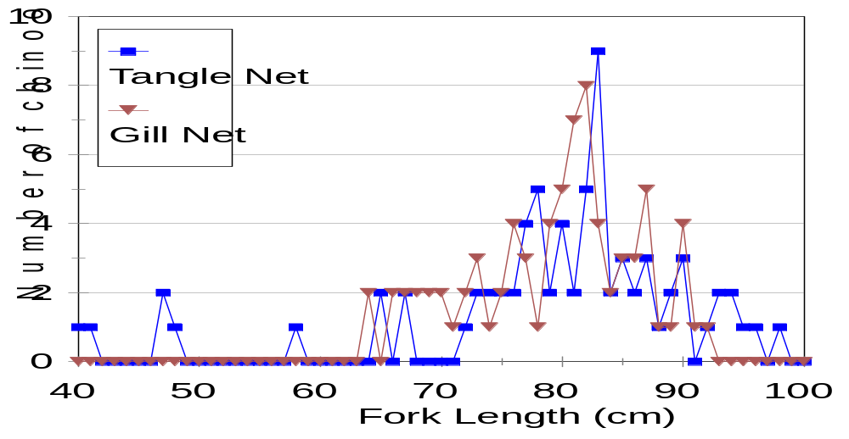
Figure 4: Length frequency distributions of fall chinook salmon caught in the tangle net and the conventional gill net during the Willapa River test fishery.

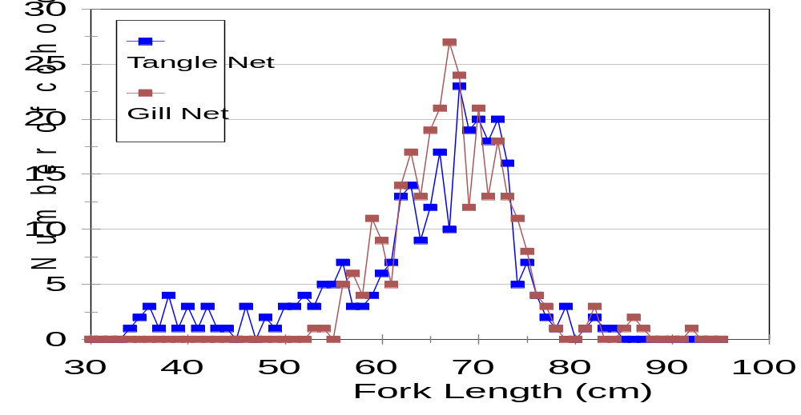
Figure 5: Length frequency distribution of coho salmon caught in the tangle net compared to coho salmon caught in the conventional gill net on the Willapa River.

Puyallup River - 2000

Thirty-five coho were captured from 21 separate sets made over 4 days between 28 Sep and 03 Nov. Twenty-five coho were captured in the gill net (44% male) and ten were captured in the tangle net (50% male). Two starry flounder (Platichthys stellatus) were incidentally captured in the tangle net. Nearly all of the fish were in excellent condition at the time of capture (Table 9). Fishers involved at this particular site felt that the gear could be improved to fish the Puyallup River. Changes such as increasing the mesh size to 4” and attaching a lighter lead line at the bottom were suggested as improvements that may increase the catch efficiency of the tangle net.

Table 9: Condition of coho salmon at capture during the Puyallup experimental fishery.
Condition at Capture | Gill Net | Tangle Net
1 | 72.4% | 83.3%
2 | 24.1% | 0
3 | 3.4% | 16.7%

EVALUATION

General Conclusions

To protect weak and endangered stocks, the commercial salmon gill net fisheries in the Western United States and Canada are facing unprecedented restrictions. To regain fishing opportunity, or to at least maintain the opportunities presently available, this industry must consider live capture, selective harvest gears and techniques. We tested the tangle net as an alternative gear to the gill net for targeting fall chinook and coho salmon while allowing for the release of nontarget species and stocks with minimal mortality. This net has shown great promise on the Columbia River for targeting spring chinook salmon (Vander Haegen et al. 2002) and sockeye and chinook salmon on the Skeena River (F. Hawkshaw, pers. comm.). We found the tangle nets we tested to be as effective for capturing coho salmon on the Willapa River, with slightly decreased immediate mortality, and would therefore have potential as a commercial gear if the post-release mortality of the coho were improved by the use of the tangle nets. Further research is required to evaluate this aspect. They also have potential for capturing coho salmon on the Puyallup River with further refinement.

Our tests of the tangle nets found them to be an unsatisfactory substitute for capturing fall chinook salmon near Miller Bay and in Budd Inlet. The catch efficiency of the tangle net was lower compared to the gill net, the immediate mortality of captured fall chinook salmon was not improved, and many more non-target species of fish were captured in the tangle net. However, fish captured in the tangle net had fewer net marks than those captured in the gill net, and could realize higher market prices. Our results of post-release survival also merit further consideration as they suggest that fish released from the tangle nets may survive at higher rates than those released from the gill nets. Further refinement of the gear, and selection of sites with a high abundance of fall chinook could provide positive results. Other gears for live capture selective harvest (e.g. beach seines, traps, reef nets, etc.) should be considered in areas where abundant stocks could be harvested if they could be separated from the weak stocks they are commingled with.

The concept of live harvest, selective fishing is a compelling method for continuing harvest while protecting weak stocks and species. Although we did not find a suitable method for selective harvest of fall chinook, research and development should continue given its success in other areas. As well as determining which gears are suitable for capturing the target species with minimal mortality of non-target species and stocks, the conservation benefits of releasing fish must be evaluated. Many questions remain. What proportion of the released salmon survives to complete their migration? Is the spawning ability or reproductive fitness of those fish impaired? If fish are released from one vessel during a fishery, they are susceptible to recapture. How often does this occur, and how do multiple recaptures affect survival? What is the fate of species other than salmonids that are released?

Objective 1

(Estimate the catch per set to +/- 10% at 95% confidence for the tangle net and conventional gill nets. Estimate the age and size for each species caught to +/-10% at 95% confidence for the tangle net and conventional gill nets.)

One consideration in substituting gears is how well the new gear captures the intended target species in comparison to the gear already being used. We estimated the catch per set at each location by counting fish as they were brought on board. Fish that fell out of the net before it was brought on board (“drop off”), and fish removed by seals could not be accurately counted, and were not included. We used these estimates to compare the catch efficiency of the gill net and the tangle net each time they were fished together. We considered the result positive if the tangle net caught as many or more of the target species as the gill net, although in some situations, lower catch efficiency might be acceptable if the higher quality of the captured fish would realize a higher market price. We found the 3.5” tangle net to be as effective as the 5.75” gill net when targeting coho salmon on the Willapa River, but not on the Puyallup River, and the tangle net captured only about 1/3 of the fall chinook encountered in the gill net in Budd Inlet.

By their very nature, gill nets are size selective, and have been identified as the cause for population-level reductions in size because they disproportionately remove the larger animals. As each fish was brought on board, we measured its fork length to evaluate whether the tangle net was more or less size selective than the gill net. We found that the tangle net tended to capture a wider range of fish sizes than the gill net, particularly towards the smaller sizes, as is expected from the smaller mesh size. In a commercial fishery, this could help to reduce the pressure on the larger fish in the population.

We did not attempt to estimate the ages of the captured fish because the live fish were too active for scale collection without causing them undue harm.

Objective 2

(Estimate the proportion of fish caught in the tangle net and in the conventional gill net that are brought aboard dead (cannot be revived) by species, to +/-2% at 95% confidence for each set.)

We estimated the immediate mortality of the target species that were captured in each net type, with the expectation that fish captured in the tangle net would survive better than those captured in the gill net. However, we found the differences between the nets to be relatively small, and the immediate mortality to be high compared to the rates encountered in other trials of the tangle net. Our test fisheries occurred in late summer and early fall, when the water temperatures are high, and the resulting stress on the maturing fish is likely greatest, while other trials showing low immediate mortality mainly occurred during late winter or spring. Temperatures during those fisheries would have been much lower, and the fish were likely able to tolerate handling. We suspect that the similar rates of mortality between the net types reflect the inability of the fish to tolerate additional stress from capture, whatever the capture method.

Objective 3

(For each species, estimate the percentage of fish released from the tangle net and conventional gill net that survived to complete their migration, to +/-25% at 90% confidence.)

In 2000 and 2001, fewer spring chinook returned to Budd Inlet and Miller Bay than expected and in spite of considerable fishing effort by experienced fishers, we were unable to capture and tag large numbers of fish for estimating post-release survival. In addition, of those fish released with tags, few were ever recovered, even though we expected to be fishing on the portions of each run that were returning to nearby hatcheries. Our inability to recover tags either represents an high number of long-term mortalities or more likely, means that the fish we captured were dispersing to other areas. Seals colonize Budd Inlet, and any fish that was impaired (as might be expected after capture) would be more susceptible to predation, and our tagged fish may have been disproportionately depredated. The fact that we do not know which of these to be the case precludes us from making any estimates in regard to survival and migration completion. The few tags we did recover in 2001 suggest that the fish released from the tangle nets may have a survival advantage, and this aspect should be studied further in smaller systems with abundant runs.

Objective 4

(Coordinate activities with fishery co-managers and fishers. In Washington, the fisheries are co-managed by the Washington Department of Fish and Wildlife (WDFW) and the Treaty Tribes of Washington State. Because the Treaty Tribes influence and participate in statewide fisheries management and research, we will notify and address comments from all of them, but will work closely with only those tribes whose usual and accustomed areas include or are near our test fishing sites. )

We successfully met Objective 4 in each area fished. In all areas, we contracted with tribal members or local fishers, and tribal biologists made substantial contributions toward implementing the test fisheries.

REFERENCES

Farrell, A.P., P. Gallaugher, C. Clarke, N. DeLury, H. Kreiberg, W. Parkhouse and R. Routledge. 2000. Physiological status of coho salmon (Oncorhynchus kisutch) captured in commercial non-retention fisheries. Canadian Journal of Fisheries and Aquatic Science 57:1668-1678.

Vander Haegen, G.E., K.W.Yi, C.E.Ashbrook, E.W.White, and L. L. LeClair. 2002. Evaluate live capture selective harvest methods. WDFW Report #FPT-02-01, 35 p.

ACKNOWLEDGEMENTS

We thank the Squaxin Island Tribe and particularly Mike Henderson, Will Henderson, Richard Peters, and Jeff Dickison for their help in planning and implementing the Budd Inlet test fishery. We thank the Suquamish Tribe and especially Jay Zhischke, Jon Oleyear, Armand Schavez (FV Salmon Bay) and Willard Pratt (FV Salmon Bay) for their help in the Miller Bay test fishery. We thank Eric Petit, Norris Petit, and Brian O’Shaughnessy for their participation in the Willapa River test fishery. We also thank the Puyallup Tribe and especially Francis John, Sr. and Fred Dillon for their voluntary participation. Finally, Washington Department of Fish and Wildlife employees Anita Swanson, Rebecca Bernard, Kyong Yi, Charmane Ashbrook, Shona Bruce, James Dixon, Brant Boelts, Keith Sweeney, Jared Laine, Lorna Wargo, and Patrick Verhey provided technical assistance.

