Historic Nez Perce Clothing and Adornment

The National Park Service [NPS] Teaching with Museum Collections provides lesson plans for teachers to use NPS museum collections in student-centered educational activities. The collections tell the story of America; its peoples, cultures, varied habitats, significant events, and ideas that continue to inspire the world. Teaching with Museum Collections [TMC] emphasizes the links between the ‘real things;’ the collections, and the sites where those collections were found, collected, or used. NPS collections include cultural objects, natural history specimens, archival documents and photographs. Lesson plans link to national education standards.

A. Header

Lesson Unit Plan Title: Historic Nez Perce Clothing and Adornment

Developer: Amy Woods, Kamiah Middle School, Kamiah, Idaho

Grade Levels: 8th Grade

Length of Lessons/Lesson Unit: Four to five 45 minute lessons

B. Overview of this Collection-Based Lesson Plan
- Park name: Nez Perce National Historical Park
- Description: The purpose of this lesson is to give students an awareness of the similarities and differences in Nez Perce clothing and adornment worn over 200 years ago, and traditional clothing and adornment worn presently. Students will also develop an understanding of the processes involved in simple clothing construction and jewelry making. Photographs of a historic Nez Perce dress, a pair of moccasins and a necklace, articles in the Nez Perce National Historical Park museum collections, may be viewed online at www.nps.gov/nepe and at www.cr.nps.gov/museum.
- Essential question
What clothing and adornment would a Nez Perce youth have worn 200-400 years ago? How would these articles be constructed and with what materials?

C. Museum Collections Used in this Lesson Plan

NEPE 34191 Dress
NEPE 2383 Moccasin
NEPE 1990 Grizzly Bear Claw Necklace
NEPE-HI-2279 Photograph of Chief Joseph’s Band Women Leading the Horse Parade
NEPE-HI-C9713 Nez Perce Drummers at the Long House, Spalding, Idaho
NEPE-HI-C9687 Studio Portrait of Three Nez Perce Women

D. National Educational Standards
Middle Grades
I. Culture
Social studies programs should include experiences that provide for the study of culture and cultural diversity, so that the learner can:
- compare similarities and differences in the ways groups, societies, and cultures meet human needs and concerns;
- explain and give examples of how language, literature, the arts, architecture, other artifacts, traditions, beliefs, values, and behaviors contribute to the development and transmission of culture;
- explain why individuals and groups respond differently to their physical and social environments and/or changes to them on the basis of shared assumptions, values, and beliefs;
- articulate the implications of cultural diversity, as well as cohesion, within and across groups.
II. Time, Continuity, and Change
Social studies programs should include experiences that provide for the study of the ways human beings view themselves in and over time, so that the learner can
- identify and use key concepts such as chronology, causality, change, conflict, and complexity
- to explain, analyze, and show connections among patterns of historical change and continuity;
IV. Individual Development and Identity
Social studies programs should include experiences that provide for the study of individual development and identity, so that these describe the ways family, gender, ethnicity, nationality, and institutional affiliations contribute to personal identity;
- describe the ways family, gender, ethnicity, nationality, and institutional affiliations contribute to personal identity;
- relate such factors as physical endowment and capabilities, learning, motivation, personality, perception, and behavior to individual development;
- identify and describe ways regional, ethnic, and national cultures influence individuals' daily lives;
- identify and describe the influence of perception, attitudes, values, and beliefs on personal identity;
- identify and interpret examples of stereotyping, conformity, and altruism;
V. Individuals, Groups, and Institutions
Social studies programs should include experiences that provide for the study of interactions among individuals, groups, and institutions, so that the learner can:
- demonstrate an understanding of concepts such as role, status, and social class in describing the interactions of individuals and social groups
- analyze group and institutional influences on people, events, and elements of culture
VII. Production, Distribution, and Consumption
Social studies programs should include experiences that provide for the study of how people organize for the production, distribution, and consumption of goods and services, so that the learner can:
a. give and explain examples of ways that economic systems structure choices about how goods and services are to be produced and distributed;
- describe the role that supply and demand, prices, incentives, and profits play in determining what is produced and distributed in a competitive market system;
- explain the difference between private and public goods and services;
- describe a range of examples of the various institutions that make up economic systems such as households, business firms, banks, government agencies, labor unions, and corporations;
- describe the role of specialization and exchange in the economic process;
- explain and illustrate how values and beliefs influence different economic decisions;
- differentiate among various forms of exchange and money;
- compare basic economic systems according to who determines what is produced, distributed, and consumed;
- use economic concepts to help explain historical and current developments and issues in local, national, or global contexts;
- use economic reasoning to compare different proposals for dealing with a contemporary social issue such as unemployment, acid rain, or high quality education.
English Language Arts Standards
The vision guiding these standards is that all students must have the opportunities and resources to develop the language skills they need to pursue life's goals and to participate fully as informed, productive members of society. These standards assume that literacy growth begins before children enter school as they experience and experiment with literacy activities — reading and writing, and associating spoken words with their graphic representations. Recognizing this fact, these standards encourage the development of curriculum and instruction that make productive use of the emerging literacy abilities that children bring to school. Furthermore, the standards provide ample room for the innovation and creativity essential to teaching and learning. They are not prescriptions for particular curricula or instruction.
- Students apply a wide range of strategies to comprehend, interpret, evaluate, and appreciate texts. They draw on their prior experience, their interactions with other readers and writers, their knowledge of word meaning and of other texts, their word identification strategies, and their understanding of textual features (e.g., sound-letter correspondence, sentence structure, context, and graphics).
- Students adjust their use of spoken, written, and visual language (e.g., conventions, style, and vocabulary) to communicate effectively with a variety of audiences and for different purposes.
- Students employ a wide range of strategies as they write and use different writing process elements appropriately to communicate with different audiences for a variety of purposes.
- Students conduct research on issues and interests by generating ideas and questions, and by posing problems. They gather, evaluate, and synthesize data from a variety of sources (e.g., print and non-print texts, artifacts, and people) to communicate their discoveries in ways that suit their purpose and audience.
- Students use a variety of technological and information resources (e.g., libraries, databases, computer networks, and video) to gather and synthesize information and to create and communicate knowledge.
- Students develop an understanding of and respect for diversity in language use, patterns, and dialects across cultures, ethnic groups, geographic regions, and social roles.
- Students use spoken, written, and visual language to accomplish their own purposes (e.g., for learning, enjoyment, persuasion, and the exchange of information).

E. Student Learning Objectives

After these lessons, students will be able to:
  - Critically analyze objects from museum exhibits of historic Nez Perce clothing and adornment
  - Recognize similarities and differences in the cultural aspects, materials, and construction of historic Nez Perce clothing and adornment and similar present day items
  - Construct replicas of historic clothing and adornment
  - Create and display a collection of exhibits for a classroom museum, cataloged in a Museum Collections Spreadsheet
  - Communicate their ideas and hypotheses through oral and written presentations

- Background and Historical Context

The Nez Perce used materials from animals in their homeland and some trade items to make and decorate their clothing. Dresses, shirts, leggings and moccasins could be constructed of deer, bighorn sheep, or elk hides. Buffalo hides and various fur baring animals were used to make winter wraps & heavier moccasins. Hides used for clothing were cleaned, hair removed and softened with a mixture of animal brains and fat.

The type of decoration used was a combination of personal choice and what items were available to the person. Dentalium, olivella, abalone and other types of shells were traded from the west coast. Porcupine quills could be dyed and sown on clothing and personal items. Feathers were used on headdresses or clothing and were sometimes dyed. Mineral paint and plant dye were also used to paint designs.

Glass beads, made in many countries of Europe and Asia, became a very popular decorative element for clothing and personal items. As a trade item beads were brought into the Pacific Northwest by Europeans and Americans in the mid to late 1700s.

In making present day traditional clothing for ceremonies and pow wows the Nez Perce have access to many of the same items used in the past. They also use modern materials such as yarn, for fancy dance regalia or tin cones for the jingle dress. Many of the materials are purchased from companies that specialize in making and selling beads, hides, etc.

G. Materials Used in this Lesson Plan

Similar Items: simple tunic style dress (very plain A-line without belts, pleats, ruffles, etc…), necklace with large ornaments, high-top sneakers
Photographs: laminated copies of historic Nez Perce dress, moccasins, and necklace from online park museum collection.
Handouts: Traditional Basket Designs, Two-Skin Dress pattern, Poncho patterns, Making Cordage.
Writing Materials: Journal paper, pencils, color pencils, chart paper for compare/contrast sheets, markers
Dress/Poncho Materials: Two yards unbleached broadcloth or faux leather, paint in a variety of colors suitable for painting on cloth, paint brushes, one spool of floss, scissors, needles with large eyes, raffia, assorted beads, dress and poncho patterns, basket design patterns.
Necklace/Bracelet Materials: raffia (natural color), scissors, assorted beads (varied in size, color, and shape), paper cups
Class Museum Materials: Museum catalog spreadsheet, black ink pen, ruler, buff colored construction paper

H. Vocabulary

Awl – tool used for punching holes in leather to allow sewing
Sinew – animal tendon used as a cord or thread
Tanned hide –cleaned and softened animal hide into buckskin
Natural pigment – a coloring property in animals, minerals and plants, used to paint or dye items.

I. Teacher Tips

  - Download and laminate color prints of the museum objects used in the Nez Perce Attire Activity
  - Download and laminate historic regalia photos.
  - Separate beads and store in plastic containers with lids. Tape or glue a bead to each lid so container contents are easily identified.
  - Enlarge animal skin pattern to fit 8 ½ x 11 paper.
  - Cut out several animal skin patterns to be used for two-skin dress pattern or poncho pattern that students will use to trace onto fabric.
  - Make a sample of a dress, poncho, necklace and bracelet for students to use as a model for each activity.

J. Lesson Implementation Procedures

Activity One: Introduction

Tell students they will be using objects from a National Park Service site as source of learning and information. Explain that they will learn to look very closely at an object or set of objects to deduce historical, cultural and social information and to draw inferences about people, events, and life then and now. Ask questions that draw on observational skills, and develop activities that exercise powers of deduction, inference, and creativity based on this introductory lesson.

Do the following with the students:
- Divide students into three groups. Assign students in each group the role of recorder or presenter. You may have as many as three students performing each role.
- Hand out laminated pictures of Nez Perce attire, giving the dress to one group, moccasins to another group, and necklace to the third group.
- Hand out the modern day dress, sneakers, and necklace to each group with a similar historic Nez Perce item.
- Provide each group with a large piece of chart paper divided into three columns. Instruct students to title columns by name of piece: Historic Nez Perce ___________ (name of item), Present Day _____________ (name of item), Common Characteristics. Example: Historic Nez Perce Moccasins; Present Day Sneakers; Common Characteristics
- Instruct groups to brainstorm unique characteristics of each assigned piece and the common characteristics of the two items being compared. Recorders write group comments on chart paper.
- Presenters from each group share group findings with class. Allow time for class discussion after each group’s presentation. Display charts on wall or bulletin board for future reference.
- Students summarize activity in response journal with writing and sketches.

Activity Two: Compare and Contrast Museum Objects with Contemporary Regalia
- Divide students into three groups. Assign students in each group the role of recorder or presenter. You may have as many as three students performing each role.
- Hand out laminated pictures of Nez Perce attire, giving the dress to one group, moccasins to another group, and necklace to the third group.
- Hand out the historic regalia photographs to each group.
- Instruct groups to look at the museum objects and see if there are versions of those still worn by Nez Perce in the contemporary pictures. What’s different? What’s the same? Record what each group sees.
- Presenters from each group share group findings with class. Allow time for class discussion after each group’s presentation.

Activity Three: Create Authentic Replica of a Nez Perce Dress or Poncho

Do the following with the students:
- Students may choose to make a dress or poncho. (Most likely the boys will make a poncho and the girls will make a dress).
- Provide each group with a collection of supplies to create the piece of attire assigned to them (products will be small versions of authentic item).
- Write vocabulary words and definitions on board. Show students the supplies they will be using in place of sinew, awls, tanned hides, and natural pigments.
- Dress/Poncho: (See diagrams of poncho and dress on handouts.) Students trace pattern on fabric. Dress requires a front and back piece. Cut around traced lines. Thread needle with arm’s length piece of floss. Sew dress front to dress back along sides and top, leaving an opening for arms and head. Cut slit in poncho for head as shown on pattern. Fold in half at slit, and sew sides leaving an opening for arms. Dress/poncho may be embellished by tracing basket design patterns (handout) on garment and painting with fabric paint. Pieces of beaded raffia may be attached to front of dress/poncho for added decorative features.
- Students summarize activity in response journal with writing and sketches.

Activity Three: Create authentic Nez Perce necklace or bracelet

Do the following with students:

- Teacher demonstrates method for making cordage using raffia. See attachment of making cordage.
- Arrange supplies in two separate areas of classroom. Place raffia and scissors in one area and various containers of beads in another area to avoid congestion. Provide pieces of raffia cut to the desired lengths for a bracelet or necklace as examples for students.
- Divide students into two groups and send one group to cut raffia pieces, and send one group to choose beads and plan bead design for a necklace or bracelet. Instruct students to place beads in paper cup. Groups trade areas when tasks are completed.
- Students return to desks or tables to string beads on the raffia. Twist raffia together following the instructions for making cordage.
- Thread beads on the cord creating the desired pattern. A knot may be made between beads or anywhere on the raffia for design purposes; however, knots need to be made at each end to prevent beads from falling off cord.
- Students summarize activity in response journal with writing and sketches.

Activity Four: Classroom Museum Exhibit

Do the following with students:

- Teacher demonstrates how to catalog items for classroom museum using a sample item prepared earlier for Activity Two and Activity Three. (dress, poncho, necklace, bracelet)
- Give each student a worksheet with categories of information needed to catalog an object; Catalog Number, Object Name, Material, Dimensions, Description, Manufacture Date, Cultural ID, Artist/Maker. Instruct students on how to complete each category on a spreadsheet using the teacher-provided sample item:
- Students write information on spreadsheet for the items they made in Activity One and Activity Two
- Each student will make a place card out of buff colored construction paper folded in half to measure 3 x 5 inches. Instruct students to write their name and the name of the item on the folded place card.
- Students display items in glass display cases with place card.

K. Evaluation/Assessment for Measurable Results

Evaluated using a rubric which identifies the following components of the Nez Perce Attire and Artifacts Unit:

- Art: hand made replica of a Nez Perce dress or poncho with artistic additions such as painted or beaded designs
- Art: hand made replica of a Nez Perce necklace using various beads and meaningful personal items
- Social Studies/History: classroom museum exhibits including similar objects of primary sources with interpretive labels
- Language Arts: daily entries of text and graphics in Response Journal describing processes for activity completion and results of lessons
- Language Arts: contribution to chart comparing and contrasting modern attire and adornment to historical Nez Perce adornment

L. Extension and Enrichment Activities

- Encourage students to bring “old” items from home (with parent or grandparent permission) and compare them to similar present day items.
- Visit a local historical society or museum and create a written record of the exhibits which are representative of similar present day items.
- After doing some research conduct an on-line tour of a museum and create a written record of the exhibits which are representative of similar present day items.

M. Resources
Bibliography
Shawley, Stephen Douglas. Nez Perce Dress: A Study in Culture Change. Washington State University, 1974.
Grafe, Steven Leroy. “The Origins of Floral Design Beadwork in the Southern Columbia River Plateau.” Ph.D dissertation, University of New Mexico, 1999.
Raymer, Dottie. Welcome to Kaya’s World 1764: Growing Up in a Native American Homeland. Middleton, Wisconsin: Pleasant Company Publications [American Girls Collection], 2003.

Web Sites
Nez Perce National Historical Park www.nepe.gov/nepe
Nez Perce Tribe: www.nezperce.org
Nez Perce National Historical Park: www.nps.gov/nepe
Colville Confederated Tribes: http://www.colriletribes.com/
Umatilla Confederated Tribes: http://www.umatilla.nsn.us/

Site Visit
- Pre-Visit: Before the visit, have the students visit the virtual museum web site and look at the online exhibit and complete activity one, how to read an object. After completing activity one, choose two more objects and analyze those. Also, have the children come prepared to analyze one or two objects of their choice on display in the museum.
- Site visit: Call the park to make arrangements to visit. Go to the park home page to contact park staff at www.nepe.gov/nepe. Have the students pick an object in the museum and analyze it using the knowledge gained in how to read an object.
- Post-visit: Have the students write down their reactions to what they learned about how museum objects can tell stories. Conduct one of the lessons extension activities.
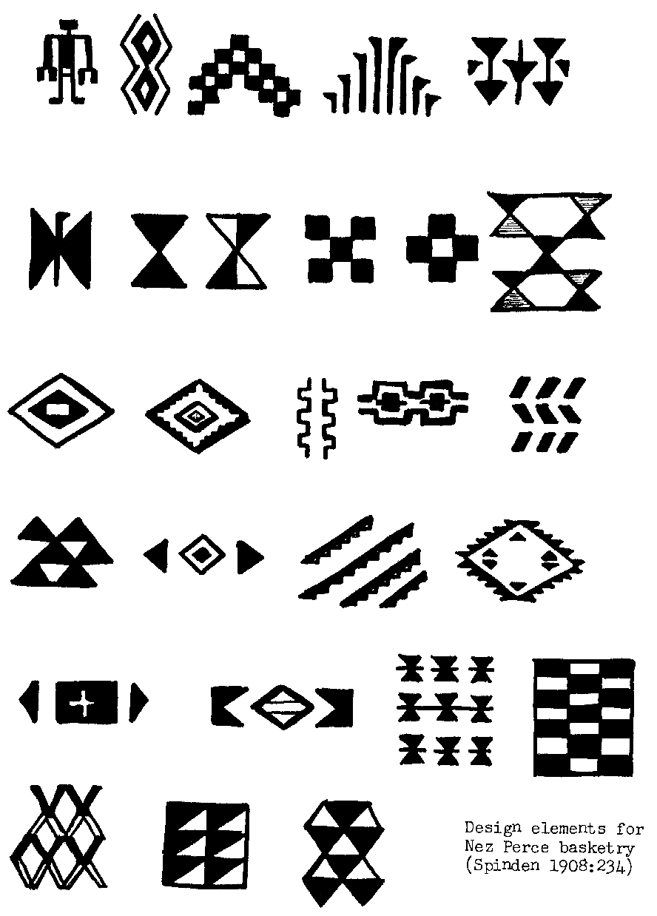
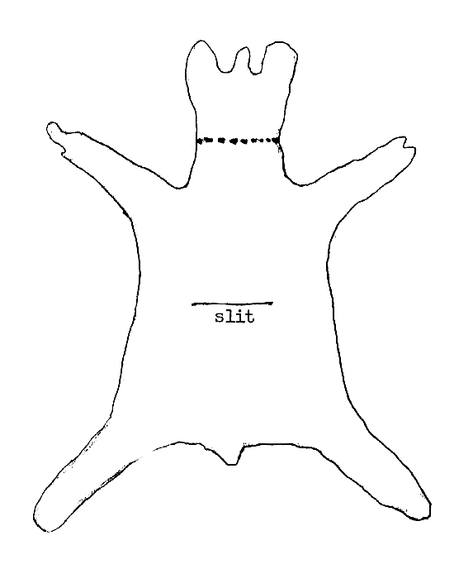
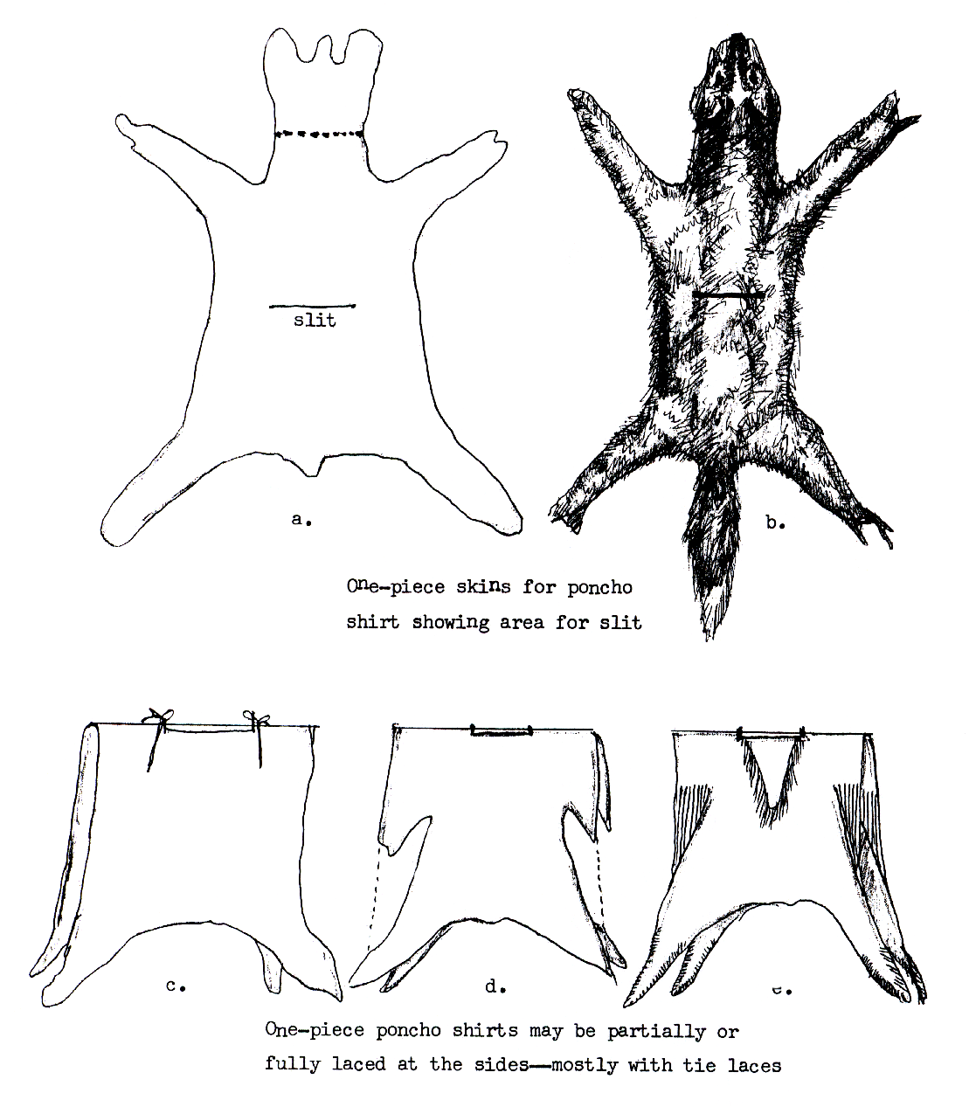
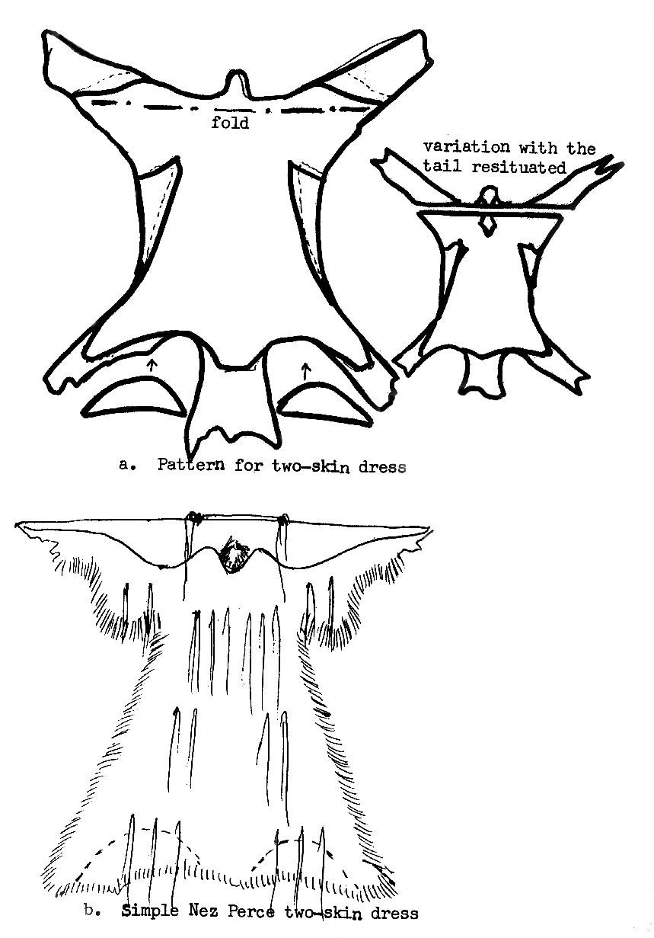N

Making Cordage

If possible show students natural fibers used for cordage: year old dead stalks of milkweed (carefully break open stalks and strip the fiber away); bark from dogbane, sage, or juniper, and yucca leaves.

Demonstrate how to make cordage with raffia, this can be purchased at a craft store, following the steps below. Divide the class into groups of 3 or 4 students. Give each student 2, 15-inch pieces of raffia. Assist each group; also have students help each other.

Tie one end of Strand A and one end of Strand B together. Hold both strands side-by-side, in your left hand between your forefinger and thumb (if right-handed, vice-versa if left-handed). Pick up Strand A between your right forefinger and thumb, and twirl the strand away from your body (clockwise), Step 1 on figure.

Figure 1

Take the twisted Strand A and bring it toward your body, over and then under Strand B, Step 2 on figure.

Hold Strands A and B between your left forefinger and thumb about where you crossed A over B, repeat the twirling and crossing sequence: pick up Strand B, twirl it away from your body, and cross it over and under Strand A.
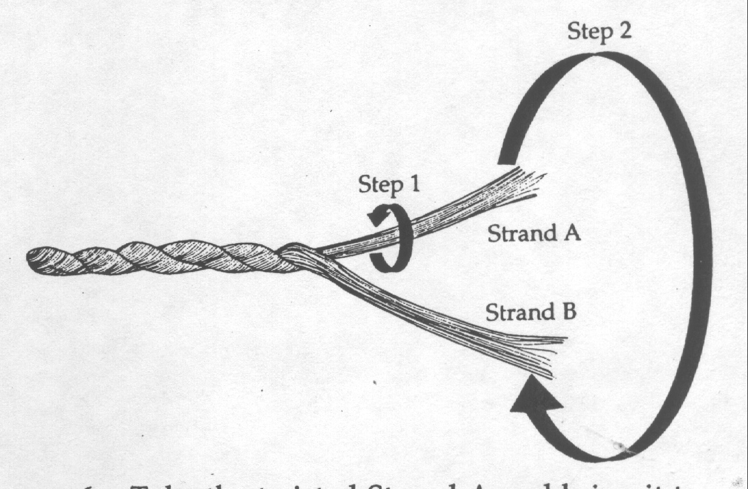
Continue these steps. The twirling in one direction and crossing in another direction forms an interlocking pattern like that of machine-made rope. If the cordage looks all twisted in the same direction, then the locking twist is not taking place, and usually the strands are being twirled in the wrong direction.

