NCUA LETTER TO CREDIT UNIONS

NATIONAL CREDIT UNION ADMINISTRATION
1775 Duke Street, Alexandria, VA

DATE: September 2003 LETTER NO: 03-CU-15

TO: Federally Insured Credit Unions

SUBJ: Real Estate Concentrations and Interest Rate Risk Management for Credit Unions with Large Positions in Fixed-Rate Mortgage Portfolios

Dear Manager and Board of Directors:

The current interest rate environment, combined with recent trends in assets and liabilities, present unique challenges to credit union management. During 2003, interest rates fell to record lows, credit unions have experienced vigorous share growth for several years, and credit union participation in the mortgage lending arena has increased to historic highs. Given these emerging trends NCUA has issued five letters over the past four years addressing the subject of prudent balance sheet risk management. These letters have addressed real estate loans, liability management, liquidity risk, managing share inflows in uncertain times, and non-maturity shares.

Background

Currently, of all credit unions that hold first mortgage loans nearly one in ten has 25 percent or more of its assets invested in fixed-rate first mortgage loans. This ratio, although not within itself an indicator of a poorly managed mortgage portfolio, has more than doubled in the past ten years. It is highly probable and reasonable to assume that many of those fixed-rate loans were originated over the last two years when interest rates were at or near record lows. If the risk is not managed effectively, this degree of concentration in fixed, low-rate first mortgage loans represents potentially high exposure to rising interest rates.

In keeping with the purpose of the risk focused examination process, NCUA will focus particular attention on the risk management processes utilized by those institutions with higher concentration levels in fixed-rate mortgages to measure and forecast their balance sheet risk. Effective risk management requires that long-term implications on the earnings and net worth of the credit union be properly addressed.

Implicit to an effective and proper risk control process is establishing a reasonable risk tolerance amount and abiding by a prudent threshold. Such a process will enable credit unions to take appropriate and timely action to reduce excessive risk positions.

NCUA does not prescribe a fixed, maximum percentage of mortgage loans in a credit union’s lending portfolio that is applicable to all credit unions. Each credit union has its own individual risk profile and risk tolerance level. However, NCUA will not permit an institution to continue an inherently high risk strategy when measures of fair value indicate net worth is approaching a dangerously low or even negative position as measured for plausible interest rate scenarios (e.g., an upward stress in rates of 300 basis points or other shock scenario). The combination of low-rate mortgage loans in existing portfolios and the prospect of higher interest rates in the future make a situation where low and/or negative economic value is quite plausible for institutions with a high risk profile.

Among the questions herein presented that institutions with high concentrations of fixed-rate mortgages in their portfolios should ask themselves are: (1) does my balance sheet have such a risk exposure? and, if so, (2) what action should I take to lower the risk to a prudent level? Similar questions will also be posed by your NCUA examiner during the risk focused examination process.

Summary

The current interest rate environment offers credit unions unique member service opportunities, but also balance sheet management challenges. Credit unions have made significant strides in the mortgage lending arena, which have resulted in greater opportunities for enhanced service to members. If managed properly, this is a positive development. However, the potential for exposure to significant risk also exists if not managed properly.

Federal Reserve Board Governor Mark W. Olson made the following observations in a speech given June 26, 2003:

“Decisions made by bankers in today’s unusual interest-rate environment can have important long-term consequences. The compression of interest margins is alerting bankers to the fact that their ample supply of core deposits provides a liquidity cushion that is fairly expensive in this setting. A natural reaction for banks would be to move out on the yield curve to achieve better interest margins ...
In another period of exceptional interest rates – the late 1970s and early 1980s – many banks that were funding long-term assets with four-and-one-half or six-year certificates of deposit found that depositors were accepting substantial interest penalties—as much as six months’ interest—to shorten their maturities and considerably improve their yields. Banks and thrifts then faced significant, and in some cases critical, interest rate risk exposures. Should interest rates return to levels of prior years, banks that rely on their savings accounts and MMDAs to fund long-term assets may be wise to consider the possibility of facing unexpected liquidity or interest rate risk pressures if depositors choose to shift deposit funds into other investment vehicles to enhance the return on their assets.

If the management challenges of this environment could be reduced to a single issue, that issue would be the need to balance the opportunities of the present with the prospects for the future.”

We strongly caution credit unions to avoid a strategy of "wait-and-see" on interest rates when holding excessive risk in portfolio. Based upon history, it is highly likely the market will experience accelerated activity at the point interest rates begin to increase as many market participants simultaneously react to higher rates. The extent of how high rates increase and how fast they will get there are not controllable factors. Losses can quickly accumulate when rates rapidly increase and reducing the risk becomes considerably more costly. Given this possibility credit unions must be adequately and properly prepared to incur the expense of necessary risk reduction.

While it is essential that credit union management balance the marketplace opportunities of the present with the economic considerations of the future, they must constantly monitor that balance and do so in a safe and sound manner which is appropriate to their ability to manage the risk. Credit unions with an excessive risk profile are expected to address such exposures in an appropriate and timely manner and manage them on an ongoing basis. The sophistication of a credit union’s risk management practices and strategies must be commensurate with the level of risk on the credit union’s balance sheet.

If you have any questions, please contact your examiner, NCUA regional office, or state supervisory authority in the case of state chartered credit unions.

Sincerely,

/S/

Dennis Dollar
Chairman

Appendix A

Real Estate Loan Trends in Credit Unions

Credit unions have become more active participants in the national mortgage origination market. The graph below depicts the trend in national mortgage originations, and the percent of national originations made by credit unions.

This graph shows that credit unions' share of total U.S. Mortgage originations has continued to increase from 1.9% in 1993 to 2.5% in 2002, despite significant increases in the volume of all U.S. originations.

Between 2000 and 2002, total loans to assets of credit unions declined from 68.8 percent to 61.5 percent. In that same period, first mortgage loans increased from 17.4 percent to 18.1 percent of assets. While total loans have decreased, which is reflective of the trends in consumer borrowing, real estate lending increased as a percent of assets during a period of unprecedented asset growth.

The following graph compares total residential real estate loans held by credit unions to residential real estate loans held by all FDIC insured institutions. Residential real estate lending held by credit unions increased significantly from 1995 to 2002. During this period, the level of residential real estate loans held by FDIC insured institutions remained fairly constant.

This graph demonstrates the increase in the concentration of assets in real estate loans held in portfolio by credit unions over the last 7 years.

When the level of mortgage backed investments (both pass through and collateralized mortgage obligations) are considered along with total real estate loans, the level of total real estate backed assets at credit unions is 30.9% of total assets. This measure has also consistently risen as reflected in the following graph.

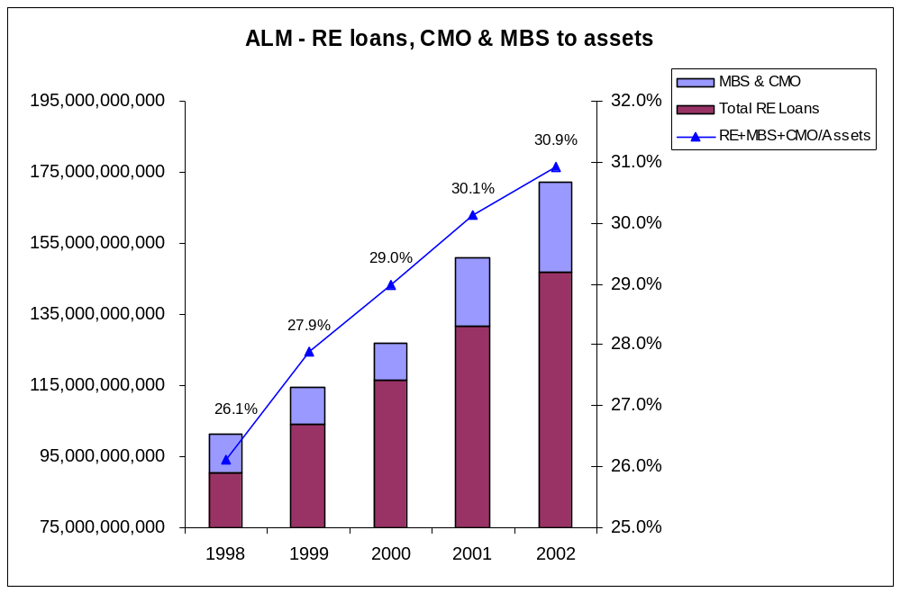

Approximately 45 percent of federally insured credit unions experienced a decline in dollar net interest margin in the first six months of 2003. Of credit unions with assets over $100 million, 435, or 39 percent, incurred a decline in dollar net interest margin in the first six months of 2003.

The declining interest rate environment and resulting compressed net interest margin have provided incentives for credit unions to move out on the yield curve to maintain net income levels. This extension is consistent with the rising levels of real estate loans and mortgage backed securities obtained and held by credit unions.

Over the past five years, member share accounts have increased 46 percent. The largest increases were in money market shares and share drafts, which increased 107 percent and 51 percent, respectively, over this period.

If interest rates rise, funds may move out of credit unions, creating pressure to increase dividend rates offered to members. This could potentially cause margin compression at the same time that value is being eroded in mortgage portfolios. Credit unions should be aware of the inter-related risks created by taking long-term asset positions which are funded by short term or rate sensitive share accounts.

Appendix B

This letter indicates NCUA will not permit institutions to operate where future higher rate scenarios cause measures of fair values to become dangerously low. As such, credit unions will be required to make a determination of the risk and loss limits they consider to be prudent, with appropriate trigger points indicating when action will need to be taken. Examiners will expect to see realistic and viable exit strategies that a credit union will employ when approaching these limits, and a firm commitment by management to execute these strategies.

To fully appreciate the implications of the current interest rate environment credit unions must follow standard and prudent steps of identifying, measuring, monitoring and controlling their interest rate risk exposures. Identifying the institution’s current exposure is only the first step. Secondly, credit unions must ensure that the measurement of interest rate risk, where based on assumptions used in ALM models, is reasonable, supportable and, wherever possible, drawn directly from available data. Interest rate exposure limits should be carefully monitored. Finally, where control of interest rate risk is needed due to excessive levels or potentially dangerous trends that are identified within a credit union, risk mitigants are available and can be entered into.

Exit alternatives may involve either management of the balance sheet itself, pricing strategies, off balance sheet measures, or a combination of these activities and can include, but are not limited to:

- Sales/securitization of long-term assets.
- Strategic pricing of credit union products.
- Securing long-term, fixed-rate funding.
- Purchasing interest rate swaps.

Sales/Securitization of Long-Term Assets

Mortgages that are underwritten according to the standards of entities in the business of securitization (e.g. FNMA/FHLMC) can be sold or passed through to these entities on a flow basis. Sales are also possible to other private entities.

Pricing and Product Strategies

Credit unions typically approach pricing on a tactical basis, reviewing and changing rates to meet market competition. Pricing can also be used to promote long-term balance sheet goals when they are stated as part of a strategic business plan. On this basis, for example, a credit union may set trigger limits permitting fixed-rate real estate products to comprise only a certain maximum percentage of originations, or may price its variable rate home equity line products to attract business from competitors.

If a credit union is not selling mortgages as a normal course of business, trigger points can be set to initiate predetermined courses of action upon reaching specific levels. When using this type of strategy, there are several things to consider:

- The trigger points should be based on sound ALM analysis.

- Management must predetermine the appropriate action to be taken when the trigger point is reached. Examples could include selling mortgage loans at a predetermined interest rate threshold or volume threshold and, although less desirable, limiting originations to keep below predetermined trigger points.

- Management must be committed to execute sales or take other predetermined steps based on the specified trigger point. Once management has determined appropriate risk tolerances, these should not be increased to accept more risk simply because the triggering point has been crossed. There should be a firm commitment by management to follow-through with the predetermined action.

- If the action to be taken is or includes selling mortgages, relationships with purchasers should be established and tested. Waiting until the trigger point has been crossed to establish these relationships will likely be too late. In addition, a credit union that elects to wait to sell mortgage loans until rates have risen could be faced with a situation where there is more supply than demand for mortgage loans, which could adversely impact pricing.

Long-Term, Fixed-Rate Funding

The interest rate and liquidity risk of long-term, fixed-rate mortgages can be offset by entering into fixed-rate funding of a similar duration to the mortgages held in portfolio. Long-term funding is available from various sources, such as the Federal Home Loan Bank system.

Off Balance Sheet Risk Reduction

The interest rate risk of long-term, fixed-rate assets can be offset through the purchase of interest rate swaps in which fixed cash flows are exchanged for cash flows based on a variable rate index. Pilot programs have made derivative products available to credit unions for risk reduction purposes.

In the current low rate environment, a credit union may wish to create a stop loss in the eventuality that rates might rise. To accomplish this on a portfolio basis, the credit union may consider the purchase of a cap on a portion of its fixed-rate portfolio above which the credit union would receive cash flows equal to the loss in value of the mortgages being hedged. Alternatively, if it wished to fix its value at current levels, a credit union may look to swap the cash flows of (a portion or all) the fixed mortgage portfolio for variable cash flows.

Credit unions should carefully consider the risks and rewards of such derivative transactions. Derivatives can be customized to meet the specific needs of the credit union and must be fully understood prior to purchase. A credit union considering these alternatives should consult closely with the pilot program provider before entering into any such transactions to ensure that the specific needs of the credit union will be addressed.

Balance sheet management techniques, such as those described here, are some options that are available to credit unions. However, it must be stressed that there is no substitute for a credit union’s own pro-active consideration of risk management. Credit unions are encouraged to implement a pro-active risk management program in an expeditious and prudent manner to avoid the costs and pitfalls that could potentially result from unnecessary delay.

Based on Freddie Mac’s survey of 30-year fixed-rate mortgages since 1971.
Previous Letters: 99-CU-12, August 1999, “Real Estate Lending and Balance Sheet Management;” 00-CU-13, December 2000, “Liquidity and Balance Sheet Risk Management;” 01-CU-08, July 2001, “Liability Management – Highly Rate Sensitive and Volatile Funding Sources;” 01-CU-19, October 2001 “Managing Share Inflows in Uncertain Times,” 03-CU-11, July 2003, “Non-Maturity Shares and Balance Sheet Risk”
Complete text of speech by Federal Reserve Board Governor Mark Olson, at the Economic Growth and Regulatory Paperwork Reduction Act of 1996 Outreach Meeting – June 26, 2003, can be found at this Website: http://www.federalreserve.gov/boarddocs/speeches/2003/20030626/default.htm
For this period, regular shares had the largest growth in dollars at $50 million (a 36% increase), with money market account growth at $49 million and share draft growth at $21.5 million.

