No Way to Meet a Neighbor

This is a story about an unexpected meeting that caused a lot of trouble and heartache for many people.

Instructions

Get together with two or three of your friends. Then read the story and answer the questions that appear in the story.

Mark your answers on the answer sheet. Please don’t mark in this booklet. After you have selected your answers to each question, discuss your choices with your friends. Then continue reading the story and answering and discussing the questions.

When you finish the story, ask for a copy of the answer key. Compare your answers to the answer key, but don't change your answers. Discuss the story and answers with your friends and the instructor. Then complete the questionnaire attached to the answer sheet. Give the booklet and your completed answer sheet and questionnaire to the instructor. Your answers will be used to improve the exercise.

Thanks!
Neighbors

Sam Johnson is 38 years old. He works in an automobile brake factory in Calverse City (population 60,000). Two months ago, he, his wife, and two kids moved out of the city to a new house in Jarrand County, a farming community. Each day Sam commutes 70 miles round trip from his new home to work and back on Route 5, a well-maintained two-lane asphalt highway with a posted speed limit of 55 mph.

Jake Fergus is 52 years old. He is a full-time farmer in Jarrand County. His 200-acre farm is only 2 miles north of Sam Johnson’s new house. Jake’s farm runs along both sides of Route 5. Jake and his wife have farmed this place for 30 years, raised three children, and have two grandchildren.

Home Sweet Home

It is 6:10 P.M. on Friday evening, July 14. The weather is sunny and warm.

Sam has worked overtime today. He is late for a family barbecue and in a hurry to get home. He is driving 65 mph.

Jake has been baling hay all day. He has just pulled out of his hayfield on the west side of Route 5 and is headed for home, pulling the square baler and the loaded hay wagon behind his 1983 90-hp diesel tractor. The tractor doesn’t have a cab and has no rollover protective structure (ROPS) or seatbelt. There is a slow moving vehicle (SMV) sign on the tractor but none on the hay wagon or baler. This is Jake’s last load for the day. He is in a hurry to get home and see his wife and grandchildren. The children are visiting and staying for supper.

Look at Figure 1 on the next page.

Then turn to page 4 and begin.

Work a page at a time.

Don’t jump ahead, but you can look back anytime you want.

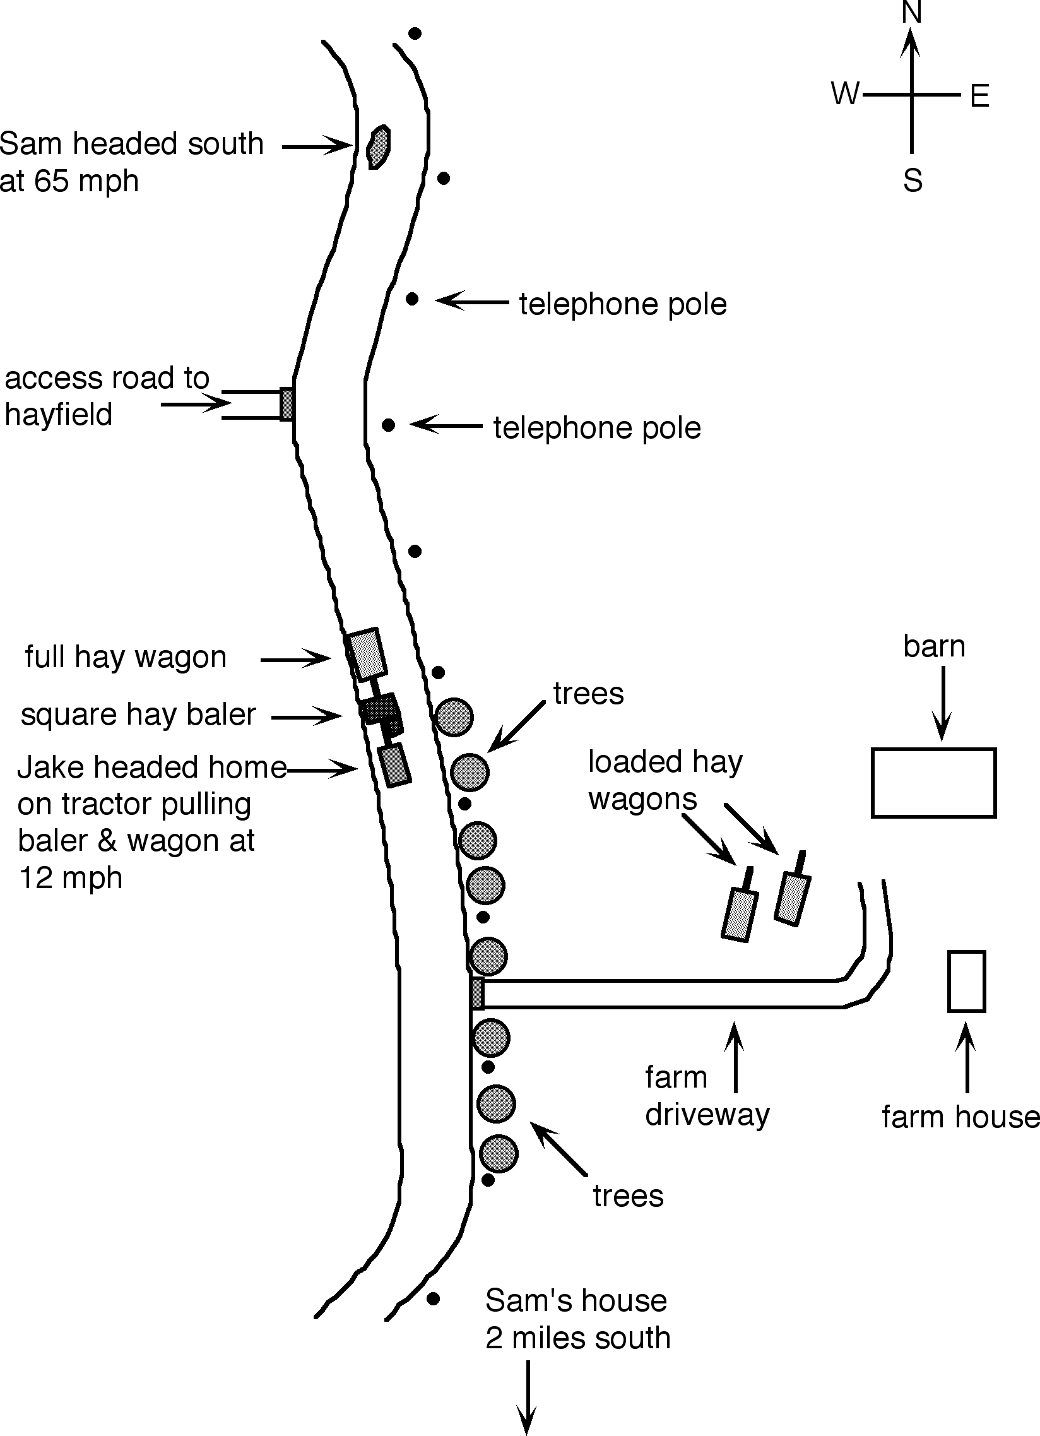

Figure 1: Positions of Sam and Jake traveling south on Route 5

Question A
Sam rounds a bend in the road and sees a large hay wagon 400 feet ahead of him. He can’t see the hay baler and the tractor because the loaded hay wagon blocks his view.
As he drives the tractor, Jake sees that the road ahead of him is clear, but the hay wagon blocks his view of what’s behind. The noise of the tractor engine drowns out sounds of any vehicles approaching from behind.
What should Sam and Jake do at this time? (For each item, circle T for true or F for false.)
Sam (the car driver) should:
T | F | 1. | Slow down and look for farm access roads.
T | F | 2. | Notice the farm, barns, and hay wagons ahead on his left.
T | F | 3. | Speed up so he can pass the hay wagon and tractor on the straight section of the road while it is clear of oncoming traffic.
T | F | 4. | Slow down to 50 mph, lie on the horn, and pull out and around the hay wagon and tractor.

As he approaches the left turn into his farmyard, Jake (the tractor driver) should:
T | F | 5. | Drive to the extreme right on the shoulder of the road.
T | F | 6. | Throttle back, slow down, and listen for traffic sounds behind him before beginning a slow gradual turn into his driveway.
T | F | 7. | Cut across the road fast to make his left turn and get the tractor, baler, and hay wagon off the highway as soon as possible.
T | F | 8. | Stop the tractor. Get off and look behind to make sure it is clear. Then hop back on and pull into his driveway.

[After you have marked your answers, please continue with the story.]

Question B
Sam didn’t notice the farm access road on his right or the barn and hay wagons down the road on his left. Jake doesn’t know that Sam is approaching his wagon, baler, and tractor from behind.
Sam slows down to 55 mph. About 50 feet from the hay wagon, Sam honks his horn once and pulls into the left lane to pass the hay wagon and tractor. Jake doesn’t hear the horn. Just as Sam accelerates to get by, Jake cuts the tractor across the highway and heads toward the driveway. In an instant, Sam sees the tractor, baler, and wagon blocking the whole highway. (See Figure 2 on the next page.)

What can Sam do to avoid a crash?
(For each item, circle T for true or F for false.)

T | F | 9. | Steer left into the field to avoid crashing into the tractor, baler, and wagon.
T | F | 10. | Slam on the brakes and stop before he hits the tractor, baler, or wagon.
T | F | 11. | Blow his horn so Jake will get out of the way.
T | F | 12. | Nothing! Too fast and too late! There is no escaping a collision!

At this same instant, Jake looks back and to his left. He sees Sam’s car bearing down on him at high speed. What can Jake do to avoid getting hurt? (For each item, circle T for true or F for false.)

T | F | 13. | Give the tractor full throttle to move it out of the way so the car will hit the baler and not the tractor.
T | F | 14. | Pull back to the right so Sam’s car can squeeze through.
T | F | 15. | Leap off the tractor and get out of the way.
T | F | 16. | Hang on tight and pray.

[After you have marked your answers, please continue with the story.]

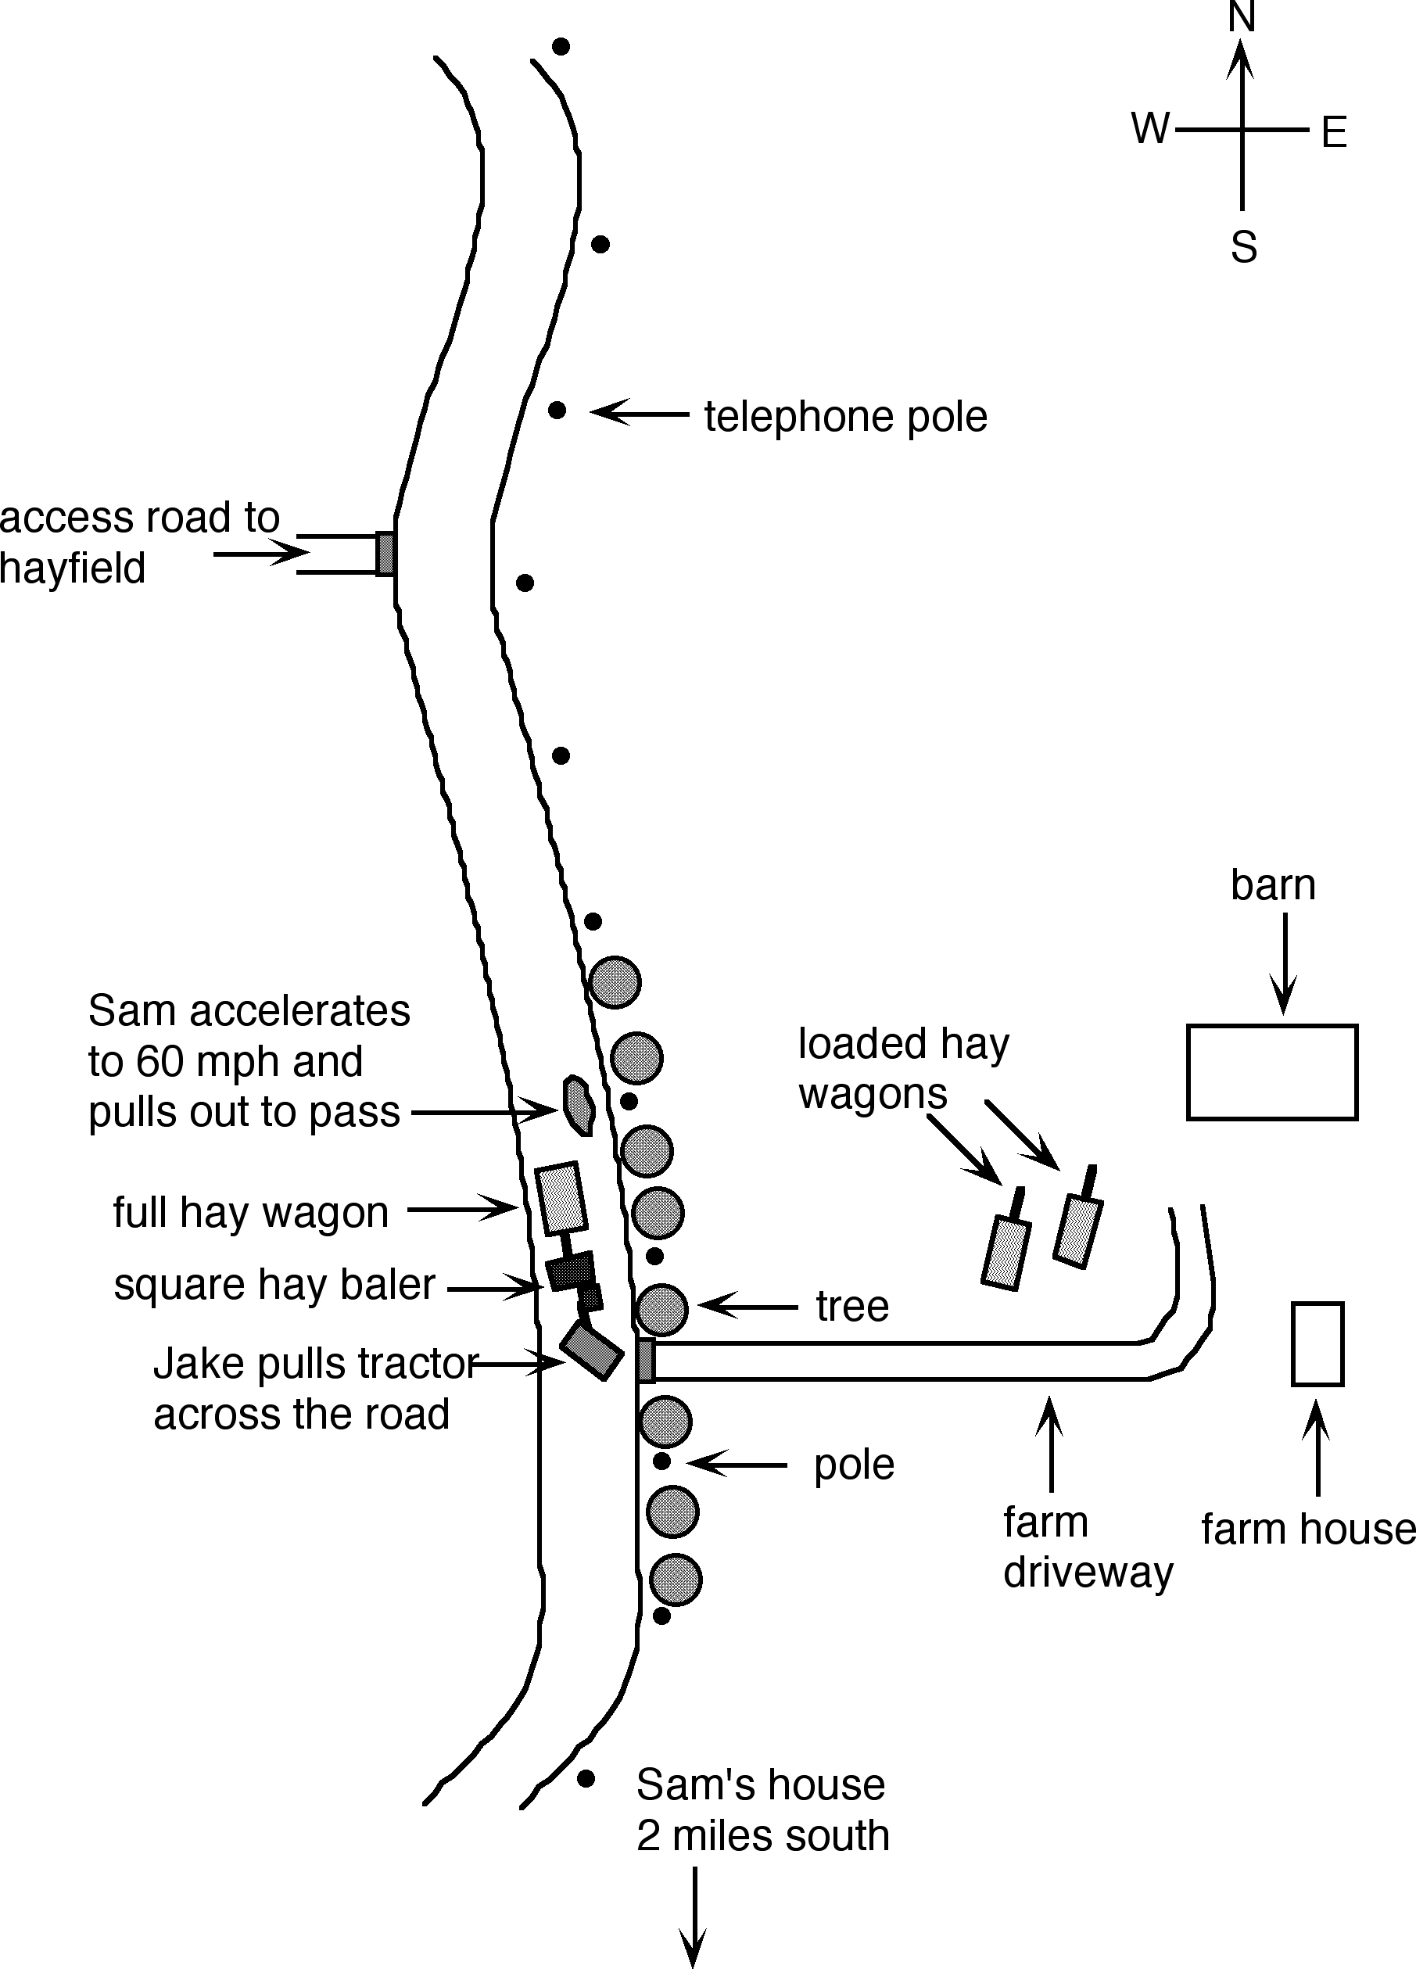

Figure 2: Impending crash between Sam’s car and Jake’s tractor.

Whump! Crash! Sam’s car hits the left rear wheel of Jake’s tractor. The tractor wheel breaks off and rolls into the field. Jake is thrown from the tractor and lands on his head 20 feet down the highway. Sam’s car wedges under the tractor and both skid off the road and smash to a stop against a large tree. Sam’s car is crushed under the 10,000-pound tractor and against the tree. The baler and hay wagon break free and run off the road to the right, just missing Jake as he lies in the road. (See Figure 3 on the next page.)

Jake’s wife hears the crash and runs to the highway to help her husband, but he is not breathing. She runs back to the house and calls 911. Both Jake and Sam are pronounced dead at the scene. Route 5 is blocked for five hours. Volunteer firefighters and EMS personnel work to free Sam’s body while police officers investigate the scene and supervise removal of the wreckage.

The investigation found no skid marks. (Sam’s car doesn’t have antilock brakes.) Sam did not apply his brakes. He was wearing his seatbelt and his airbag had deployed.

Question C

Who else is at risk because of the crash involving Sam and Jake?
(For each item, circle T for true or F for false.)

T | F | 17. | Other motorists approaching from the north and south.
T | F | 18. | Firefighters and EMS personnel.
T | F | 19. | Jake’s wife and grandchildren.
T | F | 20. | Once the crash has occurred, no one else is at more than normal risk.

[After you have studied Figure 3 and completed this page, please continue.]

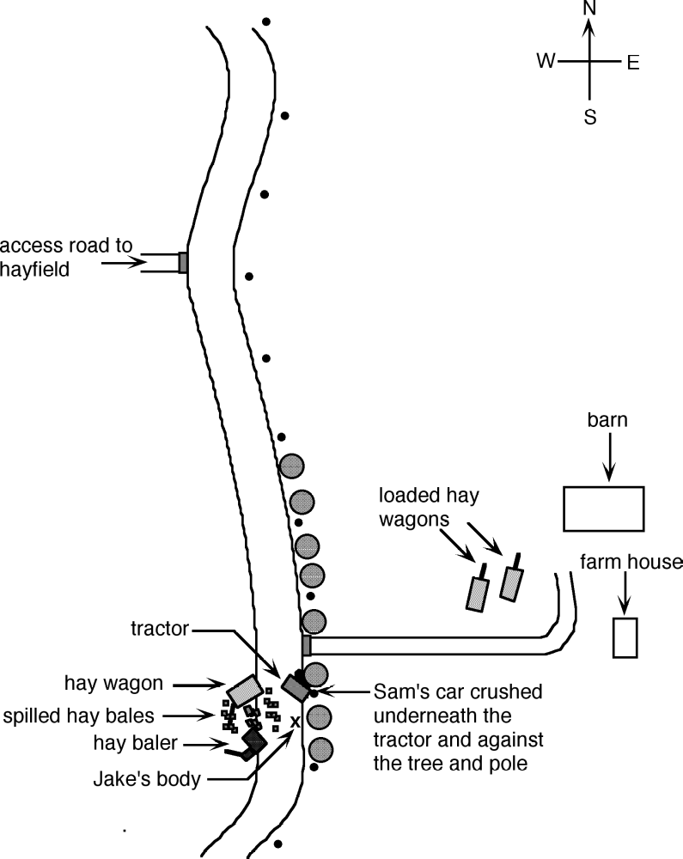

Figure 3: Crash scene after collision

Question D
Think about this whole story. What could Sam and Jake have done to avoid the crash? (For each item, circle T for true or F for false.)
Sam (the car driver):

T | F | 21. | Could have been more aware of his surroundings and realized that the tractor was likely to make a left turn.
T | F | 22. | Could have slowed down to the speed of the tractor, beeped his horn two or three times, and passed slowly and cautiously.
T | F | 23. | Could have escaped the crash if he had hit his brakes hard.
T | F | 24. | Could not be expected to take evasive action any sooner because the wagon had no turn signals.
T | F | 25. | As an experienced driver and law-abiding citizen with no previous accidents, was not obligated to do anything different.

Jake (the tractor driver):
T | F | 26. | Could have arranged to have an escort vehicle follow him.
T | F | 27. | Could have installed a telescoping wide rearview mirror on his tractor.
T | F | 28. | Could have had a ROPS installed on his tractor and worn the seatbelt.
T | F | 29. | Was not obligated to do anything different because he had lived and worked here for 30 years without a highway collision.
T | F | 30. | Could have made sure there was a clean and bright slow-moving vehicle (SMV) sign on the back of the hay wagon.
T | F | 31. | Could have moved the farm access road to be directly across the highway from the driveway to his farm.

End of the Story

Please complete the questionnaire attached to your answer sheet. Ask the instructor for a copy of the answer key. Compare your ideas and answers to the answer key. Discuss any ideas and differences of opinion. Please don't change any of your answers. Please give your problem booklet and your answer sheet and questionnaire to the instructor. If there is time, look at and discuss “Facts about Tractor/Motor Vehicle Collisions.”

Developed September 1997 by Henry P. Cole, Carol J. Lehtola, Shannon R. Thomas, and Melody Hadley at a two-day workshop titled “Translating Injury Surveillance Data into Health and Safety Educational Materials and Activities for Farm Workers and Families” at the University of Florida, Biological and Agricultural Engineering Department. The workshop and the development of this simulation exercise were supported by CDC/NIOSH Cooperative Agreements U07/CCU408035-05-2 and U06/CCU412900-01, 02, and 03 awarded to the University of Kentucky, Southeast Center for Agricultural Health and Injury Prevention. Revised August 2005 by H. Cole. The views expressed in this document are those of the authors and not necessarily those of CDC/NIOSH or the US Government.

